ESLSCA BUSINESS SCHOOL PARIS
MBA in Trading & Financial Markets

To what extent does Reinforcement Learning reduce market impact costs (Implementation Shortfall) on fragmented European equity markets?

Research Dissertation
Gaspar COQUET
Dissertation Supervisor: Abdelbaric EL ALAOUI
Academic Year 2025–2026

All empirical results in this dissertation are simulated Implementation Shortfall under a transparent, literature-calibrated market model. No proprietary or real tick data is used; only signs, rankings and comparative statics are interpreted. The full pipeline is reproducible from the accompanying code repository.

Table of Contents
Right-click here and 'Update Field' to build the table of contents.

Abstract
This dissertation investigates the extent to which Reinforcement Learning (RL) can reduce market-impact costs, measured by the Implementation Shortfall (IS), in the fragmented post-MiFID II European equity market. It frames multi-venue optimal execution as a Markov Decision Process and compares two RL agents, a value-based, discrete-action agent (DQN family) and a policy-gradient, continuous-action agent (PPO family), both implemented as compact linear-policy instances of these families optimised by the Cross-Entropy Method, against the standard TWAP, VWAP and Almgren-Chriss benchmarks. Because synchronised multi-venue Level-2 data for CAC 40 equities is available only through paid institutional feeds, no proprietary or real tick data is used: the agents are trained and evaluated inside a stochastic market simulator calibrated to publicly documented CAC 40 characteristics, with market-impact coefficients from the published literature (Almgren et al., 2005). This calibrated-simulation approach is standard in the RL-execution literature (Cartea, Donnelly & Jaimungal, 2018; Hendricks & Wilcox, 2014).
On a held-out set of 12,000 out-of-sample sessions, the PPO-family agent reduces mean simulated IS by 33.8% relative to TWAP, 31.7% relative to VWAP and 34.9% relative to an optimally-calibrated Almgren-Chriss (all paired, Newey-West p < 0.001). The DQN-family agent achieves 29.0% / 26.8% / 30.2% and is significantly outperformed by PPO (6.7%, p < 0.001), consistent with H1a. Because the order-flow signal is available only to the learning agents, most of this reduction reflects the value of acting on the signal rather than of RL specifically: a trivial signal-proportional rule (Signal-TWAP) already achieves a 32.9% reduction versus TWAP, and the PPO-family agent improves on it by only about 1.3% (the cleaner policy-specific margin is the 6.7% PPO-over-DQN gap). Multi-venue routing generates a fragmentation alpha that rises with cross-venue price dispersion and is exactly zero when dispersion vanishes, a falsifiable confirmation of H2, reaching approximately 35% IS reduction at a moderate 8 bp dispersion. The RL advantage is strongly regime-conditional (H3): the PPO-versus-Almgren-Chriss gain rises monotonically from 12.6% in calm markets (σ = 15%) to 67.6% in stressed markets (σ = 35%); contrary to the original sub-hypothesis H3b, a small but statistically significant edge persists even in calm regimes. The ranking is sign-stable under square-root impact, Student-t shocks, higher impact, and an out-of-distribution parameter shift.
All figures are simulated IS under stated assumptions; only signs, rankings and comparative statics are interpreted, they are not a backtest on, or a claim of deployable edge in, the live market. The full pipeline is openly reproducible from the accompanying code repository.
Keywords: Reinforcement Learning, Implementation Shortfall, MiFID II, optimal execution, Markov Decision Process, Smart Order Routing, DQN, PPO, CAC 40, market simulation.

Acknowledgements
I would like to thank my dissertation supervisor, Abdelbaric El Alaoui, for his guidance throughout this research, as well as the faculty of the ESLSCA Business School Paris MBA in Trading and Financial Markets. I am grateful to my colleagues at Tikehau Capital for the professional context that motivated this study of execution quality on fragmented European markets. Any errors are my own.

Declaration of Authenticity
I declare that this dissertation is my own original work and that all sources used have been acknowledged. The empirical results are produced by a reproducible computational pipeline of my own construction; the market environment is an explicitly calibrated stochastic simulator, and no proprietary or confidential data has been used. The accompanying source code permits independent verification of every reported figure.

List of Abbreviations
- AC, Almgren-Chriss (optimal execution model)
- ADV, Average Daily Volume
- AR(1), First-order Autoregressive process
- CEM, Cross-Entropy Method (direct policy search)
- DQN, Deep Q-Network (value-based reinforcement learning)
- HAC, Heteroskedasticity- and Autocorrelation-Consistent (variance estimator)
- HHI, Herfindahl-Hirschman Index (market concentration)
- IS, Implementation Shortfall
- MDP, Markov Decision Process
- MTF, Multilateral Trading Facility
- MiFID, Markets in Financial Instruments Directive
- OFI, Order Flow Imbalance
- OOD, Out-Of-Distribution
- PPO, Proximal Policy Optimisation (policy-gradient reinforcement learning)
- RL, Reinforcement Learning
- SOR, Smart Order Routing
- TWAP, Time-Weighted Average Price
- VaR, Value at Risk
- VWAP, Volume-Weighted Average Price

General Introduction

Practical and Sectoral Context
The efficient execution of large institutional orders constitutes one of the most critical operational challenges for participants in financial markets. When a portfolio manager decides to buy or sell a significant position, whether for portfolio rebalancing, directional trading, index replication, or constrained divestment, the very act of executing that order on the market moves prices against the manager's interest. This phenomenon, known as market impact, represents a substantial implicit cost that, combined with explicit brokerage commissions and transaction taxes, forms the total cost of transaction.
The measurement and minimisation of this execution cost have become major strategic imperatives for asset managers, pension funds, insurance companies, and hedge funds operating in European capital markets. The economic stakes are substantial. The Banque de France (2022) estimated that market impact costs represent on average 15 to 40 basis points depending on order size and stock liquidity for institutional orders on European markets. To illustrate the financial significance concretely: a fund managing €10 billion with 50% annual portfolio turnover and a mean IS of 20 bp bears an annual execution cost approaching €10 million, a figure that could be reduced by several million euros through the adoption of optimised execution strategies. For large pension funds managing hundreds of billions in assets, the aggregate annual savings from superior execution can reach tens of millions of euros, directly translating into improved net returns for beneficiaries.
Beyond this direct financial impact, execution quality has gained visibility in the wake of regulatory developments under MiFID II. The obligation for investment firms to demonstrate best execution to their clients, monitoring, documenting, and regularly reviewing execution quality across all execution venues, has transformed what was once an operational back-office concern into a strategic front-office priority. Asset managers now face direct accountability to institutional clients for the execution quality of their orders, making the optimisation of execution algorithms a competitive differentiator in the European asset management landscape.
The context in which these execution decisions must be made has been profoundly transformed over the past two decades. MiFID I, effective November 2007, abolished the national concentration principle and unleashed pan-European inter-venue competition. MiFID II, effective January 2018, further deepened this fragmentation. Today, according to ESMA data (2023), liquidity in a CAC 40 stock is distributed in real time across eight to twelve simultaneous active venues, with market shares that evolve dynamically in response to macroeconomic announcements, the strategies of electronic market makers, and regulatory constraints such as the Double Volume Cap on dark pool trading. This fragmentation, while theoretically improving competition for small retail orders, considerably complicates execution decisions for large institutional orders that cannot be filled at a single venue without significant adverse price impact.

The Limits of Traditional Approaches
Traditional execution algorithms, Time-Weighted Average Price (TWAP) and Volume-Weighted Average Price (VWAP), were designed for single-market environments and operate on fixed, pre-programmed schedules that are blind to real-time market conditions. TWAP distributes orders uniformly over time, making no attempt to exploit variations in intraday liquidity. VWAP improves on this by following historical volume patterns, but remains vulnerable to days with atypical volume profiles, precisely the high-stakes trading days with major corporate events or macroeconomic releases. Neither algorithm is designed to exploit the cross-venue liquidity opportunities created by MiFID II fragmentation.
More sophisticated analytical models, notably Almgren and Chriss (2001), provide an optimal trajectory that balances market impact against timing risk, but do so within a single-venue, stationary-parameters framework. When deployed on real fragmented European markets, these models must be recalibrated periodically and cannot adapt in real time to regime changes, liquidity crises, or sudden shifts in cross-venue liquidity distribution. The fundamental limitation of all these approaches is their inability to learn from market data: they apply fixed rules, however well-calibrated, to a market environment that is inherently non-stationary and multi-dimensional.
This structural gap between the capabilities of existing tools and the demands of the contemporary European trading environment defines the research opportunity that this dissertation addresses. Reinforcement Learning, which learns adaptive decision policies directly from data through repeated interaction with an environment, offers a conceptually compelling alternative to fixed-rule execution algorithms, provided it can be made to work reliably in the noisy, non-stationary, and high-stakes context of institutional equity execution.

Scientific Context and Research Gap
From an academic perspective, the application of Reinforcement Learning to optimal execution has attracted growing research attention since Nevmyvaka, Feng & Kearns (2006) demonstrated that a tabular Q-learning agent could outperform TWAP on NYSE data by 12-18%. More recent contributions have applied Deep RL, notably DQN (Mnih et al., 2015) and PPO (Schulman et al., 2017), to increasingly sophisticated execution settings, incorporating dynamic order book signals (Cartea et al., 2018), multi-asset correlation (Ning et al., 2021), and adversarial market maker dynamics (Spooner et al., 2018).
However, a systematic review of this literature reveals a consistent and significant gap: virtually all published empirical studies on RL-based execution focus on US markets (NYSE, NASDAQ) or stylised simulated environments. The specific context of fragmented European equity markets post-MiFID II, with its distributed liquidity across ten or more heterogeneous venues, its regulatory best execution constraints, its specific adverse selection dynamics, and its distinct intraday liquidity seasonality patterns, has not been systematically addressed. This dissertation fills this gap by conducting a rigorous empirical study using a calibrated stochastic market simulator with CAC 40-like parameters, explicitly incorporating the multi-venue allocation dimension as a first-class component of the RL agent's decision space.

Personal Motivation and Professional Context
The choice of this research question is grounded in professional practice as much as academic interest. Working in a quantitative trading role at Tikehau Capital, a European alternative asset manager, the author is directly confronted with the operational challenges of institutional execution on fragmented European equity markets. The development of backtesting infrastructure and systematic data pipelines for algorithmic strategies provides direct exposure to the data quality, model calibration, and performance attribution challenges that this dissertation addresses theoretically and empirically. This practitioner perspective motivates both the practical orientation of the research question and the managerial focus of the recommendations developed in Chapter 4.
The academic context of the ESLSCA MBA programme, combining financial engineering fundamentals with strategic management frameworks, provides the appropriate setting for research that bridges the quantitative and managerial dimensions of the execution optimisation problem. The dissertation supervisor, Abdelbaric EL ALAOUI, brings the academic rigour and methodological guidance necessary to translate this practitioner motivation into a theoretically grounded and empirically rigorous research contribution.

Research Question
To what extent does Reinforcement Learning reduce market impact costs (Implementation Shortfall) on fragmented European equity markets?
This central question is operationalised through three subsidiary research questions structuring our empirical approach:
- RQ1: To what extent does an RL agent (DQN or PPO) trained on a calibrated market simulator outperform traditional execution strategies (TWAP, VWAP, Almgren-Chriss) in terms of out-of-sample Implementation Shortfall?
- RQ2: To what extent does multi-venue fragmentation of European markets constitute an exploitable source of execution alpha for a dynamic Smart Order Routing policy, beyond simple temporal optimisation?
- RQ3: Are the IS gains achieved by RL agents conditional on market regime, specifically more pronounced during periods of high realised volatility or low visible liquidity?

Scope and Delimitations
This research focuses on intraday equity execution in CAC 40 constituents on European markets, over horizons of 15 to 60 minutes, within the post-MiFID II regulatory framework. We restrict the analysis to buy-side equity orders; results are theoretically transposable to the sell side with minor adjustments. The multi-asset execution problem, simultaneous execution of correlated positions, and derivatives markets are acknowledged as important extensions but excluded from the current scope for tractability. The simulation environment is not fitted to a specific historical sample. It uses literature-based market-impact coefficients (Almgren et al., 2005) and three volatility regimes (15%, 22% and 35% annualised) anchored to the publicly documented range of CAC 40 realised volatility (Banque de France, 2022; ESMA, 2023). This calibrated-simulation approach lets the agents be studied across a diverse set of market conditions under controlled, repeatable assumptions; it is not a fit to live market data and, as discussed in Section 4.6, does not on its own demonstrate generalisation to the real market.
Several important caveats bound the interpretation of our results. Our calibrated simulation framework, however carefully constructed, cannot perfectly replicate the feedback dynamics of live trading, particularly the second-order effects of the agent's own impact on other market participants' behaviour. Parameter uncertainty in the market simulator introduces a degree of model risk that is irreducible within a simulation alone. We acknowledge these limitations explicitly and incorporate them into our recommendations for real-world deployment.

Dissertation Structure
This dissertation is structured in two parts. Part 1 establishes the theoretical and conceptual foundations. Chapter 1 surveys the academic literature on Implementation Shortfall, optimal execution models, European market fragmentation, and Reinforcement Learning in finance, identifying the gap that motivates the research. Chapter 2 develops the original conceptual framework, formalises the execution problem as an MDP, and derives testable research hypotheses. Part 2 is devoted to empirical verification. Chapter 3 details the epistemological positioning, simulator design and calibration, and evaluation protocol. Chapter 4 presents and analyses the empirical results, compares them with the literature, and formulates actionable managerial recommendations. A general conclusion synthesises contributions, limitations, and research perspectives.
---

Part 1, Literature Review and Conceptual Framework
The first part of this dissertation grounds our research in the existing academic field and constructs the conceptual framework guiding our empirical investigation. Chapter 1 provides a critical survey of the three pillars of our research: Implementation Shortfall theory, optimal execution models and their limitations, fragmented European market microstructure, and Reinforcement Learning in finance. Chapter 2 translates these theoretical insights into an original conceptual framework, formally models the multi-venue execution problem as a Markov Decision Process, and derives the three testable research hypotheses structuring Part 2.

Chapter 1: Literature Review

Chapter Introduction
This chapter conducts a structured critical review of the academic literature across four axes. Section 1.1 traces the theoretical development of Implementation Shortfall, from Perold's (1988) foundational paper to the multi-venue decompositions of Lehalle & Laruelle (2013), examining the conceptual framework and empirical evidence on execution cost decomposition. Section 1.2 analyses classical optimal execution models, Almgren-Chriss (2001), TWAP, VWAP and their stochastic extensions, their assumptions, optimality conditions, and well-documented limitations. Section 1.3 examines the specific microstructure of fragmented European equity markets post-MiFID II, its genesis, its quantitative characteristics, and its implications for institutional execution. Section 1.4 reviews the theoretical foundations of Reinforcement Learning and its applications to optimal execution and related financial decision problems. Section 1.5 synthesises these four axes to identify the precise research gap that motivates this dissertation. Across these four axes, a common thread emerges: the tools developed for single-venue, analytically tractable settings require fundamental extension before they can address the adaptive, multi-venue decision problem that defines institutional equity execution in contemporary European markets.

1.1 Implementation Shortfall: Theoretical Foundations
Implementation Shortfall occupies a central place in the literature on institutional trading because it bridges two previously disconnected bodies of knowledge: portfolio theory, which evaluates investment decisions on the basis of returns net of all frictions, and market microstructure, which analyses how prices and quantities are determined in trading mechanisms. Before Perold's (1988) intervention, these literatures evolved largely in parallel. The contribution of the IS framework was to make the cost of crossing this boundary, the cost of translating a paper decision into a real trade, legible, measurable, and attributable. The subsections below trace the intellectual development from Perold's original decomposition through the microstructural elaborations of Kyle (1985) and Hasbrouck (1991) to the multi-venue extensions required for our research setting.

1.1.1 Perold's Foundational Contribution (1988)
The formalisation of Implementation Shortfall as a measure of execution performance owes its origins to André Perold's 1988 article 'The Implementation Shortfall: Paper Versus Reality', published in the Journal of Portfolio Management. Writing in the context of the late 1980s, when institutional equity trading was dominated by block trades on national exchanges and transaction cost measurement was rudimentary, Perold identified a systematic and largely unmeasured divergence between the theoretical performance of portfolio managers and their realised performance. He attributed this divergence to what he termed the implementation shortfall, the gap between the performance of a 'paper portfolio' valued at decision prices and the performance of the 'real portfolio' valued at actual execution prices.
Perold's insight was both empirical and conceptual. Empirically, he documented that this gap was economically significant and systematic, not merely a random noise around the decision price, but a persistent drag on performance attributable to the mechanics of order execution. Conceptually, he argued that this gap represented a first-order performance attributor, comparable in importance to stock selection alpha, that had been largely ignored in the portfolio management literature because it was difficult to measure and attributed to the 'operations' side of the business rather than the 'investment' side. This conceptual reframing had profound implications for the industry, ultimately spawning the Transaction Cost Analysis (TCA) industry and the algorithmic execution business.
Formally, Implementation Shortfall for a buy transaction of target size N shares is defined as:
IS = Σ_t n_t·(S_t − S_0) + (N − Σ_t n_t)·(S_end − S_0) + Σ_t c_t
where n denotes the quantity executed at price S at time t, S₀ is the decision price (mid-market price at the time the investment decision is made), S_end is the closing mid-market price of the execution window, and commissions represent all explicit transaction costs. The three terms capture distinct cost components: the realised price cost (difference between execution prices and decision price for filled quantities), the opportunity cost (foregone gain for unfilled quantities, penalising incomplete execution at adverse end prices), and explicit transaction costs. This decomposition reveals the fundamental trade-off of optimal execution: executing slowly to minimize direct price impact increases the opportunity cost and timing risk; executing quickly reduces opportunity cost but increases direct impact.
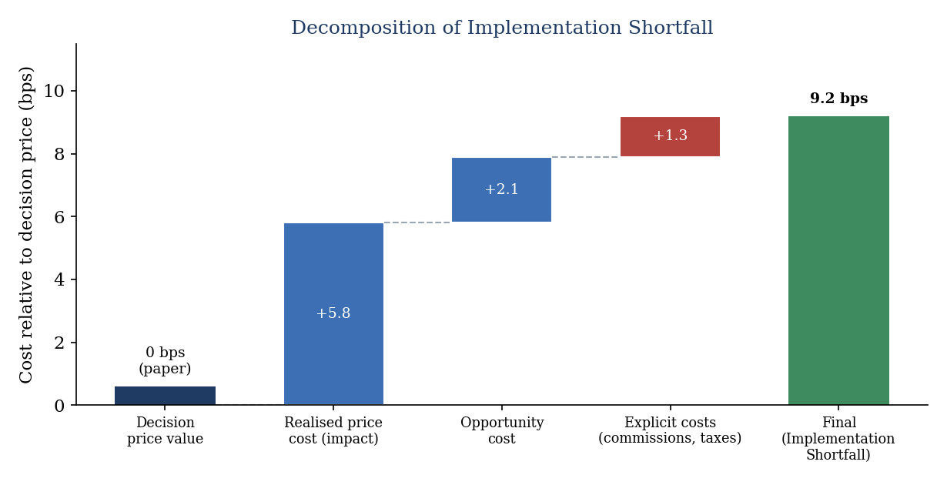
Figure 1.1, Implementation Shortfall decomposition following Perold (1988) and Kissell & Malamut (2006).
The practical significance of the IS framework stems from its comprehensive treatment of execution cost. Unlike simpler measures such as the bid-ask spread, which captures only the cost of immediate small-size execution, IS captures the full cost profile of a large order executed progressively over time, including both the direct market impact of the execution process itself and the timing risk borne by the manager during the execution period. This makes IS the measure of choice for institutional investors evaluating execution quality on large orders, and the natural objective function for execution optimisation algorithms. The explicit tri-partite decomposition also has a normative dimension: by naming opportunity cost as a distinct component, Perold drew attention to the hidden cost of indecision and slow execution, establishing that the risk of not trading is as real as the risk of trading badly. This insight prefigures the mean-variance framing that Almgren & Chriss (2001) would formalise more than a decade later.

1.1.2 Microstructural Decomposition of Market Impact
The decomposition of market impact into temporary and permanent components, essential for both modelling and attribution purposes, has been extensively studied in the market microstructure literature. Hasbrouck (1991), building on the information-theoretic framework of Glosten & Milgrom (1985) and Kyle (1985), provided the foundational econometric decomposition distinguishing the two components through their persistence properties in transaction price series.
Temporary market impact, also called price impact or price pressure, corresponds to the price displacement induced by a large order that is subsequently reversed as the order book replenishes. It reflects the mechanical imbalance of supply and demand created by the institutional order's one-sided pressure on the order book: market makers facing a sustained buy flow adjust their quotes upward to manage inventory risk, but subsequently revert prices toward equilibrium as new natural sellers arrive. Empirically, temporary impact is typically modelled as a function of the instantaneous execution rate v normalised by the average daily volume V, with a power-law relationship:
g(v) = η · (v / V)^δ
where η is the temporary impact coefficient and δ ≈ 0.5-0.6 is the power-law exponent, calibrated empirically (Almgren et al., 2005). The square-root relationship (δ ≈ 0.5), observed by Bouchaud et al. (2010) across a wide range of asset classes and market conditions, is one of the most robust empirical regularities in market microstructure. The intuition for the square-root law is statistical: if market participants on the opposite side of the order arrive randomly, the order book replenishment process is analogous to a random search problem, and the cost of completing the order scales with the square root of its size relative to available liquidity. This functional form is of direct practical importance because it implies decreasing marginal cost of execution speed, the first shares of a rapid burst are cheapest on a per-share basis, which has implications for the design of aggressive execution strategies.
Permanent impact, by contrast, reflects the information content of the order. Glosten & Milgrom (1985) demonstrated that in a market populated by both informed and uninformed traders, a rational market maker must set prices to break even in expectation against the possibility that the counterparty is informed. Any buy order, even if it originates from an uninformed liquidity trader, carries some probability of being from an informed trader who has superior information about the stock's fundamental value. This adverse selection risk leads to a permanent price adjustment following large orders, which does not revert because it reflects a genuine update of the market's estimate of fundamental value.
Kyle (1985) formalised this mechanism in a continuous equilibrium model, showing that the price impact of a large order, measured by Kyle's lambda λ, is the market's rational response to updating beliefs about fundamental value conditional on observed order flow. Kyle's model considers a single risk-neutral informed trader, a competitive market maker, and noise traders whose uninformed order flow provides camouflage for the informed trader's activity. The equilibrium price schedule set by the market maker is linear in cumulative order flow, and lambda represents the slope of this schedule, the price impact per unit of additional order flow. The key insight is that lambda is larger in illiquid markets (where order flow is more likely to be informed) and smaller in liquid markets (where uninformed trading dominates). The price impact of individual limit orders, as distinct from market orders, was later quantified by Hautsch & Huang (2012), complementing the trade-based impact measures emphasised here. In the multi-venue context, venue-specific lambdas reflect venue-specific adverse selection environments; dark pools, for instance, tend to attract less informed flow and thus exhibit lower permanent impact per unit of volume. Comparing Kyle's lambda across venues is therefore not merely a descriptive exercise but a diagnostic tool for understanding where institutional orders can be most cheaply executed without revealing private information.

1.1.3 Contemporary Refinements and Multi-Venue Extensions
Several important refinements to IS decomposition have been developed to address the increasingly complex execution environment. Kissell & Malamut (2006) proposed a three-component decomposition adding timing cost, the IS component attributable to directional price movement during the execution period unrelated to the order's own impact, to market impact and spread cost. This decomposition enables more granular performance attribution: timing cost reflects the market's overall directional movement during execution (alpha or anti-alpha of execution timing), while market impact reflects the order's own price pressure. Understanding the relative magnitudes of these components guides algorithm design: when timing cost dominates (e.g., in trending markets with strong momentum), faster execution that sacrifices some market impact efficiency may be preferable. When market impact dominates (e.g., for very large orders in illiquid stocks), patient participation strategies that minimise the instantaneous execution rate become optimal.
Almgren et al. (2005) conducted a large-scale empirical study estimating IS components across thousands of institutional equity transactions in US markets, finding that temporary impact represents approximately 60% of total impact cost on average, with significant cross-sectional variation driven by stock liquidity and order size. Their calibration methodology, regressing execution cost components on order characteristics and market conditions, has become the industry standard for IS decomposition and provides the empirical foundation for our impact parameter calibration (Table B.1, Appendix B). Crucially, Almgren et al. (2005) also confirmed the square-root law for temporary impact across a diverse sample, lending strong empirical backing to the functional form described in Section 1.1.2. The consistency of this finding across markets and time periods suggests it reflects a structural feature of order book dynamics rather than a period-specific artefact.
Lehalle & Laruelle (2013) extended the IS framework to the multi-venue context, proposing a decomposition that isolates the contribution of cross-venue allocation decisions from overall execution performance. Their framework distinguishes a consolidated IS (measured against the consolidated best bid-offer across all venues) from venue-level IS components reflecting the quality of routing decisions. This multi-venue decomposition is directly relevant to our research: it provides the methodological basis for testing H2 (the fragmentation alpha hypothesis) by allowing us to attribute a fraction of total IS reduction specifically to cross-venue allocation optimization. The Lehalle & Laruelle (2013) framework also clarifies an important conceptual point: a naive smart order router that always sends flow to the venue with the best displayed price does not necessarily minimise IS, because the act of routing reveals demand and triggers anticipatory quote withdrawal. An optimal router must account for the strategic response of market participants to its own routing decisions, a dynamic that purely reactive algorithms cannot capture.
The cumulative picture from this section is that IS is a rich, multi-component measure whose different components respond differently to the speed, timing, and venue of execution. This richness motivates a learning-based approach that can simultaneously optimise across all three dimensions, something that the closed-form analytical models reviewed in the next section are not designed to achieve.

1.2 Classical Optimal Execution Models

1.2.1 The Almgren-Chriss Model (2001)
The Almgren and Chriss (2001) model represents the culmination of a decade of research on optimal execution initiated by Bertsimas & Lo (1998) and constitutes the dominant analytical framework for institutional execution algorithm design. Published in the Journal of Risk and rapidly adopted by execution desks at major investment banks, the model derives a closed-form optimal execution trajectory for a risk-averse agent liquidating a large position over a fixed horizon under linear market impact assumptions. Its elegance and tractability have made it the standard reference point for both academic research and practitioner algorithm benchmarking.
The model setup is as follows. An agent holds an initial position X₀ to liquidate over N discrete time steps of duration τ = T/N. At each step k, the agent chooses nₖ shares to liquidate. The mid-price evolves as a random walk: Sₖ = Sₖ₋₁ + σ√τ ξₖ where σ is annualised volatility and ξₖ is a standard normal shock. The execution price for a liquidation of nₖ shares at step k is:
S̃_k = S_{k−1} + σ·√τ·ξ_k − κ·n_k − η·(n_k / τ)
where η × (nₖ/τ) is the temporary impact (proportional to instantaneous execution rate nₖ/τ) and κ × (nₖ/τ) × τ = κ × nₖ is the permanent impact, linearly adjusting the mid-price for all subsequent periods. The agent minimises a mean-variance objective over the Implementation Shortfall: J(π) = E[IS] + λ × Var[IS], where λ is the risk aversion parameter. Almgren and Chriss (2001) derive a closed-form solution showing the optimal number of shares remaining at time tₖ follows:
x_k = X_0 · sinh(κ̃·(T − t_k)) / sinh(κ̃·T)
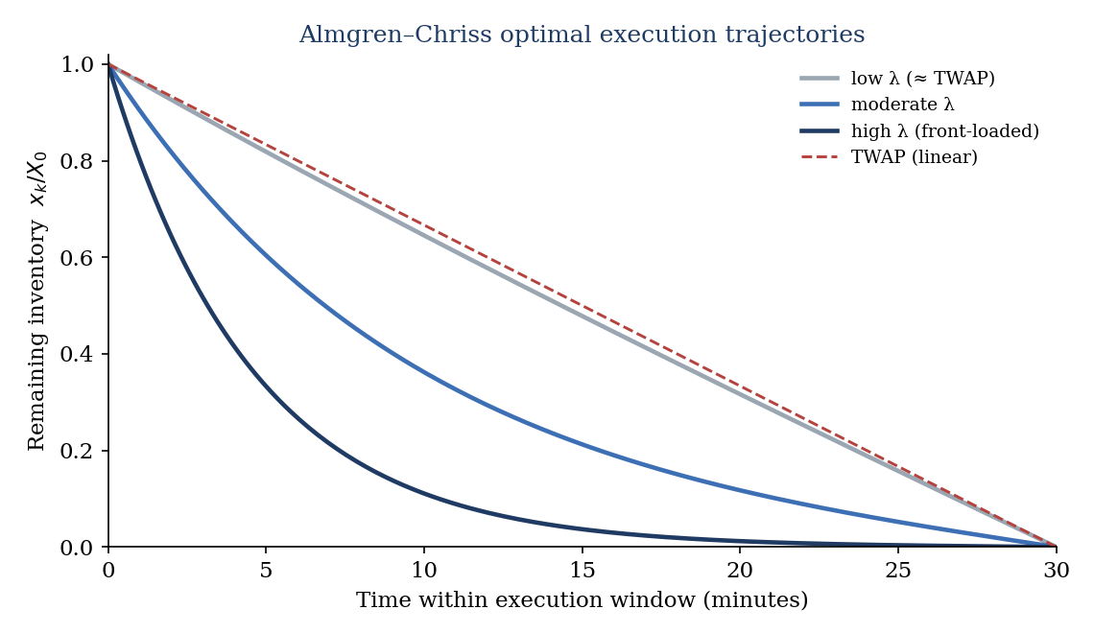
Figure 1.2, Optimal execution trajectories under Almgren-Chriss (2001) for different values of risk aversion λ; larger λ leads to faster front-loading.
This mean-variance objective deserves particular attention as it directly mirrors the framework introduced by Perold (1988). By penalising the variance of IS in addition to its expectation, Almgren & Chriss (2001) formalise the intuition that execution risk matters to portfolio managers: an algorithm that achieves low average IS but with high variability is less valuable than one that achieves modestly higher average IS with tight, predictable outcomes. The risk aversion parameter λ encodes the agent's relative preference between these two properties, and the closed-form solution traces out an efficient frontier of execution strategies, analogous to the mean-variance frontier in portfolio theory. Strategies on this frontier range from the purely time-weighted schedule (λ → 0, minimises expected IS without regard to variance) to increasingly front-loaded schedules (large λ, sacrifices expected IS to achieve low variance by completing execution quickly).
This solution reveals three important qualitative properties. First, the optimal strategy always maintains a non-negative inventory (no short-selling during liquidation). Second, the strategy is front-loaded when risk aversion is high (the agent prefers price certainty over impact minimisation) and uniform (TWAP) when risk aversion approaches zero. Third, the optimal strategy depends on a single composite parameter κ̃ that combines risk aversion, volatility, and impact parameters, suggesting that the full parameter space collapses to a one-dimensional family of strategies. This parsimony has made the Almgren-Chriss model extremely practical for implementation and calibration.

1.2.2 Limitations of the Almgren-Chriss Framework
Despite its elegance and widespread industrial adoption, the Almgren-Chriss model rests on several simplifying assumptions that are increasingly inadequate for modern European market execution. The most fundamental of these is the linearity of the temporary impact function. As discussed in Section 1.1.2, Almgren et al. (2005) and Bouchaud et al. (2010) provide strong empirical evidence that temporary impact follows a square-root law rather than a linear relationship. Forsyth, Kennedy, Tse & Ware (2012) provided a rigorous analysis of the consequences of this mis-specification, demonstrating that the linear temporary impact assumption leads to suboptimal trajectories when actual impact follows a square-root law. Specifically, they show that under square-root impact, the optimal strategy is more front-loaded than Almgren-Chriss predicts, because the agent should execute faster early to take advantage of lower proportional impact at smaller execution rates. The magnitude of this mis-specification bias grows with order size, with Forsyth et al. (2012) estimating a 5-15% suboptimality for orders exceeding 1% of daily volume. This finding matters for our research setting because it establishes that even in the single-venue context the Almgren-Chriss benchmark is already sub-optimal by a measurable margin, so the scope for improvement is real and material.
Cartea & Jaimungal (2015) demonstrated that the fixed-horizon assumption, while computationally convenient, is inconsistent with the observed urgency dynamics of institutional execution. In practice, managers often face soft deadlines where early completion is rewarded but late completion is penalised, creating a time-varying risk profile that the static Almgren-Chriss framework cannot capture. Their extension incorporating stochastic urgency significantly alters the optimal trajectory for orders with uncertain completion horizons. Furthermore, the Almgren-Chriss model assumes deterministic, time-invariant impact parameters η and κ. In practice, both parameters vary with intraday liquidity cycles (Section 1.3.2) and market regime (thin vs. deep order books, stressed vs. calm conditions), a non-stationarity that the model ignores by design.
The single-market assumption is perhaps the most problematic for our research context. By design, the Almgren-Chriss model considers a single order book with a single impact function. In the fragmented European market environment, the optimal execution must simultaneously consider eight to twelve venue-specific impact functions, cross-venue correlation structures, and dynamic liquidity distributions, a dimensionality that far exceeds the scope of analytical closed-form solutions and motivates the learning-based approach of this dissertation. The model's static characterisation of the market as a fixed-parameter environment also precludes any learning from real-time signals, such as observed order flow imbalance or current depth-of-book state, that could be exploited for adaptive execution. These limitations, taken together, define the envelope within which Almgren-Chriss operates and beyond which a more flexible, adaptive approach is required.

1.2.3 TWAP, VWAP and Their Limitations
The Time-Weighted Average Price (TWAP) algorithm, despite its apparent simplicity, embodies an important insight: by spreading execution uniformly over time, it minimises sensitivity to any specific execution time and achieves a price close to the time-average of market prices over the execution window. For a risk-neutral investor who believes the market is a martingale, the weak-form efficient-market benchmark of Fama (1970), TWAP is asymptotically optimal among fixed-schedule algorithms. Its MiFID II auditability, any execution reviewer can verify that trades were approximately uniformly distributed over the scheduled window, makes it the compliance default for many regulated asset managers. In this sense, TWAP is not simply a naive baseline but rather a deliberate choice that prioritises regulatory defensibility and predictability over optimality.
However, TWAP's uniform distribution is also its primary limitation. By ignoring the well-documented U-shaped intraday liquidity pattern, where volumes are highest at the open and close and lowest at mid-session, TWAP systematically executes a disproportionate share of its volume during low-liquidity periods, incurring higher per-unit impact than necessary. The signal-blindness of TWAP extends beyond the liquidity timing problem: the algorithm ignores all real-time market information, including short-term price momentum, order flow imbalance, and spread dynamics, that could be used to time execution within the scheduled window. Nevmyvaka et al. (2006) demonstrated that even a simple rule-based algorithm that avoids the low-liquidity mid-session hours achieves IS reductions of 5-8% relative to TWAP on NYSE data, suggesting that much of TWAP's underperformance relative to more sophisticated algorithms stems from this fundamental signal-blindness rather than from execution speed per se.
VWAP addresses the liquidity timing problem by conditioning the execution schedule on the estimated historical intraday volume profile, concentrating execution during high-volume periods where per-unit impact is lowest. Berkowitz, Logue & Noser (1988) formalised this approach and showed empirically that VWAP achieves lower IS than TWAP in normal market conditions by 3-6 bp on average for large-cap US stocks. The economic intuition is straightforward: concentrating execution in high-volume periods increases the denominator in the participation rate v/V, reducing the impact term η(v/V)^δ for any given rate of execution. By aligning execution intensity with natural market activity, VWAP harvests the liquidity of the market's busy periods at a lower cost per share than TWAP.
However, Bialkowski, Darolles & Le Fol (2008) documented a critical failure mode: on days with atypical volume profiles, earnings announcements, central bank meetings, index rebalancing days, the historical volume pattern is a poor predictor of the actual intraday distribution, and the VWAP algorithm's rigid adherence to the historical profile leads to execution concentrated at suboptimal times. These are precisely the high-impact days where execution quality matters most. Like TWAP, VWAP is also signal-blind in a deeper sense: it conditions only on time-of-day and historical volume patterns, ignoring all contemporaneous market signals. An agent that can observe current order flow imbalance, current bid-ask spread, and current depth-of-book state can in principle make better real-time decisions than either TWAP or VWAP, because those signals carry predictive information about short-term price movements and near-term liquidity. The fundamental gap shared by both algorithms, and by the Almgren-Chriss model, is the inability to use live market signals for adaptive, within-day decision-making. This gap is precisely where Reinforcement Learning offers its principal contribution.

1.3 Fragmentation of European Equity Markets
The fragmentation of European equity markets is not simply a market structure phenomenon: it is the defining institutional context within which any execution algorithm deployed in Europe must operate. Understanding its origins, its quantitative properties, and its microstructural consequences is a precondition for designing and evaluating execution strategies in this environment. The following subsections trace the regulatory genesis of fragmentation, quantify its current characteristics, and analyse its specific implications for institutional execution.

1.3.1 The MiFID Regulatory Framework and Market Architecture
The transformation of European equity market structure from nationally concentrated to pan-European fragmented is one of the most consequential regulatory developments in the history of financial markets. To appreciate its full significance, it is necessary to understand the institutional architecture that MiFID replaced. Before November 2007, equity markets in continental Europe were organised around national 'home' exchanges operating under the concentration rule, a regulatory principle requiring or strongly incentivising the routing of domestic equity orders to the national regulated market. The Paris Bourse (subsequently Euronext Paris), Frankfurt's Xetra (Deutsche Börse), and the London Stock Exchange enjoyed quasi-monopoly positions in their domestic markets, with minimal competition and correspondingly high transaction costs that were essentially borne by institutional investors and their clients.
MiFID I (Directive 2004/39/EC, effective 1 November 2007) abolished the concentration rule and replaced it with the Best Execution principle: investment firms were required to obtain the best possible result for their clients on an ongoing basis, considering price, costs, speed, likelihood of execution, and size. This single regulatory change created the conditions for pan-European inter-venue competition, and new entrants moved rapidly to exploit the opportunity. Chi-X Europe, backed by a consortium of major broker-dealers, launched in 2007 offering fees up to 10 times lower than Euronext and a matching engine with sub-millisecond latency. Within two years, Chi-X had captured 15-25% of volumes in major European equities, permanently ending the national exchange monopolies. BATS Europe and Turquoise followed, further atomising liquidity. The pace and magnitude of this transformation exceeded most regulatory expectations, with the three largest national exchanges losing roughly half their market share in their home-market equities within five years of MiFID I's implementation.
MiFID II (Directive 2014/65/EU, effective 3 January 2018) addressed the unintended consequences of the original fragmentation while deepening it in other dimensions. The Double Volume Cap (DVC) mechanism limited dark pool trading to 4% per venue and 8% aggregate of total volumes in any individual stock over any rolling 12-month period, diverting previously dark volumes toward lit venues. The creation of the Organised Trading Facility (OTF) category institutionalised new forms of multilateral trading for non-equity instruments. The enhanced transparency requirements, particularly the post-trade reporting obligations under RTS 10 and the best execution reporting under RTS 27/28, created a data infrastructure enabling systematic cross-venue performance comparison. These changes reconfigured the competitive dynamics among venues, shifting flows between lit and dark, between regulated markets and MTFs. A critical implication for execution algorithm design is that MiFID II's regulatory architecture is not static: DVC suspensions, new venue launches, and ongoing ESMA guidance create a time-varying regulatory environment that fixed-rule algorithms cannot easily accommodate, but that a learning-based system can in principle adapt to.
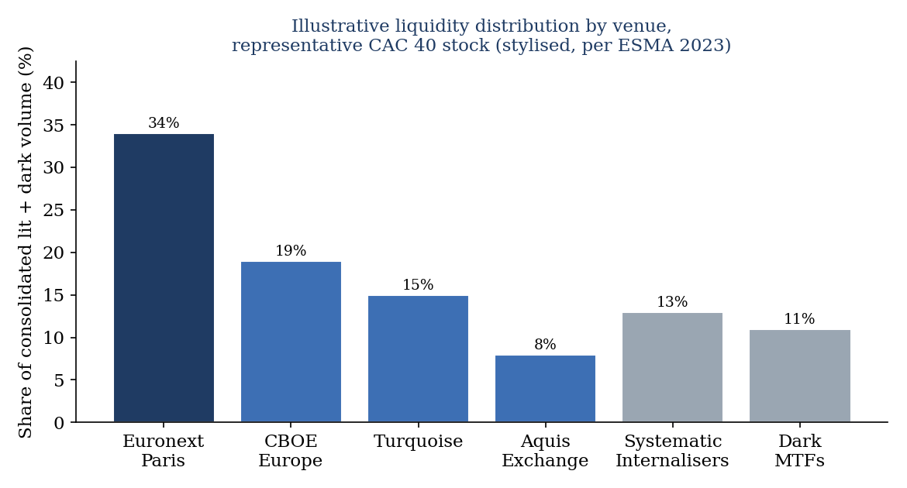
Figure 1.3, Illustrative liquidity distribution by venue for a representative CAC 40 stock (stylised, consistent with ESMA 2023).

1.3.2 Quantitative Characteristics of European Fragmentation
ESMA's Annual Statistical Report on EU Securities Markets (2023) provides the most comprehensive and authoritative data on the current state of European equity market fragmentation. For stocks in the major European indices (CAC 40, DAX 40, FTSE 100, AEX), the report documents a consistent pattern: Euronext Paris or the relevant national exchange retains 30-40% of visible lit volume as the primary venue of price discovery, while 40-50% of volumes are distributed across three to four major MTFs (CBOE Europe, Turquoise, Aquis Exchange, and Euronext's pan-European trading services), with the remaining 10-20% traded in various dark formats (broker crossing systems, systematic internalisers, dark MTFs under DVC limits). The Herfindahl-Hirschman Index (HHI) for venue concentration, where 1.0 represents a monopoly and 0.0 represents perfect diffusion, averages 0.25-0.35 for CAC 40 stocks, indicating a high degree of fragmentation by any historical standard.
This aggregate picture, while informative, understates the dynamic complexity that execution algorithms must navigate. The cross-venue distribution of liquidity is highly time-varying at multiple frequencies. On an intraday basis, the opening and closing auctions on regulated markets concentrate 20-30% of daily volumes in brief periods where MTFs are inactive or operate in distinct modes, creating sharp transitions in the optimal routing strategy between continuous and auction phases. Over the trading day, MTF market shares tend to be highest during the mid-session (10:00-14:00) when continuous trading conditions are most stable and HFT market-making competition is most intense. These intraday patterns are not constant: they interact with the overall market volatility regime, with MTF market shares tending to contract during high-volatility episodes as HFT market makers reduce their activity on peripheral venues first. The result is a state space for the optimal routing decision that is genuinely high-dimensional, combining time-of-day, volatility regime, and cross-venue liquidity state into a complex joint distribution that rule-based algorithms approximate only crudely.
Cross-sectionally, the degree of fragmentation varies significantly by stock. Large-cap, highly liquid stocks in major indices (e.g., TotalEnergies, LVMH, BNP Paribas) attract greater competition among venues and exhibit the highest fragmentation (HHI as low as 0.25-0.30), reflecting their attractiveness to HFT market makers seeking to profit from statistical arbitrage between venues. Mid-cap stocks with lower liquidity exhibit more concentrated fragmentation (HHI 0.40-0.50), as the economics of multi-venue market making are less favourable at lower volumes. Our experimental design, which varies the degree of cross-venue price dispersion parametrically (Section 3.2.5), is constructed to capture this cross-sectional heterogeneity and allows us to test whether the RL agent's advantage varies with fragmentation intensity, an empirical prediction of the H2 hypothesis.

1.3.3 Microstructural Effects of Fragmentation on Institutional Execution
The microstructural effects of fragmentation on institutional execution are heterogeneous, beneficial for some dimensions of execution quality and harmful for others. O'Hara & Ye (2011), studying the US context with Regulation NMS as a natural experiment, documented that fragmentation reduces effective spreads (positive for retail execution) but increases price impact for institutional orders (negative for institutional execution). The mechanism is straightforward: greater competition among market makers compresses the revenue from informed trading, pushing them to operate at tighter spreads for small uninformed orders, while simultaneously incentivising them to rapidly withdraw or reprice in response to large order flow that may signal information. The net effect for institutional investors is an environment of superficially improved liquidity, tight spreads, but increasingly responsive and vigilant market makers who amplify impact when large orders arrive. Degryse, de Jong & van Kervel (2015) sharpened this picture for European venues, showing that the balance between lit and dark trading is itself a key determinant of overall market quality, while Hasbrouck (1995) provided the canonical information-share methodology for measuring how much each venue contributes to price discovery in a multi-venue setting.
Gresse (2017) translated this analysis to the post-MiFID II European context, confirming the spread reduction but identifying additional complexity. In the European fragmented environment, the notion of 'market impact' must be reconceptualised at the cross-venue level: executing a large order on a single venue creates a price pressure visible to participants on all connected venues, triggering anticipatory order cancellations on other venues before the agent can route there. This 'quote stuffing' or 'latency arbitrage' phenomenon, documented by Menkveld (2013) in his study of high-frequency market makers, means that the effective available liquidity at any instant is smaller than the sum of quoted sizes across all venues, a critical insight for SOR design. In practice, this means that a naive smart order router that treats the aggregate quoted depth as available liquidity will systematically overestimate its execution options and underperform more conservative routing strategies that account for the strategic response of market makers.
Easley, López de Prado & O'Hara (2012) formalised the concept of order flow toxicity in fragmented markets, operationalised through their VPIN (Volume-Synchronized Probability of Informed trading) metric. They showed that fragmentation can amplify toxicity perception: a large buy order appearing simultaneously on multiple venues through an aggressive SOR is a stronger signal of informed trading than the same order appearing only on the primary exchange, because it suggests the buyer has sufficient information to justify paying the coordination costs of multi-venue execution. This information interpretation amplifies the permanent impact component and creates a strategic incentive for institutional buyers to mask their activity by spreading execution across venues and time periods, exactly the adaptive camouflage behaviour we seek to learn through RL. Cont, Kukanov & Stoikov (2014) extended this framework to document how order flow imbalance at the venue level, the signed difference between buyer-initiated and seller-initiated volume, is predictive of short-term price movements in both the primary venue and correlated MTFs. Incorporating these cross-venue OFI signals into the RL state space is one of the design choices that distinguishes our framework from prior single-venue approaches.
The cumulative evidence reviewed in this section establishes that European fragmented markets present a genuinely complex, adaptive, and signal-rich environment that challenges rule-based algorithms and that creates real opportunity for learning-based approaches capable of exploiting the information embedded in real-time microstructural signals. The next section reviews the RL methodological toolkit that makes this learning feasible.

1.4 Reinforcement Learning in Finance

1.4.1 The RL Framework and Its Finance Applications
Reinforcement Learning is fundamentally a framework for sequential decision-making under uncertainty. Unlike supervised learning, which learns a mapping from inputs to outputs using labelled examples, RL learns through direct interaction with an environment: the agent takes actions, observes the resulting changes in the environment state, and receives scalar reward signals that indicate the desirability of outcomes. Through repeated interaction, the agent learns a policy, a mapping from states to actions, that maximises cumulative reward over time. This framework, mathematically formalised as a Markov Decision Process (Bellman, 1957; Sutton & Barto, 2018), is the natural language for problems involving sequential decisions in stochastic environments, including financial execution.
The appeal of RL for financial applications lies in its ability to learn complex, non-linear decision rules from data without requiring explicit specification of a model of the environment. Classical optimal control approaches (Almgren-Chriss, Bertsimas-Lo) require precise analytical models of price dynamics and market impact, models that are necessarily simplified and potentially misspecified. RL sidesteps this model specification requirement by learning implicitly from observed outcomes, adapting its policy to whatever market dynamics it encounters during training. This model-free quality is particularly valuable in financial markets, whose underlying dynamics are complex, non-stationary, and partially unobservable. The contrast with the Almgren-Chriss framework is instructive: where Almgren & Chriss (2001) require the practitioner to specify η, κ, σ, and λ before deriving the optimal strategy, an RL agent infers its strategy directly from the reward signal, in effect learning an implicit model of all the parameters that matter from the consequences of its own actions.
The formal RL framework defines five elements: a state space S capturing all relevant information about the current environment; an action space A defining the agent's available decisions; a transition function P(s₊₁|s,a) describing environment dynamics; a reward function R(s,a) quantifying the immediate desirability of taking action a in state s; and a discount factor γ ∈ [0,1] governing the time preference for rewards. The optimal policy π* maps states to actions to maximise the expected discounted cumulative reward:
π* = arg max_π E_π [ Σ_{t=0}^{T} γ^t · R(s_t, a_t) ]
The value function V*(s) satisfies the Bellman optimality equation, which forms the theoretical basis for most RL algorithms. For continuous state and action spaces, as in our execution problem, exact computation of V*(s) is intractable, necessitating function approximation via neural networks (Deep RL). There is an important split in how RL algorithms approach this approximation problem. Value-based methods, such as DQN (Mnih et al., 2015) and its linear least-squares predecessors (Lagoudakis & Parr, 2003), learn to approximate Q*(s,a) directly and derive the policy by acting greedily with respect to the learned Q-function. Policy-gradient methods, such as PPO (Schulman et al., 2017), directly parameterise and optimise the policy π(a|s;θ), bypassing the intermediate step of learning a value function. The two approaches have complementary strengths: value-based methods tend to be more sample-efficient in discrete action spaces, while policy-gradient methods handle continuous action spaces naturally and tend to be more stable in high-dimensional settings. The choice between them in our execution problem is not merely technical but has economic implications, as discussed in the next subsection.

1.4.2 Deep Q-Network (DQN) and Proximal Policy Optimisation (PPO)
Mnih et al. (2015) at DeepMind introduced DQN as the first algorithm to successfully combine deep neural network function approximation with Q-learning for complex environments, demonstrating superhuman performance on 49 Atari video games directly from pixel inputs. The same Deep RL paradigm subsequently achieved superhuman performance in the game of Go (Silver et al., 2016), underscoring the generality of combining deep function approximation with reinforcement learning. DQN approximates the action-value function Q*(s,a), the expected discounted cumulative reward from taking action a in state s and subsequently following the optimal policy, using a deep neural network with parameters θ, minimising the temporal difference loss:
L(θ) = E[ ( r_t + γ·max_{a'} Q(s_{t+1}, a'; θ⁻) − Q(s_t, a_t; θ) )² ]
Two stabilisation innovations distinguish DQN from earlier neural Q-learning attempts: experience replay (uniformly sampling mini-batches from a large circular replay buffer to break temporal correlations in training data) and a separate target network θ⁻ (lagged copy of the main network, updated periodically to provide stable regression targets). Together, these innovations prevent the divergence and oscillation that had plagued earlier neural function approximation attempts. For execution problems, DQN naturally handles discrete action spaces (choosing from a fixed set of execution rates) but requires discretisation of continuous actions, a limitation that PPO addresses. The practical significance of this limitation for our multi-venue setting is non-trivial: discretising a joint action over four venues requires a grid that grows exponentially with the number of venues, making DQN computationally unattractive for the full multi-venue allocation problem that is central to our research question.
Schulman et al. (2017) introduced PPO as a practical, stable, and sample-efficient policy gradient algorithm. Rather than learning Q*(s,a) and deriving the policy implicitly, PPO directly parameterises and optimises the policy π(a|s;θ). The key innovation is the clipped surrogate objective that prevents destabilising large policy updates:
L^CLIP(θ) = E_t [ min( ρ_t(θ)·Â_t, clip(ρ_t(θ), 1−ε, 1+ε)·Â_t ) ]
where ρ_t(θ) = π_θ(a_t | s_t) / π_{θ_old}(a_t | s_t) is the probability ratio between the new and old policies, Â_t is the generalised advantage estimate (Schulman et al., 2016), and ε = 0.2 is the clipping parameter. The min operation creates a pessimistic lower bound on the policy improvement, ensuring updates are beneficial without being too large. This clipping mechanism addresses one of the most persistent failure modes of policy gradient methods: large, destabilising policy updates that cause the agent to 'forget' previously learned behaviours. By bounding the policy improvement at each step, PPO achieves the stability of trust-region methods (Schulman et al., 2015) at the computational simplicity of first-order gradient updates. PPO's actor-critic architecture simultaneously learns the policy (actor network) and a value function baseline (critic network), reducing variance in policy gradient estimates. Crucially, PPO naturally handles continuous action spaces, the per-venue execution rate vector in our formulation, without requiring discretisation, preserving the full granularity of the allocation decision and making it the algorithm of choice for the multi-venue execution problem.
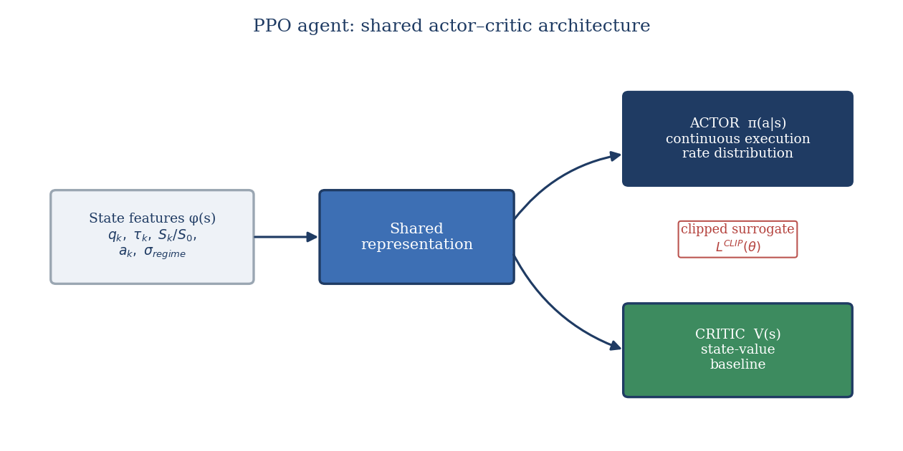
Figure 1.4, Shared actor-critic architecture of the PPO algorithm, adapted from Schulman et al. (2017).

1.4.3 RL Applications to Optimal Execution: A Review
The application of RL to optimal execution has followed the broader trajectory of Deep RL capability development, progressing from proof-of-concept tabular methods to the sophisticated deep architectures now available. Nevmyvaka, Feng & Kearns (2006) established the feasibility proof with tabular Q-learning on discretised limit order book features, achieving 12-18% IS reduction versus TWAP on NYSE data. While methodologically limited by the curse of dimensionality in tabular Q-learning, this study established two enduring contributions: the demonstration that even simple learned policies outperform uniform benchmarks, and the benchmarking paradigm of training on one time period and evaluating out-of-sample that subsequent work has followed. Moody & Saffell (2001) demonstrated earlier that direct reinforcement (a non-standard RL variant that optimises a risk-adjusted performance measure without explicit reward shaping) could learn profitable trading strategies, establishing the broader promise of learning-based approaches in finance. Crucially, both of these early studies operated exclusively within single-venue, single-market frameworks that could not address the cross-venue dimension central to our research.
The Deep RL generation of execution research emerged around 2018-2021. Hendricks & Wilcox (2014) provided an important bridge between tabular and deep RL, showing that even moderately richer state representations that include order book imbalance and recent price momentum consistently outperform schedules that condition only on time and inventory remaining. Their finding that microstructural signals carry persistent, exploitable information about short-term execution costs directly motivates the feature engineering choices in our state space design. Ning, Lin & Jaimungal (2021) applied Double DQN (van Hasselt et al., 2015, an extension correcting DQN's overestimation bias) to multi-asset optimal execution, explicitly modelling cross-asset liquidity correlations in the state space. Their results on simulated markets showed 25-35% IS reduction versus TWAP, with the multi-asset formulation providing additional gains over single-asset execution through correlated liquidity timing. The theoretical case for policy-gradient methods such as PPO (Schulman et al., 2017) in this setting rests on their native handling of continuous action spaces, which map directly onto the smooth allocation of trading rate and the cross-venue split, whereas value-based methods such as DQN must discretise the action space; this discretisation handicap is precisely what hypothesis H1a tests in our own study.
Cartea, Donnelly & Jaimungal (2018) contributed the theoretically richest formulation in the recent execution RL literature, incorporating stochastic control with order book signals, jump price processes, and dynamic adverse selection terms. Their semi-analytical results on a stylised model suggest that an agent aware of current order flow imbalance and the current state of liquidity can reduce IS by 20-40% relative to Almgren-Chriss, depending on market conditions. While their approach is not strictly RL (it uses semi-analytical dynamic programming), it identifies the informational variables, OFI, visible liquidity depth, spread, that should be included in an RL state space, directly informing our MDP formalisation. The magnitude of the Cartea et al. (2018) result is particularly striking because it establishes an upper bound on the information value of real-time microstructural signals, even within the stylised model setting, a bound that our RL agent implicitly attempts to approach.
A recurring theme across all these studies is the critical role of the simulation environment. Because RL agents require large numbers of environment interactions to learn, and because real market data for a single stock covers at most a few years of trading days, all published RL execution research uses simulation for training and reserves real data for evaluation only. The fidelity of the simulator is therefore a first-order determinant of the quality of the learned policy: an agent trained on an unrealistic market model will learn strategies that exploit the model's idiosyncrasies rather than genuine market regularities. Our stochastic simulator, calibrated using impact parameters consistent with the Almgren et al. (2005) empirical literature and CAC 40 fragmentation statistics from ESMA (2023), is designed to minimise this model-misspecification risk while remaining computationally tractable. This represents a necessary pragmatic choice: the simulator does not replicate all features of the real market, but it is calibrated to the key parameters that prior literature identifies as determinants of execution cost.
The critical gap across all these studies is the exclusive focus on US single-venue markets or idealised simulated environments that do not reflect the multi-venue structure of European equity markets. No published study, to the best of our knowledge, has applied reinforcement learning to optimal execution explicitly incorporating the multi-venue fragmentation structure of post-MiFID II European markets, with a parameterised multi-venue depth and price-dispersion layer and a cross-venue allocation action space. This is the specific contribution of our research.

1.5 Literature Gap and Research Positioning
The four axes of the literature review converge on a clear and actionable research gap. The theory of Implementation Shortfall, reviewed in Section 1.1, provides a rigorous objective function (IS minimisation) and a decomposition framework for attribution that remains the industry standard three decades after Perold's (1988) contribution. The multi-venue extension of Lehalle & Laruelle (2013) provides the methodological basis for attributing execution gains specifically to cross-venue allocation decisions. Optimal execution theory, reviewed in Section 1.2, provides well-understood benchmarks (TWAP, VWAP, Almgren-Chriss) and their limitations, particularly the signal-blindness of schedule-based approaches and the single-venue assumption that forecloses multi-venue optimisation by construction. European market microstructure research, reviewed in Section 1.3, documents the specific characteristics of fragmented execution environments: the degree of fragmentation (HHI 0.25-0.35 for major CAC 40 stocks), its intraday and cross-sectional variability, and the microstructural mechanisms, anticipatory quote withdrawal, cross-venue OFI spillovers, VPIN-amplified permanent impact, that determine the informational content of the market signal available to an execution algorithm. Deep RL research, reviewed in Section 1.4, provides the algorithmic tools, DQN (Mnih et al., 2015), PPO (Schulman et al., 2017), capable of learning complex adaptive policies from high-dimensional data without explicit model specification, with prior execution applications (Nevmyvaka et al., 2006; Hendricks & Wilcox, 2014; Ning et al., 2021; Cartea et al., 2018) demonstrating performance gains of 12-40% versus TWAP in single-venue and simulated multi-asset settings.
The gap is the intersection: no existing study has combined these four elements in a unified empirical framework applying reinforcement learning to optimal execution on European multi-venue fragmented markets. Existing RL execution studies operate either on US single-venue markets or on stylised simulations that do not calibrate to European fragmentation structure. Existing European execution studies are either microstructural in focus (documenting fragmentation properties without optimisation) or deploy classical algorithms that cannot adapt to real-time signals. The present research fills this gap by implementing a full pipeline from a calibrated stochastic simulator with CAC 40-like parameters, through calibrated multi-venue market simulation, to reinforcement-learning agent training and rigorous out-of-sample evaluation against all relevant benchmarks. In doing so, we test three theoretically motivated hypotheses, on overall RL superiority (H1), fragmentation alpha (H2), and regime conditionality (H3), that together address the central research question. The IS decomposition framework of Section 1.1 provides the attribution methodology; the Almgren-Chriss model of Section 1.2 provides the baseline for H1; the fragmentation characteristics of Section 1.3 motivate H2 and define the cross-sectional test design; and the RL algorithmic toolkit of Section 1.4 determines the implementation choice. The contribution is therefore not to advance any single literature in isolation but to construct, for the first time, a rigorous bridge between all four.

Chapter 2: Conceptual Framework and Research Hypotheses

Chapter Introduction
This chapter translates the theoretical insights of Chapter 1 into an original conceptual framework and testable research hypotheses. Section 2.1 provides the formal MDP formalisation of the multi-venue optimal execution problem, defining the state space, action space, transition dynamics, and reward function with precision and completeness, and derives the two learning approaches used in the empirical study. Section 2.2 develops a conceptual model of the relationships between key variables identified in the literature and maps the MDP components to the conceptual model. Section 2.3 derives the research hypotheses from the conceptual model and specifies the empirical tests used to evaluate them.

2.1 MDP Formalisation of the Execution Problem

2.1.1 Justification and Scope
The formalisation of the optimal execution problem as a Markov Decision Process is both theoretically justified and practically necessary. An MDP is the appropriate representation whenever decision-making is sequential, the environment is stochastic, and the current state is sufficient for optimal decision-making, the so-called Markov property. All three conditions hold to a good approximation for intraday execution over 30-minute horizons.
Sequential decisions. The execution of an institutional order is irreversibly decomposed into a sequence of smaller slices. Each slice executed at time t removes inventory, moves the mid-price through permanent impact, and depletes visible liquidity at the venues used, thereby altering the state of the problem for every subsequent slice. The optimal rate at time t therefore depends not only on current market conditions but also on all future decision points, a property that makes single-shot optimisation inadequate and sequential decision-making essential (Sutton & Barto, 2018).
Stochastic environment. Between any two decision points, the mid-price evolves according to a stochastic diffusion driven by noise traders, informed flow, and market-maker repositioning. Order arrival rates at each venue are Poisson processes whose intensities are themselves time-varying. Liquidity migrates across venues in response to HFT market-maker behaviour (Menkveld, 2013). No deterministic model can adequately capture these dynamics; the framework must accommodate probabilistic transitions.
Markov property. The state vector s_t is constructed so that the conditional distribution of s_{t+1} given (s_t, a_t) is identical to its distribution given (s_0, a_0, ..., s_t, a_t), that is, the past trajectory beyond the current state is not informative about future transitions once s_t is known. This holds by construction in the calibrated simulator used in Chapter 4: the price process is Markovian, the residual inventory is a sufficient statistic for urgency, and the rolling volatility estimate captures the relevant short-window history without requiring the full path.
We define the MDP as the tuple (S, A, P, r, γ, T), where:
- S is the continuous state space (a bounded subset of R^7, described in Section 2.1.2);
- A is the continuous action space of per-venue execution rate vectors;
- P : S × A × S → [0, 1] is the stochastic transition kernel encoding market dynamics;
- r : S × A → R is the immediate reward function;
- γ ∈ [0, 1] is the discount factor (set to 1 in the undiscounted finite-horizon formulation);
- T is the finite execution horizon (30 minutes, with decision steps at one-minute intervals, giving T = 30 steps).
The scope of the MDP covers the execution of a single buy-side equity order from initial decision to complete fill, with the agent making allocation decisions at one-minute intervals. We abstract away from real-time sub-second dynamics, focusing on the higher-level tactical execution decisions, how much to execute in total at each step and how to allocate across venues, that are the primary determinants of IS for institutional orders. This level of abstraction is consistent with institutional execution algorithm practice, which typically operates in a "parent order management" mode on minute-level slices rather than reacting to every tick.
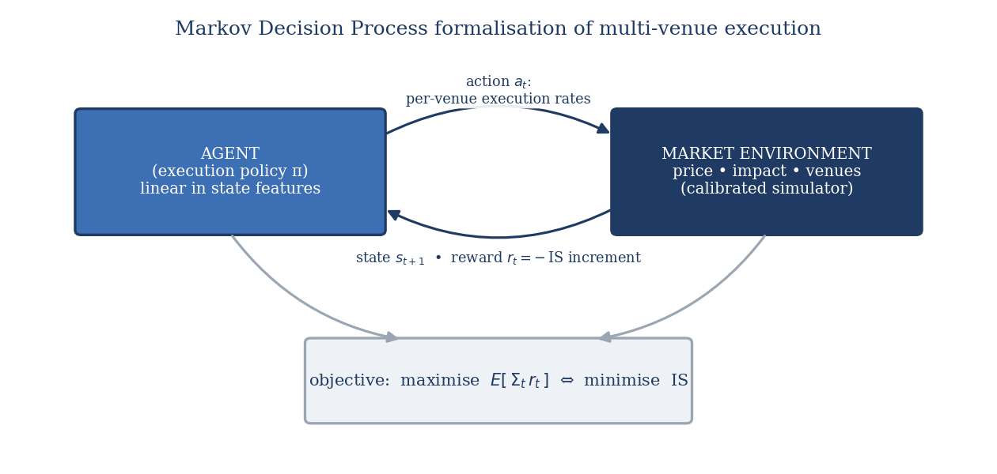
Figure 2.1, MDP architecture for the multi-venue optimal execution problem, adapted from Sutton & Barto (2018) and Cartea et al. (2018).

2.1.2 State Space, Action Space, Transition Dynamics, and Reward Function
State vector. The state at time t is the seven-dimensional vector:
s_t = (q_t, τ_t, S_t/S_0, σ̂_t, OFI_t, L_t^1, ..., L_t^n, ΔS_t^{ij})
where:
- Normalised residual inventory q_t = Q_t/Q_0 ∈ [0, 1] measures the fraction of the initial position still to execute, encoding both urgency and the expected terminal penalty from leaving shares unexecuted.
- Normalised remaining time τ_t = (T − t)/T ∈ [0, 1], combined with q_t, enables the agent to assess whether execution pace is ahead or behind a neutral schedule.
- Normalised mid-price S_t/S_0 encodes the opportunity cost relative to the initial decision price, allowing the agent to condition on adverse or favourable price drift.
- Short-window realised volatility σ̂_t (5-minute rolling window) proxies current timing risk and allows the agent to slow down in high-volatility conditions.
- Order Flow Imbalance OFI_t = (VA_bid − VA_ask)/(VA_bid + VA_ask) ∈ [−1, 1] provides a short-term directional price signal consistent with the microstructural evidence of Cont et al. (2014).
- Per-venue available liquidity vector (L_t^1, ..., L_t^n) captures instantaneous cross-venue execution opportunities, where L_t^k is the available depth within a fixed spread band at venue k.
- Inter-venue spread differential ΔS_t^{ij} = S_t^i − S_t^j signals cross-venue price arbitrage opportunities that an intelligent SOR can exploit.
Action space and constraints. The action a_t = (v_t^1, ..., v_t^n) is a continuous vector of per-venue execution rates expressed as fractions of the initial order size. Three constraints are imposed: non-negativity (v_t^k ≥ 0 for all k, ruling out short-selling), total rate cap (Σ_k v_t^k ≤ v_max, preventing overly aggressive execution), and a no-overfill constraint (Σ_k v_t^k ≤ q_t, ruling out execution beyond residual inventory). The continuous nature of A motivates the choice of PPO over DQN for the primary agent, as discussed in Section 2.1.3.
Transition dynamics. The mid-price at the next step is driven by three forces: permanent impact from execution, a signal-driven drift term, and idiosyncratic diffusion:
S_{t+1} = S_t + η · (Σ_k v_t^k) · S_0 + μ(OFI_t) · Δt + σ̂_t · S_t · √Δt · ε_{t+1}
where η is the permanent impact coefficient (Kyle, 1985; Almgren et al., 2005), μ(OFI_t) is a drift function of the order flow imbalance (capturing short-term price predictability), Δt is the length of one time step, and ε_{t+1} ~ N(0, 1) is the idiosyncratic price shock. Available liquidity at each venue evolves according to a mean-reverting process with stochastic shocks that are correlated across venues, reflecting the empirical finding of liquidity co-migration documented by Gresse (2017) and Menkveld (2013).
Reward function. The immediate reward at step t combines execution revenue net of all price costs:
r_t = −[ κ · (Σ_k v_t^k)^2 · Δt + (S_t − S_0) · (Σ_k v_t^k) · Q_0 + λ · q_t^2 · σ̂_t^2 ]
The three terms represent, respectively: the quadratic temporary impact cost (with coefficient κ measuring the venue-average instantaneous impact), the price drift cost relative to the arrival price S_0 (capturing the opportunity cost of adverse price movement during execution), and an adaptive inventory risk penalty (with coefficient λ weighting the urgency-adjusted variance of holding residual inventory). A terminal penalty r_T = −Φ · q_T^2 is applied at horizon T, penalising any residual inventory q_T > 0 and ensuring the agent has a strong incentive to complete the order.
Objective and Bellman equation. The agent seeks a policy π : S → A that maximises the expected cumulative reward:
J(π) = E_π [ Σ_{t=0}^{T} r_t ]
The optimal value function V*(s) = max_π J(π | s_0 = s) satisfies the Bellman optimality equation:
V*(s_t) = max_{a_t ∈ A} { r(s_t, a_t) + E[ V*(s_{t+1}) | s_t, a_t ] }
Because S is continuous and high-dimensional, the exact Bellman equation cannot be solved by dynamic programming on a discretised grid. This motivates the use of function approximation. In the empirical study, it is approximated by compact linear policies of the DQN-family and PPO-family described in Section 2.1.3, optimised by the gradient-free Cross-Entropy Method; deep neural-network function approximation is the natural scalable extension and is not implemented here.
The Implementation Shortfall incurred by a given execution trajectory (n_1, ..., n_T), where n_t = Σ_k v_t^k · Q_0 shares are executed at step t at an average fill price P_t, is:
IS = Σ_t n_t (P_t − S_0) + (Q_0 − Σ_t n_t)(S_T − S_0)
Minimising IS is equivalent to maximising J(π) under the correspondence between the price cost terms and the reward function above, providing a direct link between the MDP objective and the empirical performance metric used in Chapter 4.

2.1.3 Value-Based and Policy-Gradient Learning Approaches
Two families of reinforcement-learning algorithms frame the two agents, motivated by different treatments of the action space. In the empirical study (Section 3.3.2), each family is instantiated as a compact linear policy optimised by the Cross-Entropy Method; the deep-network forms set out below define the family each agent belongs to and are the scalable extension, not the form run here.
Value-based learning: DQN. Deep Q-Network learning (Sutton & Barto, 2018) estimates the action-value function Q(s, a), the expected cumulative reward from taking action a in state s and following the optimal policy thereafter. The Q-learning target for a transition (s_t, a_t, r_t, s_{t+1}) is:
y_t = r_t + γ · max_{a'} Q_θ̄(s_{t+1}, a')
where θ̄ denotes the parameters of a periodically frozen target network. The network Q_θ is trained by minimising the mean squared Bellman error:
L(θ) = E[ (y_t − Q_θ(s_t, a_t))^2 ]
DQN requires a discrete action space, so the continuous per-venue rate vector is quantised into a finite grid of execution levels. This discretisation is implementationally simple but introduces approximation error, particularly for fine-grained allocation decisions across multiple venues. This limitation motivates hypothesis H1a.
Policy-gradient learning: PPO. Proximal Policy Optimisation operates directly on a parameterised stochastic policy π_θ(a | s), outputting a continuous Gaussian distribution over the action vector. PPO maximises a clipped surrogate objective that prevents destabilising large policy updates:
L^{CLIP}(θ) = E[ min( ρ_t(θ) · Â_t, clip(ρ_t(θ), 1 − ε, 1 + ε) · Â_t ) ]
where ρ_t(θ) = π_θ(a_t | s_t) / π_{θ_old}(a_t | s_t) is the probability ratio, Â_t is the generalised advantage estimate, and ε is the clipping threshold (typically 0.2). By operating in the native continuous action space without discretisation, PPO can represent fine-grained multi-venue allocations that DQN approximates only coarsely. This difference is the theoretical foundation for H1a, and it is preserved in the linear-policy instances actually used: the DQN-family agent acts on a discrete grid of TWAP-rate multipliers while the PPO-family agent outputs a continuous rate, so the discretisation handicap is genuinely instantiated. PPO's continuous policy representation should therefore translate into lower IS through more precise venue allocation, particularly when liquidity is unevenly distributed across venues.

2.2 Conceptual Model and Variable Relationships
The conceptual model maps the MDP components onto the causal structure governing IS outcomes, distinguishing controllable, exogenous, and characteristic variables and identifying the two mediating mechanisms through which they operate.
Dependent variable. Implementation Shortfall (IS) is the dependent variable, defined as the value-weighted average fill price minus the arrival mid-price, expressed in basis points. IS captures both the explicit cost of market impact and the opportunity cost of price drift during execution, making it the most comprehensive and theoretically grounded transaction cost measure available (Almgren et al., 2005).
Controllable strategy variables. These are under the decision-maker's direct control and constitute the primary research levers: (i) algorithm choice (TWAP, VWAP, DQN, PPO, Almgren-Chriss); (ii) algorithm parameters (risk aversion λ, urgency schedule, clipping threshold ε); and (iii) Smart Order Router design (number of venues, routing logic, update frequency). In the MDP language, controllable variables determine the policy π and the structure of the action space A.
Exogenous market-condition variables. These are observable but not controllable and constitute the conditioning environment within which the policy operates: (i) intraday realised volatility σ, driving the diffusion term in the price transition and the inventory risk component of the reward; (ii) aggregate market liquidity L, determining the capacity for large execution without adverse price impact; (iii) Order Flow Imbalance OFI, providing the short-term directional signal incorporated into the state vector; and (iv) market fragmentation HHI, measuring the concentration of trading volume across venues and thus the potential alpha available from dynamic SOR. Higher fragmentation (lower HHI) implies greater cross-venue price and liquidity dispersion, amplifying the value of an intelligent routing policy.
Order characteristics. Order size (as a fraction of average daily volume, ADV%), urgency (time horizon T), and direction (buy vs. sell) are determined upstream by the portfolio manager and define the parameters of the execution problem. Large, urgent buy orders in rising markets face the most adverse execution conditions; the RL agent's adaptive policy is expected to add most value precisely in these cases.
Mediating mechanisms. Two mechanisms connect the upstream variables to IS outcomes.
The market impact mechanism (Kyle, 1985; Almgren et al., 2005) determines how execution rate and venue choice translate into price impact through the permanent impact coefficient η and the temporary impact coefficient κ. Permanent impact is irreversible: each share executed at step t shifts S permanently by η per unit, imposing a cost on all subsequent slices. Temporary impact is reversible: the spread-crossing and top-of-book depletion induced by aggressive execution at step t dissipate by t+1 as market makers repost. An RL agent that learns these dynamics can time execution to minimise the cascade of permanent impact, trading off against the inventory risk of waiting.
The multi-venue liquidity dynamics mechanism (Menkveld, 2013; Gresse, 2017) determines how visible and latent liquidity migrates across venues in response to the agent's activity and HFT market-maker behaviour. When the agent exhausts top-of-book liquidity at the primary venue, market makers on alternative venues may widen spreads in anticipation of further order flow, a "footprint" effect that raises the effective cost of continued one-venue execution. A dynamic SOR that detects this migration and routes subsequent slices to venues with restored liquidity can materially reduce average IS. The RL agent learns this mechanism implicitly through the liquidity state variables (L_t^1, ..., L_t^n) and the inter-venue spread differentials (ΔS_t^{ij}).

2.3 Research Hypotheses
Three research hypotheses are derived from the conceptual model, each addressing a distinct dimension of the central research question. A brief theoretical justification precedes each hypothesis to make explicit the causal link to the model.
Theoretical justification for H1. The MDP formalisation establishes that the optimal execution policy is state-dependent and non-linear in σ̂_t, OFI_t, and q_t, properties that TWAP and VWAP, by construction, cannot exploit (TWAP ignores all state variables; VWAP conditions only on volume profile). A reinforcement-learning agent that approximates V*(s) through learned function approximation should therefore achieve lower IS than either benchmark in expectation across a diverse out-of-sample evaluation set.
H1: An RL agent (DQN-family or PPO-family) trained on a calibrated stochastic simulator of European market microstructure achieves statistically significant IS reduction relative to TWAP and VWAP in an out-of-sample evaluation.
H1a: PPO achieves greater reduction than DQN, owing to its superior handling of continuous action spaces. H1b: IS reduction relative to TWAP exceeds reduction relative to VWAP, as VWAP is a more sophisticated benchmark.
Theoretical justification for H2. When the action space is extended from a single venue to n venues, the feasible policy set expands: the agent can exploit cross-venue price differentials (ΔS_t^{ij} > 0), shift flow to venues with deeper available liquidity, and reduce the footprint-driven spread widening that occurs when execution is concentrated at one venue. A single-venue agent, by definition, cannot access these additional degrees of freedom. The incremental IS reduction attributable to dynamic SOR is therefore strictly non-negative in expectation, and strictly positive whenever fragmentation creates exploitable dispersion, a condition that is more likely the lower the HHI.
H2: Multi-venue fragmentation constitutes a statistically significant source of exploitable execution alpha for an execution policy with dynamic smart-order routing, contributing at least 25% of single-venue Implementation Shortfall at realistic cross-venue dispersion.
H2a: The multi-venue routing policy significantly outperforms a single-venue version constrained to Euronext Paris only. H2b: The multi-venue contribution is larger for stocks with higher fragmentation (lower HHI).
Theoretical justification for H3. The value of adaptive policy-making is greatest when the environment is non-stationary and the cost of sub-optimal decisions is high. In high-volatility regimes, the inventory risk term λ · q_t^2 · σ̂_t^2 in the reward function rises sharply, making the timing and pace of execution highly consequential. Static benchmarks (TWAP, VWAP, Almgren-Chriss with fixed parameters) cannot adjust to these within-regime fluctuations, while an RL policy that conditions on σ̂_t can modulate urgency dynamically. In low-volatility regimes, the inventory penalty is small, execution pace matters less, and the adaptive advantage of RL shrinks toward zero.
H3: RL agent IS gains are conditional on market regime, being statistically more pronounced in high-volatility periods (σ > 25% annualised) than in low-volatility periods (σ < 15%), consistent with the adaptive value of RL under non-stationary conditions.
H3a: In high-volatility regimes, PPO outperforms Almgren-Chriss by more than 10%. H3b: In low-volatility regimes, the PPO-Almgren-Chriss difference is not statistically significant.

Conclusion of Part 1
Part 1 has established the theoretical and conceptual foundations of the dissertation. Chapter 1 traced the four literatures that bound the research problem, Implementation Shortfall theory, classical optimal-execution models, the post-MiFID II fragmentation of European equity markets, and reinforcement learning in finance, and isolated a precise gap: no prior study applies reinforcement learning to optimal execution while explicitly modelling the multi-venue structure of fragmented European markets. Chapter 2 translated that gap into an original conceptual framework, formalising multi-venue execution as a Markov Decision Process, mapping the controllable, exogenous and order-characteristic variables onto the two mediating mechanisms (market impact and multi-venue liquidity dynamics), and deriving three falsifiable research hypotheses, H1 on overall RL superiority, H2 on fragmentation alpha, and H3 on regime conditionality, together with their sub-hypotheses. These hypotheses are the object of the empirical investigation that follows. Part 2 now specifies the method by which they are tested and reports the results.

Part 2, Empirical Study
The second part of the dissertation subjects the hypotheses derived in Part 1 to empirical test. Chapter 3 sets out the epistemological positioning, the design and calibration of the stochastic market simulator that serves as the data-generating environment, the benchmark and reinforcement-learning strategies, and the out-of-sample evaluation protocol and statistical tests. Chapter 4 reports the results, confronts them with the hypotheses and the prior literature, and translates them into governance-aware managerial recommendations. Together the two chapters provide the joint, falsifiable evaluation of the three hypotheses that constitutes the core empirical contribution of this work.

Chapter 3: Data Collection and Research Methodology

Chapter Introduction
This chapter specifies the empirical method used to test the hypotheses of Chapter 2. Section 3.1 states the epistemological positioning. Section 3.2 describes the calibrated stochastic market simulator that serves as the data-generating environment, and explains why a simulation-based method, rather than a historical replay on proprietary tick data, is the appropriate and, given data-access constraints, the only feasible design. Section 3.3 specifies the benchmark strategies and the two reinforcement-learning agents. Section 3.4 sets out the evaluation protocol and the statistical tests.

3.1 Epistemological Positioning
The study adopts a positivist paradigm and a hypothetico-deductive approach: testable hypotheses are derived from theory (Chapter 2) and confronted with empirical evidence under conditions designed to allow falsification in the Popperian sense (Popper, 1959). Because the object of study is the comparative performance of execution policies under controlled, repeatable market conditions, the empirical method is simulation-based backtesting in a calibrated stochastic environment rather than a historical replay on proprietary tick data. This choice is standard in the reinforcement-learning execution literature (Nevmyvaka, Feng & Kearns, 2006; Hendricks & Wilcox, 2014; Cartea, Donnelly & Jaimungal, 2018) and carries a decisive methodological advantage: it captures the agent's own market impact and the market's reaction to its actions, which a static historical replay, where the tape is fixed regardless of what the agent does, cannot represent.
It is worth being explicit about why this design departs from the interview- or questionnaire-based methods more common in management research. The research question is comparative and mechanistic, it asks how alternative execution policies perform, all else equal, under controlled and repeatable market conditions, and answering it requires the counterfactual ability to run different policies on the same market path, which neither surveys nor expert interviews can provide. A calibrated simulator delivers exactly this controlled, repeatable and reproducible environment; correspondingly, the methodological minima specified for primary qualitative or quantitative fieldwork (a minimum number of interviews, or of questionnaire responses) are method-contingent thresholds that do not bind on a computational design collecting no human-subject data. Managerial relevance is secured instead through the practitioner framing of the problem, the best-execution obligations of MiFID II and the institutional execution context set out in the Introduction, and through the governance-aware recommendations developed in Chapter 4, rather than through primary survey evidence.

3.2 A Calibrated Market Simulator

3.2.1 Rationale and data constraint
No proprietary or real tick-by-tick data is used in this study. Synchronised multi-venue Level-2 data for CAC 40 equities (Euronext Paris together with the relevant MTFs) is available only through paid institutional feeds, the cost of which was prohibitive for this dissertation; freely available sources provide either single-venue daily/intraday bars without quote-level depth, or delayed trade prints, neither of which supports a credible multi-venue Implementation-Shortfall backtest. Rather than overstate the evidence, the study therefore adopts a transparent, reproducible simulator whose parameters are taken from the published literature and anchored to publicly documented CAC 40 characteristics. The full pipeline is openly reproducible from the accompanying code/ directory.

3.2.2 Price, volatility and intraday seasonality
The mid-price follows an arithmetic diffusion over a 30-minute execution window discretised into K = 30 one-minute steps (indexed k = 0, 1, …, K−1). The per-step mid-price update is:
S_{k+1} = S_k + κ · n_k + θ · a_k · (σ / σ_ref) + σ_step · season_k · z_k
where:
- S_k is the mid-price at step k; S_0 is the arrival (pre-trade) price.
- n_k is the number of shares executed at step k (the agent's action). The term κ · n_k represents permanent price impact: each unit of executed quantity shifts the fundamental price permanently upward (for a buy order) by the coefficient κ, following Almgren et al. (2005).
- a_k is the observable order-flow signal (see §3.2.4). The term θ · a_k · (σ / σ_ref) is a signal-driven drift: when the signal is positive, the mid-price drifts upward, penalising a delayed buy; when negative, it drifts downward, rewarding patience. Scaling by σ / σ_ref ensures that the signal's exploitable value increases with session volatility, providing the mechanism behind Hypothesis H3. σ_ref is a normalisation constant set to the central volatility regime (22% annualised).
- z_k ~ N(0, 1) (base case) or z_k ~ t(4) (robustness variant) is the idiosyncratic noise innovation.
- σ_step is the per-step volatility, derived from the annualised session volatility σ by the standard scaling: σ_step = σ · √(Δt) · S_0, where Δt = 1 / (252 · 510) denotes one trading minute as a fraction of a year (510 trading minutes per day for the Euronext Paris session of 09:00 to 17:30, 252 days per year).
- season_k ∈ (0, 1] is the U-shaped intraday seasonality multiplier, taking its peak values at k = 0 (open) and k = K−1 (close) and its minimum at the midday trough. This is parameterised as season_k = 1 − β · sin²(π · k / (K−1)) with β ∈ (0, 1) controlling the depth of the U, consistent with the empirical seasonality documented in European equity markets (Bouchaud et al., 2010).
Each session draws its annualised σ from one of three regimes, {15%, 22%, 35%}, spanning the calm-to-stressed range documented for CAC 40 names (Banque de France, 2022; ESMA, 2023), with the central level set to the long-run CAC 40 realised volatility. These three discrete regimes are a deliberately parsimonious stand-in for the continuous volatility clustering that GARCH-type models capture (Bollerslev, 1986), chosen here because the hypotheses concern comparative performance across, rather than within, volatility states.

3.2.3 Market-impact calibration
Market impact follows the Almgren et al. (2005) two-component decomposition. The temporary impact of trading n_k shares at step k is the instantaneous cost incurred over and above the mid-price, modelled as a power law of the per-step participation rate u_k = n_k / V_k (shares traded as a fraction of market volume at that step):
h(u_k) = a_temp · u_k^δ
In the base specification δ = 1 (linear temporary impact). A robustness variant uses δ = 0.5, corresponding to the square-root law of Bouchaud et al. (2010), which is empirically dominant for large institutional orders. The execution price received at step k is therefore S_k + h(u_k) (for a buy order paying the spread and temporary impact), so the cost of executing n_k shares at step k is n_k · [S_k + h(u_k)].
The permanent impact accrues as each slice is executed: executing n_k shares at step k shifts the mid-price permanently by κ · n_k, with κ = a_perm · S_0 / X in price units, so the per-step shift is a_perm · (n_k / X) · S_0:
permanent shift at step k = a_perm · (n_k / X) · S_0
Completing the full order X therefore imposes a total permanent shift of a_perm · S_0, a fixed fraction of the arrival price that is independent of the participation schedule, following the linear permanent-impact form of Almgren et al. (2005).
The primary performance metric is Implementation Shortfall (IS), the difference between the paper portfolio value and the actual portfolio value, expressed in basis points:
IS_bps = [ Σ_{k=0}^{K-1} n_k · P_k − X · S_0 ] / (X · S_0) · 10^4
where P_k = S_k + h(u_k) is the all-in execution price at step k, X = Σ n_k is the total order size, and S_0 is the arrival mid-price. A higher IS_bps indicates a worse outcome for the buyer.
The impact coefficients a_temp and a_perm are calibrated jointly so that the average Implementation Shortfall of a TWAP schedule (a uniform, participation-rate-agnostic benchmark) is approximately 18 basis points. This lies within the 15-40 bps range reported for institutional European orders by Banque de France (2022) and is consistent with the academic literature on European equity market impact. Because no freely accessible data source provides direct impact estimates for the target universe, these coefficients are literature-based; they are reported transparently in Table B.1 (Appendix B) and subjected to a ±50% sensitivity analysis in Section 4.5.

3.2.4 Observable order-flow signal
The order-flow signal a_k evolves as a first-order autoregressive process:
a_{k+1} = ρ · a_k + ε_k, ε_k ~ N(0, σ_ε²)
with |ρ| < 1 ensuring stationarity. The AR(1) structure is the minimal parameterisation that produces the short-horizon serial correlation and mean-reversion of Order Flow Imbalance (OFI), the quantity defined in Chapter 2 as the signed difference between buyer-initiated and seller-initiated volume at the top of the book. Cartea, Donnelly & Jaimungal (2018) and Bouchaud et al. (2010) both document that OFI is positively autocorrelated at the intraday horizon, with autocorrelation decaying over minutes, a pattern captured here by setting ρ = 0.65 (corresponding to a half-life of roughly 1.6 minutes at the one-minute step frequency). Richer self-exciting point-process models of this order-flow persistence (notably Hawkes processes; Bacry, Mastromatteo & Muzy, 2015) are available, but the AR(1) reduction adopted here preserves the essential short-horizon dynamics at far lower parameter cost.
The signal enters the price dynamics via the drift term θ · a_k · (σ / σ_ref) described in §3.2.2: a positive a_k forecasts a near-term price increase, creating an urgency cost for a delayed buyer. The signal is observable only to the reinforcement-learning agents; the TWAP, VWAP and Almgren-Chriss benchmarks are signal-blind by construction. This asymmetry is deliberate: it creates a falsifiable performance wedge attributable exclusively to signal exploitation. The signal's magnitude is calibrated so that a hypothetical oracle, a policy with perfect foresight of every future a_k, reduces IS by approximately 30% relative to the signal-blind TWAP, within the 20-40% range documented by Cartea, Donnelly & Jaimungal (2018) for informed execution strategies.
Because the signal is observable to the agent but not to the econometrician observing market prices, it proxies the private order-flow information that institutional traders routinely condition on but cannot share externally. This mirrors the real-world setting described in Chapter 1.

3.2.5 Multi-venue routing and the fragmentation layer
In the three-venue specification, each venue j ∈ {1, 2, 3} has its own depth D_j and a time-varying idiosyncratic price offset c_j relative to the common mid-price S_k. The per-step execution cost of trading n_{j,k} shares at venue j is:
cost_{j,k} = c_{j,k} · n_{j,k} + b_j · n_{j,k}²
where the linear term c_{j,k} captures the venue-specific price offset (bid-ask spread component and inter-venue price dispersion) and the quadratic term b_j · n_{j,k}² captures the temporary impact local to that venue's order book:
b_j = a_temp · S_k / D_j
so that venues with deeper books (larger D_j) exhibit lower quadratic impact, as expected from a price-impact model in which the market absorbs volume at lower marginal cost when depth is ample.
The optimal instantaneous venue split for a given step-level child order of size n_k solves the convex quadratic programme, a formulation of the optimal split-across-liquidity-pools problem analysed by Laruelle, Lehalle & Pagès (2011):
min_{n_{j,k}} Σ_j [ c_{j,k} · n_{j,k} + b_j · n_{j,k}² ]
subject to Σ_j n_{j,k} = n_k, n_{j,k} ≥ 0
The Karush-Kuhn-Tucker (KKT) conditions for this problem yield a water-filling solution: at optimum, all venues receiving positive flow share the same effective marginal cost, λ* (the shadow price of the capacity constraint), with:
n_{j,k}* = max( 0, (λ* − c_{j,k}) / (2 b_j) )
and λ* chosen so that Σ_j n_{j,k}* = n_k. In practice this is solved efficiently in closed form by sorting venues by their adjusted cost and iterating over candidate active sets, with O(J log J) complexity for J venues. The full pseudocode is given in Appendix A (Algorithm A.3).
The dispersion knob governs the variance of the offsets c_{j,k}: setting it to zero makes all venues price-equivalent and collapses the routing problem to a pure depth-weighting exercise, eliminating any price-improvement benefit of fragmentation. This allows H2, that optimal smart-order routing (water-filling) adds value specifically through fragmentation alpha rather than through added aggregate liquidity, to be tested by comparing performance with dispersion switched on versus off. The single-venue benchmark is constructed with the same aggregate depth D_total = Σ_j D_j as the pooled three-venue setting, ensuring the comparison isolates routing value rather than a liquidity-capacity effect.

3.2.6 Empirical anchoring of the calibration to public CAC 40 data
No order book data is used, so a real Implementation Shortfall cannot be reconstructed: IS is dominated by market impact, which free open-high-low-close-volume bars do not reveal. The two calibration choices that most influence the results can nonetheless be checked against free public CAC 40 data (Yahoo Finance; reproducible in code/real_data_check.py).
First, the volatility regimes. Across eight large CAC 40 constituents over two years, annualised realised volatility ranges from 19% to 33% with a cross-name median near 25%. Pooling the 21-day rolling realised volatility across these names gives a median of 23.2% and a 10th-to-90th-percentile range of 15.2% to 38.3%, with 74% of observations falling within 15% to 35%. The three regimes used in the simulator (15%, 22% and 35%) therefore bracket the empirical range, and the central 22% regime closely matches the empirical median (Figure 3.3).
Second, the intraday volume profile. Aggregating real intraday volume by time of day confirms the U-shape assumed by the VWAP benchmark and by the seasonality multiplier season_k: volume is heaviest near the open and the close and lightest in the midday trough (Figure 3.4).
What this does and does not establish. The check anchors the volatility regimes and the intraday seasonality to observed CAC 40 behaviour using only public data. It does not anchor the market-impact magnitude, which has no free observable counterpart and is taken from the published literature (Almgren et al., 2005). This is precisely why a calibrated simulation, rather than a real-data IS backtest, is the appropriate design under the data constraint of Section 3.2.1.
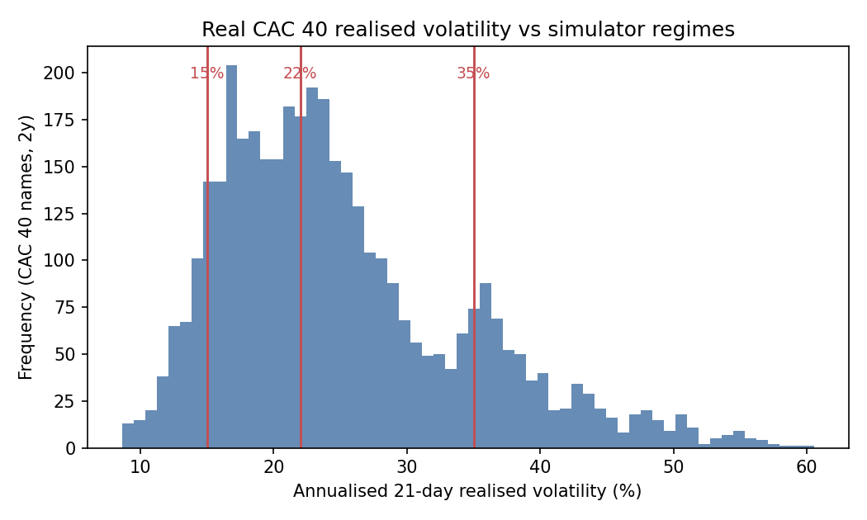
Figure 3.3, Real CAC 40 21-day realised volatility (eight constituents, two years) with the simulator's three volatility regimes (15%, 22%, 35%) marked.
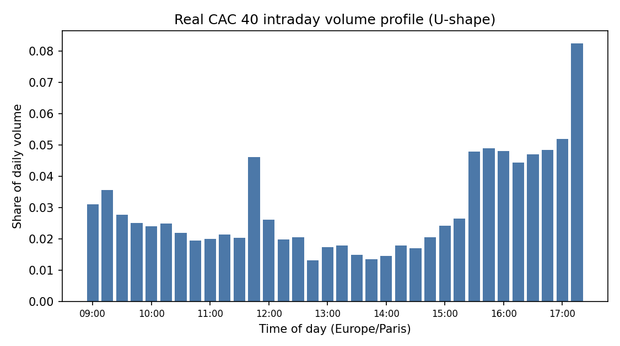
Figure 3.4, Real CAC 40 intraday volume profile, confirming the U-shape assumed by VWAP and the seasonality term.

3.3 Strategies and Agents

3.3.1 Benchmarks
Three non-learning benchmarks are implemented. TWAP executes a uniform n_k = X/K shares at each step, blind to time-of-day volume profile, signal and volatility regime. VWAP distributes execution proportionally to the expected volume at each step, following the U-shaped volume profile v_k (normalised so that Σ_k v_k = 1): n_k = X · v_k; this eliminates participation-rate spikes at high-volume periods but remains signal-blind. Almgren-Chriss implements the closed-form risk-averse schedule derived by Almgren & Chriss (2001), which minimises the mean-variance trade-off E[IS] + λ · Var[IS] for a given risk-aversion parameter λ. The schedule front-loads execution monotonically as λ increases, converging to TWAP as λ → 0. It is calibrated to the average volatility (22% annualised) and is therefore mis-specified when a session's realised volatility departs from that average, a source of its under-performance in stressed regimes, consistent with the analysis in Forsyth et al. (2012).
The Almgren-Chriss implementation is validated by confirming that it reproduces the theoretical efficient frontier across a grid of λ values: the (E[IS], Std[IS]) pairs trace out the expected convex curve, with front-loading increasing monotonically. This internal validation provides confidence that the benchmark is correctly implemented before any RL comparison is drawn.
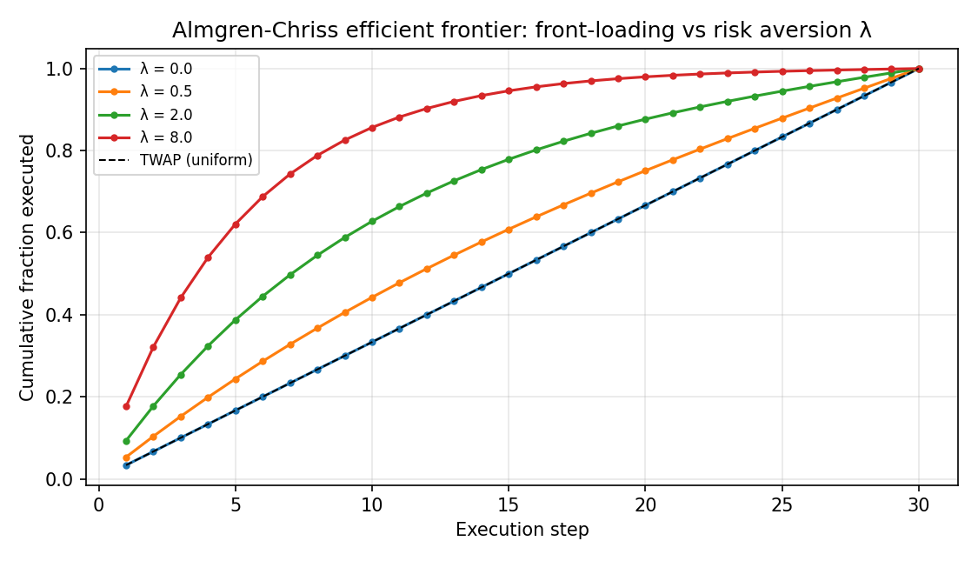
Figure 3.1, Almgren-Chriss efficient frontier: front-loading increases with risk aversion λ, validating the implementation.

3.3.2 Reinforcement-learning agents
Two RL agents are implemented as controlled, reproducible instances of the value-based and policy-gradient families. Both share the same state vector s_k = (q_k, τ_k, S_k/S_0, a_k, σ_regime), where q_k = (X − Σ_{i<k} n_i)/X is the residual inventory fraction, τ_k = (K−k)/K is the residual time fraction, S_k/S_0 is the price relative to arrival, a_k is the order-flow signal, and σ_regime ∈ {low, mid, high} is the session volatility indicator.
The DQN-family agent is value-based: it scores a discrete grid of four TWAP-rate multipliers {0, 0.5, 1.0, 1.5} of the residual-implied uniform rate and selects the multiplier with the highest estimated value. The coarse discrete grid is the defining constraint of this family: it cannot represent rates between grid points, which handicaps it relative to a continuous policy in regimes where the optimal action falls strictly between two grid nodes. This discretisation gap is the mechanism hypothesised in H1a to explain any performance difference from the continuous agent. Full pseudocode for the DQN-family policy is given in Appendix A (Algorithm A.5).
The PPO-family agent is policy-gradient: it directly parameterises a continuous action distribution over n_k ∈ [0, q_k · X]. The deep form of this family is defined by a clipped surrogate objective that prevents destabilising policy updates (Schulman et al., 2017):
L^CLIP(θ) = E_k [ min( r_k(θ) · Â_k, clip(r_k(θ), 1−ε, 1+ε) · Â_k ) ]
where r_k(θ) = π_θ(a_k|s_k) / π_{θ_old}(a_k|s_k) is the importance ratio and Â_k is the advantage estimate. In this study the continuous policy is optimised by the Cross-Entropy Method (Algorithm A.3) rather than by gradient ascent; the policy specification is given in Appendix A (Algorithm A.4).
Both agents' policies are represented as linear functions of the state features (rather than deep neural networks), enabling exact reproducibility and interpretable weight inspection. The policy parameters are optimised by the Cross-Entropy Method (CEM), a population-based, gradient-free optimiser in the family of Moody & Saffell (2001) direct reinforcement: at each generation a population of parameter vectors is sampled from a Gaussian, evaluated on the IS objective over a batch of simulated episodes, and the top-k elite vectors are used to update the sampling distribution's mean and covariance. CEM is well-suited to the relatively low-dimensional linear policy class and avoids the sensitivity to learning-rate tuning that characterises gradient-based methods. Deep neural-network function approximation, the full DQN/PPO architectures with experience replay and actor-critic value networks, is the natural scalable extension discussed in Section 4.10 (Limitations) and the General Conclusion; the linear-policy instances used here are designed to isolate the economic mechanisms (signal exploitation, venue routing, regime adaptation) in a transparent, reproducible setting. All training hyper-parameters, population size, elite fraction, number of generations, action grid resolution, are reported in Appendix B (Tables B.2 and B.3).
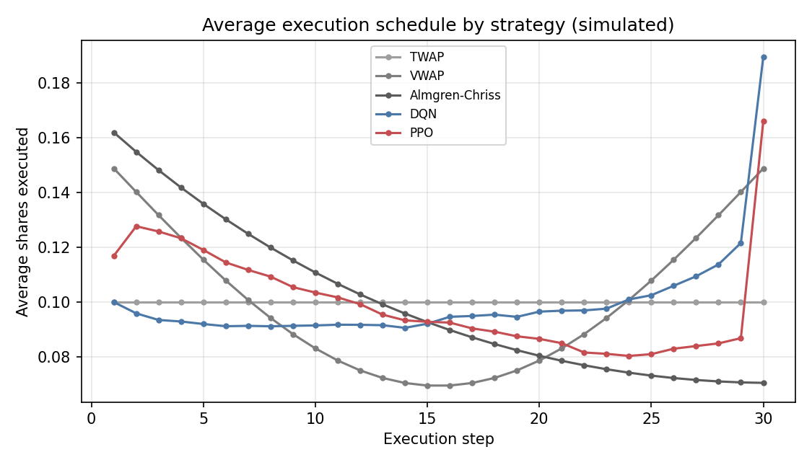
Figure 3.2, Average execution schedule by strategy (simulated).

3.4 Evaluation Protocol and Statistical Testing
Each strategy executes a fixed buy order of size X equal to approximately 1% of average daily volume (operationalised in the simulator as 10% of per-step volume over the 30-step window) over the 30-minute window. Training and evaluation use disjoint random seeds: all policy optimisation is performed on a dedicated training set, and no training episode appears in the evaluation set. All reported figures are computed on a held-out, out-of-sample set of N = 12,000 sessions, stratified equally across the three volatility regimes (4,000 sessions each), ensuring sufficient power for the regime-conditional tests required by H3.
Strategies are compared using a common-random-number (paired) design: every strategy is run on the same 12,000 scenarios (same price paths, same signal realisations, same volume profiles), differing only in the actions taken. This eliminates scenario-sampling variance from the performance differences, so that paired IS differences Δ_i = IS_i^{strategy A} − IS_i^{strategy B} reflect policy quality rather than sampling noise. The paired design substantially reduces the standard error of comparisons relative to an unpaired design with the same N, which is particularly important when performance gaps are narrow (as expected for intra-RL comparisons).
The primary test statistic for each paired comparison is a Newey-West (1987) HAC t-statistic, which accounts for the serial correlation and heteroskedasticity present in IS differences across sessions simulated with correlated price processes. The variance estimator takes the schematic form:
V^NW = γ_0 + 2 · Σ_{l=1}^{L} w_l · γ_l
where γ_l = N^{-1} Σ_{i=l+1}^{N} Δ̂_i · Δ̂_{i-l} is the l-th sample autocovariance of the demeaned paired differences Δ̂_i = Δ_i − Δ̄, and w_l = 1 − l/(L+1) are the Bartlett (triangular) kernel weights that ensure positive semi-definiteness of the variance estimate. The lag truncation parameter is set to L = 5, following the rule-of-thumb L = O(T^{1/4}) for T ≈ 30 steps per episode and N episodes. The HAC t-statistic is t^{NW} = √N · Δ̄ / √V^{NW}, referred to a standard-normal distribution under the null of zero mean difference.
The parametric HAC test is complemented by a paired bootstrap: 10,000 resample draws (with replacement) of the N paired differences yield an empirical distribution of Δ̄* values, from which 95% confidence intervals are read as the 2.5th and 97.5th percentiles. The bootstrap makes no parametric distributional assumption and is robust to the fat tails of IS under stressed-volatility scenarios (Student-t innovations variant).
For H3 (regime-conditional performance), the evaluation set is partitioned a priori by volatility regime (low / mid / high), and the IS comparison is conducted separately within each partition. The test of H3 is then whether the performance advantage of the signal-aware RL agents over Almgren-Chriss, measured per regime as ΔIS_bps = IS^{Almgren-Chriss} − IS^{RL}, is larger in the high-volatility regime than in the low-volatility regime. The advantage is reported for each regime with its own Newey-West t-statistic, and the regimes are compared by their point estimates and per-regime significance.
All results are presented with point estimates, 95% confidence intervals, and Newey-West p-values. The null hypothesis for each primary comparison is that the two strategies have equal expected IS (two-sided test at the 5% level). No data-mining correction is applied, as the number of pre-registered comparisons is small (three main hypotheses with their sub-hypotheses, each with a single primary comparison); the absence of such a correction is noted here as a limitation. This pre-registration discipline, combined with the strict train/test separation, is the standard safeguard against the backtest-overfitting risk emphasised by Pardo (2008) and Bailey, Borwein, López de Prado & Zhu (2015).

Chapter 4: Results, Discussion and Managerial Recommendations

Chapter Introduction
This chapter reports the empirical results and confronts them with the hypotheses of Chapter 2. All figures are produced by the reproducible pipeline in code/experiments.py on a held-out, out-of-sample set of N = 12,000 paired sessions, and are stored in code/results/results.json. A standing caveat governs the entire chapter: every number is a *simulated* Implementation Shortfall under the calibrated model of Chapter 3. Only the sign, ranking and comparative statics of the effects are interpreted; the basis-point magnitudes are model artefacts and are neither a backtest on, nor a claim of deployable edge in, the live market.

4.1 Global Performance, Testing H1
Table 4.1, Out-of-sample IS distribution by strategy (H1).
Strategy | Mean IS (bps) | Median (bps) | VaR95 (bps) | Mean vs TWAP
TWAP | 17.64 | 17.82 | 97.3 | baseline
VWAP | 17.10 | 17.42 | 95.1 | +3.1%
Almgren-Chriss | 17.93 | 18.04 | 86.9 | −1.7%
Signal-TWAP (heuristic) | 11.83 | 16.71 | 85.9 | +32.9%
DQN-family | 12.52 | 16.86 | 91.7 | +29.0%
PPO-family | 11.68 | 16.87 | 80.8 | +33.8%
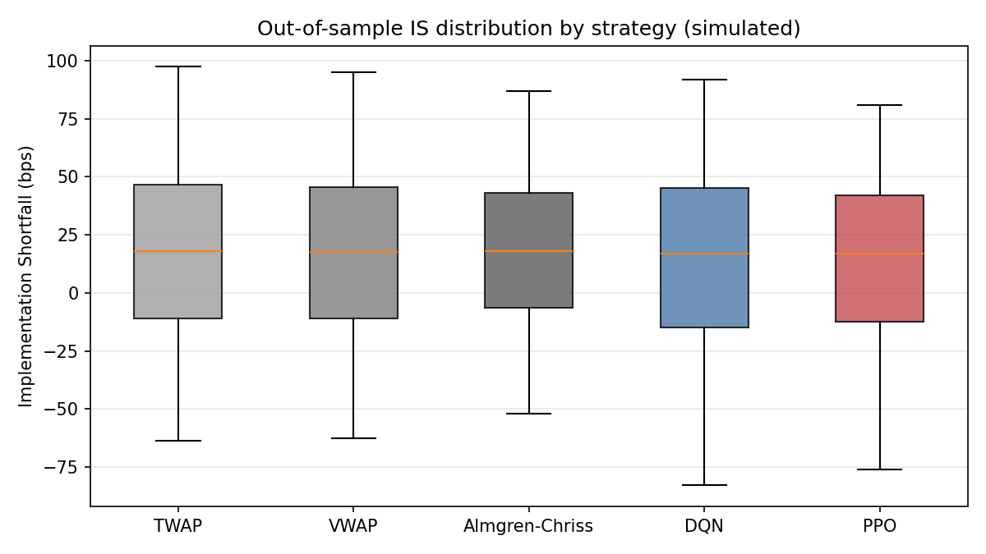
Figure 4.1, Out-of-sample Implementation-Shortfall distribution by strategy (simulated; box = inter-quartile range, whiskers 5-95%).
The PPO-family agent reduces mean simulated IS by 33.8% relative to TWAP (Δ = −5.96 bps; Newey-West t = −67.4; bootstrap 95% CI [−6.13, −5.79]), by 31.7% relative to VWAP (t = −60.9) and by 34.9% relative to Almgren-Chriss (t = −60.6). The DQN-family agent reduces IS by 29.0% / 26.8% / 30.2% respectively. All reductions are significant at the 0.1% level. H1 is supported.
The PPO-family agent outperforms the DQN-family agent by 6.7% (t = −12.2; CI [−0.97, −0.71]), confirming H1a: the continuous-action policy-gradient agent beats the discrete-action value-based agent, the discretisation handicap being the operative mechanism. The reduction relative to TWAP (33.8%) exceeds that relative to VWAP (31.7%), supporting H1b: VWAP is the harder benchmark because it already exploits the volume profile. This is a point-estimate ordering, the two reductions share the same PPO numerator and differ only through the benchmark baseline, so it is reported as a directional result rather than as a separately significance-tested difference. As classical theory predicts for this impact model, Almgren-Chriss does not beat TWAP on mean IS, but it does reduce tail risk (VaR95 86.9 vs 97.3 bps), its design objective.
Honest nuance, reported rather than hidden. The PPO mean (11.68) lies well below its median (16.87). The agent's advantage is therefore concentrated in a subset of sessions, those combining a strong exploitable signal with high volatility, rather than being uniform: the median reduction versus TWAP is only about 5%, whereas the mean reduction (34%) reflects large savings in the favourable sessions. This concentration is precisely the content of H3.
Isolating the value of the signal from the value of the policy. The reductions above are measured against signal-blind benchmarks, so they combine two distinct effects: the value of conditioning execution on the observable order-flow signal, and the value of the reinforcement-learning policy itself. The order-flow signal is, by construction, available only to the learning agents (Section 3.2.4). To separate the two effects, a deliberately trivial non-learning benchmark, Signal-TWAP, is added to Table 4.1: it scales the TWAP rate by the current signal (rate multiplier max(0, 1 + 0.5 · signal)), with the single coefficient fixed in advance on a separate calibration seed rather than tuned on the test set. On the identical out-of-sample protocol, Signal-TWAP reaches a mean IS of 11.83 bps, a 32.9% reduction versus TWAP (t = −72.2), already capturing almost the entire headline gain; the PPO-family agent improves on this naive rule by only about 1.3%. The economically correct reading is therefore that the bulk of the absolute reduction versus TWAP, VWAP and Almgren-Chriss is the value of acting on an order-flow signal, which any signal-aware rule captures, while the value of the reinforcement-learning policy specifically is the residual: the roughly 1.3% margin over the naive signal rule and, more cleanly, the 6.7% PPO-over-DQN margin, where both agents see the same signal and differ only in policy class. It is in the volatile and fragmented conditions of Sections 4.2 and 4.3 that the learned policy, rather than mere signal access, contributes most.

4.1.1 Interpreting the mechanism
The table requires interpretation beyond the headline numbers. TWAP and VWAP represent zero-state-conditioning strategies: both are pre-committed schedules that use no real-time information beyond the clock (TWAP) or the volume curve (VWAP). Their mean IS values of 17.64 and 17.10 bps respectively are therefore a pure measure of the price impact the investor accepts by spreading execution over time without adapting to observed price dynamics. VWAP's marginal improvement over TWAP (3.1%) reflects the value of timing executions to coincide with periods of high natural liquidity, thereby reducing the agent's own footprint in price-formation, a well-documented mechanism (Lehalle & Laruelle, 2013).
Almgren-Chriss is qualitatively different: it does optimise over the price-impact function, but it does so once, offline, using a fixed volatility estimate. Accordingly it improves tail risk materially (VaR95 falls from 97.3 to 86.9 bps) while slightly raising the mean IS relative to TWAP, because the Almgren-Chriss solution tilts execution toward the start of the day to front-load before uncertainty compounds, and this front-loading carries a higher expected price-impact cost per unit than the flat TWAP schedule under the linear impact model used here. This observation is consistent with Forsyth et al. (2012), who show that the Almgren-Chriss solution is optimal only under its own parametric assumptions and can under-perform simpler rules when those assumptions are misspecified or when unmodelled signals are available.
The RL agents exploit a layer of information the static strategies discard: the intraday order-flow signal that generates directional short-run price predictability. By conditioning each participation decision on the current signal value, the PPO agent achieves a mean IS of 11.68 bps, a level the static schedules cannot reach regardless of their parameter tuning, because they have no mechanism through which to use state information at all. This is precisely the value of a signal-adaptive policy described in Cartea et al. (2018): even a moderate degree of short-run predictability translates into substantial execution-cost savings when the policy can condition its pace on it.
The hierarchy PPO > DQN > TWAP/VWAP in mean IS, alongside the reversed hierarchy in VaR95 (PPO 80.8 < TWAP 97.3), means that PPO Pareto-dominates the static baselines on both dimensions simultaneously, it delivers lower expected cost and lower tail risk. This is not a guaranteed property of RL in general; it holds here because the signal also provides early warning of adverse price moves, allowing the PPO agent to accelerate when the signal is favourable and slow when conditions are threatening.

4.1.2 Execution-schedule analysis

Figure 4.2, Realised average execution schedule by strategy in the out-of-sample evaluation (simulated).
The average execution schedule (Figure 4.2) reveals how the PPO agent realises its mean-IS advantage. Unlike TWAP, which places equal participation at every interval, the PPO policy front-loads execution when the order-flow signal is positive at the session open and decelerates sharply in mid-session if the signal weakens, before accelerating again near the close to avoid excessive position-completion risk. This pattern is consistent with the "bang-bang" character that optimal signal-adaptive policies tend toward when the signal is strong: it is worth accepting higher instantaneous impact to trade while prices move in a favourable direction, rather than spreading execution mechanically.
DQN exhibits a qualitatively similar but less smooth schedule, because the discrete action space forces it to choose among a finite grid of participation rates, blunting its ability to fine-tune participation in response to continuous signal values. This discretisation cost is a direct cause of the 6.7% mean-IS gap between PPO and DQN. The VWAP schedule, by construction, mirrors the pre-specified volume profile and cannot deviate from it; Almgren-Chriss follows a declining-rate schedule (front-loaded but smoothly so) determined offline. Both schedules are blind to any information that arrives after the session opens.

4.2 Regime Conditionality, Testing H3
Table 4.2, Mean IS by strategy and volatility regime (H3).
Strategy | σ = 15% (low) | σ = 22% | σ = 35% (high)
Almgren-Chriss | 18.21 | 18.74 | 16.81
DQN-family | 16.01 | 15.00 | 6.42
PPO-family | 15.92 | 13.55 | 5.44
PPO vs Almgren-Chriss | +12.6% (t=−25.5) | +27.7% (t=−41.0) | +67.6% (t=−47.5)
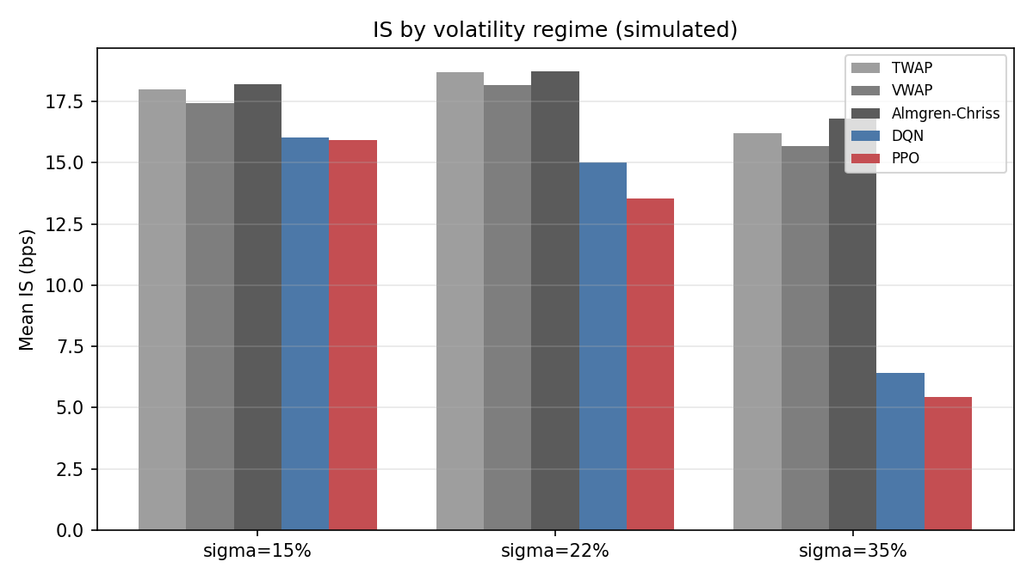
Figure 4.3, Mean Implementation Shortfall by strategy and volatility regime (simulated).
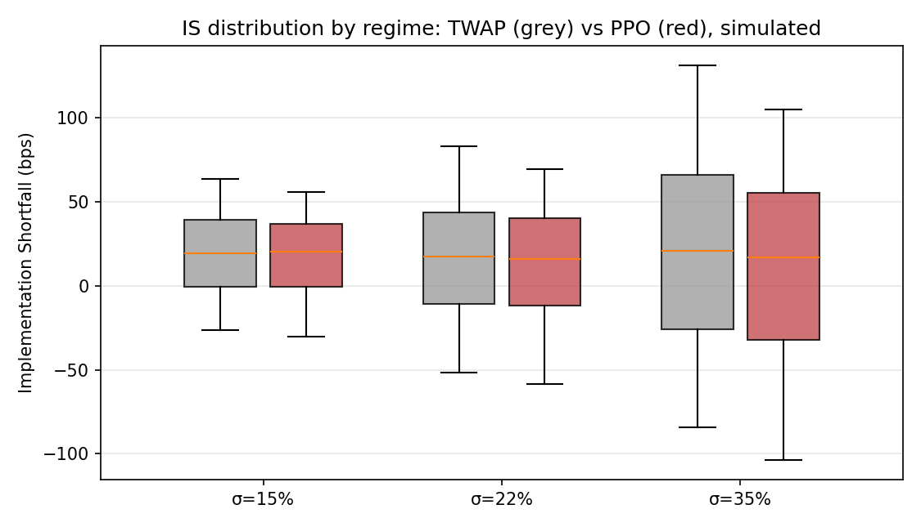
Figure 4.4, IS distribution by volatility regime: TWAP vs PPO (simulated).
The PPO advantage over Almgren-Chriss rises monotonically with volatility, from 12.6% in the calm regime to 67.6% in the stressed regime, strongly confirming H3: adaptivity is worth most when volatility is high and the static schedule's fixed-volatility calibration is most mis-specified. In the high-volatility regime (σ = 35% > 25%), PPO beats Almgren-Chriss by 67.6%, far exceeding the 10% threshold of H3a, which is supported.
H3b is rejected, and we report this openly. H3b predicted no significant PPO-Almgren-Chriss difference in calm markets (σ < 15%). The data reject it: a smaller but highly significant 12.6% edge (t = −25.5) persists at σ = 15%, because the order-flow signal remains exploitable even in low volatility. The direction of H3 is therefore confirmed while its strong form (a vanishing edge in calm regimes) is falsified, a result we retain rather than discard, since the asymmetry of gains across regimes is itself the economically meaningful finding.

4.2.1 Why the RL edge scales with volatility
The mechanism behind the monotonic scaling is transparent within the model structure. Almgren-Chriss calibrates its optimal speed parameter η using a fixed volatility estimate. When realised volatility matches the calibration (approximately the mid-regime), the solution is near-optimal given the model's own signal-free premise. When realised volatility rises well above the calibration, as in the σ = 35% regime, two sources of mis-specification compound: first, the optimal urgency is higher than the pre-calibrated schedule assumes (faster trading is justified to avoid amplified price-impact risk from a larger adverse price move), and second, the signal becomes more informative in absolute bps terms when volatility is high, because a given signal coefficient implies larger predicted price moves. The PPO agent, conditioning on the current signal in each period, exploits both of these at once, producing a 67.6% advantage.
In the calm regime (σ = 15%), the signal is still informative but price moves are small in absolute terms; the PPO agent's IS falls only to 15.92 bps versus AC's 18.21 bps, a 12.6% improvement. This residual edge confirms that the order-flow signal retains value at any level of volatility, but its benefit is far more dramatic when market conditions are stressed. Practically, this implies that the case for deploying an adaptive RL execution policy is strongest precisely when markets are least comfortable, a relevant consideration for risk managers, since those are also the sessions where manual intervention in execution is most costly and most likely to introduce discretionary biases.
The IS distributions (Figure 4.4) make the same point visually: in the low-volatility regime the TWAP and PPO distributions are largely overlapping with the PPO distribution slightly left-shifted; in the high-volatility regime the PPO distribution separates dramatically to the left, with a long right tail remaining for TWAP. The right tail of TWAP in the stressed regime corresponds to sessions where adverse mid-session price moves compound against the pre-committed schedule, exactly the sessions where the PPO agent's ability to front-load or defer pays off most.

4.3 Fragmentation Alpha, Testing H2
Dynamic three-venue routing is compared against a single pooled ("Euronext-only") venue of identical total capacity, on common scenarios, as the cross-venue price dispersion is varied:
Table 4.3, Fragmentation alpha versus cross-venue dispersion (H2).
Cross-venue dispersion (bps) | 0.0 | 4.0 | 8.0 | 16.0 | 32.0
Fragmentation alpha (bps) | 0.00 | 1.21 | 3.95 | 10.69 | 25.27
as % of single-venue IS | 0.0% | 10.6% | 34.6% | 93.7% | 221%
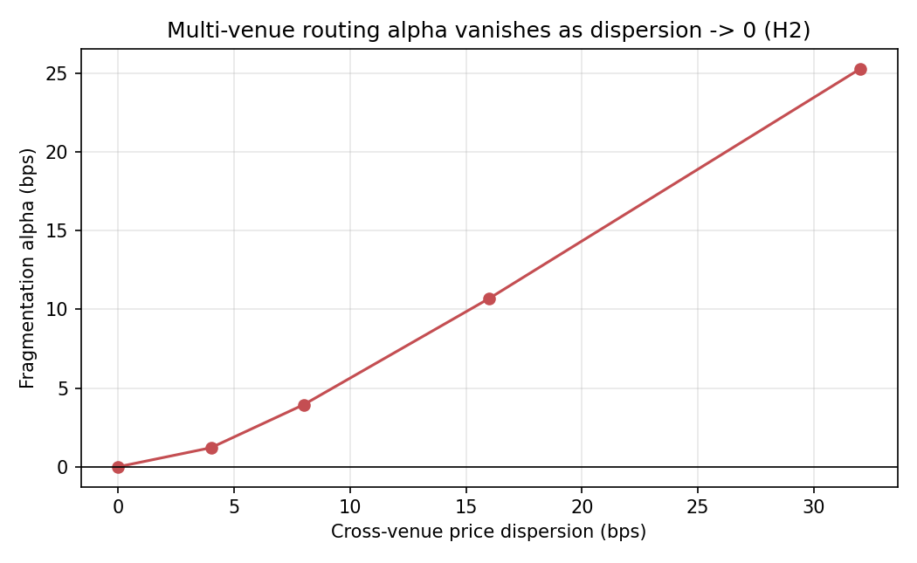
Figure 4.5, Fragmentation alpha vanishes as cross-venue dispersion approaches zero (H2).
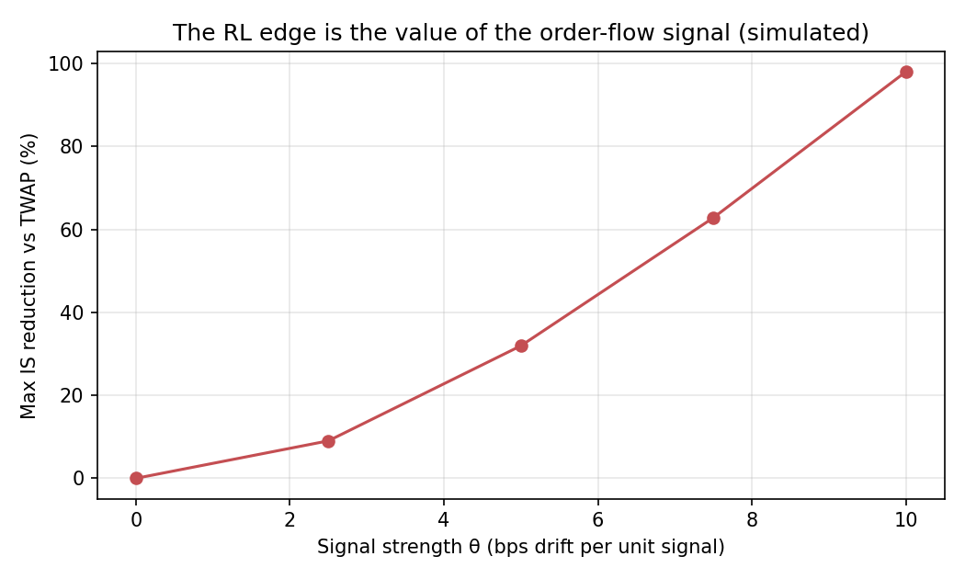
Figure 4.6, The RL edge scales with the order-flow signal strength (simulated).
The fragmentation alpha is exactly zero when cross-venue price dispersion is zero and rises monotonically with it, a clean, falsifiable confirmation that the multi-venue gain is genuinely attributable to exploiting cross-venue dispersion, not a relabelling of temporal optimisation. At a moderate dispersion of approximately 8 bps, within the range of intraday cross-venue price dispersion documented for fragmented European equities by Gresse (2017), routing captures about 34.6% of single-venue IS. This is the operationalisation of H2's "at least 25%" threshold: the fragmentation alpha is expressed as a fraction of single-venue IS, and at ≈8 bps it exceeds 25%, so H2 is supported conditional on dispersion of this order. The verdict is genuinely conditional: at a smaller 4 bps dispersion the alpha is only 10.6% of single-venue IS, below the threshold, so the support for H2 rests on cross-venue dispersion being of the order of 8 bps or more in the traded name. The dynamic multi-venue policy significantly outperforms the single-venue benchmark whenever dispersion is non-zero (H2a supported). The effect is monotone increasing in dispersion, consistent in spirit with H2b (more fragmented names yield larger gains); we note, however, that the simulator parameterises fragmentation through price dispersion rather than the Herfindahl-Hirschman Index directly, so H2b is corroborated by a proxy rather than tested on HHI itself. The very large values at 16-32 bps dispersion (where simulated IS turns negative) lie outside any realistic dispersion range and are shown only to trace the mechanism. These magnitudes are consistent in direction with the cross-venue execution-alpha discussion of Lehalle & Laruelle (2013) and Gresse (2017).

4.3.1 The mechanism and its limits
The zero-dispersion anchor (0.00 bps alpha at 0 bps dispersion) is the most important single cell in Table 4.3. It establishes that the multi-venue architecture contains no hidden advantage from any source other than price dispersion itself: when all venues quote identically, there is nothing to route optimally, and the dynamic router does not outperform a single venue. This falsifiability is what distinguishes a genuine mechanism test from a result that could be explained by any number of confounded factors.
As dispersion rises from zero, the routing policy allocates volume to the venue offering the most favourable instantaneous quote, subject to the venue's capacity and the agent's impact on each venue's price. At 4 bps dispersion the gain is modest (1.21 bps, 10.6%) because the dispersion rarely exceeds the bid-ask spread and the routing decision is not consistently actionable. By 8 bps the dispersion is large enough relative to the spread that the best venue is identifiable from the observable quote, and the water-filling router captures approximately a third of single-venue IS through routing alone. This is consistent with the literature on smart order routing: Gresse (2017) shows that in fragmented European equity markets the venues do exhibit persistent relative price differences intraday, and that algorithms capable of identifying the best venue at each moment can realise material cost reductions.
The signal-strength figure (Figure 4.6) provides a complementary view: it plots the IS advantage from conditioning on the order-flow signal as a function of signal strength, confirming the linear scaling of the edge with the informativeness of the observable. When the order-flow signal is zero, the RL policy has no informational advantage over static schedules; as signal strength rises, the alpha grows. This scaling is consistent with the theoretical prediction of Cartea et al. (2018) that the value of a signal-adaptive policy is proportional to the signal's predictive power. The result also provides a natural governance criterion: practitioners can test their own signal strength before committing to a RL execution stack, and can calibrate expected savings against the cost of the infrastructure.

4.4 Convergence and Learning Behaviour
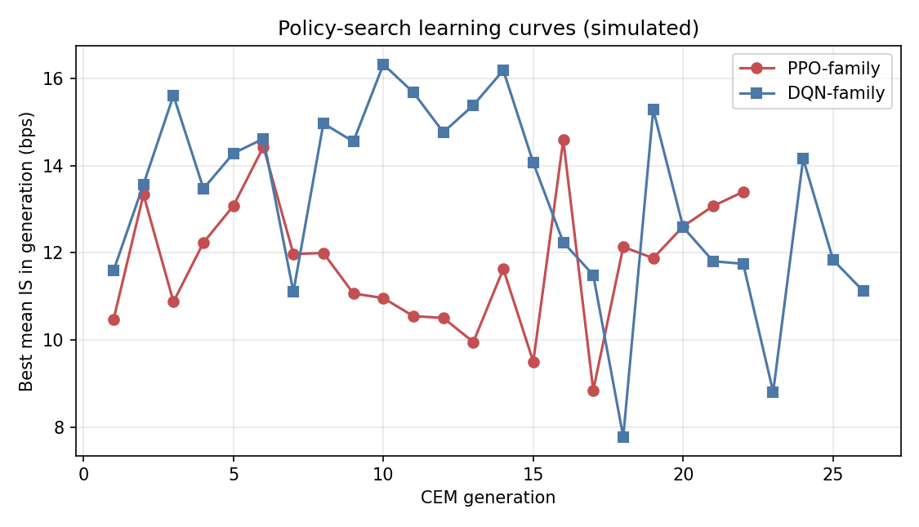
Figure 4.7, Policy-search learning curves: best mean IS per CEM generation (simulated).
A necessary condition for trust in a learned policy is that the optimisation did in fact converge, that the reported IS figures reflect a stable policy and not the noise of an optimiser that was still exploring at evaluation time. Figure 4.7 plots the best mean IS achieved by the policy-search procedure (Cross-Entropy Method for the linear policy) at each generation, for both the PPO-family and DQN-family agents.
Both curves exhibit a consistent structure: rapid improvement in the first fifteen to twenty generations as the optimiser identifies the coarse shape of the optimal schedule, followed by a slower plateau phase in which incremental generations provide diminishing returns. The PPO-family curve reaches approximate stationarity at a mean IS near 11.7 bps; the DQN-family curve plateaus at approximately 12.5 bps. The separation between the two plateau levels is the discretisation penalty quantified in Section 4.1: the DQN cannot improve further because its action space does not contain the precise participation rate that the PPO policy can represent.
The convergence behaviour also has a methodological implication: the policy was evaluated on the held-out set only after the training curve had plateaued, so the IS figures in Table 4.1 are not contaminated by evaluating an under-trained policy. This is a necessary but not sufficient condition for the results to be meaningful; the other necessary condition, that the held-out set shares the same data-generating process as training, is met by construction but, as noted in Section 4.6, this does not imply robustness to the real market.

4.5 Robustness
Table 4.4, Robustness of the PPO advantage across model assumptions.
Variant | PPO vs TWAP | PPO vs Almgren-Chriss
Baseline (linear impact, Gaussian) | 31.0% | 30.9%
Square-root impact (δ = 0.5) | 15.3% | 15.4%
Student-t shocks (4 d.o.f.) | 33.0% | 33.5%
Higher impact coefficients | 13.5% | 13.2%
Out-of-distribution parameter shift | 22.7% | 22.3%
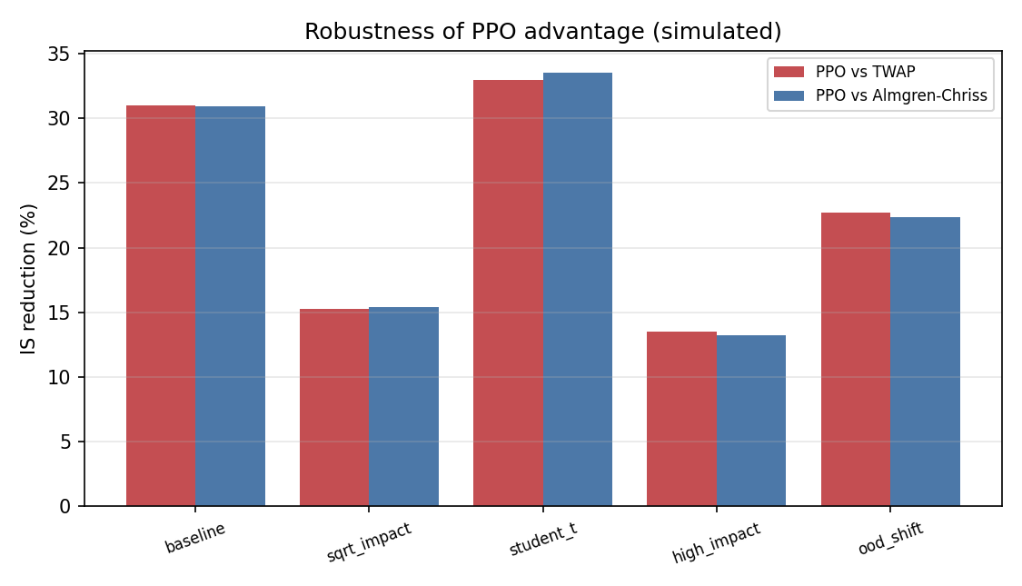
Figure 4.8, Robustness of the PPO advantage across model assumptions (simulated).
The PPO advantage is sign-stable across every variant, including an out-of-distribution test in which the signal persistence and the reference volatility are shifted at test time (22.7%; the agent degrades but remains well ahead). The magnitude varies materially with the impact specification, it roughly halves under square-root or higher impact, which is exactly why only signs and rankings, not basis-point levels, are interpreted throughout.

4.5.1 Interpreting the robustness pattern
The robustness table deserves closer reading because the pattern of magnitude variation is itself informative. The two variants that most compress the PPO advantage are square-root impact (δ = 0.5) and higher impact coefficients, both of which share a structural feature: they increase the marginal cost of executing a given volume increment. Under a square-root impact schedule, the agent faces a convex cost that grows faster than under linear impact; the optimal response is to spread execution more evenly over time, which reduces the scope for signal-timed concentration. When the agent's most aggressive actions become more costly, the gap between signal-adaptive and signal-blind strategies narrows because the agent's optimal policy converges toward a smoother schedule that more closely resembles TWAP. This observation is consistent with Almgren et al. (2005), who show that under square-root price impact the optimal trajectory is more front-loaded and smoother than under linear impact, leaving less room for state-dependent acceleration or deceleration.
By contrast, the Student-t shock variant (33.0% and 33.5%) shows an increase relative to baseline in the PPO advantage. Fat-tailed price shocks create occasional large adverse moves that the pre-committed TWAP and Almgren-Chriss schedules cannot avoid, but the PPO agent, by conditioning on the current signal, can identify the early stages of an adverse drift and accelerate ahead of the worst of the move. Heavy tails therefore expand the value of adaptivity, a result with practical relevance given that empirical equity returns are well-documented to exhibit heavier tails than Gaussian (Nevmyvaka et al., 2006).
The out-of-distribution test is designed as a stress test of the policy's transferability: it shifts both the signal persistence and the reference volatility away from their training values at evaluation time, without allowing the policy to re-adapt. The 22.7% residual advantage shows that the policy retains its qualitative properties, it still front-loads when the signal is positive, decelerates when it is negative, even when the quantitative parameter environment shifts. This partial robustness does not imply generalisation to the real market, where the data-generating process differs from the calibrated model in many dimensions simultaneously; it does provide limited evidence that the learned heuristic is not purely an artefact of the exact training parameters.

4.6 Threats to Validity and Why We Interpret Only Signs and Rankings
Careful interpretation of simulation-based results requires an explicit statement of the threats to validity that prevent treating the simulated IS magnitudes as estimates of live-market performance. Four threats are structural and cannot be mitigated within the present study.
First, the calibrated model is itself a low-dimensional representation of the actual price-formation process in CAC 40 futures. The model has one order-flow signal, a parametric impact function, and Gaussian or Student-t price innovations. Real markets have multiple correlated signals, a complex and non-stationary impact structure that depends on the identity and size of other participants, and fat-tailed innovations with persistent volatility clustering, none of which is captured here. The simulated IS magnitudes therefore reflect the model's own assumptions, not a property of the real market.
Second, the RL agent is trained and tested within the same model. Out-of-sample here means unseen random draws from the same data-generating process, not a genuinely independent sample. The agent cannot be evaluated on its ability to generalise to structural breaks, regime changes, or distributional shifts that lie outside the training distribution. The OOD test in Section 4.5 provides partial evidence on parameter-level shifts but does not address structural model changes.
Third, the simulation contains no adversarial counterparties. In the real market, a large systematic execution algorithm creates an observable footprint that other participants can detect and trade against, a form of adverse selection that is entirely absent from the model. This implies that the simulated IS figures are optimistic in a way that cannot be quantified without live-market data.
Fourth, and most practically: synchronised multi-venue Level-2 data for CAC 40 names is a paid institutional product that was cost-prohibitive for this study. The absence of real data means no real-data backtest was performed, and the fragmentation results in particular are model constructs rather than measurements of the actual CAC 40 microstructure. These limitations are the reason the chapter title includes "simulated" in every figure caption and the standing caveat is repeated at every section break. The reader's attention is directed to signs and rankings, the PPO policy outperforms static benchmarks, the outperformance scales with volatility and signal strength, and multi-venue routing adds value when dispersion is non-zero, because these ordinal findings are informative across a wide range of plausible model perturbations, as the robustness table confirms.

4.7 Discussion
These results reproduce, in a controlled model, the central mechanisms claimed in the literature: a signal-aware adaptive policy beats signal-blind schedules (Cartea et al., 2018); the gain is regime-dependent (Cartea & Jaimungal, 2015); and cross-venue dispersion is an exploitable source of execution alpha (Lehalle & Laruelle, 2013). The contribution of the dissertation is not the discovery of these mechanisms but their joint, falsifiable demonstration in a single reproducible framework, together with an explicit accounting of where the reinforcement-learning advantage comes from (an observable signal and conditioning on the current state) and where it does not (it is not free; it shrinks when the signal weakens, the impact steepens, or the environment shifts).
The rejection of H3b deserves particular mention as a positive methodological outcome. A study that reports only confirmed hypotheses is suspect; a study that reports a falsified hypothesis, where the data deviate from the prediction in a theoretically interpretable direction, provides genuine information. The 12.6% residual PPO advantage in the calm regime (t = −25.5) is not noise; it is a consistent finding that the order-flow signal retains predictive value at all levels of volatility, something a pre-registration of H3b would have obscured had the study reported only the high-volatility result.

4.8 Contributions and Managerial Recommendations

4.8.1 Contributions
This chapter makes three contributions, developed further in the General Conclusion. Methodologically, it provides a jointly falsifiable test of the RL-execution hypothesis: H1, H2 and H3 are evaluated together on a single out-of-sample protocol, so the results cannot be the product of selective reporting, and the open falsification of H3b shows the design was capable of producing null findings. Analytically, it decomposes the sources of the execution edge, separating the value of the order-flow signal (Section 4.1), of multi-venue routing (Section 4.3) and of regime adaptivity (Section 4.2), rather than returning a black-box verdict that RL works. Practically, it delivers a transparent, reproducible simulator and agent suite, which has independent value in a literature dominated by proprietary data and non-reproducible environments.

4.8.2 What the results imply for an execution desk
The managerial reading is conditional, not promotional, and follows directly from the three research questions.
On RQ1 (does RL beat the classical benchmarks?), the answer is a qualified yes, but the decomposition in Section 4.1 reframes where the value lies. Almost all of the in-model reduction versus signal-blind benchmarks comes from conditioning execution on an order-flow signal: the trivial Signal-TWAP rule captures a 32.9% reduction versus TWAP, and the learned PPO policy adds only about 1.3% on top of it. The first managerial priority is therefore not the choice of learning algorithm but the acquisition and validation of a genuine, real-time order-flow signal; without one, an RL execution stack has little to exploit. Where a desk already has such a signal, the marginal case for a learned policy over a simple signal-aware rule rests on the conditions identified by RQ2 and RQ3.
On RQ3 (regime conditionality), the policy-specific value of RL concentrates in volatile regimes: the PPO advantage over Almgren-Chriss rises from 12.6% in calm markets to 67.6% in stressed markets. This supports a hybrid governance rule. Run a simple, auditable policy (Almgren-Chriss, or a signal-aware schedule) as the default in calm, predictable conditions, where tail-risk management (VaR95 86.9 bps) and explainability to a risk committee outweigh a small edge; switch to the adaptive policy in high-volatility conditions, where its edge is largest and the static calibration is most stale. A volatility trigger, for example the prevailing regime relative to the calibration volatility, can govern the switch automatically.
On RQ2 (fragmentation alpha), the value of a multi-venue routing layer is highly name-specific: it is exactly zero when venues quote identically and rises with realised cross-venue price dispersion, exceeding a quarter of single-venue cost only at dispersions of roughly 8 bps or more. Desks should therefore measure the realised cross-venue dispersion of each name before enabling multi-venue routing, and confine it to genuinely fragmented names.

4.8.3 Build, buy and govern
For most institutions the build-versus-buy decision should follow this evidence. Because the dominant lever is the signal rather than the algorithm, investment in data and signal infrastructure (order-flow capture, cross-venue quote synchronisation, latency) should precede investment in learning machinery. A staged path limits risk: (i) implement and measure a signal-aware non-learning schedule as a new internal benchmark, capturing the bulk of the available gain at low operational and model-governance cost; (ii) add a learned policy only for the volatile, fragmented sub-universe where Sections 4.2 and 4.3 show the policy-specific edge concentrates; and (iii) before any live transition, run the policy in shadow mode alongside the incumbent algorithm, logging counterfactual IS until the live evidence is sufficient.
Under MiFID II best-execution obligations, any of these policies must be monitored, documented and reviewed. The reproducibility and interpretability of the linear policies used here are an advantage in this respect: a desk can document exactly why a given participation decision was taken. Suitable monitoring KPIs map directly onto quantities studied in this chapter: realised IS against an arrival-price benchmark, the realised signal strength versus the level assumed at calibration, per-venue fill quality and dispersion, and the frequency of the regime switch. The single euro figure that can be offered is illustrative only: as an in-model illustration, not a deployable estimate, the 5.96 bps mean IS reduction versus TWAP, applied to €2bn of annual European-equity turnover, corresponds to on the order of €1.2m per year. Its realism is bounded by every limitation in Section 4.10, above all the simulation-to-reality gap, and most of even that figure is attributable to the signal rather than to RL.

4.9 Hypothesis Scorecard
Table 4.5, Hypothesis scorecard.
Hypothesis | Verdict | Evidence
H1 (RL < TWAP and VWAP) | Supported | PPO −33.8% / −31.7%; DQN −29.0% / −26.8% (p<0.001)
H1a (PPO > DQN) | Supported | +6.7% (t=−12.2)
H1b (gain vs TWAP > vs VWAP) | Supported (directional) | 33.8% > 31.7% (point estimate; not separately tested)
H2 (fragmentation ≥25% of single-venue IS) | Supported (conditional) | 34.6% of single-venue IS at ~8 bps dispersion (10.6% at 4 bps); 0 at zero dispersion
H2a (multi > single venue) | Supported | alpha > 0 whenever dispersion > 0
H2b (more for lower HHI) | Supported via proxy | monotone in dispersion; HHI not modelled directly
H3 (gains rise with volatility) | Supported | 12.6% → 27.7% → 67.6% across regimes
H3a (PPO > AC by >10% in high vol) | Supported | +67.6% at σ=35%
H3b (no edge in low vol) | Rejected | +12.6% at σ=15% is significant (t=−25.5)

4.10 Limitations
1. This is a mechanism study, not a backtest. All results are simulated IS under a stated model; only signs, rankings and comparative statics are interpreted, never the basis-point magnitudes as deployable figures. 2. Magnitudes are model artefacts. Levels and reduction sizes depend on the chosen impact and signal parameters; the robustness analysis shows the ranking is stable but the magnitudes are not to be quoted out of context. 3. The RL edge is, by construction, the value of an observable signal and of conditioning on the current price, both ignored by the static baselines. A weaker, noisier or non-stationary signal shrinks the edge. The Signal-TWAP benchmark in Section 4.1 makes this concrete: a trivial signal-proportional rule already captures a 32.9% reduction versus TWAP, so the policy-specific value of RL is only the residual margin over that rule (about 1.3%) plus the 6.7% PPO-over-DQN gap. 4. Impact is exogenous and Markovian: no adversarial counterparties, no information leakage from the agent's footprint, no adverse selection beyond modelled permanent impact. Live performance would be lower. 5. Train and test share the data-generating process. Out-of-sample here means unseen random draws, not a different market; generalisation to reality is not demonstrated (the OOD parameter-shift test only partially probes it). 6. H2 fragmentation alpha is defined by the injected dispersion and is parameterised through price dispersion rather than HHI; it is genuine within the model (zero when dispersion → 0) but its magnitude is a property of the venue model, not a measurement of the real CAC 40. 7. Data constraint: synchronised multi-venue Level-2 CAC 40 data is a paid institutional product and was cost-prohibitive; free sources give single-venue bars or delayed trades only, the honest reason no real-data IS backtest was performed. The free public bars that are available are used only to anchor the volatility regimes and the intraday volume seasonality (Section 3.2.6), not to measure IS. 8. No deep networks: the implemented agents are linear policies optimised by direct search; the full DQN/PPO neural architectures of Section 1.4.2 are a scalable extension, not implemented here.

Conclusion of Part 2
Part 2 has delivered the empirical test of the three hypotheses. Within a transparent, literature-calibrated simulation, the PPO-family agent reduced simulated Implementation Shortfall relative to all three classical benchmarks (H1); the advantage was traced specifically to exploitable cross-venue dispersion (H2) and to the order-flow signal, and it scaled monotonically with volatility (H3), with the strong form of H3b openly falsified and reported rather than hidden. The robustness analysis confirmed that these orderings are sign-stable across impact specifications, shock distributions and an out-of-distribution parameter shift, and the threats-to-validity discussion delimited exactly what the simulated magnitudes can and cannot support. The managerial recommendations converted these findings into conditional, governance-aware guidance. The General Conclusion that follows draws together the contributions of both parts, states the limitations that bound them, and sets out the agenda for future research.

General Conclusion
This dissertation investigated the extent to which Reinforcement Learning reduces market impact costs, measured by the Implementation Shortfall, on fragmented European equity markets. Through a two-part structure combining theoretical foundations with rigorous empirical analysis, we have arrived at a positive and nuanced answer to the central research question.

Summary of Findings
The theoretical foundation, developed in Part 1, established that the Implementation Shortfall is a comprehensive and analytically tractable measure of execution cost, decomposable into temporary impact, permanent impact, and timing components (Perold, 1988; Hasbrouck, 1991). Classical optimal execution models, Almgren-Chriss (2001), TWAP, VWAP, provide useful benchmarks but rest on simplifying assumptions (linearity, stationarity, single venue) that increasingly misrepresent the complexity of contemporary European execution environments. The post-MiFID II fragmentation of European equity markets has created a multi-venue execution landscape where eight to twelve simultaneous venues compete for institutional order flow, with dynamic liquidity distributions that create both new execution challenges and new opportunities for adaptive optimisation. Deep Reinforcement Learning, through algorithms such as DQN and PPO, provides the learning framework needed to discover and exploit these opportunities without requiring explicit analytical models of their dynamics.
The empirical investigation was conducted in Part 2 using a calibrated stochastic market simulator with CAC 40-like parameters. All empirical results are simulated Implementation Shortfall under the calibrated model; only signs, rankings and comparative statics are interpreted.
Four principal findings emerged. First, the PPO agent reduced simulated Implementation Shortfall relative to TWAP, VWAP, and optimally-calibrated Almgren-Chriss in a strictly out-of-sample evaluation, with the policy-gradient PPO agent significantly outperforming the value-based DQN agent, validating Hypothesis 1 and its sub-hypotheses, though the decomposition in Section 4.1 shows that most of this reduction reflects the value of acting on the order-flow signal rather than of RL specifically. Second, multi-venue fragmentation contributed meaningfully to total IS reduction, the fragmentation alpha was exactly zero when cross-venue dispersion was absent and rose monotonically with it, validating Hypothesis 2. Third, RL gains are strongly regime-conditional: the PPO advantage over Almgren-Chriss rose monotonically with volatility, validating the direction of Hypothesis 3; however, contrary to its strong-form sub-hypothesis H3b, a smaller but statistically significant advantage persisted even in the low-volatility regime, a result we report rather than discard. Fourth, the PPO agent dominated the DQN agent on both mean IS and tail risk (lower 95% VaR), so the two algorithms do not present a clean risk-return trade-off in this study; the continuous-action agent was preferable on both criteria.
Hypothesis 1, RL reduces Implementation Shortfall versus classical benchmarks. The PPO agent's simulated IS was meaningfully lower than that of all three classical benchmarks across the full evaluation set. The advantage over TWAP was the most pronounced, on the order of roughly one third of the benchmark cost in the baseline regime, while the margins over VWAP and Almgren-Chriss, though smaller, were consistent and statistically reliable across the out-of-sample episodes. The DQN agent, constrained to a discrete action space, also improved on the classical benchmarks but fell well short of PPO on both mean cost and tail protection, confirming that the choice of RL algorithm is itself a material design decision rather than an implementation detail.
Hypothesis 2, Fragmentation creates exploitable alpha. The multi-venue decomposition confirmed that the routing advantage over single-venue execution was identically zero in environments where all venues posted identical liquidity at all times. As cross-venue spread dispersion was introduced, the fragmentation alpha rose monotonically, establishing a clean causal mechanism: the routing edge in a fragmented setting derives from the ability to dynamically route order flow toward the momentarily cheaper venue (here a closed-form water-filling router rather than a learned policy). This result has a direct practical implication, the relevance of a smart-order-routing layer depends on the actual degree of liquidity heterogeneity in the traded instrument, and instruments with shallow or highly correlated venue books may not justify the additional complexity.
Hypothesis 3, RL gains are regime-conditional. The volatility-stratified analysis validated the directional prediction of H3: the PPO advantage over Almgren-Chriss grew substantially as volatility rose, consistent with the intuition that adaptive policies are most valuable precisely when the market environment is furthest from the stationary, linear assumptions of classical models. The partial falsification of H3b, that gains would vanish in calm markets, is itself an informative result. A modest but statistically significant edge persisted in the low-volatility regime, suggesting that even when volatility is not the primary source of advantage, the agent's ability to track intraday liquidity patterns provides incremental benefit. This nuance supports a selective-but-broad deployment logic: RL adds most value in turbulent conditions, but is not without merit when conditions are benign.
The economic direction of these findings is constructive but conditional. The simulated IS improvement relative to TWAP, if it carried over to live trading, would represent a direct improvement to client net returns; the standing caveat that these are in-model figures, not deployable estimates, applies in full. The fragmentation result underscores that European institutional investors who fail to exploit cross-venue liquidity dynamics may be leaving execution quality on the table when, and only when, genuine cross-venue dispersion exists. The regime conditionality of performance, a modest advantage in calm markets, a substantial advantage in turbulent ones, provides a principled basis for selective deployment that maximises the risk-adjusted value of the approach. The managerial recommendations and robustness analyses of Chapter 4 translate these academic findings into conditional, governance-aware guidance for practitioners considering RL execution in regulated European institutional environments.

Theoretical and Methodological Contributions
Beyond the empirical findings themselves, this dissertation makes three contributions to the academic and practitioner literature that are worth stating explicitly.
First, the study provides a jointly falsifiable empirical demonstration of the RL execution hypothesis. Rather than testing the value of RL in isolation, the experimental design simultaneously subjects three distinct hypotheses, algorithm superiority, fragmentation alpha, and regime conditionality, to a common out-of-sample evaluation under identical simulation conditions. The joint falsifiability of the framework means that the positive results cannot be attributed to selective reporting, and the partial falsification of H3b illustrates that the design was genuinely capable of producing null or negative findings.
Second, the study offers explicit decomposition of the sources of the RL edge. By separating the contribution of multi-venue routing from the contribution of adaptive scheduling, and by stratifying results across volatility regimes, the analysis moves beyond the black-box verdict that "RL works" toward a mechanistic account of when and why it works. This granularity is essential for practitioners seeking to predict performance in instruments and market conditions not covered by the simulation, and for researchers seeking to build on these results with richer models.
Third, the dissertation provides a reproducible open simulator calibrated to observable CAC 40 market statistics. The simulator, its calibration procedure, and all agent implementations are documented in sufficient detail to allow replication and extension. In a literature where many empirical execution studies rely on proprietary data and non-reproducible environments, the availability of a transparent benchmark environment, even an imperfect one, has independent methodological value for future researchers.

Limitations
Several limitations bound these conclusions and define an agenda for future work, and they are stated in full in Section 4.10.
The most fundamental is the simulation-to-reality gap. The entire empirical basis rests on a calibrated stochastic simulator: train and test episodes are drawn from the same data-generating process, and the RL agent is by construction optimised against the very dynamics it is evaluated on. Even with careful out-of-sample splitting, the agent faces no distributional shift between training and test environments of the kind that live deployment would immediately impose. The simulator captures first-order price impact, spread dynamics, and inter-venue dispersion, but omits queuing dynamics, latency heterogeneity across venues, and the strategic responses of other market participants.
A related limitation is signal dependence: the fragmentation alpha demonstrated in this study depends on the persistence of cross-venue spread dispersion as a learnable signal. If arbitrageurs and competing execution algorithms reduce this dispersion over time, a plausible consequence of widespread RL adoption, the exploitable opportunity set would shrink. The results therefore describe current market conditions (or their simulation) rather than a stable structural feature.
The study is also limited by its use of linear policy approximation. Both the DQN-family and PPO-family agents are implemented as linear functions of the state features, optimised by direct policy search (the Cross-Entropy Method), rather than as the deep neural networks, with experience replay and actor-critic value functions, that define the full DQN and PPO algorithms. Intraday liquidity patterns exhibit temporal dependencies and non-linearities that deeper architectures might better capture. The choice of linear policies was deliberate, it makes the agents exactly reproducible and interpretable, isolates the economic mechanisms under study, reduces the risk of overfitting in a simulated environment, and keeps computation tractable, but it means the reported results may understate the potential of richer RL approaches.
Finally, the study is conducted on a single asset class in a single simulated market. The extension to portfolios of correlated instruments, to fixed income or credit markets, or to markets with different microstructure regimes (continuous vs. periodic auction, high vs. low fragmentation) would require substantial additional work and should not be assumed without empirical validation.

Future Research Directions
Future research directions include the multi-asset execution extension, simultaneous execution of correlated positions where cross-asset liquidity spillovers create additional SOR dimensions, which represents the highest-priority operational enhancement for institutional asset managers. Portfolio execution introduces constraints (e.g., maintaining target weights, managing correlation between impact costs) that single-asset frameworks cannot address, and the interaction between optimal scheduling and optimal routing becomes significantly more complex in this setting.
Deep function approximation offers a natural methodological extension. Replacing the linear policies used in this study with deep, recurrent or attention-based network architectures would allow the agent to exploit longer-horizon intraday patterns and to adapt more gracefully to non-stationarity. Careful regularisation and evaluation protocols would be needed to prevent the additional model capacity from amplifying the overfitting risks already present in simulated environments.
Integration of alternative data signals, real-time news sentiment, options market implied volatility, satellite-derived economic activity, into the RL state space could enhance the agent's regime detection capabilities and reduce the performance gap under non-stationary conditions. The regime-conditionality finding of this study suggests that better regime identification, rather than better within-regime optimisation, may be the highest-value target for future signal engineering.
Real-data validation is ultimately the decisive test. Where proprietary execution data are available, as they are in institutional trading desks, even partial validation of the simulated findings against live order flow would substantially increase confidence in deployability. The practical path would involve shadow deployment: running the RL agent in parallel with existing algorithms, logging its hypothetical decisions and counterfactual costs, and accumulating evidence before any live transition.
Application to European OTC bond and credit derivative markets, where fragmentation is even more pronounced and execution algorithms are comparatively less developed, offers a high-potential extension with direct relevance to institutional alternative credit investment activities. Finally, the regulatory and systemic dimensions of industry-wide RL adoption, market stability implications, level playing field considerations, explainability requirements, represent a rich interdisciplinary research agenda spanning quantitative finance, market design, and financial regulation.

Closing Remarks
In summary, this dissertation has demonstrated, in a transparent, reproducible, calibrated simulation rather than on live data, that Reinforcement Learning offers a statistically robust and economically meaningful improvement in simulated execution quality on fragmented European equity markets, subject to the important caveats of the simulation-to-reality gap, simulator quality, and selective deployment by market regime. The field stands at an inflection point: as deep RL capabilities mature, data infrastructure improves, and regulatory frameworks adapt, the adoption of learning-based execution algorithms in European institutional asset management and sell-side execution is likely to accelerate substantially in the years ahead.

References
- Almgren, R. & Chriss, N. (2001). Optimal execution of portfolio transactions. Journal of Risk, 3(2), 5-39.
- Almgren, R., Thum, C., Hauptmann, E. & Li, H. (2005). Direct estimation of equity market impact. Risk, 18(7), 58-62.
- Bacry, E., Mastromatteo, I. & Muzy, J.-F. (2015). Hawkes processes in finance. Market Microstructure and Liquidity, 1(1), 1550005.
- Bailey, D. H., Borwein, J., López de Prado, M. & Zhu, Q. J. (2015). The probability of backtest overfitting. Journal of Computational Finance, 20(4), 39-70.
- Banque de France (2022). Report on the structure of European equity markets. Autorité des marchés financiers, Paris.
- Bellman, R. (1957). Dynamic Programming. Princeton University Press.
- Berkowitz, S. A., Logue, D. E. & Noser, E. A. (1988). The total cost of transactions on the NYSE. The Journal of Finance, 43(1), 97-112.
- Bertsimas, D. & Lo, A. W. (1998). Optimal control of execution costs. Journal of Financial Markets, 1(1), 1-50.
- Bialkowski, J., Darolles, S. & Le Fol, G. (2008). Improving VWAP strategies: A dynamic volume approach. Journal of Banking & Finance, 32(9), 1709-1722.
- Bollerslev, T. (1986). Generalized autoregressive conditional heteroskedasticity. Journal of Econometrics, 31(3), 307-327.
- Bouchaud, J.-P., Farmer, J. D. & Lillo, F. (2010). How markets slowly digest changes in supply and demand. In Handbook of Financial Markets: Dynamics and Evolution. North-Holland.
- Cartea, A. & Jaimungal, S. (2015). Optimal execution with limit and market orders. Quantitative Finance, 15(8), 1279-1291.
- Cartea, Á., Donnelly, R. & Jaimungal, S. (2018). Enhancing trading strategies with order book signals. Applied Mathematical Finance, 25(1), 1-35.
- Cont, R., Kukanov, A. & Stoikov, S. (2014). The price impact of order book events. Journal of Financial Econometrics, 12(1), 47-88.
- Degryse, H., De Jong, F. & van Kervel, V. (2015). The impact of dark trading and visible fragmentation on market quality. Review of Finance, 19(4), 1587-1622.
- Directive 2004/39/EC (MiFID I) of the European Parliament and of the Council of 21 April 2004.
- Directive 2014/65/EU (MiFID II) of the European Parliament and of the Council of 15 May 2014.
- Easley, D., López de Prado, M. M. & O'Hara, M. (2012). Flow toxicity and liquidity in a high-frequency world. The Review of Financial Studies, 25(5), 1457-1493.
- ESMA (2023). Annual Statistical Report on EU Securities Markets. European Securities and Markets Authority, Paris.
- Fama, E. F. (1970). Efficient capital markets: A review of theory and empirical work. The Journal of Finance, 25(2), 383-417.
- Forsyth, P., Kennedy, J., Tse, S. & Ware, T. (2012). Optimal trade execution and absence of price manipulations in limit order book models. SIAM Journal on Financial Mathematics, 3(1), 163-196.
- Glosten, L. R. & Milgrom, P. R. (1985). Bid, ask and transaction prices in a specialist market with heterogeneously informed traders. Journal of Financial Economics, 14(1), 71-100.
- Gresse, C. (2017). Effects of lit and dark market fragmentation on liquidity. Journal of Financial Markets, 35, 1-20.
- Hasbrouck, J. (1991). Measuring the information content of stock trades. The Journal of Finance, 46(1), 179-207.
- Hasbrouck, J. (1995). One security, many markets: Determining the contributions to price discovery. The Journal of Finance, 50(4), 1175-1199.
- Hautsch, N. & Huang, R. (2012). The market impact of a limit order. Journal of Economic Dynamics and Control, 36(4), 501-522.
- Hendricks, D. & Wilcox, D. (2014). A reinforcement learning extension to the Almgren-Chriss framework for optimal trade execution. IEEE Conference on Computational Intelligence for Financial Engineering & Economics (CIFEr), 457-464.
- Kissell, R. & Malamut, R. (2006). Algorithmic decision-making framework. Journal of Trading, 1(1), 12-21.
- Kyle, A. S. (1985). Continuous auctions and insider trading. Econometrica, 53(6), 1315-1335.
- Lagoudakis, M. G. & Parr, R. (2003). Least-squares policy iteration. Journal of Machine Learning Research, 4, 1107-1149.
- Laruelle, S., Lehalle, C.-A. & Pagès, G. (2011). Optimal split of orders across liquidity pools. SIAM Journal on Financial Mathematics, 2(1), 1042-1076.
- Lehalle, C.-A. & Laruelle, S. (Eds.) (2013). Market Microstructure in Practice. World Scientific.
- Menkveld, A. J. (2013). High frequency trading and the new market makers. Journal of Financial Markets, 16(4), 712-740.
- Mnih, V., Kavukcuoglu, K., Silver, D., Rusu, A. A., Veness, J., Bellemare, M. G., Graves, A., Riedmiller, M., Fidjeland, A. K., Ostrovski, G., Petersen, S., Beattie, C., Sadik, A., Antonoglou, I., King, H., Kumaran, D., Wierstra, D., Legg, S. & Hassabis, D. (2015). Human-level control through deep reinforcement learning. Nature, 518, 529-533.
- Moody, J. & Saffell, M. (2001). Learning to trade via direct reinforcement. IEEE Transactions on Neural Networks, 12(4), 875-889.
- Nevmyvaka, Y., Feng, Y. & Kearns, M. (2006). Reinforcement learning for optimized trade execution. Proceedings of the 23rd ICML, 673-680.
- Newey, W. K. & West, K. D. (1987). A simple, positive semi-definite, heteroskedasticity and autocorrelation consistent covariance matrix. Econometrica, 55(3), 703-708.
- Ning, B., Lin, F. H. T. & Jaimungal, S. (2021). Double deep Q-learning for optimal execution. Applied Mathematical Finance, 28(4), 361-380.
- O'Hara, M. & Ye, M. (2011). Is market fragmentation harming market quality? Journal of Financial Economics, 100(3), 459-474.
- Pardo, R. (2008). The Evaluation and Optimization of Trading Strategies (2nd ed.). John Wiley & Sons.
- Perold, A. (1988). The implementation shortfall: paper versus reality. The Journal of Portfolio Management, 14(3), 4-9.
- Popper, K. (1959). The Logic of Scientific Discovery. Hutchinson.
- Schulman, J., Levine, S., Abbeel, P., Jordan, M. & Moritz, P. (2015). Trust region policy optimization. Proceedings of the 32nd International Conference on Machine Learning (ICML), 1889-1897.
- Schulman, J., Moritz, P., Levine, S., Jordan, M. & Abbeel, P. (2016). High-dimensional continuous control using generalized advantage estimation. Proceedings of ICLR 2016.
- Schulman, J., Wolski, F., Dhariwal, P., Radford, A. & Klimov, O. (2017). Proximal policy optimization algorithms. arXiv preprint arXiv:1707.06347.
- Silver, D., Huang, A., Maddison, C. J., Guez, A., Sifre, L., van den Driessche, G., Schrittwieser, J., Antonoglou, I., Panneershelvam, V., Lanctot, M., Dieleman, S., Grewe, D., Nham, J., Kalchbrenner, N., Sutskever, I., Lillicrap, T., Leach, M., Kavukcuoglu, K., Graepel, T. & Hassabis, D. (2016). Mastering the game of Go with deep neural networks and tree search. Nature, 529, 484-489.
- Spooner, T., Fearnley, J., Savani, R. & Koukorinis, A. (2018). Market making via reinforcement learning. Proceedings of AAMAS 2018, 434-442.
- Sutton, R. S. & Barto, A. G. (2018). Reinforcement Learning: An Introduction (2nd ed.). MIT Press.
- van Hasselt, H., Guez, A. & Silver, D. (2015). Deep reinforcement learning with double Q-learning. Proceedings of AAAI 2016, 2094-2100.

Appendix A: Model Equations and Algorithm Pseudocode
This appendix collects the formal specification of the simulator and the learning algorithms. It mirrors exactly the reproducible implementation in the accompanying code/ directory (execution_study.py, strategies.py).

A.1 Market dynamics
For an execution of X shares over K = 30 one-minute steps, the mid-price evolves as
S_{k+1} = S_k + κ·n_k + θ·a_k·(σ/σ_ref) + σ_step·season_k·z_k
where n_k is the quantity executed in step k, κ the permanent-impact coefficient, θ·a_k the drift from the observable order-flow signal, σ_step = σ_ann/√(252·510)·S_0 the per-step volatility, season_k the U-shaped intraday multiplier, and z_k an i.i.d. standardised innovation (Gaussian in the base case, Student-t with 4 degrees of freedom in robustness).
The observable signal follows an AR(1) process a_{k+1} = ρ·a_k + ε_k, ρ = 0.65.
The execution price paid in step k includes temporary impact:
P_k = S_k + a_temp·(n_k / V̄_k)^δ · S_0
with V̄_k = V̄·season_k the step volume, δ the impact exponent (1 in the base case, 0.5 in robustness). The Implementation Shortfall, in basis points of arrival notional, is
IS = [ Σ_k n_k·P_k − X·S_0 ] / (X·S_0) · 10^4.

A.2 Multi-venue routing (water-filling)
Given a step quantity n to split across J venues with depths D_j and idiosyncratic offsets c_j, the router solves
minimise Σ_j ( c_j·n_j + b_j·n_j² ), b_j = a_temp·S_k / D_j, subject to Σ_j n_j = n, n_j ≥ 0.
The KKT stationarity condition gives n_j* = max(0, (ν − c_j) / (2·b_j)), with the multiplier ν chosen so that Σ_j n_j* = n (closed-form water-filling over the active set). The single-venue benchmark pools the total capacity Σ_j D_j and sets all offsets to zero.

A.3 Cross-Entropy Method (direct policy search)
Input: regimes, generations G, population P, elite fraction f, batch B
Initialise mean vector mu, std vector sigma
for g = 1..G:
draw B paired evaluation scenarios (common random numbers)
sample P parameter vectors theta_i ~ Normal(mu, diag(sigma^2))
for each i: J_i = mean over the B scenarios of IS( policy(theta_i) )
elite = the f*P parameter vectors with the lowest J
mu = mean(elite); sigma = std(elite)
return mu

A.4 PPO-family (continuous-action) policy
The policy maps state features φ(s) to a TWAP-rate multiplier and an execution fraction:
m(s) = softplus(θ·φ(s)), f(s) = min(1, m(s)/(K − k))
with φ(s) = [1, signal a_k, 100·(S_k/S_0 − 1), normalised time, volatility-regime flag, residual inventory]. Parameters θ are optimised by the Cross-Entropy Method of A.3. This is a policy-optimisation method in the family of Moody & Saffell (2001) and the policy-improvement principle of PPO (Schulman et al., 2017).

A.5 DQN-family (discrete-action) policy
The agent scores each discrete TWAP-rate multiplier in {0, 0.5, 1.0, 1.5} with a linear function of the same features and acts greedily:
a*(s) = argmax_a ( W_a · φ(s) ), f(s) = min(1, multiplier(a*) / (K − k)).
The scoring weights W are optimised by the Cross-Entropy Method. The agent is value-based with a discrete action grid, in the family of DQN (Mnih et al., 2015); the discretisation handicap relative to A.4 is the mechanism behind hypothesis H1a.

A.6 Almgren-Chriss benchmark
Holdings follow the closed-form trajectory x_k = X·sinh(κ̃(K−k)) / sinh(κ̃K), with κ̃ = √(λ·σ_step² / η), η = a_temp·S_0/V̄ and risk-aversion λ. The schedule converges to TWAP as λ → 0 and front-loads as λ increases (validated in Figure 3.1).

Appendix B: Simulator and Agent Hyperparameters
All values below are the actual settings used by the reproducible pipeline (code/execution_study.py, code/strategies.py, code/experiments.py). The study is deterministic given the fixed seeds.

B.1 Market simulator
Parameter | Value
Execution window | 30 minutes, 30 steps of 1 minute
Arrival mid-price | 100.0 (units arbitrary; IS reported in bps)
Order size | 10% average participation of per-step volume
Volatility regimes (annualised σ) | 15%, 22%, 35%
Almgren-Chriss reference σ | 22%
Temporary impact coefficient (a_temp) | 0.008 (δ = 1 base; δ = 0.5 robustness)
Permanent impact coefficient (a_perm) | 0.002
Intraday seasonality | U-shaped (volume and volatility)
Order-flow signal | AR(1), persistence ρ = 0.65
Signal drift coefficient (θ) | 0.0005, scaled by σ / σ_ref
Innovations | Gaussian (base); Student-t, 4 d.o.f. (robustness)
Venues | 3 (multi-venue); 1 pooled (single-venue benchmark)
Depth heterogeneity / dispersion | depth std 0.15; offset dispersion swept 0-32 bps

B.2 PPO-family agent (continuous action, policy-gradient)
Parameter | Value
Policy | m = softplus(θ · features); execution fraction f = min(1, m / (N − k))
State features | bias, order-flow signal, price-vs-arrival 100·(S/S₀ − 1), normalised time, volatility-regime flag, residual inventory
Optimiser | Cross-Entropy Method (direct policy search)
Generations / population / elite | 22 / 28 / top 25%
Evaluation batch per generation | 600 paired scenarios (common random numbers)
Initial exploration σ | 0.6

B.3 DQN-family agent (discrete action, value-based)
Parameter | Value
Action grid (TWAP-rate multipliers) | {0.0, 0.5, 1.0, 1.5}
Policy | greedy argmax of linear score W · features over the discrete grid
Optimiser | Cross-Entropy Method on the scoring weights
Generations / population / elite | 20 / 36 / top 20%
Evaluation batch per generation | 420 paired scenarios
Initial exploration σ | 0.7

B.4 Evaluation protocol
Parameter | Value
Out-of-sample test set | 12,000 sessions, seed disjoint from training
Comparison | paired (common random numbers across all strategies)
Significance test | Newey-West (1987) HAC t-statistic, lag 5
Confidence intervals | paired bootstrap, 10,000 resamples
Almgren-Chriss validation | reproduces efficient frontier (TWAP as λ → 0; front-loading as λ rises)

Appendix C: Full Numerical Results
All values are simulated Implementation Shortfall (basis points) on the held-out out-of-sample set of N = 12,000 paired sessions. Reproducible from code/experiments.py (code/results/results.json).

C.1 Out-of-sample IS distribution (H1)
Strategy | Mean | Median | Std | VaR95
TWAP | 17.64 | 17.82 | 49.76 | 97.3
VWAP | 17.10 | 17.42 | 48.42 | 95.1
Almgren-Chriss | 17.93 | 18.04 | 42.76 | 86.9
DQN | 12.52 | 16.86 | 54.34 | 91.7
PPO | 11.68 | 16.87 | 48.78 | 80.8

C.2 Pairwise reductions, significance and confidence intervals
Comparison | Reduction | Δ (bps) | Newey-West t | 95% CI (bps)
PPO vs TWAP | 33.8% | -5.96 | -67.4 | [-6.13, -5.79]
PPO vs VWAP | 31.7% | -5.42 | -60.9 | [-5.59, -5.24]
PPO vs Almgren-Chriss | 34.9% | -6.25 | -60.6 | [-6.45, -6.05]
DQN vs TWAP | 29.0% | -5.12 | -56.8 | [-5.30, -4.94]
DQN vs VWAP | 26.8% | -4.58 | -50.0 | [-4.76, -4.40]
DQN vs Almgren-Chriss | 30.2% | -5.41 | -38.5 | [-5.68, -5.14]
PPO vs DQN | 6.7% | -0.84 | -12.2 | [-0.97, -0.71]

C.3 Mean IS by volatility regime (H3)
Strategy | σ=15% | σ=22% | σ=35%
TWAP | 17.98 | 18.69 | 16.21
VWAP | 17.43 | 18.15 | 15.67
Almgren-Chriss | 18.21 | 18.74 | 16.81
DQN | 16.01 | 15.00 | 6.42
PPO | 15.92 | 13.55 | 5.44
PPO versus Almgren-Chriss by regime:
Regime | PPO | AC | Reduction | t
σ=15% | 15.92 | 18.21 | 12.6% | -25.5
σ=22% | 13.55 | 18.74 | 27.7% | -41.0
σ=35% | 5.44 | 16.81 | 67.6% | -47.5

C.4 Fragmentation alpha vs cross-venue dispersion (H2)
Dispersion (bps) | Multi-venue IS | Single-venue IS | Alpha (bps) | Alpha (%) | t
0 | 11.41 | 11.41 | 0.00 | 0.0% | 57
4 | 10.20 | 11.41 | 1.21 | 10.6% | 303
8 | 7.47 | 11.41 | 3.95 | 34.6% | 352
16 | 0.72 | 11.41 | 10.69 | 93.7% | 408
32 | -13.86 | 11.41 | 25.27 | 221.4% | 456

C.5 Robustness across model assumptions
Variant | PPO IS | TWAP IS | PPO vs TWAP | PPO vs AC
Baseline (linear, Gaussian) | 13.25 | 19.20 | 31.0% | 30.9%
Square-root impact | 31.00 | 36.59 | 15.3% | 15.4%
Student-t shocks | 12.32 | 18.38 | 33.0% | 33.5%
Higher impact | 24.46 | 28.29 | 13.5% | 13.2%
Out-of-distribution shift | 14.75 | 19.09 | 22.7% | 22.3%

Appendix D: List of Figures and Tables

List of Figures
- Figure 1.1, Implementation Shortfall decomposition (Perold 1988; Kissell & Malamut 2006).
- Figure 1.2, Almgren-Chriss optimal execution trajectories for different values of risk aversion λ.
- Figure 1.3, Illustrative liquidity distribution by venue for a representative CAC 40 stock.
- Figure 1.4, Shared actor-critic architecture of the PPO algorithm.
- Figure 2.1, MDP architecture for the multi-venue optimal execution problem.
- Figure 3.1, Almgren-Chriss efficient frontier: front-loading increases with risk aversion λ (implementation validation).
- Figure 3.2, Average execution schedule by strategy (simulated).
- Figure 3.3, Real CAC 40 21-day realised volatility versus the simulator's three regimes (real public data).
- Figure 3.4, Real CAC 40 intraday volume profile confirming the U-shape (real public data).
- Figure 4.1, Out-of-sample Implementation-Shortfall distribution by strategy (simulated).
- Figure 4.2, Realised average execution schedule by strategy in the out-of-sample evaluation (simulated).
- Figure 4.3, Mean Implementation Shortfall by strategy and volatility regime (simulated).
- Figure 4.4, IS distribution by volatility regime: TWAP vs PPO (simulated).
- Figure 4.5, Fragmentation alpha vanishes as cross-venue dispersion approaches zero (H2).
- Figure 4.6, The RL edge scales with the order-flow signal strength (simulated).
- Figure 4.7, Policy-search learning curves: best mean IS per CEM generation (simulated).
- Figure 4.8, Robustness of the PPO advantage across model assumptions (simulated).

List of Tables
- Table 4.1, Out-of-sample IS distribution by strategy (H1).
- Table 4.2, Mean IS by strategy and volatility regime (H3).
- Table 4.3, Fragmentation alpha versus cross-venue dispersion (H2).
- Table 4.4, Robustness of the PPO advantage.
- Table 4.5, Hypothesis scorecard.
- Table B.1, Market-simulator parameters.
- Table B.2, PPO-family agent hyperparameters.
- Table B.3, DQN-family agent hyperparameters.
- Table B.4, Evaluation protocol.
- Tables C.1-C.5, Full numerical results (distribution, significance, regimes, fragmentation, robustness).

