Everything with $ before is a line to copy and paste into terminal.

# is a comment.
*** is special comment

*****As Root

$ adduser reosc

$ usermod -aG sudo reosc

$ su reosc

***As user reosc

$ cd ~/

$ sudo apt-get update

$ sudo apt install fail2ban ufw -y

$ sudo systemctl enable fail2ban && sudo systemctl start fail2ban

$ sudo ufw allow ssh/tcp

$ sudo ufw limit ssh/tcp

$ sudo ufw allow 30305/tcp

$ sudo ufw allow 30305/udp

$ sudo ufw allow 8545/tcp

$ sudo ufw logging on

$ sudo ufw enable

$ sudo ufw status

-----------------------------------------------------------------------

$ sudo apt-get update

$ sudo apt-get install mc htop

$ wget https://github.com/REOSC/mn/releases/download/2.1.4/reosc-node

$ chmod +x reosc-node

$ sudo cp reosc-node /usr/bin/reosc-node

_____________________________________________________________________________

$ sudo apt-get update

$ sudo apt-get install nano

$ sudo nano /etc/systemd/system/reosc.service

# Copy and paste adding your own ip address Inside the section below:

[Unit]
Description=REOSC Node -- MasterNode service
After=network.target

[Service]
Type=simple
Restart=always
RestartSec=30s
ExecStart=/usr/bin/reosc-node --chain=reosc --jsonrpc-interface 192.168.213.22 --port "30303"

[Install]
WantedBy=default.target

# combine Controle and x / save and exit
<controle key + x> save and exit
_________________________________________________________________________________

#Start service

$ sudo systemctl start reosc.service

# Enable Node service at boot of computer

$ sudo systemctl enable reosc.service

# Show first 50 lines of status of Node service this will tell you active or failed

$ sudo systemctl status -n50 reosc.service # Show first 50 lines of status of Node service

# ***Only If you need to Stop Node service***

$ sudo systemctl stop reosc.service

# Continue with steps to register Master-Node from website:

https://github.com/REOSC/mn/wiki/3.-REOSC-MasterNode-(MN)-Setup

$ curl --data '{"method":"parity_enode","params":[],"id":1,"jsonrpc":"2.0"}' -H "Content-Type: application/json" -X POST <ip Address>:8545

get result that looks like this

Public node URL: enode://49d11acf7cxxxxxxxxxxxxxxxxxxxxxxxxxxxxxxxxxxxxxxxxxxxxxxxxxxxxxxxxxxxxxxxxxxxxxxxxxxxxxxxxxxxxxxxxxxxxxxxxxxxxxxxxxxxxxxxxxxxxxx@192.168.213.15:30303

#Copy the first 10 caractures and put 0x in front on the extar data section within MEW as you make the transaction of 250k or 1.5 mil coins to new wallet.

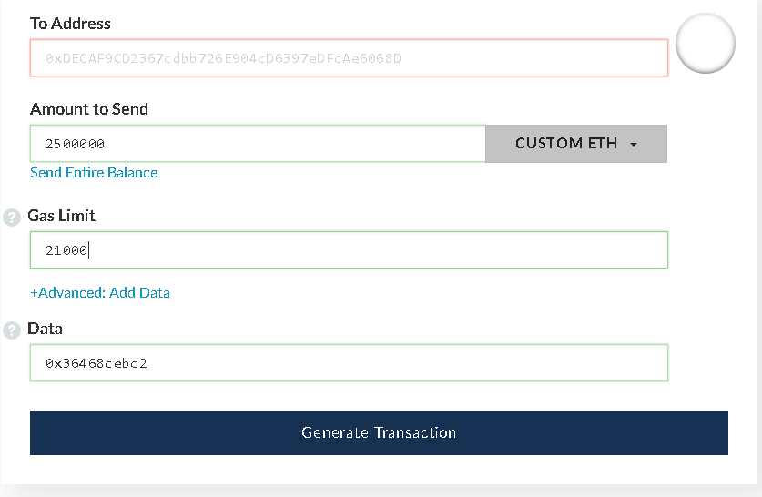

copy the transaction # and fill in all 5 steps below.

----------------------------------------------------------------
CheckList: (as Example)

1-External IP address: <Your-External-IP-Here>
Open RPC port: 8545

2-MN enode:// a6db4a0898bf042f05cab65f7be731a7653e68f3e846abe9264151872da6185bdeea58ed2c640b9bc5d12b89fb8efb7a5f2791aee237b48e5c20f6794497bc05

3-Tx number: 0x9d0b6df0f7592a4334084a814f6a17a85c9896bcc5af8f2c296b98a953122c8e

4-Wallet address: 0x37064f89aba37df6bc9e97c22c6fe19f8a0c4518

----------------------------------------------------------------

#Now you need to register your hot & fresh MN on service.

#Unfortunately, self-registration is not yet available but @Le_Gift on https://t.me/reosc_rus will do it for you if you send him these 4 items in a telegram.
All Done :)

--------------------------------------------------------------------------------

