Toggle visibility of inventory



# ULifeBar

## Parts and ULifeBar.h

* UProgressBar
* OnReceiveDmg
* NativeOnInitialized: to bind the event to the function

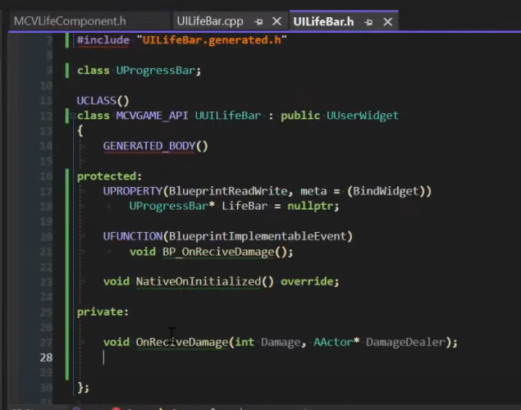

NOTE: We are going to bind the function OnReceiveDmg whit DYNAMIC_MULTICAST (for BP) so we need to UFUNCTION()

## NativeOnInitialized

We set the percent to 1 and we bind to the function

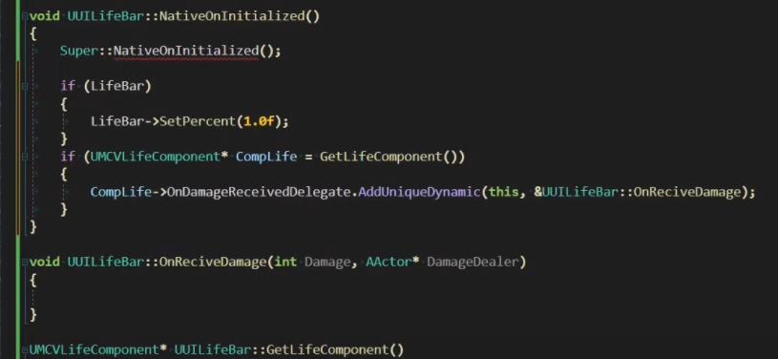

## Feedback bar

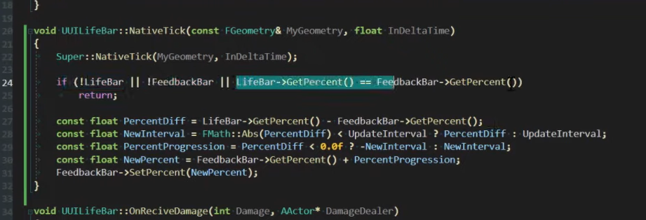

Tick for updating the second bar

## Create a Timer

In .h define a TimerHandle



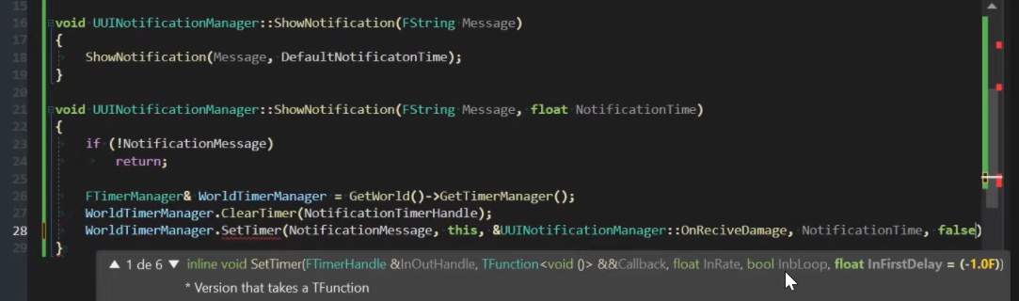

Hace en esta clase:

* UILifeBar
  + Con animaciones
* UINotificationMessage