# FOTOS

## Glow planta

<https://www.youtube.com/watch?v=xoX-wuNqeHM&ab_channel=grapexels>

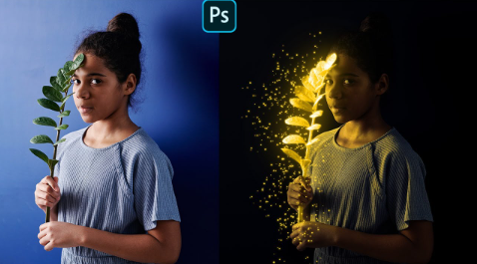

Composición lobo gigante

<https://www.youtube.com/watch?v=6mm28NAxaXA&ab_channel=MDMZ>

