Relatório Completo Bibliometrix (Todas as Abas)

Este documento contém a transcrição completa de tabelas e a visualização gráfica de todos os dados fornecidos nos arquivos originais.

Seção: MainInfo

Description | Results
MAIN INFORMATION ABOUT DATA | nan
Timespan | 2021:2026
Sources (Journals, Books, etc) | 998
Documents | 2416
Annual Growth Rate % | 293.21
Document Average Age | 0.723
Average citations per doc | 4.969
References | 93520
DOCUMENT CONTENTS | nan
Keywords Plus (ID) | 10302
Author's Keywords (DE) | 5890
AUTHORS | nan
Authors | 7933
Authors of single-authored docs | 85
AUTHORS COLLABORATION | nan
Single-authored docs | 93
Co-Authors per Doc | 5.24
International co-authorships % | 22.06
DOCUMENT TYPES | nan
article | 2395
article; book chapter | 1
article; early access | 19
article; retracted publication | 1

Seção: AnnualSciProd
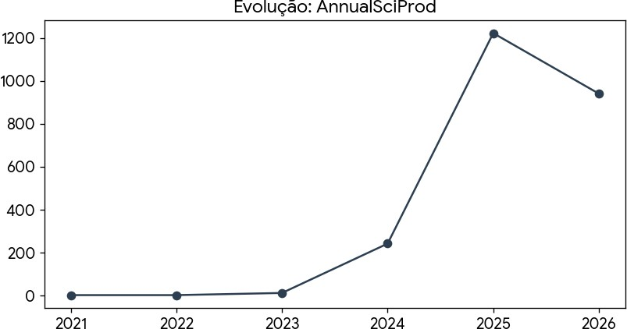

Year | Articles
2021 | 1
2022 | 1
2023 | 11
2024 | 241
2025 | 1222
2026 | 940

Seção: MostRelSources
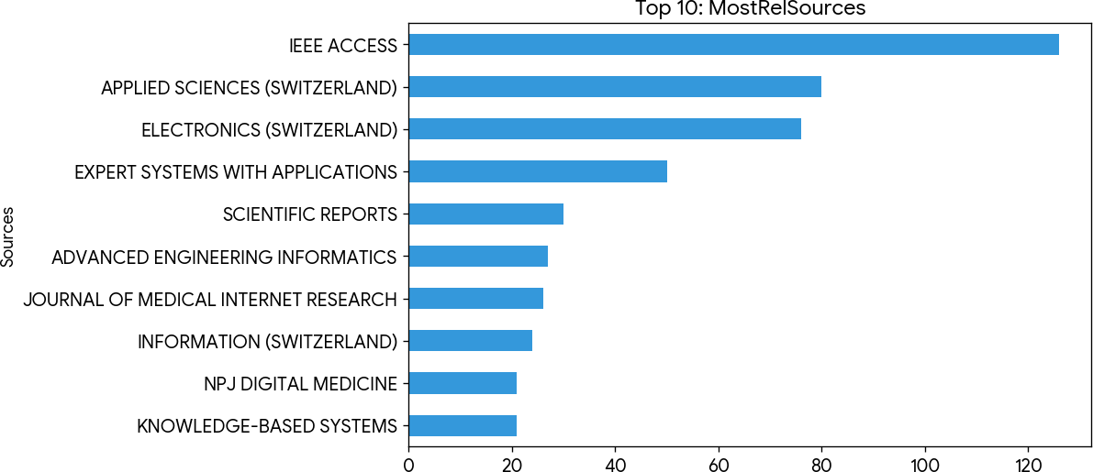

Sources | Articles
IEEE ACCESS | 126
APPLIED SCIENCES (SWITZERLAND) | 80
ELECTRONICS (SWITZERLAND) | 76
EXPERT SYSTEMS WITH APPLICATIONS | 50
SCIENTIFIC REPORTS | 30
ADVANCED ENGINEERING INFORMATICS | 27
JOURNAL OF MEDICAL INTERNET RESEARCH | 26
INFORMATION (SWITZERLAND) | 24
KNOWLEDGE-BASED SYSTEMS | 21
NPJ DIGITAL MEDICINE | 21
INFORMATION PROCESSING AND MANAGEMENT | 20
INTERNATIONAL JOURNAL OF ADVANCED COMPUTER SCIENCE AND APPLICATIONS | 20
AUTOMATION IN CONSTRUCTION | 17
PROCEEDINGS OF THE VLDB ENDOWMENT | 17
JOURNAL OF THE AMERICAN MEDICAL INFORMATICS ASSOCIATION | 16
NEUROCOMPUTING | 16
SENSORS | 15
FRONTIERS IN ARTIFICIAL INTELLIGENCE | 14
AMIA ... ANNUAL SYMPOSIUM PROCEEDINGS. AMIA SYMPOSIUM | 13
BIG DATA AND COGNITIVE COMPUTING | 13
ENGINEERING APPLICATIONS OF ARTIFICIAL INTELLIGENCE | 13
JOURNAL OF MANUFACTURING SYSTEMS | 12
COMPUTERS | 11
AI (SWITZERLAND) | 10
BIOINFORMATICS | 10

* Exibindo as primeiras 25 de 998 linhas.

Seção: MostRelAuthors
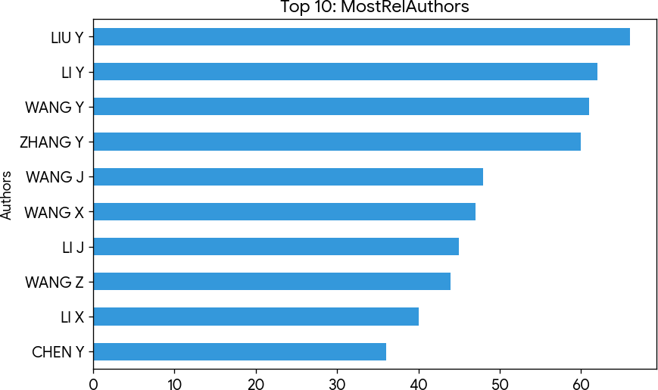

Authors | Articles | Articles Fractionalized
LIU Y | 66 | 10.5099317349317
LI Y | 62 | 10.0475972413043
WANG Y | 61 | 9.63169996669997
ZHANG Y | 60 | 10.6921934060092
WANG J | 48 | 8.32737529927932
WANG X | 47 | 7.69350181981761
LI J | 45 | 7.75258026997157
WANG Z | 44 | 8.65253357753358
LI X | 40 | 6.38324175824176
CHEN Y | 36 | 6.08226218226218
WANG H | 36 | 5.95468410158813
LI Z | 35 | 5.77959492198623
ZHANG X | 34 | 5.68257575757576
WANG S | 33 | 6.454773004773
ZHANG H | 33 | 5.8245781995782
WANG L | 32 | 5.8910135186451
ZHAO Y | 30 | 5.99920634920635
CHEN Z | 28 | 5.15156232656233
LIU J | 28 | 5.42186147186147
LIU X | 27 | 4.94716117216117
LIU Z | 27 | 4.69051226551227
ZHANG L | 26 | 5.50678210678211
WANG W | 25 | 4.13529248529249
LI H | 24 | 3.825
LIU H | 24 | 4.2047619047619

* Exibindo as primeiras 25 de 7934 linhas.

Seção: MostRelAffiliations
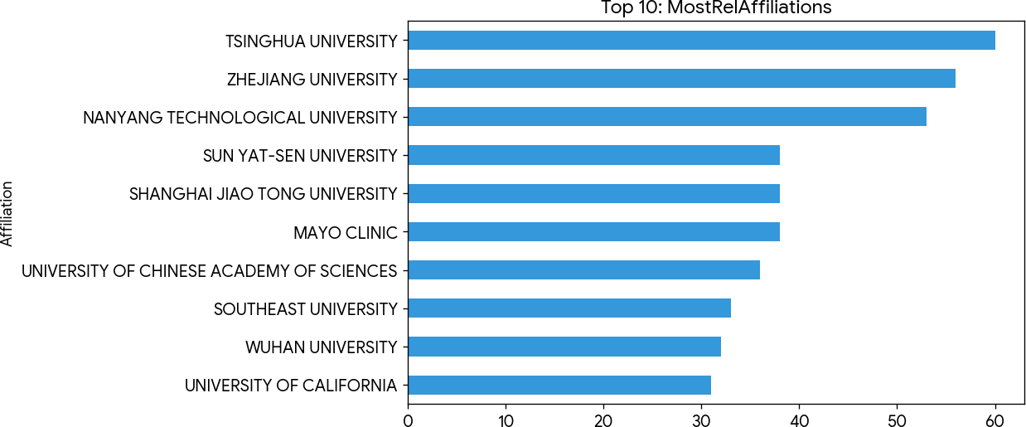

Affiliation | Articles
TSINGHUA UNIVERSITY | 60
ZHEJIANG UNIVERSITY | 56
NANYANG TECHNOLOGICAL UNIVERSITY | 53
MAYO CLINIC | 38
SHANGHAI JIAO TONG UNIVERSITY | 38
SUN YAT-SEN UNIVERSITY | 38
UNIVERSITY OF CHINESE ACADEMY OF SCIENCES | 36
SOUTHEAST UNIVERSITY | 33
WUHAN UNIVERSITY | 32
UNIVERSITY OF CALIFORNIA | 31
NATIONAL UNIVERSITY OF SINGAPORE | 29
SICHUAN UNIVERSITY | 28
TONGJI UNIVERSITY | 28
BEIHANG UNIVERSITY | 27
HUAZHONG UNIVERSITY OF SCIENCE AND TECHNOLOGY | 26
UNIVERSITY OF MINNESOTA | 25
FUDAN UNIVERSITY | 23
NANJING UNIVERSITY | 23
STANFORD UNIVERSITY | 23
SINGAPORE GENERAL HOSPITAL | 22
YALE UNIVERSITY | 22
GUANGDONG UNIVERSITY OF TECHNOLOGY | 21
INSTITUTE OF AUTOMATION | 20
UNIVERSITY OF CAMBRIDGE | 20
PEKING UNIVERSITY | 19

* Exibindo as primeiras 25 de 2924 linhas.

Seção: CountrySciProd
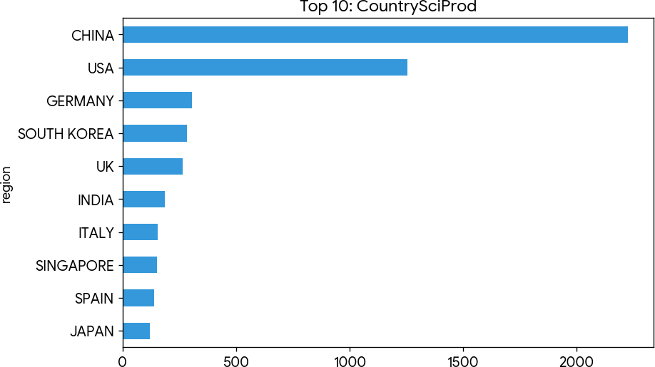

region | Freq
CHINA | 2228
USA | 1254
GERMANY | 306
SOUTH KOREA | 282
UK | 264
INDIA | 187
ITALY | 154
SINGAPORE | 150
SPAIN | 139
JAPAN | 120
CANADA | 108
AUSTRALIA | 106
TURKEY | 59
SAUDI ARABIA | 52
FRANCE | 46
BRAZIL | 42
SWITZERLAND | 41
GREECE | 37
POLAND | 35
INDONESIA | 31
ISRAEL | 31
UNITED ARAB EMIRATES | 31
HUNGARY | 29
MOROCCO | 29
PAKISTAN | 29

* Exibindo as primeiras 25 de 84 linhas.

Seção: CountryProdOverTime
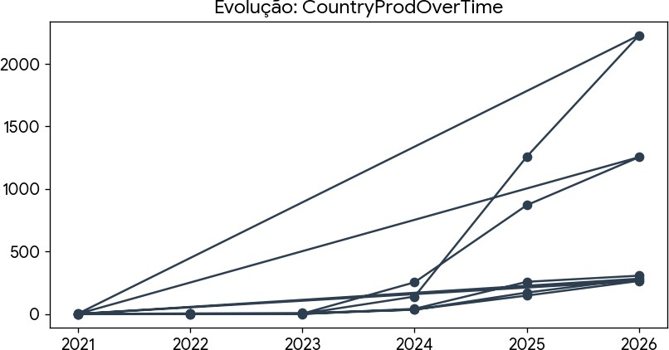

Country | Year | Articles
CHINA | 2021 | 1
CHINA | 2022 | 1
CHINA | 2023 | 1
CHINA | 2024 | 139
CHINA | 2025 | 1258
CHINA | 2026 | 2228
UNITED KINGDOM | 2021 | 1
UNITED KINGDOM | 2022 | 1
UNITED KINGDOM | 2023 | 1
UNITED KINGDOM | 2024 | 35
UNITED KINGDOM | 2025 | 147
UNITED KINGDOM | 2026 | 264
KOREA | 2021 | 0
KOREA | 2022 | 4
KOREA | 2023 | 7
KOREA | 2024 | 34
KOREA | 2025 | 171
KOREA | 2026 | 282
USA | 2021 | 0
USA | 2022 | 0
USA | 2023 | 2
USA | 2024 | 253
USA | 2025 | 870
USA | 2026 | 1254
GERMANY | 2021 | 0

* Exibindo as primeiras 25 de 30 linhas.

Seção: MostCitCountries
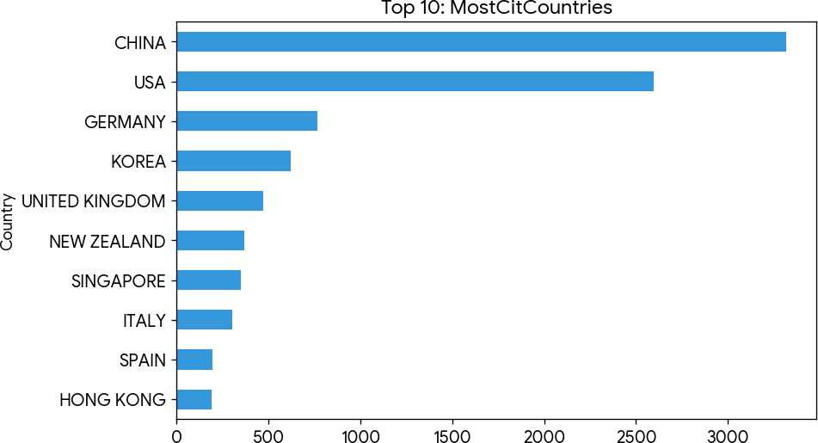

Country | TC | Average Article Citations
CHINA | 3315 | 4.1
USA | 2597 | 7.8
GERMANY | 766 | 7.9
KOREA | 624 | 4.8
UNITED KINGDOM | 471 | 6.6
NEW ZEALAND | 369 | 61.5
SINGAPORE | 351 | 10.3
ITALY | 305 | 5.5
SPAIN | 198 | 5.0
HONG KONG | 193 | 6.4
MEXICO | 181 | 20.1
AUSTRALIA | 163 | 5.8
INDIA | 143 | 1.6
JAPAN | 138 | 3.7
TURKEY | 127 | 4.0
CANADA | 126 | 2.9
NORWAY | 72 | 10.3
SWITZERLAND | 58 | 3.1
UNITED ARAB EMIRATES | 57 | 6.3
GREECE | 54 | 3.6
SAUDI ARABIA | 45 | 2.1
KAZAKHSTAN | 43 | 7.2
NETHERLANDS | 39 | 4.9
SLOVAKIA | 37 | 12.3
IRELAND | 35 | 2.9

* Exibindo as primeiras 25 de 80 linhas.

Seção: MostLocCitAuthors
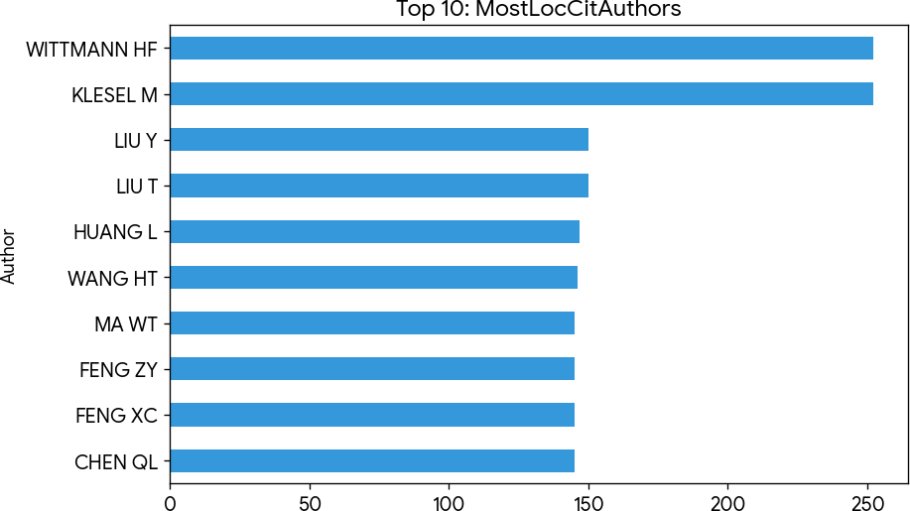

Author | LocalCitations
KLESEL M | 252
WITTMANN HF | 252
LIU T | 150
LIU Y | 150
HUANG L | 147
WANG HT | 146
CHEN QL | 145
FENG XC | 145
FENG ZY | 145
MA WT | 145
PENG WH | 145
QIN B | 145
YU WJ | 145
ZHONG WH | 145
GAMS M | 83
HORVAT T | 83
MISHEV K | 83
MISHEVA MS | 83
DOBREVA J | 81
IVANISEVIC F | 81
KARASMANAKIS I | 81
KITANOVSKI D | 81
ZHANG Y | 79
DALMEDIGOS I | 74
LEVINE Y | 74

* Exibindo as primeiras 25 de 7933 linhas.

Seção: TreeMap
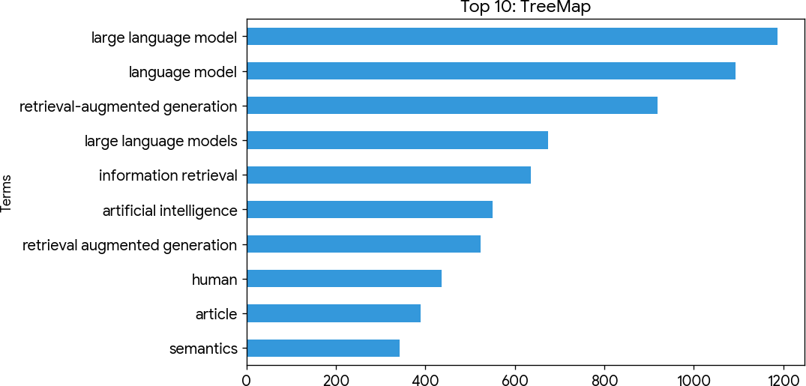

Terms | Frequency
large language model | 1188
language model | 1094
retrieval-augmented generation | 919
large language models | 675
information retrieval | 635
artificial intelligence | 551
retrieval augmented generation | 524
human | 437
article | 390
semantics | 343
humans | 266
retrieval-augmented generation (rag) | 246
knowledge graph | 241
search engines | 238
computational linguistics | 224
natural language processing | 221
natural language processing systems | 221
knowledge graphs | 205
learning systems | 198
question answering | 187
knowledge management | 176
procedures | 174
benchmarking | 157
decision making | 150
large language models (llms) | 150

* Exibindo as primeiras 25 de 50 linhas.

