Gatchalian Paulo Valentin

**Well Formed Formulas**

**P- Cheese Burger Deluxe**

**Q- Additional Fries**

**R- Drinks**

**S- Sundae**

**P⇾(Q ∧ R)) ∧ (P⇾S (**¬Q**∧**¬R))

Flow Chart

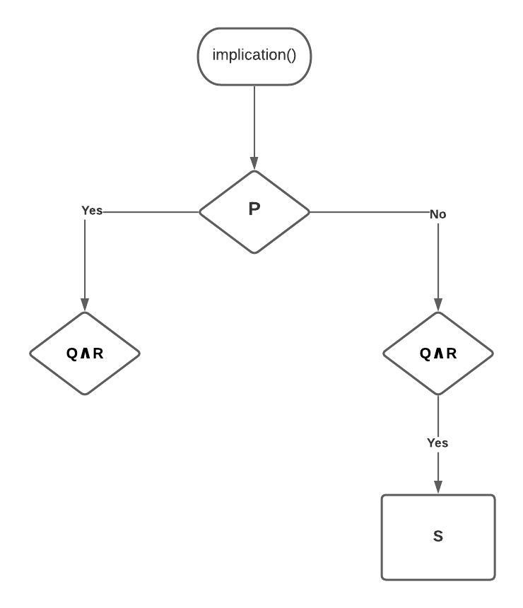

**Code:**

