- Advertising iD instructions is wrong. Change to select Settings, select Privacy and Security , select Recommendations and offers, Find Advertising ID - Let apps show me personalized ads by using my advertising ID. The toggle should be Off. If it is On, click it to turn it Off. Fix both turn it on and turn it off.
- Also throughout the .htmls there is a whole lot of different phrasing used in the Action taken item. Review my comments below and all the action taken items wording and give me options of one phrasing to uss with them all.
- Change this everywhere What Checkup found and did to “ What Checkup found and we recommend you do” or somesuch wording.
- Bitlocker instructions are wrong. Home : type encryption, seleect encryption settings, if it is off turn it on. Pro: type windows, open windows security, in the left-hand panel select device security, select manage bitlocker drive encryption, if it is on then there is nothing to do. If it is off turn it on. And establish a bitlocker backup plan in the eventuality that you need to use your bitlocker key (write them one for both home and pro) I will need to unencrypt cgdell and go through the whole process at some point soon.
- Real-time Defender – OK, but we should add the other two settings cloud and auto sample to our list of settings in checkup or at least explain them and request they appove them as well and then turn them on if off. We need to discuss. Tamper Protection is there in the same list and should be turned on if it is off, and we already have it listed in settings screen. Lets discuss
- Diagnostic Data – rewrite to “With your approval, Checkup will set Diagnostic data to Required diagnostic data. This type of wording should appear throughout all the website .htmls. Check all ,htmls and change wording to what is in the quotes. Same goes for wording in checkup and the guide.
- Startup Boost – Instructions are wrong. Home: I had to select Startup Boost first and then I could see the two settings. Pro: I had to first scroll down or use my down arrows key or page down key to get to settings, then select manage account and then select hardware acceleration and then I could see the two settings.
- Aside: Everywhere we tell them to check settings tell them to first scroll down or use down arrow key or page down key to get to settings,
- Fast Startup – Change to this wording “Under Shutdown settings, If checked, remove the checkmark from Turn on fast startup (recommended).
- Firewall & Network Protection – the first screen shows all three on or off. You only need to click one if it is off to change it to on. What about checking advanced settings, especially inbound settins
- Memory Integrity – change wording to “Look at the Memory integrity setting, if it is off, turn it on an then restart your PC when Windows asks. What happens in Checkoff? Tell them.
- Edge Passwords Saving – ok
- Aside write a pitch on every screen that quite an effort and testing went into making these free instructions, a donation would be appreciated as well as letting your friends and acquaintances know about our website gatewayguard.co NOT .com) or some such wording.
- Periodic Scanning – defender is running on sandy and cgdell and sandy3. Confirm these instructions with experts and forums and Microsoft support,
- Phishing – Change wording to “With your approval Checkup will flag them and offer to turn them on.” What is our position on the 4th item. See image and rewrite this.
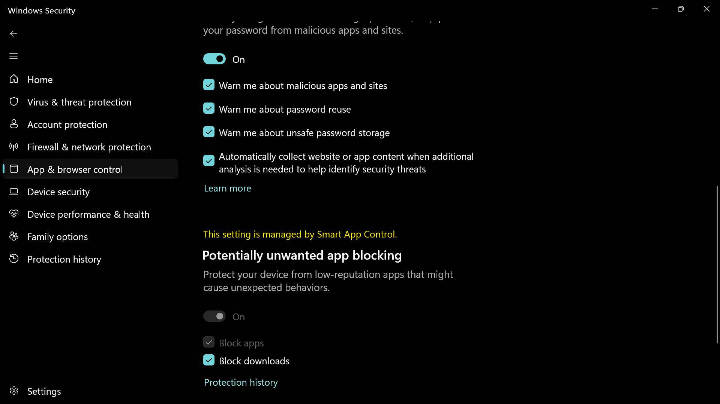
- Remote Desktoo Connection – Home & Pro: when you open it a screen pops up nowhere to turnit off I had to select options on the first screen to get the second screen to appear. Rewrite and discuss with me. See below: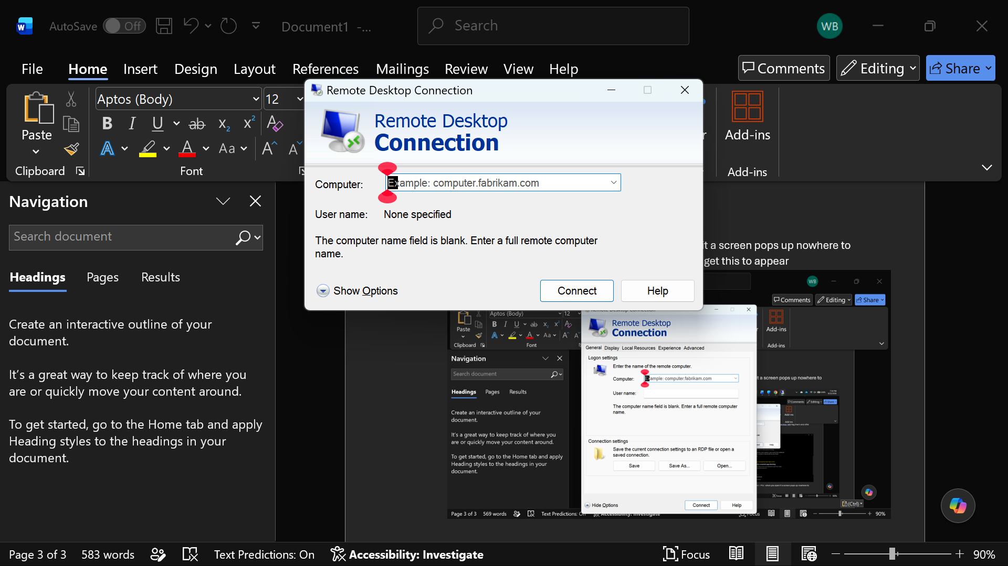 r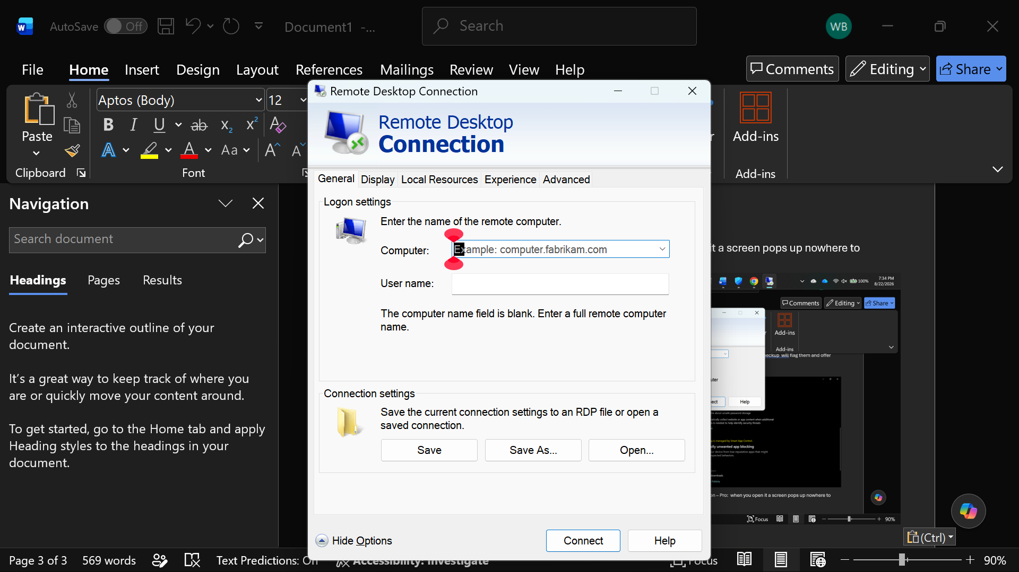
- Smartscreen – Insttruction is good but rewrite checkup action. This question applies to all the ,htmls. Are we making all these changes we are recommending on the website in Checkup?
- Tamper Protection – change action to “If Tamper Protection was off, Checkup flagged it and with your approval will offer to turn it on, No mention of the offline scan which we can tell them Checkup does autormatically.
- Aside: Write something about how Checkup will automate and step you through manual instructions where necessary. This will save you some time and do some of the tasks for you. Reword into something that will strike a sn understanding in seniors. Also mention how there are other setting we will be reviewing and including in our Checkup and Security Guide.
- Wake on Lan – Sandy had 3 a realteck controller, a realteck adaptor which was disabled and a wife usb. You couldn’t check the realteck adaptor as it was disabled. This may leave a security hole if it is a working adaptor and they enable it in the future. On cgdell and sandy there is also a number of wan miniports, none of which have a power management section. On cgdell no power management section, you have to go to advanced see two images of all the possible settings lets review this together when you get to this part. Ask questions.: 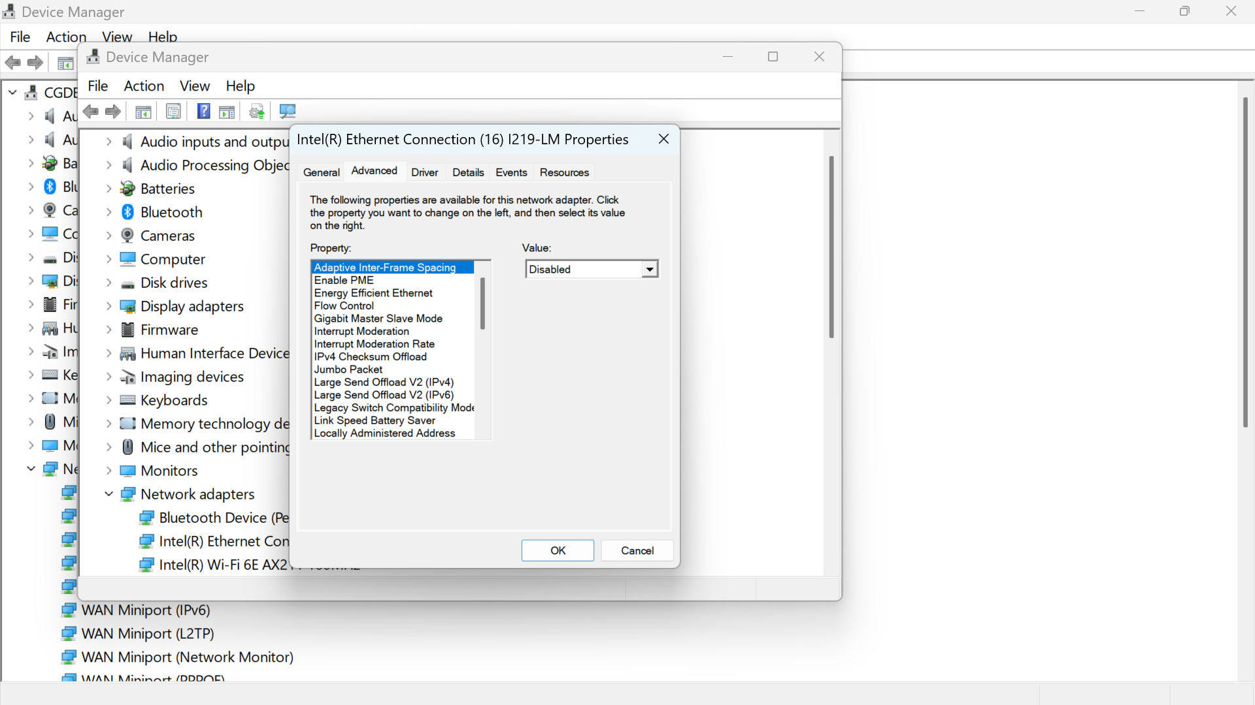
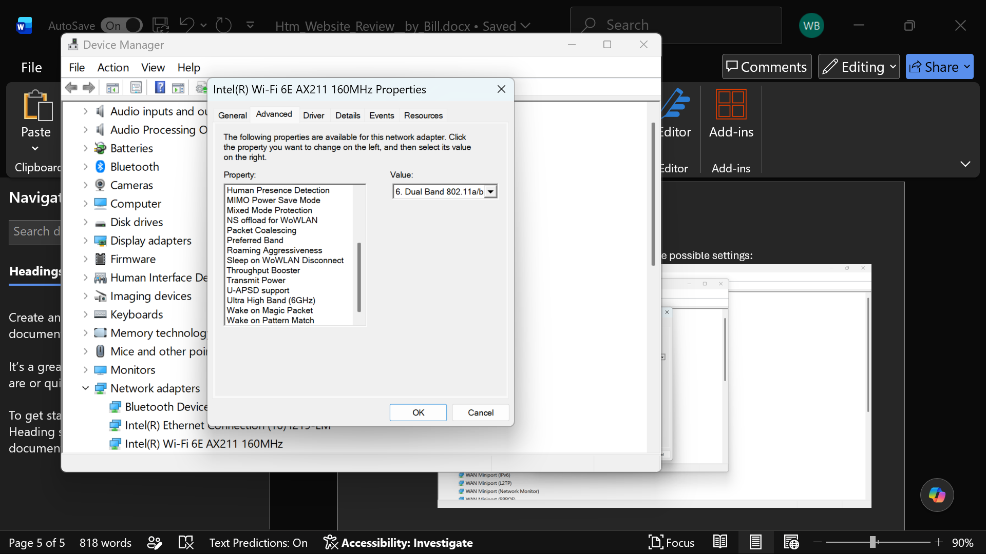
- Widgets – We need to research with experts, forums and MS support, what people use it for and what capabilities are going to be lost and explain that. Discuss with me. Rewrite Action item with whatever phrase we settle on.
- Windows hello – Sandy it says this option is currently not available – I am on a local account with admin rights and have to enter a pin. We need to take this into consideration if a user runs into this situation. Upfront do we tell them to sign on to or create an MS account? On CGDell My windows hello after bootup was turned off but I still had to enter my pin after hibernate. Sleep is set to never so it won’t sleep even if you select sleep instead of hibernate.
- Windows Update – CGDell said windows update settings and it took me to windows update which said resume updates because I had them paused until 2026-09-06. We need to rewrite to take different circumstances into consideration. Sandy also paused to that date. Does Checkup check for the 3 items in Advanced options and do we tell them about it in Checkup. If not can we check on them and turn them on.
- Aside are you aware of the MS word accessibility assistant to help readers. If not research it and make sure all of our public documents adhere to it, if we can. Make this a rule.

