FLOWCHART

Encryption Or No?

End

Share Message

Text Input

Start

Algorithm

Encryption

Yes

No

DATA FLOW DIAGRAM

Stored validation hash

Hashing Algorithm

Encryption Algorithm

Decrypted Data

Encryption Algorithm

Encrypted Data

Test for Match

Generated Encryption Key

Generated Encryption Key

Hashing Algorithm

Passcode

If the test succeeds, decryption may proceed. V If the test fails, stop processing

User edits data

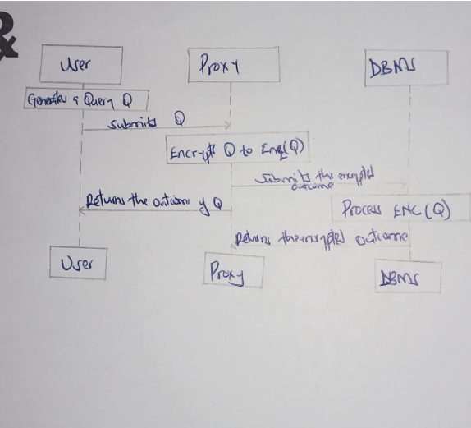SEQUENCE DIAGRAM