REPORT
Hospital Characteristics | 2011 |  |  | 2012 |  |  | P-Value
Hospital Characteristics | N | Mean | St. Dev | N | Mean | St. Dev | P-Value
1. Hospital beds | 566796.0000 | 376.6086 | 560.8998 | 574620.0000 | 376.8000 | 579.8366
2. Number of paid Employee  e | 1853439.150 | 1237.276 | 1615.797 | 2259049.058 | 1491.121 | 1961.637
3. Number of non-paid  Employee | 1199.19000 | 39.97300 | 72.58805 | 1343.09280 | 44.76976 | 81.29861
4. Total hospital cost | 326394348921 | 216873322 | 304570722 | 327490734909 | 214748023 | 294143536
5. Total hospital revenues | 344203010115 | 228706319 | 323339811 | 350717045576 | 229978391 | 321273114
6. Available Medicare days | 25092003.00 | 16739.16 | 19214.29 | 25938976.38 | 17110.14 | 19765.74
7. Available Medicaid days | 7866979.000 | 5301.199 | 9207.699 | 8054865.540 | 5366.333 | 9340.373
8. Total Hospital Discharge | 14238489.000 | 9492.326 | 10898.600 | 14478325.000 | 9544.051 | 10994.170
9. Medicare discharg | 14238489.000 | 9492.326 | 10898.600 | 14478325.000 | 9544.051 | 10994.170
10. Medicaid discharge | 1674607.000 | 1130.727 | 1757.158 | 1677082.000 | 1119.547 | 1740.423

Summary Statistics
In the year 2012, the company had a better performance since the expectation of the revenue on the year 2011 was 228706319 compares to 229978391 for year 2012.

 | year | sd_hospital_beds | sd_paid_employees | sd_non_paid_employees | sd_total_cost | sd_total_revenues | sd_medicare_days | sd_medicaid_days | sd_total_discharge | sd_medicare_discharge | sd_medicaid_discharge
Sd | 2011 | 560.8998 | 1615.797 | 72.58805 | 304570722 | 323339811 | 19214.29 | 9207.699 | 10898.600 | 10898.600 | 1757.158
Sd1 | 2012 | 579.8366 | 1961.637 | 81.29861 | 294143536 | 321273114 | 19765.74 | 9340.373 | 10994.170 | 10994.170 | 1740.423
n1 | 2011 | 566796.0000 | 1853439.150 | 1199.19000 | 326394348921 | 344203010115 | 25092003.00 | 7866979.000 | 14238489.000 | 14238489.000 | 1674607.000
n2 | 2012 | 574620.0000 | 2259049.058 | 1343.09280 | 327490734909 | 350717045576 | 25938976.38 | 8054865.540 | 14478325.000 | 14478325.000 | 1677082.000
mean1 | 2011 | 376.6086 | 1237.276 | 39.97300 | 216873322 | 228706319 | 16739.16 | 5301.199 | 9492.326 | 9492.326 | 1130.727
mean2 | 2012 | 376.8000 | 1491.121 | 44.76976 | 214748023 | 229978391 | 17110.14 | 5366.333 | 9544.051 | 9544.051 | 1119.547

year | sd_hospital_beds | sd_paid_employees | sd_non_paid_employees | sd_total_cost | sd_total_revenues | sd_medicare_days | sd_medicaid_days | sd_total_discharge | sd_medicare_discharge | sd_medicaid_discharge
2011 | 560.8998 | 1615.797 | 72.58805 | 304570722 | 323339811 | 19214.29 | 9207.699 | 10898.600 | 10898.600 | 1757.158
2012 | 579.8366 | 1961.637 | 81.29861 | 294143536 | 321273114 | 19765.74 | 9340.373 | 10994.170 | 10994.170 | 1740.423
2011 | 566796.0000 | 1853439.150 | 1199.19000 | 326394348921 | 344203010115 | 25092003.00 | 7866979.000 | 14238489.000 | 14238489.000 | 1674607.000
2012 | 574620.0000 | 2259049.058 | 1343.09280 | 327490734909 | 350717045576 | 25938976.38 | 8054865.540 | 14478325.000 | 14478325.000 | 1677082.000
2011 | 376.6086 | 1237.276 | 39.97300 | 216873322 | 228706319 | 16739.16 | 5301.199 | 9492.326 | 9492.326 | 1130.727
2012 | 376.8000 | 1491.121 | 44.76976 | 214748023 | 229978391 | 17110.14 | 5366.333 | 9544.051 | 9544.051 | 1119.547

Exercise 2
Performing t.test of exercise 1
Statistic | P_Value
hospital_beds | 0.0000
total_hospital_employees_on_payr | 0.0000
total_hospital_non_paid_workers | 0.1409
total_hosp_cost | 0.0000
total_hosp_revenue | 0.0000
total_hospital_medicare_days | 0.0000
total_hospital_medicaid_days | 0.0000
total_hospital_discharges | 0.0000
total_hospital_medicare_discharg | 0.0000
total_hospital_medicaid_discharg | 0.0000
Comparing hospital net-benefit which hospitals has better performance? To answer this question first compute the hospital net benefits with subtracting hospital costs and revenues and then use ttest to compare the significant differences between teaching and non-teaching hospitals.
var.test to know if the varianccce is equal.
##
## F test to compare two variances
##
## data: net_benefits by teaching_hospital
## F = 0.34347, num df = 2093, denom df = 935, p-value < 2.2e-16
## alternative hypothesis: true ratio of variances is not equal to 1
## 95 percent confidence interval:
## 0.3076147 0.3826102
## sample estimates:
## ratio of variances
## 0.3434651
##
## Welch Two Sample t-test
##
## data: net_benefits by teaching_hospital
## t = 8.6723, df = 1231.2, p-value < 2.2e-16
## alternative hypothesis: true difference in means between group 0 and group 1 is not equal to 0
## 95 percent confidence interval:
## 12292896 19480912
## sample estimates:
## mean in group 0 mean in group 1
## -8635257 -24522161
Use a box-plot and compare hospitals-cost and hospital-revenues between teaching and non-teaching hospitals. 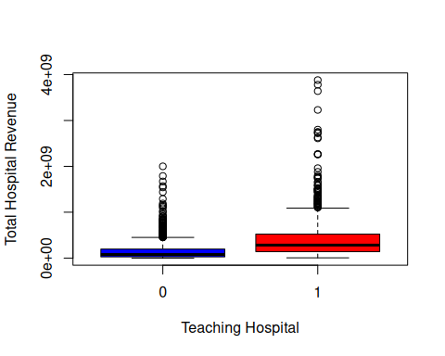

Exercise 3

herf_cat | Mean_hospital_beds | Mean_paid_employees | Mean_non_paid_employees | Mean_internes_residents | Mean_system_membership | Mean_total_hosp_cost | Mean_total_revenues | Mean_net_benefit | Mean_medicare_days | Mean_medicaid_days | Mean_total_discharge | Mean_medicare_discharge | Mean_medicaid_discharge | Mean_hhi
High | 373.6403 | 1308.9686 | 47.00928 | 86.55375 | 0.6315078 | 201077823 | 214430928 | -214430928 | 16792.697 | 4812.455 | 9120.806 | 3435.407 | 1066.6464 | 1.697769
Low | 130.9178 | 499.8935 | NaN | 38.32182 | 0.4246575 | 73687086 | 77700145 | -77700145 | 5377.214 | 1416.413 | 2607.836 | 1067.938 | 309.8802 | 1.963470
Moderate | 420.5188 | 1570.1115 | 35.87832 | 112.20558 | 0.6073574 | 255520655 | 270841127 | -270841127 | 18983.776 | 6553.995 | 11100.959 | 3781.610 | 1324.1560 | 1.668919

One way Anova test
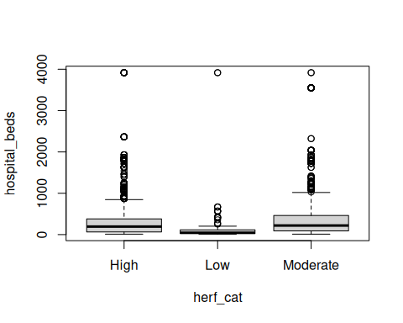
p_value_hospital_beds | p_value_paid_employees | p_value_non_paid_employees | p_value_internes_residents | p_value_system_membership | p_value_total_hosp_cost | p_value_total_revenues | p_value_medicare_days | p_value_medicaid_days | p_value_total_discharge | p_value_medicare_discharge | p_value_medicaid_discharge | p_value_hhi
0 | 0 | 0.5284202 | 9e-07 | 0 | 0 | 0 | 0 | 0 | 0 | 0 | 0 | 0

Density Curves
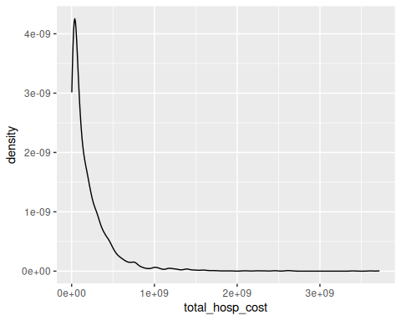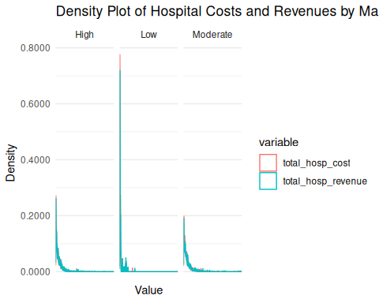

Linear Regression
##
## Call:
## lm(formula = net_benefits ~ total_hospital_beds + own, data = hospital)
##
## Residuals:
## Min 1Q Median 3Q Max
## -654363322 -3961986 1635010 9567832 572394334
##
## Coefficients:
## Estimate Std. Error t value Pr(>|t|)
## (Intercept) -906253 1146471 -0.790 0.429
## total_hospital_beds -73150 3220 -22.720 <2e-16 ***
## own1 2409879 1837706 1.311 0.190
## own2 3420199 2189969 1.562 0.118
## own3 2224995 1661067 1.339 0.181
## ---
## Signif. codes: 0 '***' 0.001 '**' 0.01 '*' 0.05 '.' 0.1 ' ' 1
##
## Residual standard error: 36300000 on 3010 degrees of freedom
## (15 observations deleted due to missingness)
## Multiple R-squared: 0.1474, Adjusted R-squared: 0.1463
## F-statistic: 130.1 on 4 and 3010 DF, p-value: < 2.2e-16
##
## Call:
## lm(formula = net_benefits ~ total_hospital_beds + own + system_member,
## data = hospital)
##
## Residuals:
## Min 1Q Median 3Q Max
## -654571181 -4329015 1786854 9697784 573220978
##
## Coefficients:
## Estimate Std. Error t value Pr(>|t|)
## (Intercept) 1939586 1371589 1.414 0.157431
## total_hospital_beds -71276 3251 -21.924 < 2e-16 ***
## own1 2172134 1834796 1.184 0.236564
## own2 3521355 2185368 1.611 0.107212
## own3 2000968 1658522 1.206 0.227728
## system_member1 -5145510 1368152 -3.761 0.000173 ***
## ---
## Signif. codes: 0 '***' 0.001 '**' 0.01 '*' 0.05 '.' 0.1 ' ' 1
##
## Residual standard error: 36220000 on 3009 degrees of freedom
## (15 observations deleted due to missingness)
## Multiple R-squared: 0.1514, Adjusted R-squared: 0.15
## F-statistic: 107.4 on 5 and 3009 DF, p-value: < 2.2e-16
##
## Call:
## lm(formula = lm(net_benefits ~ total_hospital_beds + own + system_member +
## medicare_dratio + medicaid_dratio, data = hospital))
##
## Residuals:
## Min 1Q Median 3Q Max
## -654404007 -4428627 1789724 9810925 573249954
##
## Coefficients:
## Estimate Std. Error t value Pr(>|t|)
## (Intercept) 1949233 3414651 0.571 0.568149
## total_hospital_beds -71355 3661 -19.491 < 2e-16 ***
## own1 2156294 1859286 1.160 0.246247
## own2 3545406 2209990 1.604 0.108762
## own3 1998577 1719083 1.163 0.245092
## system_member1 -5247414 1392923 -3.767 0.000168 ***
## medicare_dratio 305422 5298689 0.058 0.954038
## medicaid_dratio -300477 7626550 -0.039 0.968575
## ---
## Signif. codes: 0 '***' 0.001 '**' 0.01 '*' 0.05 '.' 0.1 ' ' 1
##
## Residual standard error: 36450000 on 2967 degrees of freedom
## (55 observations deleted due to missingness)
## Multiple R-squared: 0.1511, Adjusted R-squared: 0.1491
## F-statistic: 75.46 on 7 and 2967 DF, p-value: < 2.2e-16

