SQL DB ASSIGNMENT

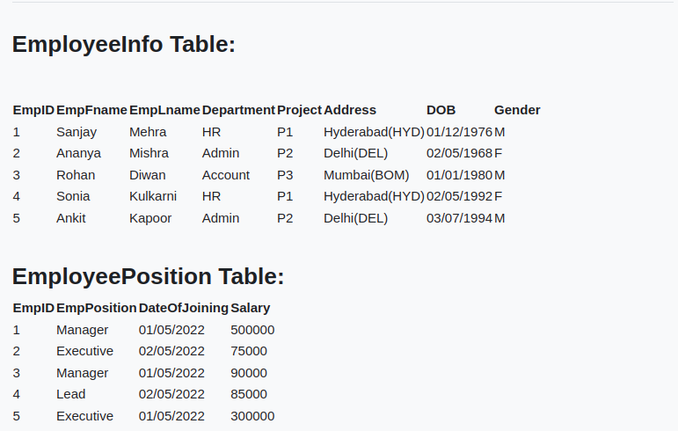

Before creating database:

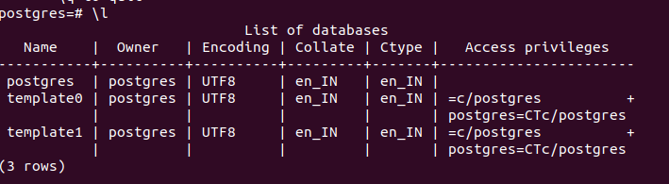
After creating database:

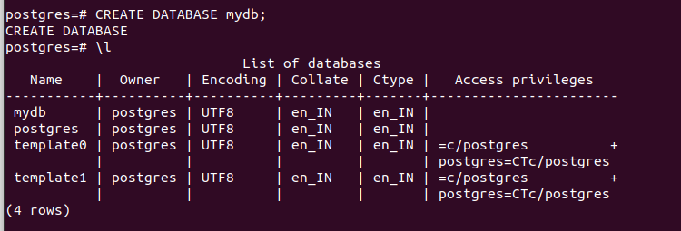

Create Table in database:

Employee_Info Table:

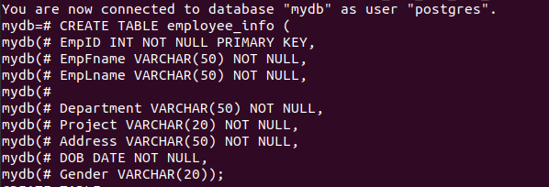

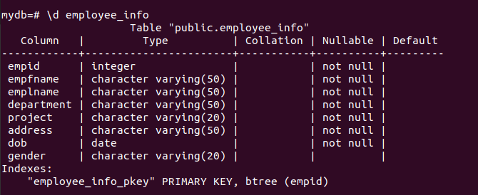

Insert data in Employee_Info Table :

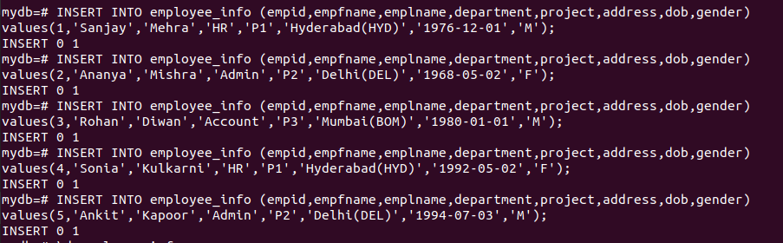
Display data of Employee_Info Table

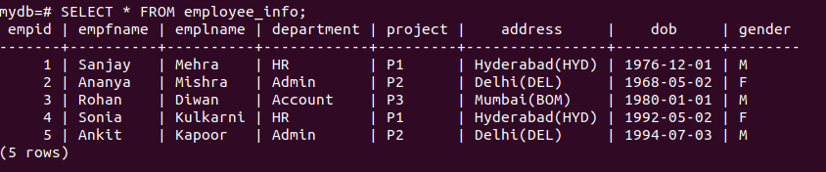
Create Employee_Position Table:

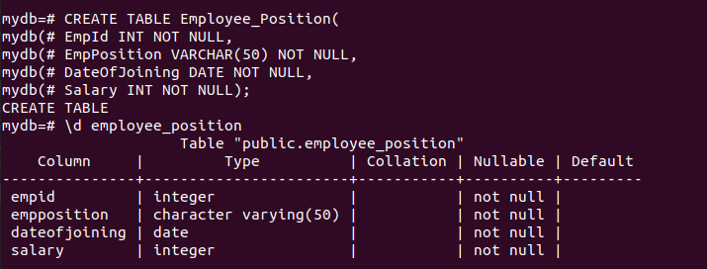
Add foreign key constraint

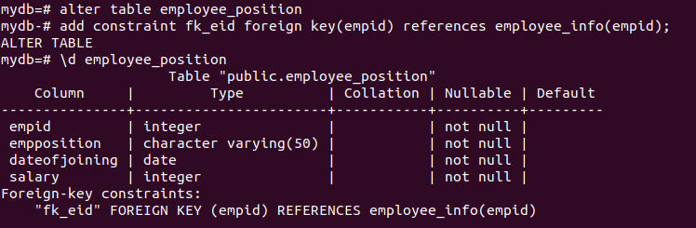

Insert data into Employee_Position Table:

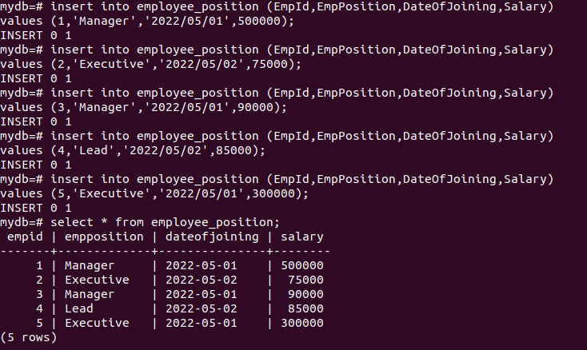

Queries:

1. Write a query to fetch the number of employees working in the department ‘Admin’
select count(*) as employee_count from employee_info where department = 'Admin';
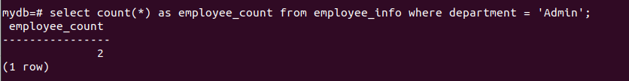
2. Write a query to retrieve the first four characters of EmpLname from the EmployeeInfo table.
select substring(emplname , 1,4) from employee_info;
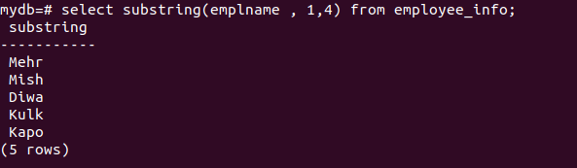
3. Write q query to find all the employees whose salary is between 50000 to 100000.
select e.empfname,e.emplname,p.salary from employee_info e inner join employee_position p on e.empid = p.empid and p.salary between 50000 and 100000;
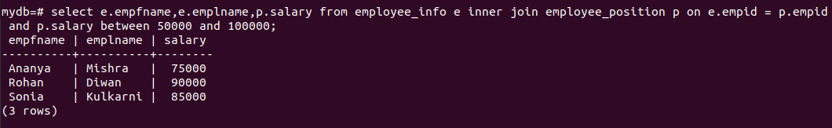
4. Write a query to find the names of employees that begin with ‘S’
select emplname,empfname from employee_info where empfname like 'S%';
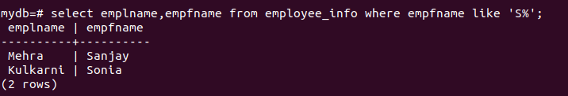
5. Write a query to fetch top N records order by salary. (ex. top 5 records)
select * from employee_position order by salary desc limit 5;
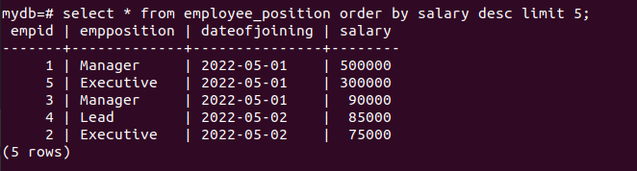
6. Write a query to fetch details of all employees excluding the employees with first names, “Sanjay” and “Sonia” from the EmployeeInfo table.

select * from employee_info where empfname not in ('Sanjay','Sonia');
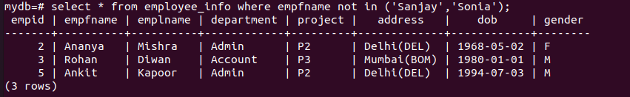
7. Write a query to fetch the department-wise count of employees sorted by department’s count in ascending order.
select count(*),department from employee_info group by department order by count(*) desc;
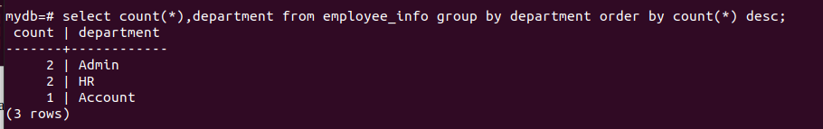
8. Create indexing for any particular field and show the difference in data fetching before and after indexing
before indexing:
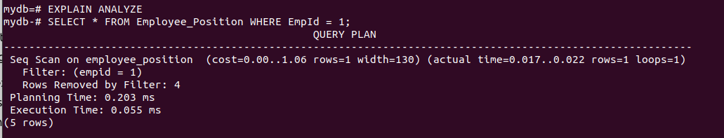
after indexing:

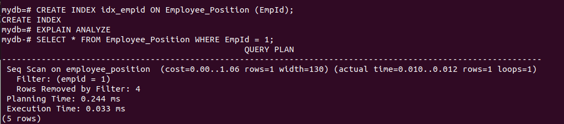

Pgadmin:

