https://medium.com/javarevisited/java-stream-api-with-examples-and-interview-questions-819024eb8bc8

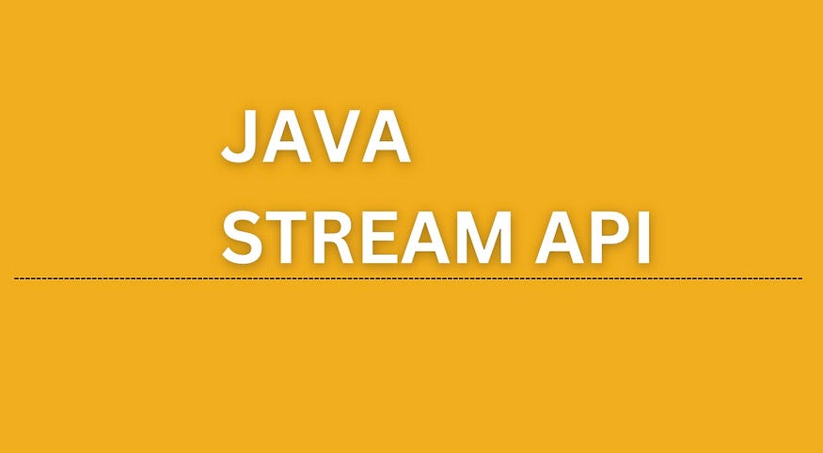
In today’s article let’s discuss one of the powerful tools provided by Java, Stream API.
What is Stream Api?
So it’s the sequence of objects that provides various methods to process our collections of objects.
Stream doesn’t change the original data structure it just processes the data based on the pipelined method.
What are the advantages of using stream API over the traditional way of processing data?
- Stream is more of a declarative style implementation.
- It reduces the complexity of code.
- Less mutability which is sort of related to the functional programming aspect
- It uses lambda expressions and functions and effectively applies it to the sequence of objects.
Stream Operations —
Map — The map method of the stream is used to return results by applying the specified method to each element of the stream, In simple words whatever operation you specify in the map method it will be applied to each element of the stream.
Filter: The filter element takes and predicate passed as an argument and selects the element which satisfies the condition of the predicate. we can use a filter to get only data for specific conditions from a set of data.
Sorted: The sorted method returns a stream consisting of the elements of this stream, sorted according to the natural order. We can use Java comparator to sort complex objects along with the sorted method of the stream.
Reduce: The reduce method is used to reduce the elements of a stream to a single value. The reduce method takes a BinaryOperator as a parameter.
forEach: The forEach method is used to iterate through every element of the stream.
collect: The collect method is used to return the result of the intermediate operations performed on the stream
Now we will be learning methods of stream API by using examples, we will use all the above-listed operations on stream to understand its function in a better way.
Let’s create one Employee class which have id, name and salary of the employees.
public class Employee {
int empId;
String empName;
long empSalary;
public Employee(int empId, String empName, long empSalary) {
this.empId = empId;
this.empName = empName;
this.empSalary = empSalary;
}
public int getEmpId() {
return empId;
}
public void setEmpId(int empId) {
this.empId = empId;
}
public String getEmpName() {
return empName;
}
public void setEmpName(String empName) {
this.empName = empName;
}
public long getEmpSalary() {
return empSalary;
}
public void setEmpSalary(long empSalary) {
this.empSalary = empSalary;
}
@Override
public String toString() {
return "Employee{" +
"empId=" + empId +
", empName='" + empName + '\'' +
", empSalary=" + empSalary +
'}';
}
}
Next, we will be creating an object and performing a few operations on this collections of data using stream API.
public class StreamExamples {
public static void main(String[] args) {
ArrayList<Employee> employees = new ArrayList<>();
employees.add(new Employee(1,"John",23000));
employees.add(new Employee(2,"Doug",190000));
employees.add(new Employee(3,"Jack",200000));
employees.add(new Employee(4,"Daisy",240000));
employees.add(new Employee(5,"William",220000));
}
}
Example 1: Print the employee data using the stream
employees.stream().forEach(employee -> System.out.println(employee));
/* Output
Employee{empId=1, empName='John', empSalary=230000}
Employee{empId=2, empName='Doug', empSalary=190000}
Employee{empId=3, empName='Jack', empSalary=200000}
Employee{empId=4, empName='Daisy', empSalary=240000}
Employee{empId=5, empName='William', empSalary=220000}*/
Example 2: Print the employee data by sorting employee salaries in descending order.
List<Employee> sortedDescOrder =
employees.stream().sorted((Comparator.comparingLong(Employee::getEmpSalary).reversed())).collect(Collectors.toList());
sortedDescOrder.forEach(employee -> System.out.println(employee));
/* Output
Employee{empId=4, empName='Daisy', empSalary=240000}
Employee{empId=1, empName='John', empSalary=230000}
Employee{empId=5, empName='William', empSalary=220000}
Employee{empId=3, empName='Jack', empSalary=200000}
Employee{empId=2, empName='Doug', empSalary=190000}*/
Example 3: Filter the employee names starting with ‘J’
employees.stream()
.filter(employee -> employee.getEmpName().startsWith("J"))
.collect(Collectors.toList())
.forEach(System.out::println);
/* Output ::
Employee{empId=1, empName='John', empSalary=230000}
Employee{empId=3, empName='Jack', empSalary=200000}*/
}
Example 4: Add 10000 to each employee’s salary and print
List<Long> salary =
employees.stream()
.map(employee -> employee.getEmpSalary() + 10000)
.collect(Collectors.toList());
salary.forEach(System.out::println);
/* Output ::
240000
200000
210000
250000
230000*/
Example 5: Return the employee object having max salary
Employee employee =
employees.stream()
.reduce(
(employee1, employee2) ->
employee1.getEmpSalary() > employee2.getEmpSalary() ? employee1 : employee2)
.get();
System.out.println("Employee having max salary us :: " + employee);
NOTE’S —
Reduce operation applies a binary operator to each element in the stream where the first argument to the operator is the return value of the previous application and the second argument is the current stream element.
Reduce method return type is optional as the result may or may not be empty.
In the above examples we have used statements something like System.out::println, here we are using the Java 8 method reference feature which allows us to reference a method without invoking it using (::) syntax.
More Questions -
What is flatmap ?
flatMap() is the combination of a map and a flat operation i.e., it first applies the map function and then flattens the result.
To understand the difference between a map and a flat map let's take an example -
List<List<Integer>> listofInts = Arrays.asList(Arrays.asList(1,2,3),Arrays.asList(4,5,6));
listofInts.stream().map(list -> list.stream()).collect(Collectors.toList());
System.out.println("Result of map() : " + listofInts);
List<Integer> flatMapResult = listofInts.stream().flatMap(list -> list.stream()).collect(Collectors.toList());
System.out.println("Result of flatMap() : " + flatMapResult);
/* Output
Result of map() : [[1, 2, 3], [4, 5, 6]]
Result of flatMap() : [1, 2, 3, 4, 5, 6]*/
What is findFirst() method of stream?
findFirst() will return the first result that matches the criteria from the given stream. In our above Employee example let’s find out the first employee which has name that starts with “J”
Employee firstEmployee = employees.stream()
.filter(emp -> emp.getEmpName().startsWith("J")).findFirst().get();
System.out.println("First result : " + firstEmployee);
/* Output
First result : Employee{empId=1, empName='John', empSalary=230000}
*/

