Statistical analysis.R

2024-04-16

# Load required libraries  
library(dplyr)

##   
## Attaching package: 'dplyr'

## The following objects are masked from 'package:stats':  
##   
## filter, lag

## The following objects are masked from 'package:base':  
##   
## intersect, setdiff, setequal, union

library(ggplot2)  
library(caret)

## Loading required package: lattice

library(randomForest)

## randomForest 4.7-1.1

## Type rfNews() to see new features/changes/bug fixes.

##   
## Attaching package: 'randomForest'

## The following object is masked from 'package:ggplot2':  
##   
## margin

## The following object is masked from 'package:dplyr':  
##   
## combine

# Read the data  
laptops_data <- read.csv("Laptop_Merged(cleaned).csv")  
  
# Summary statistics  
summary(laptops_data)

## u_id name offer_price original_price   
## Length:14040 Length:14040 Min. : 14890 Min. : 18890   
## Class :character Class :character 1st Qu.: 41900 1st Qu.: 59054   
## Mode :character Mode :character Median : 58990 Median : 76990   
## Mean : 74545 Mean : 95740   
## 3rd Qu.: 89890 3rd Qu.:112608   
## Max. :481990 Max. :481990   
## off_now total_ratings total_reviews rating   
## Length:14040 Min. : 0.0 Min. : 0.00 Min. :0.000   
## Class :character 1st Qu.: 2.0 1st Qu.: 0.00 1st Qu.:3.000   
## Mode :character Median : 43.0 Median : 5.00 Median :4.200   
## Mean : 450.6 Mean : 56.78 Mean :3.215   
## 3rd Qu.: 261.0 3rd Qu.: 30.00 3rd Qu.:4.400   
## Max. :30936.0 Max. :3710.00 Max. :5.000   
## description item_link created_at   
## Length:14040 Length:14040 Length:14040   
## Class :character Class :character Class :character   
## Mode :character Mode :character Mode :character   
##   
##   
##

# Histograms for numerical variables  
ggplot(laptops_data, aes(x = offer_price)) + geom_histogram(bins = 30) + theme_minimal()

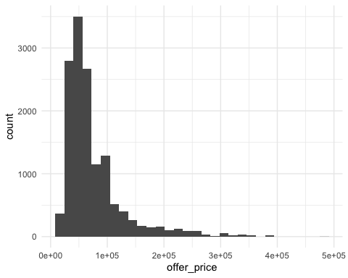

# Box plots for comparing price distributions  
ggplot(laptops_data, aes(x = as.factor(rating), y = offer_price)) + geom_boxplot() + theme_minimal()

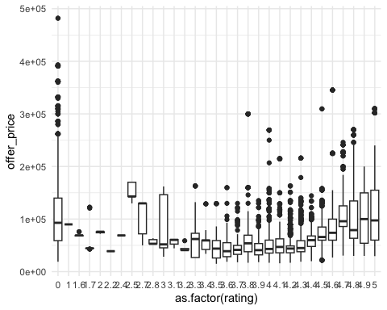

# Correlation matrix  
correlations <- cor(laptops_data %>% select(offer_price, original_price, total_ratings, total_reviews, rating), use = "complete.obs")  
  
# Heatmap  
library(corrplot)

## corrplot 0.92 loaded

corrplot(correlations, method = "circle")

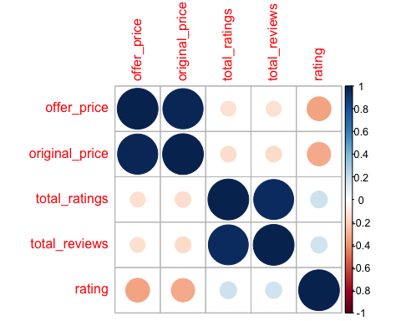

# Convert discount levels from percentage to numerical  
laptops_data$discount_numeric <- as.numeric(sub("% off", "", laptops_data$off_now))  
  
  
# Create scatter plot for Number of Reviews vs. Discount with color based on Rating  
ggplot(laptops_data, aes(x = discount_numeric, y = total_reviews, color = rating)) +  
 geom_point() +  
 labs(x = "Discount Level (%)", y = "Total Reviews", title = "Reviews vs. Discount Levels") +  
 theme_minimal()

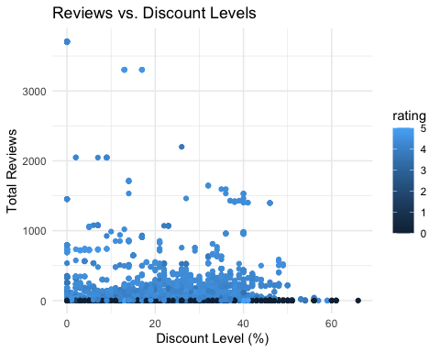

# Split the data into training and testing sets  
set.seed(123)  
train_index <- createDataPartition(laptops_data$offer_price, p = 0.8, list = FALSE)  
train_data <- laptops_data[train_index, ]  
test_data <- laptops_data[-train_index, ]  
  
# Build the random forest model  
rf_model <- randomForest(offer_price ~ original_price + off_now + total_ratings + total_reviews + rating,  
 data = train_data, importance = TRUE)  
  
# Get the column names of the importance data frame  
importance_cols <- names(rf_model$importance)  
  
# Determine the column name for importance values  
importance_col_name <- ifelse("IncNodePurity" %in% importance_cols, "IncNodePurity", "%IncMSE")  
  
# Create a data frame with variable importance  
importance_df <- data.frame(Variable = rownames(rf_model$importance),  
 Importance = rf_model$importance[, importance_col_name])  
  
# Plot variable importance››  
ggplot(importance_df, aes(x = Importance, y = reorder(Variable, Importance))) +  
 geom_col(fill = "steelblue") +  
 labs(x = paste0("Importance (", importance_col_name, ")"), y = "Variable") +  
 ggtitle("Variable Importance Plot") +  
 theme_minimal()

