

Application Documentation

## Overview

The **Petri-Dish Posse** is a Django-based web application designed to simulate the spread and control of infectious diseases using the SEIRS (Susceptible-Exposed-Infectious-Recovered-Susceptible) model. This application allows users to explore disease dynamics under various conditions, including scenarios with and without interventions such as vaccination and treatment.

### Key Features

* **SEIRS Model Simulation**: Models the progression of diseases by dividing the population into susceptible, exposed, infectious, and recovered groups.
* **Intervention Scenarios**: Users can run simulations with various interventions, including vaccination and treatment strategies.
* **Visualization Tools**: Generates graphs and charts to visually represent the simulation results, such as infection rates and recovery trends.
* **Customizable Parameters**: Provides a range of parameters that users can adjust to model different scenarios and explore their effects on disease spread.

## Installation Guide

### System Requirements

To run "The Petri-Dish Posse," you'll need the following:

* **Python 3.9 +** : A version of Python compatible with Starsim and the other dependencies.
* **Django**: The web framework used to build the application.
* **Matplotlib**: A library for generating plots and graphs.
* **Other Dependencies**: Listed in requirements.txt and include libraries needed for the SEIRS model and data manipulation.

Git Set up  
 **Cloning the repository:**

|  |
| --- |
| bash |
| git clone <https://github.com/janymuong/meningitis_sim.git>cd meningitis_sim |

### Environment Set-Up

Using a virtual environment is crucial for managing project-specific dependencies and avoiding conflicts with system-wide packages. Here’s how to set up a virtual environment:

1. **Create and activate a virtual environment**:
   * First, ensure that **Python 3.12** is installed on your system. You can verify this by checking the Python path:

|  |
| --- |
| bash |
| **$ which python3** |

* + Install virtualenv if it's not already installed:

|  |
| --- |
| bash |
| **$ python3 -m pip install --user virtualenv** |

* + Create a new virtual environment and activate it:

|  |
| --- |
| bash |
| **$ python3 -m virtualenv --python=<path-to-python3.12> ../.dj_sim**  **$ source ../.dj_sim/bin/activate** |

1. Alternatively  
   You can use the make setup command defined in the Makefile to automate this process.
2. **Install project dependencies**:
   * After activating the virtual environment, install the necessary packages:

|  |
| --- |
| bash |
| **$ make install** |

1. **Open the project directory**:
   * Navigate to the project directory to access and edit project files:

|  |
| --- |
| bash |
| **$ cd meningitis_sim**  **$ code .** |

### Installation Steps

1. **Set up the virtual environment**:

|  |
| --- |
| bash |
| **make setup** |

1. **Activate the virtual environment**:

|  |
| --- |
| bash |
| **source ../.dj_sim/bin/activate** |

1. **Install the required packages**:

|  |
| --- |
| bash |
| make install |

1. **Run the Django server**:

|  |
| --- |
| bash |
| **python3 manage.py runserver** |

1. **Run database migrations**:

|  |
| --- |
| bash |
| make migrate |

### Configuration

* No additional configuration is needed beyond the installation steps. Ensure that the virtual environment is activated whenever you run the application to maintain the correct context for dependencies.

## User Guide

### Getting Started

1. **Access the Application**:
   * Open a web browser and go to <http://127.0.0.1:8000/>. This URL will load the application’s homepage – accessing on localhost.
2. **Run a Simulation**:
   * On the homepage, select the appropriate simulation form based on the type of scenario you want to model (e.g., **standard SEIRS model**, **vaccination scenario**, etc.).
   * Input the required parameters into the form. These parameters will vary depending on the simulation type.

### Detailed Usage

#### Navigation

* **Home Page**: Provides links to different simulation forms and displays the results of previous simulations.
* **Forms**: The application includes several forms for different simulation types:
  + **Normal Simulation**: For basic SEIRS simulations without interventions.
  + **Vaccine Simulation**: For simulations that include vaccination as an intervention.
  + **Age-Based Vaccine Simulation**: For simulations with age-specific vaccination strategies.
  + **Treatment Simulation**: For simulations involving treatment as an intervention.

#### Main Functions

* **Run Simulation**: After setting up the simulation parameters, submit them to start the simulation. The system will process the data and generate results.
* **View Results/**Visualizations: Once the simulation is complete, the results will be displayed on the screen, including graphical visualizations of disease dynamics.

Home Page Overview

This is the dashboard of the app on launch.

Normal Simulation

Setting Parameters

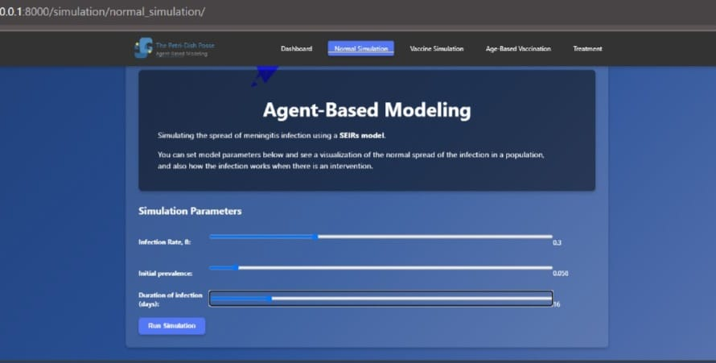

Visualization

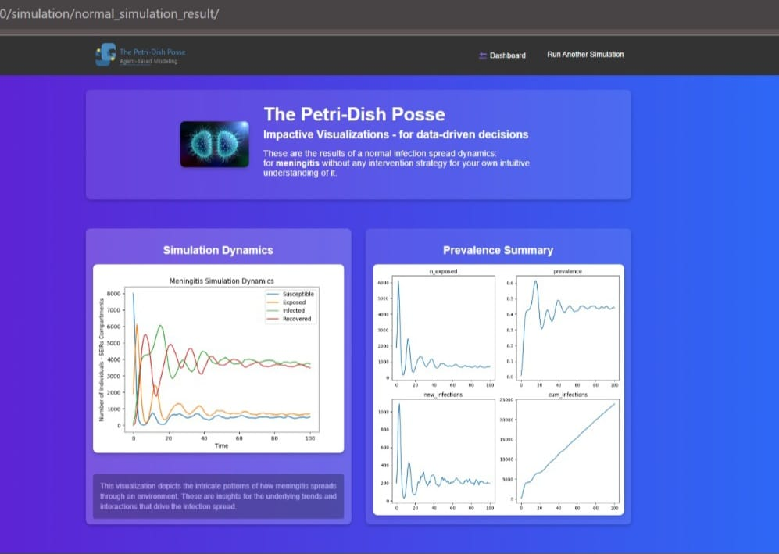

Vaccine Simulation

Setting Parameters

You can set parameters using the sliders and type in values for input fields if necessary.

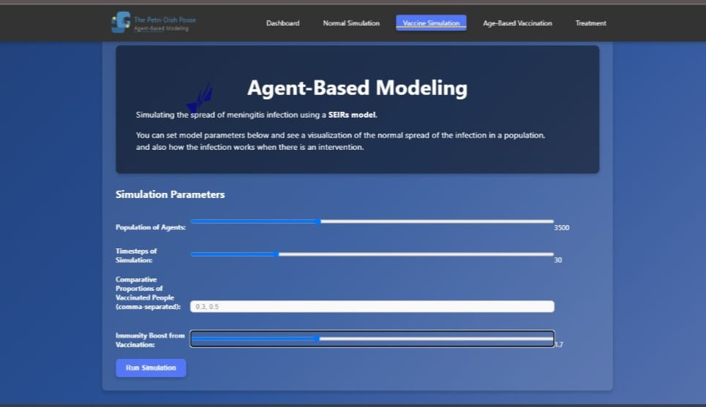

Visualization

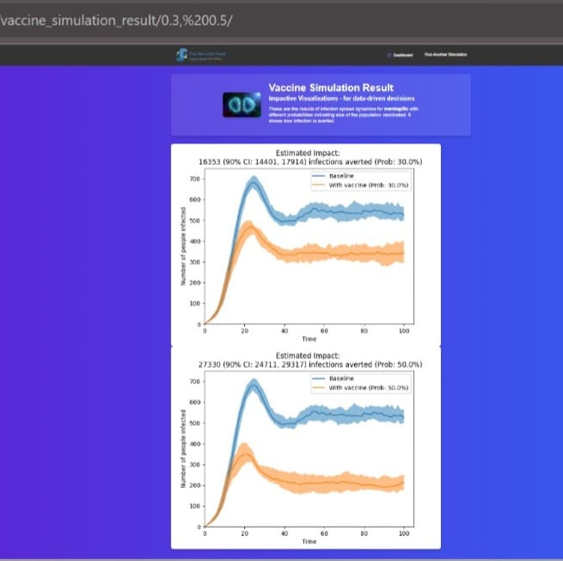

Age-Based Vaccine Simulation

Setting Parameters

You can set parameters using the sliders and type in values for input fields if necessary.



Visualization

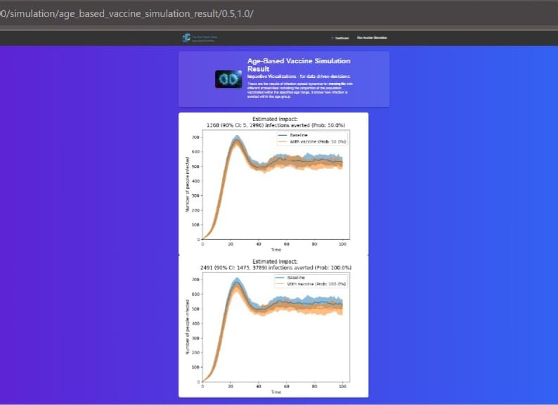

Treatment Simulation

Setting Parameters

You can set parameters using the sliders and type in values for input fields if necessary.

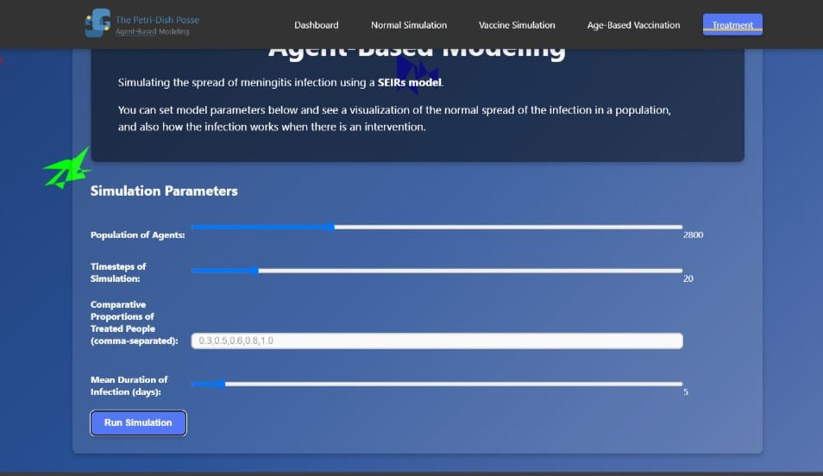

Visualization

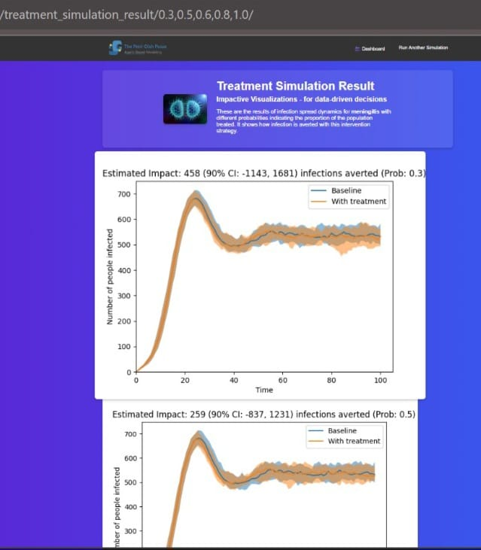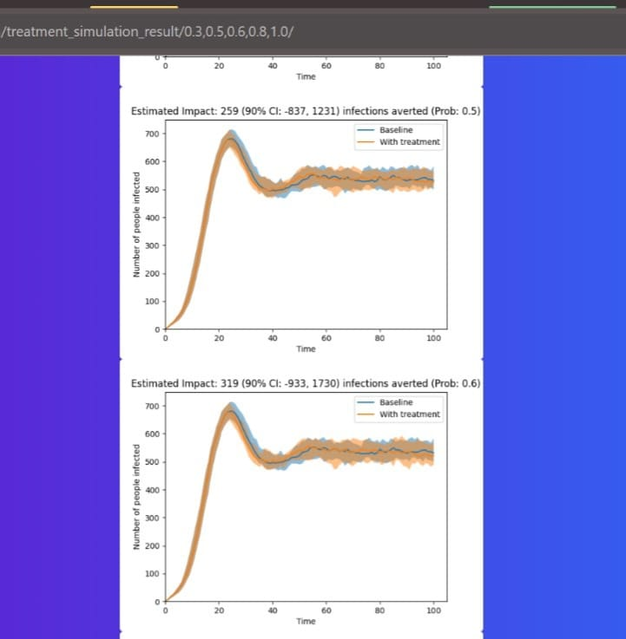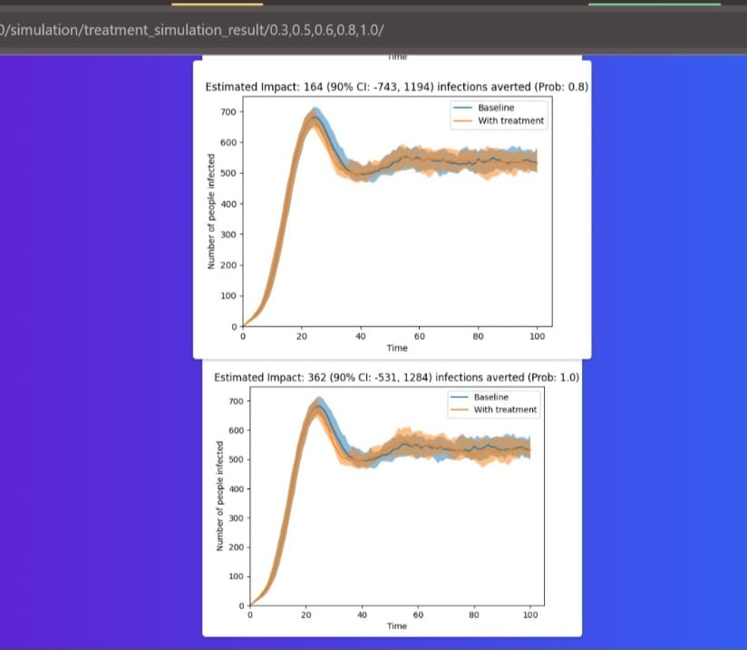

## API Reference

### Endpoints

* **/:** This is the entry point of the simulation.
* **/simulation/normal_simulation**: This endpoint accepts simulation parameters and starts the simulation process. It returns the results of a non-intervention simulation and does visualization for transmission dynamics/prevalence summary.
* **/simulation/vaccine_simulation**: This endpoint accepts simulation parameters and starts the simulation process. It returns the results of a vaccinated population simulation and does visualization
* **/simulation/age_basde_vaccine_simulation**: This endpoint accepts simulation parameters for an age-specific vaccination intervention and starts the simulation process. It returns the results of an age-specific vaccination simulation and does visualization
* **/simulation/treatment_simulation**: This endpoint accepts simulation parameters and starts the simulation process. It returns the results of a treatment simulation and does visualization of it.

### HTTP Request and Response

• **Request**:

* Data is sent as form data. The specific form and parameters depend on the simulation type selected.
* For instance, submitting a form for a normal simulation will require different parameters than submitting a form for a vaccination simulation.

• **Response**:

* The response includes the results of the simulation, such as time-series data for infection and recovery rates, and visualizations like graphs.

### Authentication

* Basic access does not require authentication.

### Error Codes

* **500 Internal Server Error**: Indicates an issue with the server or the simulation process. Only happens if the app server is down.

## FAQ

* **How do I start a simulation?**
  + Navigate to the appropriate form on the homepage, enter the required parameters, and submit the form.

### Troubleshooting Tips

* **Virtual Environment Issues**: Make sure the virtual environment is activated. If it's not, the application may fail to run correctly due to missing dependencies.
* **Dependency Problems**: If you encounter issues related to missing packages, re-run make install to ensure all required packages are installed.

## Contact and Support

### Support Channels

* **Email**: thepetridishposse@gmail.com
* **GitHub Issues**: Report issues and contribute to the project on https://github.com/janymuong/meningitis_sim.git.

### Feedback

Please get in touch with Jany Muong at me.roumuong@gmail.com for feedback or suggestions.