HABITA Website Proposal
English 1 Role Play

Asignatura: Inglés I
Profesora: Claudia San Martín
Fecha de exposición: 15 de octubre de 2026
Alumnos: Eduardo Labbe · Gabriel Miranda · Daniel Morales
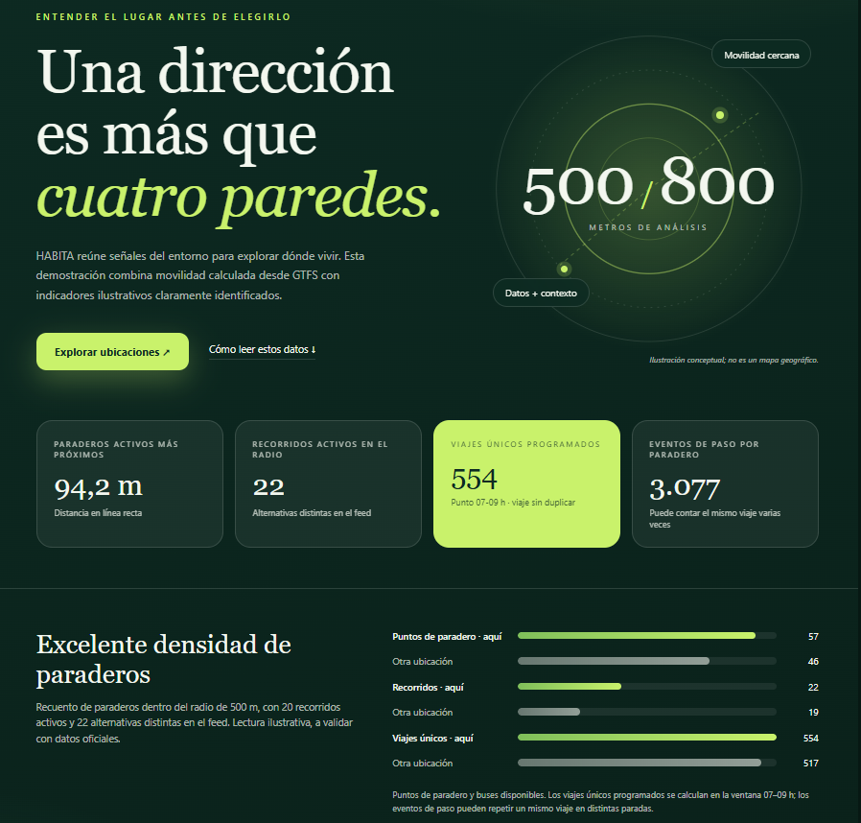

Índice
1 Greeting and Introductions 3
2 Learning About the Business 4
3 Jobs and Daily Routines 5
4 The Website Proposal 6
5 Agreement and Closing 7

1 Greeting and Introductions
Daniel: Good morning! I’m Daniel Morales, the founder and product manager of Habita.
Gabriel: Good morning, Daniel. I’m Gabriel Miranda, a web designer at Bright Web Solutions. I create clear, friendly designs for our clients.
Eduardo: Hello! I’m Eduardo Labbe, the web developer on our team. I build and test our websites.
Daniel: Nice to meet you both. Welcome to Habita. Thank you for coming.
Gabriel: Thank you. Where does the idea for Habita come from?
Daniel: It comes from Chile. We help Chilean users and also Argentinian and Brazilian people who move to Santiago.
Eduardo: What does Habita offer?
Daniel: Habita helps people find verified rooms and apartments, compare options, and schedule visits.
Eduardo: Bright Web Solutions creates modern websites, online platforms, and secure tools for small businesses.
Gabriel: We also create simple designs. Today, we want to learn about Habita and its users.
Daniel: Perfect. I want a website that feels trustworthy, simple, modern, and professional.

2 Learning About the Business
Gabriel: Why does Habita need a new website?
Daniel: Our current prototype is basic and difficult to use on phones. Users cannot search or make reservations online.
Eduardo: Who usually uses Habita?
Daniel: Students, young professionals, families, and property owners use our service.
Gabriel: Where does Habita operate?
Daniel: We currently operate in Santiago, but we want to reach other Chilean cities later.
Eduardo: When can people use the platform?
Daniel: The website is always available. Our team usually answers messages from Monday to Friday.
Gabriel: How do users contact you now?
Daniel: They often use Instagram or WhatsApp. Sometimes they email us, but the information is in different places.
Eduardo: What is the main purpose of the new website?
Daniel: Its purpose is to connect renters with verified homes and make the rental process easier.

3 Jobs and Daily Routines
Gabriel: Can you tell us about your daily routine, Daniel?
Daniel: I usually start at eight thirty, check new listings, and answer user messages.
Eduardo: Do you verify the properties too?
Daniel: Yes. I often review photos and details, and I talk with property owners before publication.
Gabriel: Who manages the listings and reservation fees?
Daniel: I manage them with my team. We sometimes use spreadsheets, but we do not have a central dashboard.
Eduardo: A central dashboard lets you manage listings, visits, and users from a computer or phone.
Daniel: That is important for us. What do you do as a web designer, Gabriel?
Gabriel: I plan the visual style and user experience. I design filters, property cards, pages, and accessible layouts.
Gabriel: I always check my projects at nine. I often meet clients in the morning and design in the afternoon.
Daniel: And what are your responsibilities, Eduardo?
Eduardo: I build search tools, user accounts, visit booking tools, payment systems, and mobile features. I also protect user information.
Eduardo: I usually write code in the morning. I test every day, and I sometimes meet clients after lunch.
Daniel: Do you work together on every project?
Gabriel: Yes. We always share feedback and check each other’s work.
Eduardo: Our jobs are different, but our goal is the same: a useful, safe, attractive platform.

4 The Website Proposal
Gabriel: We propose a modern website with Habita’s colors and a calm, trustworthy style.
Daniel: What pages does the website include?
Gabriel: It includes a home page, a property catalog, listing pages, a How It Works page, and a contact page.
Eduardo: Users can search with filters, create accounts, schedule visits, and pay a reservation fee securely.
Daniel: Can users sign documents online or collect them at our office?
Eduardo: Yes. They choose digital documents or an office appointment, and the system sends a confirmation.
Gabriel: Each listing shows photos, price, location, rooms, rules, and a verified badge. The contact page shows your details.
Eduardo: We also connect Habita’s Instagram and other social media.
Daniel: Does the platform work well on phones?
Eduardo: Yes. Its responsive design adapts to phones, tablets, and computers.
Gabriel: The filters and buttons are clear, so users can compare homes quickly.
Daniel: Who adds new property listings after the website is ready?
Eduardo: You or an authorized agent can add them. We provide training and a short guide.
Daniel: How do online payments work?
Eduardo: We connect a secure payment service. Users pay the reservation fee and receive a receipt. Their private data stays protected.
Daniel: When can you start, and how long does the project take?
Gabriel: We can start next Monday. The project usually takes four weeks after we receive your materials.
Eduardo: First, we organize the content. Gabriel presents the design, and then I build and test the platform.
Daniel: What do you need from me?
Gabriel: We need your logo, sample listings, fees, property photos, service policies, and comments on our design.
Daniel: That sounds clear. Can we test the website before it goes online?
Eduardo: Of course. You review a private version, and we correct problems before launch.

5 Agreement and Closing
Gabriel: To summarize, Habita receives a responsive site, property catalog, search filters, reservations, and a contact page.
Eduardo: It also includes secure payments, digital or office documents, social media, training, and testing.
Daniel: The proposal meets our needs. It helps people find homes and gives property owners a clear process.
Gabriel: Excellent. Do you have any final questions?
Daniel: Everything is clear. I accept your proposal, and I’m happy to work with Bright Web Solutions.
Eduardo: Wonderful. We can send the schedule today. Can you send your materials by Friday?
Daniel: Perfect. I can prepare our logo, sample listings, fees, property photos, and policies.
Gabriel: Thank you for your time, Daniel. Habita is a useful idea with a clear purpose.
Eduardo: Yes, thank you. We look forward to creating your new platform.
Daniel: Thank you both. I look forward to the first design. Have a great day!
Gabriel: You too. Goodbye!
Eduardo: Goodbye, Daniel!

