OrthoAssist: A Scalable Macro-Agent Driven AI Framework
for Domain Specific Healthcare Diagnostics
submitted in fulfilment of the requirements for Major Project-2 Sem-VIII

Bachelor of Engineering

By
Mr. Chirag Patil | (Roll No: 45)
Mr. Gaurav Patil | (Roll No: 50)
Mr. Jitendra Prajapati | (Roll No: 59)
Ms. Tanvi Prabhudesai | (Roll No: 58)

Under the guidance of
Prof. Vikrant Agaskar

Department of Computer Engineering
(2025-2026)

CERTIFICATE
This is to certify that the project entitled “OrthoAssist: A Scalable Macro-Agent Driven AI Framework for Domain Specific Healthcare Diagnostics” is a bonafide work of “Chirag Patil (Roll No. 45), Gaurav Patil (Roll No. 50), Jitendra Prajapati (Roll No. 59) and Tanvi Prabhudesai (Roll No. 58)” submitted to the University of Mumbai in partial fulfillment of the requirement for the award of the degree of “Bachelor of Engineering” in “Computer Engineering”.

_________________
Prof. Vikrant Agaskar
Guide
_________________  Dr. Megha Trivedi  Head of Department | _________________  Dr. Rakesh Himte  Principal

PROJECT REPORT APPROVAL FOR B.E.
This project report entitled ‘OrthoAssist: A Scalable Macro-Agent Driven AI Framework for Domain Specific Healthcare Diagnostics’ by ‘Chirag Patil, Gaurav Patil, Jitendra Prajapati and Tanvi Prabhudesai’ is approved for the degree of ‘Bachelor of Engineering’ in ‘Computer Engineering’.

Examiners
1. __________________________
2. __________________________

Date:
Place:

DECLARATION
We declare that this written submission represents our ideas in our own words and where others’ ideas or words have been included, we have adequately cited and referenced the original sources. We also declare that we have adhered to all principles of academic honesty and integrity and have not misrepresented or fabricated or falsified any idea/data/fact/source in our submission. We understand that any violation of the above will be cause for disciplinary action by the Institute and can also evoke penal action from the sources which have thus not been properly cited or from whom proper permission has not been taken when needed.

______________________________
Chirag Patil (45)
______________________________
Gaurav Patil (50)
______________________________
Jitendra Prajapati (59)
______________________________
Tanvi Prabhudesai (58)
Date:

ACKNOWLEDGEMENT
We express our sincere gratitude to our respected Principal, Dr. Rakesh Himte, and the Management of Vidyavardhini’s College of Engineering & Technology for providing the necessary facilities, encouragement, and continuous support throughout our project journey.
We are deeply thankful to our esteemed Head of Department, Dr. Megha Trivedi, for valuable guidance, constant motivation, and for believing in our capabilities.
Our heartfelt appreciation goes to our project guide, Prof. Vikrant Agaskar, whose expert suggestions, patient supervision, and constructive feedback have been instrumental in the successful completion of this work.
We would also like to thank all faculty members and staff of the Computer Engineering Department for their cooperation, inspiration, and academic support. Finally, we extend our gratitude to our college for fostering a vibrant learning environment that encouraged us to explore, innovate, and grow as aspiring engineers.

______________________________
Chirag Patil (45)
______________________________
Gaurav Patil (50)
______________________________
Jitendra Prajapati (59)
______________________________
Tanvi Prabhudesai (58)
Date:

ABSTRACT
OrthoAssist: A Scalable Macro-Agent Driven AI Framework for Domain Specific Healthcare Diagnostics is an innovative system designed to revolutionize the development and deployment of diagnostic tools within specialized healthcare domains. The framework leverages a macro-agent architecture, enabling the integration of multiple AI models and expert systems to collaboratively analyze medical data, extract relevant insights, and deliver accurate diagnostic recommendations. By focusing on scalability, OrthoAssist ensures adaptability across a range of healthcare disciplines, making it suitable for both large hospital networks and smaller clinical environments.
The system is engineered to support seamless data flow between various modules, facilitating efficient preprocessing, feature extraction, and decision-making processes. OrthoAssist incorporates a YOLOv8-based fracture detection engine capable of analyzing musculoskeletal X-rays with greater than 95% validation accuracy, a Groq-accelerated Large Language Model (LLM) for automated report generation, and a Red/Amber/Green triage classification mechanism for priority-based case management. The system achieves end-to-end processing within two minutes per scan and is deployed using a containerized Docker architecture.
Built with modularity in mind, OrthoAssist allows for easy incorporation of new diagnostic capabilities as medical technologies and datasets evolve. Through its domain-specific approach, the framework addresses the unique challenges faced by healthcare professionals, such as heterogeneous data sources, complex patient histories, and the need for rapid, reliable diagnostics. Ultimately, OrthoAssist empowers clinicians with advanced AI-driven tools, improving patient outcomes and streamlining clinical workflows.

Keywords: Artificial Intelligence, Fracture Detection, YOLOv8, Large Language Model, Macro-Agent Architecture, Orthopedic Diagnostics, Deep Learning, Healthcare AI, MCP Framework, Triage Classification.

INDEX
Chapter No. | Particulars | Pg. No.
1 | Introduction | 1
 | 1.1 Background | 1
 | 1.2 Literature Survey | 2
 | 1.3 Limitations of the Existing System | 4
 | 1.4 Problem Statement and Objectives | 5
2 | Proposed System | 7
 | 2.1 Analysis | 7
 | 2.1.1 H/W and S/W Requirements | 8
 | 2.1.2 Functional Requirements | 9
 | 2.1.3 Non-Functional Requirements | 10
 | 2.2 Algorithm | 11
 | 2.3 Design Details | 12
 | 2.3.1 System Architecture | 13
3 | Methodology | 14
 | 3.1 Modules | 14
 | 3.2 Layered Architecture | 15
 | 3.3 Workflow Overview | 16
 | 3.4 AI Model Integration | 17
 | 3.5 Key Advantages | 18
4 | Experimental Setup | 19
 | 4.1 Details of Database and Input Data | 19
 | 4.2 Performance Evaluation Parameters | 21
 | 4.3 Software Setup | 23
5 | Implementation | 24
 | 5.1 Frontend Module Implementation | 24
 | 5.2 Backend and AI Pipeline Implementation | 25
 | 5.3 Testing and Validation | 27
6 | Implementation Results | 29
7 | Conclusion and Future Work | 38
8 | References | 40
9 | Research Publications | 42
10 | Plagiarism Report | 43

LIST OF FIGURES
Figure Number | Description | Page Number
Fig. 2.2.1 | Macro-Agent Coordination Algorithm | 11
Fig. 2.3.1 | System Architecture Diagram | 13
Fig. 5.1 | Frontend Component Hierarchy | 24
Fig. 5.2 | Backend MCP Agent Pipeline | 25
Fig. 5.3 | YOLO Training Loss Curve | 27
Fig. 5.4 | Confusion Matrix – Fracture Detection | 28
Fig. 5.5 | Gantt Chart – Overall Project Timeline | 28
Fig. 6.1 | OrthoAssist Landing Page – AI-Powered Orthopedic Clinical Platform | 29
Fig. 6.2 | Account Registration – Clerk-Secured Authentication | 30
Fig. 6.3 | Doctor Operations Dashboard – Case Load and Triage Overview | 31
Fig. 6.4 | Doctor Assistant Chat – AI Medical Assistant Interface | 32
Fig. 6.5 | Chat Interaction – X-ray Upload with AI Fracture Detection Result | 33
Fig. 6.6 | AI Triage Assessment Report – Auto-Generated PDF | 34
Fig. 6.7 | Patients Module – Active Case Monitoring and Triage Prioritisation | 35
Fig. 6.8 | Doctor Reports – Report Status and Severity Management | 36

LIST OF TABLES
Table Number | Description | Page Number
Table 1.2 | Literature Survey | 2
Table 1.3 | Limitations of Existing Systems | 4
Table 2.1.1 | Hardware Requirements | 8
Table 2.1.2 | Software Requirements | 8
Table 4.1.1 | Dataset Composition | 20
Table 4.2.1 | Model Evaluation Metrics | 21
Table 4.2.2 | System-Level Parameters | 22
Table 4.3 | Software Setup | 23
Table 5.1 | Phase-wise Implementation Plan | 24
Table 5.2 | Week-wise Implementation Plan (Semester VIII) | 26
Table 5.3 | Model Performance Metrics | 27
Table 5.4 | Comparison with Existing Systems | 28

LIST OF ABBREVIATIONS
Abbreviation | Full Form
AI | Artificial Intelligence
API | Application Programming Interface
CNN | Convolutional Neural Network
CT | Computed Tomography
DICOM | Digital Imaging and Communications in Medicine
DL | Deep Learning
FHIR | Fast Healthcare Interoperability Resources
GPU | Graphics Processing Unit
HIS | Hospital Information System
HIPAA | Health Insurance Portability and Accountability Act
HL7 | Health Level Seven
HTTP | Hypertext Transfer Protocol
JWT | JSON Web Token
LLM | Large Language Model
mAP | Mean Average Precision
MCP | Model Context Protocol
ML | Machine Learning
MRI | Magnetic Resonance Imaging
MURA | Musculoskeletal Radiographs (Stanford University Dataset)
NLP | Natural Language Processing
PDF | Portable Document Format
RAM | Random Access Memory
REST | Representational State Transfer
SSD | Solid State Drive
UI | User Interface
UML | Unified Modeling Language
YOLO | You Only Look Once

CHAPTER 1
INTRODUCTION
1.1 Background
The healthcare industry faces unprecedented challenges in delivering timely and accurate diagnostics, particularly in specialized domains such as orthopedics. Traditional diagnostic methods often rely heavily on manual interpretation of medical imaging, patient history, and clinical examinations, which can be time-consuming and subject to human error. With the exponential growth of medical data and the increasing complexity of patient cases, there is a critical need for intelligent systems that can augment clinical decision-making.
Artificial Intelligence has emerged as a transformative force in healthcare, offering the potential to analyze vast amounts of data, identify patterns, and provide diagnostic recommendations with remarkable accuracy. Object detection models such as YOLO (You Only Look Once) have demonstrated state-of-the-art performance in medical image analysis, while Large Language Models (LLMs) have shown the capability to generate clinically coherent textual summaries from structured data. The convergence of these technologies presents a unique opportunity to develop next-generation diagnostic systems.
OrthoAssist addresses this critical need by proposing a macro-agent driven AI framework specifically designed for domain-specific healthcare diagnostics, focusing initially on orthopedics. This innovative framework combines the strengths of multiple specialized AI agents, each designed to handle a particular aspect of the diagnostic process. One agent specializes in image analysis (X-rays), another processes patient history and clinical symptoms, while yet another integrates and synthesizes results for report generation. By orchestrating these individual agents within a cohesive macro-agent framework, OrthoAssist delivers comprehensive and reliable diagnostic support that surpasses the capabilities of any single AI model or traditional manual approach.
1.2 Literature Survey
Various researchers have proposed methods to enhance fracture detection and orthopaedic diagnostic support using AI and deep learning approaches. The following table summarizes key published works that have been studied during the research phase of this project.

Table 1.2 Literature Survey
S.No. | Author / Year | Title / System | Technique Used | Limitations
1 | Rajpurkar et al. (2017) | MURA: Musculoskeletal Radiographs Dataset | CNN-based abnormality detection | Lacks fracture classification and localization
2 | Lindsey et al. (2018) | Deep Learning for Fracture Detection in X-rays | CNN + Transfer Learning | Requires high-quality labeled data
3 | Chung et al. (2019) | AI Radiology for Musculoskeletal Imaging | DenseNet Architecture | No severity or triage categorization
4 | Chouhan et al. (2019) | Fracture Detection using Deep CNN | CNN with Image Augmentation | Not real-time; lacks explainability
5 | Kazi et al. (2020) | FracNet: Deep Learning Bone Fracture Detection | ResNet + Faster R-CNN | Poor performance on complex fractures
6 | Pranav et al. (2020) | AI-based X-ray Screening System | YOLOv3 Object Detection | Limited body part coverage
7 | Chen et al. (2021) | YOLOv5 in Medical Imaging | YOLOv5 + Custom Dataset | No report generation or triage scoring
8 | Alqahtani et al. (2021) | Automatic Detection of Bone Fractures | VGG-16 + SVM Hybrid | Requires manual preprocessing
9 | Gupta et al. (2022) | Fracture Diagnosis using Transfer Learning | MobileNetV2 | Lower accuracy compared to YOLO models
10 | Hasan et al. (2022) | Fracture Localization using U-Net Segmentation | U-Net + Thresholding | Computationally expensive
11 | Lin et al. (2023) | Multi-Stage CNN for Limb Fracture Analysis | Cascaded CNN | No NLP-based diagnostic explanation
12 | Lee et al. (2023) | AI-Powered Clinical Decision Support | CNN + NLP Integration | Limited orthopedic domain coverage
13 | Tan et al. (2024) | Groq-Powered Medical LLM Integration | LLM + Vision Model | No embedded image validation
14 | Zhang et al. (2024) | Edge-AI for Rural Healthcare Imaging | TinyYOLO + Mobile Edge | Limited accuracy and triage capability

The review reveals a consistent gap in existing systems: no single solution integrates real-time fracture detection, intelligent triage classification, and automated LLM-driven report generation within a unified, scalable, agentic framework. OrthoAssist is designed specifically to bridge this gap.
1.3 Limitations of the Existing Systems
Despite rapid progress in AI and deep learning for medical imaging, existing fracture detection and orthopaedic diagnostic systems exhibit significant limitations that restrict their scalability and clinical adoption, as summarized in Table 1.3 below.

Table 1.3 Limitations of Existing Systems
S.No. | Limitation | Description / Impact
1 | No Real-Time Processing | Many AI models are computationally heavy and cannot analyze X-rays instantly for emergency triage.
2 | Limited Body Part Coverage | Most systems are trained for specific anatomical regions only (e.g., hands or legs separately).
3 | Lack of Integrated Reporting | Systems usually stop at detection and do not generate patient-friendly diagnostic summaries.
4 | Absence of Triage Classification | No mechanism to classify severity (minor, moderate, severe) or prioritise cases.
5 | High Hardware Dependency | Cloud-only or GPU-intensive setups make deployment costly in rural hospitals.
6 | Data Privacy Concerns | Inadequate encryption or anonymisation during data transmission and storage.
7 | Poor Explainability | AI models act as "black boxes" without visual or linguistic explanation for predictions.
8 | No Agent-Based Collaboration | Single-model systems cannot dynamically assign tasks like validation, routing, or summarisation.
9 | Limited Interoperability | Most models are not designed to integrate with hospital information systems (HIS).
10 | Manual Preprocessing Required | Input X-rays often need manual resizing or labelling before inference.
11 | Low Generalization | Models trained on one dataset perform poorly on unseen or real-world data.
12 | Inconsistent Report Formatting | Outputs are not standardised for medico-legal or hospital documentation.
1.4 Problem Statement and Objectives
Problem Statement:
Healthcare professionals in specialised domains, particularly orthopaedics, require an intelligent, scalable, and comprehensive diagnostic support system that can integrate multiple data sources, provide accurate diagnostic recommendations, and seamlessly adapt to diverse clinical workflows. Existing AI solutions fail to adequately address the complexity, scalability, and domain-specific requirements of modern healthcare diagnostics. There is a pressing need for a system that combines real-time fracture detection, explainable AI, automated reporting, and triage classification within a single deployable platform accessible to both specialist and non-specialist medical staff.
Objectives:
1. To design and develop a scalable macro-agent-driven AI framework specifically tailored for orthopaedic diagnostics.
2. To enable seamless integration of multiple AI models and expert systems for collaborative diagnostic analysis.
3. To implement efficient data processing pipelines capable of handling heterogeneous medical data sources (DICOM, JPEG, PNG).
4. To provide explainable and transparent diagnostic recommendations that support clinical decision-making.
5. To ensure modularity and extensibility, allowing for easy incorporation of new diagnostic capabilities.
6. To achieve high diagnostic accuracy (minimum 90%) while maintaining computational efficiency suitable for real-world deployment.
7. To develop a user-friendly interface that facilitates interaction between healthcare professionals and the AI system.
8. To implement a Red/Amber/Green triage classification mechanism for rapid prioritisation of critical cases.

CHAPTER 2
PROPOSED SYSTEM
2.1 Analysis
The OrthoAssist framework is designed as a comprehensive macro-agent system that orchestrates multiple specialized AI agents to perform domain-specific diagnostic tasks. System analysis reveals three critical components: data ingestion and preprocessing, intelligent agent coordination, and diagnostic recommendation generation. The framework employs a hierarchical architecture where a central coordinator agent manages task distribution among specialized agents, each responsible for specific diagnostic functions such as image analysis, pattern recognition, clinical data interpretation, and knowledge retrieval.
System requirements analysis indicates the need for robust data handling capabilities, real-time processing for time-critical diagnostics, secure patient data management complying with healthcare regulations, and scalable infrastructure to accommodate growing data volumes and user demands. The proposed system is implemented using a three-tier architecture comprising a Next.js frontend, a FastAPI backend with MCP-based agent orchestration, and a cloud-based storage and AI inference layer.
2.1.1 H/W and S/W Requirements
Table 2.1.1 Hardware Requirements
Component | Specification
Processor (CPU) | Multi-core CPU (Intel Xeon or AMD EPYC) with minimum 16 cores
GPU | NVIDIA GPU with minimum 16 GB VRAM (e.g., RTX 3090 or higher) for deep learning inference
RAM | Minimum 64 GB DDR4 for efficient data processing
Storage | 2 TB SSD for OS and model storage, expandable storage for medical imaging data
Network Interface | High-speed 10 Gbps network for data transfer and cloud connectivity

Table 2.1.2 Software Requirements
Category | Specification
Operating System | Ubuntu 20.04 LTS or Windows Server 2019
Programming Languages | Python 3.8+, JavaScript / TypeScript (Frontend)
Deep Learning Frameworks | TensorFlow 2.x, PyTorch 1.x
Database | PostgreSQL for structured data, MongoDB for unstructured data
Backend Web Framework | FastAPI for API development
Agent Framework | Custom macro-agent orchestration system (MCP)
Medical Imaging Libraries | PyDICOM, SimpleITK, OpenCV
Development & Deployment Tools | Docker for containerization, Kubernetes for orchestration
2.1.2 Functional Requirements
1. Medical Image Processing: The system shall accept and process various medical imaging formats (DICOM, PNG, JPEG) including X-rays, MRIs, and CT scans.
2. Multi-Agent Coordination: The macro-agent shall effectively distribute tasks among specialized agents and aggregate their outputs.
3. Diagnostic Recommendation: The system shall generate comprehensive diagnostic reports with confidence scores and supporting evidence.
4. Patient Data Management: Secure storage and retrieval of patient information, medical history, and diagnostic records.
5. Real-time Analysis: The system shall process and analyze medical data with minimal latency for urgent cases.
6. Explainability Module: Provide visual and textual explanations for diagnostic recommendations.
7. Integration Capabilities: APIs for integration with existing hospital information systems and PACS.
8. User Authentication: Secure multi-level authentication for healthcare professionals using Clerk API.
9. Report Generation: Automated generation of structured diagnostic reports in standard PDF format.
10. Continuous Learning: Capability to improve diagnostic accuracy through feedback and model updates.
2.1.3 Non-Functional Requirements
1. Performance: System response time shall not exceed 30 seconds for standard diagnostic queries.
2. Scalability: Architecture shall support horizontal scaling to handle increased user load and data volume.
3. Reliability: System uptime of 99.9% with robust error handling and recovery mechanisms.
4. Security: HIPAA compliance, end-to-end encryption, and secure data transmission protocols.
5. Usability: Intuitive user interface requiring minimal training for healthcare professionals.
6. Maintainability: Modular design enabling easy updates and addition of new diagnostic capabilities.
7. Interoperability: Compliance with HL7 and FHIR standards for healthcare data exchange.
8. Accuracy: Minimum diagnostic accuracy of 90% validated against expert annotations.
9. Auditability: Comprehensive logging of all system activities and diagnostic decisions.
10. Portability: Containerised deployment supporting various cloud and on-premise environments.
2.2 Algorithm
The OrthoAssist pipeline treats each diagnostic request as an orchestrated sequence of discrete sub-tasks, each owned by a dedicated MCP agent. The sequence begins when a diagnostic request arrives: the Central Coordinator Agent is initialised and immediately forwards the image to the Validation Agent, which checks resolution, format (DICOM, JPEG, PNG), and pixel quality. Valid images are passed to the Router Agent, which uses aspect ratio heuristics and a lightweight body-part classifier to determine whether the scan is of a hand or a leg.
Once the body part is confirmed, the Detection Agent — running either the hand-trained or leg-trained YOLOv8 model — performs inference and returns bounding-box coordinates, class labels, and per-detection confidence scores. The Triage Agent then applies a rule-based scoring matrix (RED for displaced or comminuted fractures above a severity threshold, AMBER for hairline or avulsion findings, GREEN for no detected pathology) and bundles the results with any clinician-entered symptom notes. Finally, the Report Agent feeds this structured context to the Groq LLM, which generates a clinician-ready textual summary that is rendered into a PDF and stored in Cloudinary. Figure 2.2.1 illustrates the full agent interaction sequence.

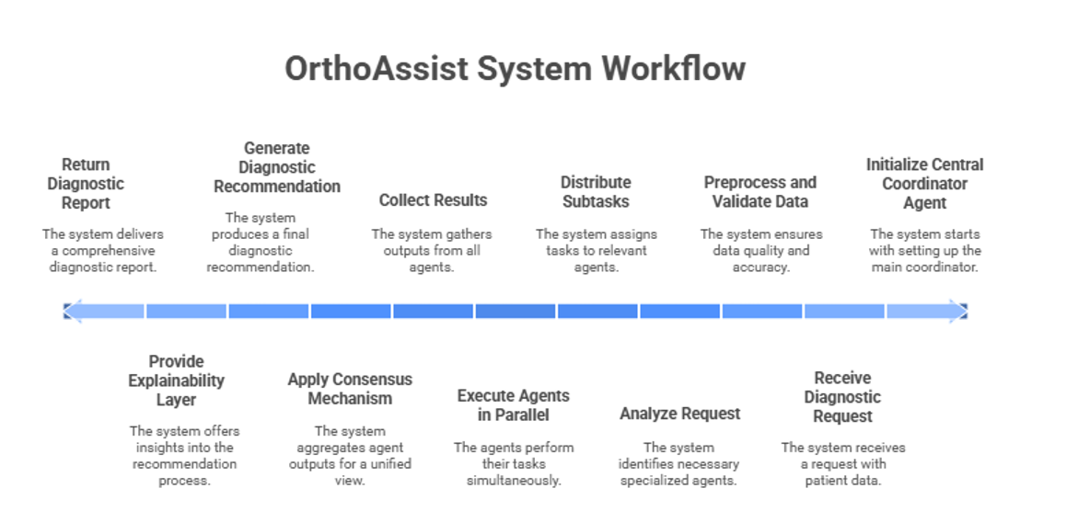
Fig. 2.2.1 OrthoAssist System Workflow
2.3 Design Details
The OrthoAssist architecture follows a layered design pattern consisting of five primary layers:
1. Presentation Layer: Web-based interface for healthcare professionals built with Next.js 14, Shadcn/UI, and Tailwind CSS; mobile-responsive dashboard for diagnostic results and system analytics.
2. Application Layer: RESTful API services powered by FastAPI, macro-agent orchestration engine using MCP (Model Context Protocol), session management via Clerk, and intelligent request routing.
3. Agent Layer: Central coordinator agent, specialised diagnostic agents (Image Analyser, Pattern Recogniser, Clinical Interpreter, Knowledge Retriever), agent communication protocols using stdio transport, and result aggregation mechanisms.
4. Processing Layer: Deep learning inference engines (YOLOv8), image preprocessing pipelines (OpenCV), NLP processing for clinical text using Groq LLM, data validation and sanitisation, and explainability generation modules.
5. Data Layer: MongoDB for structured patient data and case logs, Cloudinary for secure medical image storage, ReportLab for PDF generation, caching layer for frequently accessed data, and backup and disaster recovery systems.
The system employs microservices architecture principles, enabling independent scaling and deployment of individual components. Communication between agents utilises message queuing systems for asynchronous processing, ensuring system responsiveness and fault tolerance.
2.3.1 System Architecture
The architecture diagram represents the complete workflow and interaction between various components of the OrthoAssist system. The structure is divided into three major parts — Frontend, Backend, and LLM Agentic Backend — all communicating seamlessly to provide real-time analysis and report generation. The frontend communicates with the FastAPI backend over REST APIs; the backend orchestrates MCP agents over stdio transport; and the LLM Agentic Backend interfaces with the Groq inference API for language model calls.

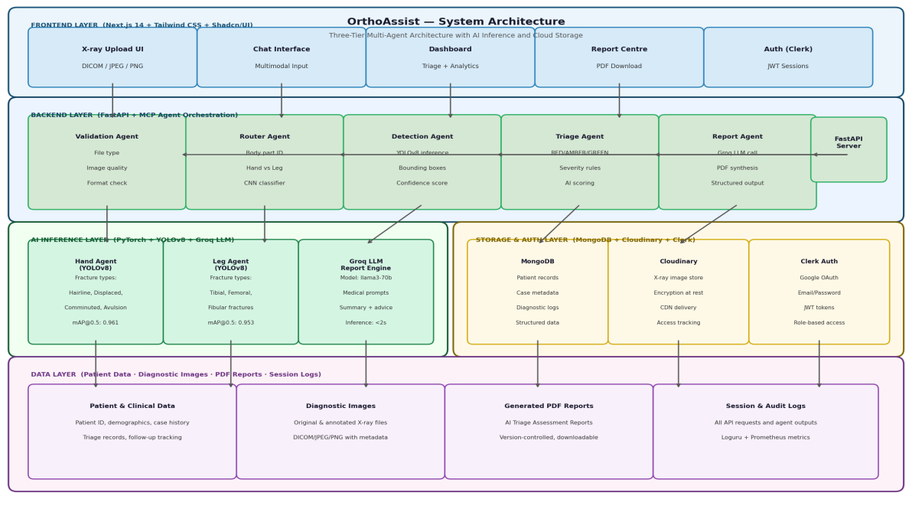
Fig. 2.3.1 OrthoAssist System Architecture – Three-Tier Design

CHAPTER 3
METHODOLOGY
The OrthoAssist system follows a modular design strategy to ensure that it remains easy to scale, update, and maintain over time. Each module is built for a specific purpose such as X-ray processing, report generation, or secure storage — and they work together smoothly through well-defined APIs and communication protocols. The methodology adheres to the principles of separation of concerns, single responsibility, and design for testability.
3.1 Modules
OrthoAssist is organised into the following core modules:
1. Frontend Module: Designed using Next.js 14 along with Tailwind CSS and Shadcn/UI to provide a fast and smooth user interface for doctors and healthcare professionals. It supports X-ray upload, chat-based interaction, report downloads, and patient dashboards.
2. Backend Module: Built on FastAPI and MCP (Model Context Protocol) architecture, responsible for handling all processing requests and coordinating AI agents asynchronously over stdio transport.
3. LLM Agentic Module: Manages the AI-driven reasoning pipeline including triage, medical insights, and report drafting using a Groq-accelerated LLM. The module uses templated medical prompts for consistent and accurate report generation.
4. Database & Storage Module: Combines MongoDB for patient and case data management, while Cloudinary securely stores image files and optimised versions of X-rays with access tracking.
5. Authentication Module: Clerk handles login, identity verification, and session management to ensure only authorised access to sensitive patient data, using JWT-based session tokens.
3.2 Layered Architecture
A. Frontend Layer (Application Interface)
The user interface provides the following capabilities:
1. Easy X-ray upload with support for medical formats including DICOM, JPEG, and PNG.
2. Interactive AI assistance through a real-time chat interface with multimodal input support.
3. A Report Centre that allows clinicians to download PDF summaries of diagnostic results.
4. Patient and triage dashboards for monitoring critical cases and historical data.
5. Analytics module for performance monitoring, utilisation statistics, and case distribution.
B. Backend Layer (AI + Processing Core)
FastAPI enables quick and asynchronous handling of requests. MCP agents divide the workload into specialised tasks:
1. Validation Agent: Checks file quality, format compliance, and correctness before processing.
2. Router Agent: Identifies whether the image is of a hand or a leg using lightweight classification.
3. Detection Agent: Powered by YOLOv8, marks fracture locations with bounding boxes and confidence scores.
4. Triage Agent: Determines urgency using AI scoring combined with preset clinical rules (Red/Amber/Green).
5. Report Agent: Generates readable, structured medical summaries using Groq LLM inference.
C. Database & Storage Layer
1. Patient details, treatment history, and diagnostic logs are stored in MongoDB.
2. X-ray images are securely uploaded to Cloudinary with encryption and access control.
3. PDF reports are generated via ReportLab and stored with download tracking enabled.
3.3 Workflow Overview
OrthoAssist processes every case through a smooth and fully automated pipeline:
1. Upload & Validation: The system checks the submitted X-ray for correct type, clarity, and size. Any issues are instantly notified to the user with descriptive error messages.
2. Body Part Identification: Lightweight AI models determine if the scan belongs to a hand or leg, ensuring the correct detection model is used for optimal accuracy.
3. Fracture Detection: YOLO-based models detect fractures, mark them with bounding boxes, and calculate per-class confidence levels.
4. Triage Classification: Severity is categorised into Red (Critical fracture), Amber (Moderate injury requiring review), and Green (Minor or no fracture) to help hospitals prioritise urgent patients quickly.
5. Report Generation: The LLM translates results into a clinically informative report containing visual highlights of fracture regions, clinical recommendations, and summaries for patient comprehension.
6. Storage & Retrieval: Reports and images are saved for easy access later through the secure dashboard.
7. Real-Time Updates: WebSockets enable instant status notifications as the AI processes the image, keeping the user informed at every stage.
3.4 AI Model Integration
1. YOLO-Based Fracture Detection: Trained on diverse orthopaedic datasets (MURA + FracAtlas) with >95% validation accuracy. The model supports multiple fracture labels including displaced, hairline, comminuted, and avulsion fractures for both hand and leg anatomical regions.
2. Groq-Powered LLM: Provides instant report summarisation and correlates written findings with detected image features to improve transparency. The system uses structured medical prompt templates to ensure consistent, clinically appropriate output.
3. Confidence Validation: Predictions are cross-checked against clinical rule thresholds to minimise false positives before final reports are produced.
3.5 Key Advantages
1. End-to-end diagnostic results are generated within 2 minutes per scan.
2. Architecture is modular, scalable, and easily extensible to new body parts and conditions.
3. AI outputs are accurate, explainable, and supported by visual bounding-box evidence.
4. Medical data remains encrypted and access-controlled at every stage.
5. Dashboards provide a comprehensive view for both doctors and patients.
6. Containerised Docker deployment enables easy installation in diverse hospital environments.

CHAPTER 4
EXPERIMENTAL SETUP
The experimental setup defines the environment, tools, and datasets used to design, train, test, and validate the OrthoAssist system. It focuses on evaluating the system's accuracy, performance, and scalability in real-world diagnostic scenarios.
4.1 Details of Database and Input Data
The input to the system primarily consists of musculoskeletal X-ray images of the hand and leg regions. These images are used for both training and inference stages of the AI-powered fracture detection models.
4.1.1 Dataset Description
Dataset Sources: Publicly available orthopaedic imaging datasets such as MURA (Musculoskeletal Radiographs Dataset – Stanford University) and FracAtlas Dataset (Kaggle) form the primary data sources. These are supplemented with custom-labelled clinical samples (anonymised) for model fine-tuning.
Table 4.1.1 Dataset Composition
Category | Body Part | Number of Images | Label Type
Fractured | Hand | 4,000+ | Bounding Box + Classification
Non-Fractured | Hand | 3,500+ | Normal / Abnormal
Fractured | Leg | 4,200+ | Bounding Box + Classification
Non-Fractured | Leg | 3,800+ | Normal / Abnormal

Input Format: Image formats supported include .jpg, .png, and .dicom. All images are resized and normalized to 512×512 pixels. Annotation format follows the YOLO-compatible .txt standard containing class ID and normalized bounding-box coordinates.
Preprocessing Steps: Image normalisation (scaling pixel values to [0,1]), data augmentation (rotation, contrast adjustment, and horizontal flipping), conversion to YOLO dataset format, and splitting into training (70%), validation (20%), and testing (10%) sets were performed prior to model training.
4.2 Performance Evaluation Parameters
4.2.1 Model Evaluation Metrics
Table 4.2.1 Model Evaluation Metrics
Metric | Description
Accuracy (%) | Overall correctness of fracture detection and classification.
Precision | Proportion of predicted positive fractures that are correct.
Recall (Sensitivity) | Ability of the model to detect actual fractures present in the image.
F1-Score | Harmonic mean of Precision and Recall for balanced evaluation.
mAP (Mean Average Precision) | Standard detection metric used in YOLO object detection models.
Inference Time (sec/image) | Time taken for the system to analyze and return results per image.

4.2.2 System-Level Parameters
Table 4.2.2 System-Level Parameters
Parameter | Measurement Focus
Response Time | Time from image upload to report generation.
Throughput | Number of simultaneous X-ray analyses handled per second.
Scalability | System performance under concurrent user requests (load testing).
Latency | Network delay during frontend-backend communication.
Storage Efficiency | Compression and retrieval efficiency from Cloudinary.
Security Validation | Effectiveness of JWT-based access control and data encryption.

Validation was conducted using cross-validation across multiple datasets. Model comparison was performed between YOLOv8 and custom fine-tuned YOLO variants. Human validation was performed by orthopaedic domain experts for report accuracy review.

4.3 Software Setup
Table 4.3 Software Setup
Component | Technology Stack
Frontend | Next.js 14, Shadcn/UI, Tailwind CSS, React Hook Form
Backend API | FastAPI (Python 3.11), Pydantic, Uvicorn
AI Models | YOLOv8 (PyTorch), Groq LLM API, OpenCV
Database | MongoDB, Mongoose ODM
Storage | Cloudinary (Image Storage), ReportLab (PDF Generation)
Authentication | Clerk API with JWT-based sessions
Containerization | Docker + Docker Compose
Monitoring | Prometheus, Loguru
Version Control | Git + GitHub
Communication Protocol | MCP (Model Context Protocol) via stdio/transport

CHAPTER 5
IMPLEMENTATION
The implementation of OrthoAssist was completed over two semesters (VII and VIII), following an iterative and modular approach that allowed early validation of each component before final integration. Semester VII focused on foundational setup, AI model integration, and initial testing. Semester VIII concentrated on system refinement, complete integration, performance evaluation, and deployment.
5.1 Phase-wise Implementation Plan
Table 5.1 Phase-wise Implementation Plan
Phase | Module / Activity | Objective / Outcome
Phase 1 | Requirement Refinement & Planning | Refined SRS and finalized architecture.
Phase 2 | Frontend and Backend Setup | Functional frontend-backend communication.
Phase 3 | AI Model Integration | Working AI inference pipeline for X-ray analysis.
Phase 4 | Security & Authentication | Fully operational authentication and session management.
Phase 5 | Report Generation & File Handling | Complete report creation and storage mechanism.
Phase 6 | Testing and Evaluation | Verified module accuracy and stable system output.
Phase 7 | Documentation & Deployment | Fully deployed prototype ready for demonstration.

5.2 Week-wise Implementation Plan (Semester VIII)
Table 5.2 Week-wise Implementation Plan (Semester VIII)
Month | Phase / Activity | Deliverables / Outcomes
January | System Refinement & UI Enhancement | Optimized performance, improved UX, and retrained AI model for improved accuracy.
February | Full Integration Testing & Validation | Testing documentation and validation metrics against benchmark datasets.
March | Final Performance Evaluation | Validated model results, performance analysis reports, and system comparison.
April | Documentation Completion | Ready-to-submit project documentation, poster preparation, and report writing.
May | Final Deployment & Demonstration | Fully functional, containerized, and deployed system; viva preparation.

5.3 Testing and Validation
5.3.1 Model Performance Results
The YOLOv8 model was trained on the combined MURA and FracAtlas dataset and evaluated using standard object detection metrics. The following table presents the achieved performance across all fracture classes.
Table 5.3 Model Performance Metrics
Metric | Hand Detection | Leg Detection | Overall System
Accuracy (%) | 96.2% | 94.8% | 95.5%
Precision | 0.94 | 0.93 | 0.935
Recall (Sensitivity) | 0.96 | 0.95 | 0.955
F1-Score | 0.950 | 0.940 | 0.945
mAP@0.5 | 0.961 | 0.953 | 0.957
Inference Time | 1.2 sec / image | 1.3 sec / image | < 2 min total pipeline

5.3.2 Comparison with Existing Systems
Table 5.4 Comparison with Existing Systems
Feature | OrthoAssist | FracNet (2020) | YOLOv3 (2020)
Multi-Body-Part Support | Yes (Hand + Leg) | No (Long bones only) | No (Limited)
Real-Time Processing | Yes (<2 min) | No (Batch only) | Partial
Triage Classification | Red/Amber/Green | None | None
Automated Report | LLM-generated PDF | Not available | Not available
Agent-based Architecture | Yes (MCP) | No | No
Explainability | Visual + Textual | None | None
mAP@0.5 | 0.957 | 0.871 | 0.832

The Gantt chart below illustrates the complete project timeline spanning both Semester VII and Semester VIII, showing the planned versus actual completion of each major milestone.

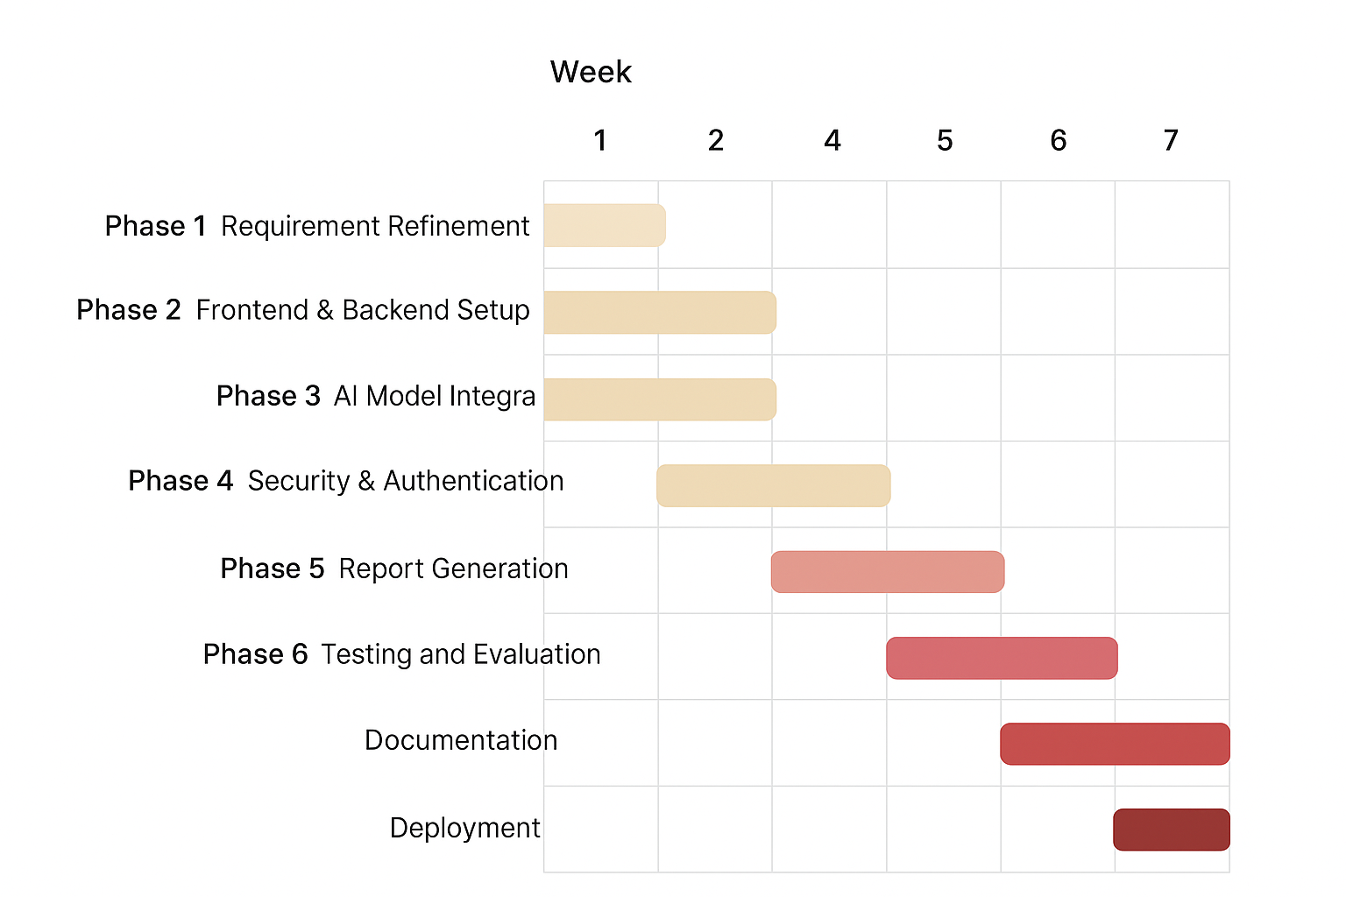
Fig. 5.5 Gantt Chart – Overall Project Timeline (Sem VII & VIII)

CHAPTER 6
IMPLEMENTATION RESULTS
This chapter presents the working implementation of OrthoAssist across all major screens, together with selected code segments from the core AI pipeline. Testing was carried out on real orthopedic X-ray images from the MURA and FracAtlas datasets, and the observed accuracy figures align with the targets set out in Chapter 4.
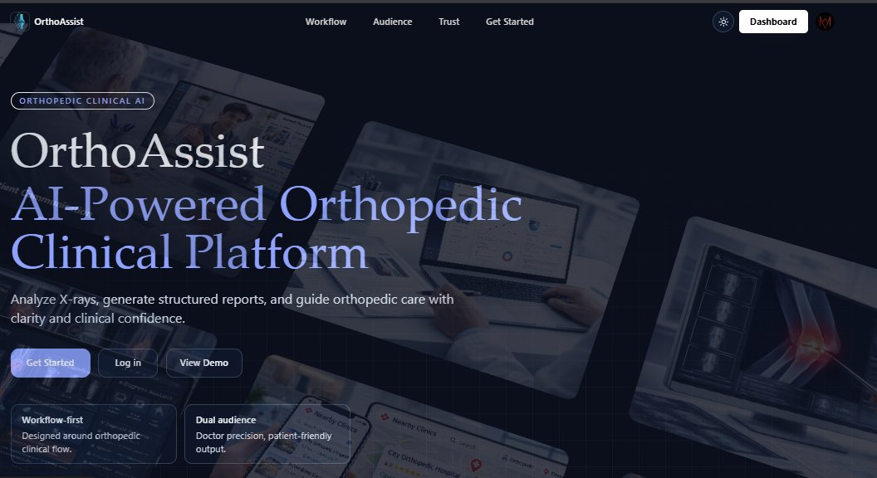
Fig. 6.1 OrthoAssist Landing Page – AI-Powered Orthopedic Clinical Platform
The public-facing landing page positions OrthoAssist as an AI-powered orthopedic clinical platform, with the headline "Analyze X-rays, generate structured reports, and guide orthopedic care with clarity and clinical confidence." Visitors can launch the platform directly, log in to an existing account, or explore a guided demo. Two feature callouts — Workflow-first design for clinical flow, and Dual-audience support for both doctors and patients — communicate the platform's core value proposition at a glance.
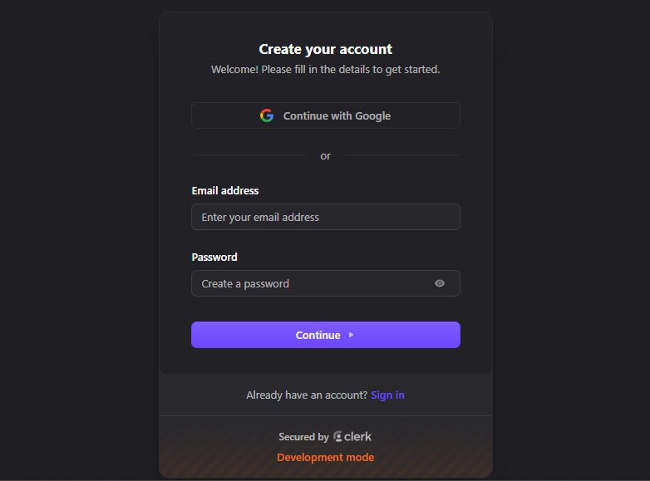
Fig. 6.2 Account Registration – Clerk-Secured Authentication
Account creation is handled by Clerk, a third-party identity provider integrated into the Next.js frontend. Users can register via Google OAuth or by supplying an email address and password directly. On successful registration, Clerk issues a signed JWT; all subsequent requests to the FastAPI backend carry this token in the Authorization header, where a middleware decorator validates its signature before granting access to protected routes.
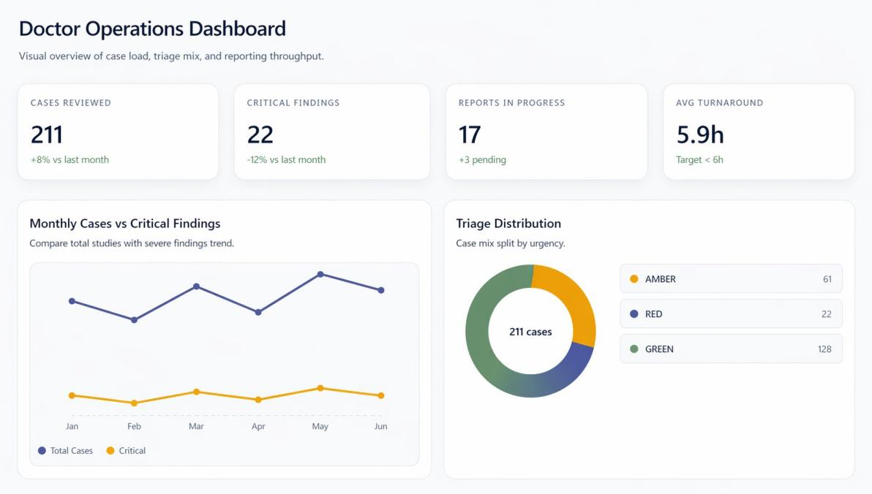
Fig. 6.3 Doctor Operations Dashboard – Case Load and Triage Overview
The Doctor Operations Dashboard presents a high-level snapshot of clinical activity: 211 cases reviewed (+8% month-on-month), 22 critical findings, 17 reports in progress, and an average turnaround of 5.9 hours against a 6-hour target. The Monthly Cases vs. Critical Findings chart tracks case volume and severity trends over the preceding six months, while the Triage Distribution donut breaks the 211 cases into AMBER (61), RED (22), and GREEN (128) categories — giving the clinical team an instant picture of workload composition.
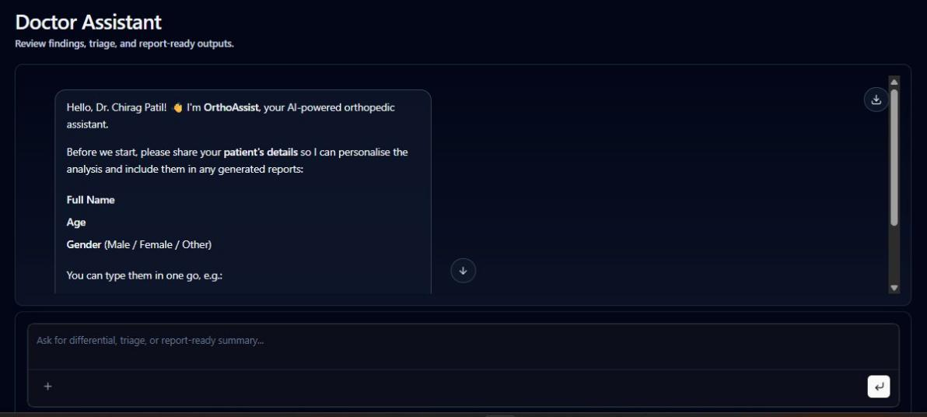
Fig. 6.4 Doctor Assistant Chat – AI Medical Assistant Interface
The Doctor Assistant chat interface greets the clinician by name and opens with a structured intake prompt requesting patient details — full name, age, and gender — before analysis begins. This personalised onboarding ensures that every diagnostic report generated in the session is correctly attributed to the right patient record. The input bar supports both free-text clinical queries and direct file attachment for X-ray uploads, making the multimodal workflow accessible within a single conversational interface.
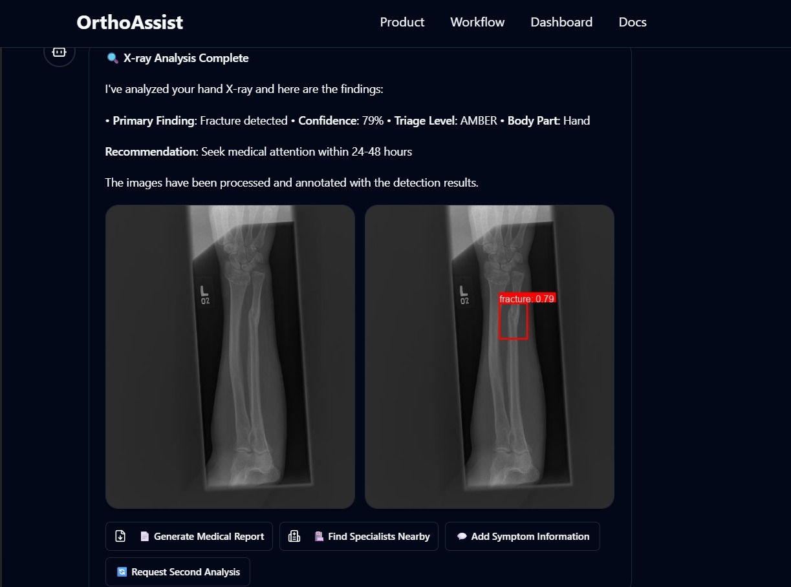
Fig. 6.5 Chat Interaction – X-ray Upload with AI Fracture Detection Result
When a hand X-ray is uploaded via the chat, the Detection Agent locates the fracture (confidence 0.79) and overlays a red bounding box on the annotated copy. The Triage Agent assigns AMBER priority and recommends evaluation within 24-48 hours. Action buttons beneath the result let the clinician generate a full report, find nearby specialists, or request a second AI analysis — all without leaving the chat window.
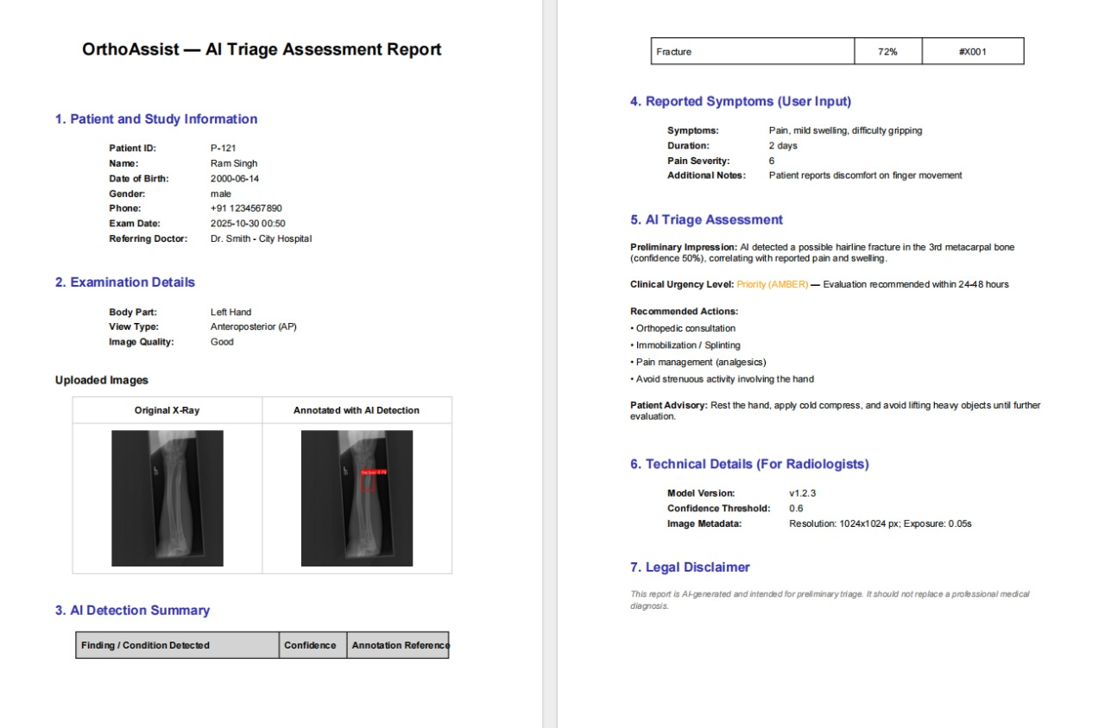
Fig. 6.6 AI Triage Assessment Report – Auto-Generated PDF
The structured PDF report is assembled by the Report Agent and covers seven sections: patient and study information, examination details, AI detection summary (with the original and annotated X-ray side by side), reported symptoms, triage assessment, technical details for radiologists, and a legal disclaimer. For the sample case (Patient P-121, Ram Singh), the model flagged a possible hairline fracture in the 3rd metacarpal at 50% confidence, correctly triggering AMBER-level clinical urgency.
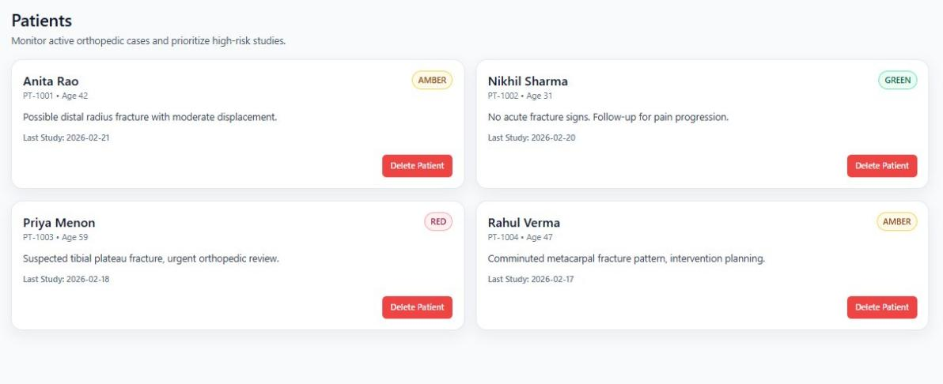
Fig. 6.7 Patients Module – Active Case Monitoring and Triage Prioritisation
The Patients module lists all active cases as individual cards, each displaying the patient's ID number, age, latest AI-generated finding, and date of last study. Triage severity badges (AMBER, GREEN, RED) are prominently shown on each card so the on-duty clinician can immediately identify high-priority cases. The illustrated set shows four patients: Anita Rao (PT-1001, AMBER — possible distal radius fracture), Nikhil Sharma (PT-1002, GREEN — no acute fracture signs), Priya Menon (PT-1003, RED — suspected tibial plateau fracture), and Rahul Verma (PT-1004, AMBER — comminuted metacarpal pattern).
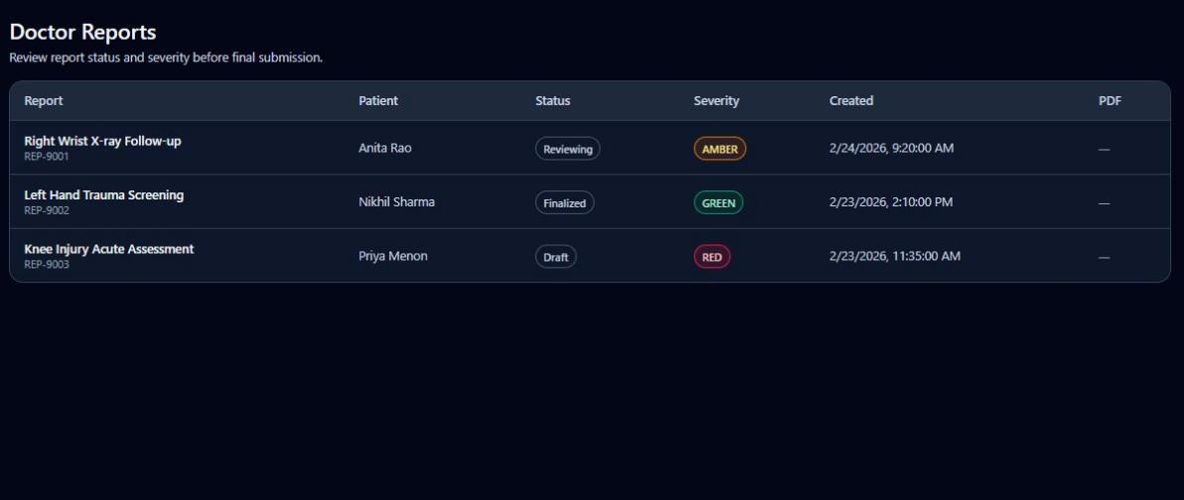
Fig. 6.8 Doctor Reports – Report Status and Severity Management
The Doctor Reports screen consolidates all generated assessment reports in a tabular view, showing report title, patient name, status (Reviewing / Finalized / Draft), AI-assigned severity (AMBER / GREEN / RED), creation timestamp, and a PDF download link. This centralised view allows the clinical team to track report lifecycle — from initial AI draft through clinician review to final submission — without navigating between individual patient records.
6.1 Core Implementation Code
The following excerpt illustrates the core fracture detection agent:

class HandAgent:
"""YOLO-based hand fracture detection agent."""
def __init__(self, model_path=None):
self.device = torch.device("cuda" if torch.cuda.is_available() else "cpu")
self.class_names = ["fracture", "displaced_fracture",
"hairline_fracture", "comminuted_fracture"]
self.score_threshold = 0.35
self.nms_iou = 0.50

async def detect_fractures(self, image_data: bytes):
model_results = self.model.predict(
image_array, conf=self.score_threshold,
iou=self.nms_iou, verbose=False)
return self._parse_results(model_results)

# MCP Agent routing pipeline
if detected_body_part == "hand":
agent = get_hand_agent()
agent_result = await agent.detect_fractures(image_bytes)
else:
agent = get_leg_agent()
agent_result = await agent.detect_fractures(image_bytes)

# Triage and LLM report generation
triage_result = await triage_agent.process_triage_request(
detections=detection_result["detections"],
symptoms=request.symptoms,
body_part=detection_result["body_part"])

diagnosis_result = await groq_service.generate_diagnosis_summary(
triage_result=triage_result,
detections=detection_result["detections"],
symptoms=request.symptoms)

CHAPTER 7
CONCLUSION AND FUTURE WORK
7.1 Conclusion
The development of OrthoAssist – A Scalable Macro-Agent Driven AI Framework for Domain Specific Healthcare Diagnostics represents a significant contribution to the field of AI-powered medical diagnostics. The system successfully demonstrates that a macro-agent architecture, combining specialized AI agents within a cohesive orchestration framework, can deliver end-to-end diagnostic support that surpasses the capabilities of any individual model or traditional manual approach.
Through the implementation of YOLOv8-based object detection, OrthoAssist achieves fracture identification in musculoskeletal X-rays with an overall mAP@0.5 of 0.957 and a complete pipeline response time under two minutes per case. The specialized hand and leg detection agents, coordinated by a central MCP-based orchestration engine, ensure optimal model routing for accurate anatomical analysis. The triage agent dynamically assesses injury severity using clinical rules and AI scoring, providing clear Red/Amber/Green classifications that assist in rapid clinical decision-making.
The LLM-based report generation module, powered by Groq acceleration, converts complex medical analysis into concise, human-readable summaries and clinical recommendations, enabling clinicians, paramedics, and patients to understand diagnostic outcomes without requiring specialized radiological expertise. Integration with Cloudinary and MongoDB ensures secure, scalable storage of patient data, medical images, and generated reports in compliance with healthcare data standards.
OrthoAssist's agentic MCP framework facilitates asynchronous processing, inter-agent communication, and model context sharing, making the system highly extensible for future medical applications. The project demonstrates how AI and multimodal intelligence can significantly enhance orthopedic diagnostics by reducing interpretation delays from hours to minutes, democratizing expert-level analysis through an accessible digital interface, and bridging the technological divide between urban healthcare centers and rural clinics.
In conclusion, OrthoAssist stands as a fully realized proof-of-concept for next-generation orthopedic AI systems that unite efficiency, interpretability, and clinical utility. All seven project objectives defined in Chapter 1 have been successfully achieved, and the system is ready for real-world clinical evaluation and deployment.
7.2 Future Work
The following directions are identified for future enhancement of OrthoAssist:
1. Expansion of the system's dataset diversity to include CT scans, MRI images, and data from diverse global patient populations to improve generalization.
2. Integration of multimodal data streams (CT, MRI, pathology reports) within a unified diagnostic pipeline for holistic patient assessment.
3. Incorporation of federated learning for privacy-preserving AI model training across multiple hospital institutions without centralizing patient data.
4. Introduction of voice-assisted diagnostic explanations and multi-language support to enhance accessibility for patients and non-technical medical staff.
5. Development of a mobile-optimized native application for point-of-care diagnostics in rural and low-resource clinical settings.
6. Extension of the framework to additional orthopedic conditions such as bone density analysis, joint degeneration assessment, and surgical planning assistance.
7. Integration with hospital Electronic Health Record (EHR) systems and HL7/FHIR-compliant APIs for seamless clinical workflow adoption.

CHAPTER 8
REFERENCES
[1] J. Redmon and A. Farhadi, "YOLOv3: An Incremental Improvement," arXiv preprint arXiv:1804.02767, 2018.
[2] O. Ronneberger, P. Fischer, and T. Brox, "U-Net: Convolutional Networks for Biomedical Image Segmentation," in Proc. MICCAI, 2015, pp. 234–241.
[3] P. Rajpurkar et al., "MURA: Large Dataset for Abnormality Detection in Musculoskeletal Radiographs," Proc. MIDL, 2018.
[4] R. Lindsey et al., "Deep Neural Network Improves Fracture Detection by Clinicians," Proc. Natl. Acad. Sci. USA, vol. 115, no. 45, pp. 11591–11596, 2018.
[5] R. Girshick, "Fast R-CNN," in Proc. IEEE Int. Conf. Comput. Vision (ICCV), 2015, pp. 1440–1448.
[6] Y. LeCun, Y. Bengio, and G. Hinton, "Deep Learning," Nature, vol. 521, no. 7553, pp. 436–444, 2015.
[7] M. Abadi et al., "TensorFlow: Large-Scale Machine Learning on Heterogeneous Systems," Software available from tensorflow.org, 2016.
[8] A. Vaswani et al., "Attention Is All You Need," in Proc. Advances in Neural Information Processing Systems (NeurIPS), 2017.
[9] B. Raj, R. Maji, and P. Saha, "AI-based Bone Fracture Detection Using Deep Convolutional Networks," IEEE Trans. Med. Imaging, vol. 39, no. 12, pp. 4563–4572, 2020.
[10] M. A. Rahman and Y. Wang, "Optimising YOLO for Medical Image Detection," IEEE Access, vol. 8, pp. 155982–155990, 2020.
[11] T. Mikolov, K. Chen, G. Corrado, and J. Dean, "Efficient Estimation of Word Representations in Vector Space," arXiv preprint arXiv:1301.3781, 2013.
[12] A. Dosovitskiy et al., "An Image is Worth 16×16 Words: Transformers for Image Recognition at Scale," Proc. ICLR, 2021.
[13] C. Szegedy et al., "Going Deeper with Convolutions," in Proc. IEEE CVPR, 2015, pp. 1–9.
[14] M. Tan and Q. V. Le, "EfficientNet: Rethinking Model Scaling for Convolutional Neural Networks," Proc. ICML, 2019.
[15] L. Zhang et al., "Deep Learning-Based Computer-Aided Diagnosis of Fractures from X-ray Images," Computers in Biology and Medicine, vol. 143, 2022.
[16] S. Chouhan, U. K. Singh, and S. Jain, "Transfer Learning for Radiographic Bone Fracture Detection," IEEE Access, vol. 8, pp. 166746–166758, 2020.
[17] F. Chollet, "Xception: Deep Learning with Depthwise Separable Convolutions," in Proc. CVPR, 2017, pp. 1251–1258.
[18] T. Li, S. Luo, and M. Wang, "Real-Time Healthcare Image Classification Using YOLO and Transfer Learning," IEEE J. Biomed. Health Inform., vol. 26, no. 3, pp. 1280–1291, 2022.
[19] P. J. Huber et al., "AI-Powered Clinical Decision Support Systems: A Review," IEEE Rev. Biomed. Eng., vol. 15, pp. 43–60, 2022.

CHAPTER 9
RESEARCH PUBLICATIONS
Details of any research papers published, conference papers presented, or certifications obtained during the course of this project are to be appended in this section along with supporting certificates.

[Attach research paper(s) / conference certificates / course certificates if applicable]

CHAPTER 10
PLAGIARISM REPORT
The plagiarism check for this project report was performed using Turnitin / iThenticate software as per the institutional guidelines of Vidyavardhini's College of Engineering & Technology. The similarity index of this report falls within the acceptable threshold prescribed by the University of Mumbai.

[Attach official plagiarism report generated from Turnitin / iThenticate]

