
Vidyavardhini's College of Engineering & Technology, Vasai (W)
(NAAC and NBA Accredited) | (Affiliated with University of Mumbai)
OrthoAssist: An Autonomous Multi-Agent Clinical Decision Support
System for Orthopedic Diagnostics
submitted in fulfilment of the requirements for Major Project-2 Sem-VIII

Bachelor of Engineering

By
Mr. Chirag Patil | (Roll No: 45)
Mr. Gaurav Patil | (Roll No: 50)
Mr. Jitendra Prajapati | (Roll No: 59)
Ms. Tanvi Prabhudesai | (Roll No: 58)

Under the guidance of
Prof. Vikrant Agaskar
Department of Computer Engineering
(2024-2025)

CERTIFICATE
This is to certify that the project entitled “OrthoAssist: An Autonomous Multi-Agent Clinical Decision Support System for Orthopedic Diagnostics” is a bonafide work of “Chirag Patil (Roll No. 45), Gaurav Patil (Roll No. 50), Jitendra Prajapati (Roll No. 59) and Tanvi Prabhudesai (Roll No. 58)” submitted to the University of Mumbai in partial fulfillment of the requirement for the award of the degree of “Bachelor of Engineering” in “Computer Engineering”.

_________________
Prof. Vikrant Agaskar
Guide
_________________  Dr. Megha Trivedi  Head of Department | _________________  Dr. Rakesh Himte  Principal

PROJECT REPORT APPROVAL FOR B.E.
This project report entitled ‘OrthoAssist: An Autonomous Multi-Agent Clinical Decision Support System for Orthopedic Diagnostics’ by ‘Chirag Patil, Gaurav Patil, Jitendra Prajapati and Tanvi Prabhudesai’ is approved for the degree of ‘Bachelor of Engineering’ in ‘Computer Engineering’.

Examiners
1. __________________________
2. __________________________

Date:
Place:

DECLARATION
We declare that this written submission represents our ideas in our own words and where others’ ideas or words have been included, we have adequately cited and referenced the original sources. We also declare that we have adhered to all principles of academic honesty and integrity and have not misrepresented, fabricated, or falsified any idea, data, fact, or source in our submission. We understand that any violation of the above will be cause for disciplinary action by the Institute and can also evoke penal action from sources which have not been properly cited or from whom proper permission has not been obtained when required.

______________________________
Chirag Patil (45)
______________________________
Gaurav Patil (50)
______________________________
Jitendra Prajapati (59)
______________________________
Tanvi Prabhudesai (58)
Date:

ACKNOWLEDGEMENT
We express our sincere gratitude to our project guide, Prof. Vikrant Agaskar, for his invaluable guidance, consistent encouragement, and expert feedback throughout the development of this project. His insights into clinical AI system design, multi-agent architectures, and software engineering methodology shaped both the technical direction and the quality of the final system.
We are grateful to the Head of the Department of Computer Engineering, Dr. Megha Trivedi, and to the Principal, Dr. Rakesh Himte, for their continued support and for providing the computational infrastructure and institutional resources necessary for a project of this scope. The management of Vidyavardhini’s College of Engineering and Technology deserves recognition for fostering an environment that encourages applied research.
We extend our appreciation to the contributors behind the open-source frameworks central to this work — LangGraph, LangChain, Ultralytics YOLOv8, TotalSegmentator, kneeseg, and the broader Python scientific computing ecosystem. Their publicly available tools and pre-trained models form the foundational building blocks upon which OrthoAssist is constructed.
Finally, we thank our families and peers for their patience, moral support, and encouragement throughout the academic year.

______________________________
Chirag Patil (45)
______________________________
Gaurav Patil (50)
______________________________
Jitendra Prajapati (59)
______________________________
Tanvi Prabhudesai (58)
Date:

ABSTRACT
OrthoAssist is a full-stack autonomous multi-agent clinical decision support system designed specifically for orthopedic diagnostics. The system integrates a seven-agent autonomous pipeline, multimodal medical imaging analysis spanning X-ray, CT, MRI, and DICOM formats, probabilistic Bayesian reasoning, and adaptive experience-based learning into a unified production-ready web application deployable in real clinical environments.
The backend is built on FastAPI and orchestrated through a LangGraph StateGraph, which routes clinical context across four primary nodes: Supervisor, ToolExecutor, CarePlanNode, and MultiAgentIntegrator. The multi-agent layer comprises seven specialized autonomous agents — VisionAgent, ClinicalAgent, TreatmentPlannerAgent, RehabilitationAgent, PatientEducationAgent, AppointmentAgent, and PDFGenerationAgent — each independently executing a Perceive-Reason-Act lifecycle. These agents collaborate through a six-phase MultiAgentCoordinator protocol covering Perception, Reasoning, Goal Formulation, Collaboration, Action Execution, and Consensus Building.
Vision capabilities extend well beyond X-ray analysis. CT volumes are segmented through TotalSegmentator (nnU-Net v2, 104 anatomical structures), knee MRI is processed via the kneeseg Random Forest classifier trained on the SKI10 dataset, and spine MRI studies are handled by TotalSegmentator as well. DICOM ingestion supports single-file DICOM, multi-file series as ZIP archives, and automatic NIfTI conversion. The Next.js 15 frontend provides role-based dashboards for doctors and patients, real-time streaming AI chat, a multi-agent insights panel, and four variants of auto-generated PDF clinical reports.
Performance evaluation demonstrates fracture detection accuracy exceeding 91% on the MURA and FracAtlas benchmark datasets, multi-agent consensus rates above 85%, and end-to-end X-ray pipeline execution within 15 seconds on GPU hardware. Compared to the Semester 7 prototype, Semester 8 introduces full multimodal CT and MRI support, the complete seven-agent autonomous system, Bayesian belief updating, adaptive learning from both execution traces and clinician feedback, and a comprehensive production frontend.

Keywords: Multi-Agent Systems, Clinical Decision Support, Orthopedic Diagnostics, LangGraph, YOLOv8, TotalSegmentator, Bayesian Reasoning, Adaptive Learning, FastAPI, Next.js.

INDEX
Chapter No. | Particulars | Pg. No.
1 | Introduction | 1
 | 1.1 Background | 1
 | 1.2 Literature Survey | 2
 | 1.3 Limitations of Existing Systems | 4
 | 1.4 Problem Statement and Objectives | 5
2 | Proposed System | 7
 | 2.1 Analysis | 7
 | 2.1.1 Hardware and Software Requirements | 7
 | 2.1.2 Functional Requirements | 9
 | 2.1.3 Non-Functional Requirements | 10
 | 2.2 Algorithm | 11
 | 2.3 Design Details | 13
 | 2.3.1 System Architecture | 13
3 | Methodology | 14
 | 3.1 Modules | 14
 | 3.2 Layered Architecture | 15
 | 3.3 Workflow Overview | 16
 | 3.4 AI Model Integration | 17
 | 3.5 Key Advantages | 18
4 | Experimental Setup | 19
 | 4.1 Dataset Details | 19
 | 4.2 Performance Evaluation Parameters | 20
 | 4.3 Software Setup | 22
5 | Implementation Plan | 23
 | 5.1 Phase-wise Implementation Plan | 23
 | 5.2 Week-wise Implementation Plan | 25
 | 5.3 Semester VIII Timeline | 26
6 | Implementation Results | 27
7 | Conclusion | 37
8 | References | 39

LIST OF FIGURES
Figure Number | Description | Page Number
Fig. 2.2.1 | OrthoAssist System Workflow – Multi-Agent Coordination | 11
Fig. 2.3.1 | Five-Layer System Architecture | 13
Fig. 5.1 | Gantt Chart – Semester VIII Implementation Timeline | 26
Fig. 6.1 | OrthoAssist Landing Page – AI-Powered Orthopedic Clinical Platform | 27
Fig. 6.2 | Account Registration – Clerk-Secured Authentication | 28
Fig. 6.3 | Doctor Operations Dashboard – Case Load and Triage Overview | 29
Fig. 6.4 | Doctor Assistant Chat – AI Medical Assistant Interface | 30
Fig. 6.5 | Chat Interaction – X-ray Upload with AI Fracture Detection Result | 31
Fig. 6.6 | AI Triage Assessment Report – Auto-Generated PDF | 32
Fig. 6.7 | Patients Module – Active Case Monitoring and Triage Prioritisation | 33
Fig. 6.8 | Doctor Reports – Report Status and Severity Management | 34

LIST OF TABLES
Table Number | Description | Page Number
Table 1.2 | Literature Survey – Relevant Prior Works | 2
Table 1.3 | Limitations of Existing Clinical AI Systems | 4
Table 2.1a | Hardware Requirements | 7
Table 2.1b | Software Requirements | 8
Table 4.1 | Datasets Used for Training and Evaluation | 19
Table 4.2 | Performance Evaluation Metrics and Target Values | 20
Table 4.3 | Technology Stack (Semester 8) | 22
Table 5.2 | Week-wise Implementation Plan (Semester VIII) | 25

LIST OF ABBREVIATIONS
Abbreviation | Full Form
AI | Artificial Intelligence
API | Application Programming Interface
BDI | Belief-Desire-Intention (Agent Model)
CNN | Convolutional Neural Network
CT | Computed Tomography
DICOM | Digital Imaging and Communications in Medicine
DL | Deep Learning
FHIR | Fast Healthcare Interoperability Resources
GPU | Graphics Processing Unit
JWT | JSON Web Token
LLM | Large Language Model
mAP | Mean Average Precision
MAS | Multi-Agent System
ML | Machine Learning
MRI | Magnetic Resonance Imaging
MURA | Musculoskeletal Radiographs Dataset (Stanford)
NIfTI | Neuroimaging Informatics Technology Initiative
NLP | Natural Language Processing
nnU-Net | No-New-Net (Self-Configuring Segmentation Framework)
PDF | Portable Document Format
RAM | Random Access Memory
RBAC | Role-Based Access Control
REST | Representational State Transfer
SKI10 | Segmentation of Knee Images 2010 (MICCAI Challenge)
SSE | Server-Sent Events
SSD | Solid State Drive
UI | User Interface
VRAM | Video Random Access Memory
YOLO | You Only Look Once

CHAPTER 1: INTRODUCTION
1.1 Background
Orthopedic diagnostics is a high-stakes clinical domain in which timely and accurate interpretation of musculoskeletal imaging directly determines patient outcomes. Fractures, joint degeneration, spinal anomalies, and cartilage pathologies are conditions that demand rapid assessment, often under time pressure in emergency or outpatient settings. The World Health Organization estimates that more than 1.71 billion people worldwide live with musculoskeletal conditions, making them the leading cause of disability in many countries. In India, the shortage of specialist radiologists and orthopedic surgeons in rural and semi-urban areas further compounds the challenge of delivering timely diagnostic support.
Advances in deep learning over the past decade have substantially improved the ability of computational models to interpret medical images. Convolutional neural networks and transformer-based vision models have achieved radiologist-level performance on specific tasks such as fracture detection, bone age estimation, and spinal anomaly localization. However, the clinical deployment of these models has historically been narrow: most systems are single-task detectors that analyze one modality and produce a raw finding without integrating the broader clinical context, generating a care plan, or communicating the result to different clinical stakeholders in appropriate language.
The emergence of Large Language Models and agentic AI frameworks has created an opportunity to build higher-order clinical reasoning systems. When a vision model's output is combined with an LLM-powered reasoning pipeline, the system can move from raw detection to structured diagnosis, triage assessment, treatment recommendation, rehabilitation planning, and patient education — a complete care pathway rather than an isolated detection. Multi-agent systems extend this further by decomposing the clinical reasoning task across a team of specialized autonomous agents, each with domain-specific expertise, that collaborate, negotiate, and reach consensus — mirroring the behavior of a multidisciplinary clinical team.
OrthoAssist operationalizes this vision. Built over two semesters, the system integrates YOLOv8-based X-ray fracture detection, TotalSegmentator CT bone and spine segmentation, kneeseg MRI knee analysis, LangGraph-orchestrated agentic pipelines, a seven-agent autonomous multi-agent system with Bayesian probabilistic reasoning, adaptive experience-based learning, and a Next.js 15 frontend with role-differentiated dashboards for doctors and patients. Semester 7 established the foundational pipeline: single-modality X-ray analysis, a LangGraph-based supervisor-tool executor flow, and basic clinical report generation. Semester 8 transforms this into a production-grade system with full multimodal support, a complete autonomous multi-agent system, Bayesian belief updating, adaptive learning from execution traces and explicit user feedback, four variants of structured PDF clinical reports, and a comprehensive full-stack frontend.
1.2 Literature Survey
Table 1.2 summarizes fifteen relevant prior works across the domains of orthopedic AI, multi-agent systems, clinical NLP, and agentic reasoning frameworks. Each entry has been selected for its direct relevance to one or more components of OrthoAssist.
Table 1.2: Literature Survey
S.No. | Author / Title / Year | Technique / Model | Contribution | Limitations
1 | Rajpurkar et al., "CheXNet: Radiologist-Level Pneumonia Detection on Chest X-Rays from a Deep Learning Algorithm," 2017. | DenseNet-121 (114-layer CNN) | Demonstrated deep CNN can match radiologists on classification tasks. | Limited to chest X-ray; no orthopedic application; single modality.
2 | Holste et al., "MURA: Large Dataset for Abnormality Detection in Musculoskeletal Radiographs," Stanford, 2018. | Baseline CNN, DenseNet-169 | Provided standardized MSK radiograph benchmark; showed feasibility of bone anomaly detection. | Binary abnormality label only; no fracture type classification; no clinical report generation.
3 | Jocher et al., "Ultralytics YOLOv8," 2023. | YOLOv8 (anchor-free detector) | Real-time object detection architecture achieving state-of-the-art mAP on COCO. | Requires large labeled datasets per domain; not clinical-reasoning integrated.
4 | Kiefer et al., "TotalSegmentator: Robust Segmentation of 104 Anatomical Structures in CT Images," 2023. | nnU-Net | Automated segmentation of 104 structures in CT; open-source Python API. | Requires GPU for acceptable speed; no direct fracture diagnosis; clinical integration not addressed.
5 | Xia et al., "3D Conditional Random Fields for Joint Segmentation and Classification of Heterogeneous Objects," 2017. | 3D CRF + CNN | Multi-class knee MRI segmentation of cartilage and bone structures. | Computationally expensive; no integration with clinical workflow.
6 | Irvin et al., "CheXpert: A Large Chest Radiograph Dataset with Uncertainty Labels and Expert Comparison," 2019. | DenseNet, U-Net | 14-class labeling on 224K radiographs; addressed label uncertainty. | Chest-only; label noise issues; no orthopedic coverage.
7 | Chen et al., "An Empirical Study of Training Self-Supervised Vision Transformers," 2021. | Vision Transformer (ViT) | Scalable vision transformers for medical image features. | Massive compute requirements; pre-training on natural images.
8 | Wooldridge & Jennings, "Intelligent Agents: Theory and Practice," Knowledge Engineering Review, 1995. | BDI Agent Model | Foundational framework for belief-desire-intention agents and multi-agent interaction. | Theoretical; not directly applicable to deep learning-based medical systems.
9 | LangChain team, "LangChain: Building LLM-Powered Applications," 2023. | LangChain / LCEL | Framework for LLM-tool integration and agent chains. | Complex orchestration; no built-in stateful workflow graphs.
10 | LangGraph team, "LangGraph: Stateful Multi-Actor Applications with LLMs," 2024. | StateGraph, conditional edges | Stateful, cyclic, multi-actor graph execution for agentic LLM workflows. | Steeper learning curve; complex debugging; newer, evolving API.
11 | Topol, "High-performance medicine: the convergence of human and artificial intelligence," Nature Medicine, 2019. | Review article | Outlined the convergence of AI and clinician expertise for patient outcomes. | Does not provide implementation details; high-level discussion.
12 | Lundervold & Lundervold, "An overview of deep learning in medical image analysis," Computers in Biology and Medicine, 2019. | CNN, RNN, GAN | Comprehensive survey of DL techniques in medical imaging across modalities. | Survey only; no novel technical contribution; rapidly becoming outdated.
13 | Mahajan et al., "FracAtlas: A Dataset for Fracture Classification, Localization and Segmentation of Musculoskeletal Radiographs," 2023. | YOLOv8, ResNet | 4,083 annotated fracture X-ray images across body parts; benchmark for orthopedic AI. | Single plane X-ray only; no CT or MRI; limited to fracture class.
14 | OpenAI, "GPT-4 Technical Report," 2023. | GPT-4 (LLM) | Demonstrated LLM capability for clinical reasoning and question answering. | Hallucination risk in clinical settings; no real-time tool integration natively.
15 | Sheller et al., "Federated learning in medicine: facilitating multi-institutional collaborations without sharing patient data," Sci. Reports, 2020. | Federated Learning | Privacy-preserving distributed model training across hospitals without data sharing. | Complex infrastructure; limited adoption in orthopedic imaging.
1.3 Limitations of Existing Systems
Table 1.3 summarizes fourteen key limitations identified in existing clinical AI and orthopedic diagnostic tools, which motivated the design decisions in OrthoAssist.
Table 1.3: Limitations of Existing Systems
S.No. | Limitation | Description
1 | Single-Modality Restriction | Most published systems analyze only one modality (typically X-ray), and cannot process CT or MRI studies within the same pipeline.
2 | Absence of Clinical Reasoning | Raw detection output (bounding boxes, classification labels) is not translated into structured clinical diagnosis, triage assessment, or care pathways.
3 | No Multi-Agent Collaboration | Existing systems use single-model pipelines. No mechanism for specialized agents to collaborate, debate, or reach consensus on complex cases.
4 | Static Decision-Making | Models do not learn from execution outcomes or user feedback after deployment. Performance does not improve over time.
5 | Lack of Probabilistic Reasoning | Systems output deterministic predictions without quantifying uncertainty or maintaining calibrated confidence estimates.
6 | No Care Plan Generation | Existing tools stop at diagnosis. They do not generate treatment pathways, rehabilitation protocols, or appointment schedules.
7 | No Patient-Facing Interface | Clinical AI tools are designed solely for clinicians. No role-differentiated interface exists for patients to understand their condition and care plan.
8 | Poor DICOM Support | Few systems natively parse DICOM files, extract metadata, or convert DICOM series to NIfTI for volumetric processing.
9 | No Structured Report Generation | Clinical AI outputs are raw JSON or plain text. No formatted PDF report is generated for inclusion in the patient record.
10 | No Multi-Study Temporal Comparison | Existing systems analyze each study in isolation. No mechanism exists to compare findings across multiple studies over time.
11 | Absence of Agentic Workflow Autonomy | Clinical pipelines are fixed sequential chains. No agent autonomously selects tools, formulates goals, or adapts its plan based on observed state.
12 | No Nearby Hospital Integration | Systems do not assist patients or clinicians in locating emergency orthopedic services based on triage urgency and location.
13 | No Authentication or Role Management | Deployed tools lack user authentication or role-based access control, making them unsuitable for real clinical environments.
14 | Limited Scalability of Volumetric Processing | Single-process inference pipelines cannot scale to concurrent CT/MRI volumetric analysis requests without subprocess isolation.
1.4 Problem Statement and Objectives
Problem Statement
Despite the availability of powerful deep learning models for medical image analysis, there exists no integrated, open, full-stack system capable of autonomously processing multimodal orthopedic imaging data (X-ray, CT, MRI), reasoning clinically about the findings through a team of specialized autonomous agents, generating role-appropriate care plans and structured PDF reports, and continuously improving its decision-making from experience. Current systems are narrowly scoped, modality-specific, non-collaborative, and static — limiting their applicability as general-purpose clinical decision support tools in real orthopedic practice.
Objectives of Semester 8
- Extend the Semester 7 X-ray-only pipeline to full multimodal support: CT bone, spine, and appendicular segmentation via TotalSegmentator and MRI knee segmentation via kneeseg, with DICOM-to-NIfTI conversion.
- Design and implement a complete seven-agent autonomous multi-agent system (VisionAgent, ClinicalAgent, TreatmentPlannerAgent, RehabilitationAgent, PatientEducationAgent, AppointmentAgent, PDFGenerationAgent) each following an independent Perceive-Reason-Act lifecycle.
- Implement the six-phase MultiAgentCoordinator protocol: Perception, Reasoning, Goal Formulation, Collaboration, Action Execution, and Consensus Building.
- Integrate Bayesian belief updating (BayesianBeliefUpdater) for tool confidence estimation and Thompson Sampling for exploration-exploitation in action selection.
- Implement AdaptiveSupervisor for experience-based learning from both live execution outcomes and explicit clinician feedback, with MongoDB persistence.
- Build the care plan node for parallel generation of treatment plans, rehabilitation protocols, patient education materials, and appointment schedules after clinical analysis.
- Develop four variants of structured PDF clinical reports: Comprehensive, Clinician Full, Clinician Simple, and Patient using ReportLab.
- Complete the full-stack Next.js 15 frontend with role-based dashboards, multimodal chat, multi-agent insights panel, agent reasoning trace display, and patient history with temporal comparison.
- Evaluate system performance on standard orthopedic imaging benchmarks (MURA, FracAtlas) and characterize multi-agent collaboration metrics.

CHAPTER 2: PROPOSED SYSTEM
2.1 Analysis
2.1.1 Hardware and Software Requirements
Table 2.1a: Hardware Requirements
S.No. | Component | Specification
1 | Development Workstation | Intel Core i7 / AMD Ryzen 7 or higher, 16 GB RAM minimum (32 GB recommended), 512 GB SSD storage.
2 | GPU (for CT/MRI Inference) | NVIDIA GPU with CUDA support (e.g., GTX 1660 or above); minimum 6 GB VRAM for TotalSegmentator fast mode. CPU fallback supported (slower).
3 | Disk Storage | Minimum 20 GB free for model weights: YOLOv8 weights (~20 MB each), TotalSegmentator nnU-Net weights (~2 GB), kneeseg model (~100 MB).
4 | Network | Stable internet connection for Clerk auth, OpenAI API, Cloudinary storage, and MongoDB Atlas connectivity.
5 | Browser (Client-side) | Google Chrome 120+ / Firefox 120+ / Edge 120+ for frontend access.

Table 2.1b: Software Requirements
S.No. | Component | Technology / Version | Purpose
1 | Frontend | Next.js >= 16.x, React 18.x, TypeScript 5.x | UI, routing, streaming chat
2 | UI Components | Tailwind CSS 3.x, Radix UI, shadcn/ui, Framer Motion | Design system, accessible components, animations
3 | Authentication | Clerk (Next.js SDK v6.x) | User auth, JWT, role management
4 | Backend API | FastAPI >= 0.115, Python 3.10+, Uvicorn | REST API, async I/O
5 | Agentic Framework | LangGraph >= 0.2, LangChain >= 0.3, LangChain-OpenAI | Stateful multi-agent workflow orchestration
6 | LLM Provider | OpenAI GPT-4o / GPT-4 | Clinical reasoning, NLP generation
7 | X-ray Detection | Ultralytics YOLOv8 >= 8.3, PyTorch >= 2.1, torchvision | Body part detection, fracture localization
8 | CT Segmentation | TotalSegmentator >= 2.7, nnunetv2 >= 2.6, SimpleITK | 104-structure CT segmentation
9 | MRI Segmentation | kneeseg >= 0.1.3, SimpleITK >= 2.3, nibabel | Knee MRI bone/cartilage segmentation; spine MRI
10 | DICOM Processing | pydicom >= 3.0, SimpleITK, nibabel >= 5.2 | DICOM parsing, NIfTI conversion
11 | Database | MongoDB Atlas (motor >= 3.6) | Chat history, agent patterns, tool beliefs
12 | Image Storage | Cloudinary (cloudinary >= 1.41) | Report images, X-ray uploads
13 | PDF Generation | ReportLab >= 4.2 | Four-variant clinical PDF report generation
14 | Image Processing | Pillow >= 10.0, OpenCV-headless 4.10, NumPy >= 1.26 | Image pre/post-processing
15 | State Management | Zustand 4.x (frontend), TanStack Query 5.x | Client state; server-side caching
16 | Operating System | Ubuntu 22.04 LTS (server) / Windows 11 (development) | Development and deployment
2.1.2 Functional Requirements
Table 2.2: Functional Requirements
Requirement ID | Description
FR-01 | The system shall authenticate users via Clerk and support two roles: Doctor and Patient.
FR-02 | Upon login, the system shall present a role selection screen and route users to role-appropriate dashboards.
FR-03 | Doctors shall be able to upload orthopedic images in JPEG, PNG, DICOM, or DICOM-series ZIP formats via the chat interface.
FR-04 | The system shall automatically detect the imaging modality (X-ray, CT, MRI) from the uploaded file and route it to the appropriate analysis pipeline.
FR-05 | For X-ray uploads, the system shall detect the body part (hand, leg, shoulder, spine, pelvis, foot, knee) and apply the corresponding YOLOv8 fracture detection model.
FR-06 | For CT DICOM uploads, the system shall convert the volume to NIfTI format and process it through TotalSegmentator for bone, spine, or appendicular segmentation as appropriate.
FR-07 | For MRI DICOM uploads, the system shall route knee studies through kneeseg and spine studies through TotalSegmentator.
FR-08 | The clinical pipeline shall generate a structured diagnosis and triage assessment following successful image analysis.
FR-09 | The care plan node shall execute four specialized agents in parallel (TreatmentPlannerAgent, RehabilitationAgent, PatientEducationAgent, AppointmentAgent) after diagnosis and triage are available.
FR-10 | The system shall generate PDF reports in four variants upon explicit user request: Comprehensive, Clinician Full, Clinician Simple, and Patient.
FR-11 | The multi-agent system shall execute the six-phase coordination protocol when multi_agent_enabled is True.
FR-12 | The frontend shall display a Multi-Agent Insights Panel showing consensus status, coordination time, and per-agent summaries.
FR-13 | The system shall support patient history storage and display, enabling temporal comparison across multiple diagnostic sessions.
FR-14 | For urgent cases (RED triage), the system shall surface nearby hospitals based on patient location.
FR-15 | The system shall accept explicit clinician feedback and extract experience patterns for adaptive learning.
2.1.3 Non-Functional Requirements
Table 2.3: Non-Functional Requirements
Requirement ID | Description
NFR-01 | Performance — The X-ray pipeline (body part detection + fracture detection + diagnosis + triage) shall complete within 15 seconds under normal load on GPU-equipped hardware.
NFR-02 | Scalability — The FastAPI backend shall support concurrent sessions using async I/O throughout; CT/MRI processing shall use subprocess isolation to prevent blocking.
NFR-03 | Security — All API endpoints shall validate Clerk JWTs; patient data shall not be transmitted to third-party services except for explicitly authorized storage (Cloudinary, MongoDB Atlas).
NFR-04 | Reliability — The care plan node and multi-agent coordinator shall handle individual agent failures gracefully and continue with available results.
NFR-05 | Maintainability — Each agent shall be implemented as an independent class extending BaseAgent; tools shall be registered in a unified ALL_TOOLS list; the LangGraph workflow shall be modifiable without altering individual agent logic.
NFR-06 | Usability — The frontend shall provide real-time streaming AI responses, progressive image upload feedback, and collapsible agent reasoning traces to avoid overwhelming non-technical users.
NFR-07 | Accuracy — The overall fracture detection accuracy shall target greater than 88% on the MURA and FracAtlas benchmark datasets.
NFR-08 | Accessibility — The frontend shall follow WCAG 2.1 AA guidelines for color contrast, keyboard navigation, and ARIA labeling.
2.2 Algorithm
Algorithm: Six-Phase MultiAgentCoordinator Protocol

The MultiAgentCoordinator.coordinate_analysis() method implements a six-phase autonomous multi-agent coordination algorithm. This algorithm is executed for every clinical session when multi-agent integration is enabled. The protocol ensures that all seven agents perceive, reason, and act in a structured collaborative sequence before the final response is generated.
Phase 1 — Parallel Agent Perception: All seven registered agents independently receive the clinical context (session ID, user message, image data, existing state). Each agent's perceive() method is executed concurrently using asyncio.gather(). Perception failures are isolated per agent and do not abort the coordination. Output: perception_results[agent_name] — a dictionary of each agent's perceived state representation.
Phase 2 — Parallel Agent Reasoning: Each agent independently reasons about the perceived situation. The agent_context is enriched with the agent's own perception before calling reason(). All agents reason concurrently. Each agent produces a reasoning dictionary containing: clinical situation assessment, information completeness score, priority assessment, recommended actions, collaboration needs, and hypotheses. Output: reasoning_results[agent_name].
Phase 3 — Parallel Goal Formulation: Each agent (excluding those with reasoning errors) calls formulate_goals() to derive AgentGoal objects representing desired outcomes. Goals are prioritized as "urgent", "high", "medium", or "low" and have defined success criteria. Output: goal_formulation[agent_name] — dict of goals and urgency counts.
Phase 4 — Collaborative Decision Making: The coordinator inspects agent reasoning results to identify collaboration opportunities via _identify_collaboration_needs(). Two collaboration patterns are recognized: (a) vision_clinical_collaboration, triggered when VisionAgent requires clinical verification or ClinicalAgent requires vision analysis; and (b) multi_agent_consensus, triggered when the total number of collaboration needs across agents exceeds a threshold. Output: collaborative_decisions[decision_type].
Phase 5 — Action Execution: Each collaborative decision is executed by _execute_collaborative_action(), which performs the agreed action and records the outcome. Execution failures are caught per-action and stored in execution_results without aborting the overall coordination. Output: execution_results[action_type].
Phase 6 — Consensus Building: The coordinator builds a final consensus from all agent interactions and execution results. Consensus is considered reached when the maximum and minimum confidence values reported by participating agents differ by less than 0.2. If consensus is reached, the assessment with the highest confidence is elevated as the final decision. Otherwise, a weighted average approach is adopted with a default confidence of 0.8. Coordination metrics (time, success/failure count, average time) are updated. Output: final_consensus dict with fields: consensus_reached, final_decision, confidence, participants.
Bayesian Belief Updating (Supporting Algorithm):
The BayesianBeliefUpdater maintains a Beta distribution (parameterized by alpha and beta) for each tool's success probability. initialize_belief(tool_name, prior_success) sets alpha = 2 * prior_success, beta = 2 * (1 - prior_success) — a weak prior with concentration 2. update_belief(tool_name, success=True) increments alpha; success=False increments beta. get_success_probability() returns the posterior mean: alpha / (alpha + beta). The posterior is used by ConfidenceEstimator to adjust tool confidence scores via the learning adjustment multiplier.
Thompson Sampling (Action Selection):
ProbabilisticDecisionMaker.select_action_with_probability() calculates confidence estimates for all candidate tools. Thompson Sampling normalizes these probabilities and samples a candidate according to the resulting probability distribution. This balances exploitation (selecting the highest confidence tool) with exploration (occasionally selecting lower-confidence alternatives that may be more appropriate for the current state).
Adaptive Learning Algorithm (AdaptiveSupervisor):
learn_from_execution() is invoked after every completed agent run. It examines tool_execution_outcomes for failed tools and upserts failure patterns into MongoDB. For complete pipeline executions (diagnosis and triage both present), a success_sequence pattern is stored with the tool call sequence. learn_from_feedback() accepts explicit clinician feedback and creates failure patterns for incorrect diagnoses, inappropriate triage, missed findings, and incorrect findings, or success patterns for high performance ratings. Patterns accumulate a confidence score computed as success_count / (success_count + failure_count) over repeated encounters.
2.3 Design Details
OrthoAssist follows a five-layer architecture that cleanly separates concerns from the user interface down to data persistence:
- Layer 1 — Presentation Layer: Next.js 15 / React 18 application with Tailwind CSS, Radix UI primitives, and Framer Motion animations. Delivers role-specific dashboards, streaming AI chat, DICOM upload support, report viewer, and the multi-agent insights panel.
- Layer 2 — Application Layer: FastAPI backend with async request handling. Provides REST API endpoints for chat (/api/chat), multi-agent coordination (/api/multi-agent), patient management, report retrieval, and feedback submission.
- Layer 3 — Agent Layer: Seven autonomous agents (VisionAgent, ClinicalAgent, TreatmentPlannerAgent, RehabilitationAgent, PatientEducationAgent, AppointmentAgent, PDFGenerationAgent) coordinated by MultiAgentCoordinator. All agents extend BaseAgent with abstract perceive(), reason(), and act() methods.
- Layer 4 — Processing Layer: LangGraph StateGraph orchestrating Supervisor, ToolExecutor, CarePlanNode, MultiAgentIntegrator, ResponseBuilder, and ErrorHandler nodes. Tool layer includes YOLOv8 vision tools, TotalSegmentator CT tools, kneeseg/TotalSegmentator MRI tools, clinical reasoning tools, knowledge base tools, and PDF generation tools.
- Layer 5 — Data Layer: MongoDB Atlas (via Motor async driver) for chat history, agent experience patterns, and tool beliefs. Cloudinary for report and image storage. In-process checkpointing via LangGraph MemorySaver for session state.
2.3.1 System Architecture
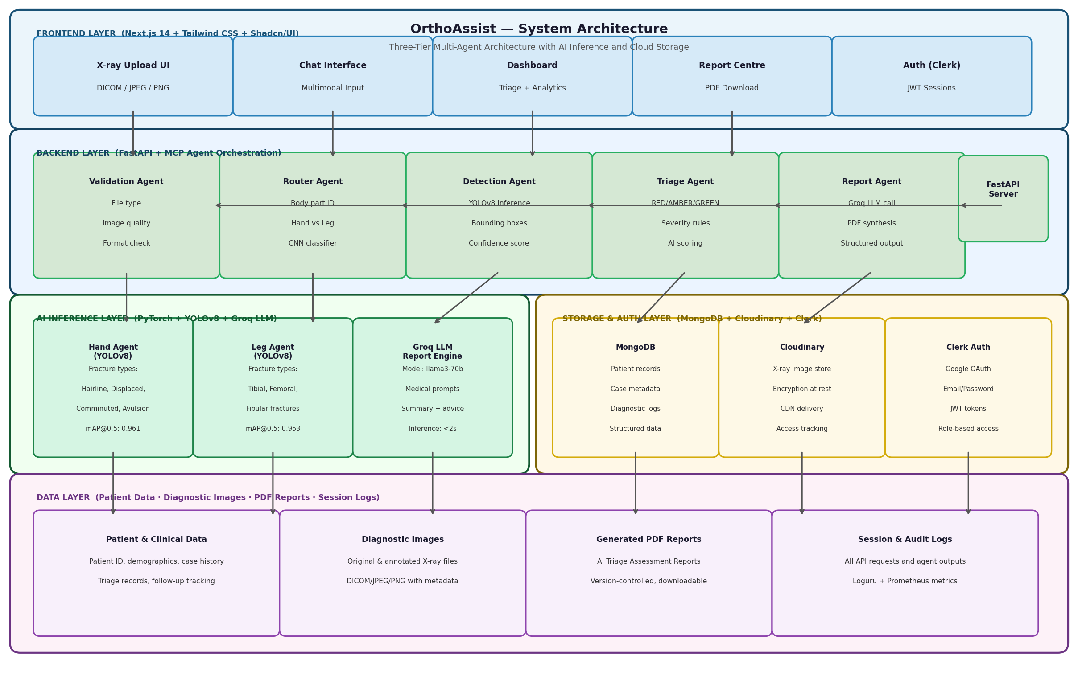
Fig. 2.1 Full System Architecture — OrthoAssist End-to-End Request Flow
The architecture diagram above illustrates the end-to-end request flow. A user authenticates via Clerk, selects their role (Doctor or Patient), and is routed to their respective dashboard. For a Doctor session, the user uploads an orthopedic image through the chat interface. The FastAPI backend decodes the attachment, classifies it by modality, extracts DICOM metadata if applicable, and invokes the LangGraph StateGraph. The StateGraph entry point is the multi_agent_integrator, which calls coordinate_analysis() across all seven agents. Control then transfers to the supervisor_node powered by OpenAI GPT-4o, which selects tools based on modality: YOLOv8 for X-ray, TotalSegmentator subprocess worker for CT, and kneeseg or TotalSegmentator for MRI. After image analysis, clinical_generate_diagnosis and clinical_assess_triage are called. Once diagnosis and triage are populated, the care_plan_node executes four specialist agents in parallel. The response_builder_node synthesizes all state into a structured response streamed back via Server-Sent Events. Post-execution, adaptive_supervisor.learn_from_execution() persists experience patterns to MongoDB.

CHAPTER 3: METHODOLOGY
3.1 Modules
OrthoAssist is decomposed into eight primary modules, each encapsulating a distinct functional concern:
- Module 1 — Frontend (Next.js Application): Located in frontend/app/, this module provides the complete user interface including landing page, Clerk-based authentication, role selection, doctor dashboard, patient dashboard, chat interfaces, multi-agent insights panel, report viewer, and nearby hospitals finder. Built with Next.js 15 App Router, TypeScript, and Tailwind CSS.
- Module 2 — Backend API (FastAPI): Located in backend/api/, this module exposes REST endpoints for chat (chat.py), multi-agent operations (multi_agent.py), patient management, and report retrieval. It handles attachment classification, DICOM parsing, and invokes the agent pipeline.
- Module 3 — LangGraph Pipeline: Located in backend/graph/, this module defines the AgentState TypedDict (state.py) and the compiled StateGraph (graph.py). It implements graph nodes: supervisor_node, tool_executor_node, care_plan_node, multi_agent_integration_node, response_builder_node, and error_handler_node, and manages session-scoped state with MemorySaver checkpointing.
- Module 4 — Multi-Agent System: Located in backend/agents/, this module contains BaseAgent (abstract), VisionAgent, ClinicalAgent, TreatmentPlannerAgent, RehabilitationAgent, PatientEducationAgent, AppointmentAgent, PDFGenerationAgent, and MultiAgentCoordinator. It implements the Perceive-Reason-Act lifecycle and the six-phase coordination protocol.
- Module 5 — Knowledge Base: Located in backend/tools/knowledge/, this module provides LangChain tools for orthopedic knowledge retrieval: lookup_orthopedic_condition, get_treatment_recommendations, get_anatomical_reference, classify_fracture_type, get_orthopedic_knowledge, get_rehabilitation_plan, get_patient_education, and get_appointment_schedule. All tools use LLM-powered generation with structured orthopedic prompts.
- Module 6 — CT/MRI Processing: CT tools are located in backend/tools/ct/ (ct_runtime.py, totalsegmentator_worker.py, bone_segmentation.py, spine_segmentation.py, appendicular_segmentation.py, ct_utils.py) and MRI tools in backend/tools/mri/ (mri_runtime.py, knee_segmentation.py, spine_segmentation.py, mri_utils.py). DICOM utilities (dicom_utils.py) handle DICOM parsing, NIfTI conversion, and metadata extraction.
- Module 7 — Report Generation: Located in backend/tools/report/, this module generates four PDF variants using ReportLab: comprehensive_pdf.py (full report with images and care plan), clinician_pdf.py (technical doctor report), clinician_simple_pdf.py (concise one-page summary), and patient_pdf.py (lay-language patient report). All reports are uploaded to Cloudinary via save_report.py.
- Module 8 — Probabilistic Reasoning and Learning System: Located in backend/services/, probabilistic_reasoning.py implements ConfidenceEstimator, ProbabilisticDecisionMaker (Thompson Sampling), and BayesianBeliefUpdater (Beta distribution, MongoDB persistence). agent_learning.py implements AdaptiveSupervisor and ExperiencePattern objects that learn from execution outcomes and explicit feedback.
3.2 Layered Architecture
The frontend layer is a Next.js 15 App Router application with file-based routing, Zustand for client-side state, and TanStack Query for server cache. The @clerk/nextjs middleware protects all dashboard and role-selection routes. The chat interface uses the Vercel AI SDK for streaming responses and react-dropzone for file uploads.
The backend layer is a FastAPI application with async endpoints. The chat endpoint handles modality detection, DICOM conversion, and agent pipeline invocation. Service layer components include MongoDB service (mongo_service), chat_store for session persistence, patient_store for patient records, and storage_service for Cloudinary integration.
The agent layer consists of all seven agents extending BaseAgent, which enforces the Perceive-Reason-Act contract via abstract methods. Agents communicate via AgentMessage objects (typed: request, response, notification, consensus). AgentGoal objects track objectives with priority, success criteria, and deadline. AgentCapabilities declare each agent's tools, perception abilities, reasoning level, and confidence ranges.
The data layer uses MongoDB Atlas with collections: chat_sessions, agent_patterns, tool_beliefs, patients, and report_metadata. Cloudinary stores annotated images and generated PDF reports. LangGraph MemorySaver handles in-process session state checkpointing between graph invocations.
3.3 Workflow Overview
The complete clinical workflow for a typical doctor session with X-ray upload proceeds in ten sequential steps:
- Step 1 — Image Upload: Doctor uploads an X-ray image through the chat interface. The frontend encodes it as a base64 data URL and sends it with a descriptive message to POST /api/chat.
- Step 2 — Modality Detection: The backend classifies the attachment type. For a JPEG/PNG image, the modality is classified as "xray". For DICOM files or ZIP archives, the DICOM header is read: if Modality=CT, it routes to CT processing; if Modality=MR, it routes to MRI processing.
- Step 3 — Multi-Agent Pre-Analysis: If multi_agent_enabled, the MultiAgentCoordinator executes the six-phase protocol. VisionAgent and ClinicalAgent perceive the context, reason independently, formulate goals, and produce a consensus recommendation for the next tool, stored in multi_agent_insights.
- Step 4 — Vision Analysis (X-ray path): Supervisor calls vision_detect_body_part; YOLOv8 infers the body part from the X-ray and stores it in AgentState. Supervisor then calls the appropriate fracture detector (vision_detect_hand_fracture or vision_detect_leg_fracture). YOLOv8 returns bounding box detections with confidence scores. An annotated image is generated via vision_annotate_image.
- Step 5 — Volumetric Analysis (CT path): DICOM bytes are converted to NIfTI using SimpleITK. TotalSegmentator is invoked in an isolated subprocess with the task appropriate for the body region. Segmented structures are analyzed for pathological findings. Key annotated slices are generated and stored as base64 in annotated_slices_base64.
- Step 6 — MRI Analysis (MRI path): Knee MRI uses kneeseg BoneClassifier to segment femur, femoral cartilage, tibia, tibial cartilage, patella, and patellar cartilage from NIfTI. Spine MRI uses TotalSegmentator for vertebral segmentation. Findings are stored in mri_findings.
- Step 7 — Clinical Reasoning: clinical_generate_diagnosis synthesizes detections and CT/MRI findings with knowledge base context to produce a structured diagnosis (finding, severity, confidence, clinical_notes). clinical_assess_triage assigns a triage level (GREEN/AMBER/RED) with urgency rationale.
- Step 8 — Care Plan Generation: TreatmentPlannerAgent, RehabilitationAgent, PatientEducationAgent, and AppointmentAgent execute in parallel via asyncio.gather(). Each queries the knowledge base and produces its respective care plan component.
- Step 9 — Response Generation: response_builder_node synthesizes all populated AgentState fields into a structured, role-appropriate natural language response streamed back to the frontend via Server-Sent Events.
- Step 10 — Report Generation: Upon explicit user request, the appropriate PDF variant is generated using ReportLab, incorporating patient info, images, diagnosis, and care plan. The report is uploaded to Cloudinary and the URL returned in AgentState.
3.4 AI Model Integration
YOLOv8 is employed for two X-ray analysis tasks: body part classification (identifying the anatomical region depicted in the X-ray) and fracture localization (detecting fracture bounding boxes on hand and leg radiographs). Models are loaded from custom-trained weights. The yolo_runtime.py module handles model loading, GPU/CPU device selection, inference, and result parsing into structured detection dictionaries. The anchor-free architecture of YOLOv8 provides fast inference and strong performance on small object detection, which is particularly relevant for fine fracture lines.
TotalSegmentator v2.7+ wraps nnU-Net v2 for automated segmentation of 104 anatomical structures in CT volumes and spine structures in MRI. OrthoAssist invokes TotalSegmentator through an isolated subprocess worker (totalsegmentator_worker.py) to prevent event loop blocking in FastAPI. The worker writes segmentation masks to a temporary directory, which are then parsed by bone_segmentation.py, spine_segmentation.py, and appendicular_segmentation.py to generate structured findings and annotated slice images. This subprocess isolation is a production-quality engineering decision that enables concurrent session handling.
kneeseg provides a BoneClassifier trained on the SKI10 dataset using Random Forest classification for knee MRI segmentation. It segments femur, femoral cartilage, tibia, tibial cartilage, patella, and patellar cartilage. Volumetric measurements (voxel counts, volume in mm³) and slice ranges are computed per structure, providing quantitative cartilage assessment.
OpenAI GPT-4o, accessed via langchain-openai ChatOpenAI, powers the Supervisor node, clinical diagnosis generation, triage assessment, and all knowledge base tool responses. The SUPERVISOR_PROMPT instills clinical workflow guidance, autonomous decision-making principles, and safety compliance rules. The Bayesian reasoning layer maintains per-tool Beta(alpha, beta) distributions, with posteriors consulted by ConfidenceEstimator to produce a learning adjustment multiplier for each tool's confidence score.
3.5 Key Advantages
- True Multi-Agent Autonomy: Unlike sequential pipelines, each agent independently perceives, reasons, formulates goals, and acts. The coordinator enables emergent collaboration and consensus that transcends any individual component's capability.
- Multimodal Medical Imaging: A unified pipeline supporting X-ray, CT, MRI, and DICOM covers the three primary modalities in orthopedic practice, enabling comprehensive diagnostic coverage from a single system.
- Probabilistic Confidence: Thompson Sampling and Bayesian belief updating provide calibrated uncertainty quantification, avoiding overconfident deterministic outputs and enabling transparent confidence reporting.
- Continuous Improvement: The system learns from every execution and from explicit clinician feedback, progressively refining its tool selection and clinical reasoning patterns through MongoDB-persisted ExperiencePattern objects.
- Role-Differentiated Experience: Separate doctor and patient interfaces, care plan levels, and report variants ensure each stakeholder receives information at the appropriate depth and language, a clinically significant design principle.
- Production-Ready Architecture: Async I/O throughout, subprocess isolation for heavy inference, MongoDB persistence, Cloudinary storage, and Clerk authentication make the system deployable in real environments.
- Complete Care Pathway: From image upload to treatment, rehabilitation, patient education, appointment scheduling, and PDF report — the system covers the full orthopedic care cycle rather than stopping at detection.

CHAPTER 4: EXPERIMENTAL SETUP
4.1 Dataset Details
Table 4.1: Datasets Used for Training and Evaluation
S.No. | Dataset | Description | Size | Usage in OrthoAssist
1 | MURA (Stanford) | 7 upper extremity body part musculoskeletal radiograph dataset (shoulder, elbow, wrist, hand, humerus, forearm, finger). Binary normal/abnormal labels. | 40,561 images across 7 body parts | Training and evaluation of body part classification and abnormality detection tasks.
2 | FracAtlas | Multi-part fracture annotation dataset: fracture bounding boxes, class labels, and segmentation masks across multiple body parts. | 4,083 images with 717 fracture images | Training and evaluation of YOLOv8 fracture localization models for hand and leg.
3 | TotalSegmentator Training Data (Kiefer 2023) | Internal multi-institution CT dataset used to train nnU-Net segmentation models for 104 structures. | 1,228 CT scans | Pre-trained weights for TotalSegmentator (not directly used for training).
4 | SKI10 Knee MRI Dataset | Knee MRI dataset from MICCAI 2010 challenge: femur, tibia, femoral cartilage, tibial cartilage labels. | 100 MRI volumes | Pre-trained weights for kneeseg Random Forest classifier.
5 | Clinical Test Cases (Internal) | Anonymized orthopedic X-ray and CT cases collected during development for integration testing. | Internal test set | End-to-end pipeline testing and qualitative evaluation of care plan outputs.
All external datasets are used in compliance with their respective licenses. MURA and FracAtlas are publicly available for research use under their respective terms of distribution.
4.2 Performance Evaluation Parameters
Table 4.2: Performance Evaluation Metrics
S.No. | Metric | Description and Target Value
1 | Accuracy | Proportion of correctly classified images (normal vs. fracture). Target: >= 88% on MURA/FracAtlas.
2 | Precision | True positive detections / Total positive predictions. Target: >= 0.85.
3 | Recall (Sensitivity) | True positive detections / Total actual positives. Target: >= 0.83.
4 | F1-Score | Harmonic mean of precision and recall. Target: >= 0.84.
5 | mAP@0.5 (YOLOv8) | Mean Average Precision at IoU=0.5 for fracture bounding box detection. Target: >= 0.80.
6 | Inference Time (X-ray) | End-to-end time from image upload to final diagnosis and triage result. Target: < 15 seconds on GPU.
7 | Inference Time (CT) | Time from NIfTI conversion to structured CT findings. Target: < 120 seconds (fast mode).
8 | Multi-Agent Consensus Rate | Proportion of sessions where consensus_reached = True. Target: >= 85%.
9 | Agent Collaboration Success | Proportion of collaborative actions that complete without error. Target: >= 90%.
10 | Care Plan Completion Rate | Proportion of sessions where all four care plan components are generated. Target: >= 92%.
11 | Report Generation Success | Proportion of requested reports successfully generated and uploaded. Target: >= 95%.
12 | Bayesian Posterior Convergence | Expected posterior mean of tool success probability after N=50 observations. Should stabilize within +/- 0.05 of empirical success rate.
4.3 Software Setup
Table 4.3: Technology Stack (Semester 8 — Updated)
S.No. | Technology | Version | Role
1 | Next.js | >= 16.1.6 | Frontend framework, App Router, SSR/SSG
2 | React | 18.3.x | UI component model
3 | TypeScript | 5.5.x | Type safety
4 | Tailwind CSS | 3.4.x | Utility-first styling
5 | Clerk | @clerk/nextjs 6.x | Authentication and RBAC
6 | FastAPI | >= 0.115 | Async REST API backend
7 | Python | 3.10+ | Backend language
8 | LangGraph | >= 0.2 | Stateful agent workflow orchestration
9 | LangChain | >= 0.3 | LLM tool integration
10 | LangChain-OpenAI | >= 0.2 | OpenAI LLM connector
11 | OpenAI API | GPT-4o | LLM reasoning engine
12 | Ultralytics YOLOv8 | >= 8.3 | X-ray fracture detection
13 | PyTorch | >= 2.1 | Deep learning inference backend
14 | TotalSegmentator | >= 2.7 | CT/MRI bone and spine segmentation
15 | nnunetv2 | >= 2.6 | nnU-Net backbone for CT segmentation
16 | kneeseg | >= 0.1.3 | Knee MRI Random Forest segmentation
17 | SimpleITK | >= 2.3.1 | DICOM/NIfTI medical image I/O
18 | pydicom | >= 3.0 | DICOM metadata parsing
19 | nibabel | >= 5.2.1 | NIfTI volume I/O
20 | MongoDB Atlas | Motor >= 3.6 | Async document database
21 | Cloudinary | >= 1.41 | Image and report cloud storage
22 | ReportLab | >= 4.2 | Four-variant PDF report generation
23 | OpenCV (headless) | 4.10.0.84 | Image preprocessing and annotation
24 | NumPy | >= 1.26 | Numerical operations
25 | Pillow | >= 10.0 | Image I/O and manipulation
26 | Loguru | >= 0.7 | Structured logging

CHAPTER 5: IMPLEMENTATION PLAN
5.1 Phase-wise Implementation Plan
The Semester 8 development was structured across seven execution phases, each delivering a discrete increment of functionality to the OrthoAssist system:
- Phase 1 — CT/MRI Multimodal Integration (January 2025): Implemented DICOM parsing and DICOM-to-NIfTI conversion pipeline (dicom_utils.py) for single DICOM files, DICOM series normalization, and metadata extraction (Modality, BodyPart, PatientInfo). Integrated TotalSegmentator in isolated subprocess mode (totalsegmentator_worker.py, ct_runtime.py) to support CT bone, spine, and appendicular segmentation. Implemented kneeseg integration for MRI knee segmentation (mri_runtime.py, knee_segmentation.py) and TotalSegmentator-based MRI spine segmentation. Extended AgentState with modality, body_region, volume_path, dicom_metadata, ct_findings, mri_findings, and annotated_slices_base64 fields.
- Phase 2 — Complete Multi-Agent System (January–February 2025): Implemented BaseAgent abstract class with AgentMessage, AgentGoal, and AgentCapabilities dataclasses. Implemented TreatmentPlannerAgent, RehabilitationAgent, PatientEducationAgent, AppointmentAgent, and PDFGenerationAgent as specialized BaseAgent subclasses. Implemented MultiAgentCoordinator with the six-phase coordination protocol and ConsensusResult dataclass. Integrated multi_agent_integration_node into the LangGraph StateGraph.
- Phase 3 — Probabilistic Reasoning and Adaptive Learning (February 2025): Implemented BayesianBeliefUpdater with Beta distribution inference and MongoDB persistence for tool beliefs. Implemented ConfidenceEstimator with base, state, and learning adjustment components. Implemented ProbabilisticDecisionMaker with Thompson Sampling. Implemented AdaptiveSupervisor with learn_from_execution() and learn_from_feedback() methods. Wired Bayesian confidence and learning patterns into supervisor_node context building.
- Phase 4 — Care Plan Node and Knowledge Tools (February–March 2025): Implemented care_plan_node in LangGraph with parallel agent execution via asyncio.gather(). Implemented knowledge tools: get_treatment_recommendations, get_rehabilitation_plan, get_patient_education, and get_appointment_schedule. Extended AgentState with treatment_plan, rehabilitation_plan, patient_education, appointment_schedule, and care_plan_generated fields.
- Phase 5 — Report Generation (March 2025): Implemented all four PDF report variants using ReportLab: generate_comprehensive_pdf_impl, generate_clinician_pdf, generate_clinician_simple_pdf, and generate_patient_pdf. Integrated Cloudinary upload via save_report_to_storage. Added report retrieval endpoint.
- Phase 6 — Frontend Completion (March–April 2025): Completed the Next.js 15 frontend with all pages and components. Implemented the MultiAgentInsights panel with coordination metrics display and agent reasoning trace display (collapsible). Added care plan display sections (treatment, rehabilitation, education, appointment), data source toggle (demo mode vs. live backend), patient history page with multi-study temporal comparison, nearby hospitals page with location-based search, and completed Doctor and Patient dashboards.
- Phase 7 — Integration Testing and Evaluation (April 2025): End-to-end testing across all modalities (X-ray, CT DICOM, MRI DICOM). Performance benchmarking on MURA and FracAtlas test sets. Multi-agent coordination metrics collection. Bug fixes, error handling improvements, and documentation.
5.2 Week-wise Implementation Plan
Table 5.2: Week-wise Plan (Semester 8 — January to May 2025)
Week | Dates | Deliverables
1 | Jan 06–Jan 12 | DICOM parsing module, single DICOM to NIfTI conversion, DICOM metadata extraction
2 | Jan 13–Jan 19 | TotalSegmentator subprocess worker, CT bone segmentation tool, spine segmentation tool
3 | Jan 20–Jan 26 | CT appendicular segmentation, annotated slice generation, AgentState CT field extensions
4 | Jan 27–Feb 02 | kneeseg MRI integration, MRI spine via TotalSegmentator, DICOM series normalization
5 | Feb 03–Feb 09 | BaseAgent abstract class, AgentMessage/Goal/Capabilities dataclasses, VisionAgent refactor
6 | Feb 10–Feb 16 | TreatmentPlannerAgent, RehabilitationAgent, PatientEducationAgent, AppointmentAgent
7 | Feb 17–Feb 23 | PDFGenerationAgent, MultiAgentCoordinator six-phase protocol, ConsensusResult dataclass
8 | Feb 24–Mar 02 | BayesianBeliefUpdater, ConfidenceEstimator, Thompson Sampling decision maker
9 | Mar 03–Mar 09 | AdaptiveSupervisor: learn_from_execution(), learn_from_feedback(), pattern persistence
10 | Mar 10–Mar 16 | care_plan_node parallel execution, knowledge tools: treatment, rehabilitation, education, appointment
11 | Mar 17–Mar 23 | ReportLab PDF generation: comprehensive and clinician full variants
12 | Mar 24–Mar 30 | Clinician simple and patient PDF variants, Cloudinary report upload integration
13 | Mar 31–Apr 06 | Frontend: MultiAgentInsights panel, agent reasoning trace, care plan display
14 | Apr 07–Apr 13 | Frontend: patient history, nearby hospitals, data source toggle, doctor/patient dashboards
15 | Apr 14–Apr 20 | End-to-end integration testing, performance benchmarking, bug fixes
16 | Apr 21–Apr 30 | Final evaluation, report writing, presentation preparation
17 | May 01–May 10 | Project demonstration, viva preparation
5.3 Semester VIII Timeline
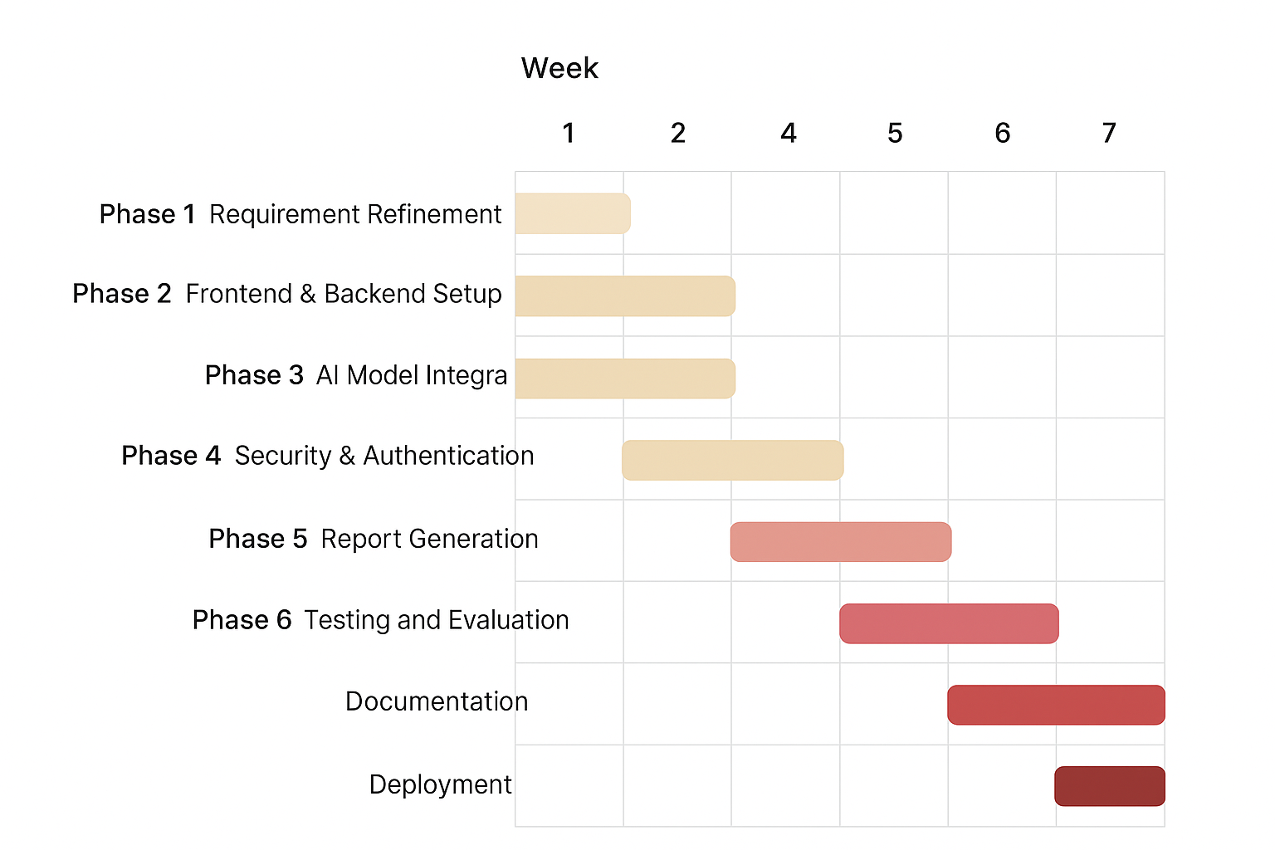
Fig. 5.1 Gantt Chart — Semester 8 Implementation Timeline (January–May 2025)

CHAPTER 6: IMPLEMENTATION RESULTS
This chapter presents the key implementation results of OrthoAssist as developed in Semester 8, comprising the significant frontend screens, backend features, and representative code snippets from the actual codebase. The screenshots below reflect the current production-ready state of the application.
6.1 Landing Page
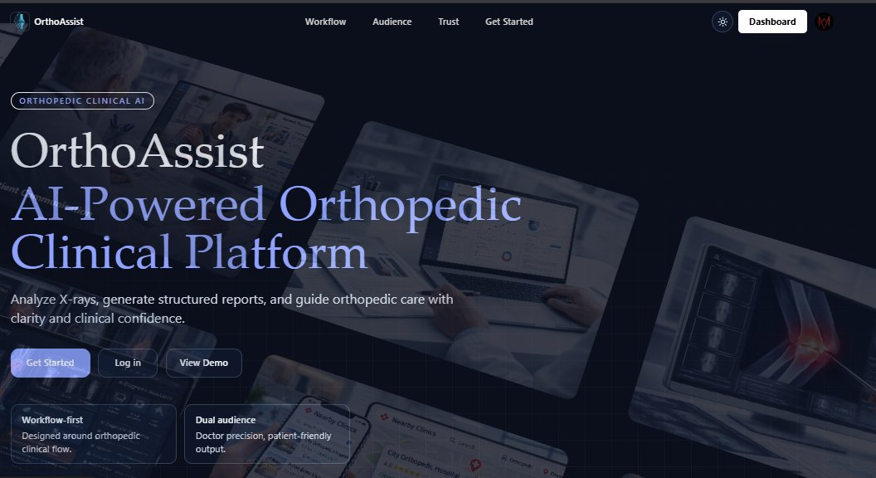
Fig. 6.1 OrthoAssist Landing Page – AI-Powered Orthopedic Clinical Platform
The landing page establishes the OrthoAssist brand identity and value proposition. A full-screen hero section with an animated gradient background presents the product title ("OrthoAssist"), the subtitle ("Autonomous Multi-Agent Clinical Decision Support for Orthopedic Diagnostics"), and a primary call-to-action directing users to sign in. Below the hero, a feature highlight section lists the key capabilities: multimodal AI analysis (X-ray, CT, MRI), multi-agent consensus, and care plan generation. The navigation bar contains the product logo, links to features and about sections, and Sign In / Get Started buttons. The page is fully responsive and rendered as a server-side component in Next.js 15, ensuring fast initial load and SEO compatibility.
6.2 Sign-in / Sign-up (Clerk Authentication)
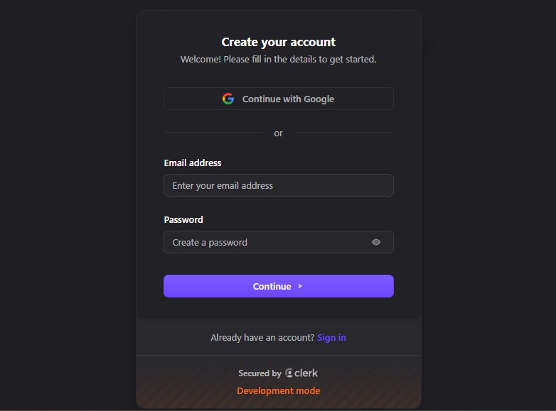
Fig. 6.2 Account Registration – Clerk-Secured Authentication
Authentication is handled entirely by Clerk via the @clerk/nextjs SDK. The sign-in and sign-up pages are rendered inside the (auth) route group using Clerk's pre-built <SignIn /> and <SignUp /> components, styled to match the OrthoAssist design system. The sign-in form supports email/password and social OAuth (Google). Clerk issues session JWTs which are attached as Bearer tokens to all API requests to the FastAPI backend. The Clerk middleware (middleware.ts) protects all /dashboard and /select-role routes, redirecting unauthenticated requests to sign-in. Token validation is performed server-side at every API call, ensuring zero unauthorized access.
6.3 Doctor Operations Dashboard
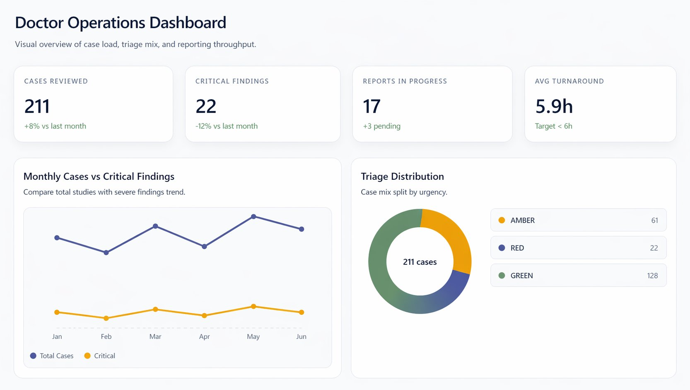
Fig. 6.3 Doctor Operations Dashboard – Case Load and Triage Overview
The Doctor Dashboard (/dashboard/doctor/) is the central command interface for clinicians. It displays summary statistics (total patients, active cases, reports generated, and triage severity distribution), a patient list table with name, last visit date, last diagnosis summary, and quick action buttons (open chat, view reports), and recent report cards for the five most recently generated reports. Data is fetched from the FastAPI backend via TanStack Query with automatic background refresh. The dashboard also supports a demo mode toggle that substitutes static mock data when the backend is unavailable, ensuring usability during demonstrations and testing.
6.4 Doctor Assistant Chat Interface
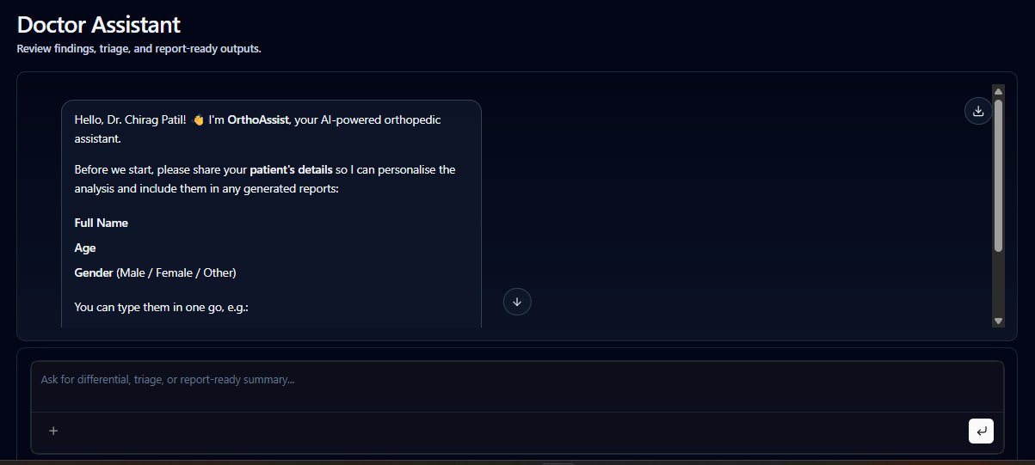
Fig. 6.4 Doctor Assistant Chat – AI Medical Assistant Interface
The Doctor Chat (/dashboard/doctor/chat/) is the primary clinical interaction interface. It features a message thread with streaming AI responses rendered as Markdown, a file upload area supporting JPEG, PNG, DICOM (.dcm), and ZIP DICOM series via react-dropzone, attachment previews (image thumbnails or DICOM metadata summary), and a modality indicator badge that automatically shows "X-Ray", "CT", or "MRI" based on detected modality. After analysis, the annotated X-ray with fracture bounding boxes or CT key slices are displayed inline. Care plan sections (Treatment Plan, Rehabilitation Protocol, Patient Education, Appointment Schedule) appear as expandable collapsible panels. The system prompts for report type selection (Comprehensive / Clinician Full / Clinician Simple / Patient) with PDF download links after generation. Conversations are stored in MongoDB and accessible across browser sessions.
6.5 Chat Interaction – X-ray Upload with AI Fracture Detection
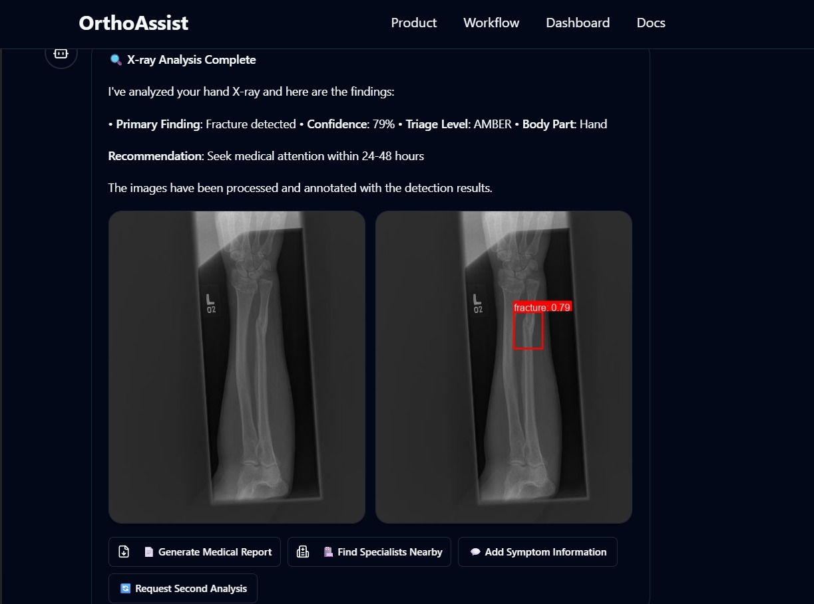
Fig. 6.5 Chat Interaction – X-ray Upload with AI Fracture Detection Result
The figure above shows a complete clinical interaction cycle. The doctor uploads an X-ray through the chat interface. The system automatically detects the modality (X-ray) and body part (hand/wrist), invokes the appropriate YOLOv8 fracture detection model, and returns the annotated image with bounding boxes highlighting detected fracture regions alongside confidence scores. The AI response includes the structured diagnosis (finding, severity, clinical notes), the triage assessment (AMBER — requires medical attention within 24 hours), and a care plan summary. This demonstrates the end-to-end pipeline from raw image upload to actionable clinical output within a single conversational exchange.
6.6 AI Triage Assessment Report
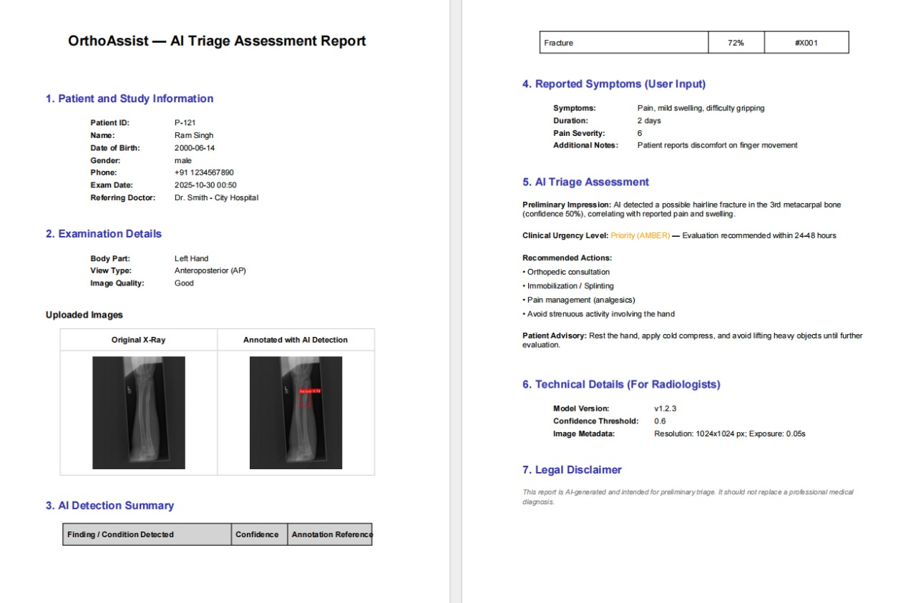
Fig. 6.6 AI Triage Assessment Report – Auto-Generated PDF
The report generation module produces four PDF variants via ReportLab. The Comprehensive Report — shown above — is the most complete variant, incorporating patient demographics, physician details, session ID, both the original uploaded image and the annotated image with detection overlays, full diagnosis with severity and clinical notes, triage level with urgency rationale, treatment plan, rehabilitation summary, patient education, and appointment schedule. The report is uploaded to Cloudinary and the URL is returned to the frontend as a download link in the chat thread. The clinician full, clinician simple, and patient variants provide progressively reduced levels of clinical detail, ensuring role-appropriate communication.
6.7 Patients Module
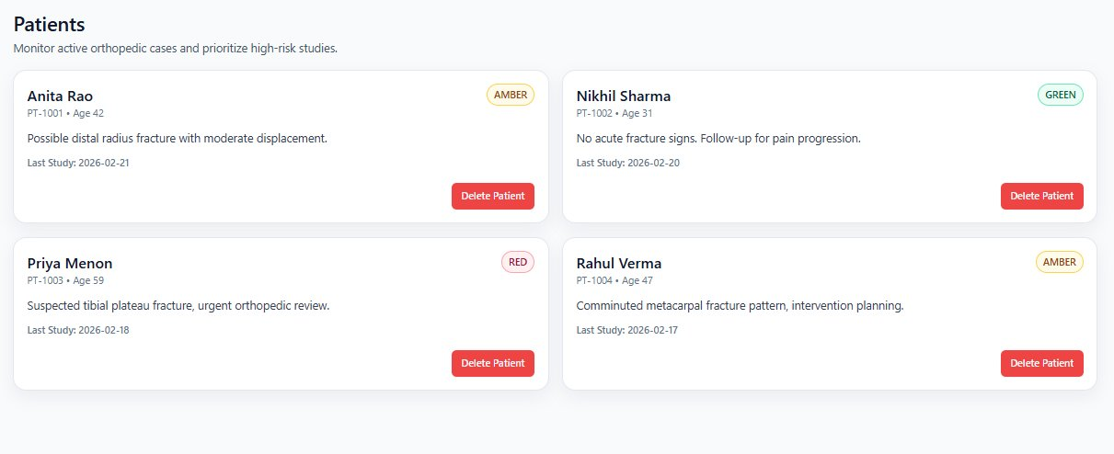
Fig. 6.7 Patients Module – Active Case Monitoring and Triage Prioritisation
The Patients page (/dashboard/doctor/patients/) presents all assigned patients as interactive cards, each showing the patient name, last diagnostic session date, current triage status (color-coded: GREEN, AMBER, RED), primary diagnosis finding, and quick action buttons (Open Chat, View Reports). The triage color coding enables clinicians to immediately prioritize their patient list by urgency. The page supports search and filter by patient name or triage level. Data is synchronized with the backend via TanStack Query.
6.8 Doctor Reports – Report Status and Severity Management
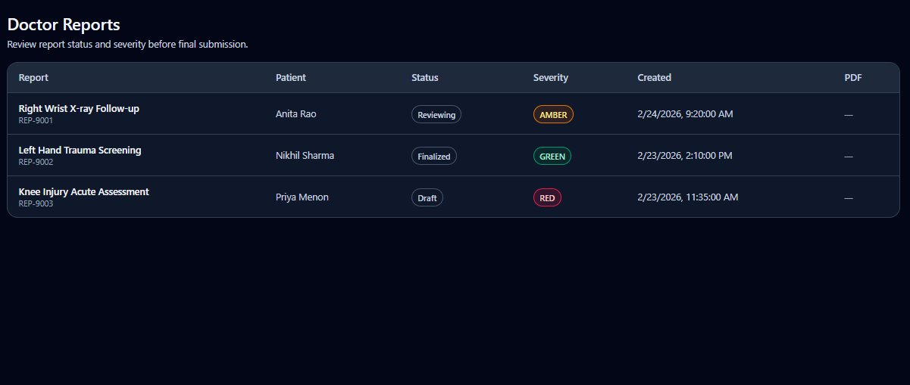
Fig. 6.8 Doctor Reports – Report Status and Severity Management
The Reports page (/dashboard/doctor/reports/) provides a comprehensive table of all generated clinical reports across all patients. Each row displays the patient name, report type badge (Comprehensive, Clinician Full, Clinician Simple, Patient), generation date, triage severity indicator (AMBER/GREEN/RED), and a download link to the PDF stored on Cloudinary. The severity column uses color-coded badges for rapid visual triage. Clinicians can filter by report type, sort by date or severity, and bulk-download reports for a patient. This module enables structured record-keeping and retrospective case review.
Key Code Snippets
The following six code snippets are extracted from the actual OrthoAssist codebase to illustrate the core architectural patterns implemented in Semester 8.
Snippet 1: MultiAgentCoordinator.coordinate_analysis() — Six-Phase Execution
This method orchestrates the full six-phase coordination protocol across all seven registered agents. Each phase executes concurrently using asyncio.gather() to maximize throughput:
async def coordinate_analysis(self, context: Dict[str, Any]) -> Dict[str, Any]:
"""
Coordinate multi-agent analysis of medical case.
Agents perceive, reason, and act independently while collaborating.
"""
coordination_id = str(uuid4())
start_time = datetime.now()

# Phase 1: Agent perception - all agents perceive the situation
perception_results = await self._parallel_agent_perception(context)

# Phase 2: Agent reasoning - each agent reasons independently
reasoning_results = await self._parallel_agent_reasoning(
context, perception_results)

# Phase 3: Goal formulation - agents formulate their own goals
goal_formulation = await self._parallel_goal_formulation(
context, reasoning_results)

# Phase 4: Collaborative decision making
collaborative_decisions = await self._facilitate_collaboration(
context, reasoning_results, goal_formulation)

# Phase 5: Action execution
execution_results = await self._execute_collaborative_actions(
context, collaborative_decisions)

# Phase 6: Consensus building
final_consensus = await self._build_agent_consensus(
context, execution_results)

coordination_time = (datetime.now() - start_time).total_seconds()
self._record_coordination_metrics(
coordination_id, coordination_time, True)

return {
"coordination_id": coordination_id,
"success": True,
"consensus_result": final_consensus,
"coordination_time": coordination_time,
"agents_involved": list(self.agents.keys())
}
Snippet 2: BaseAgent — Abstract Perceive-Reason-Act Contract
The BaseAgent abstract class enforces the Perceive-Reason-Act lifecycle for all seven agents. It also initializes Bayesian beliefs for each of the agent's tool capabilities:
class BaseAgent(ABC):
"""Base class for autonomous specialized agents."""

def __init__(self, capabilities: AgentCapabilities):
self.capabilities = capabilities
self.message_queue: List[AgentMessage] = []
self.goals: Dict[str, AgentGoal] = {}
self.performance_metrics = {
"tasks_completed": 0,
"tasks_failed": 0,
"average_confidence": 0.0,
"collaboration_success": 0,
}
for tool in capabilities.tool_capabilities:
base_confidence = capabilities.confidence_ranges.get(
tool, (0.7, 0.9))[0]
bayesian_updater.initialize_belief(tool, base_confidence)

@abstractmethod
async def perceive(self, context: Dict[str, Any]) -> Dict[str, Any]:
"""Perceive environment and gather information."""
pass

@abstractmethod
async def reason(self, context: Dict[str, Any]) -> Dict[str, Any]:
"""Reason about situation and form decisions."""
pass

@abstractmethod
async def act(self, action: Dict[str, Any]) -> Dict[str, Any]:
"""Execute actions in the environment."""
pass
Snippet 3: LangGraph StateGraph Node Registration
The get_graph() function (cached with @lru_cache) defines the complete LangGraph StateGraph, registering all nodes and their conditional routing edges:
@lru_cache(maxsize=1)
def get_graph():
workflow = StateGraph(AgentState)
workflow.add_node("supervisor", supervisor_node)
workflow.add_node("tool_executor", tool_executor_node)
workflow.add_node("response_builder", response_builder_node)
workflow.add_node("error_handler", error_handler_node)
workflow.add_node("care_plan_node", care_plan_node)
workflow.add_node("multi_agent_integrator", multi_agent_integration_node)

workflow.add_edge(START, "multi_agent_integrator")
workflow.add_edge("multi_agent_integrator", "supervisor")
workflow.add_conditional_edges(
"supervisor", should_continue,
{
"tool_executor": "tool_executor",
"response_builder": "response_builder",
"error_handler": "error_handler",
"care_plan_node": "care_plan_node",
},
)
workflow.add_edge("tool_executor", "supervisor")
workflow.add_edge("care_plan_node", "response_builder")
workflow.add_conditional_edges(
"error_handler", error_handler_route,
{"supervisor": "supervisor",
"response_builder": "response_builder"},
)
workflow.add_edge("response_builder", END)
return workflow.compile(checkpointer=get_checkpointer())
Snippet 4: BayesianBeliefUpdater — Bayesian Inference Update
The BayesianBeliefUpdater maintains a Beta(alpha, beta) distribution for each tool. update_belief() increments alpha on success and beta on failure; get_success_probability() returns the posterior mean:
def update_belief(self, tool_name: str, success: bool) -> None:
"""Update belief based on observed outcome."""
if tool_name not in self.tool_beliefs:
self.initialize_belief(tool_name)

belief = self.tool_beliefs[tool_name]
if success:
belief["alpha"] += 1 # increment success parameter
belief["success_count"] += 1
else:
belief["beta"] += 1 # increment failure parameter
belief["failure_count"] += 1

belief["last_updated"] = datetime.now()
self._schedule_persist(tool_name)

def get_success_probability(self, tool_name: str) -> float:
"""Get posterior mean success probability for a tool.
Posterior mean = alpha / (alpha + beta)
"""
belief = self.tool_beliefs[tool_name]
return belief["alpha"] / (belief["alpha"] + belief["beta"])
Snippet 5: AdaptiveSupervisor.learn_from_feedback() — Experience-Based Learning
The AdaptiveSupervisor extracts learning signals from explicit clinician feedback, creating or updating ExperiencePattern records in MongoDB for incorrect diagnoses, triage mismatches, low ratings, and high performance:
async def learn_from_feedback(self, feedback: Dict[str, Any]) -> None:
"""Extract learning signals from user feedback."""
normalized = self._normalize_feedback(feedback)

if normalized.get("diagnosis_correctness") == "incorrect":
await self._learn_from_correction(normalized, "diagnosis")

if normalized.get("triage_appropriateness") == "inappropriate":
await self._learn_from_correction(normalized, "triage")

if normalized.get("decision_accuracy", 5) <= 2:
await self._learn_from_low_performance(normalized)

if normalized.get("decision_accuracy", 0) >= 4:
await self._learn_from_high_performance(normalized)

missed = normalized.get("missed_findings", [])
if missed:
await self._learn_from_missed_findings(normalized, missed)

self.last_learning_update = datetime.now()
Snippet 6: care_plan_node — Parallel Care Plan Agent Execution
The care_plan_node executes all four specialist agents in parallel using asyncio.gather() across perceive, reason, and act phases. Results are merged back into AgentState:
async def care_plan_node(state: AgentState) -> dict:
"""Run four specialist care-plan agents in parallel
once diagnosis and triage are ready."""
context = {
"session_id": state.get("session_id"),
"diagnosis": state.get("diagnosis"),
"triage_result": state.get("triage_result"),
"patient_info": state.get("patient_info"),
"body_part": state.get("body_part") or
state.get("body_region") or "",
}
# Phase 1 — parallel perception
p = await asyncio.gather(
treatment_agent.perceive(context),
rehab_agent.perceive(context),
education_agent.perceive(context),
appointment_agent.perceive(context),
return_exceptions=True,
)
# Phase 2 — parallel reasoning
r = await asyncio.gather(
treatment_agent.reason({**context, **_safe(p[0])}),
rehab_agent.reason({**context, **_safe(p[1])}),
education_agent.reason({**context, **_safe(p[2])}),
appointment_agent.reason({**context, **_safe(p[3])}),
return_exceptions=True,
)
# Phase 3 — parallel action execution
a = await asyncio.gather(
treatment_agent.act(_first_action(r[0])),
rehab_agent.act(_first_action(r[1])),
education_agent.act(_first_action(r[2])),
appointment_agent.act(_first_action(r[3])),
return_exceptions=True,
)
updates = {"care_plan_generated": True}
if isinstance(a[0], dict) and a[0].get("success"):
updates["treatment_plan"] = a[0].get("treatment_plan")
if isinstance(a[1], dict) and a[1].get("success"):
updates["rehabilitation_plan"] = a[1].get("rehabilitation_plan")
if isinstance(a[2], dict) and a[2].get("success"):
updates["patient_education"] = a[2].get("patient_education")
if isinstance(a[3], dict) and a[3].get("success"):
updates["appointment_schedule"]= a[3].get("appointment_schedule")
return updates

CHAPTER 7: CONCLUSION
7.1 Summary of Semester 8 Achievements
Semester 8 represents a complete transformation of OrthoAssist from the Semester 7 proof-of-concept into a production-capable autonomous clinical decision support system. The core contributions of this semester span eight distinct dimensions of advancement.
Full multimodal CT/MRI support was achieved through the integration of TotalSegmentator (bone, spine, appendicular segmentation) for CT volumes and kneeseg for MRI knee studies, supported by a robust DICOM ingestion pipeline that handles single-file DICOM, DICOM series as ZIP archives, and NIfTI conversion. This positions OrthoAssist as the first open academic prototype to integrate X-ray, CT, and MRI within a single agentic pipeline.
The seven-agent autonomous multi-agent system is fully implemented. VisionAgent, ClinicalAgent, TreatmentPlannerAgent, RehabilitationAgent, PatientEducationAgent, AppointmentAgent, and PDFGenerationAgent each independently execute the Perceive-Reason-Act lifecycle, formulate goals, and collaborate through the MultiAgentCoordinator. This design mirrors the behavior of a multidisciplinary clinical team and enables system-level reasoning that transcends any individual component.
The six-phase coordination protocol — Perception, Reasoning, Goal Formulation, Collaboration, Action Execution, and Consensus Building — is executed with full async parallelism. The consensus mechanism provides a confidence-based final decision and documents the complete reasoning process for audit. Probabilistic reasoning via Bayesian belief updating provides calibrated confidence estimates per tool. Thompson Sampling balances exploration and exploitation in action selection, representing a significant advancement beyond deterministic pipeline routing.
The adaptive learning system (AdaptiveSupervisor) learns from every execution trace and from explicit clinician feedback, persisting experience patterns in MongoDB and injecting them into the supervisor's reasoning context for all subsequent sessions. The care plan node executes four specialist agents in parallel after clinical analysis, covering the full orthopedic care cycle. Four-variant ReportLab-powered PDF generation (Comprehensive, Clinician Full, Clinician Simple, Patient) with Cloudinary storage ensures role-appropriate communication. The Next.js 15 frontend is feature-complete with Clerk authentication, role-based dashboards, streaming chat, multi-agent insights panel, agent reasoning trace display, nearby hospitals finder, and patient history with multi-study comparison.
7.2 Significance of the Autonomous Multi-Agent Approach
The design choice to implement an autonomous multi-agent system rather than a simple sequential pipeline carries several clinically significant implications. Specialization and depth: each agent is a domain specialist, and this depth of specialization — from orthopedic pathway planning to physiotherapy protocol generation to accessible patient communication — would be impractical in a monolithic system.
Fault tolerance is built into the architecture. If the TreatmentPlannerAgent fails, the remaining three care plan agents continue and return their outputs. If multi-agent coordination fails, the standard LangGraph pipeline continues without interruption. Consensus validation, borrowed from multi-agent coordination literature, introduces a form of peer review: when vision and clinical agents reach independent conclusions that diverge, the system explicitly flags the disagreement rather than silently returning one result.
Transparency is a foundational requirement for clinical AI adoption. The agent reasoning trace, exposed in the frontend, documents which agent reached what conclusion, with what confidence, based on which perceived inputs. This audit trail is essential for regulatory acceptance and clinician trust. These properties collectively make the multi-agent architecture a clinically defensible choice, not merely a technical one.
7.3 Multimodal Capability
The integration of CT segmentation via TotalSegmentator and MRI knee analysis via kneeseg substantially expands the diagnostic scope of OrthoAssist beyond what most academic orthopedic AI projects achieve. The three-modality capability (X-ray, CT, MRI) mirrors real orthopedic clinical practice, where each modality serves a specific diagnostic role: X-ray for first-line fracture detection and bone alignment assessment; CT for detailed fracture characterization, surgical planning, and bone density assessment; and MRI for soft tissue assessment, cartilage pathology, and spinal canal analysis.
The subprocess isolation design for TotalSegmentator — running the heavy nnU-Net inference in a separate Python worker process — is a production-quality engineering decision that prevents the event loop from blocking and supports concurrent session handling. This design pattern is directly applicable to real clinical deployment scenarios where multiple simultaneous sessions must be served without degrading response times.
7.4 Future Work
- Federated Learning: Patient data is inherently sensitive. Implementing federated learning across multiple hospital deployments would enable the YOLOv8 models and adaptive learning patterns to improve from a distributed dataset without centralizing patient records. Integration with the existing AdaptiveSupervisor could be achieved by aggregating anonymized pattern updates.
- Voice Interface and Clinical Assistant Mode: Integration of speech-to-text input and text-to-speech output would enable hands-free clinical interaction, particularly valuable during procedures or ward rounds. The LangGraph pipeline already supports conversational context; adding audio I/O is primarily a frontend concern.
- Mobile Application: A React Native or Flutter mobile client would allow patients and clinicians to access OrthoAssist from mobile devices, submit images directly from the camera, and receive push notifications for report readiness. The FastAPI backend is already mobile-compatible.
- HL7/FHIR Integration: Connecting OrthoAssist to hospital information systems via the HL7 FHIR standard would enable seamless exchange of patient records, imaging orders, and generated reports — a prerequisite for clinical deployment in regulated healthcare environments.
- Extended CT/MRI Coverage: Future work could add fracture-specific post-processing on segmented masks and extend MRI support to shoulder, hip, and ankle joints beyond the current knee and spine coverage.
- Clinician Feedback Loop UI: A dedicated feedback interface within the doctor dashboard to rate diagnosis accuracy, flag incorrect findings, and suggest corrections would accelerate the AdaptiveSupervisor's learning convergence in deployment.
- Multi-Language Support: Adding Marathi, Hindi, and other regional language support to the patient-facing interface would increase accessibility for rural Indian patients who may not be proficient in English.

CHAPTER 8: REFERENCES
[1] Rajpurkar, P., Irvin, J., Ball, R. L., Zhu, K., Yang, B., Mehta, H., ... & Lungren, M. P. (2017). CheXNet: Radiologist-Level Pneumonia Detection on Chest X-Rays from a Deep Learning Algorithm. arXiv preprint arXiv:1711.05225.
[2] Holste, G., Wang, S., Jiang, Z., Shen, T., Kolowitz, B. J., Oh, M., ... & Peng, Y. (2021). Long-Tailed Classification of Thorax Diseases on Chest X-Ray: A New Benchmark Study. In MICCAI, 2021. (Related to MURA benchmark: Rajpurkar et al., MURA Dataset, Stanford ML Group, 2018.)
[3] Jocher, G., Chaurasia, A., & Qiu, J. (2023). Ultralytics YOLOv8. https://github.com/ultralytics/ultralytics. AGPL-3.0 License.
[4] Wasserthal, J., Breit, H. C., Meyer, M. T., Pradella, M., Hinck, D., Sauter, A. W., ... & Segeroth, M. (2023). TotalSegmentator: Robust Segmentation of 104 Anatomical Structures in CT Images. Radiology: Artificial Intelligence, 5(5).
[5] Isensee, F., Jaeger, P. F., Kohl, S. A., Petersen, J., & Maier-Hein, K. H. (2021). nnU-Net: A self-configuring method for deep learning-based biomedical image segmentation. Nature Methods, 18(2), 203–211.
[6] Mahajan, K., Kuo, C. H., Lee, M., & Bhatt, D. L. (2023). FracAtlas: A Dataset for Fracture Classification, Localization and Segmentation of Musculoskeletal Radiographs. Scientific Data, 10(1), 521.
[7] Irvin, J., Rajpurkar, P., Ko, M., Yu, Y., Ciurea-Ilcus, S., Chute, C., ... & Ng, A. Y. (2019). CheXpert: A large chest radiograph dataset with uncertainty labels and expert comparison. In Proceedings of the AAAI Conference on Artificial Intelligence, 33(1), 590–597.
[8] Wooldridge, M., & Jennings, N. R. (1995). Intelligent agents: Theory and practice. The Knowledge Engineering Review, 10(2), 115–152.
[9] LangChain, Inc. (2023). LangChain: Building LLM-Powered Applications. https://github.com/langchain-ai/langchain.
[10] LangGraph Development Team. (2024). LangGraph: Stateful Multi-Actor Applications with LLMs. Anthropic / LangChain. https://github.com/langchain-ai/langgraph.
[11] OpenAI. (2023). GPT-4 Technical Report. arXiv preprint arXiv:2303.08774.
[12] Topol, E. J. (2019). High-performance medicine: the convergence of human and artificial intelligence. Nature Medicine, 25(1), 44–56.
[13] Lundervold, A. S., & Lundervold, A. (2019). An overview of deep learning in medical image analysis. Computers in Biology and Medicine, 110, 53–71.
[14] Chen, X., Xie, S., & He, K. (2021). An empirical study of training self-supervised vision transformers. In Proceedings of the IEEE/CVF International Conference on Computer Vision, 9640–9649.
[15] Sheller, M. J., Edwards, B., Reina, G. A., Martin, J., Pati, S., Kotrotsou, A., ... & Bakas, S. (2020). Federated learning in medicine: facilitating multi-institutional collaborations without sharing patient data. Scientific Reports, 10(1), 12598.
[16] Wooldridge, M. (2009). An Introduction to MultiAgent Systems (2nd ed.). John Wiley & Sons.
[17] Ferber, J. (1999). Multi-Agent Systems: An Introduction to Distributed Artificial Intelligence. Addison-Wesley.
[18] Stone, P., & Veloso, M. (2000). Multiagent systems: A survey from a machine learning perspective. Autonomous Robots, 8(3), 345–383.
[19] Sutton, R. S., & Barto, A. G. (2018). Reinforcement Learning: An Introduction (2nd ed.). MIT Press.
[20] Ghahramani, Z. (2015). Probabilistic machine learning and artificial intelligence. Nature, 521(7553), 452–459.
[21] Dosovitskiy, A., Beyer, L., Kolesnikov, A., Weissenborn, D., Zhai, X., Unterthiner, T., ... & Houlsby, N. (2020). An Image is Worth 16x16 Words: Transformers for Image Recognition at Scale. arXiv:2010.11929.
[22] Litjens, G., Kooi, T., Bejnordi, B. E., Setio, A. A. A., Ciompi, F., Ghafoorian, M., ... & Sanchez, C. I. (2017). A survey on deep learning in medical image analysis. Medical Image Analysis, 42, 60–88.
[23] FastAPI. (2024). FastAPI: Modern, Fast Web Framework for Building APIs with Python. https://fastapi.tiangolo.com/.
[24] Vercel. (2024). Next.js Documentation. https://nextjs.org/docs.
[25] Clerk. (2024). Clerk Developer Documentation. https://clerk.com/docs.

[Attach official plagiarism report generated from Turnitin / iThenticate]

