# Stock Pair Analyzer

**Date:** 7th June 2024

**Submitted by:** Gattupalli.Amruthasri (22kq1a0710)

**Details of project:** I’m implementing this project by using Python Programming Language

**Code:**

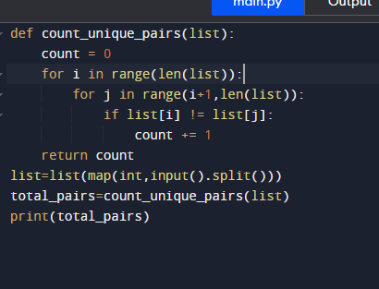

**Input and output**

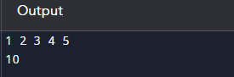

**Explanation:**

**In this program I have implement project name which is nothing but Stock Pair Analyzer.count_unique_pairs is defind to take a list as input and return the number of take a list as input and return the number of unique pairs. Inside the function the variable count is taken as 0 this value used to keep the number of unique pairs. The outer for loop runs with I taking value 0 to len(list)to1. The inner loop runs with I taken value i+1 to len(list) to 1. Then the function will return the total no. of unique pairs as integer.**

**Conclusion:**

**Finally I have got the desired output 10.**