JAVA PROGRAMMS LIST
LAB-1 Date: 27-02-25
1.Program to Print "Hello, World!"
public class HelloWorld {
public static void main(String[] args) {
System.out.println("Hello, World!");
}
}
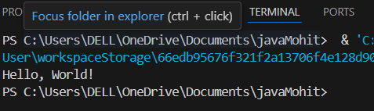
2.Program to Add Two Numbers
public class AddTwoNumbers {
public static void main(String[] args) {
int a = 10, b = 20;
int sum = a + b;
System.out.println("Sum = " + sum);
}
}
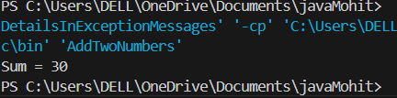
3.Program to Calculate Area of a Rectangle
public class RectangleArea {
public static void main(String[] args) {
int length = 5, width = 10;
int area = length * width;
System.out.println("Area = " + area);
}
}
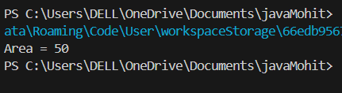
4.Program to Find the Square of a Number
public class SquareNumber {
public static void main(String[] args) {
int num = 6;
int square = num * num;
System.out.println("Square = " + square);
}
}
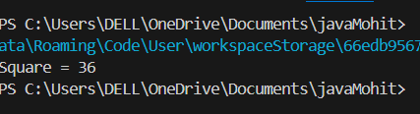
5.Program to Calculate Simple Interest public class SimpleInterest {
public static void main(String[] args) {
double p = 1000, r = 5, t = 2;
double si = (p * r * t) / 100;
System.out.println("Simple Interest = " + si);
}
}
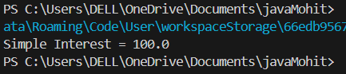
6.Program to Convert Celsius to Fahrenheit
public class CelsiusToFahrenheit {
public static void main(String[] args) {
double celsius = 30;
double fahrenheit = (celsius * 9/5) + 32;
System.out.println("Fahrenheit = " + fahrenheit);
}
}
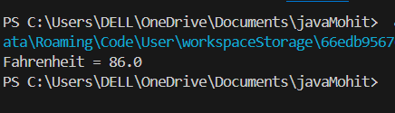
7.Program to Find Maximum of Two Numbers
public class MaxOfTwo {
public static void main(String[] args) {
int a = 15, b = 20;
int max = (a > b) ? a : b;
System.out.println("Maximum = " + max);
}
}
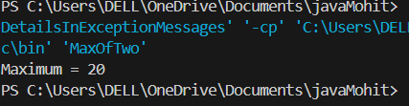
8.Program to Check if a Number is Even or Odd
public class EvenOdd {
public static void main(String[] args) {
int num = 7;
if (num % 2 == 0)
System.out.println("Even");
else
System.out.println("Odd");
}
}
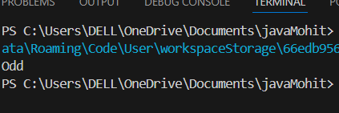
9.Swapping of 2 numbers
public class SwapTwoNumbers {
public static void main(String[] args) {
int a = 5, b = 10;
int temp = a;
a = b;
b = temp;
System.out.println("a = " + a + ", b = " + b);
}
}
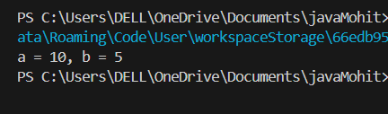
10.Swapping of 3 numbers.
public class SwapThreeNumbers {
public static void main(String[] args) {
int a = 1, b = 2, c = 3;
int temp = a;
a = b;
b = c;
c = temp;
System.out.println("a = " + a + ", b = " + b + ", c = " + c);
}
}
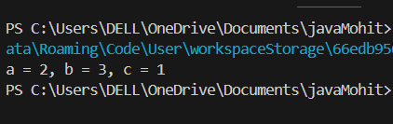
11. Data Types program using local and instance variables
public class DataTypesExample {
int instanceVar = 50; // instance variable

public void display() {
int localVar = 20; // local variable
System.out.println("Instance Variable = " + instanceVar);
System.out.println("Local Variable = " + localVar);
}

public static void main(String[] args) {
DataTypesExample obj = new DataTypesExample();
obj.display();
}
}
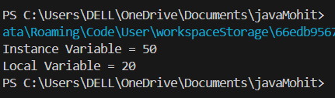
LAB-2 Date: 03-02-25
1 Arithima c operators
public class ArithmeticOperators {
public static void main(String[] args) {
int a = 10, b = 5;
System.out.println("Addition: " + (a + b));
System.out.println("Subtraction: " + (a - b));
System.out.println("Multiplication: " + (a * b));
System.out.println("Division: " + (a / b));
System.out.println("Modulus: " + (a % b));
}
}
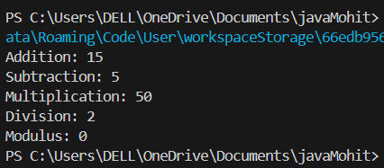
2 Assignment Operators
public class AssignmentOperators {
public static void main(String[] args) {
int x = 10;
x += 5;
x -= 2;
x *= 3;
x /= 2;
x %= 4;
System.out.println("Final value of x: " + x);
}
}
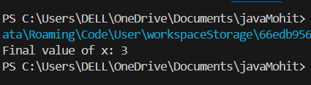
3 Bitwise Operators
public class BitwiseOperators {
public static void main(String[] args) {
int a = 5, b = 3;
System.out.println("AND: " + (a & b));
System.out.println("OR: " + (a | b));
System.out.println("XOR: " + (a ^ b));
System.out.println("Complement: " + (~a));
System.out.println("Left Shift: " + (a << 1));
System.out.println("Right Shift: " + (a >> 1));
}
}
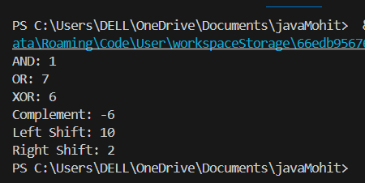
4 Logical Operators
public class LogicalOperators {
public static void main(String[] args) {
boolean a = true, b = false;
System.out.println("AND: " + (a && b));
System.out.println("OR: " + (a || b));
System.out.println("NOT A: " + (!a));
}
}
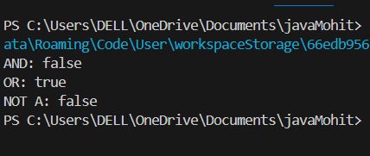
5 Rela onal Operators
public class RelationalOperators {
public static void main(String[] args) {
int x = 10, y = 20;
System.out.println("x == y: " + (x == y));
System.out.println("x != y: " + (x != y));
System.out.println("x > y: " + (x > y));
System.out.println("x < y: " + (x < y));
System.out.println("x >= y: " + (x >= y));
System.out.println("x <= y: " + (x <= y));
}
}
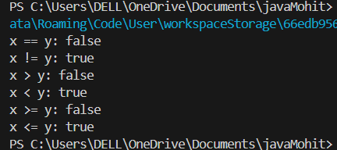
6 Unary Operator
public class UnaryOperator {
public static void main(String[] args) {
int a = 5;
System.out.println("Post-increment: " + a++);
System.out.println("Pre-increment: " + ++a);
System.out.println("Post-decrement: " + a--);
System.out.println("Pre-decrement: " + --a);
}
}
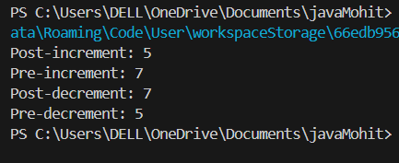
7 Arithima c with Instance variables
public class ArithmeticInstance {
int a = 20, b = 10;

void calculate() {
System.out.println("Addition: " + (a + b));
}

public static void main(String[] args) {
new ArithmeticInstance().calculate();
}
}
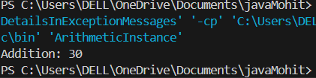
8 Assignment with Instance Variables
public class AssignmentInstance {
int x = 10;

void assign() {
x += 5;
System.out.println("x after assignment: " + x);
}

public static void main(String[] args) {
new AssignmentInstance().assign();
}
}
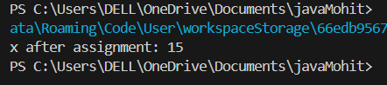
9 Bitwise with Instance Variables
public class BitwiseInstance {
int a = 6, b = 3;

void operate() {
System.out.println("a & b: " + (a & b));
}

public static void main(String[] args) {
new BitwiseInstance().operate();
}
}
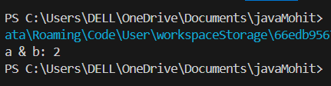
10 Logical with Instance Variables
public class LogicalInstance {
boolean flag1 = true, flag2 = false;

void logic() {
System.out.println("flag1 && flag2: " + (flag1 && flag2));
}

public static void main(String[] args) {
new LogicalInstance().logic();
}
}
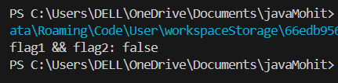
11 Rela onal with Instance Variables
public class RelationalInstance {
int a = 15, b = 20;

void check() {
System.out.println("a < b: " + (a < b));
}

public static void main(String[] args) {
new RelationalInstance().check();
}
}
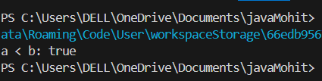
12 Unary with Instance Variables
public class UnaryInstance {
int x = 5;

void modify() {
System.out.println("++x: " + (++x));
System.out.println("--x: " + (--x));
}

public static void main(String[] args) {
new UnaryInstance().modify();
}
}
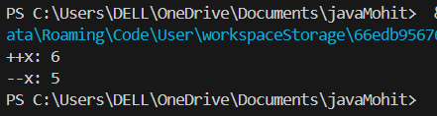
13 Sum of numbers using Instance Variables
public class SumInstance {
int a = 10, b = 20, c = 30;

void sum() {
int total = a + b + c;
System.out.println("Sum: " + total);
}

public static void main(String[] args) {
new SumInstance().sum();
}
}
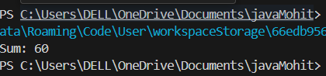
LAB-3 Date: 10-02-25
1 Write a program explaining IF Example
public class IfExample {
public static void main(String[] args) {
int age = 20;
if (age >= 18) {
System.out.println("You are eligible to vote.");
}
}
}
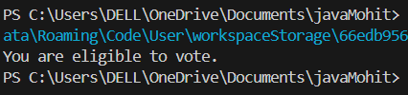
2 Write a program explaining IF Else Example
public class IfElseExample {
public static void main(String[] args) {
int number = 10;
if (number % 2 == 0) {
System.out.println("Even number");
} else {
System.out.println("Odd number");
}
}
}
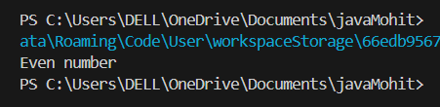
3 Write a program explaining ELSE IF example
public class ElseIfExample {
public static void main(String[] args) {
int marks = 75;
if (marks >= 90) {
System.out.println("Grade A");
} else if (marks >= 75) {
System.out.println("Grade B");
} else {
System.out.println("Grade C");
}
}
}
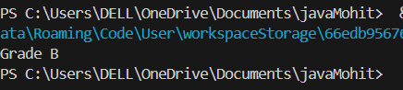
4 Write a program explaining Else If Ladder example
public class ElseIfLadder {
public static void main(String[] args) {
int number = 0;
if (number > 0) {
System.out.println("Positive");
} else if (number < 0) {
System.out.println("Negative");
} else {
System.out.println("Zero");
}
}
}
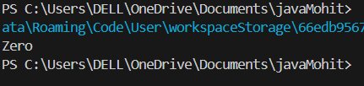
5 Write a program explaining Nested If Example
public class NestedIfExample {
public static void main(String[] args) {
int age = 25;
String citizen = "India";
if (age >= 18) {
if (citizen.equals("India")) {
System.out.println("Eligible to vote in India");
}
}
}
}
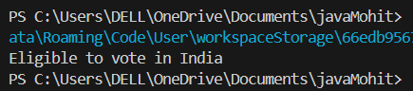
6 Write a program explaining Switch Case Example 1(Simple switch
Statement) .
public class SwitchExample1 {
public static void main(String[] args) {
int day = 3;
switch (day) {
case 1: System.out.println("Monday"); break;
case 2: System.out.println("Tuesday"); break;
case 3: System.out.println("Wednesday"); break;
default: System.out.println("Other day");
}
}
}
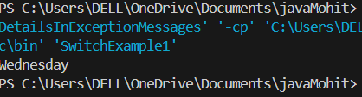
7 Write a program explaining Case example 2(Switch String Example

Traffic lights)
public class TrafficLights {
public static void main(String[] args) {
String signal = "Red";
switch (signal) {
case "Red": System.out.println("Stop"); break;
case "Yellow": System.out.println("Ready"); break;
case "Green": System.out.println("Go"); break;
default: System.out.println("Invalid signal");
}
}
}
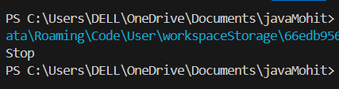
8 Write a program explaining Break Statement
public class BreakExample {
public static void main(String[] args) {
for (int i = 1; i <= 5; i++) {
if (i == 3) break;
System.out.println(i);
}
}
}
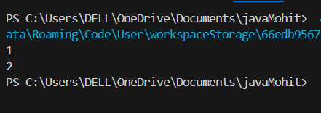
9 Write a program explaining Con nue Statement
public class ContinueExample {
public static void main(String[] args) {
for (int i = 1; i <= 5; i++) {
if (i == 3) continue;
System.out.println(i);
}
}
}
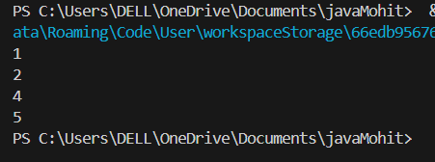
10 Write a program explaining Do while Loop
public class DoWhileExample {
public static void main(String[] args) {
int i = 1;
do {
System.out.println(i);
i++;
} while (i <= 5);
}
}
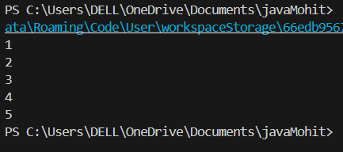
11 Write a program explaining For Loop
public class ForLoopExample {
public static void main(String[] args) {
for (int i = 1; i <= 5; i++) {
System.out.println(i);
}
}
}
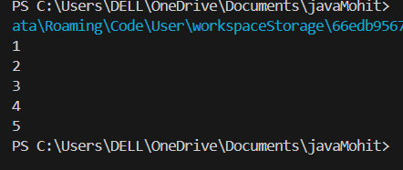
12 Write a program explaining While Loop
public class WhileLoopExample {
public static void main(String[] args) {
int i = 1;
while (i <= 5) {
System.out.println(i);
i++;
}
}
}
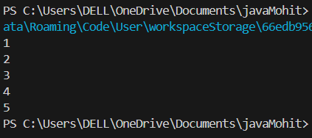
13 Write a program explaining Largest number from Input
import java.util.Scanner;

public class LargestNumber {
public static void main(String[] args) {
Scanner sc = new Scanner(System.in);
System.out.print("Enter three numbers: ");
int a = sc.nextInt(), b = sc.nextInt(), c = sc.nextInt();
int max = (a > b) ? ((a > c) ? a : c) : ((b > c) ? b : c);
System.out.println("Largest number is: " + max);
}
}
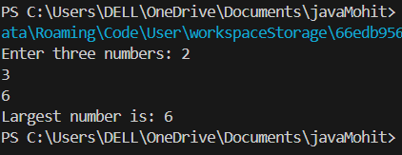
14.Write a Java program to find the sum of the digits of a given

number.
import java.util.Scanner;

public class SumOfDigits {
public static void main(String[] args) {
Scanner sc = new Scanner(System.in);
int num = sc.nextInt(), sum = 0;
while (num != 0) {
sum += num % 10;
num /= 10;
}
System.out.println("Sum of digits: " + sum);
}
}

15.Write a Java program to reverse a given number and display the
result.
import java.util.Scanner;

public class ReverseNumber {
public static void main(String[] args) {
Scanner sc = new Scanner(System.in);
int num = sc.nextInt(), reverse = 0;
while (num != 0) {
reverse = reverse * 10 + num % 10;
num /= 10;
}
System.out.println("Reversed number: " + reverse);
}
}
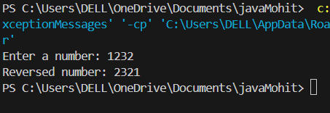
16.Write a Java program to calculate the factorial of a given number
using loops.
import java.util.Scanner;

public class Factorial {
public static void main(String[] args) {
Scanner sc = new Scanner(System.in);
int n = sc.nextInt(), fact = 1;
for (int i = 1; i <= n; i++) {
fact *= i;
}
System.out.println("Factorial: " + fact);
}
}
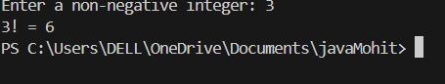
17.Write a Java program to generate the Fibonacci series up to n
terms.
import java.util.Scanner;

public class FibonacciSeries {
public static void main(String[] args) {
Scanner sc = new Scanner(System.in);
int n, a = 0, b = 1;
System.out.print("Enter number of terms: ");
n = sc.nextInt();
System.out.print("Fibonacci Series: " + a + " " + b + " ");
for (int i = 2; i < n; i++) {
int c = a + b;
System.out.print(c + " ");
a = b;
b = c;
}
}
}
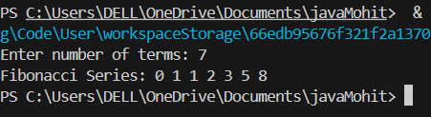

18. Write a Java program to check whether a given number is an
Armstrong number or not.
import java.util.Scanner;

public class ArmstrongCheck {
public static void main(String[] args) {
Scanner sc = new Scanner(System.in);
int num, temp, sum = 0, digit;
System.out.print("Enter a number: ");
num = sc.nextInt();
temp = num;
while (num > 0) {
digit = num % 10;
sum += Math.pow(digit, 3);
num /= 10;
}
System.out.println(temp == sum ? "Armstrong Number" : "Not an Armstrong Number");
}
}
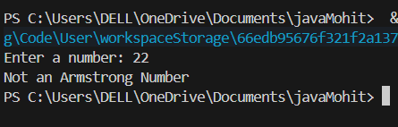
19.Write a Java program to check whether a given number is a
palindrome or not
import java.util.Scanner;

public class PalindromeCheck {
public static void main(String[] args) {
Scanner sc = new Scanner(System.in);
int num, rev = 0, temp;
System.out.print("Enter a number: ");
num = sc.nextInt();
temp = num;
while (num > 0) {
rev = rev * 10 + num % 10;
num /= 10;
}
System.out.println(temp == rev ? "Palindrome" : "Not a Palindrome");
}
}
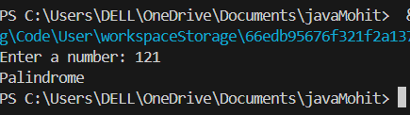
20. The electricity company charges ₹3 per unit for the first 100 units,
₹5 per unit for the next 200 units, and ₹8 per unit for units beyond
that. Write an algorithm to calculate the total bill for a customer
using u units of electricity.
import java.util.Scanner;

public class ElectricityBill {
public static void main(String[] args) {
Scanner sc = new Scanner(System.in);
int units, bill;
System.out.print("Enter electricity units: ");
units = sc.nextInt();
if (units <= 100) {
bill = units * 3;
} else if (units <= 300) {
bill = 100 * 3 + (units - 100) * 5;
} else {
bill = 100 * 3 + 200 * 5 + (units - 300) * 8;
}
System.out.println("Total Bill: ₹" + bill);
}
}
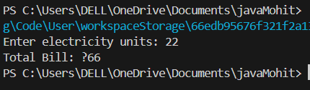
21.A bus company charges ₹10 for the first 5 kilo meters and ₹2 for
each addi onal kilo meter. Write an algorithm to calculate the total
fare for a journey of n kilo meters.
import java.util.Scanner;

public class BusFare {
public static void main(String[] args) {
Scanner sc = new Scanner(System.in);
int km;
System.out.print("Enter kilometers: ");
km = sc.nextInt();
int fare = 10;
if (km > 5) {
fare += (km - 5) * 2;
}
System.out.println("Total Fare: ₹" + fare);
}
}
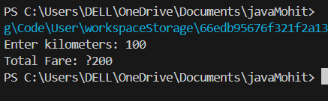
22.The cost of a movie cket is ₹100 for adults and ₹50 for children.
Write an algorithm to calculate the total cost for a family of 5 adults
and 2 children going to the movies.
import java.util.Scanner;
import java.text.NumberFormat;
import java.util.Locale;

public class MovieTicketCost {
public static void main(String[] args) {
final int ADULT_PRICE = 100;
final int CHILD_PRICE = 50;

Scanner scanner = new Scanner(System.in);

System.out.print("Enter number of adult tickets: ");
int adults = scanner.nextInt();

System.out.print("Enter number of child tickets: ");
int children = scanner.nextInt();

if (adults < 0 || children < 0) {
System.out.println("Error: Ticket quantities cannot be negative");
return;
}

int total = (adults * ADULT_PRICE) + (children * CHILD_PRICE);
NumberFormat currency = NumberFormat.getCurrencyInstance(new Locale("en", "IN"));

System.out.println("\nTicket Summary:");
System.out.println("Adult tickets: " + adults + " × ₹" + ADULT_PRICE);
System.out.println("Child tickets: " + children + " × ₹" + CHILD_PRICE);
System.out.println("Total cost: " + currency.format(total));

scanner.close();
}
}
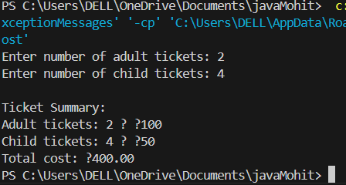
23. Shopping Discount Calcula on
Problem Statement:
A store offers discounts based on the total purchase amount:
*No discount for purchases below ₹500
*10% discount for purchases between ₹500 and ₹2000
*20% discount for purchases above ₹2000
Write a program to calculate the total bill amount a er applying the
discount.
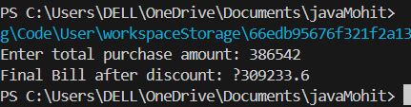
24.Hospital Bill Calcula on
Problem Statement:
A hospital charges:
*₹500 per day for General Ward
*₹1000 per day for Semi-Private Room
*₹2000 per day for Private Room
Addi onally, if the stay is more than 7 days, a 5% discount is given.
Write a program to calculate the final hospital bill.
import java.util.Scanner;

public class HospitalBill {
public static void main(String[] args) {
Scanner sc = new Scanner(System.in);
System.out.print("Enter room type (1- General, 2- Semi-Private, 3- Private): ");
int type = sc.nextInt();
System.out.print("Enter number of days: ");
int days = sc.nextInt();

int rate = switch (type) {
case 1 -> 500;
case 2 -> 1000;
case 3 -> 2000;
default -> 0;
};

double bill = rate * days;
if (days > 7) {
bill *= 0.95;
}
System.out.println("Final Hospital Bill: ₹" + bill);
}
}
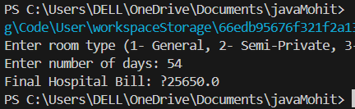
25. Grocery Store Bulk Purchase Discount
Problem Statement:
A grocery store offers:
*₹40 per kg for rice
*₹50 per kg for wheat
*₹100 per kg for dry fruits
If a customer buys more than 10 kg, they get a 15% discount on the
total bill.
import java.util.Scanner;

public class GroceryDiscount {
public static void main(String[] args) {
Scanner sc = new Scanner(System.in);
System.out.print("Enter kg of rice: ");
double rice = sc.nextDouble();
System.out.print("Enter kg of wheat: ");
double wheat = sc.nextDouble();
System.out.print("Enter kg of dry fruits: ");
double dryFruits = sc.nextDouble();

double totalKg = rice + wheat + dryFruits;
double total = rice * 40 + wheat * 50 + dryFruits * 100;

if (totalKg > 10) {
total *= 0.85;
}

System.out.println("Total Grocery Bill: ₹" + total);
}
}
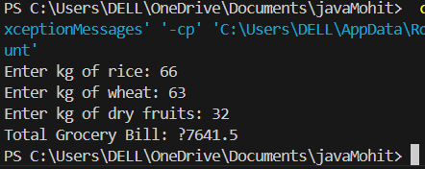
Write a program to calculate the total cost.
26. Write a Java program to implement a simple calculator using a
switch statement. The program should take two numbers and an
operator (+, -, *, /) as input from the user and perform the
corresponding arithme c opera on. Also, explain the working of the
switch statement in your program.
import java.util.Scanner;

public class Calculator {
public static void main(String[] args) {
Scanner sc = new Scanner(System.in);
System.out.print("Enter first number: ");
double a = sc.nextDouble();
System.out.print("Enter second number: ");
double b = sc.nextDouble();
System.out.print("Enter operator (+, -, *, /): ");
char op = sc.next().charAt(0);

double result;
switch (op) {
case '+' -> result = a + b;
case '-' -> result = a - b;
case '*' -> result = a * b;
case '/' -> result = (b != 0) ? a / b : Double.NaN;
default -> {
System.out.println("Invalid operator!");
return;
}
}
System.out.println("Result: " + result);
}
}
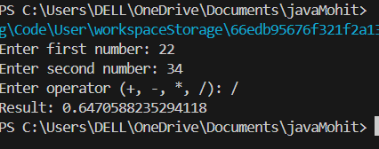
27. A smart toll system calculates the toll fee for vehicles based on
various parameters. The toll charges are determined by:
Vehicle Type:
1. Car → ₹100
2. Truck → ₹200
3. Bike → ₹50
Time-Based Charges:
1. Peak hours (8 AM - 11 AM, 5 PM - 8 PM) → Addi onal
20% surcharge
2. Night hours (11 PM - 5 AM) → 10% discount
(Time of Travel (24-hour format, e.g., 17 for 5 PM))
Frequent Traveler Discount:
1. If the vehicle has crossed the toll more than 10 mes in a
month, apply a 15% discount.
Fast Tag Bonus:
1. If the vehicle has an ac ve Fast Tag, an extra ₹20 discount
is applied.
Overloaded Trucks Penalty:
1. If a truck exceeds 1000 kg of cargo, a 30% penalty is
added.
Write a Java program that takes the vehicle type, me of travel,
number of trips in a month, Fast Tag status, and cargo weight (if
applicable) as input and calculates the final toll fee a er applying
all condi ons.
import java.util.Scanner;

public class SmartTollSystem {
public static void main(String[] args) {
Scanner sc = new Scanner(System.in);
System.out.print("Enter vehicle type (1-Car, 2-Truck, 3-Bike): ");
int type = sc.nextInt();
System.out.print("Enter hour of travel (0-23): ");
int hour = sc.nextInt();
System.out.print("Trips this month: ");
int trips = sc.nextInt();
System.out.print("Has Fast Tag (true/false): ");
boolean fastTag = sc.nextBoolean();

double weight = 0;
if (type == 2) { // Only for trucks
System.out.print("Enter cargo weight in kg: ");
weight = sc.nextDouble();
}

double baseFare = switch (type) {
case 1 -> 100;
case 2 -> 200;
case 3 -> 50;
default -> 0;
};

// Time-based charges
if ((hour >= 8 && hour <= 11) || (hour >= 17 && hour <= 20)) {
baseFare *= 1.2; // 20% surcharge
} else if (hour >= 23 || hour < 5) {
baseFare *= 0.9; // 10% discount
}

// Frequent traveler discount
if (trips > 10) {
baseFare *= 0.85;
}

// Fast tag discount
if (fastTag) {
baseFare -= 20;
}

// Overloaded truck penalty
if (type == 2 && weight > 1000) {
baseFare *= 1.3;
}

System.out.println("Final Toll Fee: ₹" + baseFare);
}
}

LAB-4 Date: 17-02-25
1 Write a program explaining Reference type Example( Func on)
class Person {
String name;
}

public class ReferenceTypeExample {
static void changeName(Person p) {
p.name = "Changed Name";
}

public static void main(String[] args) {
Person p1 = new Person();
p1.name = "Original Name";
changeName(p1);
System.out.println("Name after function call: " + p1.name); // Outputs: Changed Name
}
}
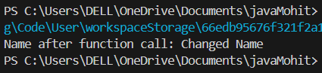
2 Write a program explaining Value Type Example (Func on)
public class ValueTypeExample {
static void changeValue(int a) {
a = 50;
}

public static void main(String[] args) {
int x = 10;
changeValue(x);
System.out.println("Value after function call: " + x); // Outputs: 10
}
}
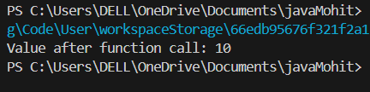
UNIT-2
3 Write a program to explain object of a class
class Student {
String name;
int age;
}

public class ObjectExample {
public static void main(String[] args) {
Student s1 = new Student(); // Object creation
s1.name = "Anil";
s1.age = 20;
System.out.println("Name: " + s1.name);
System.out.println("Age: " + s1.age);
}
}
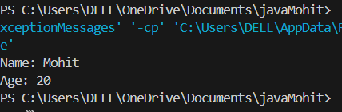
4. Write a program explaining a method in the class to set values for fields.
class Student {
String name;
int age;

void setDetails(String n, int a) {
name = n;
age = a;
}

void display() {
System.out.println("Name: " + name);
System.out.println("Age: " + age);
}
}

public class SetMethodExample {
public static void main(String[] args) {
Student s1 = new Student();
s1.setDetails("Sita", 22);
s1.display();
}
}
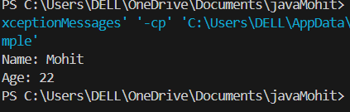
LAB-5 Date: 24-02-25
1.Write a program explaining default constructor
class DefaultConstructorExample {
int x;

// Default constructor
DefaultConstructorExample() {
x = 10;
System.out.println("Default constructor called. Value of x: " + x);
}

public static void main(String[] args) {
DefaultConstructorExample obj = new DefaultConstructorExample();
}
}
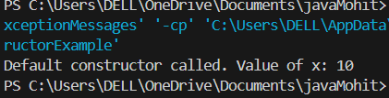
2.Write a java program explaining Parameterized constructor
class ParameterizedConstructorExample {
int x;

// Parameterized constructor
ParameterizedConstructorExample(int value) {
x = value;
System.out.println("Parameterized constructor called. Value of x: " + x);
}

public static void main(String[] args) {
ParameterizedConstructorExample obj = new ParameterizedConstructorExample(25);
}
}
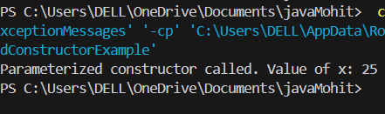
3 Write a java program explaining Constructor overloading
class ConstructorOverloadingExample {
int x;
String message;

// Default constructor
ConstructorOverloadingExample() {
x = 0;
message = "Default";
}

// Constructor with one parameter
ConstructorOverloadingExample(int value) {
x = value;
message = "One parameter";
}

// Constructor with two parameters
ConstructorOverloadingExample(int value, String msg) {
x = value;
message = msg;
}

void display() {
System.out.println("x: " + x + ", message: " + message);
}

public static void main(String[] args) {
ConstructorOverloadingExample obj1 = new ConstructorOverloadingExample();
ConstructorOverloadingExample obj2 = new ConstructorOverloadingExample(50);
ConstructorOverloadingExample obj3 = new ConstructorOverloadingExample(75, "Two parameters");

obj1.display();
obj2.display();
obj3.display();
}
}
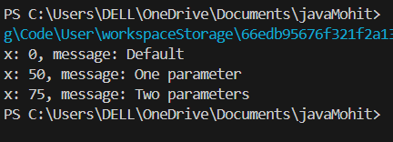
4. Write a java program explaining Garbage collector(GC)
class GarbageCollectorExample {
String name;

GarbageCollectorExample(String name) {
this.name = name;
}

// finalize method called by GC before object is destroyed
protected void finalize() {
System.out.println("Garbage collected for object: " + name);
}

public static void main(String[] args) {
GarbageCollectorExample obj1 = new GarbageCollectorExample("Object1");
GarbageCollectorExample obj2 = new GarbageCollectorExample("Object2");

obj1 = null;
obj2 = null;

// Suggesting JVM to run Garbage Collector
System.gc();

System.out.println("End of main method.");
}
}
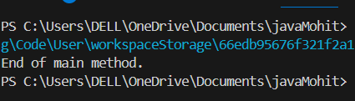
5.Write a Java program to demonstrate constructor overloading in a
Car class, where:
• The first constructor ini alizes the brand.
• The second constructor ini alizes the brand and model.
• The third constructor ini alizes the brand, model, and price.
class Car {
String brand;
String model;
double price;

// Constructor 1: only brand
Car(String brand) {
this.brand = brand;
System.out.println("Brand: " + brand);
}

// Constructor 2: brand and model
Car(String brand, String model) {
this.brand = brand;
this.model = model;
System.out.println("Brand: " + brand + ", Model: " + model);
}

// Constructor 3: brand, model and price
Car(String brand, String model, double price) {
this.brand = brand;
this.model = model;
this.price = price;
System.out.println("Brand: " + brand + ", Model: " + model + ", Price: $" + price);
}

public static void main(String[] args) {
Car car1 = new Car("Toyota");
Car car2 = new Car("Honda", "Civic");
Car car3 = new Car("BMW", "X5", 75000.0);
}
}
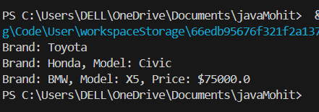

LAB-6 Date: 03-03-25
1. Write a java program explaining methods in a class
class MethodExample {
void display() {
System.out.println("Hello from display method");
}

int add(int a, int b) {
return a + b;
}

public static void main(String[] args) {
MethodExample obj = new MethodExample();
obj.display();
System.out.println("Sum: " + obj.add(5, 10));
}
}
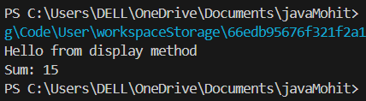
2. Write a java program explaining method overloading by changing
number of parameters .
class OverloadNumber {
void show(int a) {
System.out.println("One parameter: " + a);
}

void show(int a, int b) {
System.out.println("Two parameters: " + a + ", " + b);
}

public static void main(String[] args) {
OverloadNumber obj = new OverloadNumber();
obj.show(10);
obj.show(10, 20);
}
}
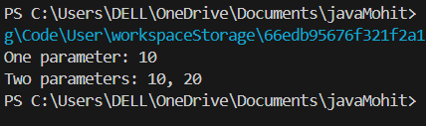
3. Write a java program explaining method overloading by changing
data types of parameters
class OverloadType {
void display(int a) {
System.out.println("int: " + a);
}

void display(double a) {
System.out.println("double: " + a);
}

public static void main(String[] args) {
OverloadType obj = new OverloadType();
obj.display(100);
obj.display(99.9);
}
}
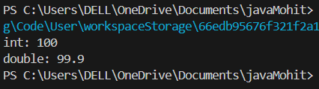
4. Write a Java program demonstra ng Method Overloading in a
Math Opera ons class that
includes:
sum(int, int),
sum(double, double), and
sum(int, int, int).
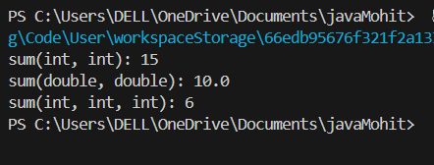
5. Write a java program explaining method overriding in java class Parent {
void show() {
System.out.println("Parent show()");
}
}

class Child extends Parent {
void show() {
System.out.println("Child show()");
}

public static void main(String[] args) {
Child c = new Child();
c.show();
}
}
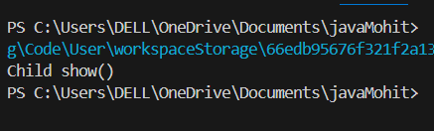
6. Write a Java program demonstra ng Method Overriding using an
Animal class and a Dog subclass that overrides make Sound().
class Animal {
void makeSound() {
System.out.println("Animal makes sound");
}
}

class Dog extends Animal {
void makeSound() {
System.out.println("Dog barks");
}

public static void main(String[] args) {
Dog d = new Dog();
d.makeSound();
}
}
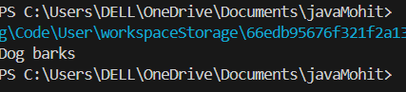
7. Write a java program explaining Super keyword (parent class
variable)
class Parent {
int x = 50;
}

class Child extends Parent {
int x = 100;

void display() {
System.out.println("Child x: " + x);
System.out.println("Parent x: " + super.x);
}

public static void main(String[] args) {
Child c = new Child();
c.display();
}
}
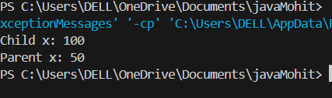
8. Write a java program explaining Super keyword(Parent class
methods)
class Parent {
void message() {
System.out.println("Message from Parent");
}
}

class Child extends Parent {
void message() {
super.message();
System.out.println("Message from Child");
}

public static void main(String[] args) {
Child c = new Child();
c.message();
}
}
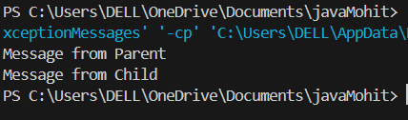
9 Write a java program explaining Super keyword (parent class
Constructor)
class Parent {
Parent() {
System.out.println("Parent constructor");
}
}

class Child extends Parent {
Child() {
super();
System.out.println("Child constructor");
}

public static void main(String[] args) {
Child c = new Child();
}
}
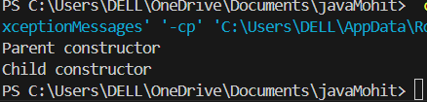
10. Write a java program explaining Java final keyword(Final variable)
class FinalVariableExample {
final int x = 10;

void display() {
System.out.println("Final variable x: " + x);
}

public static void main(String[] args) {
FinalVariableExample obj = new FinalVariableExample();
obj.display();
}
}
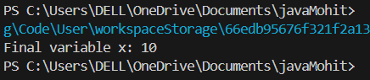
11.Write a java program explaining Java final keyword(Final method)
class Parent {
final void display() {
System.out.println("Final method in parent");
}
}

class Child extends Parent {
public static void main(String[] args) {
Child c = new Child();
c.display();
}
}
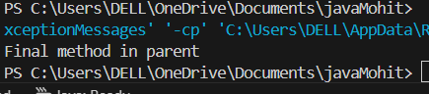
12.Write a java program explaining Java final keyword(Final class)
final class FinalClass {
void show() {
System.out.println("This is a final class");
}
}

public class Test {
public static void main(String[] args) {
FinalClass obj = new FinalClass();
obj.show();
}
}
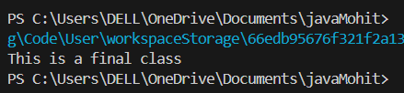
LAB-7 Date: 10-03-25
1. Write a java program explaining Single inheritance
class Parent {
void show() {
System.out.println("Parent method");
}
}

class Child extends Parent {
public static void main(String[] args) {
Child c = new Child();
c.show();
}
}
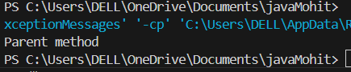
2. Write a java program explaining Mul level inheritance
class Grandparent {
void display() {
System.out.println("Grandparent class");
}
}

class Parent extends Grandparent {
void print() {
System.out.println("Parent class");
}
}

class Child extends Parent {
public static void main(String[] args) {
Child c = new Child();
c.display();
c.print();
}
}
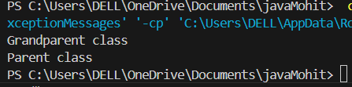
3. Write a java program explaining Hierarchical Inheritance
class Parent {
void greet() {
System.out.println("Hello from Parent");
}
}

class Child1 extends Parent {
void child1Method() {
System.out.println("Child1 method");
}
}

class Child2 extends Parent {
void child2Method() {
System.out.println("Child2 method");
}
}

class Main {
public static void main(String[] args) {
Child1 c1 = new Child1();
Child2 c2 = new Child2();
c1.greet();
c2.greet();
}
}
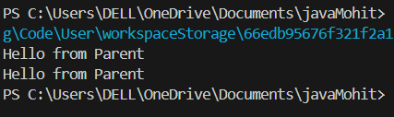
4. Write a java program explaining Mul ple Inheritance
interface A {
void methodA();
}

interface B {
void methodB();
}

class C implements A, B {
public void methodA() {
System.out.println("Method A");
}

public void methodB() {
System.out.println("Method B");
}

public static void main(String[] args) {
C obj = new C();
obj.methodA();
obj.methodB();
}
}
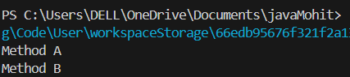
5. Write a java program explaining Hybrid Inheritance
interface A {
void showA();
}

interface B extends A {
void showB();
}

class C {
void showC() {
System.out.println("Class C");
}
}

class D extends C implements B {
public void showA() {
System.out.println("Interface A");
}

public void showB() {
System.out.println("Interface B");
}

public static void main(String[] args) {
D obj = new D();
obj.showA();
obj.showB();
obj.showC();
}
}
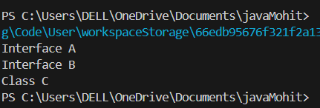
6. Write a java program explaining implementa on of Interface in
java
interface Drawable {
void draw();
}

class Circle implements Drawable {
public void draw() {
System.out.println("Drawing Circle");
}

public static void main(String[] args) {
Circle c = new Circle();
c.draw();
}
}
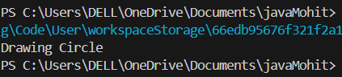
7. Write java programs explaining Rela onship between class and
interface
interface Vehicle {
void run();
}

class Bike implements Vehicle {
public void run() {
System.out.println("Bike is running");
}

public static void main(String[] args) {
Bike b = new Bike();
b.run();
}
}
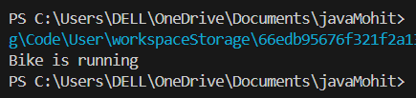
LAB-8 Date: 29-03-25
1. Write java programs explaining Packages
package mypackage;

public class Main {
public void display() {
System.out.println("This is a package example.");
}

public static void main(String[] args) {
Main obj = new Main();
obj.display();
}
}
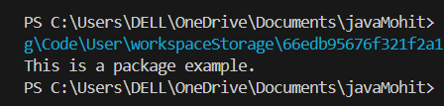

2. Write java programs explaining Sub Packages
package mypackage.subpackage;

public class SubMain {
public void show() {
System.out.println("This is a sub-package example.");
}

public static void main(String[] args) {
SubMain obj = new SubMain();
obj.show();
}
}
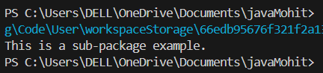
3.Write a java program explaining handling a built in excep on
public class BuiltInExceptionExample {
public static void main(String[] args) {
try {
int a = 5 / 0;
} catch (ArithmeticException e) {
System.out.println("Caught ArithmeticException: " + e.getMessage());
}
}
}
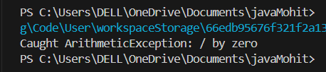
4.Write a java program explaining Crea on of Custom Excep on
class MyException extends Exception {
public MyException(String message) {
super(message);
}
}

public class CustomExceptionExample {
public static void main(String[] args) {
try {
throw new MyException("This is a custom exception");
} catch (MyException e) {
System.out.println("Caught: " + e.getMessage());
}
}
}
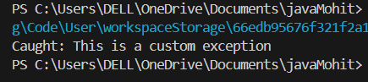
5. Write a java program explaining Using throw to Manually Throw an
Excep on
public class ThrowExample {
public static void main(String[] args) {
throw new ArithmeticException("Manually thrown exception");
}
}
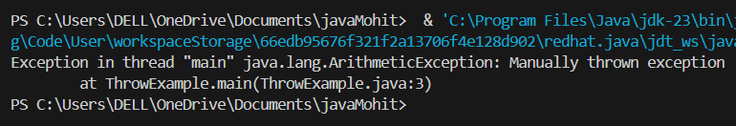
6. Write a Java Program Using throws Arithme c Excep on
public class ThrowsExample {
public static void divide() throws ArithmeticException {
int result = 10 / 0;
}

public static void main(String[] args) {
try {
divide();
} catch (ArithmeticException e) {
System.out.println("Caught: " + e.getMessage());
}
}
}
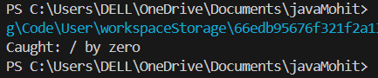
7. Write a java program explaining Invalid age excep on
class InvalidAgeException extends Exception {
public InvalidAgeException(String message) {
super(message);
}
}

public class AgeCheck {
public static void checkAge(int age) throws InvalidAgeException {
if (age < 18) {
throw new InvalidAgeException("Age is invalid");
}
}

public static void main(String[] args) {
try {
checkAge(15);
} catch (InvalidAgeException e) {
System.out.println("Caught: " + e.getMessage());
}
}
}
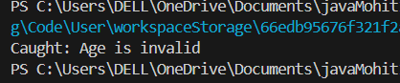
8. Write a java program explaining Insufficient balance excep on
class InsufficientBalanceException extends Exception {
public InsufficientBalanceException(String message) {
super(message);
}
}

public class Bank {
static int balance = 500;

public static void withdraw(int amount) throws InsufficientBalanceException {
if (amount > balance) {
throw new InsufficientBalanceException("Insufficient balance");
}
balance -= amount;
}

public static void main(String[] args) {
try {
withdraw(600);
} catch (InsufficientBalanceException e) {
System.out.println("Caught: " + e.getMessage());
}
}
}
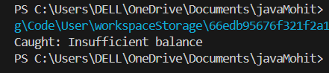
9. Write a java program explaining invalid marks excep on
class InvalidMarksException extends Exception {
public InvalidMarksException(String message) {
super(message);
}
}

public class MarksCheck {
public static void validateMarks(int marks) throws InvalidMarksException {
if (marks < 0 || marks > 100) {
throw new InvalidMarksException("Marks are invalid");
}
}

public static void main(String[] args) {
try {
validateMarks(120);
} catch (InvalidMarksException e) {
System.out.println("Caught: " + e.getMessage());
}
}
}
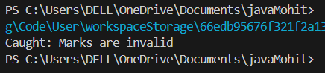
10. Write a java program explaining product out of stock excep on
class OutOfStockException extends Exception {
public OutOfStockException(String message) {
super(message);
}
}

public class Product {
static int stock = 0;

public static void purchase(int quantity) throws OutOfStockException {
if (quantity > stock) {
throw new OutOfStockException("Product out of stock");
}
stock -= quantity;
}

public static void main(String[] args) {
try {
purchase(1);
} catch (OutOfStockException e) {
System.out.println("Caught: " + e.getMessage());
}
}
}
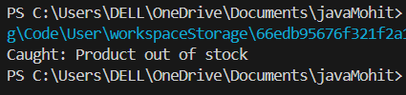
11. Write a java program explaining invalid username excep on
class InvalidUsernameException extends Exception {
public InvalidUsernameException(String message) {
super(message);
}
}

public class UsernameCheck {
public static void validate(String username) throws InvalidUsernameException {
if (!username.equals("admin")) {
throw new InvalidUsernameException("Invalid username");
}
}

public static void main(String[] args) {
try {
validate("guest");
} catch (InvalidUsernameException e) {
System.out.println("Caught: " + e.getMessage());
}
}
}
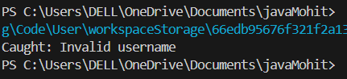
LAB-9 Date: 7-04-25
1. Write a java program explaining Print Mul plica on Table using
Thread
class TableThread extends Thread {
int number;

TableThread(int number) {
this.number = number;
}

public void run() {
for (int i = 1; i <= 10; i++) {
System.out.println(number + " x " + i + " = " + (number * i));
}
}

public static void main(String[] args) {
TableThread t = new TableThread(5);
t.start();
}
}
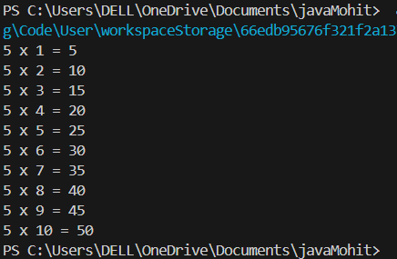
2. Write a java program explaining even and odd numbers prin ng
using two threads
class EvenThread extends Thread {
public void run() {
for (int i = 0; i <= 20; i += 2) {
System.out.println("Even: " + i);
}
}
}

class OddThread extends Thread {
public void run() {
for (int i = 1; i <= 20; i += 2) {
System.out.println("Odd: " + i);
}
}
}

public class EvenOddThreads {
public static void main(String[] args) {
EvenThread even = new EvenThread();
OddThread odd = new OddThread();
even.start();
odd.start();
}
}
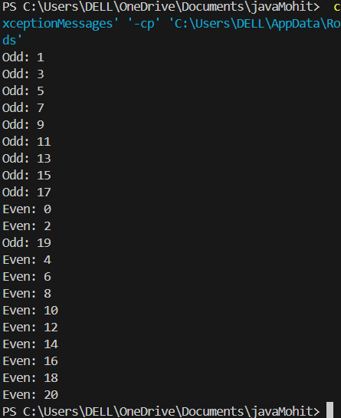
3. Write a java program explaining factorial using thread
class FactorialThread extends Thread {
int number;

FactorialThread(int number) {
this.number = number;
}

public void run() {
int fact = 1;
for (int i = 1; i <= number; i++) {
fact *= i;
}
System.out.println("Factorial of " + number + " is " + fact);
}

public static void main(String[] args) {
FactorialThread t = new FactorialThread(5);
t.start();
}
}
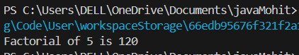
4. Write a java program explaining Fibonacci series using thread
class FibonacciThread extends Thread {
int count;

FibonacciThread(int count) {
this.count = count;
}

public void run() {
int a = 0, b = 1;
System.out.print(a + " " + b);
for (int i = 2; i < count; i++) {
int c = a + b;
System.out.print(" " + c);
a = b;
b = c;
}
}

public static void main(String[] args) {
FibonacciThread t = new FibonacciThread(10);
t.start();
}
}
