MACHINE LEARNING

LAB – 2

Aim : To perform exploratory data analysis (EDA) on a student performance dataset using Pandas and Matplotlib.

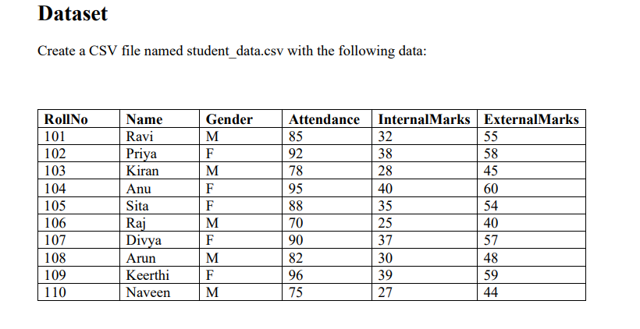

Tasks

Task A: Dataset Loading and Inspection

• Import the necessary Python libraries.
• Load the dataset into a Pandas DataFrame.
• Display the first five records.
• Display the last five records.
• Find the total number of rows and columns.
• Display the names of all columns.
• Display the data type of each column.
• Generate dataset information using info().

Code:

#Task A
import pandas as pd

from google.colab import files

uploaded = files.upload()

df = pd.read_csv("student_data.csv")

print(df)

# Display the first five records
print(df.head(5))

#Display the last five records
print(df.tail(5))

# Find the total number of rows and columns

print(df.shape[0])
print(df.shape[1])

#Display the names of all columns.
print(df.columns.tolist())

# Display the datatype of each column
print(df["RollNo"].dtype)
print(df["Name"].dtype)
print(df["Gender"].dtype)
print(df["Attendance"].dtype)
print(df["InternalMarks"].dtype)
print(df["ExternalMarks"].dtype)

#Generate dataset information using info()
print(df.info())

OUTPUT:

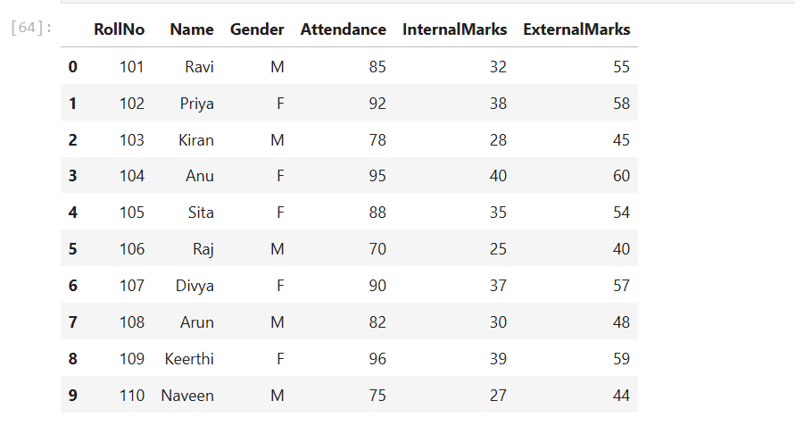

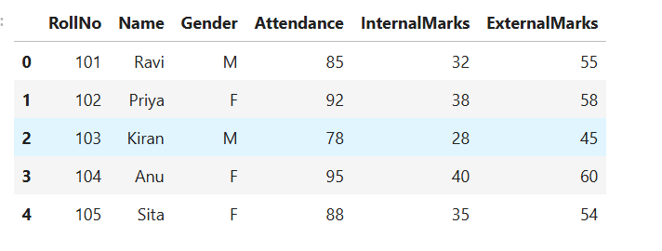

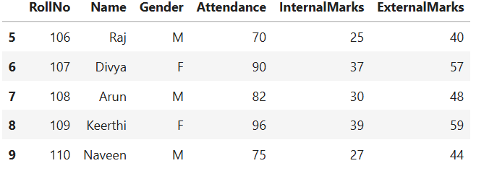
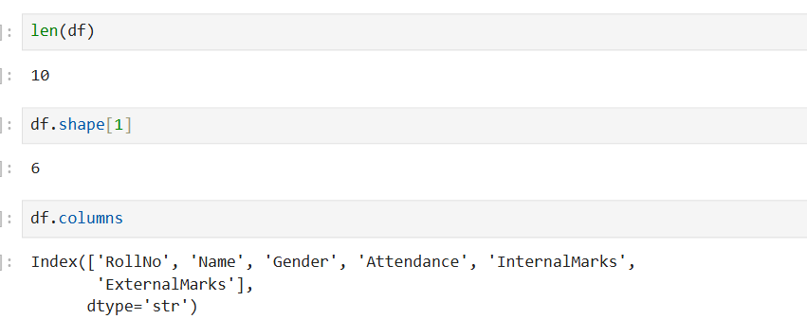

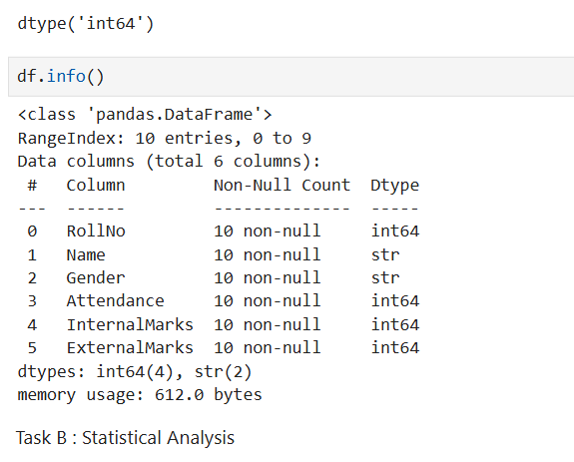

Task B: Statistical Analysis

• Calculate the mean attendance of all students.
• Calculate the average Internal Marks.
• Calculate the average External Marks.
• Find the maximum Internal Marks.
• Find the minimum Internal Marks.
• Find the maximum External Marks.
• Find the minimum External Marks.
• Calculate the standard deviation of Internal Marks.
• Generate summary statistics using describe().

Code:

# Task B

#Calculate the mean attendance of all students.

print(df["Attendance"].mean())

#Calculate the average Internal Marks

print(df["InternalMarks"].mean())

#Calculate the average External Marks

print(df["ExternalMarks"].mean())

#Find the maximum Internal Marks.

print(df["InternalMarks"].max())
#Find the minimum Internal Marks.

print(df["InternalMarks"].min())

#Find the maximum External Marks.

print(df["ExternalMarks"].max())

#Find the minimum External Marks.

print(df["ExternalMarks"].min())

# Calculate the standard deviation of Internal Marks.
print(df["InternalMarks"].std())

#Generate summary statistics using describe().

print(df.describe())

OUTPUT:

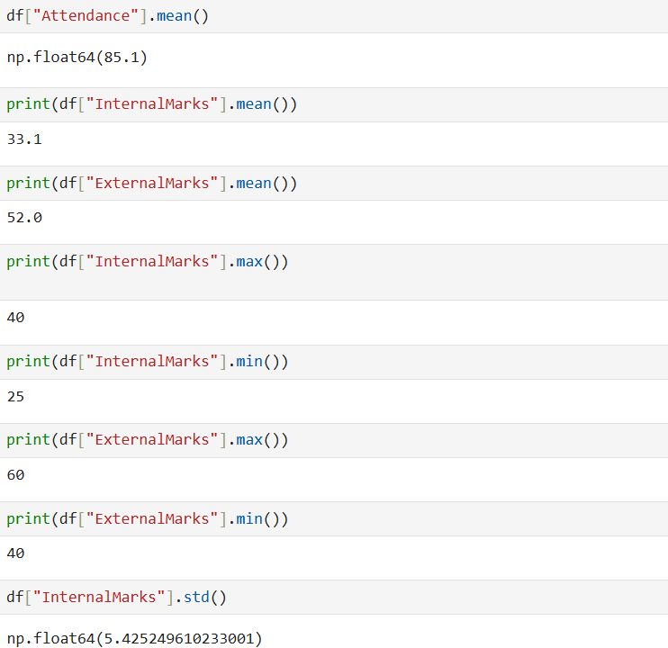

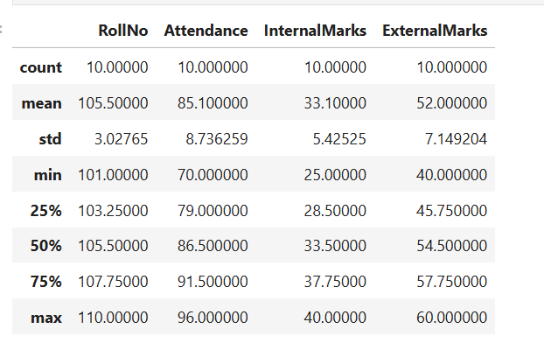

Task C: Data Manipulation
• Create a new column named TotalMarks.
• TotalMarks=InternalMarks+ExternalMarks
• Create a new column named Percentage. 1. Percentage=TotalMarks/100×100
• Display the updated DataFrame

Code:

#Task C

#Create a new column named TotalMarks.

df["TotalMarks"] = df["InternalMarks"] + df["ExternalMarks"]

print(df["TotalMarks"])

#Create a new column named Percentage.
# Percentage=TotalMarks/100×100

df["Percentage"] = df["TotalMarks"]/100*100

print(df["Percentage"])

#Display the updated DataFrame

print(df)

OUTPUT:

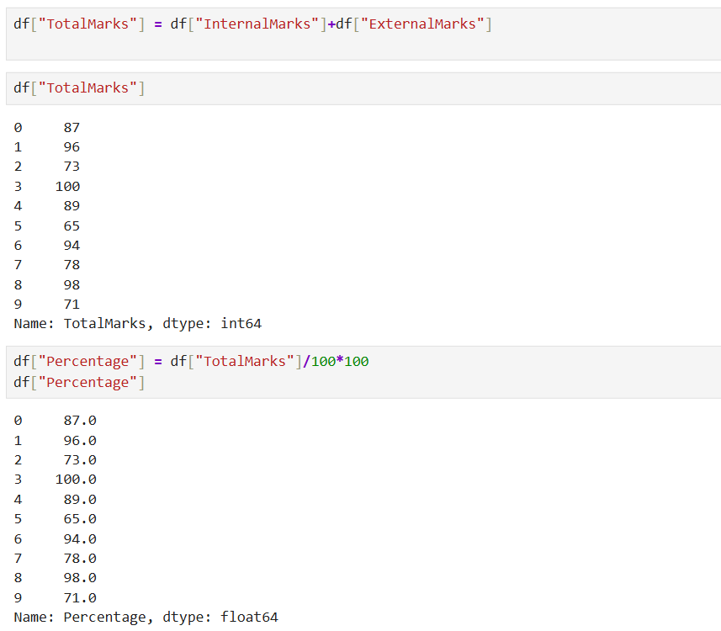

Task D: Filtering and Searching

• Display the details of students whose attendance is greater than 90%.
• Display the details of students whose TotalMarks exceed 90.
• Display the details of female students.
• Display the details of male students.
• Display students whose ExternalMarks are less than 50.

Code:

#Display the details of students whose attendance is greater than 90%.

df[df["Attendance"] > 90 ]

#Display the details of students whose TotalMarks exceed 90.
df[df["TotalMarks"] > 90]

#Display the details of female students.
df[df["Gender"] == "F"]

#Display the details of male students.
df[df["Gender"] == "M"]

# Display students whose ExternalMarks are less than 50.

df[df["ExternalMarks"] < 50]

OUTPUT:

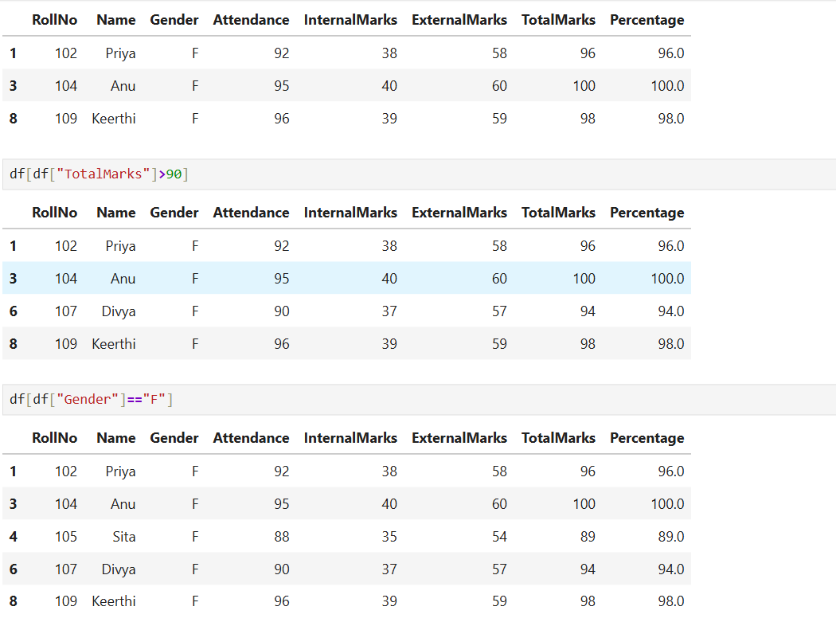

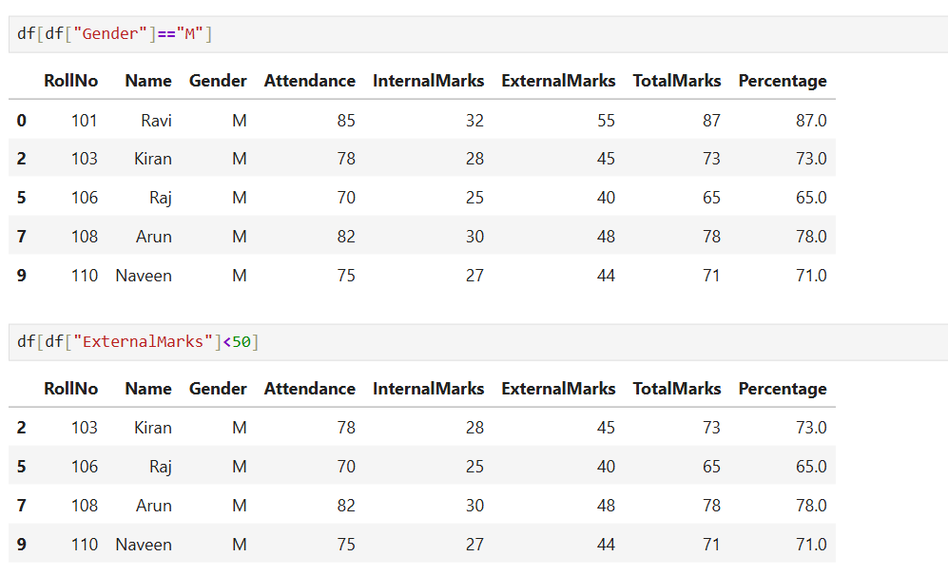

Task E: Ranking and Comparison
• Identify the student with the highest TotalMarks.
• Identify the student with the lowest TotalMarks.
• Display the top three performers based on TotalMarks.
• Display the bottom three performers based on TotalMarks.
• Determine how many students scored above the class average.

Code:

#Task E

# Highest TotalMarks
highest_student = df.nlargest(1, 'TotalMarks')['Name'].values[0]
print("Highest TotalMarks Student:", highest_student)

# Lowest TotalMarks
lowest_student = df.nsmallest(1, 'TotalMarks')['Name'].values[0]
print("Lowest TotalMarks Student:", lowest_student)

# Top 3 performers
print("\nTop 3 Performers:")
print(df.nlargest(3, 'TotalMarks')[['Name', 'TotalMarks']])

# Bottom 3 performers
print("\nBottom 3 Performers:")
print(df.nsmallest(3, 'TotalMarks')[['Name', 'TotalMarks']])

# Students above class average
avg = df['TotalMarks'].mean()
above_avg = df[df['TotalMarks'] > avg]
print(f"\nClass Average: {avg}")
print(f"Students above average: {len(above_avg)}")
print(above_avg[['Name', 'TotalMarks']])

OUTPUT:

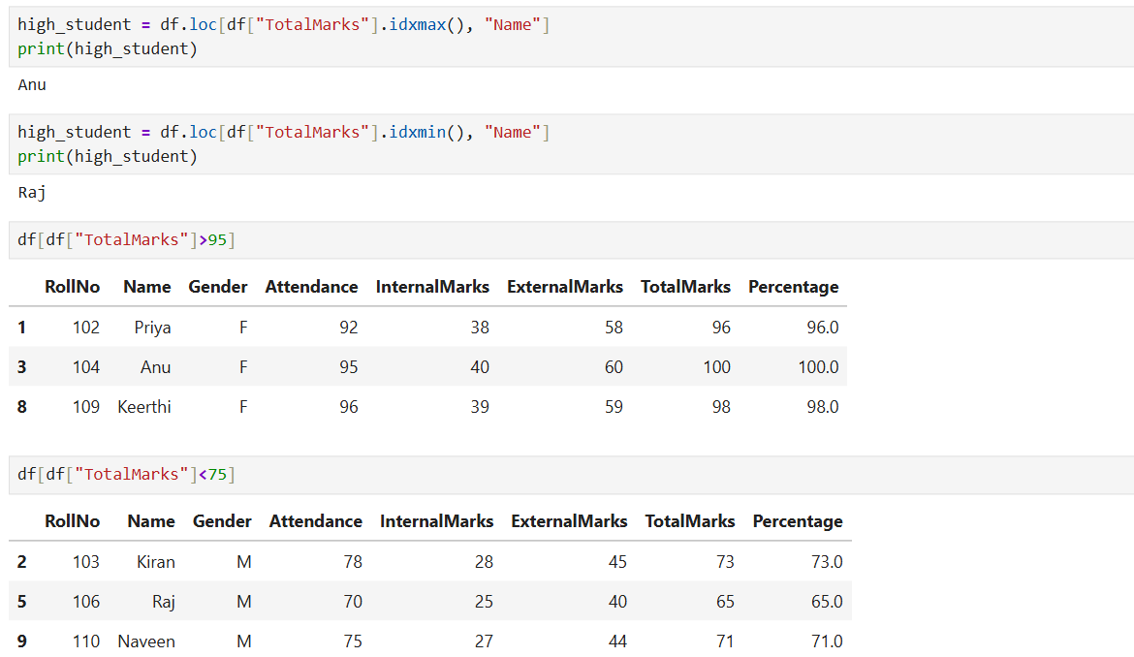
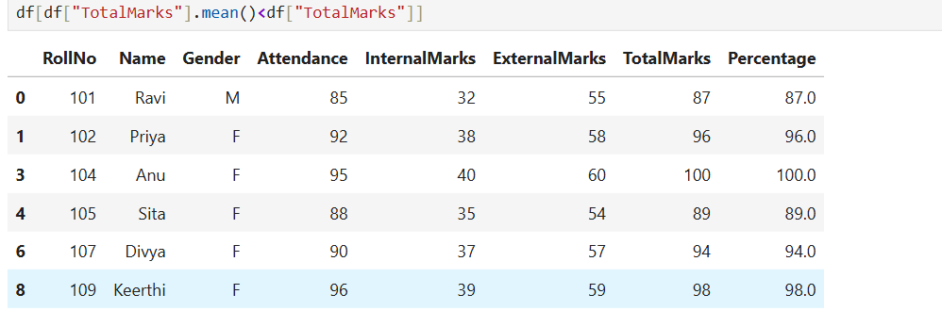

Task F: Group-wise Analysis

• Calculate the average TotalMarks of male students.
• Calculate the average TotalMarks of female students.
• Compare the average attendance of male and female students.

Code:

#Task F

# Average TotalMarks by Gender
avg_male = df[df['Gender'] == 'M']['TotalMarks'].mean()
avg_female = df[df['Gender'] == 'F']['TotalMarks'].mean()
print(f"Average TotalMarks - Male : {avg_male}")
print(f"Average TotalMarks - Female: {avg_female}")

# Average Attendance by Gender
att_male = df[df['Gender'] == 'M']['Attendance'].mean()
att_female = df[df['Gender'] == 'F']['Attendance'].mean()
print(f"\nAverage Attendance - Male : {att_male}")
print(f"Average Attendance - Female: {att_female}")

OUTPUT:
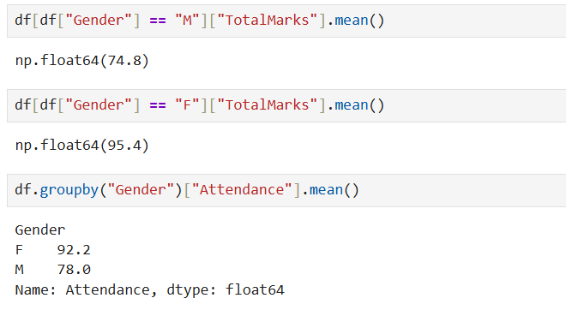

Task G: Data Visualization
• Plot a bar chart showing TotalMarks of all students.
• Plot a histogram of Attendance.
• Plot a pie chart showing the distribution of male and female students.
• Plot a scatter plot between Attendance and TotalMarks.
• Interpret the relationship between Attendance and TotalMarks.

Code:

#Task G

# 1. Bar Chart - TotalMarks of all students

import matplotlib.pyplot as plt
plt.bar(df["Name"], df["TotalMarks"])

# 2. Histogram – Attendance

plt.hist(df["Attendance"])

# 3. Pie Chart - Gender Distribution
import matplotlib.pyplot as plt

gender_counts = df["Gender"].value_counts()

plt.figure(figsize=(6,6))
plt.pie(
gender_counts,
labels=gender_counts.index,
autopct="%1.1f%%",
startangle=90
)
plt.show()

# 4. Scatter Plot - Attendance vs TotalMarks

plt.scatter(df["Attendance"], df["TotalMarks"])

OUTPUT:
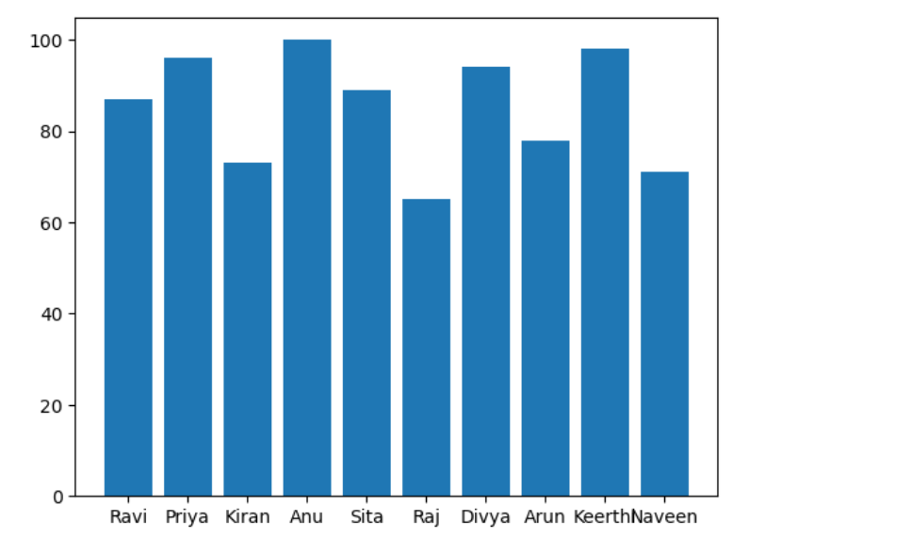

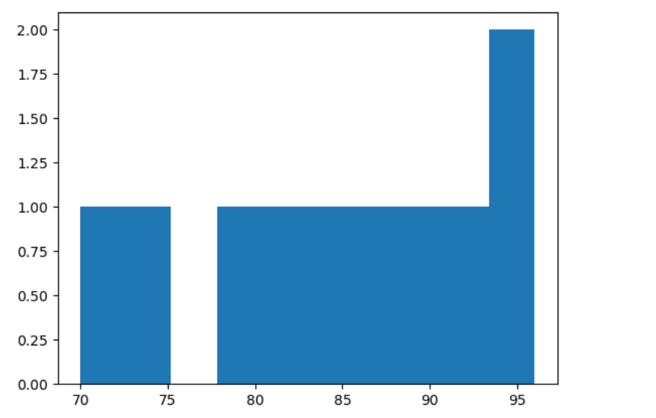

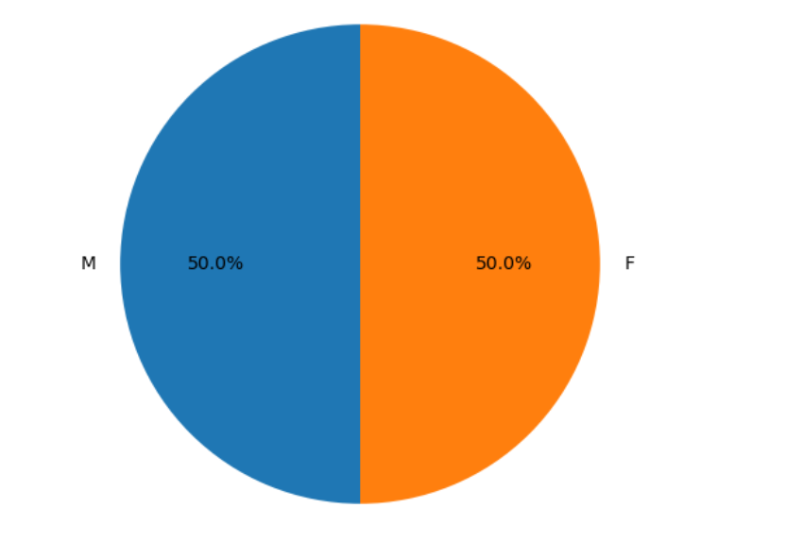
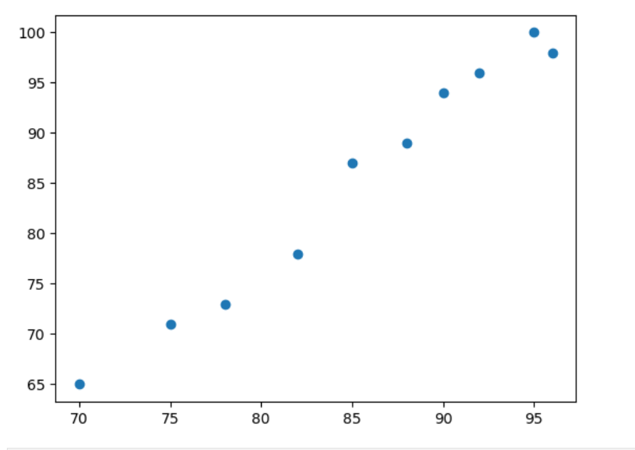
Task H: Observations
• Write any three observations based on the analysis performed.
• State whether higher attendance appears to be associated with better academic performance.

OBSERVATIONS:

1. Students who attended more classes generally scored better marks.
For example, Anu had 95% attendance and scored the highest marks,
while Raj had only 70% attendance and scored the lowest.

2. Female students performed slightly better than male students
on average in both attendance and total marks.

3. Most students scored between 70 to 100 marks out of 120,
which shows the overall class performance was average to good.

CONCLUSION:

Yes, higher attendance is linked to better performance.
Students with more than 90% attendance scored above the class average,
and students with low attendance scored lower marks.

