**CSV response payload:**

And each sentence is key and the sentence words are in alphabetically in order stored as value in map.

Note-some word are not in alphabetical order like Chinese word, carriage return etc.

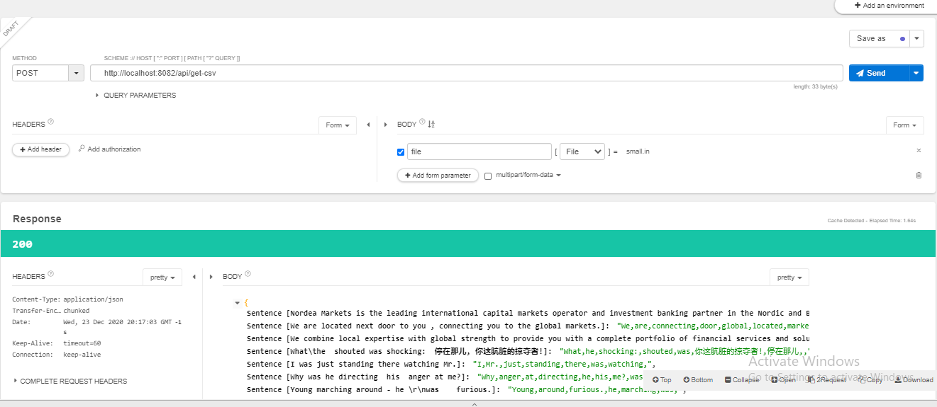

**Xml response payload:**

