1) Hunter Gaukel
2) https://github.com/Gaukelh/CS380/tree/master/exercises/exercise_6
3)

Ted without password:
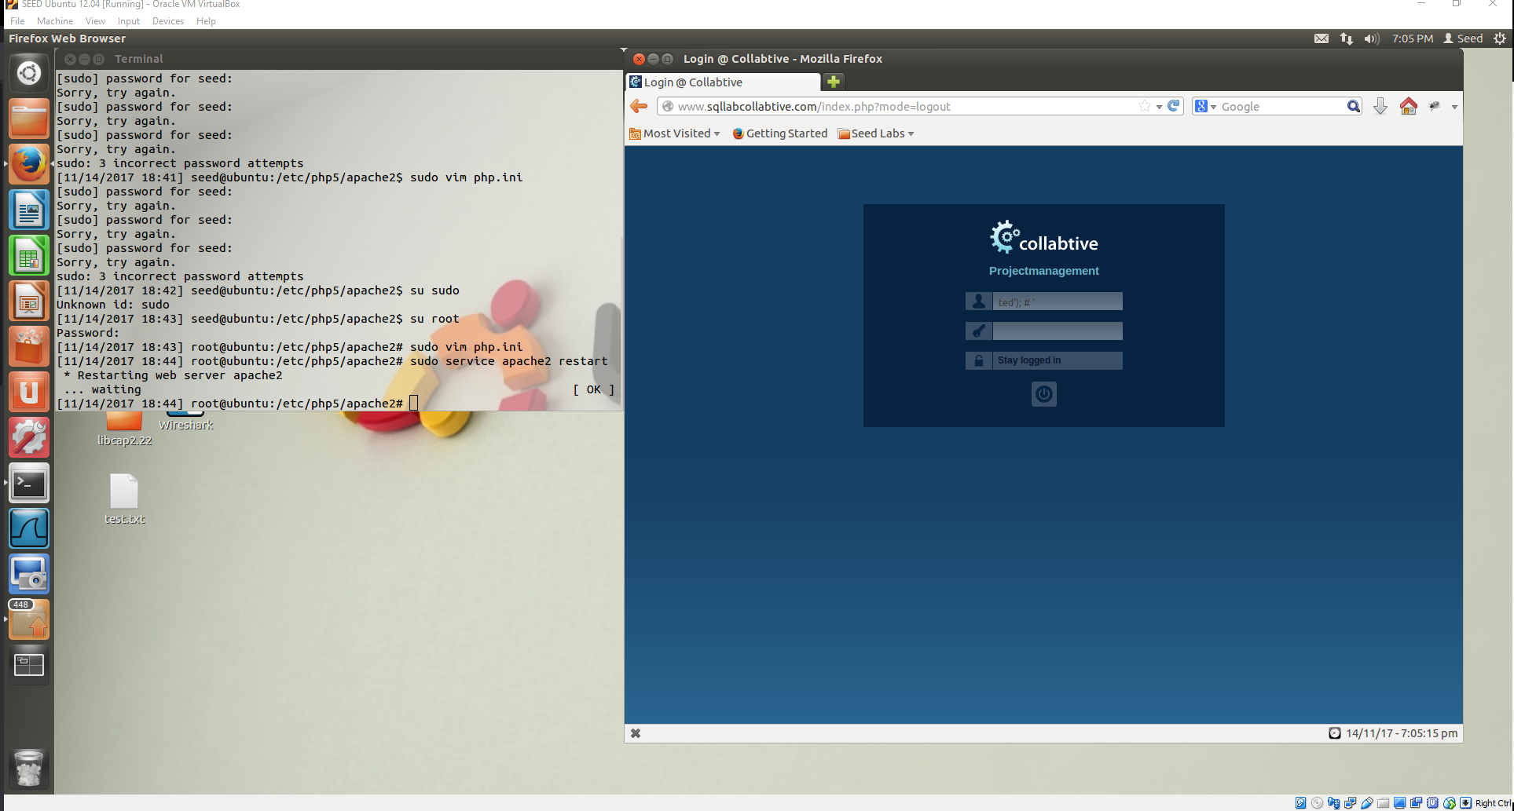

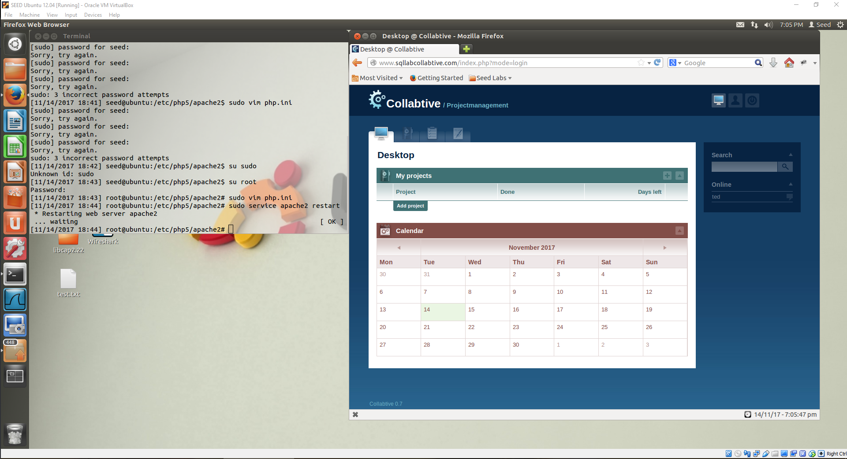
Admin:
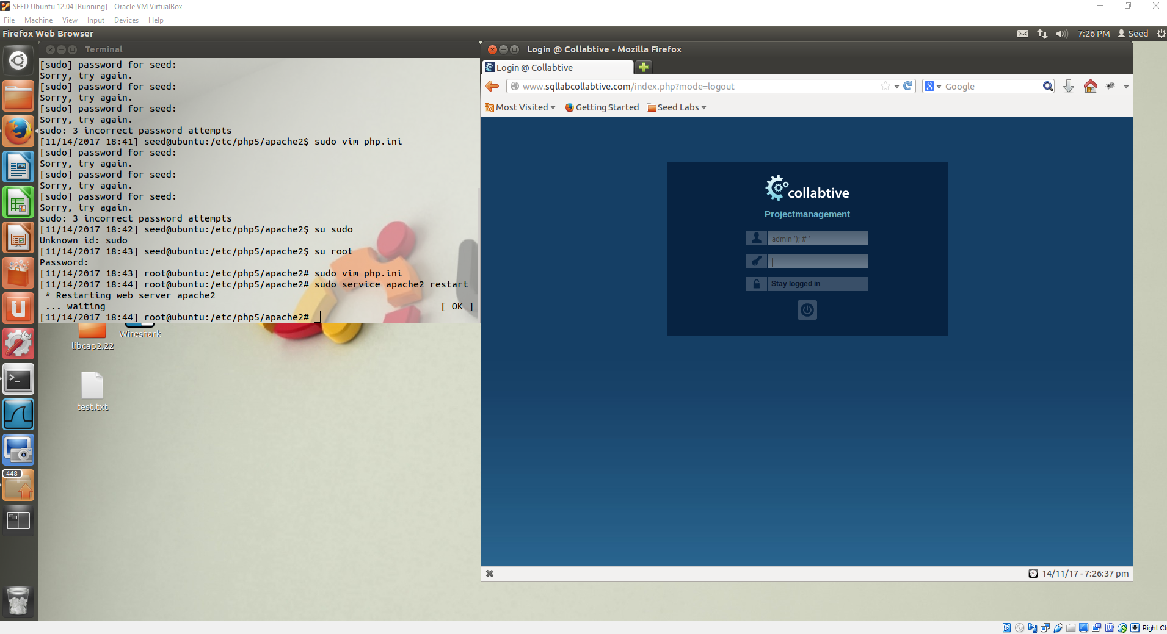
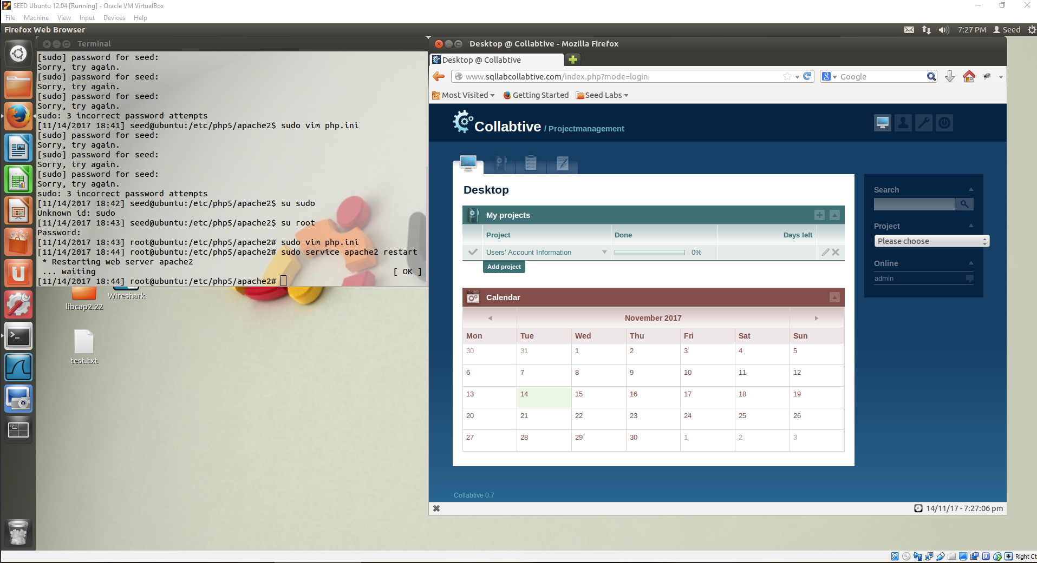
Blank username:
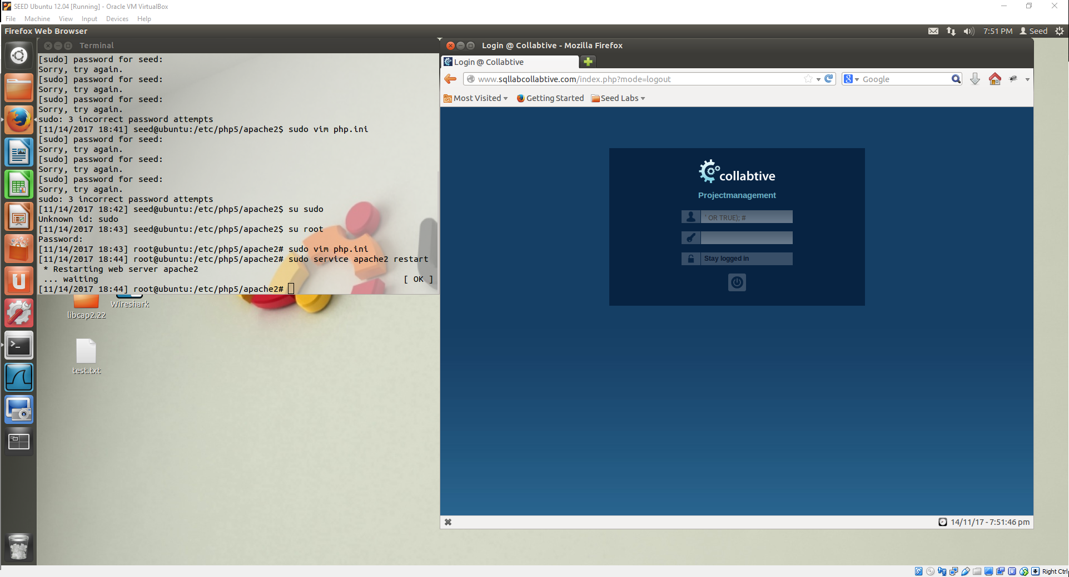
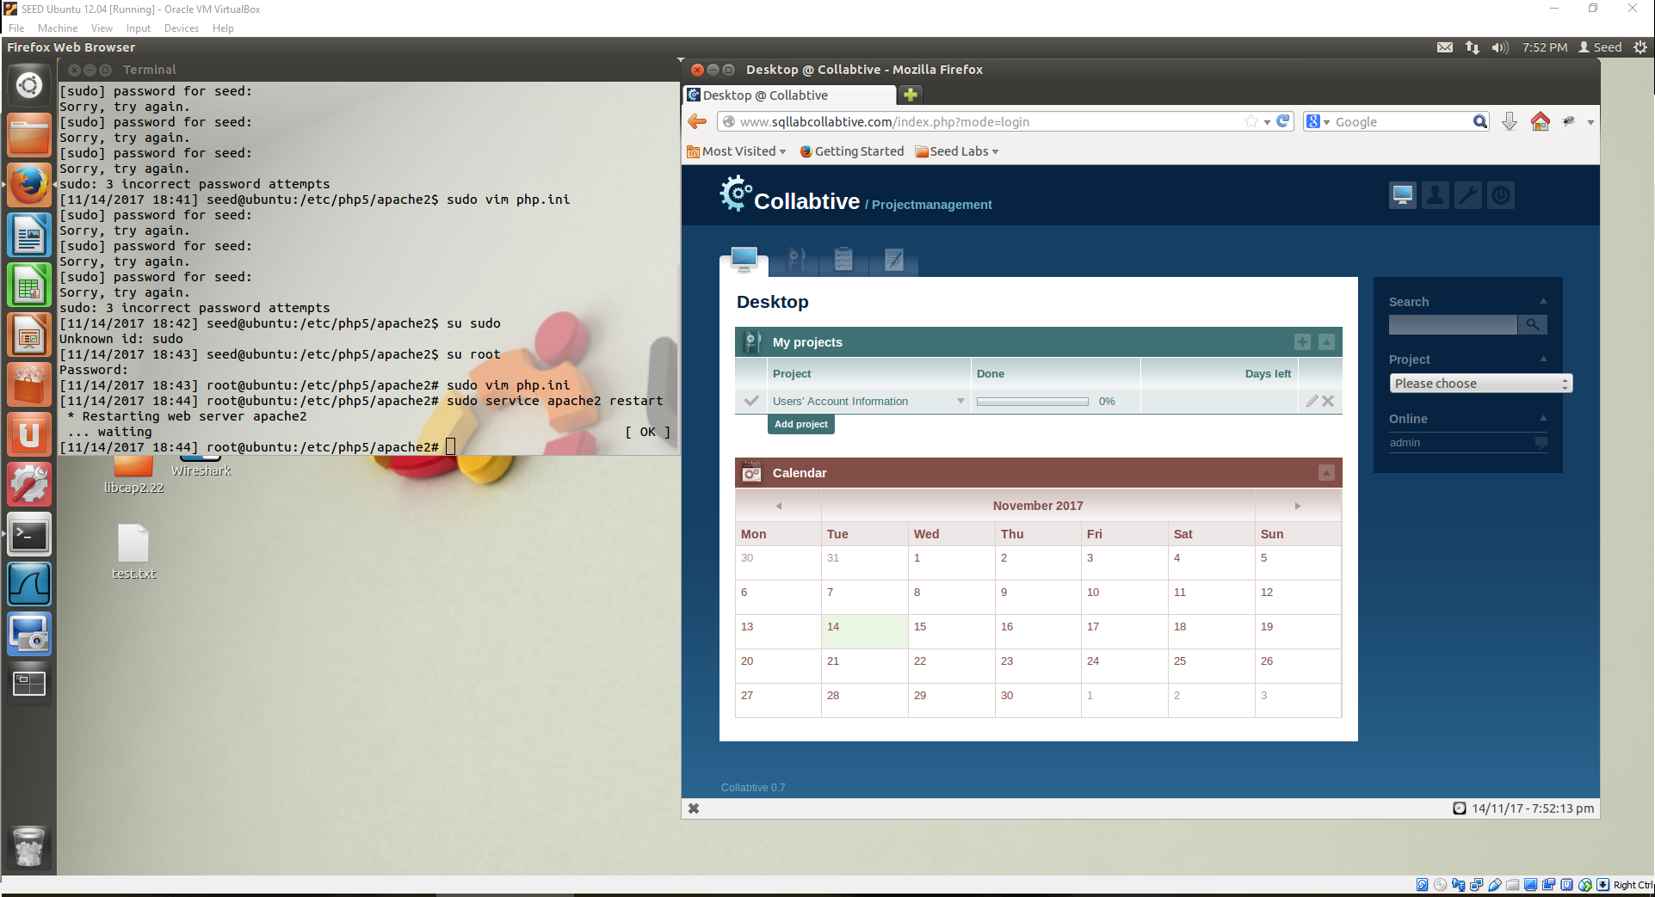
Website evaluates it’s internal SQL statement with an OR TRUE, so that it will always return and login correctly. The website thinks we’re an admin user.

