Assignmet -Name-Gaurav Ratnaparkhi

reg no-2020bBIT025

1. Travellingsalesman Problem.

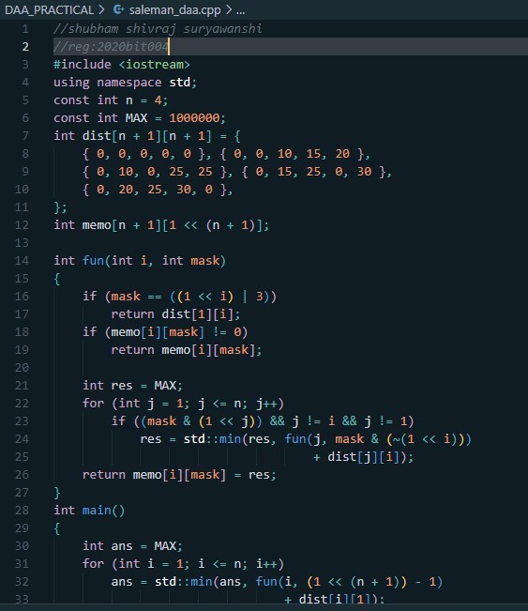

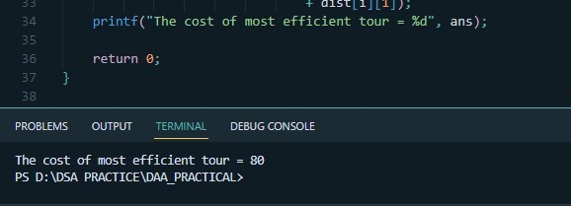

1. **BF stringMatchingAlgorithm**

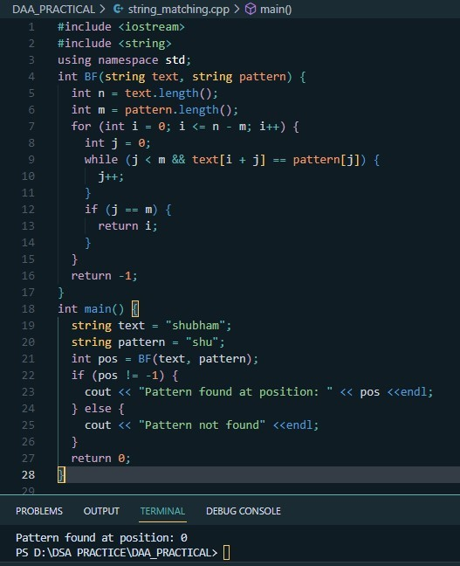

1. **ExhaustiveSearchAlgorithm**

