Tribhuvan University
Institute of Science and Technology
Amrit Science Campus, Lainchaur


LAB SHEET

C-Lab Report Submitted By
Name: Gaurab Ale Magar
Roll No: 2031/081 (BIT)

Submitted To:
Pankaj Kumar Jaiswal
Department of Computer Science and Information Technology

Submission Date:
S. No | Name of Experiment | Date of Submission | Signature
1 | - Write a program to display “hello world’ in C  - Write a program to enter two integers and then display their sum  - Write a program to multiply two numbers (10&8) and display its sum.  - Write a program to calculate simple interest for given P=4000, T=2 , R=5.5.
2 | - Write a program to prompt the user to input 3 integer values and print these values in forward and reversed order.  - Write a program that defines a variable and then increments and decrements the value of the variable using the ++ (increment) and – (decrement) operators. Print the value of the variable after each operation to the console.  - Write a program to calculate simple and compound interest.  - Write a program to swap two variables’ values with and without using third variables.  - Write a program to check odd or even number using (a) modulus operator (b) using bitwise operator (c) without using bitwise and modulus operator (d) using conditional operator.  - Write a program that declares variables of different data types) int, float, char etc.) and prints their sizes using the size of operator.
3 | - Write a program to produce the output as shown.  - Given the three numbers a(=8) , b9=4), c and constant value of PI =3.1415, calculate and display the following using macros (preprocessor directives).  - Demonstrate the differences among getch(), getche(), getchar(). Demonstrate the difference between scanf() & gets() , printf() & puts().
4 | - Write a program to find the largest and smallest among the three entered numbers and also display whether the identified largest/smallest number is even or odd.  - Write a program to get input of two or higher digit integer number and display inverse order.  - Write a program to read the values of coefficients a, b and c of a quadratic equation ax²+bx+c=0 and find roots of the equation.
5 | - Write a program to input two integer numbers and display the sum of even numbers between these two input numbers.  - Write a program to display Fibonacci series of last term up to 300.  - Write a program using for loop with a break statement to find the first prime number between 1 and 100 and print it.  - Write a program using while loop to print the number from 10 to 1 to the console.  - Write a program to display the following pattern.
6 | - Write a program to calculate sum of first 50 natural numbers using recursive function.  - Define a function named fact() to calculate factorial of a number n and then write a program that uses this function fact() to calculate combination and permutation.  - Write a recursive function to general Fibonacci series.
7 | - Write a program that creates a one-dimensional array of 5 integers. Assign value to each element of an array and print them to the console  - Write a program that asks the user to enter 5 integers and store them in an array. Print the elements of the array in the console.  - Write a program to read two matrices of order 3*2, add them and display the resultant matrix in matrix form.  - Write a program that defines a function that takes an array of integers as a parameter. The function should print the sum of the elements in the array to the console. Call the function with an array of your choice.  - Write a program to multiply two 3*3 matrix.  - Write a program to read a string and check for palindrome without using string related function.
8 | - Write a program to swap value of two variables using pointer.  - Write a program to copy one string to another string with and without suing string handling function.  - Write a program to concatenate two strings.  - Write a program to sort string words stored in an array of pointers.  - Write a program to print the following pattern.
9 | - Create a structure named company which has name, address, phone, no Of Employee as member variables. Read name of company, its address, phone and noOfEmployee. Finally display the members’ value.  - Write a program which accepts structure as argument and returns structure to the calling program.  - Write a program to read RollNo, Name, Address, Age & average-marks of 12 students in the BCT calls and display the details from functions.  - Wap that access the members of a structure using dot operator. Create a structure to store information about a rectangle, including its length and width. Compute its area and print to the console.  - Write a program that creates a pointer to an integer variable and prints its value to the console. Use the * operator to declare the pointer.  - Write a program that uses pointers to iterate over an array of integers and prints its values to the console.  - Write a program that uses pointer to structure. Create a structure to store information about book including its title, author, and publication- year. Use a pointer to the structure to access the members of the structure to display in console.
10 | - Write characters into a file ‘file.txt’. The set of characters are read from the keyboard until an enter key is pressed (use putc() and getc() function).  - Read characters from file “file.txt” created in question 1. Also count the number of character in the file (use fputs() and fgets() function)  - Write set of strings each of length 40 into a file “string.txt” and display it (use fputs() and fgets() function).  - Write name, age and height of a person into a data file “person.txt” and read it (use fprintf () and fscanf() function).  - Write a program that copies the contents of one file to another. Use the fopen() function to open the source file and the destination file,and the use a loop to read and write each character in the source file.

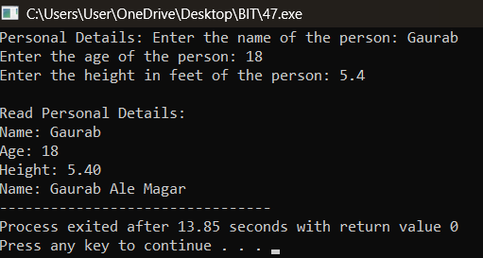
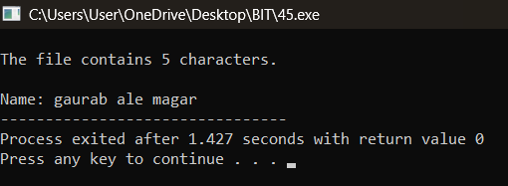
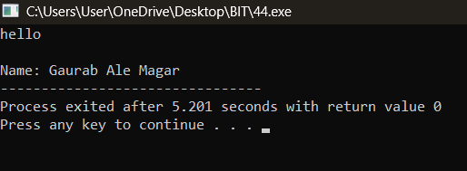
LAB ASSIGNMENT 10
4
3
2
1
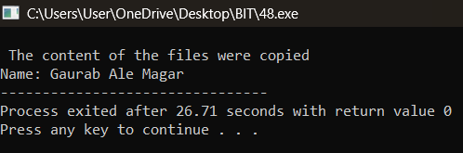
5

