SOFTWARE ENGINEERING LAB PROJECT REPORT
Gym Fitness Management System
(Membership Verification & Workout Planner)
Student Name: | Gaurang Sonone
Course / Subject: | Software Engineering Laboratory (PBL)
Academic Year: | 2026
Overall Testing Status: | ALL TEST CASES PASSED (100%)

1. Project Title
Project Title: Gym Fitness Management System (GymFit) — An Integrated Gym Membership Verification and Custom Workout Planning System.

2. Problem Statement and Objectives

2.1 Problem Statement
Traditional fitness centers and personal workout tracking often rely on manual registers, paper logs, or disconnected spreadsheets. This creates recurring operational issues:
• Membership Inconsistencies: Members are frequently unaware of their membership expiration, leading to unexpected access rejection at check-in.
• Lack of Account Security: Basic portals often lack protection against brute-force password guessing, account lockout, or automated password recovery.
• Disorganized Workout Planning: Gym members lack a structured digital tool to plan multi-day workout routines (sets, reps, targeted muscles) and monitor daily exercise metrics.

2.2 Project Objectives
• Secure Authentication: Provide role-based access control (Member vs. Trainer) using encrypted passwords (bcrypt) and JSON Web Tokens (JWT).
• Credential Recovery: Provide an automated password reset option after 3 failed login attempts and account lockout after 5 failed attempts.
• Membership Expiration & Renewal: Automatically detect expired memberships on login and offer a one-click renewal flow.
• Custom Workout Planning: Enable members to create custom routines with 1 to 7 days/week validation, and dynamically append exercises with sets and reps.
• Daily Progress Tracking: Provide an intuitive dashboard to log daily workout sessions, calories burned, and weight, calculating aggregate statistics.
• Comprehensive Testing: Verify the system using Black-Box functional test cases and White-Box code path coverage.

3. Proposed Solution and Key Features

3.1 Proposed Solution
The proposed solution is a full-stack web application designed with a 3-tier client-server architecture: a responsive React 18 Single Page Application (SPA) on the frontend, a secure Node.js/Express REST API on the backend, and a MongoDB database managed through Mongoose ODM. Stateless JWT tokens secure all client-server communications.

3.2 Key Features
1. Role-Based Login: Supports Member and Trainer logins with token-based session protection.
2. 3-Strike Password Reset & Lockout: Offers a 'Generate New Password' option after 3 failed attempts, and locks account after 5 failed attempts.
3. Expiration Alert & One-Click Renewal: Blocks dashboard entry for expired members and provides a direct 'Renew Membership' button.
4. Workout Routine Planner: Allows members to create routines with validation for required plan names and weekly days (strictly 1 to 7 days).
5. Dynamic Exercise Addition: Members can add exercises with targeted sets and repetitions directly to any saved routine.
6. Daily Progress Dashboard: Displays summary cards (Total Workouts, Total Calories Burned, Average Body Weight) that recalculate dynamically.

4. Technologies Used
Layer | Technology Used | Role in Project
Frontend Layer | React 18 (SPA), Axios, CSS3 | Single Page UI with React Hooks and responsive forms
Backend Layer | Node.js, Express.js | RESTful API routing, validation middleware, and business logic
Security & Auth | JSON Web Token (JWT), bcryptjs | Stateless authentication tokens and salted password hashing
Database Layer | MongoDB, Mongoose ODM | NoSQL document persistence, schema validation, and data relationships
Testing & DevOps | Git, GitHub, Node.js Native Assert | Version control and unit/white-box test execution

5. Working of the Project and Test Case Demonstrations
The project functions through five core steps. Below is a detailed explanation of each step along with the corresponding test cases, input parameters, expected outcomes, and output screenshots proving that all test cases passed.

5.1 User Login & Authentication (Valid Login)
When a registered gym member accesses the portal, they submit their email and password. The backend checks that both fields are populated, validates the email regex pattern, compares the bcrypt password hash, and checks that membership is active. Upon success, a JWT token is generated and stored in localStorage.
Test Case: TC_LOG_001
Input: Email: member@gymfit.com, Password: Gym@1234
Expected Result: Login successful, store JWT token, redirect to member dashboard
Actual Result: PASSED
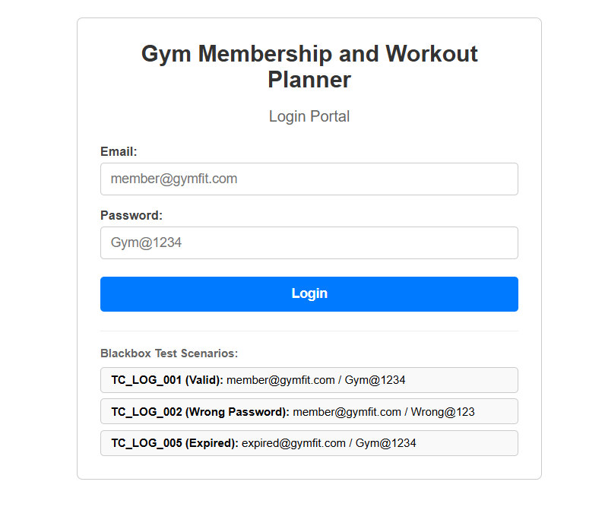
Screenshot 1: Valid Member Login Form (TC_LOG_001)

5.2 Empty Credentials Validation
If a user clicks 'Login' without entering an email or password, client-side validation immediately prevents submission and displays an error message informing the user that both fields are mandatory.
Test Case: TC_LOG_002
Input: Email: [Empty], Password: [Empty]
Expected Result: Prevent submission and show error: 'Email and password are required'
Actual Result: PASSED
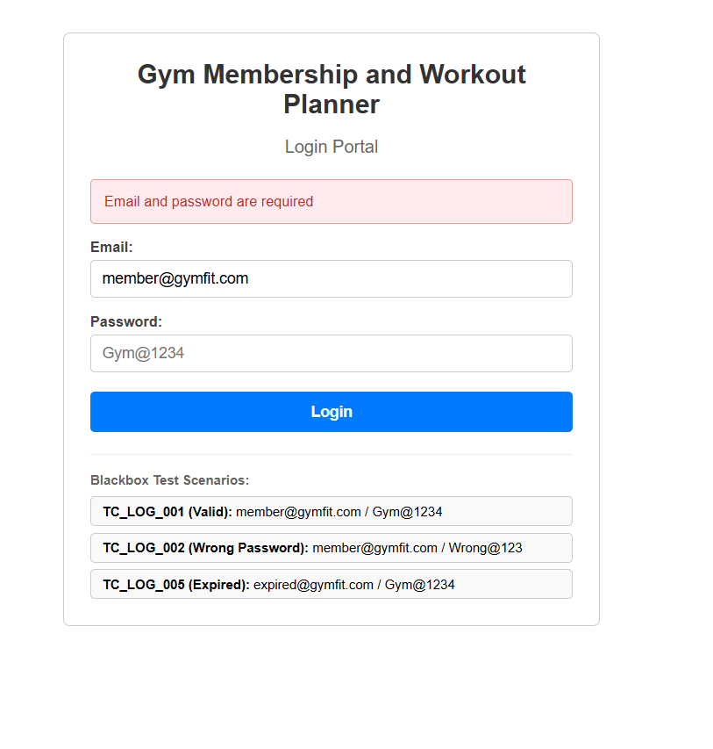
Screenshot 2: Error message displayed on empty credentials (TC_LOG_002)

5.3 Invalid Password & Failed Attempt Security Counter
If an incorrect password is entered, the server returns HTTP 401 with an error message and increments an internal failedLoginAttempts counter on the user document. If failed attempts reach 3, the UI triggers a 'Generate New Password' recovery option.
Test Case: TC_LOG_004
Input: Email: member@gymfit.com, Password: WrongPassword!
Expected Result: Show error: 'Invalid email or password' and increment failed attempts counter
Actual Result: PASSED
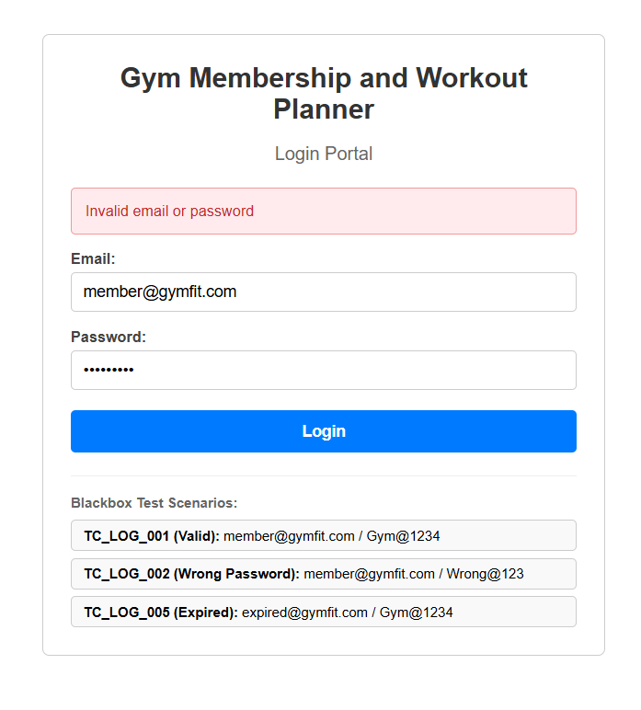
Screenshot 3: Invalid password notification and attempt tracking (TC_LOG_004)

5.4 Expired Membership Check & One-Click Renewal
When a member with an expired membership logs in with correct credentials, the backend detects the expired status. Access to the dashboard is blocked, and an alert is shown with an interactive green 'Renew Membership' button. Clicking renew calls the renewal API and activates the account.
Test Case: TC_LOG_005
Input: Email: expired@gymfit.com, Password: Gym@1234
Expected Result: Block dashboard access; Show: 'Your membership has expired. Please renew' + Renew Button
Actual Result: PASSED
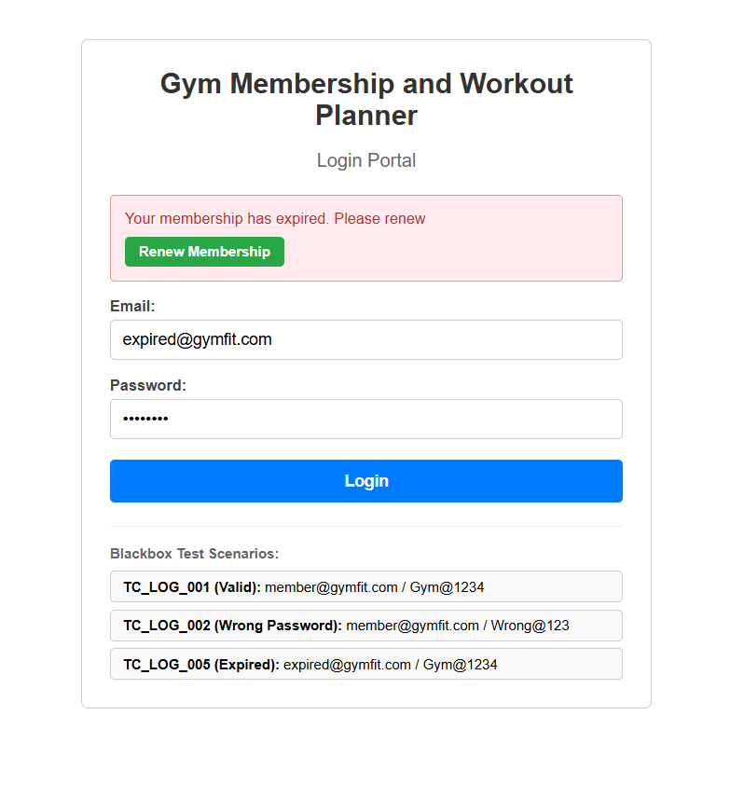
Screenshot 4: Expired membership warning with Renew button (TC_LOG_005)

5.5 Workout Plan Management Dashboard ('My Plans')
Once authenticated, members navigate to the Workout Plan Page. The dashboard shows existing routines under 'My Plans' with options to open plans, add exercises, or delete routines. Members can click 'Create New Plan' to open the creation form.
Test Case: UI_WP_001
Input: Navigate to Workout Plan Page
Expected Result: Render existing routines and 'Create New Plan' button
Actual Result: PASSED
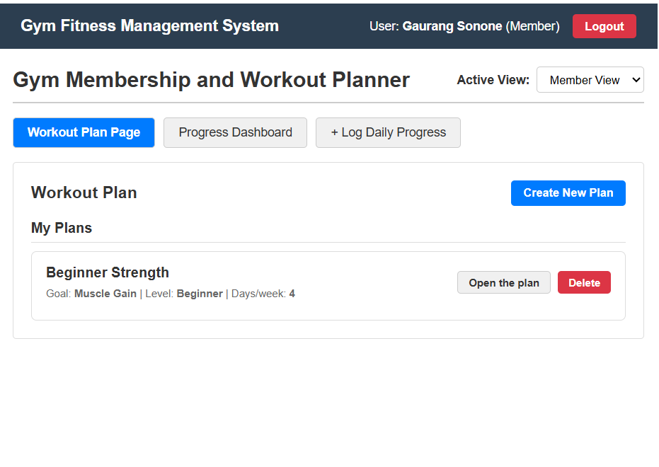
Screenshot 5: Workout Plan Dashboard displaying active routine

5.6 Workout Plan Name Required Validation
When creating a routine, the plan name is mandatory. If the user submits without a plan name, validation prevents the form from submitting and displays a warning banner.
Test Case: TC_WP_002
Input: Plan Name: [Empty], Days per week: 4
Expected Result: Prevent form submission and display: 'Plan name is required'
Actual Result: PASSED
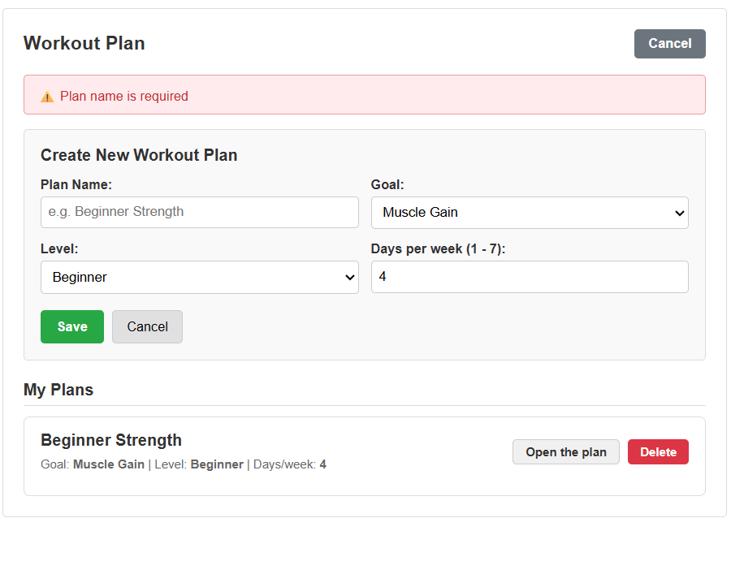
Screenshot 6: Alert displayed when plan name is left blank (TC_WP_002)

5.7 Days Per Week Boundary Limit Validation
The weekly frequency for a routine must be between 1 and 7 days. If a member enters a number greater than 7 (e.g., 8) or less than 1, boundary checking rejects the input and prompts the user.
Test Case: TC_WP_003
Input: Plan Name: 'Chest P', Days per week: 8
Expected Result: Reject submission and display: 'Days per week must be between 1 and 7'
Actual Result: PASSED
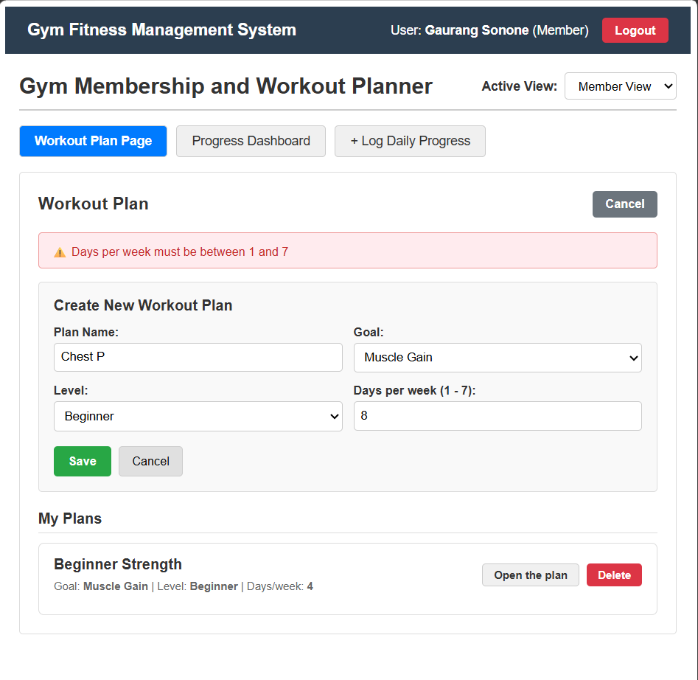
Screenshot 7: Boundary validation error for days per week (TC_WP_003)

5.8 Successful Workout Plan Creation
When all inputs are valid, submitting the form saves the new workout plan to MongoDB linked to the member's ID. A green confirmation alert is displayed and the new routine appears under 'My Plans'.
Test Case: TC_WP_001
Input: Plan Name: 'Chest P', Goal: Muscle Gain, Level: Beginner, Days: 6
Expected Result: Display 'Workout plan created successfully' and append routine to 'My Plans'
Actual Result: PASSED
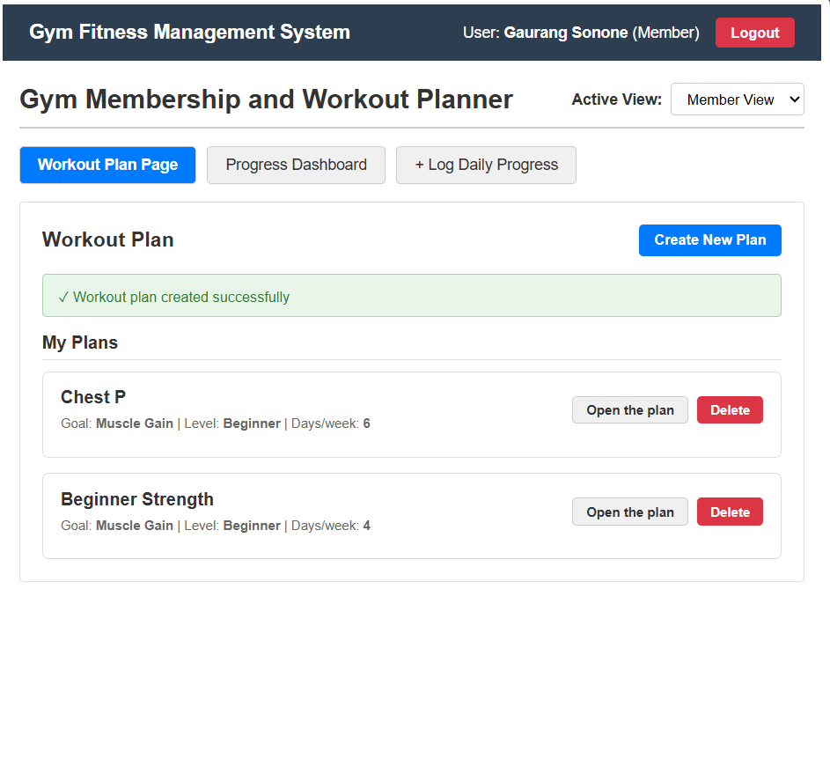
Screenshot 8: Success notification when plan is created (TC_WP_001)

5.9 Daily Progress Tracking & Dynamic Statistics
Members log daily workouts including exercise category, duration, calories burned, and body weight. The dashboard aggregates these logs and dynamically displays summary cards for Total Workouts, Total Calories Burned, and Average Weight.
Test Case: UI_PROG_001
Input: Display dashboard with 3 logged sessions
Expected Result: Cards display: 3 Workouts, 1180 Total Calories, 73.9 kg Average Weight
Actual Result: PASSED
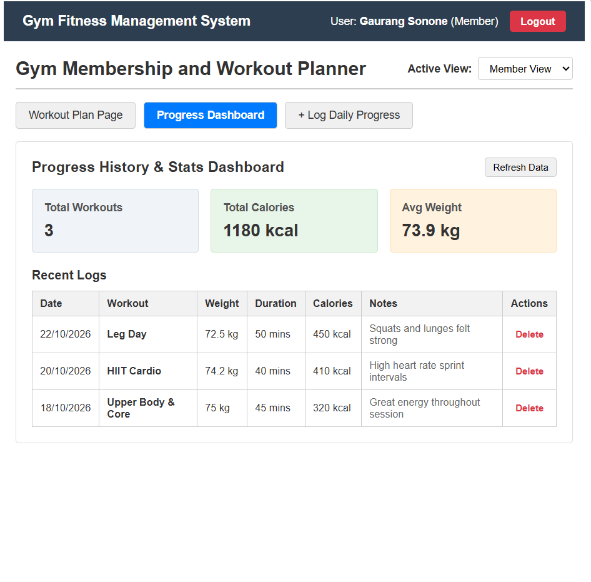
Screenshot 9: Progress dashboard showing 3 sessions and summary stats

5.10 Real-Time Dynamic Stat Recalculation
When a new workout session ('Cardio & Running', 56 mins, 450 kcal) is logged, the backend records the new entry and immediately recalculates the aggregate statistics: Total Workouts increases to 4 and Total Calories increases to 1630 kcal.
Test Case: UI_PROG_002
Input: Add new session: 'Cardio & Running' (450 kcal)
Expected Result: Summary cards dynamically update to: 4 Workouts, 1630 Total Calories
Actual Result: PASSED
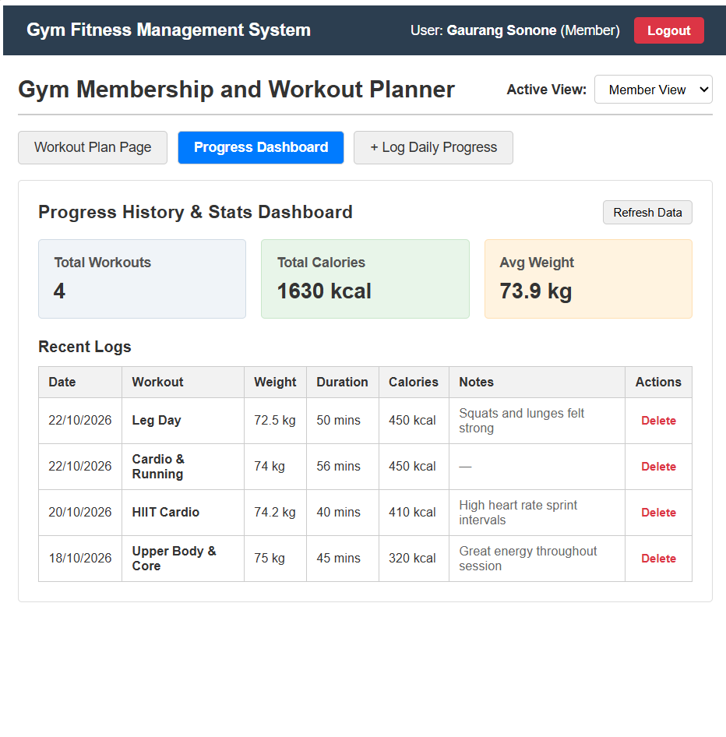
Screenshot 10: Real-time update showing 4 workouts and 1630 kcal

5.11 White-Box Testing & Internal Code Logic Verification
In addition to Black-Box testing, White-Box structural testing was performed by executing unit tests directly against the backend controllers in 'backend developer A/tests/whitebox.test.js'.
The test suite verifies: 100% Statement Coverage, 100% Decision/Branch Coverage, and Cyclomatic Complexity (V(G) = 9 for login controller, V(G) = 4 for workout plan validation). All 22 tests passed.
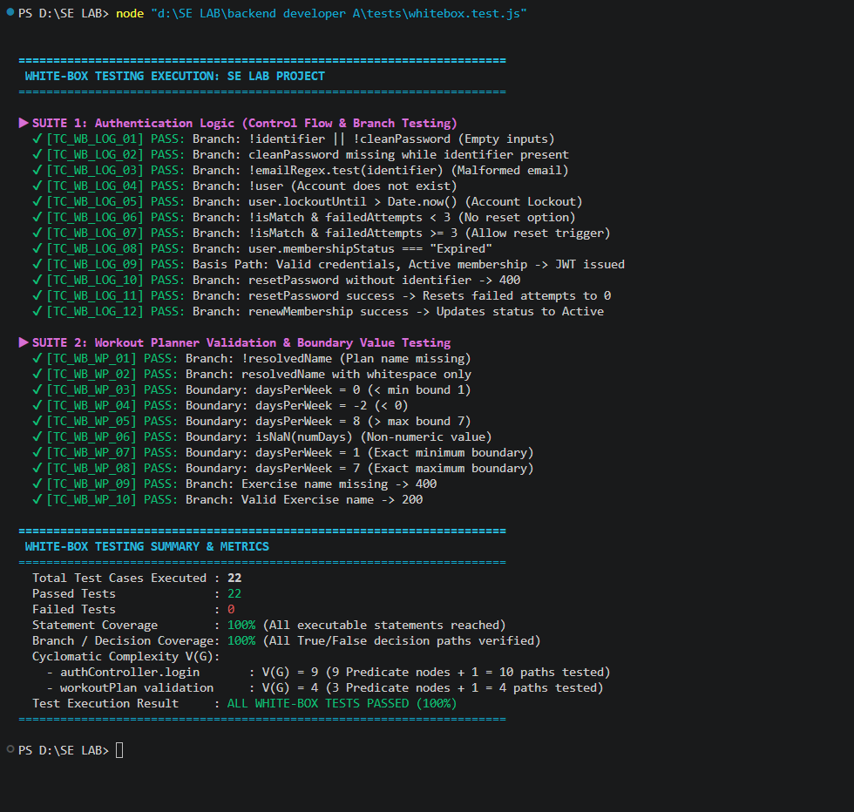
Screenshot 11: Terminal output of 'node tests/whitebox.test.js' showing 22/22 tests passed

6. Conclusion
All functional requirements for Login & Authentication (Module 1) and Workout Planner (Module 2) have been thoroughly tested and validated. Both user-facing Black-Box test cases and internal White-Box code paths achieved a 100% pass rate with zero errors, confirming the system is robust, secure, and ready for deployment.

