a) Plot the power, alpha value, and force before and after the controller for the 90 seconds for:

1) No delay

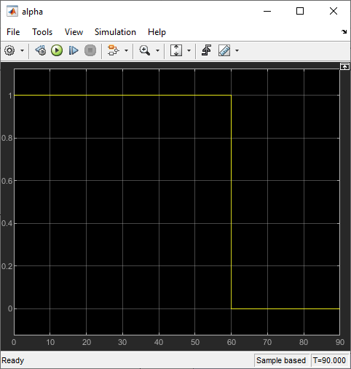

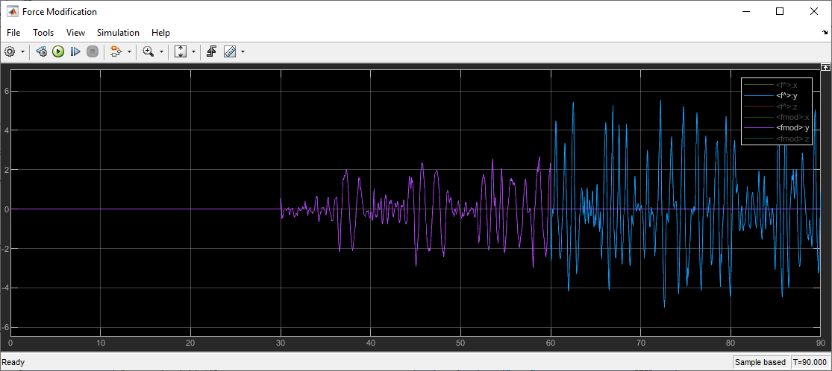

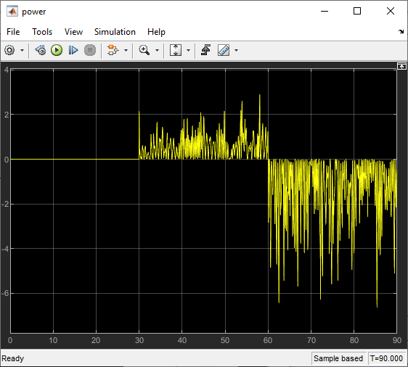

2) With 0.1 𝑠𝑒𝑐 delay

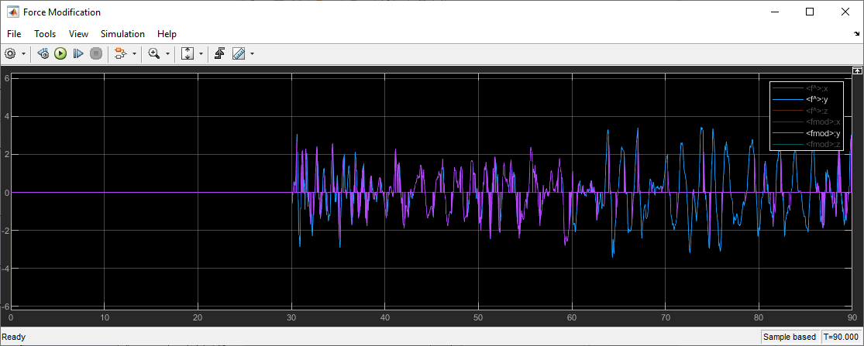

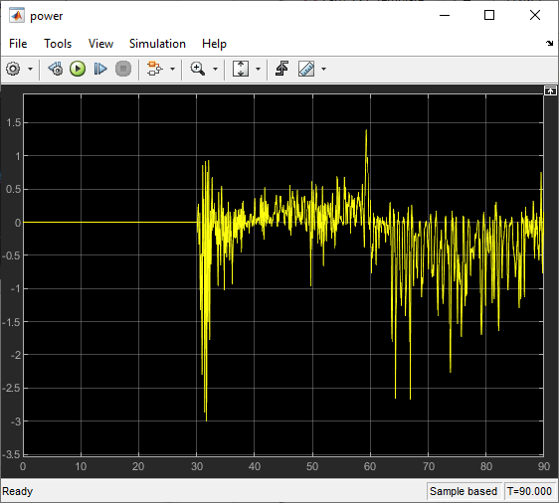

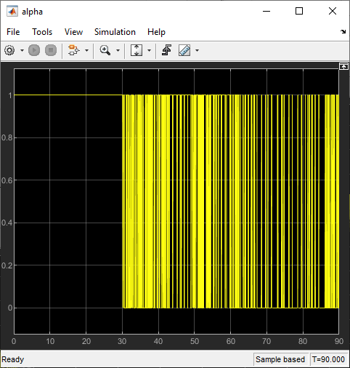

Answer the following questions:

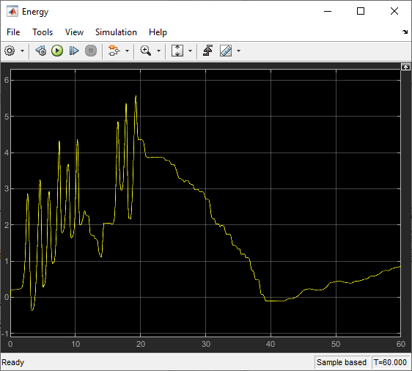

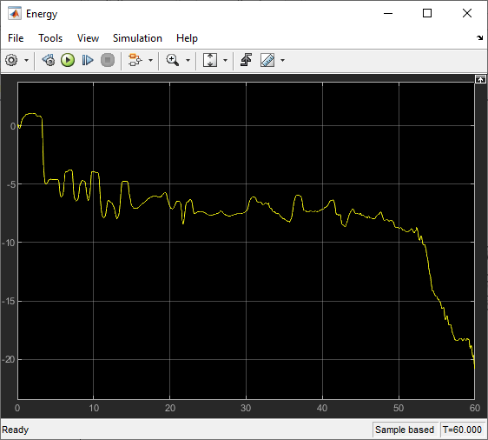

PD controller will correct the directions, it is like a combination of spring and damper coupler between the leader and follower robot

Resistive therapy is passive

Assistive therapy is non-passive

Free motion is considered as 0 energy

The delay injects power, the system is non passive for all the time, the system is always non-stable

a) Explain in your own words how a Power TDPC controller works.

 b) Are the results/observations as expected? Why or why not?

Felt jitter, delayed response

o Explain in terms of no therapy, resistive therapy, and assistive therapy.

o Explain in comparison with the observed power and alpha values.

o Think about: When is the force being modified? Why?