**Exercise 1**

1. **Explain in your own words how a Power TDPC controller works.**

Power Time Domain Passivity Approach (TDPA) includes a family of controllers that observe power of a system to adaptively damp the excess (non-passive) energy. They do this by either scaling down the force or subtracting from the force. There are 2 main components: a passivity observer and a passivity controller. The passivity observer measures the power accumulation at each individual time step and feeds it to the passivity controller. If the system is passive, the power is positive. If the system is non-passive, the power is negative. This information is sent to the passivity controller to modify the force. There may be issues in this controller as a result of being subject to “chattering”; this is when the conditions of the system change frequently between passive and non-passive behavior causing the controller to switch on/off rapidly and making the force change rapidly.

**b) Plot the power, alpha value, and force before and after the controller for the 90 seconds for:**

**1) No delay**

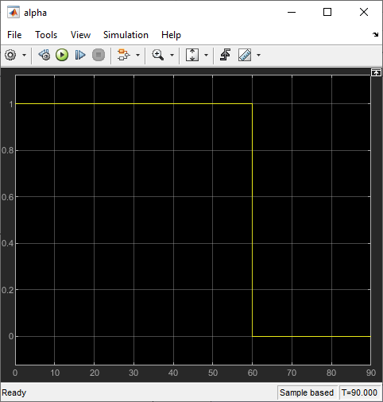

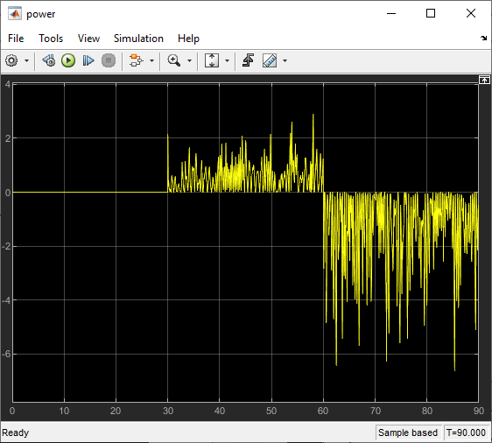

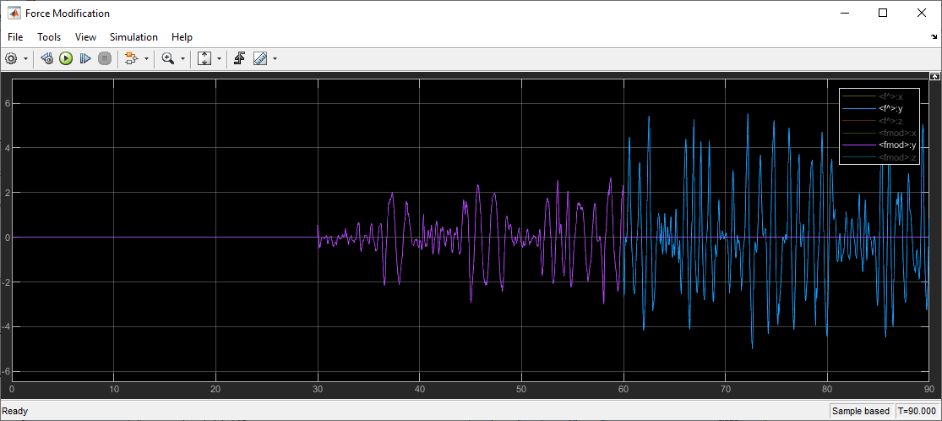

**2) With 0.1 𝑠𝑒𝑐 delay**

Answer the following questions:

**• Are the results/observations as expected? Why or why not?**

1. **Explain in terms of no therapy, resistive therapy, and assistive therapy.**

No therapy occurs from time 0 to 30 seconds for both no delay and delay graphs. During this interval, the therapist provides no damping (b=0). For both the graphs, it is observed that power, force and force modified are 0 and alpha is 1 during the first 30 seconds. This is expected because there is no power being generated by the user during no therapy, so force is 0 because power information being fed back is 0.

Resistive therapy occurs from time 30 to 60 seconds for both no delay and delay graphs. During this interval, the therapist provides positive damping (b=be). For the no delay graph, it is observed that power is positive during this interval and alpha is 1 and force modification is identical to force (graphs overlap). This is because resistive therapy is passive and is expected according to our code. However, for the delay graph, the delay injects power, the system is non passive for all the time, and therefore the system is always non-stable. For delay graph, it is observed that power oscillates between positive and negative during this interval and also that alpha oscillates between 0 and 1. Therefore, force modification oscillates between 0 and the value of force except a translation due to the delay and this was expected because we know about the concept of “chattering.”

Assistive therapy occurs from time 60 to 90 seconds for both no delay and delay graphs. During this interval, the therapist provides negative damping (b=-be). For the no delay graph, it is observed that power is negative during this interval and alpha is 0 and force modification is 0 but force keeps increasing. This is because assistive therapy is non-passive and is expected according to our code. The delay injects power, the system is non passive for all the time, and therefore the system is always non-stable. For delay graph, it is observed that power oscillates between positive and negative (but is mostly negative) during this interval and also that alpha oscillates between 0 and 1. Therefore, force modification oscillates between 0 and the value of force except a translation due to the delay and this was expected because we know about the concept of “chattering.”

1. **Explain in comparison with the observed power and alpha values.**

For both the delay and no-delay graphs, it is observed that power is 0 and alpha is 1 during the first 30 seconds, which leads to force, force modified being 0. This is expected because there is no power being generated by the user during no therapy, so force is 0 because power information being fed back is 0.

From time 30 to 60 seconds, for the no delay graph, it is observed that power is positive during this interval and alpha is 1 and force modification is identical to force (graphs overlap). This is because resistive therapy is passive and is expected according to our code. However, for the delay graph, the delay injects power, the system is non passive for all the time, and therefore the system is always non-stable. This was expected. For delay graph, it is observed that power oscillates between positive and negative during this interval and that alpha oscillates between 0 and 1. Therefore, force modification oscillates between 0 and the value of force except a translation due to the delay and this was expected because we know about the concept of “chattering.”

From time 60 to 90 seconds), for the no delay graph, it is observed that power is negative during this interval and alpha is 0 and force modification is 0 but force keeps increasing. This is because assistive therapy is non-passive and is expected because we know about the concept of “chattering.”

1. **Think about: When is the force being modified? Why?**

The force is being modified whenever the system is passive, because in that case Power >= 0, alpha is set to one and force modified is the same value as force.

For non-passive systems (Power <0) and systems with no power, the force modified is set to 0.

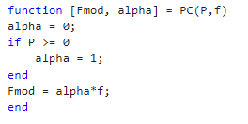

**Exercise 2**

**Scope the delivered force and energy; try to simulate resistive therapy, assistive therapy, and no therapy for 20 seconds each (total 60 seconds):**

**1) With no delay.**

1. **With delay 0.05 𝑠.**

1. **Explain in your own words how a PD Controller works.**

A PD controller, also known as a proportional-derivative controller, is a control system that uses the proportional and derivative control actions to compute the control signal for a system. The control signal computed by the PD controller is applied to the system in order to bring its output closer to the desired value. The output of a PD controller is proportional to the current error and is also proportional to the rate of change of the current error. In this lab we are given the equation:

Where force is the output, $x_{d}-x$ is the error between the desired output of the system and its actual output and $v_{d}-v$ is the difference between the rate of change of desired output and rate of change of actual output. $K_{p}$ and $K_{d}$ are proportionality constants.

1. **Comment on the observed energy (when was it assistive, resistive, none)?**

For non-delay graph, 0 to 20 seconds was resistive therapy shown by the positive energy in the graph. 20 to 40 seconds was assistive therapy shown by the declining negative energy in the graph. 40 to 60 seconds was none shown by the flat line in energy where no damping was provided.

The delay injects power, the system is non-passive for all the time, the system is always non-stable. For delay, 0 to 20 seconds was resistive therapy, but we don’t see it in the graph because system was non-passive and energy was always declining. 20 to 40 seconds was assistive therapy but we don’t see it in the graph because system was non-passive and energy was always declining. 40 to 60 seconds was none but we don’t see it in the graph because system was non-passive and energy was always declining.

1. **How did delay affect the effectiveness of the ‘therapy’? Comment on the observed energy.**

The delay injects power, the system is non-passive for all the time, the system is always non-stable. For delay, 0 to 20 seconds was resistive therapy, but we don’t see it in the graph because system was non-passive and energy was always declining. 20 to 40 seconds was assistive therapy but we don’t see it in the graph because system was non-passive and energy was always declining. 40 to 60 seconds was none but we don’t see it in the graph because system was non-passive and energy was always declining. The delay reduced the effectiveness of the resistive therapy and added assistive therapy even when the therapist does not provide any therapy.