

Guide Name:-

Prof. Dhenu Patel

*Health Care & Well Being*

Project Associates:-

• Gaurang Gohil(2202030400037)

• Jain Sujal(2202030400050)

• Aarti Bhatiya(2202030400015)

Heart Diseases Detection using Artificial

Intelligence & Machine Learning

ABSTRACT

3

INTRODUCTION

4

WHY MACHINE LEARNING ? 5

ABOUT DATASET

6-7

PROPOSED SOLUTION

8

TIMELINE CHART (GANTT CHART) 9

REPORTS

10

CONCLUSION

11

REFERENCES

12

ABSTRACT

• Heart disease is one of the leading causes of death globally, making early detection and prevention crucial. This project aims to develop a machine learning model capable of predicting the risk of heart disease based on various clinical and lifestyle factors. We utilized a publicly available dataset containing patient records, including features such as age, cholesterol levels, blood pressure, and more. Several classification algorithms, including Logistic Regression, Decision Trees, Random Forest, and Support Vector Machines (SVM), were implemented to determine the most effective model for prediction.

• The dataset was preprocessed through normalization, missing value treatment, and feature selection techniques to enhance model accuracy. Cross-validation was employed to avoid overfitting and ensure the robustness of the models. After training and testing the models, Random Forest emerged as the most accurate, with a prediction accuracy of over 85%, precision, recall, and F1 scores indicating a well-balanced model.

• The results suggest that machine learning can be a valuable tool for healthcare professionals in predicting heart disease risk, providing insights that can assist in early intervention and personalized treatment strategies.

3

Introduction

Welcome to our presentation on Heart Diseases analysis. Heart Diseases is a chronic metabolic disorder characterized by high blood sugar levels over a prolonged period. It is a significant global health concern, affecting millions of people worldwide and posing substantial challenges to healthcare systems.

Through this analysis, we aim to provide insights into the epidemiology of Heart Diseases, identifying populations at higher risk, such as individuals with a family history of the disease, obesity, sedentary lifestyle, or certain other factors.

The dataset we used is originally from the National Institute of Heart Diseases.

The objective of the dataset is to diagnostically predict whether a patient has Heart Diseases, based on certain diagnostic measurements included in the dataset, such as BMI(Body Mass Index), Insulin levels and many more.

Thank you for your attention, and let's delve into our analysis of Heart Diseases.

HOW CAN MACHINE LEARNING IMPROVE HEART DISEASE ANALYSES DECISION-MAKING?

• ML algorithms can analyze large datasets containing patient demographics, medical history, lifestyle factors, and biomarkers to predict the risk of developing Heart disease or its

complications. By identifying high-risk individuals, healthcare providers can intervene early with targeted interventions to prevent or delay the onset of the disease.

• ML algorithms can assist healthcare providers in making informed decisions by analyzing complex clinical data and providing evidence-based recommendations. Decision support systems can help clinicians interpret diagnostic tests, prioritize treatment options, and optimize resource allocation, ultimately improving patient outcomes and reducing healthcare costs.

• ML algorithms can analyze clinical data, such as blood glucose levels, blood pressure, and cholesterol levels, to detect early signs of heart-related complications, such as diabetic retinopathy, neuropathy, nephropathy, and cardiovascular disease. Early detection allows for timely intervention and prevention of irreversible damage.

About Dataset

Variables:

o Heart Failure: The heart can’t pump the enough blood to meet the body need o Stroke: Too little blood reaches the brain

o Blood Pressure: To express the Blood pressure measurement

o Sudden Cardiac Arrest: It usually due to a problem with the heart electric system o Peripheral Artery Disease: The arms or legs don’t get enough blood o BMI: To express the Body mass index

o Age: To express the age

o Outcome: To express the final result 1 is Yes and 0 is No

General Information on Variables:

• **Blood Pressure*:***

**- Normal:** Systolic less than 120 and diastolic less than 80

**- Elevated:** Systolic 120–129 and diastolic less than 80

**- Hypertension stage 1**: Systolic 130–139 and diastolic 80–89

**- Hypertension stage 2:** Systolic 140-plus and diastolic 90 or more

• **Adult Body Mass Index*:***

-If your BMI is **less than 18.5**, it falls within the **underweight** range.

-If your BMI is **18.5 to <25**, it falls within the **healthy weight** range.

-If your BMI is **25.0 to <30**, it falls within the **overweight** range.

-If your BMI is **30.0 or higher,** it falls within the **obesity** range.

• **Glucose Tolerance*:***

**- Normal:** less than 140 mg/dL

**- Impaired :** 140 to 200 mg/dL

**- Abnormal (Diagnostic):** Tw greater than 200 mg/dL7

Solution we Proposed

Our team has proposed multiple solution to analyze, review & overcome this problem:-

• Firstly, we can make a Supervised machine learning model in which we will train this dataset and predict whether the person having Heart Disease can be detected using ML model, based on the parameters that are given by the person’s health, as suggested by Doctor. Based on multiple data entries of all parameters over model will learn how to predict, so a person just have to enter their details and rest work our model will do.

• Second solution was to create an Unsupervised machine learning model, that means using cluster of data points, we can predict which all customers requires what kind of treatments based on the group of cluster the patient fall under. It gives more clear idea of how much time and treatment different patients need according to their condition. Based on more diversity or how scatter data points are we might get more clusters.

Timeline chart (GANTT CHART)

Chart Title

Time Line 2 5 10 Reaserch Data collection Model Training

9

ECG/Heart Trend

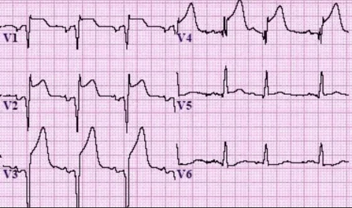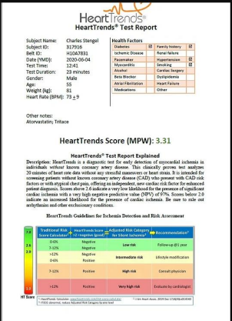Reports

10

Conclusion

IN SUMMARY, MACHINE LEARNING (ML) CAN GREATLY ENHANCE DIABETES ANALYSIS AND DECISION MAKING IN HEALTHCARE. ML ALGORITHMS CAN PREDICT THE RISK OF DEVELOPING DIABETES OR ITS COMPLICATIONS, TAILOR PERSONALIZED TREATMENT PLANS BASED ON INDIVIDUAL PATIENT DATA,

DETECT EARLY SIGNS OF COMPLICATIONS, ENABLE REMOTE MONITORING OF PATIENTS' HEALTH STATUS, AND PROVIDE DECISION SUPPORT TO HEALTHCARE PROVIDERS. BY LEVERAGING ML POWERED TOOLS AND TECHNIQUES, HEALTHCARE PROFESSIONALS CAN IMPROVE PATIENT OUTCOMES, OPTIMIZE RESOURCE ALLOCATION, AND ULTIMATELY ENHANCE THE MANAGEMENT OF DIABETES AS A CHRONIC CONDITION.

**References**



Google Searches Kaggle.com Dr. Parekh Trivedi

12

thank you