# USCS3P01:USCS303-Operating System (OS) Practical-06

## Banker’s Algorithm

Contents

USCS3P01:USCS303-Operating System (OS) Practical-06 1

Banker’s Algorithm 1

Practical Date 2

Parctical Aim 2

Banker's Algorithm 2

Data Structures reqiured in Banker's Algorithm 5

Algorithm 6

Safety 6

Resource- Allocation 7

Solved Example 8

Question 8

Implementation 9

Input 12

Output 12

Sample Output 13

**Practical Date :** 20th August , 2021(Friday)

**Parctical Aim :** Write a Java program that implements the banker's algorithm

### Banker's Algorithm

**Banker's Algorithm**

* Content:
  + For the banker's algorithm to operate, each process has to a priority specify its maximum requirement of resources.
* Process:
  + One can find out whether the system is in the safe state or not.
  + One can also determine whether a process's request for allocation of resources be safely granted immediately.
* Prior Knowledge:
  + Data structures used in bankers algorithm.
  + Safety algorithm and resource request algorithm.

Banker’s Algorithm

* The resource-allocation-graph algorithm is not applicable to a resource allocation system with multiple instances of each resource type.
* The deadlock-avoidance algorithm that we describe next is applicable to such a system but is less efficient than the resource-allocation graph scheme.
* This algorithm is commonly known as the banker's algorithm.
* Banker's algorithm is a deadlock avoidance algorithm.
* It is named so because this algorithm is used in banking systems to determine whether a loan can be granted or not.
* The name was chosen because the algorithm could be used in a banking system to ensure that the bank never allocated its available cash in such a way that it could no longer satisfy the needs of all its customers.
* Consider there are n account holders in a bank and the sum of the money in all of their accounts is S.
* Every time a loan has to be granted by the bank, it subtracts the loan amount from the total money the bank has
* Then it checks if that difference is greater than 5.
* It is done because, only then, the bank would have enough money even if all the n account holders draw all their money at once.
* When a new thread enters the system, it must declare the maximum number of instances of each resource type that it may need
* This number may not exceed the total number of resources in the system.
* When a user requests a set of resources, the system must determine whether the allocation of these resources will leave the system in a safe state.
* If it will, the resources are allocated; otherwise, the thread must wait until some other thread releases enough resources.

### Data Structures reqiured in Banker's Algorithm

**Data Structures reqiured in Banker's Algorithm**

* Several data structures must be maintained to implement the banker's algorithm.
* These data structures encode the state of the resource-allocation system.
* We need the following data structures, where n is the number of threads in the system and m is the number of resources types:

**Available:**

**Data structures**

A vector of length m indicates the number of available resources of each type. If Available[j] equals k, then k instances of resource type Rj are available.

**Max:**

An n * m matrix defines the maximum demand of each thread. If Max[i][j] equals k, then thread Ti may request at most k instances of resource type Rj.

**Allocation:**

An n * m matrix defines the number of resources of each type currently allocated to each thread. If **Allocation[i][j]** equals k, then thread Ti is currently allocated k instances of resource type Rj.

**Need:**

An n * m matrix indicates the remaining resource need of each thread. If Need[i][j] equals k, then thread Ti may need k more instances of resources type Rj to complete its task.

**Need[i][j] = Max[i][j] - Allocation[i][j]**

### Algorithm:

### Safety:

**Safety Algorithm**

**Step 1:** Let Work and Finish be vectors of length m and n, respectively. initialize Work = Available and Finish[i]= flase for i =0,1,. ,n-1**.**

**Step 2:** Find an index i such that both

**Step 2.1:** Finish[i] == false

**Step 2.2:** Needi <= Work

if no such i exists, go to **Step 4.**

**Step 3**: Work= Work+Allocationi Finish[i] = true

Go to **Step 2.**

**Step 4**: if Finish[i] == true for all i, then the system is in a safe state.

### Resource- Allocation:

**Resource-Request Algorithm**

* + Let **Requesti** be the request vector for thread Ti.
  + if **Requesti [j] == k**, then thread Ti wants k instances of resource type Rj.
  + When a request for resources is made by thread Ti, the following actions are taken:

**Step 1:** if Requesti <= Needi, go to **Step 2.** otherwise, raise an error condition, since the thread has exceeded its maximum claim.

**Step 2:** if Requesti <= Available, go to **Step 3.** otherwise, Ti must wait, since the resources are not available.

**Step 3:** Have the system prented to have allocated the requested resources to thread Ti, by modifying the state as follows:

Available = Available - Requesti Allocationi = Availablei + Requesti

Needi = Needi - Requesti

if the resulting resource-allocation state is safe, the transaction is completed, and thread Ti is allocated its resources. However, if the new state is unsafe, then Ti must wait for **Requesti,** and the old resource-allocation state is restored.

### Solved Example:

**Solved Example**

**Question:01**

Write a Java program that implements the banker's algorithm Consider the following system:

Calculate the content of the need matrix ? Check if the system is in a safe state?

**Solution:**

Consider a system with five threads T0 through T4 and three resource types A,B and C. Resource type A has ten instances , resource Type B has five instances and resource type C has seven instances.Suppose that the following snapshot represent current state of the system:

|  |  |  |  |
| --- | --- | --- | --- |
| **Threads** | **Allocations** | **Max** | **Available** |
|  | **A B C** | **A B C** | **A B C** |
| **T0** | **0 1 0** | **7 5 3** | **3 3 2** |
| **T1** | **2 0 0** | **3 2 2** |  |
| **T2** | **3 0 2** | **9 0 2** |  |
| **T3** | **2 1 1** | **2 2 2** |  |
| **T4** | **0 0 2** | **4 3 3** |  |

Need Matrix = Max – Allocation

|  |  |  |  |  |
| --- | --- | --- | --- | --- |
|  |  |  |  |  |
| **Threads** | **Allocations** | **Max** | **Available** | **Need** |
|  | **A B C** | **A B C** | **A B C** | **A B C** |
| **T0** | **0 1 0** | **7 5 3** | **3 3 2** | **7 4 3** |
| **T1** | **2 0 0** | **3 2 2** |  | **1 2 2** |
| **T2** | **3 0 2** | **9 0 2** |  | **6 0 0** |
| **T3** | **2 1 1** | **2 2 2** |  | **0 1 1** |
| **T4** | **0 0 2** | **4 3 3** |  | **4 3 1** |

We claim that the system is currently in a safe state.

Indeed, the sequence < T1,T3,T4,T0,T2> satisfies the safety criteria.

### Implementation:

//Name:Gaurang sanyasi

//Batch No:B2

//PRN:2020016400785461

//Date:20-08-2021

import java.util.Scanner;

public class P6_BankersAlgo_GS

{

private int need[][], allocate[][], max[][], avail[][], np, nr; private void input()

{

Scanner sc = new Scanner(System.in); System.out.print("Enter no. of processes: "); np = sc.nextInt(); // no. of process System.out.print("Enter no. of resources : "); nr = sc.nextInt(); // no. of resources

need = new int[np][nr]; // initializing arrays max = new int[np][nr];

allocate = new int[np][nr]; avail = new int[1][nr];

for (int i = 0; i < np; i++) {

System.out.print("Enter allocation matrix for process P" + i + ": ");

for (int j = 0; j < nr; j++) allocate[i][j] = sc.nextInt(); // allocation matrix

}

for (int i = 0; i < np; i++) {

System.out.print("Enter maximum matrix for process P" + i + ": "); for (int j = 0; j < nr; j++)

max[i][j] = sc.nextInt(); // max matrix

}

System.out.print("Enter available matrix for process PO: "); for (int j = 0; j < nr; j++)

avail[0][j] = sc.nextInt(); // available matrix sc.close();

} // input() ends

private int[][] calc_need()

{

for (int i = 0; i < np; i++)

for (int j = 0; j < nr; j++) // calculating need matrix need[i][j] = max[i][j] - allocate[i][j];

return need;

} // calc_need() ends

private boolean check(int i) {

// checking if all resources for ith process can be allocated for (int j = 0; j < nr; j++)

if (avail[0][j] < need[i][j]) return false;

return true;

} // check() ends public void isSafe()

{

input(); calc_need();

boolean done[] = new boolean[np]; int j = 0;

// printing Need Matrix System.out.println("========Need Matrix========");

for (int a = 0; a < np; a++) {

for (int b = 0; b < nr; b++) { System.out.print(need[a][b] + "\t");

}

System.out.println();

}

System.out.println("Allocated process: "); while (j<np) { // until all process allocated

boolean allocated = false; for (int i = 0; i < np; i++)

if (!done[i] && check(i)) { // trying to allocate for (int k = 0; k < nr; k++)

avail[0][k] = avail[0][k] - need[i][k] + max[i][k]; System.out.print("P" +i+" > ");

allocated = done[i] = true; j++;

} // if block if (!allocated)

break; // if no allocation

} // while ends

if (j == np) // if all processes are allocated System.out.println("\nSafely allocated");

else

System.out.println("All/Remaining process can\'t be allocated safely");

}//isSafe() ends

public static void main(String[] args) {

new P6_BankersAlgo_GS().isSafe();

}

}// class ends

### Input:

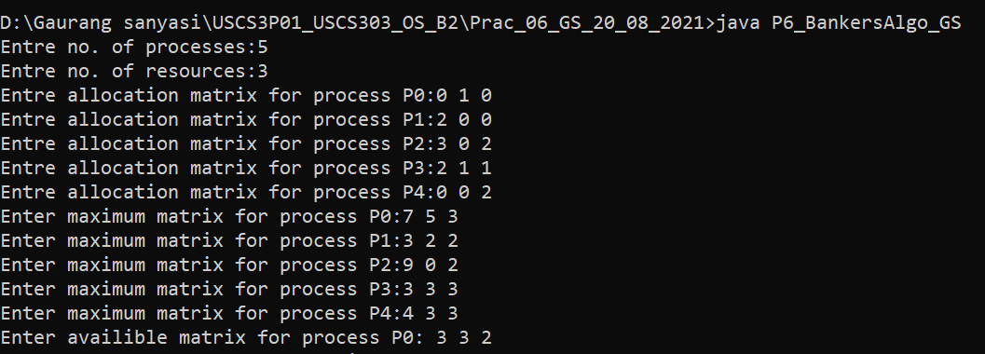

### Output:

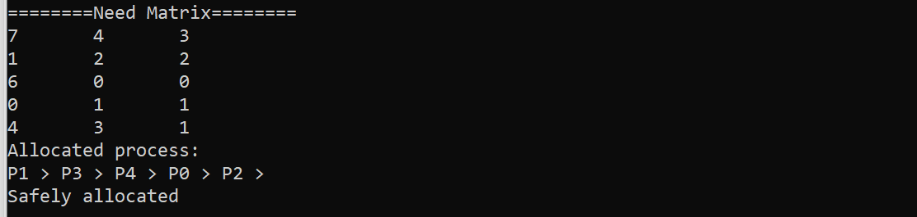

### Sample Output:

### Question: 01

Calculate the content of the need matrix ? Check if the system is in a safe state?

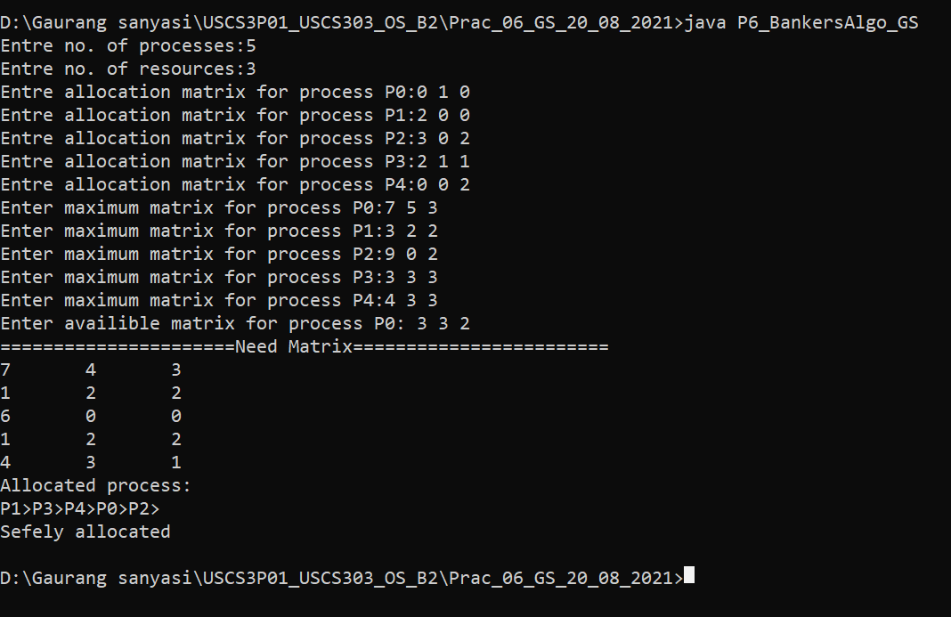

**Question:02**

Calculate the content of the need matrix ? Check if the system is in a safe state?

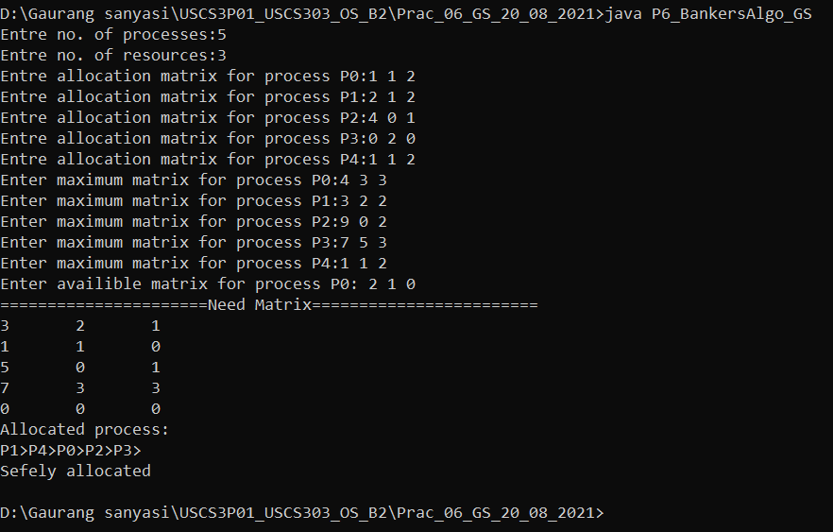

**Question:03**

Consider the following example containting five processes and 4 types of resources: Calculate the Need Matrix and the sequence of safety allocation ?

