**USCSP301 : USCS303 - Operating System (OS)**

**PRACTICAL - 07 – Synchronization**

Table of Contents

**Practical Date: 27 Aug 2021** 2

**Practical Aim:** 2

**Synchronization :** 2

**Producer:** 3

**Consumer:** 5

**Question -01** 5

**Source Code :** 6

**Output :** 12

**Screenshot-1** 12

**Screenshot-2** 13

**Screenshot-3** 14

**Reader Writers Problem** 14

**Question - 02:** 15

**Source Code :** 15

**Output :** 19

**Sleeping Barber Problem:** 19

**Question - 03:** 20

**Source Code :** 20

**Output :** 23

**Screenshot-1:** 24

**Screenshot-2** 25

# 

# **Practical Date: 27 Aug 2021**

**Practical Aim: a) Bounded Buffer Problem ;**

**b)** **Readers - Writer’s Problem;**

**c)** **Sleeping Barber Problem;**

# **Synchronization :**

( Bounded Buffer ,Readers - Writers , Sleeping Barber Problem)

**Bounded Buffer Problem :**

* Producer-consumer problem, also known as Bounded buffer problem, illustrated the need for synchronisation in systems where many processes share a resource .
* These processes do not take turns accessing the buffer; they both work concurrently. Herein lies the problem .
* What happens if the producer tries to put an item into a full buffer?
* What happens if the consumer tries to take an item from an Empty buffer?
* Order to synchronise these processes, we will block the producer when the buffer is full, and we will block the consumer when the buffer is empty.

So the two processes Producer and Consumer, should work as follows:

**(i)** The producer must first create a new widget.

**(ii)** Then, it checks to see if the buffer is full .If it is, the producer will put it safe to sleep until the consumer wake it up. A “wake up'' will come if the consumer finds the buffer empty.

**(iii)** Next , the producer put the new widget in the buffer. if the producer goes to sleep in step 2 it will not wake up until the buffer is empty, so the buffer will never overflow.

**(iv)** Then the producer checks to see if the buffer is empty. if it is, the producer assumed that the consumer is sleeping, and so it will make the consumer. keep in mind that between any of these steps, An interrupt might occur allowing the consumer to run .

# **Producer:**

**1. Make new widget → W**

**2. IF buffer is full , go to sleep**

|  |  |  |  |
| --- | --- | --- | --- |
| **W** | **W** | **W** | **= Procedure** |

**3. Put widget i buffer**

|  |  |  |
| --- | --- | --- |
| **W** |  |  |

**4. If buffer was empty, wake consumer**

|  |
| --- |
| **Wake up** |

|  |
| --- |
| **Consumer** |

|  |
| --- |
| **Producer** |

So the two processes Producer and Consumer, should work as follows:

**(i)**  The consumer checks to see if the buffer is empty. If so, the cusumer will put it safe to sleep until the producer wakes it up . A “wakeup” the occur is the producer find the buffer empty after food send item into the buffer.

**(ii)** Then, the consumer will remove a widget from the buffer. the consumer will never try to remove a widget from an empty buffer because it will not wake up until the buffer is full.

**(iii)** if the buffer was full before it removed the widget, the consumer will wake the producer.

**(iv)** Finally, the consumer will consume the widget. As was the case with the producer, an interrupt could occur between any of these steps along the producer to run.

# **Consumer:**

**1. IF buffer is empty , Go to sleep**

|  |  |  |
| --- | --- | --- |
|  |  |  |

|  |
| --- |
| **Consumer** |

**2. Take widget from Buffer**

|  |  |  |
| --- | --- | --- |
| **W** | **W** |  |

**W**

**3. IF buffer was Full , wake Producer**

|  |
| --- |
| **Wake up** |

|  |
| --- |
| **Consumer** |

|  |
| --- |
| **Producer** |

**4.Consume the widget**

**<W**

# **Question -01**

Write a Java Program for bounded buffer problem using synchronisation.

# **Source Code :**

// Name: Gaurang Sanyasi

// Batch: B2

// PRN: 2020016400785461

// Date: 27 August, 2021

// Prac-07: Synchronization

public interface P7_Q1_Buffer_GS

{

public void set(int value) throws InterruptedException;

public int get() throws InterruptedException;

}

**Source code 2:**

// Name: Gaurang Sanyasi

// Batch: B2

// PRN: 2020016400785461

// Date: 27 August, 2021

// Prac-07: Synchronization

public class P7_Q1_CircularBuffer_GS implements P7_Q1_Buffer_GS

{

private final int[] buffer={-1,-1,-1}; //shared buffer

private int occupiedCells=0; //count number of buffer used

private int writeIndex=0; //Index of next element to write to

private int readIndex=0; //Index of next element to read

public synchronized void set(int value) throws InterruptedException

{

while(occupiedCells==buffer.length)

{

System.out.println("Buffer is full.Producer waits.");

wait();

}

buffer[writeIndex]=value;

writeIndex=(writeIndex + 1) % buffer.length;

++occupiedCells;

displayState("Producer write "+value);

notifyAll();

}//set() ends

public synchronized int get() throws InterruptedException

{

while(occupiedCells==0)

{

System.out.println("Buffer is empty.Consumer waits.");

wait();

}

int readvalue=buffer[readIndex];

readIndex=(readIndex + 1) % buffer.length;

--occupiedCells;

displayState("Consumer reads "+readvalue);

notifyAll();

return readvalue;

} //get() ends

public void displayState(String operation)

{

System.out.printf("%s%s%d)\n%s",operation," (buffer Cells occupied: ",occupiedCells,

"buffer Cells: ");

for(int value:buffer)

System.out.printf(" %2d ",value);

System.out.print("\n ");

for(int i=0;i<buffer.length;i++)

System.out.print(" .... ");

System.out.print("\n ");

for (int i=0;i<buffer.length;i++)

{

if(i==writeIndex && i==readIndex)

System.out.print(" WR");

else if(i==writeIndex)

System.out.print(" W ");

else if(i==readIndex)

System.out.print(" R ");

else

System.out.print(" ");

}

System.out.println("\n");

}//displayState() ends

}//CircularBuffer class ends

Source code 3:

// Name: Gaurang Sanyasi

// Batch: B2

// PRN: 2020016400785461

// Date: 27 August, 2021

// Prac-07: Synchronization

import java.util.Random;

public class P7_Q1_Consumer_GS implements Runnable

{

private final static Random generator=new Random();

private final P7_Q1_Buffer_GS sharedLocation;

public P7_Q1_Consumer_GS(P7_Q1_Buffer_GS shared)

{

sharedLocation=shared;

}

public void run()

{

int sum=0;

for(int count=1;count<=10;count++)

{

try{

Thread.sleep(generator.nextInt(3000));

sum+=sharedLocation.get();

}catch(InterruptedException e){

e.printStackTrace();

}

}

System.out.printf("\n%s %d\n%s\n","Consumer read values totaling", sum,"Terminating Consumer");

}//run() ends

}//Consumer class ends

Source code 4:

// Name: Gaurang Sanyasi

// Batch: B2

// PRN: 2020016400785461

// Date: 27 August, 2021

// Prac-07: Synchronization

import java.util.Random;

public class P7_Q1_Producer_GS implements Runnable

{

private final static Random generator=new Random();

private final P7_Q1_Buffer_GS sharedLocation;

public P7_Q1_Producer_GS(P7_Q1_Buffer_GS shared)

{

sharedLocation=shared;

}

public void run()

{

for(int count=1;count<=10;count++)

{

try{

Thread.sleep(generator.nextInt(3000));

sharedLocation.set(count);

}catch(InterruptedException e){

e.printStackTrace();

}

}

System.out.println("Producer done producing. Terminating Producer");

}//run() ends

}//Producer class ends

Source code 5:

// Name: Gaurang Sanyasi

// Batch: B2

// PRN: 2020016400785461

// Date: 27 August, 2021

// Prac-07: Synchronization

import java.util.concurrent.*;

public class P7_Q1_Test_GS

{

public static void main(String args[])

{

ExecutorService application=Executors.newCachedThreadPool();

P7_Q1_CircularBuffer_GS sharedLocation=new P7_Q1_CircularBuffer_GS();

sharedLocation.displayState("Initial State");

application.execute(new P7_Q1_Producer_GS(sharedLocation));

application.execute(new P7_Q1_Consumer_GS(sharedLocation));

application.shutdown();

}

}

# **Output :**

# **Screenshot-1**

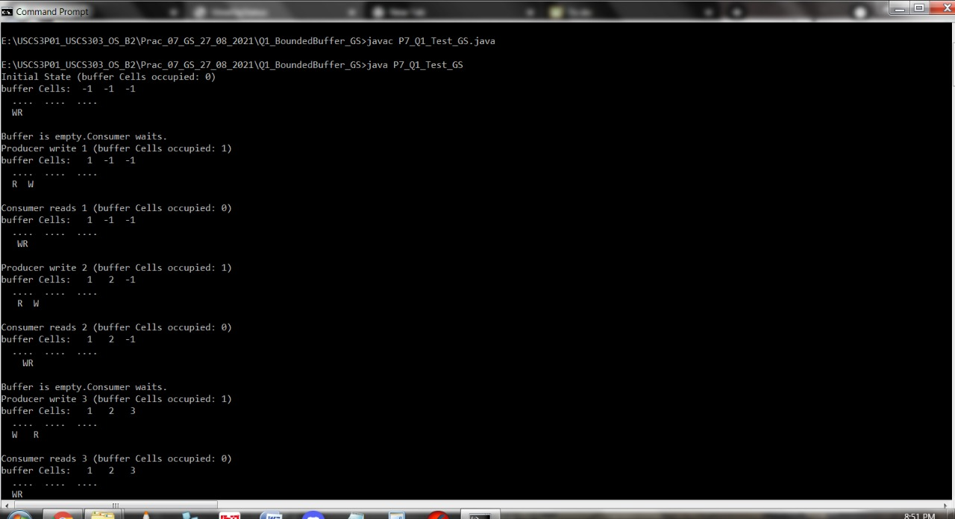

# **Screenshot-2**

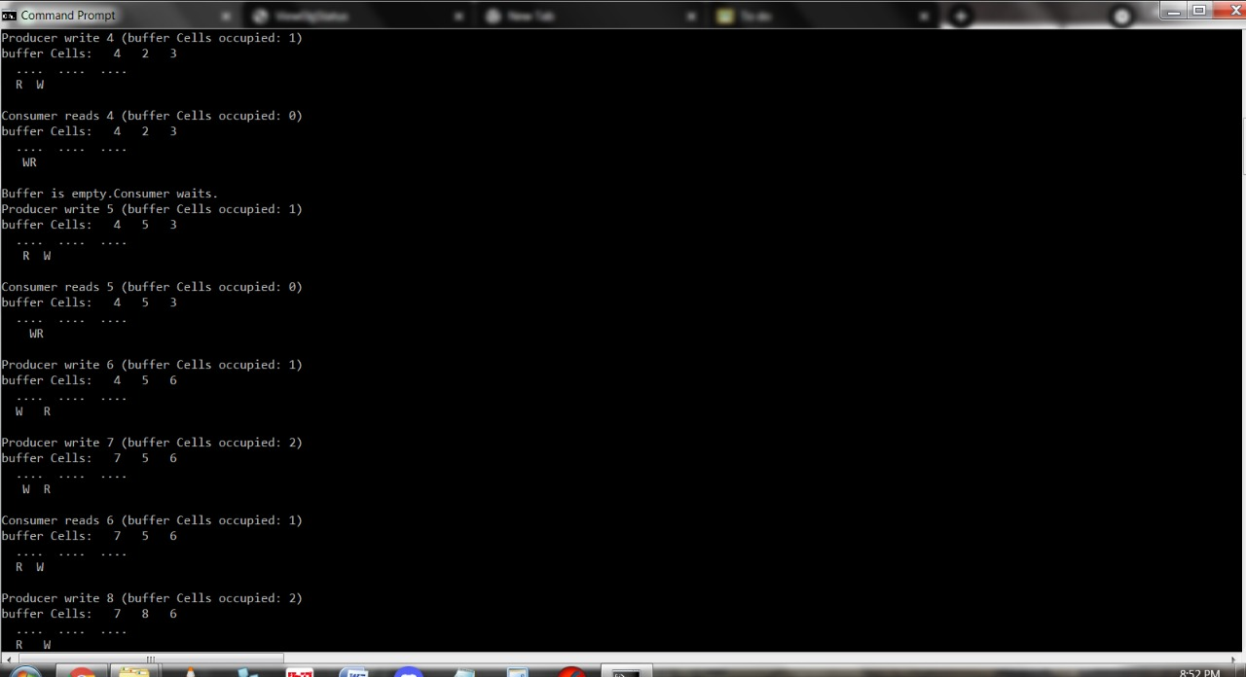

# **Screenshot-3**

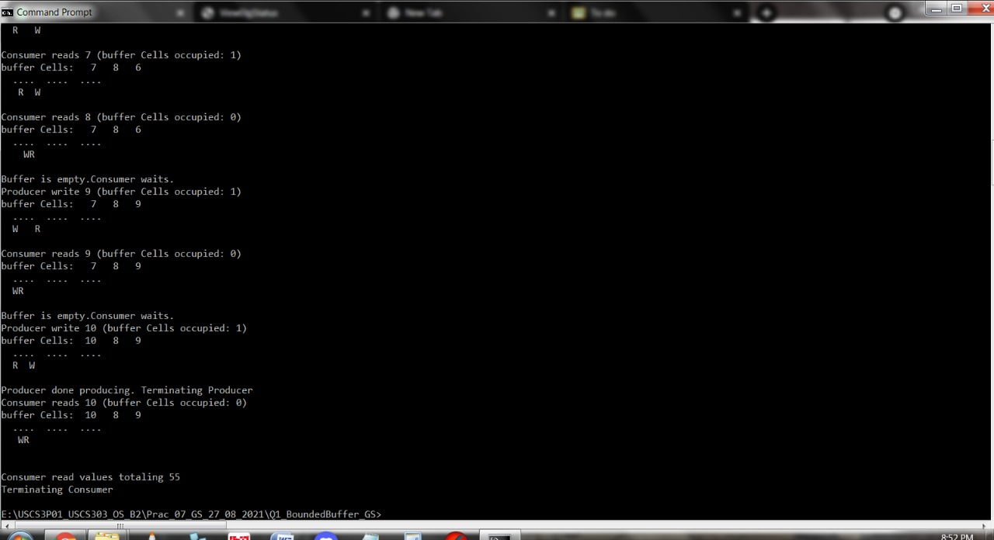

# **Reader Writers Problem**

* In Computer Science,the readers-writers problem are examples of a common computing problem in concurrency .
* Here many Threads (small processes which share data) try to access the same shared resource at one time.
* Some Trends married and some may write, with the constraint that no process may access the shared resource for other reading or writing while another process is in the act of writing to it.
* (In particular we want to prevent more than one thread modify the shared resource simultaneously and allowed for two or more readers to access the shared resource at the same time).
* A readers-writer lock is a data structure that solves one or more of the readers writers problems.

# **Question - 02:**

Write a Java Program for Readers Writers problem using semaphore.

(Implement readers writers problem using semaphore)

# **Source Code :**

// Name: Gaurang Sanyasi

// Batch: B2

// PRN: 2020016400785461

// Date: 27 August, 2021

// Prac-07: Synchronization

import java.util.concurrent.Semaphore;

class P7_Q2_ReaderWriter_GS

{

static Semaphore readLock = new Semaphore(1,true);

static Semaphore writeLock = new Semaphore(1,true);

static int readCount = 0;

static class Read implements Runnable {

@Override

public void run() {

try {

// Acquire Section

readLock.acquire();

readCount++;

if(readCount == 1){

writeLock.release();

}

readLock.release();

//Reading section();

System.out.println("Thread"+ Thread.currentThread().getName() + " is READING");

Thread.sleep(1500);

System.out.println("Thread"+ Thread.currentThread().getName() + "has FINISHED READING");

//Releasing section

readLock.acquire();

readCount--;

if(readCount == 0){

writeLock.release();

}

readLock.release();

} //try ends

catch (InterruptedException e){

System.out.println(e.getMessage());

}

}//run() ends

}//static class Read ends

static class Write implements Runnable {

@Override

public void run() {

try {

writeLock.acquire();

System.out.println("Thread "+Thread.currentThread().getName() + " is WRITING ");

Thread.sleep(2500);

System.out.println("Thread "+Thread.currentThread().getName() + " has finished WRITING ");

writeLock.release();

} catch (InterruptedException e) {

System.out.println(e.getMessage());

}

}// run() ends

}//class Write ends

public static void main(String[] args)

throws Exception {

Read read = new Read();

Write write = new Write();

Thread t1 = new Thread(read);

t1.setName("thread1");

Thread t2 = new Thread(read);

t2.setName("thread2");

Thread t3 = new Thread(write);

t3.setName("thread3");

Thread t4 = new Thread(read);

t4.setName("thread4");

t1.start();

t3.start();

t2.start();

t4.start();

} // main ends

} //class P7_Q2_ReaderWriter_GS ends

# **Output :**

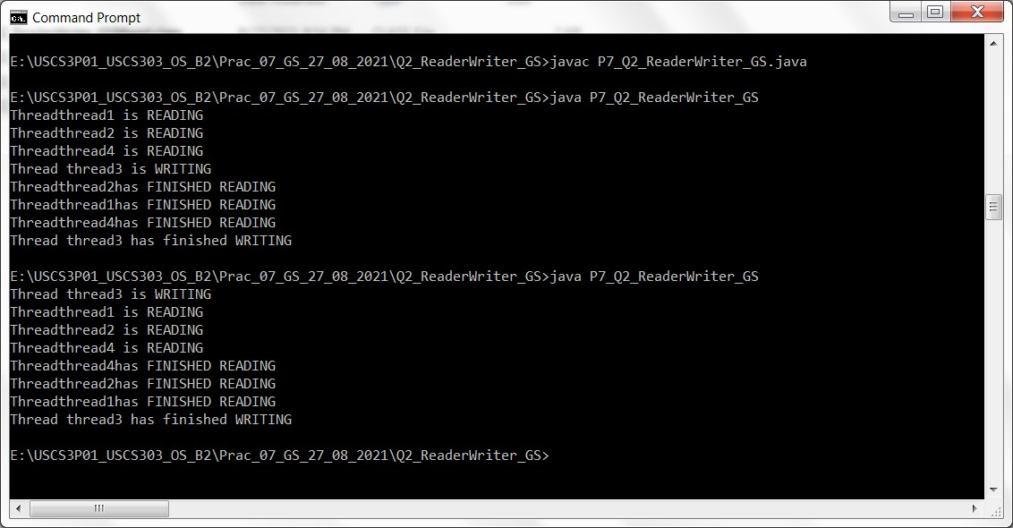

# **Sleeping Barber Problem:**

CHMCS/SEM-III/2021-22

* Barber shop consists of a waiting room with and chairs and a barber room with one Barber chair.
* If there are no customers to be served the barber goes to sleep.
* If a customer enters the barber shop and all chairs are occupied then the customer leaves the shop.
* If the barber is busy but chairs are available then the customers its in one of the features if the barber is asleep the customer with sharp the barber .

# **Question - 03:**

Write a program to co-ordinate the barber and the customers using Java synchronisation.

(Implement Sleeping-Barber problem)

# **Source Code :**

// Name: Gaurang Sanyasi

// Batch: B2

// PRN: 2020016400785461

// Date: 27 August, 2021

// Prac-07: Synchronization

import java.util.concurrent.*;

import java.util.concurrent.atomic.AtomicInteger;

import java.util.Random;

public class P7_Q3_Barber_GS implements Runnable

{

private AtomicInteger spaces;

private Semaphore bavailable;

private Semaphore cavailable;

private Random ran = new Random();

public P7_Q3_Barber_GS(AtomicInteger spaces, Semaphore bavailable, Semaphore cavailable){

this.spaces = spaces;

this.bavailable = bavailable;

this.cavailable = cavailable;

}

@Override

public void run(){

while(true){

try{

cavailable.acquire();

//Space freed up in waiting area

System.out.println("Customer getting hair cut");

Thread.sleep(ThreadLocalRandom.current().nextInt(1000,10000+1000));

//Sleep to imitate length of time to cut hair

System.out.println("Customer pays and leaves");

bavailable.release();

}catch(InterruptedException e){}

}//while ends

}//run ends

}//class ends

Source code 2:

// Name: Gaurang Sanyasi

// Batch: B2

// PRN: 2020016400785461

// Date: 27 August, 2021

// Prac-07: Synchronization

import java.util.concurrent.atomic.AtomicInteger;

import java.util.concurrent.*;

class P7_Q3_BarberShop_GS{

public static void main(String[] args)

{

AtomicInteger spaces = new AtomicInteger(15);

final Semaphore barbers = new Semaphore(3, true);

final Semaphore customers = new Semaphore(0, true);

ExecutorService openUp = Executors.newFixedThreadPool(3);

P7_Q3_Barber_GS[] employees = new P7_Q3_Barber_GS[3];

System.out.println("Opening up shop");

for(int i = 0; i < 3; i++){

employees[i] = new P7_Q3_Barber_GS(spaces, barbers, customers);

openUp.execute(employees[i]);

}

while(true)

{

try{

Thread.sleep(ThreadLocalRandom.current().nextInt(100, 1000+100));

//Sleep until next person gets in

}

catch(InterruptedException e){}

System.out.println("Customer walks in");

if(spaces.get() >= 0){

new Thread(new P7_Q3_Customer_GS(spaces,

barbers,customers)).start();

}

else{

System.out.println("Customer walks out, as no seats are available");

}

}//while ends

}//main ends

}//P7_Q3_BarberShop_GS class ends

Source code 3:

// Name: Gaurang Sanyasi

// Batch: B2

// PRN: 2020016400785461

// Date: 27 August, 2021

// Prac-07: Synchronization

import java.util.concurrent.*;

import java.util.concurrent.atomic.AtomicInteger;

import java.util.Random;

public class P7_Q3_Customer_GS implements Runnable

{

private AtomicInteger spaces;

private Semaphore bavailable;

private Semaphore cavailable;

private Random ran = new Random();

public P7_Q3_Customer_GS(AtomicInteger spaces, Semaphore bavailable, Semaphore cavailable){

this.spaces = spaces;

this.bavailable = bavailable;

this.cavailable = cavailable;

}

@Override

public void run(){

try{

cavailable.release();

if(bavailable.hasQueuedThreads()){

spaces.decrementAndGet();

System.out.println("Customer in waiting area");

bavailable.acquire();

spaces.incrementAndGet();

}

else

{

bavailable.acquire();

}

}catch(InterruptedException e){}

}//run ends

}//P7_Q3_Customer_GS class

# **Output :**

# **Screenshot-1:**

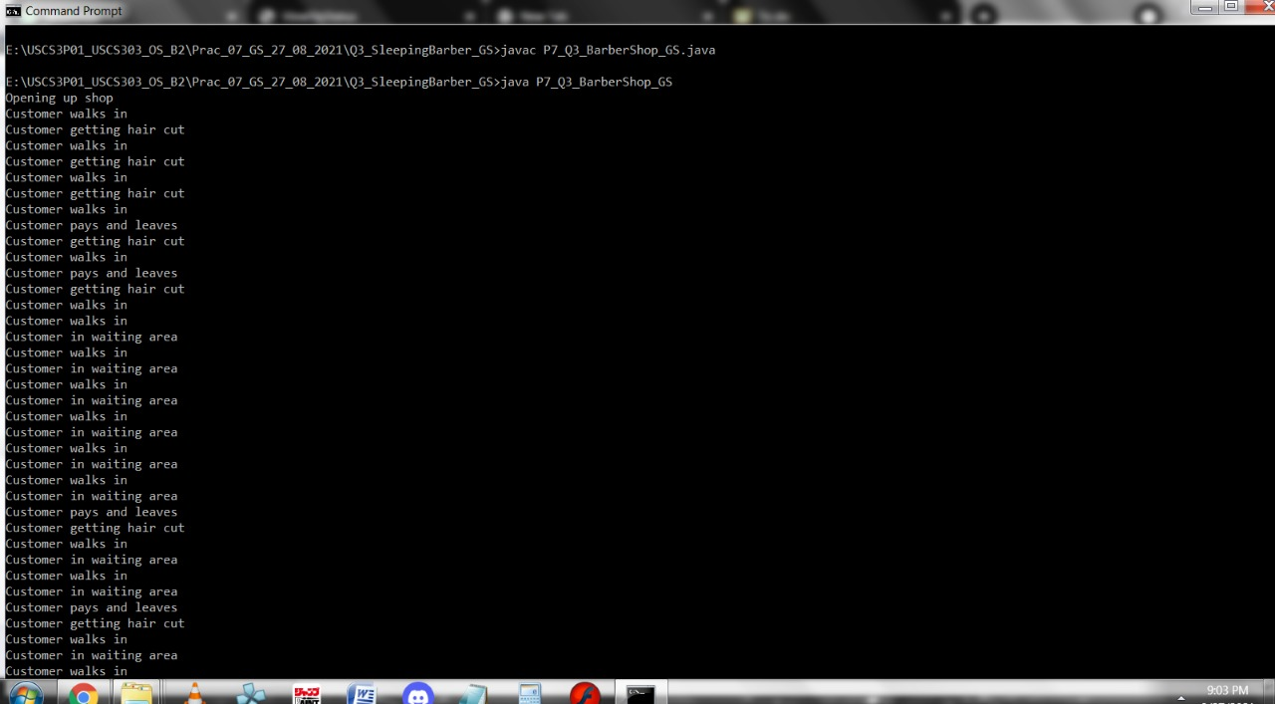

# **Screenshot-2**

