
A Project Report on
SocialNEURON: AI Social Media Content Automation Platform
In fulfillment of the requirement for the 4th Semester of
Master of Computer Application Program

Course Code | Course Name | Program | Semester
MCA-401 | Software Development Project | MCA | IV


Submitted by
Gohel Gaurang HarishBhai
Enrollment No.: 824000110192MCA
Session: [2025 - 2026]
Under the Guidance of
[Name of the Project Guide]
[Designation / Institution]
Learner Support Centre
PySquad Informatics LLP
Ahmedabad
Certificate of Originality from the Guide

This is to certify that the project report entitled SocialNEURON: AI Social Media Content Automation Platform submitted to Dr. Babasaheb Ambedkar Open University in partial fulfilment of the requirement for the award of the degree of Master of Computer Applications, is an original work carried out by

Mr. / Ms.: Gohel Gaurang Harish Bhai
Enrolment No.: 824000110192MCA
Under the Supervision of: ______________________________

The matter embodied in this project is a genuine work done by the learner and has not been submitted either to this University or to any other University/Institute for the fulfilment of the requirement of any course of study.

Signature of the Learner:  Name: Gohel Gaurang HarishBhai  Address: _____________________  Enrolment No.: 824000110192MCA  Date: ____________________ | Signature of the Guide:  Name: _________________________  Designation: __________________  Address: ______________________  Date: ____________________

ACKNOWLEDMENT

I express my sincere gratitude to my project guide, faculty members, and the Learner Support Centre for their valuable guidance and support during the development of this software project. Their suggestions helped in shaping the project scope, improving the system design, and preparing this report in a structured manner.
I am thankful to Dr. Babasaheb Ambedkar Open University for providing the MCA-401 Software Development Project framework, which encouraged practical application of software engineering, database design, web development, and project management concepts.
I also thank my family, peers, and all users who provided feedback during the development and testing of SocialNEURON. Their inputs helped improve the usability, workflow, and overall quality of the project.

Signature of Learner: __________________________________
Name: Gohel Gaurang HarishBhai
Enrollment No.: 824000110192MCA
Date: __________________________________
DECLARATION

I hereby declare that this project report titled SocialNEURON: AI Social Media Content Automation Platform is an original software development project prepared by me for MCA-401. The work presented in this report is based on my own analysis, design, implementation, testing, and documentation of the project. All references used have been acknowledged in the References section.
This project report has not been submitted previously for any degree or diploma to any university or institution.

Signature of Learner: __________________________________
Name: Gohel Gaurang HarishBhai
Enrollment No.: 824000110192MCA
Date: __________________________________

Table Of Contents

Chapter / Section | Title | Page No.
Certificate | Certificate of Originality from the Guide
Acknowledgement | Acknowledgement
Declaration | Declaration
Synopsis | Project Proposal / Synopsis
Chapter 1 | Introduction
1.1 | Brief Idea About the Project
1.2 | Objective of the Project
1.3 | Scope of the Project
1.4 | Existing System
1.5 | Proposed System
1.6 | Platform Used (Hardware & Software)
1.7 | Project Location
Chapter 2 | Requirement Analysis
2.1 | Introduction
2.2 | Tools Used for Requirement Gathering
2.3 | Problems in Existing System
2.4 | Conclusion
Chapter 3 | Logical Design
3.1 | Introduction
3.2 | Data Flow Diagram (0th, 1st, 2nd Level)
3.3 | ER Diagram
3.4 | Use Case Diagram
3.5 | Activity Diagram
3.6 | Conclusion
Chapter 4 | Physical Design
4.1 | Introduction
4.2 | Database Design
4.3 | Module Design
4.4 | Input / Output Design
4.5 | Conclusion
Chapter 5 | Implementation
5.1 | Introduction
5.2 | Process Description
5.3 | Output & Report
5.4 | Conclusion
Chapter 6 | Testing
6.1 | Introduction
6.2 | Types of Testing Performed
6.3 | Conclusion
References | References

Project Proposal (Synopsis)

Title of the Project
SocialNEURON: AI Social Media Content Automation Platform

Introduction and Objectives of the Project
SocialNEURON is a web-based software application designed to help businesses, creators, and marketing teams plan, generate, review, and verify social media content. The platform allows users to define brand details during onboarding, upload or manually create content topics, generate AI-assisted drafts, review content, manage email alerts, and maintain a publication history.
The primary objective of the project is to create a practical, scalable, and user-friendly web application that solves the real-world problem of consistent social media content production. The project demonstrates concepts of web development, database management, user authentication, workflow automation, AI integration, file import, email notification, and report-oriented project documentation.

Project Category
The project belongs to the Application Oriented and Database Oriented categories. It is a web-based application developed using Python and Django with a relational database backend.

Tools, Platform, Hardware and Software Requirements
Category | Specification
Programming Language | Python
Web Framework | Django 5.2
Frontend | HTML, CSS, HTMX, JavaScript
Database | SQLite for development, compatible with relational databases for production
AI Integration | Ollama local API for content generation
Task Processing | Celery and Redis
Data Import | Pandas and OpenPyXL for Excel / CSV schedule upload
Email | Django email backend
Operating System | Linux / Windows compatible development environment
Hardware | Minimum 8 GB RAM, modern CPU, 2 GB free disk space

Industry / Client
This project is developed as an academic software development project. The target users are small businesses, founders, content teams, freelancers, agencies, and creators who need a structured system for content planning and review.

Methodology
The project follows an iterative software development approach. Requirements were identified from the workflow of content teams. The system was divided into modules such as authentication, onboarding, topic generation, schedule upload, AI draft generation, review workflow, email integration, contact inquiry, and dashboard reporting. Each module was developed, tested, and improved incrementally based on observed user flows.

Expected Output
The expected output is a working web application where a user can register, define a brand profile, generate or upload content topics, create AI-generated drafts, approve or reject content, mark published content with a verification link, receive email alerts, and manage content history.

Conclusion
SocialNEURON demonstrates a real-world application of software development concepts. It combines database design, web interface design, authentication, file processing, AI integration, task automation, and testing practices to build a functional content automation platform.

Chapter 1: Introduction

1.1 Brief Idea About the Project
SocialNEURON is an AI-powered social media content automation system. It helps users move from idea generation to content review and publication tracking in a single web application. A typical user first creates an account, completes onboarding by entering brand information, then uses the dashboard to generate topics, upload Excel schedules, review generated content, and manage published history.
The system supports content planning for platforms such as LinkedIn, Instagram, X (Twitter), Facebook, and multiple content types such as post, reel, carousel, story, thread, and short. This flexibility makes the application suitable for modern social media workflows.

1.2 Objective of the Project
The objectives of SocialNEURON are:
- To provide a secure user registration and login system.
- To capture brand profile information such as niche, audience, platforms, tone, and goals.
- To generate topic ideas using AI according to selected platform and content type.
- To allow manual topic creation and Excel-based bulk schedule upload.
- To generate AI-assisted content drafts using brand voice and topic context.
- To provide review actions such as approve, reject, regenerate, comment, and mark as published.
- To send email notifications to configured recipients.
- To maintain dashboard analytics and history of published content.
- To collect contact inquiries from the public home page.

1.3 Scope of the Project
The scope includes complete user and content workflow management for a social media automation platform. It covers authentication, onboarding, dashboard reporting, schedule import, topic generation, draft generation, review management, published link verification, email alert routing, contact inquiry submission, and basic administrative management through Django admin.
The system can be extended in future to include direct publishing APIs, advanced analytics, team roles, payment plans, file storage, and deeper AI prompt management.

1.4 Existing System
Many small businesses manage social media content using spreadsheets, messaging apps, manual notes, and disconnected AI tools. In such workflows, topic planning, AI content generation, approval, and publication tracking are spread across multiple tools. This causes duplication, inconsistent brand tone, missed deadlines, and difficulty in tracking approved or published posts.

1.5 Proposed System
The proposed system centralizes the content workflow into one web application. A user can create topics manually, generate AI topics, upload schedules through Excel, run the AI workflow for due drafts, approve or reject generated content, and manually verify published posts. Brand profile information influences the generated content so the output remains consistent with the business identity.

1.6 Platform Used: Hardware and Software
Type | Details
Backend Platform | Django web framework using Python
Frontend Platform | Django templates, Tailwind CSS, HTMX, JavaScript
Database | SQLite during development
Background Jobs | Celery with Redis
AI Provider | Ollama local text generation API
Development Tools | Python virtual environment, Git, Django management commands

1.7 Project Location
The project is developed locally as a Django web application. The source code is organized under the project folder named SocialNEURON. The application can be deployed to a web server or cloud platform after configuring the database, email backend, Redis, and environment variables.

Chapter 2: Requirement Analysis

2.1 Introduction
Requirement analysis identifies what the system must do and what constraints it must satisfy. For SocialNEURON, requirements were derived from the content operations workflow of users who need to create regular social media posts with consistent tone and controlled approvals.

2.2 Tools Used for Requirement Gathering
The following tools and methods were used for requirement gathering:
- Observation of social media planning workflows.
- Review of spreadsheet-based content calendars.
- Study of AI-assisted content generation use cases.
- Module analysis based on Django app structure and database models.
- Feedback-driven iteration during implementation.

Functional Requirements
Req. ID | Description | Module
FR-01 | User can sign up, login, logout, reset password, and change password. | Authentication
FR-02 | User can enter and update brand profile information. | Onboarding / Settings
FR-03 | User can generate topic ideas using query, tone, audience, platform, content type, and count. | Topic Generator
FR-04 | User can add a manual topic with date, time, platform, and content type. | Manual Topic
FR-05 | User can upload content schedule through Excel or CSV. | Upload
FR-06 | System can generate AI content drafts for due posts. | AI Workflow
FR-07 | User can approve, reject, regenerate, comment on, and verify posts. | Review
FR-08 | System can send email notifications to configured recipients. | Email Integration
FR-09 | User can view dashboard statistics and published history. | Dashboard / History
FR-10 | Visitor can submit a contact inquiry from the public home page. | Contact

Non-Functional Requirements
Requirement | Description
Usability | The interface must be easy to understand with clear cards, forms, and workflow actions.
Security | Password hashing, session-based access control, CSRF protection, and scoped user data are required.
Reliability | Cron should avoid regenerating already generated content unnecessarily.
Maintainability | Code should be divided into Django apps, services, models, views, and templates.
Scalability | The design should allow migration from SQLite to production relational databases.
Extensibility | The system should support future platform APIs, richer analytics, and subscription plans.

2.3 Problems in Existing System
Existing manual systems lack workflow continuity. Topic ideas may be generated in one tool, reviewed in another, scheduled in a spreadsheet, and published manually without reliable history. Email alerts are often not centralized, and brand voice is usually not stored in a structured manner. This leads to operational delays, inconsistent content quality, and weak tracking.

2.4 Conclusion
The requirement analysis shows that an integrated web application is needed to support planning, AI generation, review, and publication verification. SocialNEURON satisfies these requirements by combining content operations and AI generation in a single workflow.

Chapter 3: Logical Design

3.1 Introduction
Logical design describes the system in terms of processes, data flow, entities, and user interactions. It defines how the system should behave before focusing on physical implementation details.

3.2 Data Flow Diagram

0th Level DFD (Context Diagram)

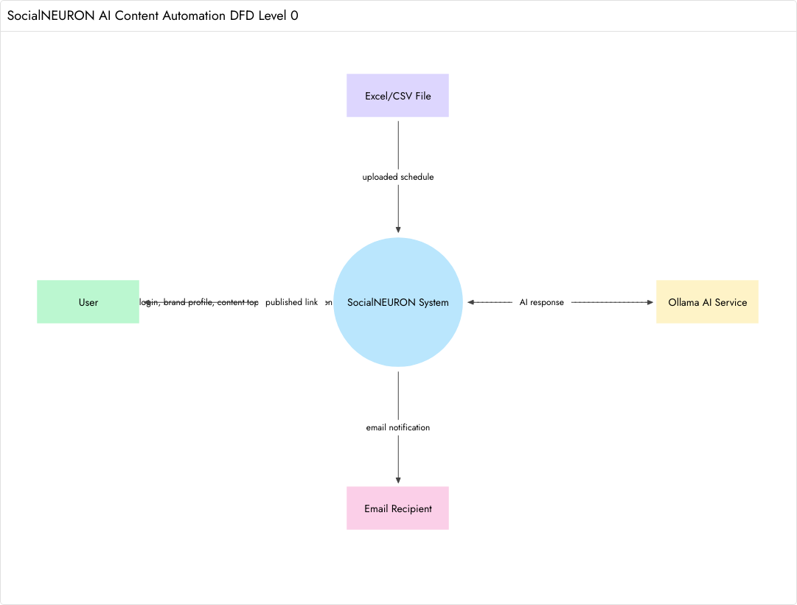
[Figure 3.1: 0th Level Data Flow Diagram]

1st Level DFD

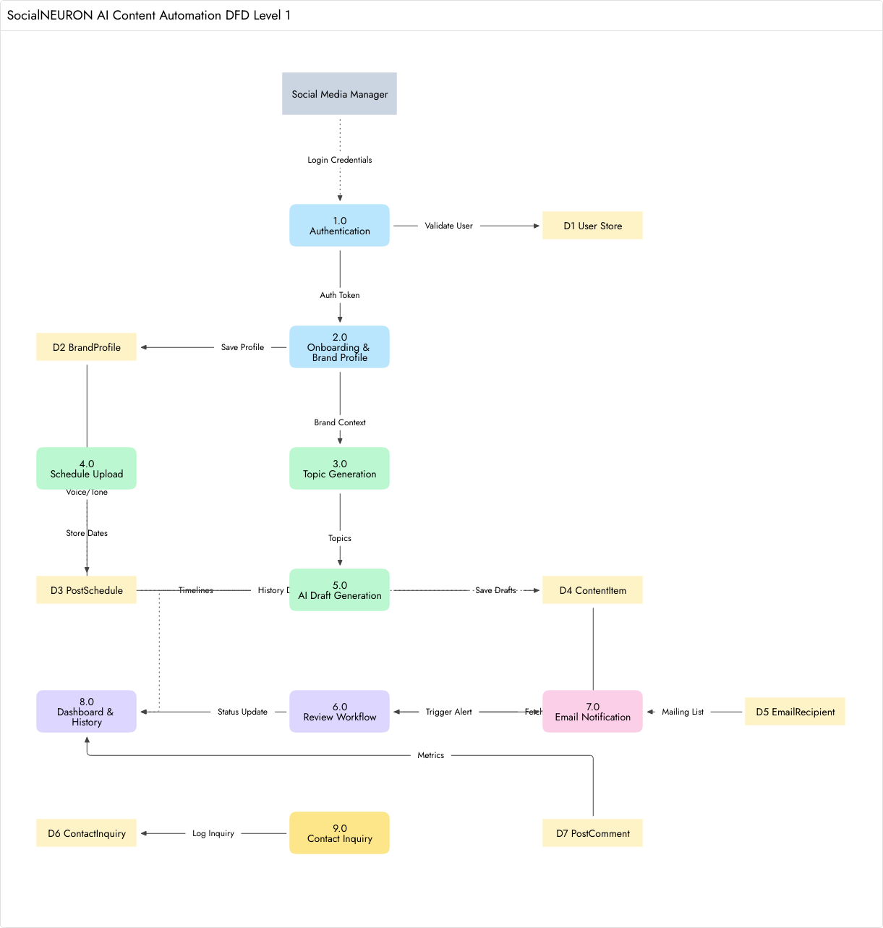
[Figure 3.2: 1st Level Data Flow Diagram]

2nd Level DFD: Review Workflow

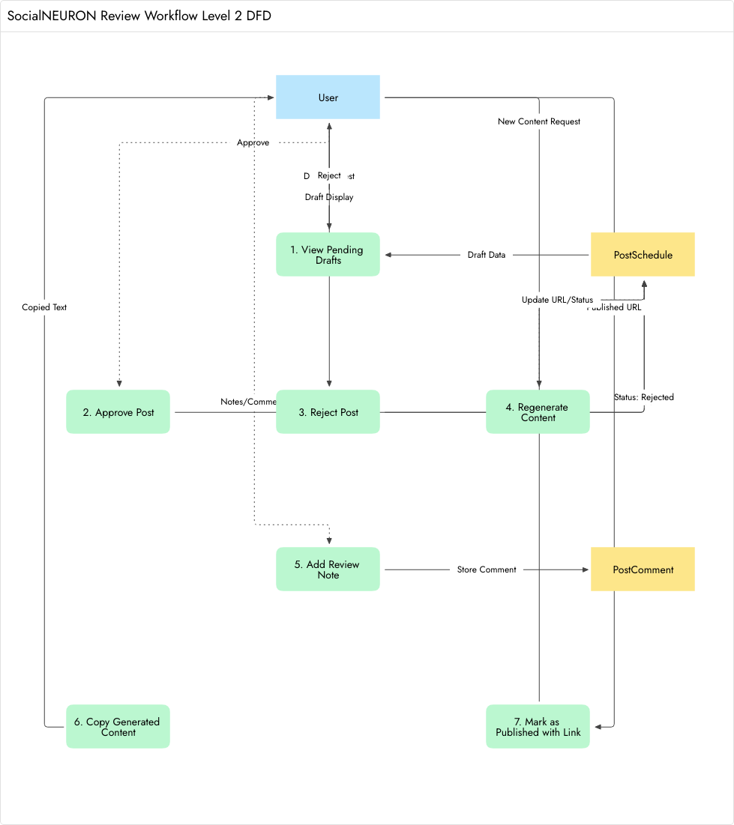
[Figure 3.3: 2nd Level Data Flow Diagram — Review Workflow]

3.3 ER Diagram

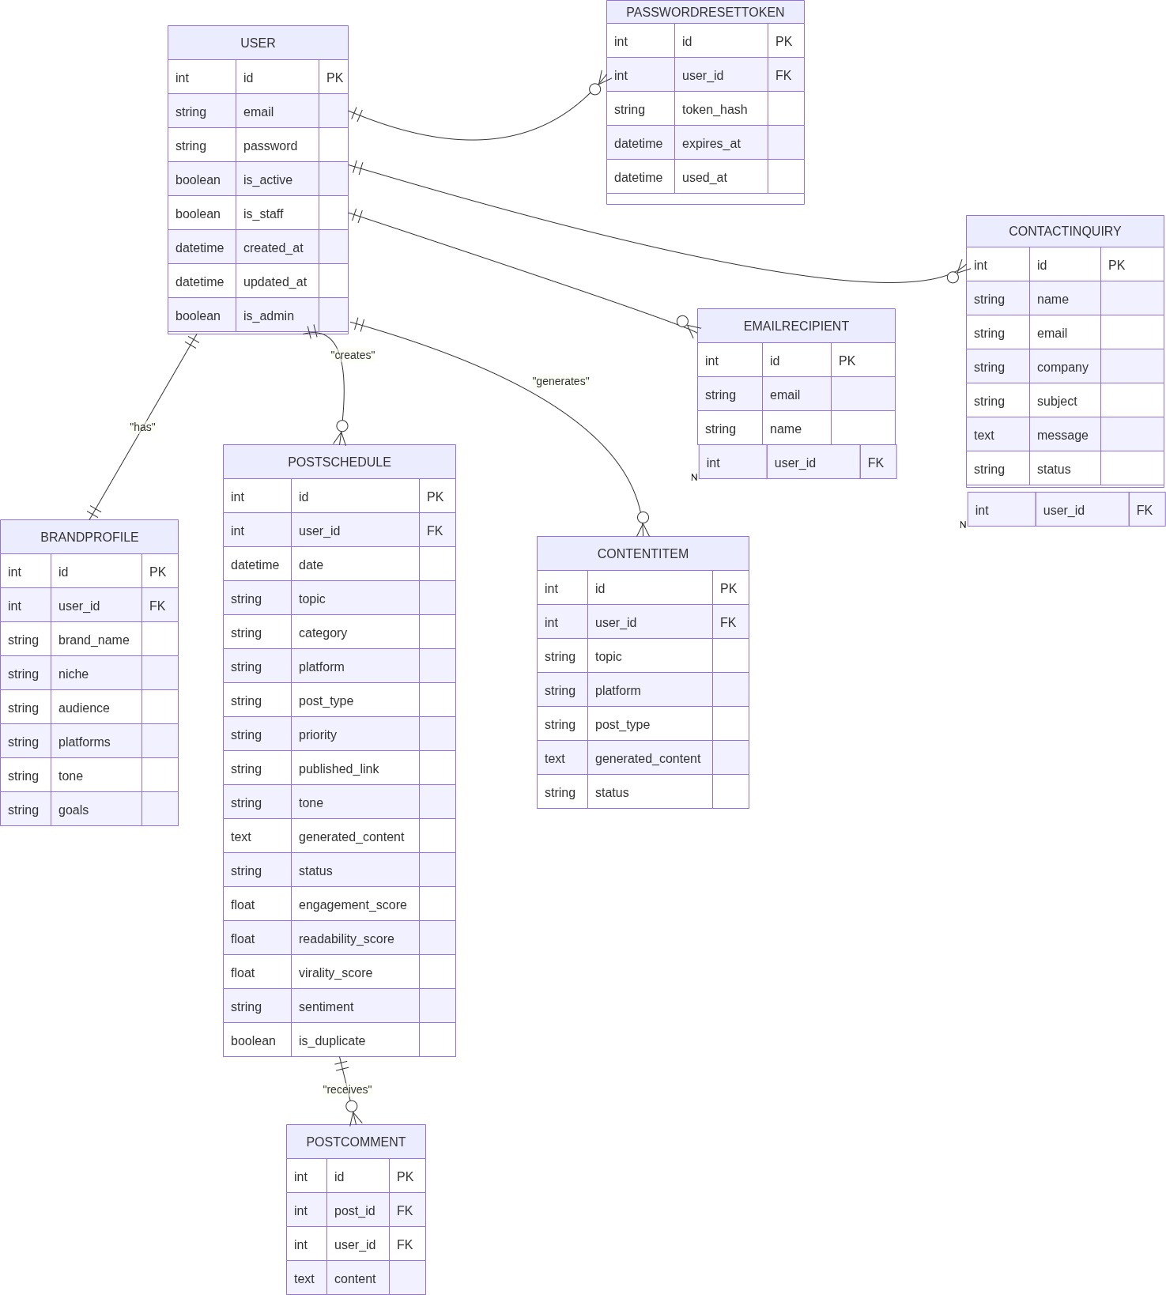
[Figure 3.4: Entity Relationship Diagram]

3.4 Use Case Diagram

[Figure 3.5: Use Case Diagram]
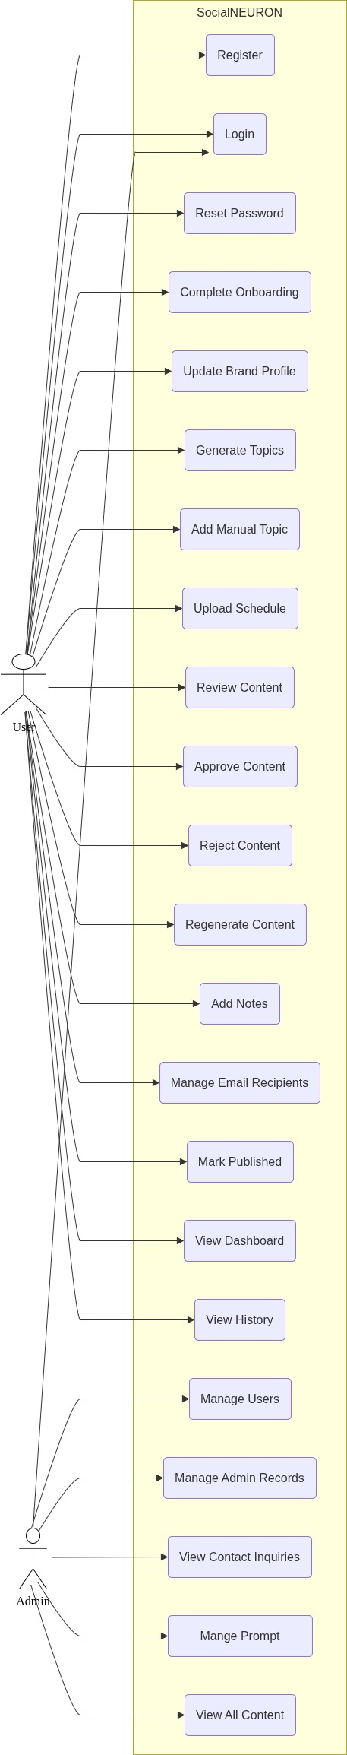

3.5 Activity Diagram
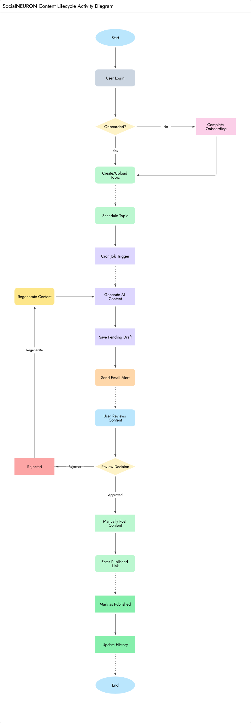
[Figure 3.6: Activity Diagram]

3.6 Conclusion
The logical design shows that SocialNEURON follows a modular workflow. Data flows from user input to schedule records, then to AI-generated drafts, review decisions, email notifications, and final publication history.

Chapter 4: Physical Design

4.1 Introduction
Physical design describes how the logical design is implemented using database tables, Django models, templates, services, views, and background task functions.

4.2 Database Design (Normalized)
Table / Model | Purpose | Important Fields
User | Stores authentication identity. | email, password, is_active, is_staff, is_admin
BrandProfile | Stores onboarding and brand voice information. | brand_name, niche, audience, platforms, tone, goals
PasswordResetToken | Stores password reset tokens securely. | user, token_hash, expires_at, used_at
PostSchedule | Stores scheduled topics and content status. | date, topic, platform, post_type, generated_content, status
ContentItem | Stores generated draft items for approval workflow. | topic, platform, post_type, generated_content, status
PostComment | Stores review notes on scheduled posts. | post, user, content, created_at
EmailRecipient | Stores configured email recipients for alerts. | email, name, is_active
ContactInquiry | Stores home page contact form submissions. | name, email, company, subject, message, status
PlatformIntegration | Stores optional integration configuration. | platform, webhook_url, setup_email, is_active

Normalization
The database design separates users, brand profiles, scheduled posts, generated content, comments, and email recipients into separate models. This reduces duplication and supports maintainability. User-related records are linked through foreign keys or one-to-one relations. Contact inquiries and email recipients are independent operational records.

4.3 Module Design
Module | Key Files / Components | Description
Authentication | auth/auth_service.py, users/models.py, login/reset templates | User creation, login, password reset, password change.
Onboarding | users/onboarding.py, onboarding template, settings page | Brand profile creation and update.
Topic Generator | core/views.py, content_generation.py, topic_generator.html | Generates topic ideas based on query, tone, audience, platform, and type.
Schedule Upload | schedule_import.py, upload.html | Imports Excel or CSV schedule into PostSchedule.
AI Draft Workflow | core/tasks.py, content_generation.py | Generates content and scoring for due scheduled posts.
Review Center | review_dashboard.html, post_detail.html | Approve, reject, regenerate, comment, and publish verification.
Email Integration | email_integration.html, approval_service.py | Manages recipients and sends review alerts.
Dashboard | dashboard.html, dashboard_settings.html | Displays metrics and settings.
Contact | home.html, ContactInquiry model | Stores public inquiry submissions.

4.4 Input / Output Design
Input | Source | Output
Email and password | Signup / Login forms | User account and session
Brand profile | Onboarding / Settings | Brand voice context
Topic query, platform, post type | Topic Generator | AI topic suggestions
Excel / CSV file | Upload page | Scheduled draft topics
Review action (approve/reject) | Review Center | Status change (approved, rejected, or published)
Email recipient list | Email Integration page | Notification routing list
Contact details | Home page | Contact inquiry record

4.5 Conclusion
The physical design maps the logical workflow to Django models, templates, services, and views. It supports modular growth and separates business logic from presentation wherever practical.

Chapter 5: Implementation

5.1 Introduction
The implementation is carried out using Django. The project contains a main Django project package, application modules, templates, migrations, services, and supporting scripts. The implementation emphasizes readable workflows, secure user handling, and practical integration with AI and email services.

5.2 Process Description

User Authentication Process
Users can sign up with email and password. Passwords are hashed using Django password hashers. Users can login, logout, request a reset link, reset password through token, and change password from the dedicated settings page.

Onboarding and Brand Profile Process
After signup, users enter brand name, niche, target audience, preferred platforms, writing tone, and content goals. This data is used to build a reusable brand voice payload for AI prompts.

Topic Generation Process
The topic generator accepts query, tone, audience, platform, content type, and number of topics. The server calls the content generation service, which prepares a prompt for Ollama and parses returned lines into topic objects. The results are displayed with score, virality, tone, audience, platform, and content type information.

Schedule Upload Process
Users can upload Excel or CSV files containing columns such as date, topic, tone, audience, platform, priority, and post_type. The import service reads the file and creates scheduled draft records.

AI Draft Generation Process
The cron workflow checks today's and tomorrow's draft records. If a draft does not already contain generated content, the system generates content using AI, assigns scores, changes status to pending, saves a content item, and sends email notifications to active recipients.

Review and Publishing Process
Users review pending drafts, approve or reject them, regenerate content, add comments, and mark approved content as published by entering a live URL. Published posts appear in the history page.

5.3 Output and Reports
The application produces the following outputs:
- Dashboard statistics for total, draft, pending, approved, rejected, and published content.
- AI-generated topic ideas.
- AI-generated social media content drafts.
- Email notifications for review-ready content.
- Published history with platform, tone, score, and link information.
- Contact inquiry records for public visitors.

Screenshots

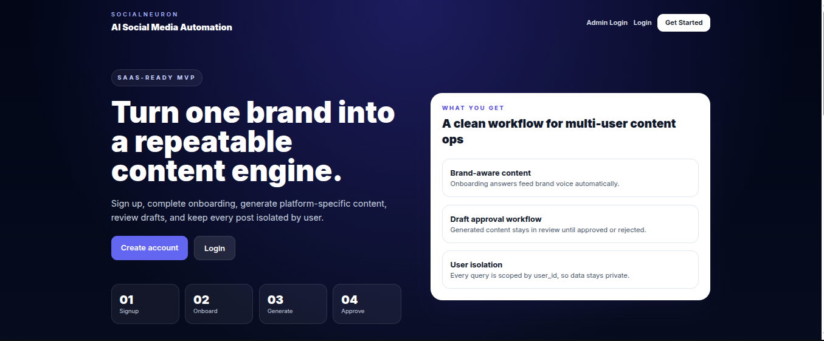
[Figure 5.1: Home Page]

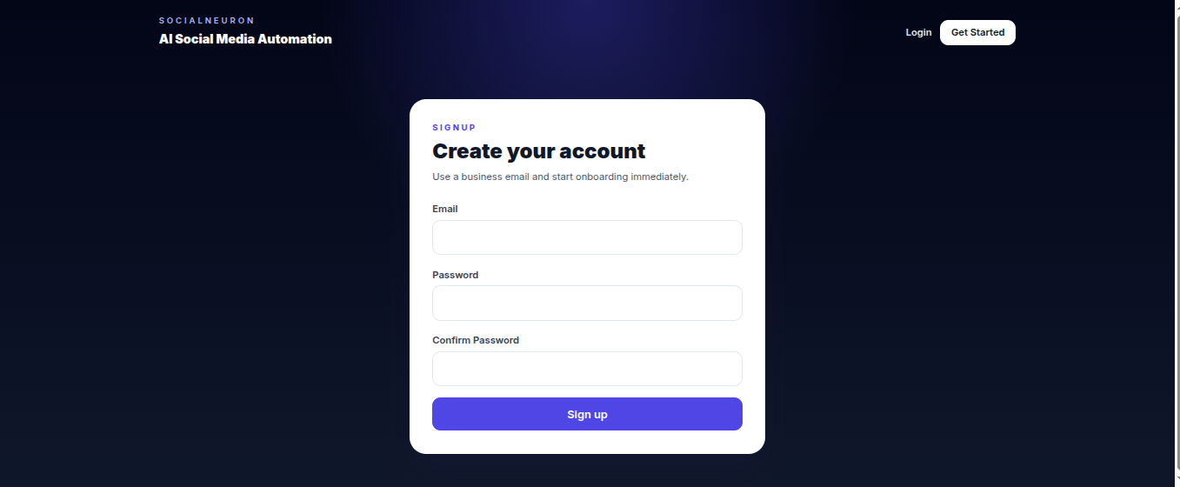
[Figure 5.2: Sign Up]

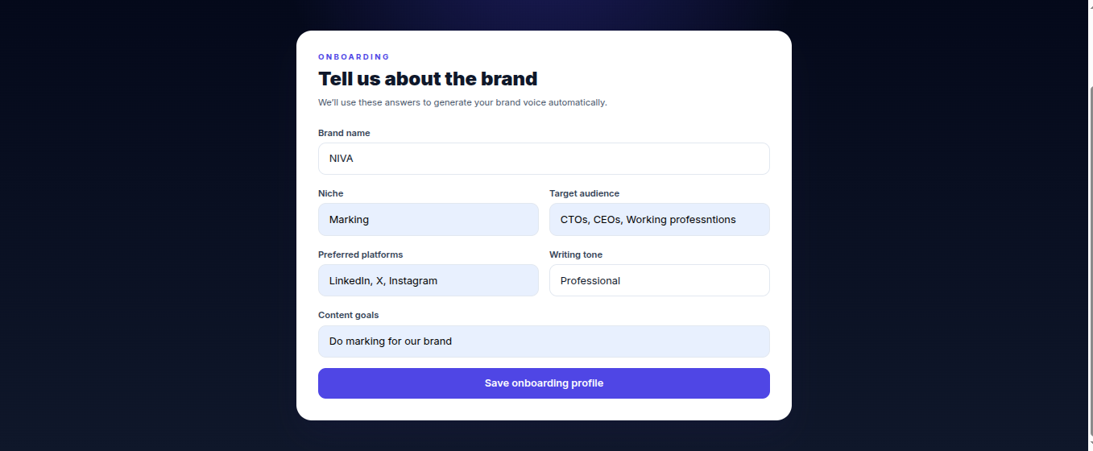

[Figure 5.3: Onboarding]

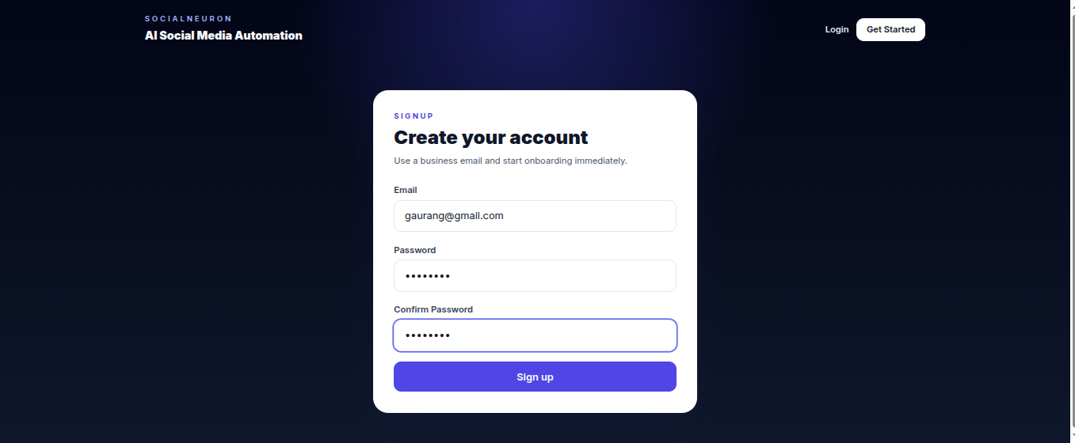
[Figure 5.4: Login]

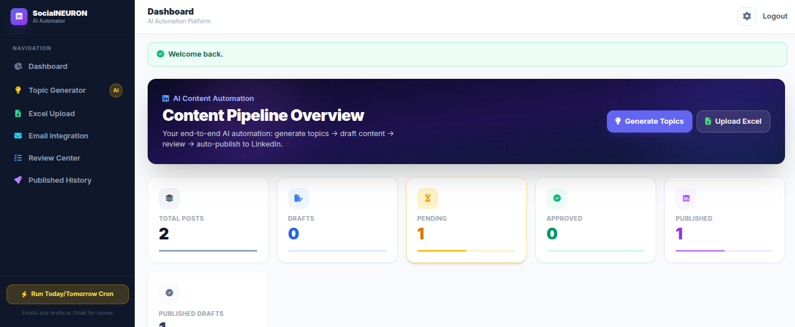
[Figure 5.5: Dashboard]

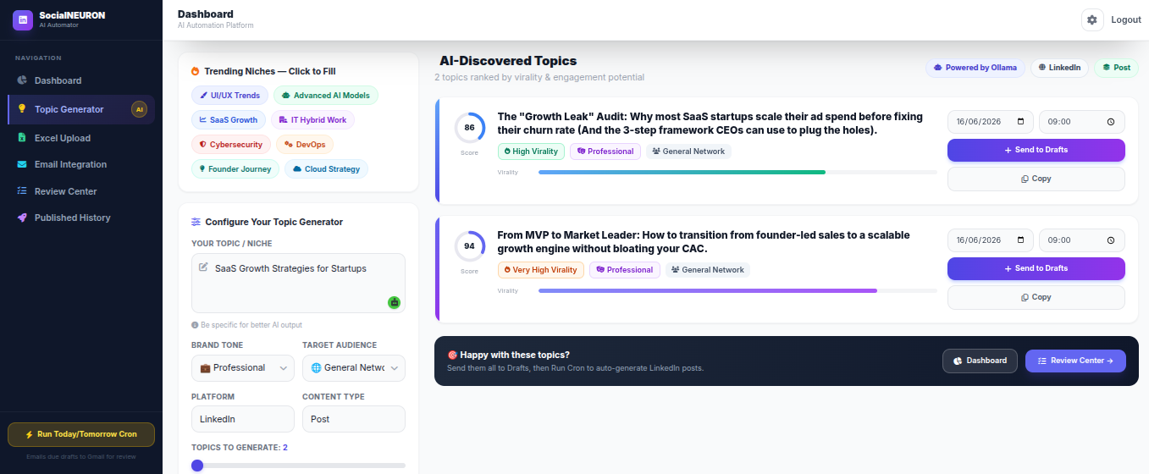
[Figure 5.6: Topic Generator]

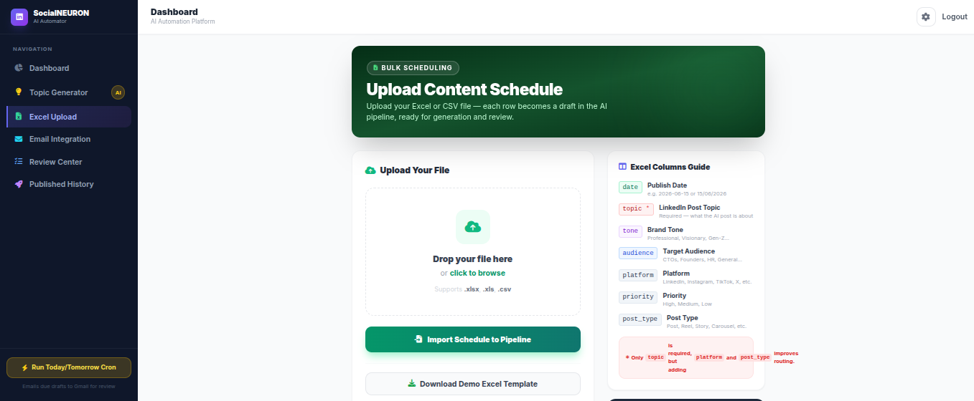
[Figure 5.7: Upload Content Schedule]

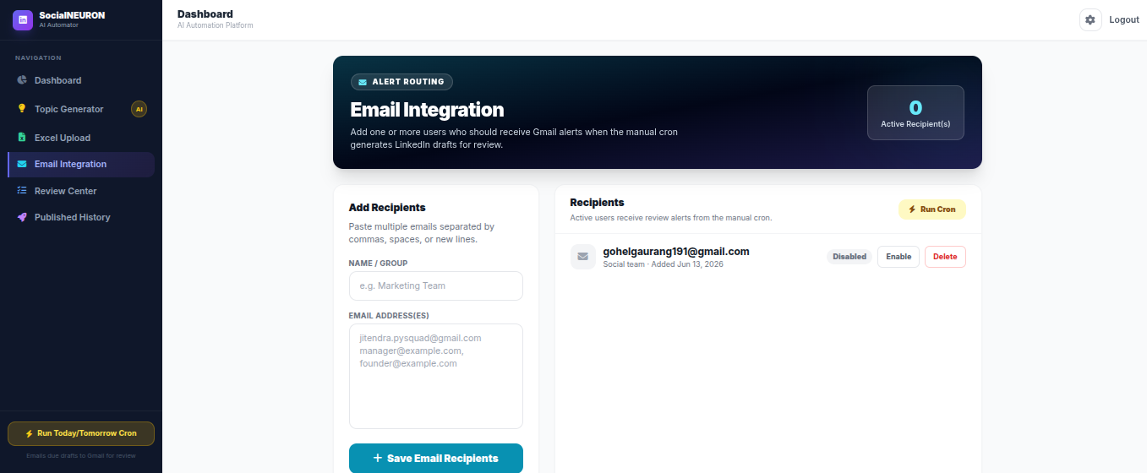
[Figure 5.8: Email Integration]

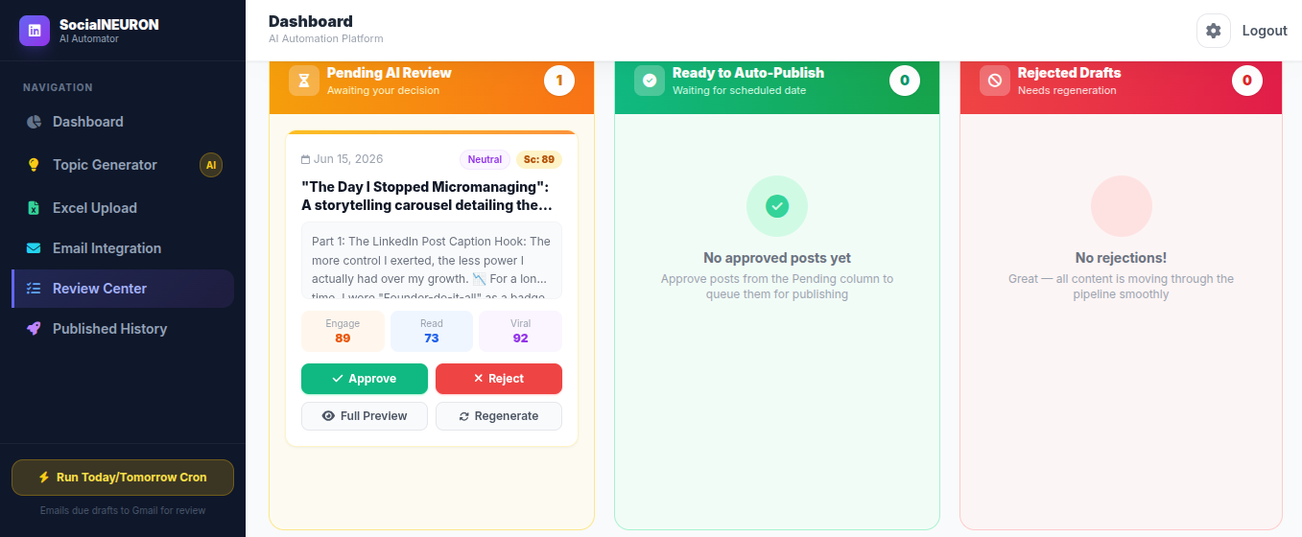
[Figure 5.9: Content Review Center]

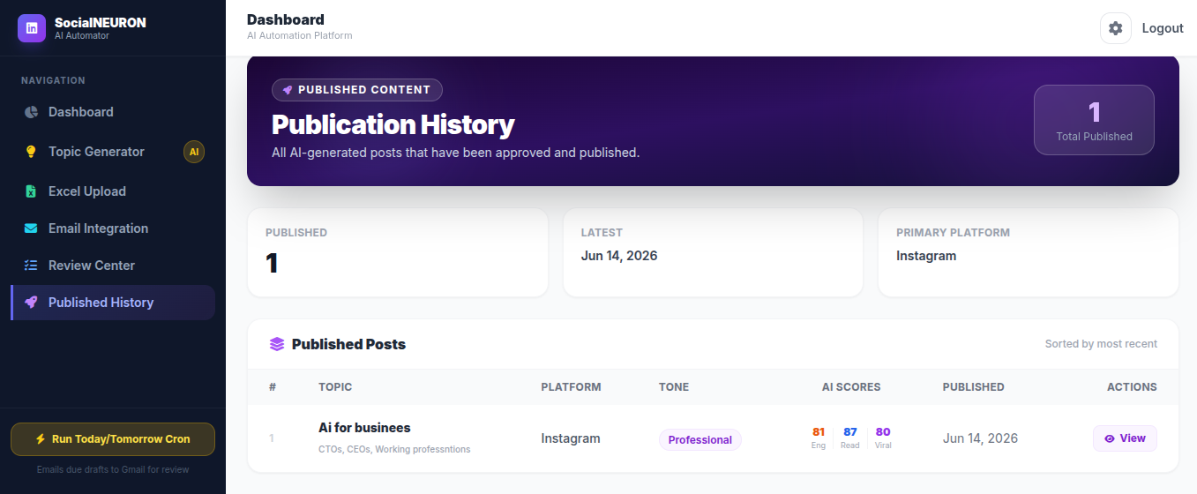
[Figure 5.10: Published History]

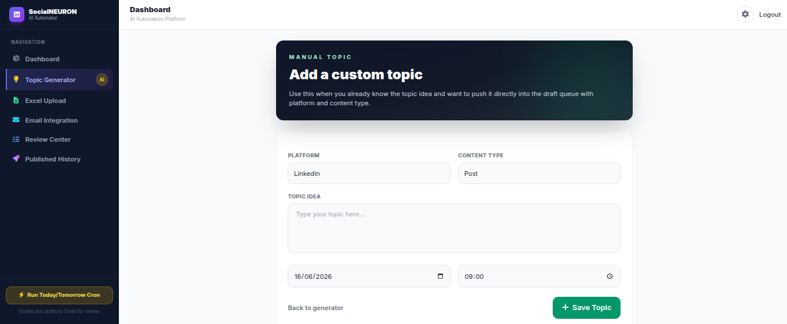
[Figure 5.11: Custom Topic]

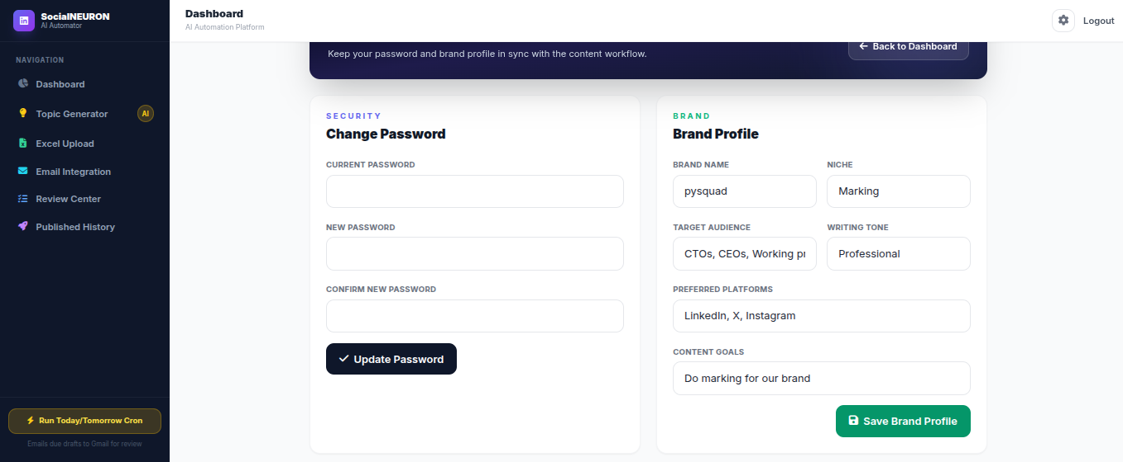
[Figure 5.12: Workspace Settings]

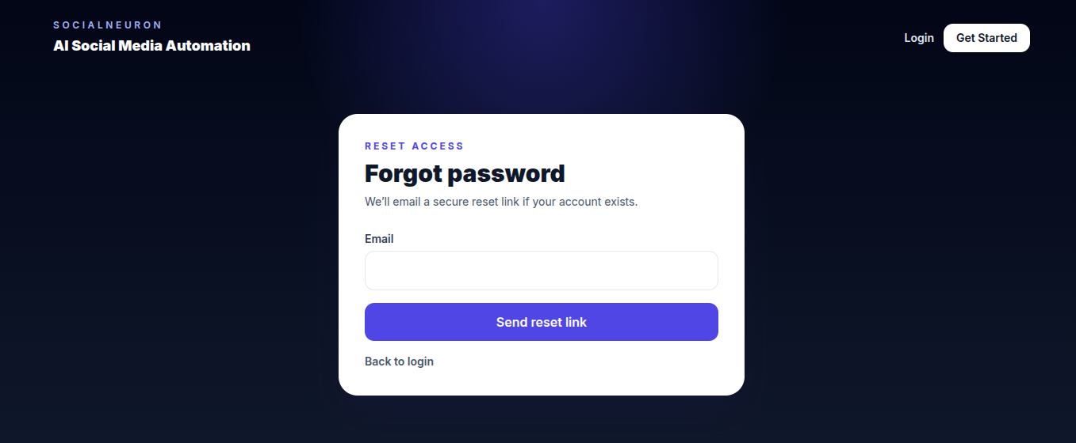

[Figure 5.13: Forgot Password]

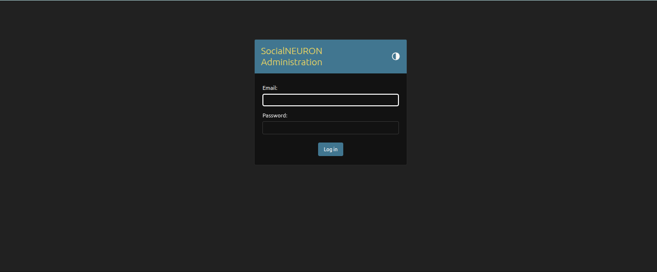
[Figure 5.13: Admin Login ]

5.4 Conclusion
The implementation successfully creates a functional end-to-end content automation workflow. It integrates user management, AI generation, review controls, file import, email notifications, and public contact handling into a single Django application.

Chapter 6: Testing

6.1 Introduction
Testing verifies that the system works according to the requirements. The project was tested through module-level testing, integration testing, user interface testing, form validation testing, and workflow testing.

6.2 Types of Testing Performed

Unit Testing
Individual functions such as password validation, schedule parsing, topic generation parsing, and contact submission handling can be tested independently to verify correctness of each unit in isolation.

Integration Testing
Integration testing checks whether modules work together. Examples include signup to onboarding flow, topic generation to draft saving, schedule upload to AI generation, and review approval to published history.

System Testing
The complete system is tested as a web application by navigating through all major workflows from login to content publication.

Validation Testing
Form validation checks required fields in contact inquiry, login, signup, reset password, topic creation, schedule upload, and published link entry.

Regression Testing
Regression testing verifies that updates such as contact form, settings page, email recipient deletion, topic platform selection, and score ring fixes do not break older workflows.

Test Cases
Test ID | Scenario | Expected Result | Status
TC-01 | User signs up with valid email and password. | Account created and redirected to onboarding. | Pass
TC-02 | User enters mismatched signup passwords. | Error message is displayed. | Pass
TC-03 | User updates brand profile from settings page. | Brand profile is updated. | Pass
TC-04 | User generates topics for Instagram Reel. | Results show selected platform and content type. | Pass
TC-05 | User uploads Excel schedule. | Rows are added as draft scheduled topics. | Pass
TC-06 | User runs cron for due draft. | AI content is generated and status becomes pending. | Pass
TC-07 | User runs cron again for already generated content. | Content is not regenerated unnecessarily. | Pass
TC-08 | User adds note on post detail. | Comment is saved and displayed. | Pass
TC-09 | User adds email recipient. | Recipient appears in email integration list. | Pass
TC-10 | User deletes email recipient. | Recipient is removed. | Pass
TC-11 | Visitor submits contact inquiry. | Inquiry is saved and success message displayed. | Pass
TC-12 | User marks post as published without URL. | Error message is displayed. | Pass

6.3 Conclusion
Testing confirms that the core modules of the SocialNEURON system meet the defined requirements. The application handles common workflows such as authentication, onboarding, topic generation, schedule upload, AI draft generation, review, email alerts, and contact inquiry submission.

References

- Dr. Babasaheb Ambedkar Open University, MCA-401 Software Development Project Guidelines. Available at: https://baou.edu.in/assets/pdf/MCA-401.pdf
- Django Software Foundation, Django Documentation. Available at: https://docs.djangoproject.com/
- Celery Documentation. Available at: https://docs.celeryq.dev/
- Pandas Documentation. Available at: https://pandas.pydata.org/docs/
- HTMX Documentation. Available at: https://htmx.org/docs/
- Ollama Documentation. Available at: https://ollama.com/

