
A Project Report on
SocialNEURON: AI Social Media Content Automation Platform
In fulfillment of the requirement for the 4th Semester of
Master of Computer Application Program

Course Code | Course Name | Program | Semester
MCA-401 | Software Development Project | MCA | IV


Submitted by
Gohel Gaurang HarishBhai
Enrollment No.: 824000110192MCA
Session: [2025 - 2026]
Under the Guidance of
[Name of the Project Guide]
[Designation / Institution]
Learner Support Centre
PySquad Informatics LLP
Ahmedabad
Certificate of Originality from the Guide

This is to certify that the project report entitled SocialNEURON: AI Social Media Content Automation Platform submitted to Dr. Babasaheb Ambedkar Open University in partial fulfilment of the requirement for the award of the degree of Master of Computer Applications, is an original work carried out by

Mr. / Ms.: Gohel Gaurang Harish Bhai
Enrolment No.: 824000110192MCA
Under the Supervision of: ___Yogesh Chauhan___________________________

The matter embodied in this project is a genuine work done by the learner and has not been submitted either to this University or to any other University/Institute for the fulfilment of the requirement of any course of study.

Signature of the Learner:  Name: Gohel Gaurang HarishBhai  Address: ___ahemdabad__________________  Enrolment No.: 824000110192MCA  Date: ____________________ | Signature of the Guide:  Name: Yogesh Chauhan  Designation: Team Lead  Address: _____ahemdabad_________________  Date: ____________________

ACKNOWLEDMENT

I express my sincere gratitude to my project guide, faculty members, and the Learner Support Centre for their valuable guidance and support during the development of this software project. Their suggestions helped in shaping the project scope, improving the system design, and preparing this report in a structured manner.
I am thankful to Dr. Babasaheb Ambedkar Open University for providing the MCA-401 Software Development Project framework, which encouraged practical application of software engineering, database design, web development, and project management concepts.
I also thank my family, peers, and all users who provided feedback during the development and testing of SocialNEURON. Their inputs helped improve the usability, workflow, and overall quality of the project.

Signature of Learner: __________________________________
Name: Gohel Gaurang HarishBhai
Enrollment No.: 824000110192MCA
Date: __________________________________
DECLARATION

I hereby declare that this project report titled SocialNEURON: AI Social Media Content Automation Platform is an original software development project prepared by me for MCA-401. The work presented in this report is based on my own analysis, design, implementation, testing, and documentation of the project. All references used have been acknowledged in the References section.
This project report has not been submitted previously for any degree or diploma to any university or institution.

Signature of Learner: __________________________________
Name: Gohel Gaurang HarishBhai
Enrollment No.: 824000110192MCA
Date: __________________________________

Table Of Contents

Chapter / Section | Title | Page No.
Certificate | Certificate of Originality from the Guide
Acknowledgement | Acknowledgement
Declaration | Declaration
Synopsis | Project Proposal / Synopsis
Chapter 1 | Introduction
1.1 | Brief Idea About the Project
1.2 | Objective of the Project
1.3 | Scope of the Project
1.4 | Existing System
1.5 | Proposed System
1.6 | Platform Used (Hardware & Software)
1.7 | Project Location
Chapter 2 | Requirement Analysis
2.1 | Introduction
2.2 | Tools Used for Requirement Gathering
2.3 | Problems in Existing System
2.4 | Conclusion
Chapter 3 | Logical Design
3.1 | Introduction
3.2 | Data Flow Diagram (0th, 1st, 2nd Level)
3.3 | ER Diagram
3.4 | Use Case Diagram
3.5 | Activity Diagram
3.6 | Sequence Diagram
3.7 | Conclusion
Chapter 4 | Physical Design
4.1 | Introduction
4.2 | Database Design
4.3 | Module Design
4.4 | Input / Output Design
4.5 | Conclusion
Chapter 5 | Implementation
5.1 | Introduction
5.2 | Process Description
5.3 | Output & Report
5.4 | Conclusion
Chapter 6 | Testing
6.1 | Introduction
6.2 | Types of Testing Performed
6.3 | Conclusion
References | References

Project Proposal (Synopsis)

Title of the Project
SocialNEURON: AI Social Media Content Automation Platform

Introduction and Objectives of the Project
SocialNEURON is a web-based software application designed to help businesses, creators, and marketing teams plan, generate, review, and verify social media content. The platform allows users to define brand details during onboarding, upload or manually create content topics, generate AI-assisted drafts, review content, manage email alerts, and maintain a publication history.
The primary objective of the project is to create a practical, scalable, and user-friendly web application that solves the real-world problem of consistent social media content production. The project demonstrates concepts of web development, database management, user authentication, workflow automation, AI integration, file import, email notification, and report-oriented project documentation.

Project Category
The project belongs to the Application Oriented and Database Oriented categories. It is a web-based application developed using Python and Django with a relational database backend.

Tools, Platform, Hardware and Software Requirements
Category | Specification
Programming Language | Python
Web Framework | Django 5.2
Frontend | HTML, CSS, HTMX, JavaScript
Database | SQLite for development, compatible with relational databases for production
AI Integration | Ollama local API for content generation
Task Processing | Celery and Redis
Data Import | Pandas and OpenPyXL for Excel / CSV schedule upload
Email | Django email backend
Operating System | Linux / Windows compatible development environment
Hardware | Minimum 8 GB RAM, modern CPU, 2 GB free disk space

Industry / Client
This project is developed as an academic software development project. The target users are small businesses, founders, content teams, freelancers, agencies, and creators who need a structured system for content planning and review.

Methodology
The project follows an iterative software development approach. Requirements were identified from the workflow of content teams. The system was divided into modules such as authentication, onboarding, topic generation, schedule upload, AI draft generation, review workflow, email integration, contact inquiry, and dashboard reporting. Each module was developed, tested, and improved incrementally based on observed user flows.

Expected Output
The expected output is a working web application where a user can register, define a brand profile, generate or upload content topics, create AI-generated drafts, approve or reject content, mark published content with a verification link, receive email alerts, and manage content history.

Conclusion
SocialNEURON demonstrates a real-world application of software development concepts. It combines database design, web interface design, authentication, file processing, AI integration, task automation, and testing practices to build a functional content automation platform.

Chapter 1: Introduction

1.1 Brief Idea About the Project
SocialNEURON is an AI-powered social media content automation system. It helps users move from idea generation to content review and publication tracking in a single web application. A typical user first creates an account, completes onboarding by entering brand information, then uses the dashboard to generate topics, upload Excel schedules, review generated content, and manage published history.
The system supports content planning for platforms such as LinkedIn, Instagram, X (Twitter), Facebook, and multiple content types such as post, reel, carousel, story, thread, and short. This flexibility makes the application suitable for modern social media workflows.

1.2 Objective of the Project
The objectives of SocialNEURON are:
- To provide a secure user registration and login system.
- To capture brand profile information such as niche, audience, platforms, tone, and goals.
- To generate topic ideas using AI according to selected platform and content type.
- To allow manual topic creation and Excel-based bulk schedule upload.
- To generate AI-assisted content drafts using brand voice and topic context.
- To provide review actions such as approve, reject, regenerate, comment, and mark as published.
- To send email notifications to configured recipients.
- To maintain dashboard analytics and history of published content.
- To collect contact inquiries from the public home page.

1.3 Scope of the Project
The scope includes complete user and content workflow management for a social media automation platform. It covers authentication, onboarding, dashboard reporting, schedule import, topic generation, draft generation, review management, published link verification, email alert routing, contact inquiry submission, and basic administrative management through Django admin.
The system can be extended in future to include direct publishing APIs, advanced analytics, team roles, payment plans, file storage, and deeper AI prompt management.

1.4 Existing System
Many small businesses manage social media content using spreadsheets, messaging apps, manual notes, and disconnected AI tools. In such workflows, topic planning, AI content generation, approval, and publication tracking are spread across multiple tools. This causes duplication, inconsistent brand tone, missed deadlines, and difficulty in tracking approved or published posts.

1.5 Proposed System
The proposed system centralizes the content workflow into one web application. A user can create topics manually, generate AI topics, upload schedules through Excel, run the AI workflow for due drafts, approve or reject generated content, and manually verify published posts. Brand profile information influences the generated content so the output remains consistent with the business identity.

1.6 Platform Used: Hardware and Software
Type | Details
Backend Platform | Django web framework using Python
Frontend Platform | Django templates, Tailwind CSS, HTMX, JavaScript
Database | SQLite during development
Background Jobs | Celery with Redis
AI Provider | Ollama local text generation API
Development Tools | Python virtual environment, Git, Django management commands

1.7 Project Location
The project is developed locally as a Django web application. The source code is organized under the project folder named SocialNEURON. The application can be deployed to a web server or cloud platform after configuring the database, email backend, Redis, and environment variables.

Chapter 2: Requirement Analysis

2.1 Introduction
Requirement analysis identifies what the system must do and what constraints it must satisfy. For SocialNEURON, requirements were derived from the content operations workflow of users who need to create regular social media posts with consistent tone and controlled approvals.

2.2 Tools Used for Requirement Gathering
The following tools and methods were used for requirement gathering:
- Observation of social media planning workflows.
- Review of spreadsheet-based content calendars.
- Study of AI-assisted content generation use cases.
- Module analysis based on Django app structure and database models.
- Feedback-driven iteration during implementation.

Functional Requirements
Req. ID | Description | Module
FR-01 | User can sign up, login, logout, reset password, and change password. | Authentication
FR-02 | User can enter and update brand profile information. | Onboarding / Settings
FR-03 | User can generate topic ideas using query, tone, audience, platform, content type, and count. | Topic Generator
FR-04 | User can add a manual topic with date, time, platform, and content type. | Manual Topic
FR-05 | User can upload content schedule through Excel or CSV. | Upload
FR-06 | System can generate AI content drafts for due posts. | AI Workflow
FR-07 | User can approve, reject, regenerate, comment on, and verify posts. | Review
FR-08 | System can send email notifications to configured recipients. | Email Integration
FR-09 | User can view dashboard statistics and published history. | Dashboard / History
FR-10 | Visitor can submit a contact inquiry from the public home page. | Contact

Non-Functional Requirements
Requirement | Description
Usability | The interface must be easy to understand with clear cards, forms, and workflow actions.
Security | Password hashing, session-based access control, CSRF protection, and scoped user data are required.
Reliability | Cron should avoid regenerating already generated content unnecessarily.
Maintainability | Code should be divided into Django apps, services, models, views, and templates.
Scalability | The design should allow migration from SQLite to production relational databases.
Extensibility | The system should support future platform APIs, richer analytics, and subscription plans.

2.3 Problems in Existing System
Existing manual systems lack workflow continuity. Topic ideas may be generated in one tool, reviewed in another, scheduled in a spreadsheet, and published manually without reliable history. Email alerts are often not centralized, and brand voice is usually not stored in a structured manner. This leads to operational delays, inconsistent content quality, and weak tracking.

2.4 Conclusion
The requirement analysis shows that an integrated web application is needed to support planning, AI generation, review, and publication verification. SocialNEURON satisfies these requirements by combining content operations and AI generation in a single workflow.

Chapter 3: Logical Design

3.1 Introduction
Logical design describes the system in terms of processes, data flow, entities, and user interactions. It defines how the system should behave before focusing on physical implementation details.

3.2 Data Flow Diagram

0th Level DFD (Context Diagram)

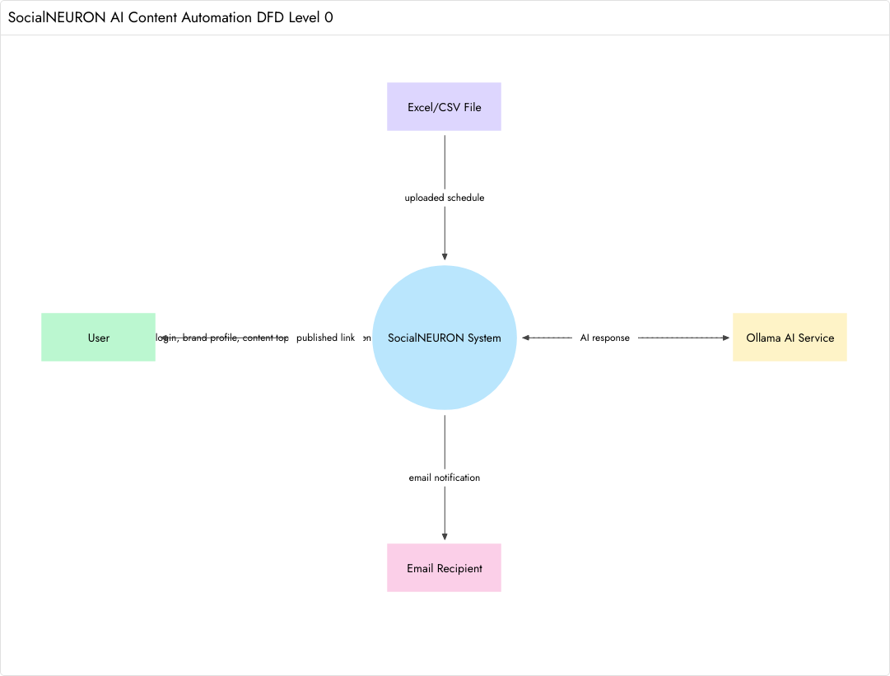
[Figure 3.1: 0th Level Data Flow Diagram]

1st Level DFD

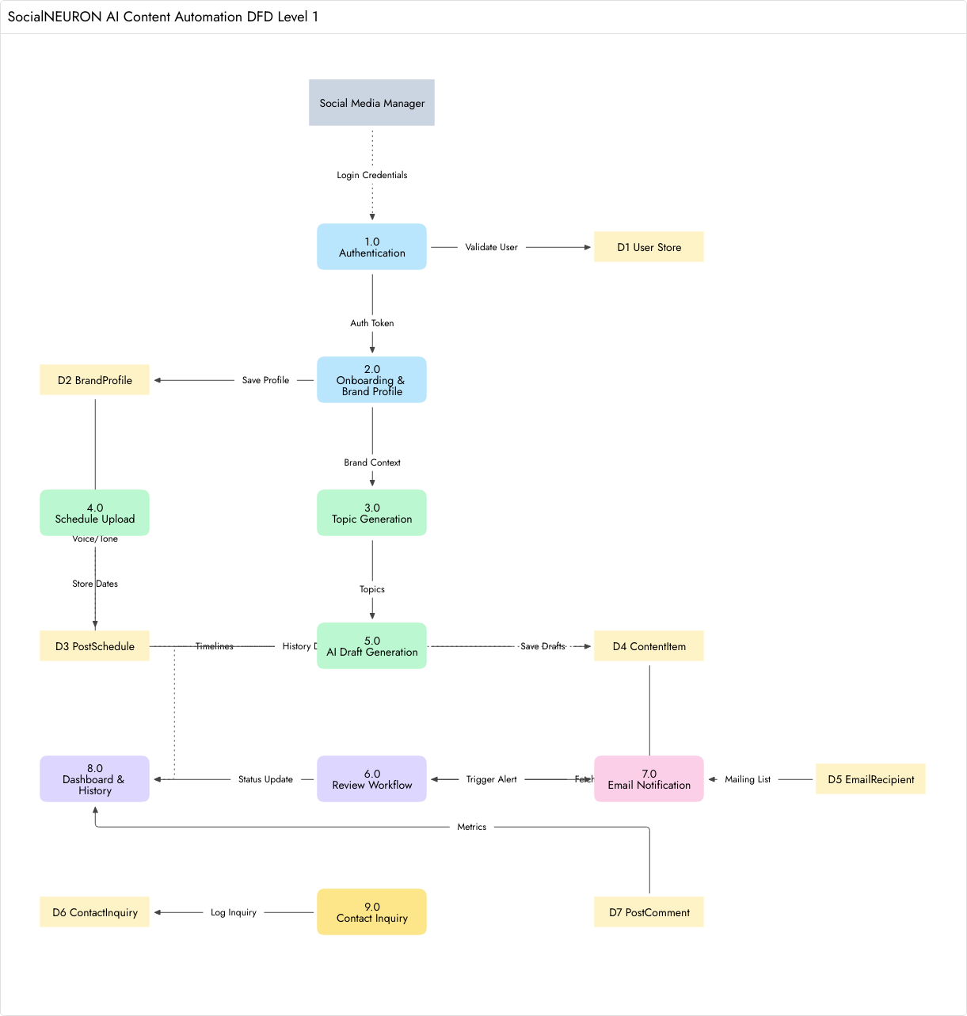
[Figure 3.2: 1st Level Data Flow Diagram]

2nd Level DFD: Review Workflow

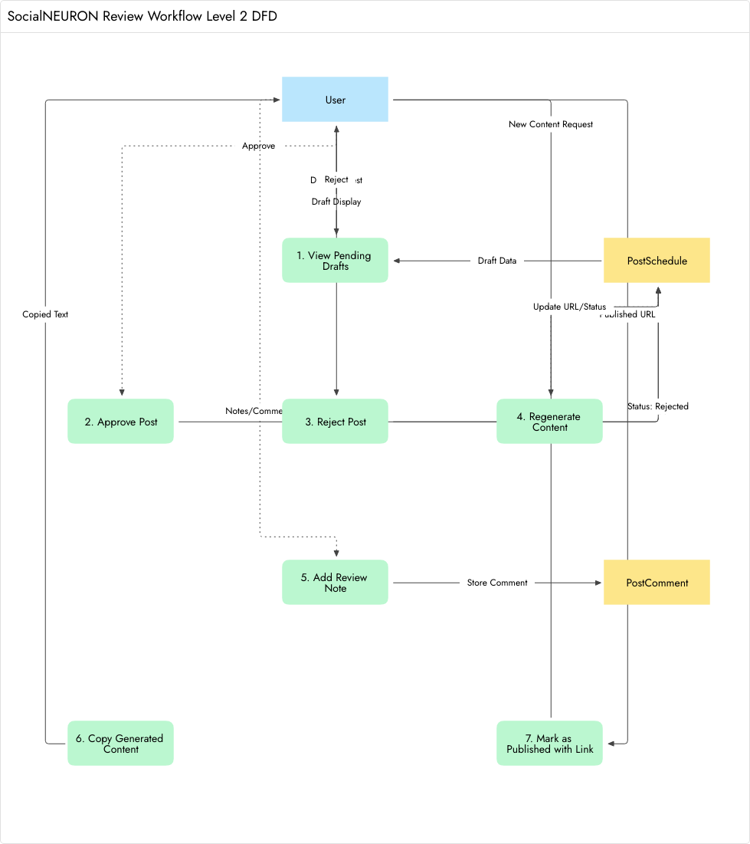
[Figure 3.3: 2nd Level Data Flow Diagram — Review Workflow]

3.3 ER Diagram

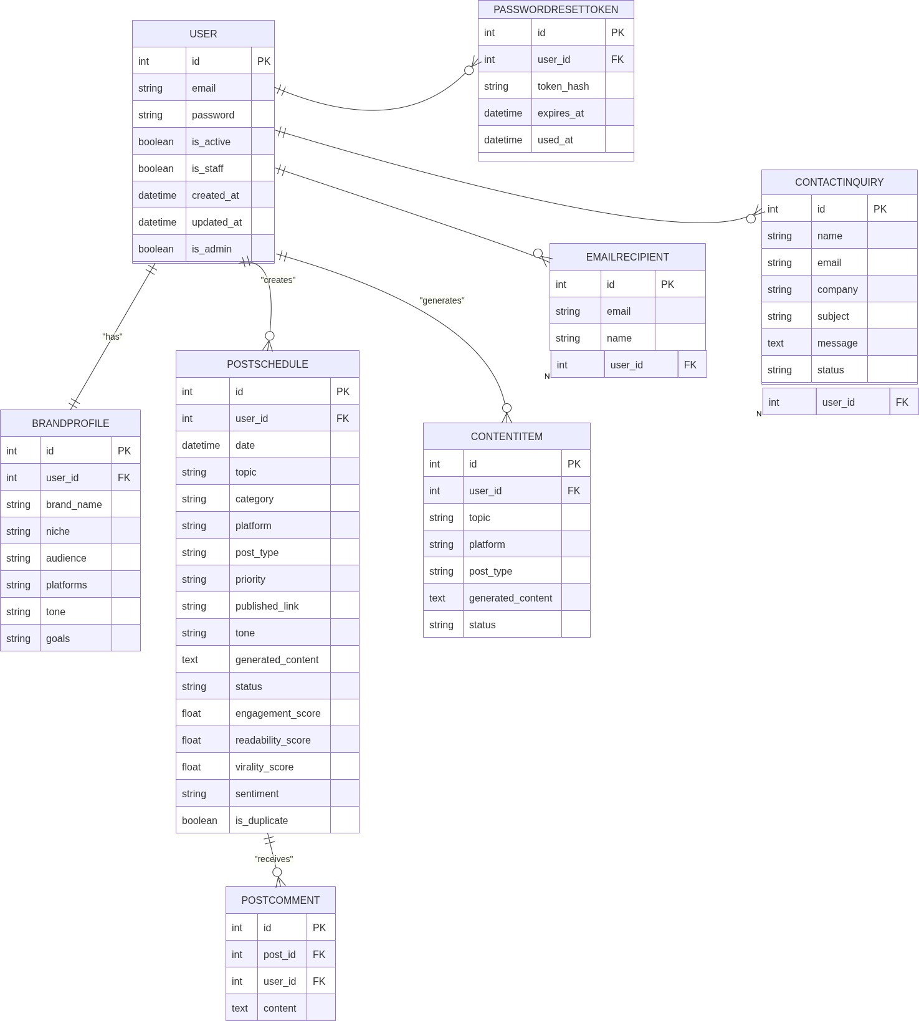
[Figure 3.4: Entity Relationship Diagram]

3.4 Use Case Diagram

[Figure 3.5: Use Case Diagram]
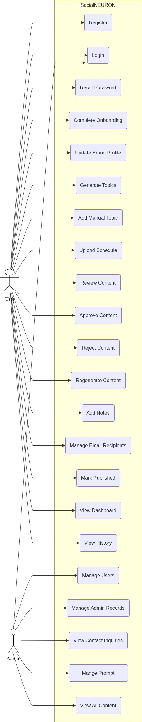

3.5 Activity Diagram
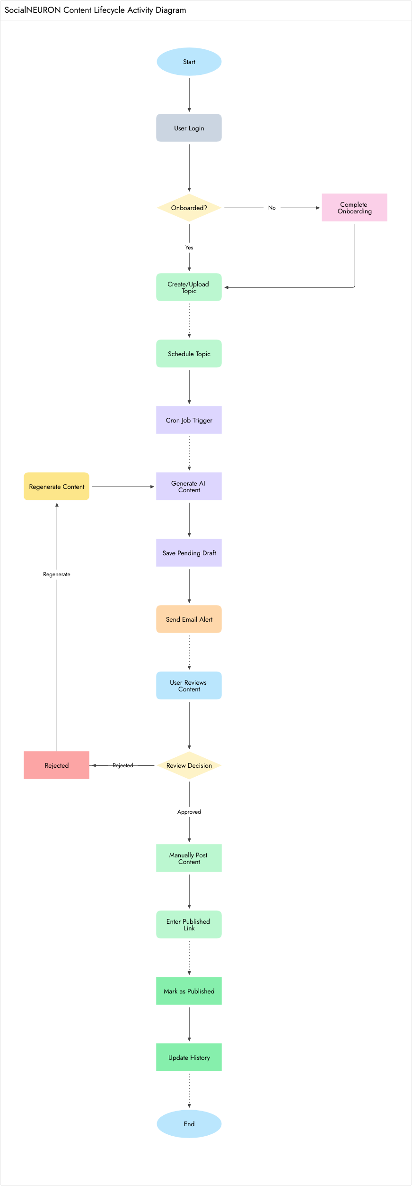
[Figure 3.6: Activity Diagram]

3.6 Sequence Diagrams

User Registration & Onboarding

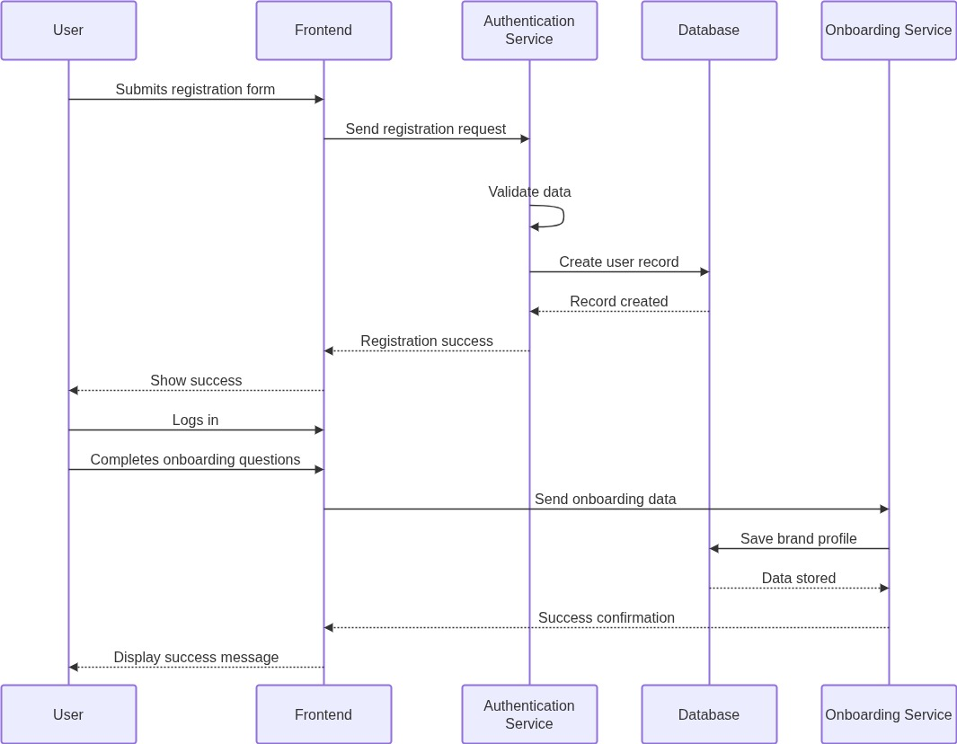
[Figure 3.4: User Registration & Onboarding]

Content Generation
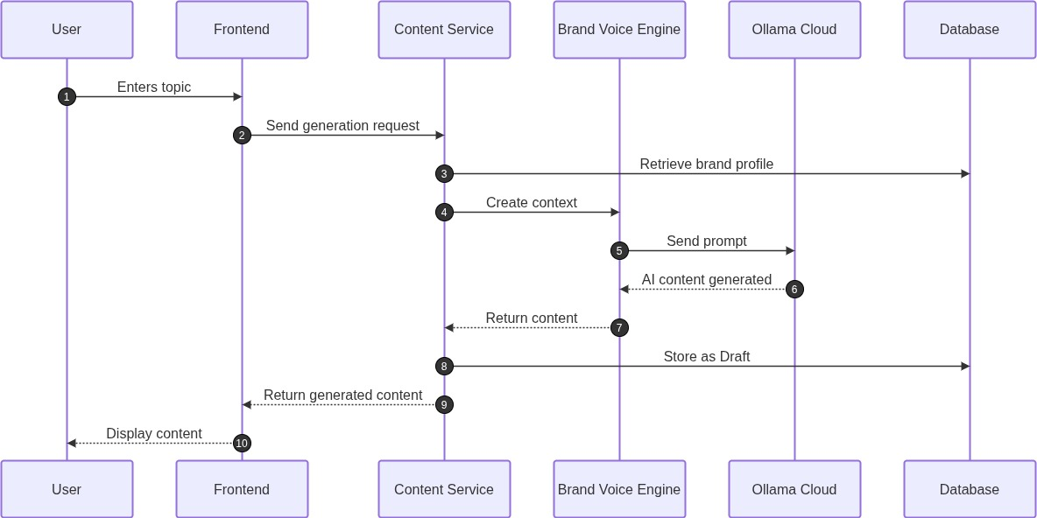

[Figure 3.4: Content Generation]

Content Approval & Regeneration
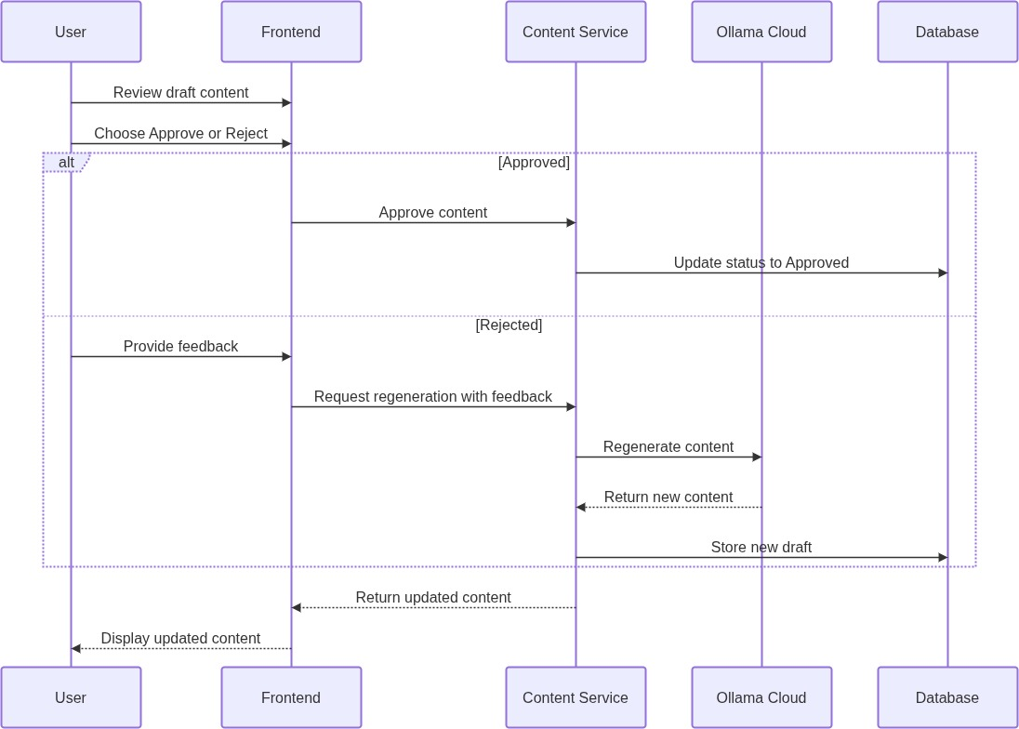

[Figure 3.5: Content Approval & Regeneration]

Schedule & Email Notification
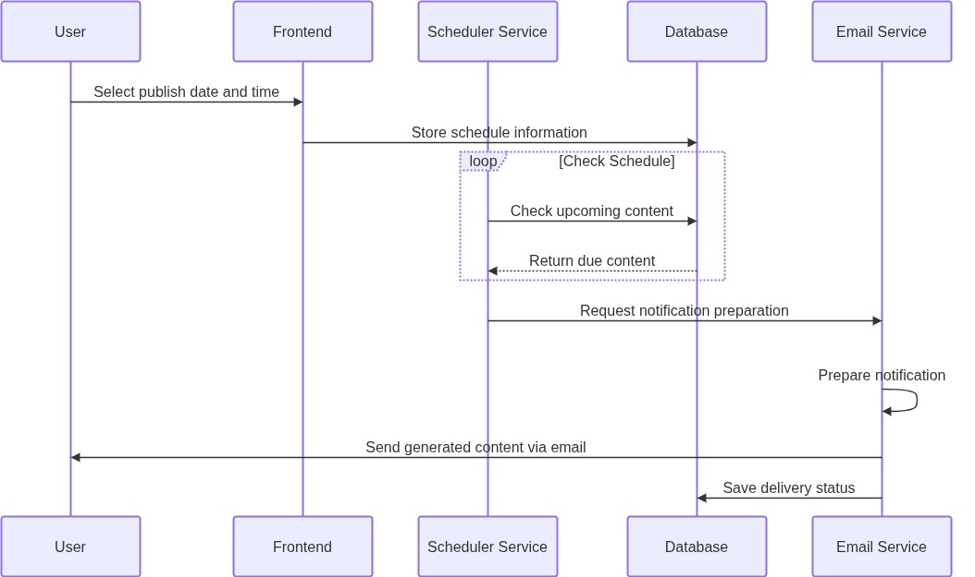

[Figure 3.5: Schedule & Email Notification]

3.7 Conclusion
The logical design shows that SocialNEURON follows a modular workflow. Data flows from user input to schedule records, then to AI-generated drafts, review decisions, email notifications, and final publication history.

Chapter 4: Physical Design

4.1 Introduction
Physical design describes how the logical design is implemented using database tables, Django models, templates, services, views, and background task functions.

4.2 Database Design (Normalized)
Table / Model | Purpose | Important Fields
User | Stores authentication identity. | email, password, is_active, is_staff, is_admin
BrandProfile | Stores onboarding and brand voice information. | brand_name, niche, audience, platforms, tone, goals
PasswordResetToken | Stores password reset tokens securely. | user, token_hash, expires_at, used_at
PostSchedule | Stores scheduled topics and content status. | date, topic, platform, post_type, generated_content, status
ContentItem | Stores generated draft items for approval workflow. | topic, platform, post_type, generated_content, status
PostComment | Stores review notes on scheduled posts. | post, user, content, created_at
EmailRecipient | Stores configured email recipients for alerts. | email, name, is_active
ContactInquiry | Stores home page contact form submissions. | name, email, company, subject, message, status
PlatformIntegration | Stores optional integration configuration. | platform, webhook_url, setup_email, is_active

Normalization
The database design separates users, brand profiles, scheduled posts, generated content, comments, and email recipients into separate models. This reduces duplication and supports maintainability. User-related records are linked through foreign keys or one-to-one relations. Contact inquiries and email recipients are independent operational records.

4.3 Module Design
Module | Key Files / Components | Description
Authentication | auth/auth_service.py, users/models.py, login/reset templates | User creation, login, password reset, password change.
Onboarding | users/onboarding.py, onboarding template, settings page | Brand profile creation and update.
Topic Generator | core/views.py, content_generation.py, topic_generator.html | Generates topic ideas based on query, tone, audience, platform, and type.
Schedule Upload | schedule_import.py, upload.html | Imports Excel or CSV schedule into PostSchedule.
AI Draft Workflow | core/tasks.py, content_generation.py | Generates content and scoring for due scheduled posts.
Review Center | review_dashboard.html, post_detail.html | Approve, reject, regenerate, comment, and publish verification.
Email Integration | email_integration.html, approval_service.py | Manages recipients and sends review alerts.
Dashboard | dashboard.html, dashboard_settings.html | Displays metrics and settings.
Contact | home.html, ContactInquiry model | Stores public inquiry submissions.

4.4 Input / Output Design
Input | Source | Output
Email and password | Signup / Login forms | User account and session
Brand profile | Onboarding / Settings | Brand voice context
Topic query, platform, post type | Topic Generator | AI topic suggestions
Excel / CSV file | Upload page | Scheduled draft topics
Review action (approve/reject) | Review Center | Status change (approved, rejected, or published)
Email recipient list | Email Integration page | Notification routing list
Contact details | Home page | Contact inquiry record

4.5 Conclusion
The physical design maps the logical workflow to Django models, templates, services, and views. It supports modular growth and separates business logic from presentation wherever practical.

Chapter 5: Implementation

5.1 Introduction
The implementation is carried out using Django. The project contains a main Django project package, application modules, templates, migrations, services, and supporting scripts. The implementation emphasizes readable workflows, secure user handling, and practical integration with AI and email services.

5.2 Process Description

User Authentication Process
Users can sign up with email and password. Passwords are hashed using Django password hashers. Users can login, logout, request a reset link, reset password through token, and change password from the dedicated settings page.

Onboarding and Brand Profile Process
After signup, users enter brand name, niche, target audience, preferred platforms, writing tone, and content goals. This data is used to build a reusable brand voice payload for AI prompts.

Topic Generation Process
The topic generator accepts query, tone, audience, platform, content type, and number of topics. The server calls the content generation service, which prepares a prompt for Ollama and parses returned lines into topic objects. The results are displayed with score, virality, tone, audience, platform, and content type information.

Schedule Upload Process
Users can upload Excel or CSV files containing columns such as date, topic, tone, audience, platform, priority, and post_type. The import service reads the file and creates scheduled draft records.

AI Draft Generation Process
The cron workflow checks today's and tomorrow's draft records. If a draft does not already contain generated content, the system generates content using AI, assigns scores, changes status to pending, saves a content item, and sends email notifications to active recipients.

Review and Publishing Process
Users review pending drafts, approve or reject them, regenerate content, add comments, and mark approved content as published by entering a live URL. Published posts appear in the history page.

5.3 Output and Reports
The application produces the following outputs:
- Dashboard statistics for total, draft, pending, approved, rejected, and published content.
- AI-generated topic ideas.
- AI-generated social media content drafts.
- Email notifications for review-ready content.
- Published history with platform, tone, score, and link information.
- Contact inquiry records for public visitors.

Screenshots

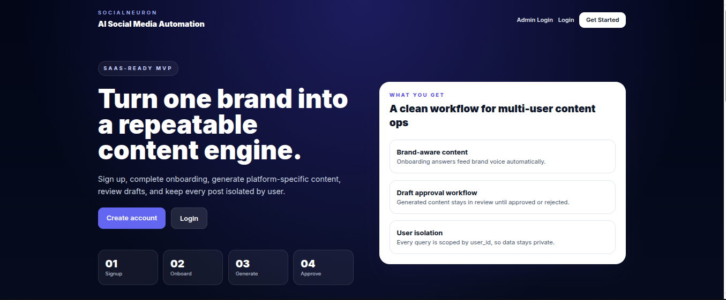
[Figure 5.1: Home Page]

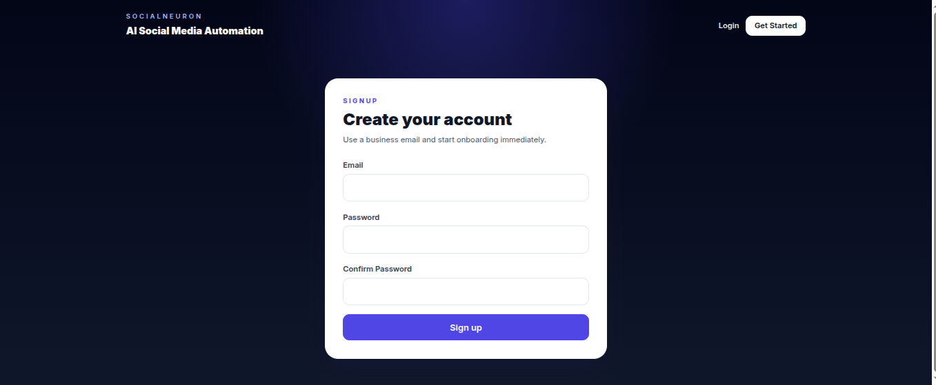
[Figure 5.2: Sign Up]

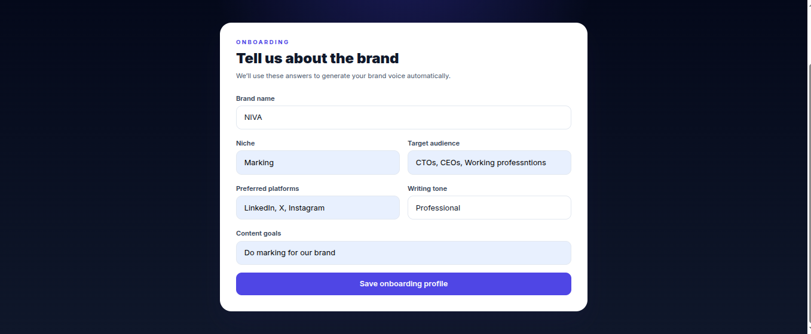

[Figure 5.3: Onboarding]

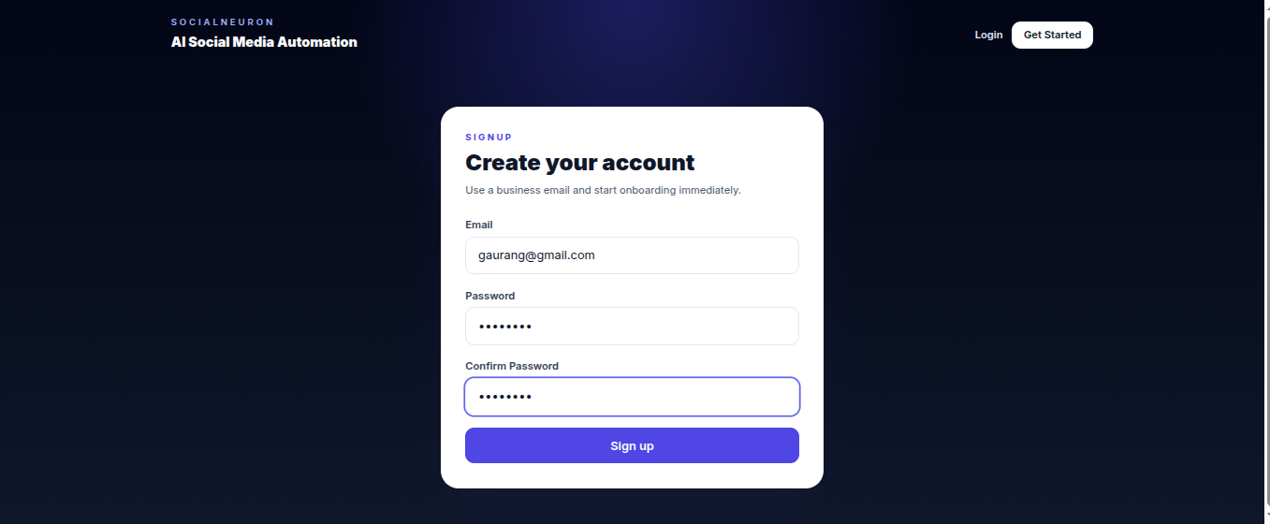
[Figure 5.4: Login]

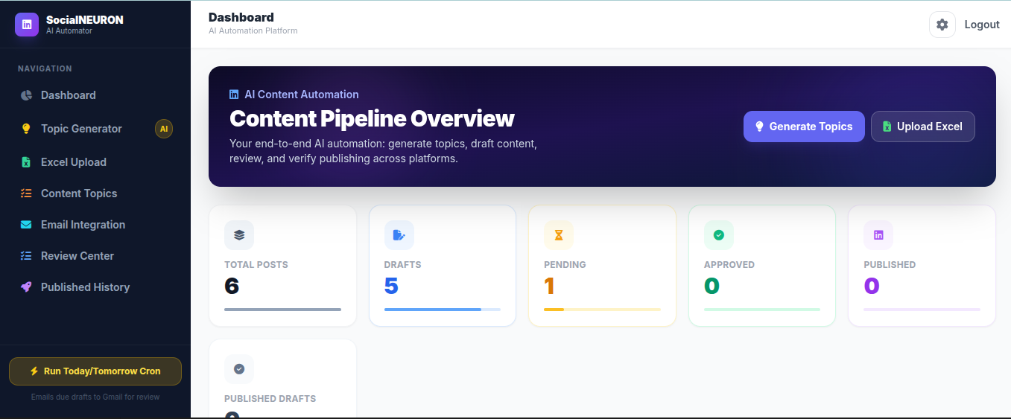

[Figure 5.5: Dashboard]

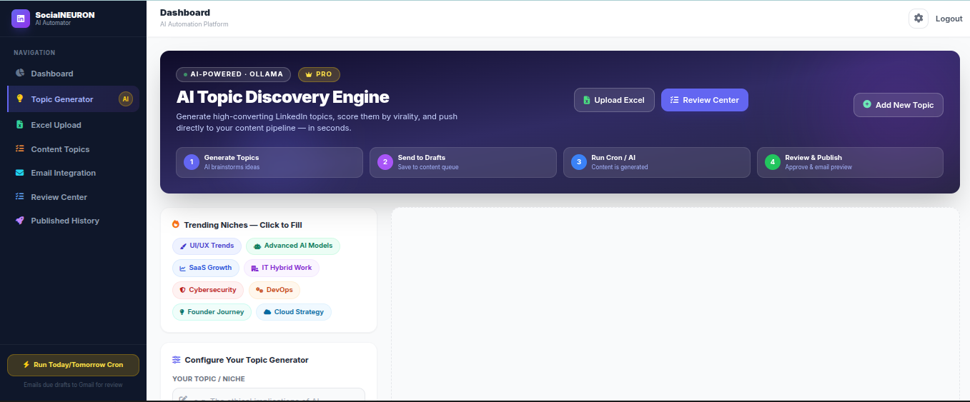

[Figure 5.6: Topic Generator]

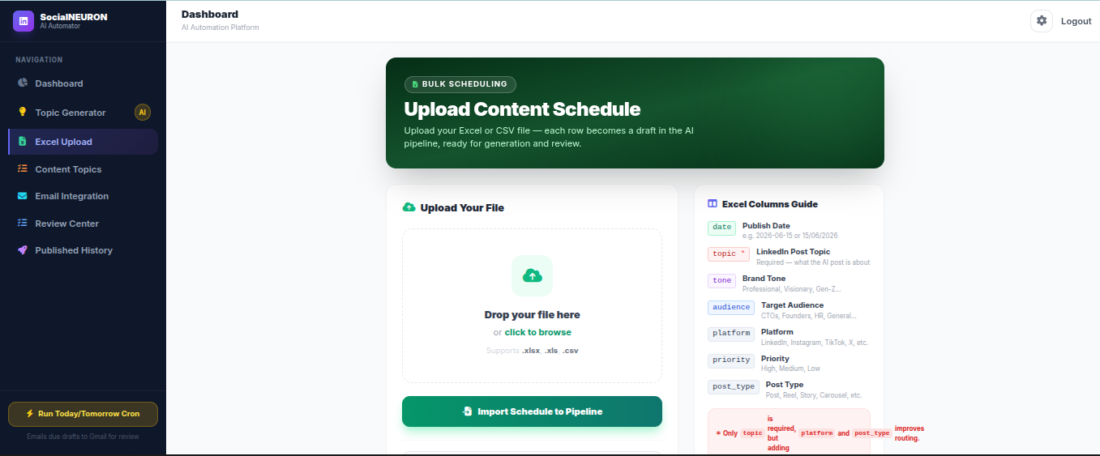

[Figure 5.7: Upload Content Schedule]

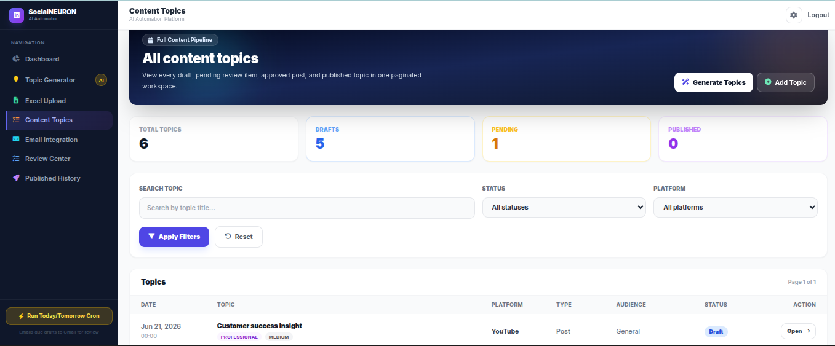

[Figure 5.8: Content Topics]

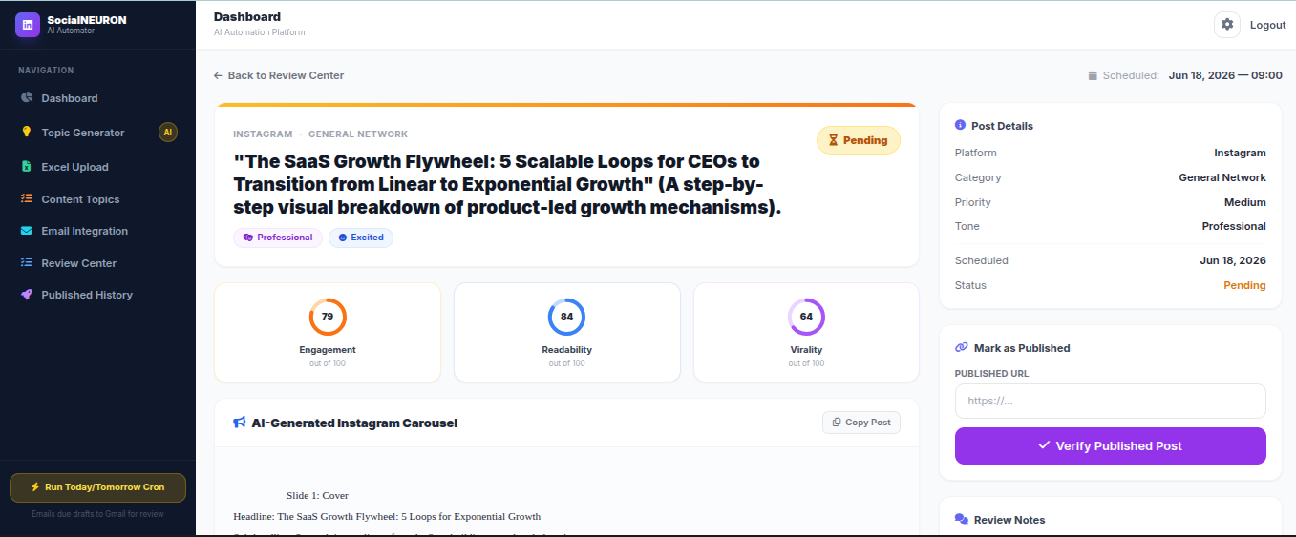

[Figure 5.9: Generated Post]

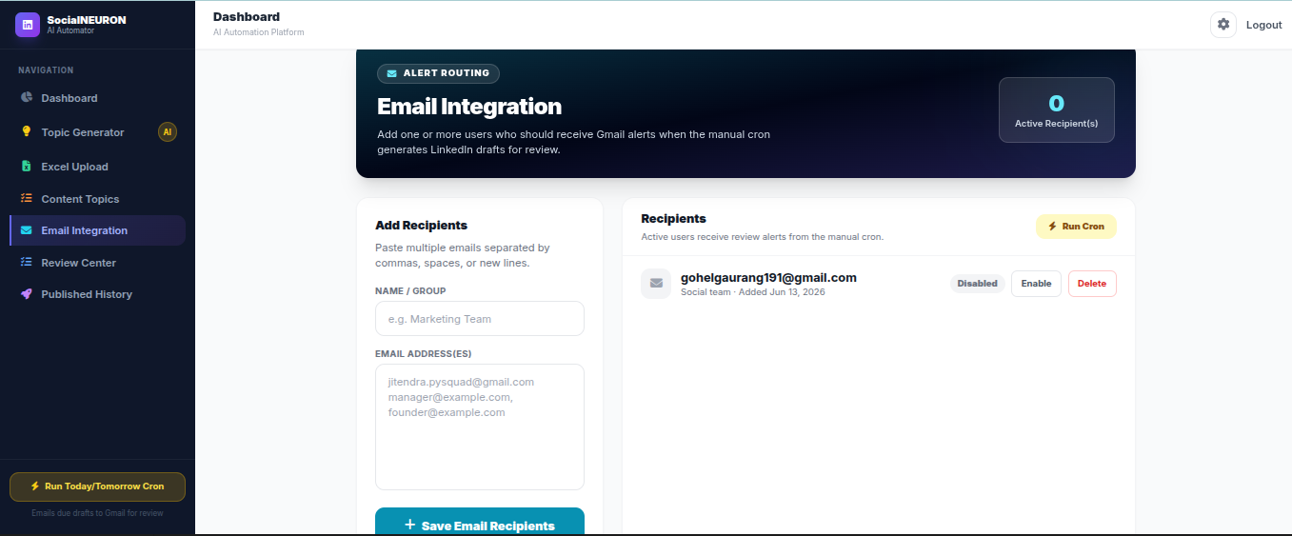

[Figure 5.10: Email Integration]

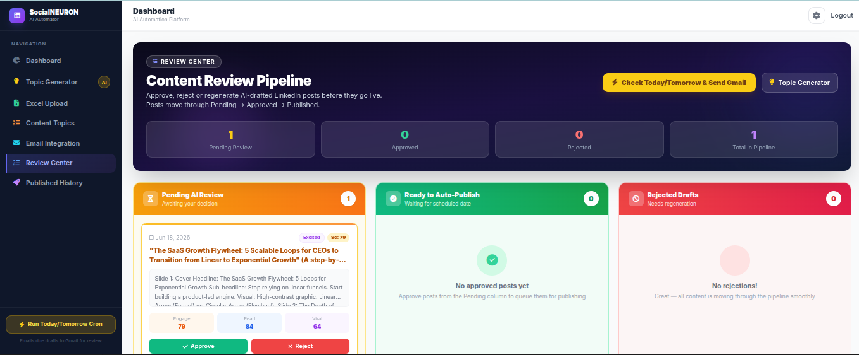

[Figure 5.11: Content Review Center]

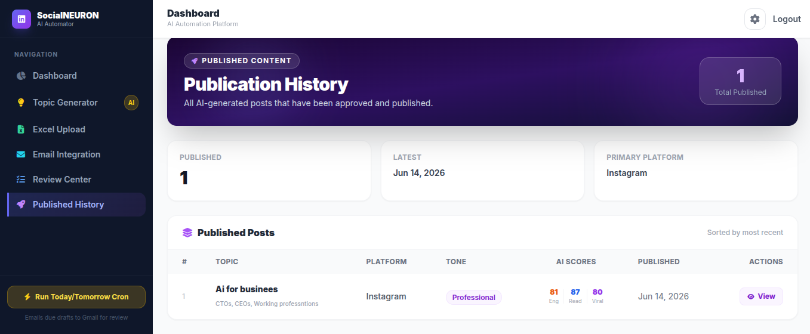
[Figure 5.12: Published History]

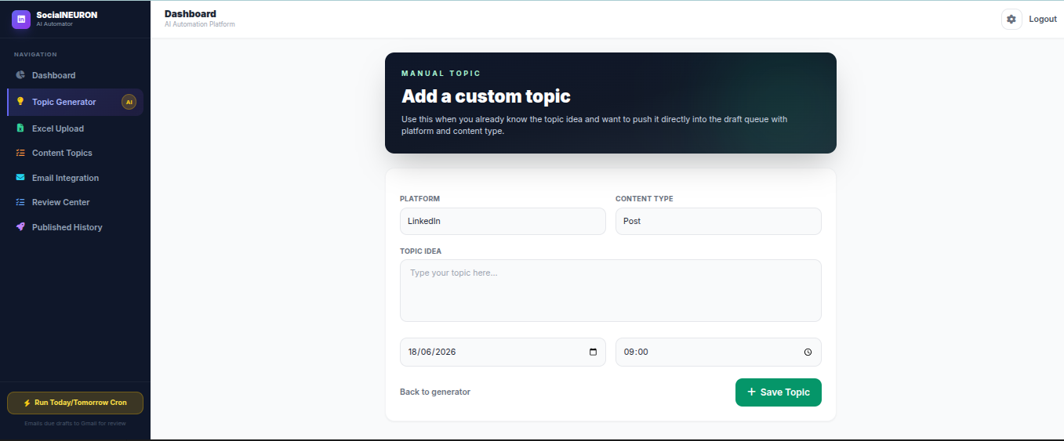
[Figure 5.13: Custom Topic]

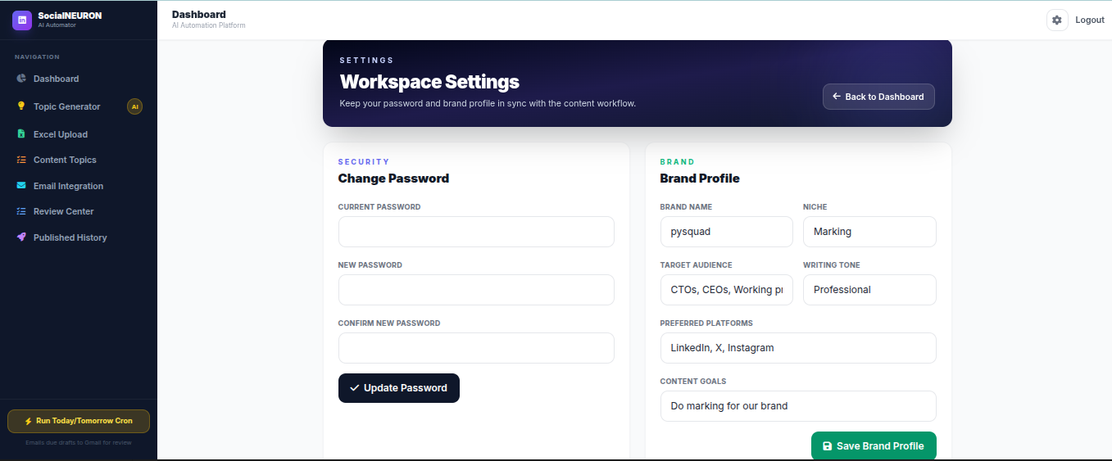

[Figure 5.14: Workspace Settings]

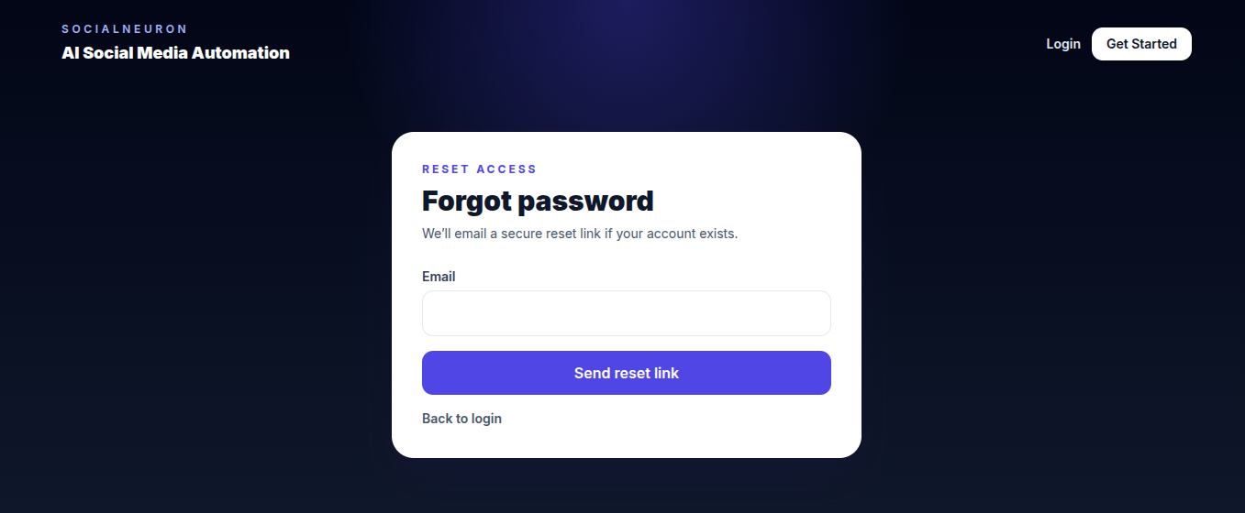

[Figure 5.15: Forgot Password]

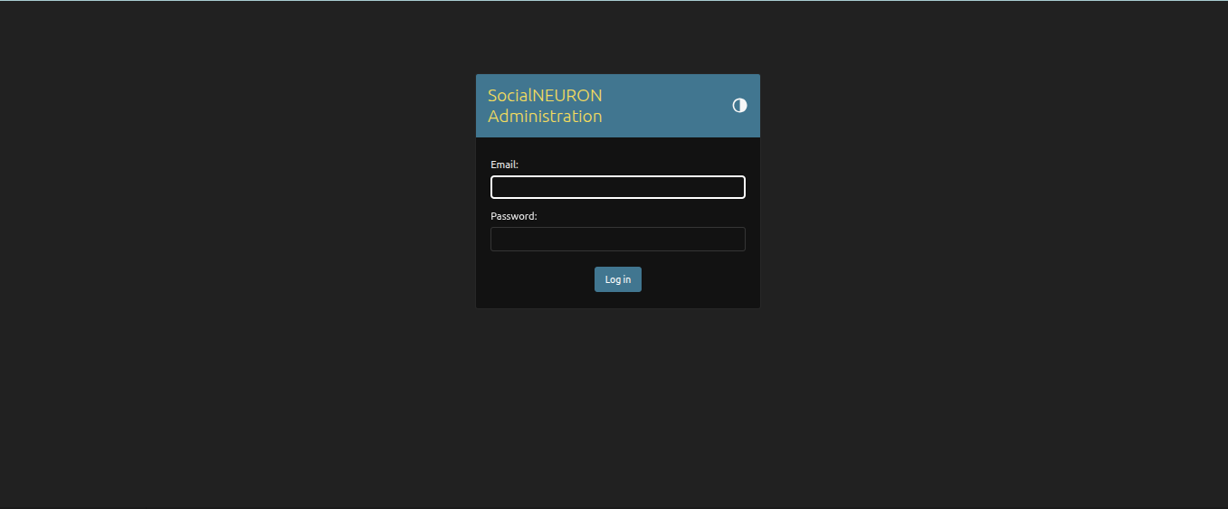
[Figure 5.16: Admin Login ]
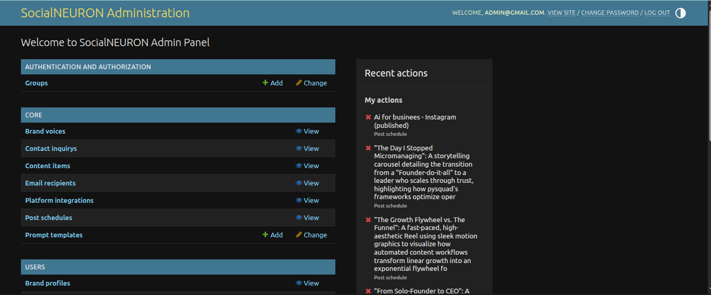

[Figure 5.17: Admin Dashboard ]

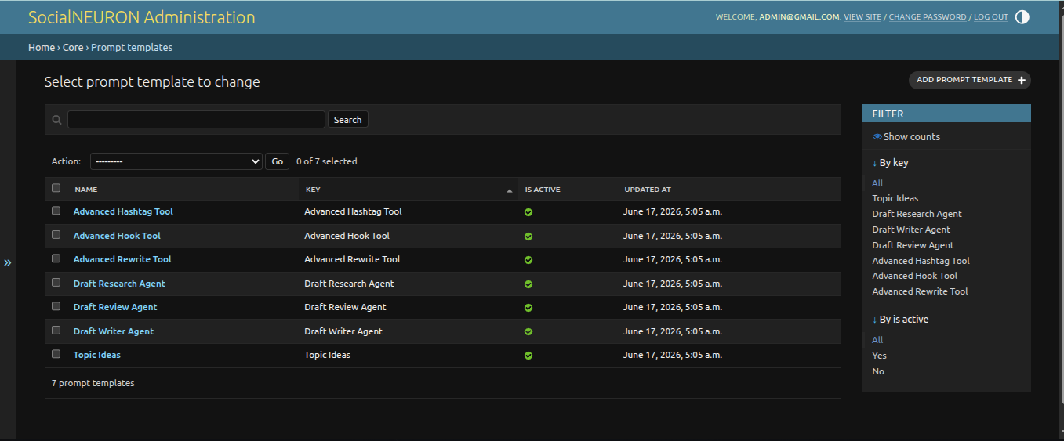
[Figure 5.18: Mange Prompt Templates]

5.4 Conclusion
The implementation successfully creates a functional end-to-end content automation workflow. It integrates user management, AI generation, review controls, file import, email notifications, and public contact handling into a single Django application.

Chapter 6: Testing

6.1 Introduction
Testing verifies that the system works according to the requirements. The project was tested through module-level testing, integration testing, user interface testing, form validation testing, and workflow testing.

6.2 Types of Testing Performed

Unit Testing
Individual functions such as password validation, schedule parsing, topic generation parsing, and contact submission handling can be tested independently to verify correctness of each unit in isolation.

Integration Testing
Integration testing checks whether modules work together. Examples include signup to onboarding flow, topic generation to draft saving, schedule upload to AI generation, and review approval to published history.

System Testing
The complete system is tested as a web application by navigating through all major workflows from login to content publication.

Validation Testing
Form validation checks required fields in contact inquiry, login, signup, reset password, topic creation, schedule upload, and published link entry.

Regression Testing
Regression testing verifies that updates such as contact form, settings page, email recipient deletion, topic platform selection, and score ring fixes do not break older workflows.

Test Cases
Test ID | Scenario | Expected Result | Status
TC-01 | User signs up with valid email and password. | Account created and redirected to onboarding. | Pass
TC-02 | User enters mismatched signup passwords. | Error message is displayed. | Pass
TC-03 | User updates brand profile from settings page. | Brand profile is updated. | Pass
TC-04 | User generates topics for Instagram Reel. | Results show selected platform and content type. | Pass
TC-05 | User uploads Excel schedule. | Rows are added as draft scheduled topics. | Pass
TC-06 | User runs cron for due draft. | AI content is generated and status becomes pending. | Pass
TC-07 | User runs cron again for already generated content. | Content is not regenerated unnecessarily. | Pass
TC-08 | User adds note on post detail. | Comment is saved and displayed. | Pass
TC-09 | User adds email recipient. | Recipient appears in email integration list. | Pass
TC-10 | User deletes email recipient. | Recipient is removed. | Pass
TC-11 | Visitor submits contact inquiry. | Inquiry is saved and success message displayed. | Pass
TC-12 | User marks post as published without URL. | Error message is displayed. | Pass

6.3 Conclusion
Testing confirms that the core modules of the SocialNEURON system meet the defined requirements. The application handles common workflows such as authentication, onboarding, topic generation, schedule upload, AI draft generation, review, email alerts, and contact inquiry submission.

REFERENCES

- Dr. Babasaheb Ambedkar Open University, MCA-401 Software Development Project Guidelines. Available at: https://baou.edu.in/assets/pdf/MCA-401.pdf
- Django Software Foundation, Django Documentation. Available at: https://docs.djangoproject.com/
- Celery Documentation. Available at: https://docs.celeryq.dev/
- Pandas Documentation. Available at: https://pandas.pydata.org/docs/
- HTMX Documentation. Available at: https://htmx.org/docs/
- Ollama Documentation. Available at: https://ollama.com/

EXTENDED PROJECT DOCUMENTATION
The following pages are added to strengthen the MCA-401 report length and depth while preserving the original report content, website screenshots, and diagram images.
E.1 Extended Project Documentation: Purpose and Guide Alignment
This extended documentation section is added to support the MCA-401 project report requirements without changing the previously prepared report pages, screenshots, diagrams, and certificates. The additional pages explain the SocialNEURON system in greater depth from a software engineering perspective. The focus remains on the actual project, its planning, requirements, design, implementation, testing, and maintenance rather than generic theory.
The BAOU MCA-401 guide expects a well documented software project containing project proposal material, originality certificate, structured chapters, numbered figures and tables, implementation details, and testing explanation. SocialNEURON is suitable for this format because it is a practical web application that solves a real workflow problem for businesses and creators: planning, generating, reviewing, and verifying social media content across platforms.
The following pages may be treated as supplementary chapter material. They can be placed after the main chapters or before the appendix, depending on the final editing preference. They are intentionally written in report language and use project-specific examples such as Django models, prompt templates, review workflow, Excel upload, email notifications, and publication verification.

E.2 Detailed Project Planning and Milestones
The project was planned as an iterative software development activity. Instead of attempting to build every feature at once, the work was divided into practical milestones that could be designed, implemented, and tested independently. This approach reduced risk because authentication, onboarding, topic generation, draft generation, review workflow, and dashboard reporting could each be verified before moving to the next stage.
The first milestone covered project setup, Django app structure, database models, custom user authentication, login, signup, forgot password, and change password. The second milestone focused on brand profile onboarding so that each user could provide niche, audience, tone, platform preferences, and content goals. The third milestone added topic generation and manual topic creation. The fourth milestone added Excel upload for bulk scheduling. The fifth milestone connected AI generation, review, approval, rejection, comments, and published link verification.
Later milestones improved SaaS readiness by adding dashboard settings, email recipients, contact inquiry storage, prompt management through admin controls, pagination for all content topics, and view-only operational data in Django admin. This milestone-based plan made the project easier to test and document.

E.3 Stakeholder and User Persona Analysis
The primary stakeholders of SocialNEURON are small business owners, startup founders, marketing executives, freelancers, content creators, and agencies that manage regular social media content. These users may not always have a dedicated content team, but they still need consistent posts, platform-specific ideas, and a review workflow before publication.
A founder persona uses the system to generate thought leadership ideas, schedule posts for the coming week, review generated drafts, and manually mark published posts with a link. A marketing executive persona uses Excel upload to plan many topics for a month, checks pending drafts from the review center, and sends content alerts to team email recipients. An agency persona may use the brand profile and prompt settings to maintain a specific voice and content style for a client.
The admin stakeholder manages users, prompt templates, and high-level operational visibility. In an MVP SaaS product, admin access should not casually edit customer content because user-owned records must remain trustworthy. Therefore, operational data is made view-only in admin while prompts and users remain manageable.

E.4 Feasibility Study
Technical feasibility is strong because the system uses Python and Django, which are mature technologies for secure web application development. SQLite is sufficient for development and demonstration, while the Django ORM allows migration to PostgreSQL or MySQL for production. Celery and Redis support background generation, and the Ollama API allows AI content generation during local or private deployment.
Operational feasibility is also strong because the application maps to a real content workflow. Users already plan topics, generate content, review drafts, and publish manually across multiple platforms. SocialNEURON reduces scattered work by collecting these steps into one dashboard. Manual publication verification is appropriate for an MVP because not every platform supports easy automatic posting through public APIs, and platform policies can change.
Economic feasibility is practical because the project uses open-source components such as Django, Tailwind CSS, HTMX, Pandas, OpenPyXL, Celery, Redis, and Ollama. For academic and MVP usage, the development cost remains low while still demonstrating real software design, database handling, workflow automation, and AI integration.

E.5 Detailed Software Requirement Specification Overview
The Software Requirement Specification for SocialNEURON defines the functions, data requirements, interface requirements, and quality attributes of the system. The system must allow users to register, log in, complete onboarding, manage brand profile, generate topic ideas, add manual topics, upload Excel schedules, generate AI drafts, review content, approve or reject drafts, add notes, and mark approved content as published.
The system must store all user-specific data with proper ownership. Content topics created by one user should not be visible to another user. The dashboard, content topics page, review center, history page, and post detail page all filter by the current logged-in user. This requirement is important for SaaS readiness because customer data separation is a core expectation in multi-user products.
The system must also allow staff/admin users to manage prompt templates and user account roles. Prompt templates should be editable from the dashboard by staff users, but generation should not fail if a database prompt is missing or inactive. Safe fallback prompts maintain application reliability.

E.6 Functional Requirements Matrix
Table E.1: Functional Requirements Matrix. FR-01: The visitor can create an account using email and password. FR-02: The registered user can log in and log out securely. FR-03: The user can reset forgotten password through email token flow. FR-04: The user can change password from dashboard settings. FR-05: The user can create and update brand profile details.
FR-06: The user can generate AI topic ideas by selecting query, tone, audience, platform, content type, and number of topics. FR-07: The user can save any generated topic into the draft schedule with selected date and time. FR-08: The user can manually add a new topic idea. FR-09: The user can upload Excel or CSV schedules containing platform, post type, date, topic, tone, and priority.
FR-10: The system can generate AI draft content for due topics. FR-11: The user can approve, reject, regenerate, comment, and mark posts as published. FR-12: The system can send content-ready emails to active recipients. FR-13: The admin can manage prompt templates and users. FR-14: The public visitor can submit a contact inquiry.

E.7 Non-Functional Requirements Matrix
Table E.2: Non-Functional Requirements Matrix. Security: passwords must be hashed, forms must use CSRF protection, and records must be scoped by logged-in user. Reliability: generation should not unnecessarily regenerate already generated drafts for today or tomorrow. Usability: pages should use production-style cards, clear calls to action, and readable status badges.
Maintainability: code should be organized into Django apps, models, services, tasks, templates, and migrations. Extensibility: prompt templates should be database managed so future prompt changes do not require code deployment. Performance: paginated content topic listing should be used for monthly schedules instead of loading all records on one page.
Auditability: content status, published link, comments, and timestamps should make the content lifecycle understandable. Portability: the system should run in a local development environment and be deployable to a Linux server or cloud platform after configuring database, Redis, email, environment variables, and AI provider.

E.8 Requirement Gathering and Analysis Method
Requirements were gathered by studying common social media planning workflows. Many users plan posts in spreadsheets, generate ideas in separate AI tools, send drafts by email or chat, and then manually publish on social platforms. These disconnected steps cause duplication and make it difficult to know which content is drafted, pending, approved, published, or rejected.
The project requirements were also refined by examining the actual application flow during development. When topic generation supported multiple platforms, it became necessary to store platform and content type in every scheduled draft. When generated topics were saved directly for today, the workflow was improved by allowing selection of posting date and time. When the review center became too narrow for monthly planning, a paginated content topics page was added.
This shows that requirement analysis was not a one-time activity. It continued throughout implementation, which is realistic for a SaaS-style product. User feedback and observed workflow gaps directly influenced the system design.

E.9 Detailed Problems in the Existing Manual System
The existing manual system usually depends on spreadsheets, copied AI output, messaging applications, and separate platform dashboards. This creates several problems. First, there is no single source of truth for content status. A topic may be planned in Excel, rewritten in an AI tool, discussed in chat, and finally published on a social platform, but no central record tracks the entire lifecycle.
Second, brand voice is inconsistent because the AI tool may not know the business niche, target audience, writing tone, and content goals for every generation. Third, content can be missed because posting dates and review status are not clearly connected. Fourth, it is difficult to verify publication after approval when multiple platforms are involved.
Fifth, a growing monthly calendar becomes hard to manage on one page. The SocialNEURON content topics page solves this by allowing filtering, searching, and pagination. The review center remains focused only on items that need approval, while the content topics page becomes the operational calendar.

E.10 Detailed Proposed System Workflow
The proposed SocialNEURON workflow starts when a user creates an account and completes onboarding. The brand profile captures important context such as brand name, niche, target audience, preferred platforms, writing tone, and content goals. This information is converted into brand voice context for prompt generation.
The user can then generate topic ideas from the topic generator. The selected platform and content type are passed into the AI prompt so that topics are not generic. A topic can be saved into drafts with a selected date and time. The user may also add a manual topic or upload a schedule file. All these paths create PostSchedule records for the logged-in user.
When the cron flow runs, due draft records for today and tomorrow are checked. If content has not already been generated, the system creates AI content, stores scores, marks the item pending, and can send email alerts. The user reviews the draft, approves or rejects it, optionally regenerates it, adds notes, publishes manually, and enters a live link for verification.

E.11 Application Architecture Narrative
The SocialNEURON architecture follows a layered web application design. The browser layer contains Django templates styled with Tailwind CSS and enhanced with HTMX and JavaScript where needed. The view layer receives requests, validates user session, reads form data, calls services, and returns templates or redirects. The service layer contains reusable business logic such as content generation, prompt rendering, file import, authentication helpers, and approval notifications.
The model layer stores persistent information in relational tables. Important models include User, BrandProfile, PostSchedule, ContentItem, PostComment, EmailRecipient, ContactInquiry, BrandVoice, PlatformIntegration, and PromptTemplate. The AI integration layer connects to Ollama through an API client. The background task layer uses Celery-style task functions for draft generation.
This architecture improves maintainability because templates are not responsible for generation logic, models are not responsible for HTTP behavior, and AI prompts are centralized through prompt templates. Such separation supports future improvements like API publishing, subscriptions, team roles, and advanced analytics.

E.12 Authentication and Access Control Design
Authentication is implemented around a custom email-based user model. Users sign up with email and password, and passwords are stored using Django password hashing instead of plain text. Login validates the user and stores session information. Logout clears the session. Forgot password uses a reset token flow with expiry, and dashboard settings allow password changes after validating the old password.
Access control is implemented at the view level by checking the current session user. Sensitive pages such as dashboard, topic generator, content topics, review center, post detail, upload, email integration, and history require a signed-in user. Querysets are filtered by user_id so that a user can only view and act on their own records.
Admin-level actions are separated from normal user workflow. Prompt management requires staff status. Operational records in Django admin are view-only to reduce accidental changes to customer-owned data. This distinction makes the MVP closer to a real SaaS product.

E.13 Brand Profile and Prompt Context Design
The brand profile is an important part of SocialNEURON because AI content quality depends heavily on context. During onboarding or dashboard settings, the user provides brand name, niche, audience, platform preferences, tone, and goals. These values are not only displayed to the user but also converted into structured brand voice context for generation prompts.
Prompt context includes voice summary, writing style, tone rules, and content rules. When topic ideas are generated, the prompt receives query, audience, tone, selected platform, selected post type, niche, goals, and brand voice. When a draft is generated, the writer and review prompts receive topic, category, platform, post type, tone, research data, and voice context.
This design is better than hardcoding one prompt for every user. Different brands can have different audiences and tones. The admin-managed prompt template feature also allows improvement of prompt wording without editing source code, which is useful for production SaaS operations.

E.14 Topic Generation Module Design
The topic generation module allows a user to enter a topic or niche and select tone, audience, platform, content type, and number of topics. The selected values are sent to the server through the topic generator form. The server builds a prompt using the active PromptTemplate for topic_ideas or a safe fallback prompt if the database template is not active.
The AI response is parsed line by line. Each valid line becomes a topic suggestion with a generated score, virality label, tone, and audience. The result page shows cards with score rings, topic title, virality, tone, audience, selected platform, selected post type, date, and time inputs. When the user clicks Send to Drafts, the form sends title, tone, audience, platform, post type, scheduled date, and scheduled time.
This module supports multi-platform planning. It avoids the earlier limitation where generated topics were saved with LinkedIn as the default platform even when the user selected another platform.

E.15 Excel Upload and Schedule Import Design
The Excel upload module supports bulk planning for users who prefer preparing a monthly calendar in spreadsheet format. The demo Excel file includes multiple platforms, content types, and dates starting from the current date. The import service reads the uploaded file and converts each valid row into a PostSchedule record for the logged-in user.
The expected columns include date, topic, tone, audience or category, platform, priority, and post_type. Pandas and OpenPyXL are used for reading Excel data. CSV support can also be handled for simpler text-based uploads. Uploaded files are stored temporarily and deleted after processing, reducing unnecessary storage usage.
Validation is important in this module because incorrect dates, missing topics, or unsupported columns can create confusing records. The current implementation reports upload errors through Django messages. Future enhancement can include a preview screen showing valid and invalid rows before committing records to the database.

E.16 AI Draft Generation Pipeline
The AI draft generation pipeline converts scheduled topics into review-ready draft content. The process begins by selecting due draft records for today and tomorrow. The system only generates content if the status is draft and generated_content is empty. This avoids repeated generation for the same item when cron is run multiple times.
The generation service uses a three-step prompt approach. The first prompt acts as a research agent and returns angles for the topic. The second prompt acts as a writer and creates the main draft using platform, content type, topic, category, tone, brand voice, and research context. The third prompt acts as a review agent and cleans up grammar, readability, markdown artifacts, and platform fit.
The final content is stored in PostSchedule.generated_content. Scores such as engagement, readability, and virality can be assigned to help the user evaluate quality. The item then becomes pending for review. This pipeline demonstrates service-layer design and AI integration.

E.17 Review and Approval Workflow Design
The review workflow is designed to prevent generated content from being treated as final automatically. After AI generation, the draft is placed in pending status. The review center displays pending, approved, and rejected groups so the user can make editorial decisions. The post detail page shows the generated content, platform, content type, category, tone, scores, comments, and available actions.
The user can approve a draft when it is suitable for publication. The user can reject it if the content is not acceptable. The user can regenerate content if a new AI attempt is needed. The user can also add notes, which creates PostComment records linked to the scheduled post. These comments preserve review context and make it easier to understand editorial decisions later.
This workflow reflects real content operations. AI assists with drafting, but human review remains part of the process. This is important because brand correctness, platform suitability, legal safety, and factual accuracy still require human judgment.

E.18 Publication Verification Workflow
Automatic posting is not included as the primary MVP workflow because the application supports multiple platforms, and each platform has different API rules, permissions, review requirements, rate limits, and policy changes. Instead, SocialNEURON uses a manual publication verification workflow. The user approves the content, posts it manually on the chosen platform, then pastes the live URL into the post detail page.
When a valid URL is submitted, the system stores it in published_link and changes the status to published. The published history page lists published records with their links. This approach is simple, reliable, and platform-independent. It also keeps the user responsible for final publication while allowing the system to maintain an audit trail.
For future production releases, the verification step can be improved by checking whether the URL domain matches the selected platform, using platform APIs where available, or adding a reviewer confirmation button. The current design is appropriate for an MVP and academic demonstration.

E.19 Email Notification Workflow
The email integration module allows content-ready notifications to be sent to configured recipients. A user can add one or more email addresses, enable or disable recipients, and delete recipients when no longer needed. Active recipients receive content review alerts when new draft content becomes ready.
The purpose of this module is to support team collaboration. In many real workflows, a founder, marketer, or client may want to receive generated drafts by email for review. Email integration prevents users from constantly checking the dashboard and gives a familiar notification channel.
The system uses Django email backend settings such as host, port, TLS, username, password, and default from email. For production, email credentials should be stored in environment variables. Bounce handling, per-user recipient lists, and branded email templates can be future improvements.

E.20 Dashboard and Reporting Design
The dashboard provides a summary of the content pipeline. It displays total posts, drafts, pending items, approved items, published items, upcoming schedule, and recent activity. The dashboard is not meant to show every monthly record because a large calendar would make the page too long and difficult to scan.
For that reason, the new Content Topics page acts as the full operational list. It includes pagination, search, platform filter, and status filter. This separation follows a SaaS design pattern: the dashboard gives a quick overview, while dedicated list pages handle detailed management.
The reporting design helps users answer common questions quickly. How many posts are still drafts? Which items are pending review? What is scheduled this week? Which content is already published? Where can I find all Instagram reels or all rejected content? These questions are supported by dashboard cards and filtered tables.

E.21 Database Normalization Explanation
The database design separates major concepts into different tables. User stores authentication identity. BrandProfile stores onboarding and brand voice details. PostSchedule stores planned topics, generated content, scores, status, date, platform, content type, and published link. PostComment stores notes separately so one post can have many comments.
ContentItem stores generated draft item records used by the approval service. EmailRecipient stores notification recipients independently. ContactInquiry stores public contact form submissions. PromptTemplate stores editable AI prompt templates by stable key. This separation reduces duplication and improves clarity.
The design is normalized because repeated values are not stored in large unstructured blobs when they need to be queried separately. For example, comments are not appended to the post text; they are separate records linked to PostSchedule. Brand profile is not duplicated on every post; it is linked to the user and used as generation context. This structure supports maintainability and future reporting.

E.22 Data Dictionary: User and Brand Profile
Table E.3: User Data Dictionary. The User entity contains id, email, password, is_active, is_staff, is_superuser, created_at, and updated_at. The email field uniquely identifies the user. The password field stores the hashed password. is_active controls account access. is_staff and is_superuser define administrative privileges. Audit fields support record tracking.
Table E.4: BrandProfile Data Dictionary. The BrandProfile entity contains id, user_id, brand_name, niche, audience, platforms, tone, goals, created_at, and updated_at. user_id links the profile to the User entity. brand_name stores the company or personal brand name. niche identifies the content domain. audience stores target audience description. platforms and goals are JSON fields to support multiple values.
The relationship between User and BrandProfile is one-to-one. Each registered user should have one onboarding profile. This profile is used for AI prompt context and dashboard settings.

E.23 Data Dictionary: Content Schedule and Comments
Table E.5: PostSchedule Data Dictionary. Important fields include id, user_id, date, topic, category, platform, post_type, priority, published_link, tone, generated_content, status, engagement_score, readability_score, virality_score, sentiment, is_duplicate, created_at, and updated_at. This model is the main operational record for the content lifecycle.
The status field can be draft, pending, approved, rejected, scheduled, or published. draft means topic exists but AI content may not be ready. pending means generated content awaits review. approved means the user accepted it. rejected means the content was not accepted. published means the user has posted it and stored verification link.
Table E.6: PostComment Data Dictionary. PostComment contains id, post_id, user_id, content, and created_at. It allows one scheduled post to have many notes. This supports review discussion and maintains context for later audit.

E.24 Data Dictionary: Communication and Prompt Tables
Table E.7: EmailRecipient Data Dictionary. EmailRecipient contains id, email, name, is_active, and created_at. The email field is unique. is_active controls whether notifications should be sent to that recipient. This design lets users temporarily disable recipients without deleting them.
Table E.8: ContactInquiry Data Dictionary. ContactInquiry stores name, email, company, subject, message, status, and created_at. It supports the public contact form on the home page. The status field allows inquiry processing states such as new, in progress, and closed.
Table E.9: PromptTemplate Data Dictionary. PromptTemplate contains key, name, description, template, is_active, created_at, and updated_at. The key is a stable identifier used by code, such as topic_ideas or draft_writer. The template field contains placeholders that are rendered safely at runtime. This table enables admin-managed AI behavior.

E.25 Input Design Details
Input design focuses on collecting enough information without overwhelming the user. Signup requires email and password. Onboarding collects brand information through structured fields. Topic generation uses dropdowns for tone, audience, platform, and content type so that common values remain consistent. The count slider controls how many topic ideas should be generated.
The Send to Drafts form includes hidden fields for title, tone, audience, platform, and post type, plus visible date and time fields. This ensures that selected generation context is preserved when a topic is saved. The manual topic page uses similar fields so manually entered ideas can enter the same draft pipeline.
The Excel upload input accepts spreadsheet files for bulk scheduling. The email integration page accepts recipient emails. The contact form accepts name, email, company, subject, and message. All important POST actions use CSRF protection provided by Django templates.

E.26 Output and Report Design Details
Output design in SocialNEURON is organized around the user workflow. The dashboard outputs summary cards and upcoming schedule records. The topic generator outputs topic cards with scores and virality labels. The post detail page outputs generated content, scores, platform, content type, status, review actions, notes, and publication link controls.
The review center outputs grouped queues for pending, approved, and rejected items. The content topics page outputs all records in a paginated table with filters. The history page outputs published records and verification links. Email output includes generated content details sent to active recipients. The public home page outputs success or validation messages after contact form submission.
The outputs are designed to be actionable. A user should not only see information but also know the next step: generate topics, upload schedule, open a draft, approve content, add note, mark published, or review history. This improves usability and production readiness.

E.27 Security and Privacy Considerations
Security is considered at multiple levels. Passwords are never stored as plain text; Django password hashing is used. Forms include CSRF tokens. Login-protected views check the current user session. Most database queries filter by user_id to prevent one user from accessing another user's content.
Admin access is restricted to staff users. Prompt management requires staff status because prompt changes affect AI output. Operational data in Django admin is view-only, reducing the chance of accidental changes to customer records. In a production deployment, HTTPS, secure cookies, strong secret keys, environment-based configuration, database backups, and proper email credential handling are required.
Privacy is important because brand profiles, content topics, drafts, comments, and contact inquiries may contain business-sensitive information. Future enhancements can include team-based permissions, audit logs for admin actions, per-user email recipients, and stronger published link validation.

E.28 Testing Strategy and Test Coverage
Testing for SocialNEURON includes unit testing, integration testing, system testing, validation testing, and regression testing. Unit testing applies to isolated functions such as prompt rendering, schedule parsing, password validation, and markdown cleanup. Integration testing checks flows such as signup to onboarding, topic generation to draft save, upload to schedule creation, and cron generation to review queue.
System testing is performed by using the application from the browser as a normal user. The tester checks login, dashboard, settings, topic generator, manual topic, Excel upload, review center, post detail, email integration, contact form, and history page. Validation testing checks missing fields, invalid email, invalid date/time, invalid published link, and empty prompt templates.
Regression testing is important because many features are connected. For example, fixing platform selection in topic generator must also preserve post detail display, AI prompt context, and draft saving. Adding a content topics page must not break review center behavior. Prompt management must not break fallback generation.

E.29 Expanded Test Case Matrix
Table E.10: Expanded Test Cases. TC-01 signup with valid details should create user. TC-02 signup with short password should show validation. TC-03 login with wrong password should fail. TC-04 forgot password should send reset email. TC-05 reset with expired token should fail. TC-06 change password with wrong old password should fail.
TC-07 onboarding should save brand profile. TC-08 dashboard settings should update brand profile. TC-09 topic generator should respect selected platform and content type. TC-10 generated topic save should store selected date and time. TC-11 manual topic should create draft. TC-12 Excel upload should create multiple draft records. TC-13 invalid spreadsheet row should show error.
TC-14 cron should generate due draft. TC-15 cron should not regenerate existing content. TC-16 approve should change status. TC-17 reject should change status. TC-18 regenerate should replace content. TC-19 comment should save note. TC-20 published link without http should fail. TC-21 content topics pagination should show records. TC-22 staff prompt edit should save template.

E.30 Deployment and Configuration Plan
For local development, the project runs with Python, Django, SQLite, Ollama, and optional Redis/Celery setup. Environment variables should define the secret key, debug flag, allowed hosts, email configuration, Ollama base URL, and model name. Static files and media files should be handled according to Django deployment practices.
For production deployment, SQLite should be replaced by PostgreSQL or MySQL. The application should run behind a web server such as Nginx with a WSGI or ASGI server. HTTPS should be enabled. Redis should be configured for background tasks. Email should use a reliable SMTP provider. Backups should be scheduled for the database and uploaded media.
The AI provider may be local Ollama or another model service depending on cost, privacy, and performance requirements. Prompt templates should be seeded in production using the seed_prompts management command. Admin users should be created carefully and staff access should be limited.

E.31 Maintenance and Backup Strategy
Maintenance activities include monitoring application errors, checking email delivery, verifying AI service availability, reviewing prompt quality, and updating dependencies. Because AI output quality depends on prompts, the PromptTemplate feature allows safe improvement without changing source code. Older prompts can be copied before editing to maintain a rollback reference.
Database backup is important because content schedules, generated drafts, comments, published links, brand profiles, and contact inquiries are valuable business records. In production, automated daily backups should be configured and periodically restored in a test environment to confirm backup validity.
Operational maintenance also includes reviewing failed uploads, checking cron execution, cleaning old temporary files, and ensuring that users cannot access other users' records. As the SaaS grows, observability tools, structured logging, admin audit trails, and health checks should be added.

E.32 Limitations and Future Enhancements
The current MVP has several planned limitations. Automatic posting is not implemented for all platforms because platform APIs differ and may require approvals. Published verification currently depends on user-entered links. Email recipients are operationally useful, but future versions should support per-user or per-workspace recipients. Advanced analytics are basic and can be expanded.
Future enhancements include direct publishing integrations where supported, domain validation for published links, calendar drag-and-drop scheduling, team roles, approval permissions, client workspaces, subscription billing, richer analytics, media asset upload, version history for regenerated drafts, and AI prompt A/B testing.
The system can also be extended with a REST API, background queue dashboard, notifications, webhooks, and model provider selection. These enhancements would move SocialNEURON from academic MVP toward a commercial SaaS platform while preserving the core workflow already implemented.

E.33 Viva-Voce Preparation Notes and Final Summary
During viva-voce, the project can be explained as a Django-based SaaS application for AI-assisted social media planning and content review. Important points to present include the problem of scattered content workflows, the proposed centralized dashboard, the custom user model, brand profile onboarding, AI prompt rendering, schedule upload, review workflow, and publication verification.
Likely viva questions may cover why Django was selected, how user data is separated, how AI prompts are managed, why automatic posting was not used for every platform, how cron avoids duplicate generation, how Excel upload works, and how the database is normalized. The answer should connect every technical choice to a user need or project requirement.
In conclusion, SocialNEURON demonstrates practical software development using authentication, database design, templates, AI integration, file processing, email notifications, admin controls, testing, and iterative improvement. The project aligns with MCA-401 expectations because it solves a real problem through a functional, modular, and user-friendly web application.

