
A Project Report on
SocialNEURON: AI Social Media Content Automation Platform
In fulfillment of the requirement for the 4th Semester of
Master of Computer Application Program

Course Code | Course Name | Program | Semester
MCA-401 | Software Development Project | MCA | IV


Submitted by
Gohel Gaurang HarishBhai
Enrollment No.: 824000110192MCA
Session: [2025 - 2026]
Under the Guidance of
[Name of the Project Guide]
[Designation / Institution]
Learner Support Centre
PySquad Informatics LLP
Ahmedabad
Certificate of Originality from the Guide

This is to certify that the project report entitled SocialNEURON: AI Social Media Content Automation Platform submitted to Dr. Babasaheb Ambedkar Open University in partial fulfilment of the requirement for the award of the degree of Master of Computer Applications, is an original work carried out by

Mr. / Ms.: Gohel Gaurang Harish Bhai
Enrolment No.: 824000110192MCA
Under the Supervision of: ___Yogesh Chauhan___________________________

The matter embodied in this project is a genuine work done by the learner and has not been submitted either to this University or to any other University/Institute for the fulfilment of the requirement of any course of study.

Signature of the Learner:  Name: Gohel Gaurang HarishBhai  Address: ___ahemdabad__________________  Enrolment No.: 824000110192MCA  Date: ____________________ | Signature of the Guide:  Name: Yogesh Chauhan  Designation: Team Lead  Address: _____ahemdabad_________________  Date: ____________________

ACKNOWLEDMENT

I express my sincere gratitude to my project guide, faculty members, and the Learner Support Centre for their valuable guidance and support during the development of this software project. Their suggestions helped in shaping the project scope, improving the system design, and preparing this report in a structured manner.
I am thankful to Dr. Babasaheb Ambedkar Open University for providing the MCA-401 Software Development Project framework, which encouraged practical application of software engineering, database design, web development, and project management concepts.
I also thank my family, peers, and all users who provided feedback during the development and testing of SocialNEURON. Their inputs helped improve the usability, workflow, and overall quality of the project.

Signature of Learner: __________________________________
Name: Gohel Gaurang HarishBhai
Enrollment No.: 824000110192MCA
Date: __________________________________
DECLARATION

I hereby declare that this project report titled SocialNEURON: AI Social Media Content Automation Platform is an original software development project prepared by me for MCA-401. The work presented in this report is based on my own analysis, design, implementation, testing, and documentation of the project. All references used have been acknowledged in the References section.
This project report has not been submitted previously for any degree or diploma to any university or institution.

Signature of Learner: __________________________________
Name: Gohel Gaurang HarishBhai
Enrollment No.: 824000110192MCA
Date: __________________________________

Table Of Contents

Chapter / Section | Title | Page No.
Certificate | Certificate of Originality from the Guide
Acknowledgement | Acknowledgement
Declaration | Declaration
Synopsis | Project Proposal / Synopsis
Chapter 1 | Introduction
1.1 | Brief Idea About the Project
1.2 | Objective of the Project
1.3 | Scope of the Project
1.4 | Existing System
1.5 | Proposed System
1.6 | Platform Used (Hardware & Software)
1.7 | Project Location
Chapter 2 | Requirement Analysis
2.1 | Introduction
2.2 | Tools Used for Requirement Gathering
2.3 | Problems in Existing System
2.4 | Conclusion
Chapter 3 | Logical Design
3.1 | Introduction
3.2 | Data Flow Diagram (0th, 1st, 2nd Level)
3.3 | ER Diagram
3.4 | Use Case Diagram
3.5 | Activity Diagram
3.6 | Sequence Diagram
3.7 | Conclusion
Chapter 4 | Physical Design
4.1 | Introduction
4.2 | Database Design
4.3 | Module Design
4.4 | Input / Output Design
4.5 | Conclusion
Chapter 5 | Implementation
5.1 | Introduction
5.2 | Process Description
5.3 | Output & Report
5.4 | Conclusion
Chapter 6 | Testing
6.1 | Introduction
6.2 | Types of Testing Performed
6.3 | Conclusion
References | References

Project Proposal (Synopsis)

Title of the Project
SocialNEURON: AI Social Media Content Automation Platform

Introduction and Objectives of the Project
SocialNEURON is a web-based software application designed to help businesses, creators, and marketing teams plan, generate, review, and verify social media content. The platform allows users to define brand details during onboarding, upload or manually create content topics, generate AI-assisted drafts, review content, manage email alerts, and maintain a publication history.
The primary objective of the project is to create a practical, scalable, and user-friendly web application that solves the real-world problem of consistent social media content production. The project demonstrates concepts of web development, database management, user authentication, workflow automation, AI integration, file import, email notification, and report-oriented project documentation.
Additional project context: SocialNEURON was selected because content planning is a common operational problem for small businesses, founders, and agencies. Many teams use separate tools for ideas, spreadsheets for scheduling, AI tools for writing, email for approval, and manual notes for publication tracking. The project combines these disconnected steps into one software workflow.
The project objective is not limited to generating text. It also demonstrates account management, brand profile collection, multi-platform scheduling, prompt configuration, AI draft generation, review decisions, publication verification, email alerts, and historical reporting. This makes the project suitable for MCA-401 because it applies database design, web development, software engineering, and integration concepts in one practical application.

Project Category
The project belongs to the Application Oriented and Database Oriented categories. It is a web-based application developed using Python and Django with a relational database backend.
The project is primarily application-oriented because it provides a working web interface for end users. It is also database-oriented because the main value of the system depends on persistent records such as users, brand profiles, scheduled topics, generated content, review comments, email recipients, prompt templates, and contact inquiries.
The project can additionally be considered AI-assisted software because it connects a web application with an AI generation service. However, the AI layer is used as a supporting service, while the Django application remains responsible for workflow control, storage, validation, user access, and reporting.

Tools, Platform, Hardware and Software Requirements
Category | Specification
Programming Language | Python
Web Framework | Django 5.2
Frontend | HTML, CSS, HTMX, JavaScript
Database | SQLite for development, compatible with relational databases for production
AI Integration | Ollama local API for content generation
Task Processing | Celery and Redis
Data Import | Pandas and OpenPyXL for Excel / CSV schedule upload
Email | Django email backend
Operating System | Linux / Windows compatible development environment
Hardware | Minimum 8 GB RAM, modern CPU, 2 GB free disk space

Industry / Client
This project is developed as an academic software development project. The target users are small businesses, founders, content teams, freelancers, agencies, and creators who need a structured system for content planning and review.

Methodology
The project follows an iterative software development approach. Requirements were identified from the workflow of content teams. The system was divided into modules such as authentication, onboarding, topic generation, schedule upload, AI draft generation, review workflow, email integration, contact inquiry, and dashboard reporting. Each module was developed, tested, and improved incrementally based on observed user flows.
The methodology followed an iterative development approach. First, the core workflow was identified: onboarding, topic creation, draft generation, review, and publication verification. After the basic flow worked, supporting modules such as Excel upload, email integration, password reset, dashboard settings, prompt management, and contact inquiry were added.
Each iteration focused on keeping the product usable. For example, the review center was kept dedicated to review-ready items, while a separate content topics page was added for viewing all monthly topics with pagination. This design decision improves user experience and supports a more SaaS-ready MVP.

Expected Output
The expected output is a working web application where a user can register, define a brand profile, generate or upload content topics, create AI-generated drafts, approve or reject content, mark published content with a verification link, receive email alerts, and manage content history.

Conclusion
SocialNEURON demonstrates a real-world application of software development concepts. It combines database design, web interface design, authentication, file processing, AI integration, task automation, and testing practices to build a functional content automation platform.

Additional Synopsis Details
The synopsis of SocialNEURON can be understood as a proposal for a practical SaaS-style content operations platform. The project does not only demonstrate a static website or a single form-based application. It combines multiple real modules that are expected in a modern software product: authentication, onboarding, dashboard, file upload, AI integration, review workflow, email notification, admin configuration, and public contact inquiry.
The problem selected for the project is relevant because social media content has become a regular operational activity for companies and creators. Planning content manually is manageable for a few posts, but it becomes difficult when a user has to manage multiple platforms, content types, posting dates, review status, and publication links. SocialNEURON converts this manual process into a structured software workflow.
The project also demonstrates practical decision-making. Full automatic posting was not selected as the default MVP workflow because different platforms have different API rules. Instead, the system supports manual publication verification through a live URL. This approach is realistic, safe, and suitable for a multi-platform MVP.
The expected output of the project is a working Django application that allows a user to move from brand setup to content publication tracking. The final application can be demonstrated through a complete flow: register, complete onboarding, generate topics, select platform and content type, save topic to drafts, run AI generation, review content, approve content, publish manually, and store the verification link.
From an academic perspective, the synopsis also shows how MCA concepts are applied. Database design is used for models and relationships, software engineering is used for module separation, web technology is used for templates and views, and integration concepts are used for AI and email services. This makes the project suitable for the MCA-401 software development project requirement.

Chapter 1: Introduction

1.1 Brief Idea About the Project
SocialNEURON is an AI-powered social media content automation system. It helps users move from idea generation to content review and publication tracking in a single web application. A typical user first creates an account, completes onboarding by entering brand information, then uses the dashboard to generate topics, upload Excel schedules, review generated content, and manage published history.
The system supports content planning for platforms such as LinkedIn, Instagram, X (Twitter), Facebook, and multiple content types such as post, reel, carousel, story, thread, and short. This flexibility makes the application suitable for modern social media workflows.
In simple terms, SocialNEURON acts as a content operations assistant. It does not replace the user; instead, it organizes the content lifecycle and uses AI to reduce repetitive thinking and drafting work. The user remains responsible for choosing topics, reviewing final content, and verifying publication.
The application is designed for multiple platforms rather than only one network. A topic may be prepared as a LinkedIn post, Instagram reel, X thread, Facebook post, carousel, story, or short-form content. This makes the system more realistic for modern content teams that work across many channels.

1.2 Objective of the Project
The objectives of SocialNEURON are:
- To provide a secure user registration and login system.
- To capture brand profile information such as niche, audience, platforms, tone, and goals.
- To generate topic ideas using AI according to selected platform and content type.
- To allow manual topic creation and Excel-based bulk schedule upload.
- To generate AI-assisted content drafts using brand voice and topic context.
- To provide review actions such as approve, reject, regenerate, comment, and mark as published.
- To send email notifications to configured recipients.
- To maintain dashboard analytics and history of published content.
- To collect contact inquiries from the public home page.
The objectives are divided into functional and learning objectives. Functionally, the system should help users plan content, generate drafts, manage review status, and maintain publication history. Academically, the project demonstrates how a real software system is analyzed, designed, implemented, tested, and documented.
A special objective of the project is to maintain consistency of brand voice. The onboarding profile and prompt templates allow AI output to be influenced by brand niche, audience, tone, goals, and writing style. This is important because generic AI output is usually not sufficient for professional content workflows.

1.3 Scope of the Project
The scope includes complete user and content workflow management for a social media automation platform. It covers authentication, onboarding, dashboard reporting, schedule import, topic generation, draft generation, review management, published link verification, email alert routing, contact inquiry submission, and basic administrative management through Django admin.
The system can be extended in future to include direct publishing APIs, advanced analytics, team roles, payment plans, file storage, and deeper AI prompt management.
The current scope includes a complete MVP from account creation to published history. Users can generate topics, upload schedules, manually add ideas, generate content for due drafts, review AI output, add notes, approve or reject content, and mark published posts with verification links.
The scope intentionally avoids full automatic posting to every platform because each platform has different API permissions and approval requirements. Manual publication verification is therefore a practical MVP decision that keeps the system platform-independent while still maintaining an audit trail.

1.4 Existing System
Many small businesses manage social media content using spreadsheets, messaging apps, manual notes, and disconnected AI tools. In such workflows, topic planning, AI content generation, approval, and publication tracking are spread across multiple tools. This causes duplication, inconsistent brand tone, missed deadlines, and difficulty in tracking approved or published posts.
In the existing manual workflow, content teams commonly use spreadsheets for planning, ChatGPT or other AI tools for drafting, email or messaging apps for approvals, and platform dashboards for publishing. Since these tools are separate, the status of each content item is difficult to track.
Another issue with the existing approach is inconsistency. If AI prompts are typed manually each time, the tone and structure of content can vary. SocialNEURON solves this by storing brand profile details and admin-managed prompt templates that standardize how content is generated.

1.5 Proposed System
The proposed system centralizes the content workflow into one web application. A user can create topics manually, generate AI topics, upload schedules through Excel, run the AI workflow for due drafts, approve or reject generated content, and manually verify published posts. Brand profile information influences the generated content so the output remains consistent with the business identity.
The proposed system provides a central database-backed workflow. Each topic has a schedule date, platform, content type, audience/category, tone, generated content, status, scores, comments, and optional published URL. This makes the content lifecycle traceable from idea to publication.
The system also separates operational pages by purpose. The dashboard gives a quick summary, the content topics page shows the full calendar with pagination, the review center focuses on items needing approval, and the history page shows published content. This structure is suitable for an MVP SaaS product.

1.6 Platform Used: Hardware and Software
Type | Details
Backend Platform | Django web framework using Python
Frontend Platform | Django templates, Tailwind CSS, HTMX, JavaScript
Database | SQLite during development
Background Jobs | Celery with Redis
AI Provider | Ollama local text generation API
Development Tools | Python virtual environment, Git, Django management commands

1.7 Project Location
The project is developed locally as a Django web application. The source code is organized under the project folder named SocialNEURON. The application can be deployed to a web server or cloud platform after configuring the database, email backend, Redis, and environment variables.

1.8 Project Significance and Practical Value
The significance of SocialNEURON lies in the way it connects a real business problem with a technically structured solution. Many businesses already use AI tools, but they often use them separately from planning, review, and publishing records. SocialNEURON gives the AI output a proper workflow and database history.
The project is valuable for solo creators because it reduces the effort needed to plan content regularly. It is valuable for agencies because clients often need review-ready drafts and visible status tracking. It is valuable for founders because the system stores brand voice and makes content creation more repeatable.
The project also has practical value as an MVP. It contains the foundation for future SaaS features such as organization workspaces, team roles, subscription billing, platform analytics, calendar views, and official social media API integrations. The existing design keeps these future extensions possible.
The application demonstrates that a student project can go beyond simple CRUD operations. Although CRUD operations are present, they are connected to a meaningful workflow: the data created by the user later drives AI generation, review decisions, email notification, and publication history.

1.9 Module-Wise Overview
The authentication module controls signup, login, logout, forgot password, reset password, and change password. This protects user-specific content and supports account recovery. The onboarding module stores brand information so that generated content can be personalized.
The topic generator module allows the user to produce ideas based on selected query, tone, audience, platform, and content type. The manual topic module allows fast entry of any idea without AI. The Excel upload module supports bulk scheduling for monthly calendars.
The AI draft generation module converts draft topics into review-ready content. The review module allows approve, reject, regenerate, comment, and publish verification actions. The dashboard and content topics modules provide reporting and navigation for both short-term and monthly planning.
The prompt management module allows staff users to modify AI prompts from the dashboard. This is important because prompt tuning is part of AI product development. The contact inquiry module supports public communication and makes the product feel more complete as a SaaS application.

Chapter 2: Requirement Analysis

2.1 Introduction
Requirement analysis identifies what the system must do and what constraints it must satisfy. For SocialNEURON, requirements were derived from the content operations workflow of users who need to create regular social media posts with consistent tone and controlled approvals.
Requirement analysis was performed by studying how social media content is usually planned and reviewed. The main requirement was not only content generation, but control over the whole process: who created the topic, when it should be posted, what platform it belongs to, whether it was reviewed, and where it was finally published.
The analysis also considered user mistakes. For example, users may upload incomplete spreadsheets, select different platforms, forget to publish approved content, or accidentally run cron more than once. These possibilities influenced validations and status checks in the project.

2.2 Tools Used for Requirement Gathering
The following tools and methods were used for requirement gathering:
- Observation of social media planning workflows.
- Review of spreadsheet-based content calendars.
- Study of AI-assisted content generation use cases.
- Module analysis based on Django app structure and database models.
- Feedback-driven iteration during implementation.
Requirement gathering was supported by observing spreadsheet-based content calendars, reviewing common SaaS dashboard patterns, and converting repeated manual content tasks into software modules. The actual project implementation also acted as feedback: each missing workflow was identified and converted into a feature.
The final requirements were grouped into authentication, onboarding, content planning, AI generation, review workflow, publication verification, email integration, dashboard reporting, prompt management, and admin controls. This grouping helped keep the implementation modular.

Functional Requirements
Req. ID | Description | Module
FR-01 | User can sign up, login, logout, reset password, and change password. | Authentication
FR-02 | User can enter and update brand profile information. | Onboarding / Settings
FR-03 | User can generate topic ideas using query, tone, audience, platform, content type, and count. | Topic Generator
FR-04 | User can add a manual topic with date, time, platform, and content type. | Manual Topic
FR-05 | User can upload content schedule through Excel or CSV. | Upload
FR-06 | System can generate AI content drafts for due posts. | AI Workflow
FR-07 | User can approve, reject, regenerate, comment on, and verify posts. | Review
FR-08 | System can send email notifications to configured recipients. | Email Integration
FR-09 | User can view dashboard statistics and published history. | Dashboard / History
FR-10 | Visitor can submit a contact inquiry from the public home page. | Contact

Non-Functional Requirements
Requirement | Description
Usability | The interface must be easy to understand with clear cards, forms, and workflow actions.
Security | Password hashing, session-based access control, CSRF protection, and scoped user data are required.
Reliability | Cron should avoid regenerating already generated content unnecessarily.
Maintainability | Code should be divided into Django apps, services, models, views, and templates.
Scalability | The design should allow migration from SQLite to production relational databases.
Extensibility | The system should support future platform APIs, richer analytics, and subscription plans.

2.3 Problems in Existing System
Existing manual systems lack workflow continuity. Topic ideas may be generated in one tool, reviewed in another, scheduled in a spreadsheet, and published manually without reliable history. Email alerts are often not centralized, and brand voice is usually not stored in a structured manner. This leads to operational delays, inconsistent content quality, and weak tracking.
The existing system has limited accountability because generated drafts and approval comments may not stay connected with the original topic. A user may approve content in a message thread but later lose track of whether it was actually posted. SocialNEURON addresses this by storing review status and published link in the same record.
Another problem is scalability. A small number of posts can be managed manually, but a monthly content calendar across several platforms becomes difficult to view on one dashboard. The new paginated content topics page solves this by allowing large schedules to be filtered and browsed.

2.4 Conclusion
The requirement analysis shows that an integrated web application is needed to support planning, AI generation, review, and publication verification. SocialNEURON satisfies these requirements by combining content operations and AI generation in a single workflow.

2.5 Detailed Functional Requirement Notes
FR-01 Authentication: The system must allow a visitor to register using email and password. It must validate the password, store the password securely, and create a session after successful signup. It must also allow an existing user to log in and access protected pages.
FR-02 Onboarding: The system must collect brand information immediately after signup. Required brand information includes brand name, niche, target audience, preferred platforms, writing tone, and content goals. This information must be editable later from dashboard settings.
FR-03 Topic Generation: The system must allow the user to select query, tone, audience, platform, content type, and number of topics. The selected values must be sent to the prompt rendering service and must also be preserved when a generated topic is saved as a draft.
FR-04 Manual Topic Creation: The user must be able to add a topic manually with scheduled date, scheduled time, platform, content type, tone, and audience. This requirement is important because not every topic should depend on AI generation.
FR-05 Excel Upload: The system must accept a spreadsheet containing content calendar rows. Each row should create a draft content topic for the current user. The import must support multiple platforms and content types rather than assuming LinkedIn only.
FR-06 AI Draft Generation: The system must generate content only for due draft records that do not already have generated content. This prevents repeated cron execution from overwriting previously generated drafts.
FR-07 Review Workflow: The user must be able to approve, reject, regenerate, comment on, and publish-verify generated content. These actions must be available only for posts owned by the current user.
FR-08 Admin Prompt Management: Staff users must be able to manage AI prompt templates from the dashboard. Normal users should not access prompt settings because prompt changes affect system-wide AI behavior.

2.6 Requirement Prioritization
The highest priority requirements are authentication, onboarding, topic scheduling, AI generation, review actions, and user-scoped data access. Without these features, the main content lifecycle would be incomplete.
Medium priority requirements include email integration, contact inquiry, prompt management, content topics pagination, and dashboard analytics. These features improve product readiness and make the application more realistic as a SaaS MVP.
Future priority requirements include direct platform publishing, subscription billing, team roles, advanced analytics, and official social media integrations. These are important for production but are not mandatory for the academic MVP demonstration.

1.10 Feasibility Study of the Project
Technical feasibility: SocialNEURON is technically feasible because Django provides the core web framework features required for the system. The project uses models for database tables, views for request handling, templates for presentation, and service modules for business logic. The AI integration is handled through a separate client, which means the system can later shift to another model provider without rewriting the user interface.
Operational feasibility: The application follows a workflow that content users already understand. Instead of forcing users to learn a complex new process, it organizes familiar activities such as topic planning, spreadsheet upload, draft review, email notification, and published link tracking. This makes the system acceptable for users who already manage content manually.
Economic feasibility: The MVP can be developed and demonstrated with open-source tools. Python, Django, SQLite, Tailwind CSS, HTMX, Celery, Redis, Pandas, and Ollama reduce licensing cost. For production, the system can start with a small cloud server and scale later depending on usage.

1.11 Stakeholder Analysis
The primary stakeholder is the registered user who plans and reviews content. This user needs a simple interface, correct status tracking, and reliable AI assistance. The system is designed around this user because most workflows begin after login and onboarding.
The secondary stakeholder is the administrator. The administrator manages users and prompt templates and may inspect operational records for support. The admin role is intentionally separated from normal content ownership to reduce the risk of accidental data changes.
Other stakeholders include email recipients, guide/evaluator, public visitors, and future clients. Email recipients need notification visibility. Public visitors need a contact form. The evaluator needs a clear demonstration of requirement analysis, design, implementation, testing, and documentation.

1.12 Business Rules Summary
Business Rule 1: Every content record must belong to a user. This rule protects data separation and supports SaaS-style usage. Dashboard, content topics, review center, history, and post detail pages must filter by current user.
Business Rule 2: AI-generated content should not be automatically considered final. It must pass through human review where the user can approve, reject, regenerate, or comment. This makes the system more reliable for professional content use.
Business Rule 3: Published status should require a published link. Since the MVP does not directly publish to every platform, the link acts as a manual verification record and provides traceability.

Chapter 3: Logical Design

3.1 Introduction
Logical design describes the system in terms of processes, data flow, entities, and user interactions. It defines how the system should behave before focusing on physical implementation details.

3.2 Data Flow Diagram

0th Level DFD (Context Diagram)

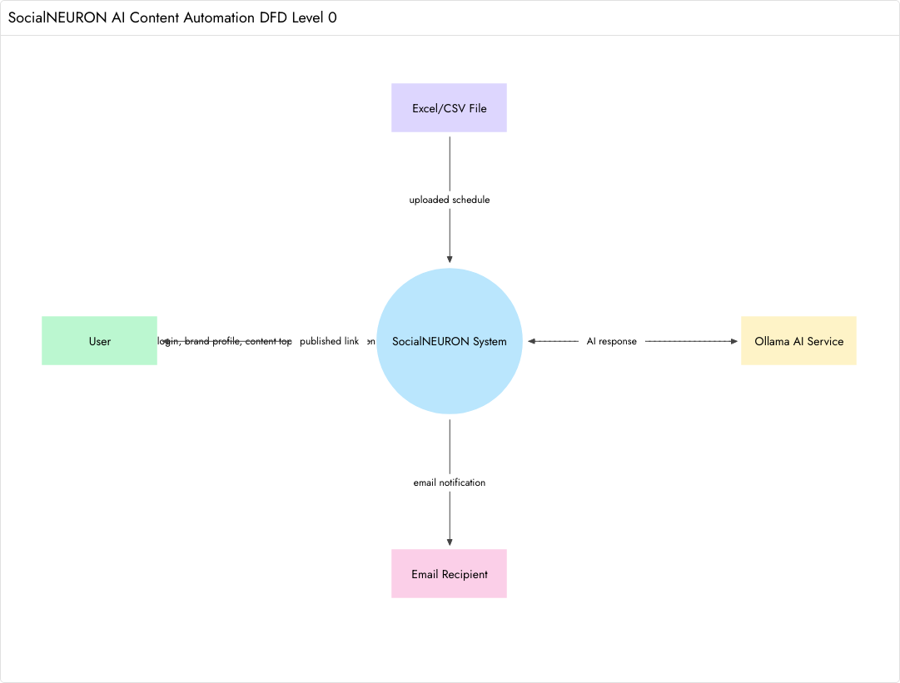
[Figure 3.1: 0th Level Data Flow Diagram]
Explanation: The 0th level DFD shows SocialNEURON as one complete system. It receives user details, brand profile data, schedule uploads, review decisions, and published links. It also communicates with the AI service and email recipients. This diagram gives a high-level view of the application boundary.

1st Level DFD

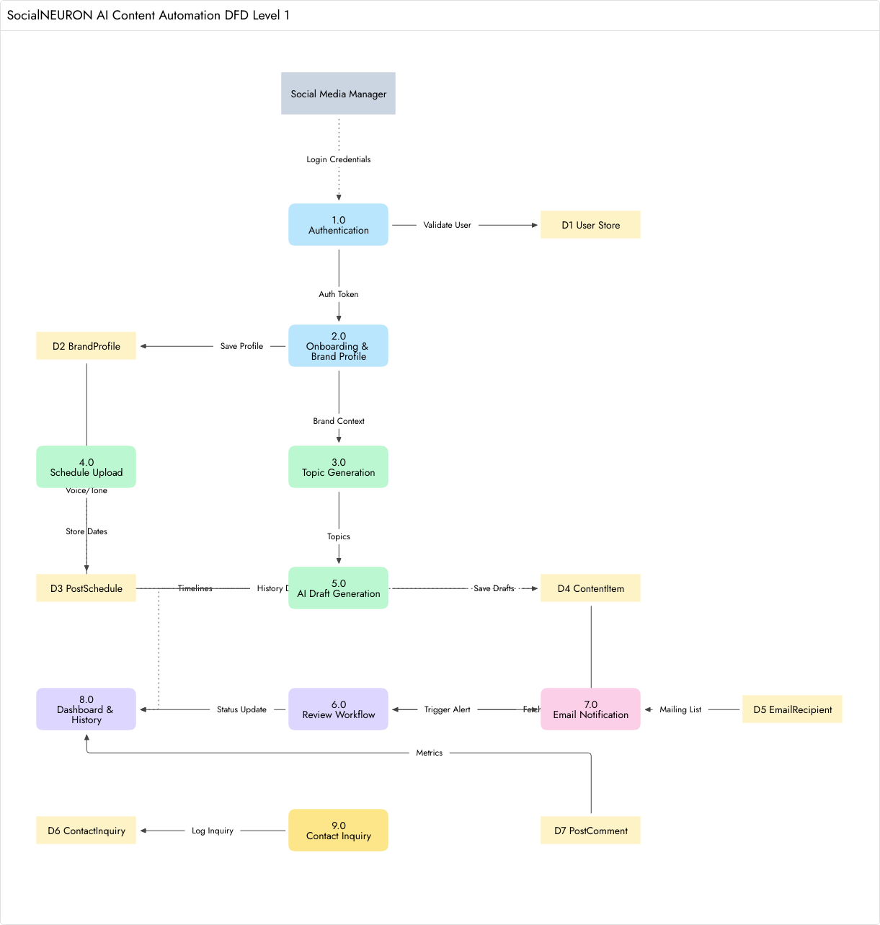
[Figure 3.2: 1st Level Data Flow Diagram]
Explanation: The 1st level DFD expands the system into major internal processes such as authentication, onboarding, topic generation, schedule upload, AI draft generation, review workflow, email notification, dashboard, and history. It explains how user input becomes stored content records.

2nd Level DFD: Review Workflow

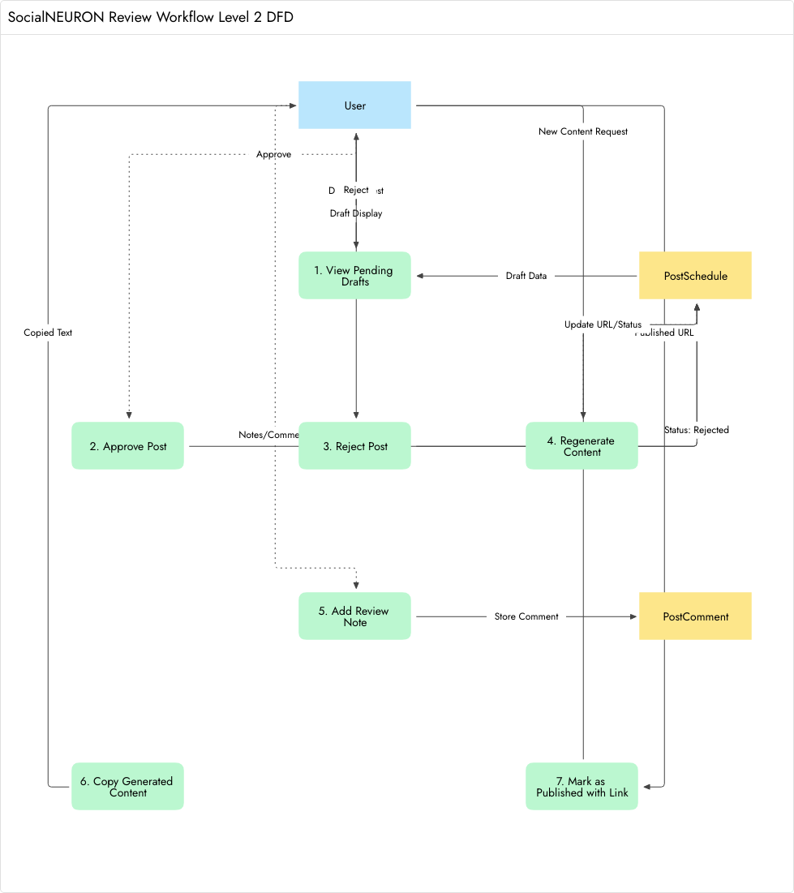
[Figure 3.3: 2nd Level Data Flow Diagram — Review Workflow]
Explanation: The 2nd level DFD focuses on the review workflow. It shows how pending AI drafts are opened, commented on, approved, rejected, regenerated, or marked as published. This is important because the project follows a human-in-the-loop content approval model.

3.3 ER Diagram

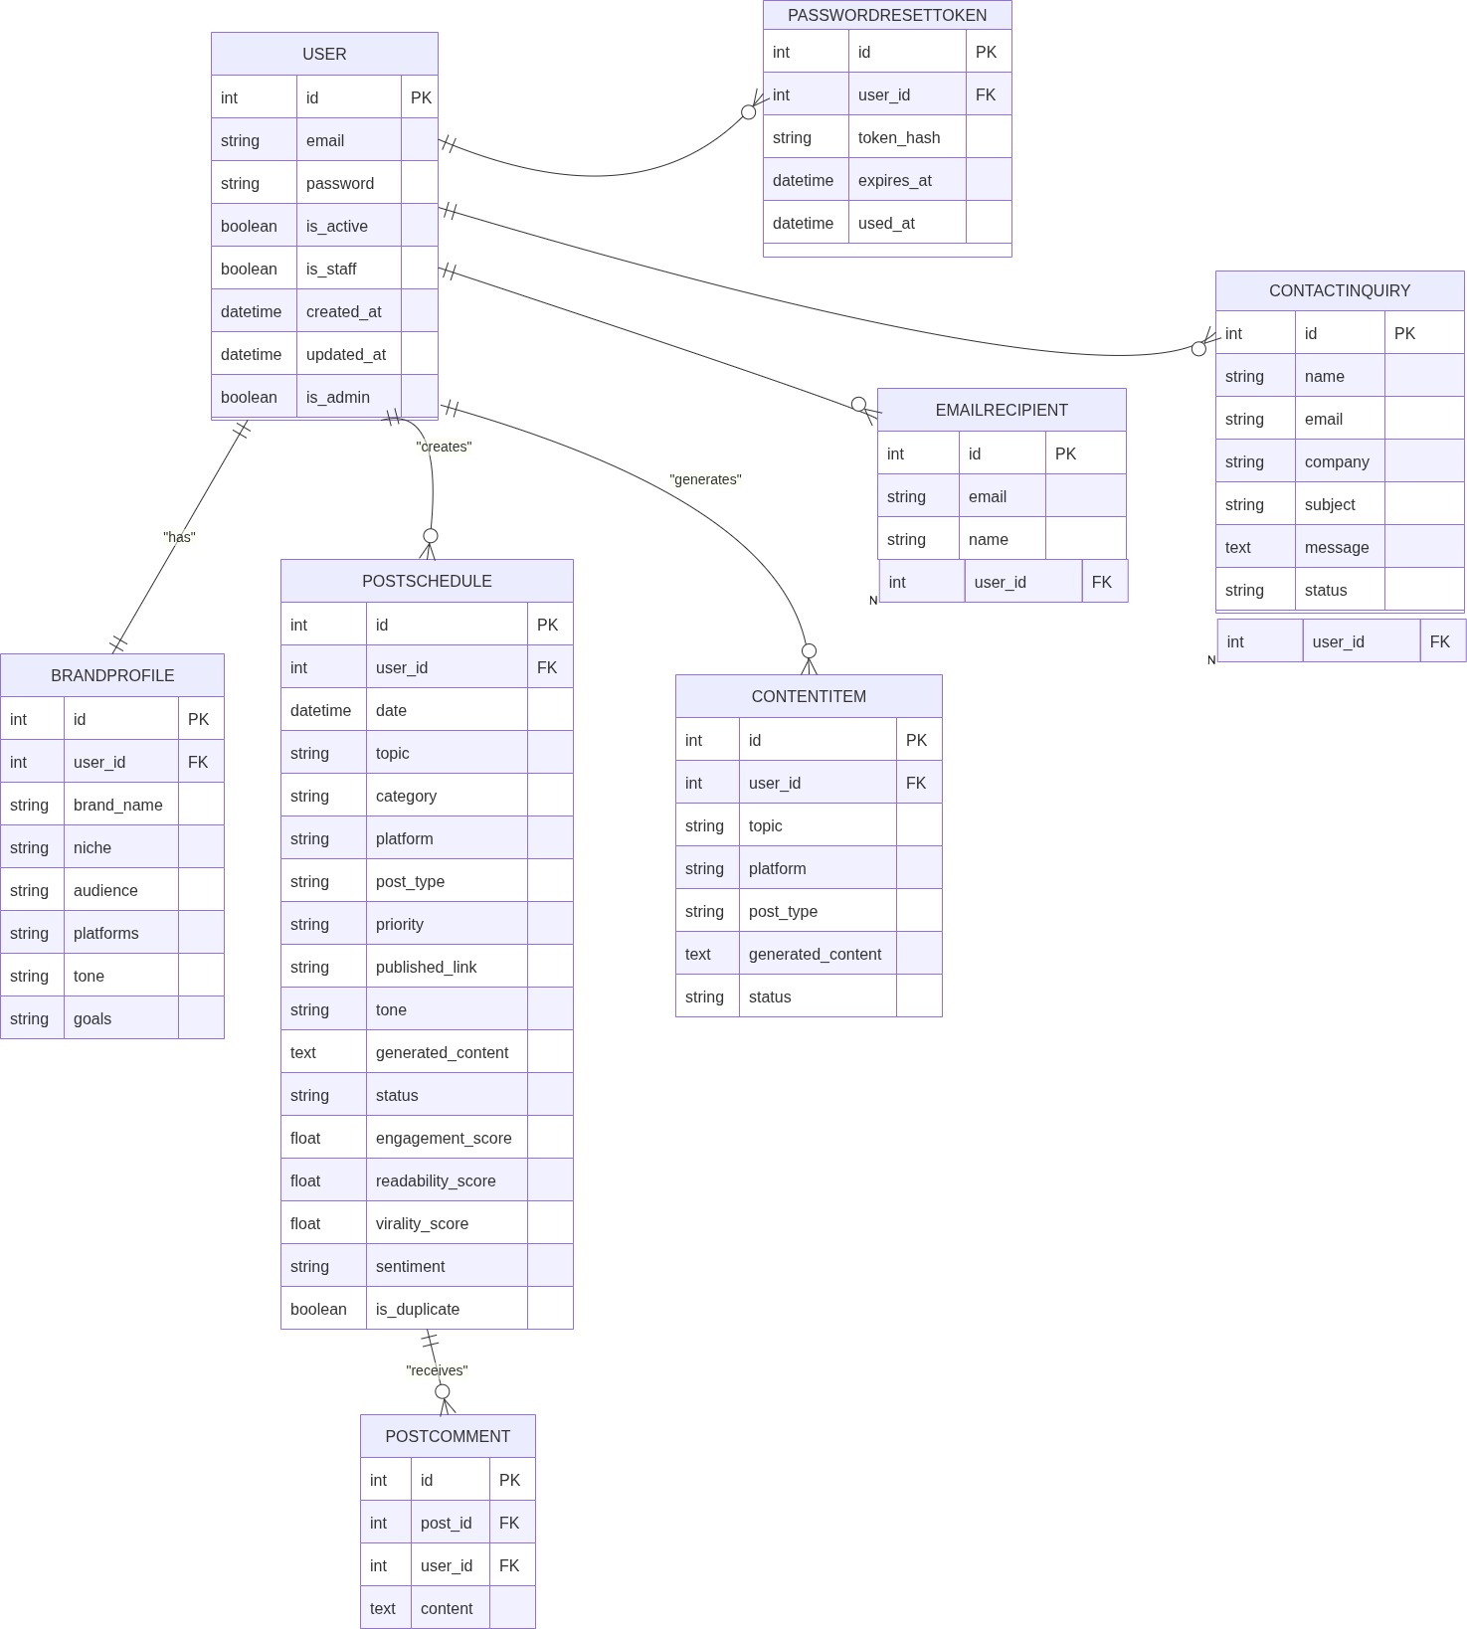
[Figure 3.4: Entity Relationship Diagram]
Explanation: The ER diagram shows the normalized database design. User, BrandProfile, PostSchedule, PostComment, EmailRecipient, ContactInquiry, ContentItem, and PromptTemplate are separated so that each table has a clear responsibility and data duplication is reduced.

3.4 Use Case Diagram

[Figure 3.5: Use Case Diagram]
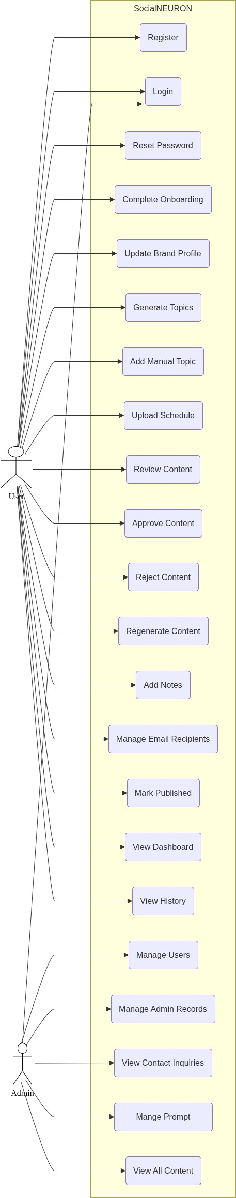
Explanation: The use case diagram identifies the main actors and actions of the system. A visitor can contact or sign up, a registered user manages the content workflow, the administrator manages prompts and users, and external services support AI generation and email notifications.

3.5 Activity Diagram
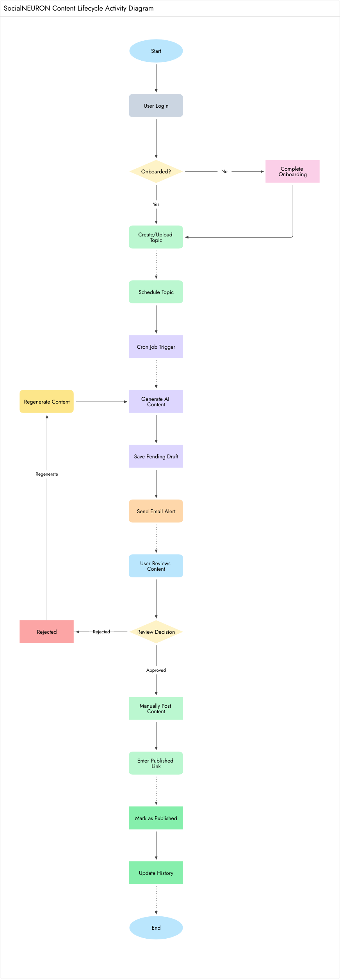
[Figure 3.6: Activity Diagram]
Explanation: The activity diagram presents the step-by-step content lifecycle. It starts from login and topic creation, continues through AI draft generation and review, and ends with manual publication verification and history update.

3.6 Sequence Diagrams

User Registration & Onboarding

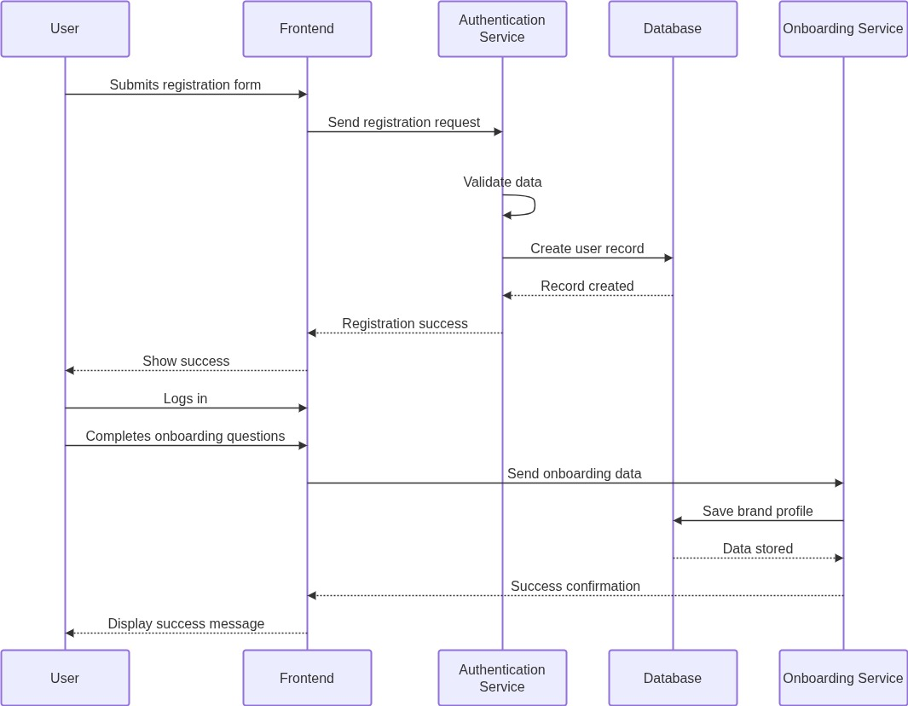
[Figure 3.4: User Registration & Onboarding]
Explanation: This sequence diagram explains how a new user moves from registration to onboarding. It highlights the interaction between browser, Django view, user model, brand profile storage, and dashboard redirection.

Content Generation
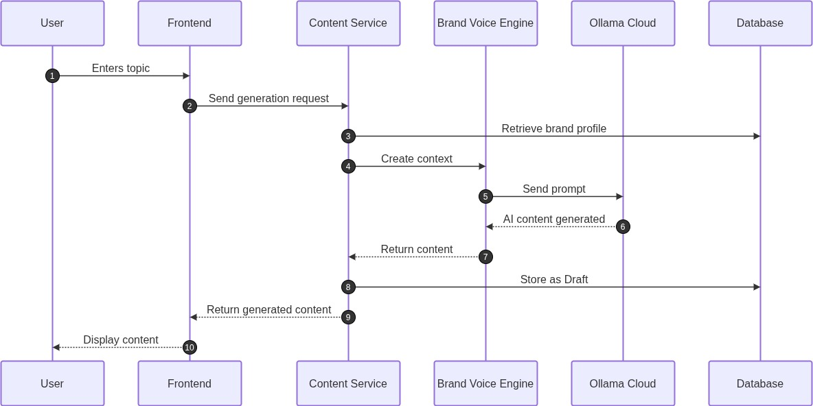

[Figure 3.4: Content Generation]
Explanation: This sequence diagram shows how a scheduled topic is converted into AI-generated content. The Django view or task retrieves the post, prepares prompt context, calls the AI service, saves generated content, and updates the record status.

Content Approval & Regeneration
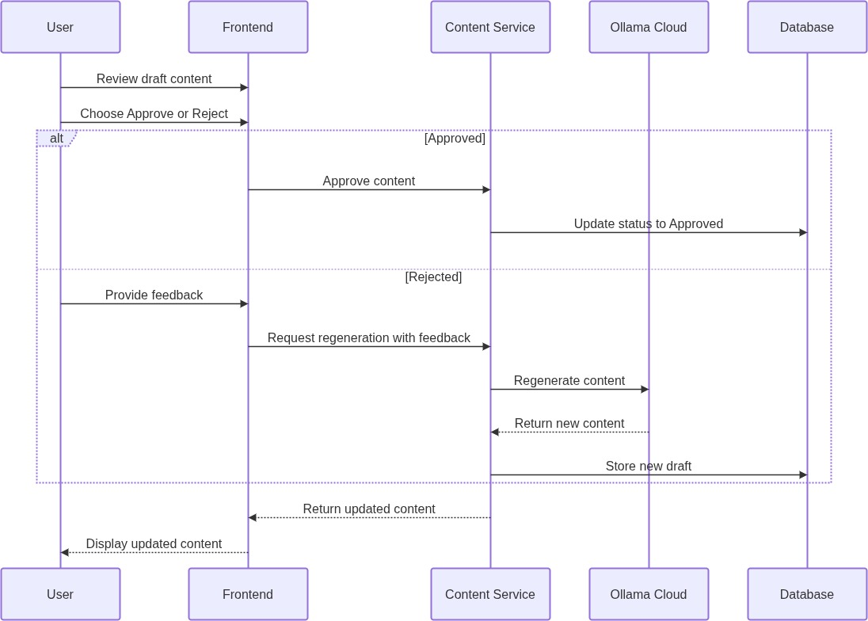
Explanation: This sequence diagram explains how review actions update the content lifecycle. The user opens the post detail page, chooses approve, reject, or regenerate, and the system saves the status change or creates a new AI output.

[Figure 3.5: Content Approval & Regeneration]

Schedule & Email Notification
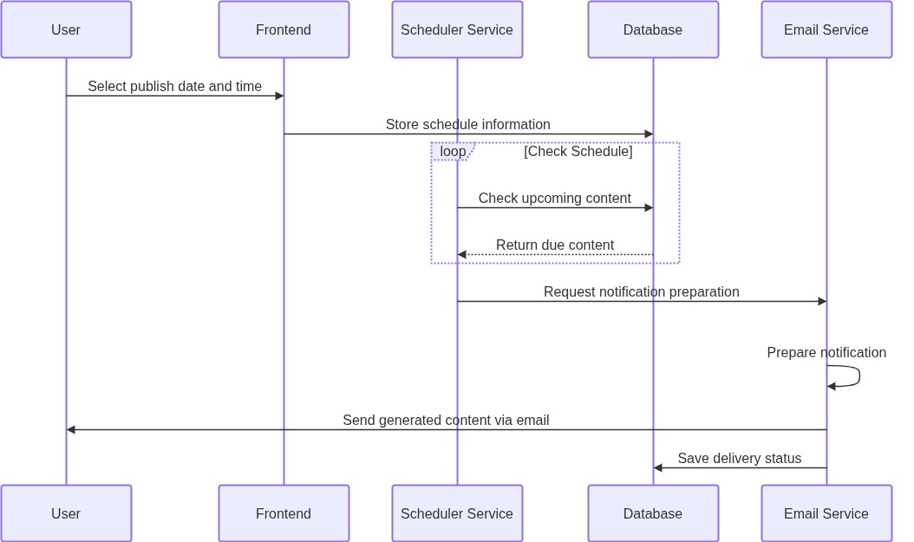
Explanation: This sequence diagram shows how due schedules and email notifications are connected. When a draft becomes ready for review, configured active recipients can receive an email alert.

[Figure 3.5: Schedule & Email Notification]

3.7 Conclusion
The logical design shows that SocialNEURON follows a modular workflow. Data flows from user input to schedule records, then to AI-generated drafts, review decisions, email notifications, and final publication history.

Logical design also confirms why different views are required for different tasks. Dashboard, Content Topics, Review Center, Post Detail, Email Integration, and History each solve a separate workflow need. This separation reduces confusion and makes the product easier to extend.
The diagrams in this chapter show that SocialNEURON is not only a content generator. It is a complete workflow system with data entry, AI processing, user review, notifications, publication tracking, and administrative prompt control.

3.8 Detailed Diagram Interpretation
The logical design diagrams show that SocialNEURON follows a clear flow from input to processing and output. The user provides information through forms and uploads. The application processes this information using Django views and services. The database stores the results, and the user later reviews or publishes the generated content.
The DFD diagrams are useful because they separate external entities from internal processes. User, AI service, email recipient, and uploaded files are outside or around the system boundary, while authentication, onboarding, content generation, review, and dashboard reporting are internal system processes.
The ER diagram is important because most project features depend on correct relationships. User to BrandProfile is one-to-one, User to PostSchedule is one-to-many, PostSchedule to PostComment is one-to-many, and prompt templates are managed as system configuration records.
The use case diagram demonstrates that the application has multiple actors. A visitor can contact the business or sign up. A registered user operates the content workflow. An administrator manages users and prompts. External services support AI generation and email delivery.
The activity diagram shows the lifecycle in a form that is easy to explain during viva. The content starts as an idea, becomes a scheduled draft, is processed by AI, is reviewed by the user, and is finally marked as published only after manual verification.
The sequence diagrams are useful for understanding timing and responsibility. They show which component acts first, which component stores data, when the AI service is called, and how a response is returned to the user interface.

3.9 Logical Design Strengths
The logical design is modular. If the AI service changes from Ollama to another provider, the core workflow does not need to change. Only the AI client and prompt handling layer would need adjustment.
The logical design is also user-safe. Every major workflow begins by identifying the current user and filtering records by user_id. This makes the system suitable for SaaS usage where multiple users have separate content pipelines.
The design supports future growth. New platforms, content types, prompt templates, and reporting views can be added because the system already stores platform and post_type values separately from the topic itself.

2.7 Requirement Traceability Matrix
Authentication requirements are implemented through signup, login, logout, forgot password, reset password, and change password screens. These requirements map to the custom User model, PasswordResetToken model, authentication service, and protected dashboard routes.
Brand profile requirements are implemented through onboarding and dashboard settings. These map to the BrandProfile model and onboarding service. The collected data is reused by AI prompt generation, proving that the requirement is connected to later modules.
Content planning requirements are implemented through topic generator, manual topic creation, Excel upload, and content topics list. These map to PostSchedule records and provide the foundation for AI draft generation and review workflow.
Review and publication requirements are implemented through review dashboard, post detail page, approval actions, rejection actions, regeneration, comments, and published link verification. These requirements map directly to status changes and PostComment records.

2.8 Risk Analysis
Risk 1: AI service may be unavailable during generation. Mitigation: The application returns a clear error message and keeps the content record unchanged. This prevents data loss and informs the user what needs to be fixed.
Risk 2: Users may upload incorrect spreadsheet formats. Mitigation: The upload workflow catches parsing errors and reports failure. The demo Excel file provides a correct format that users can follow.
Risk 3: A user may try to access another user's post by changing the URL. Mitigation: post detail, review actions, history, and content topics views filter records by user_id, so unauthorized records are not returned.
Risk 4: Admin prompt changes may reduce AI output quality. Mitigation: The system keeps built-in fallback prompts and allows prompt reset. Prompt changes are restricted to staff users only.

2.9 Acceptance Criteria
The project is acceptable if a new user can register, complete onboarding, create topics, save scheduled drafts, generate AI content, review the result, approve or reject it, and mark it as published with a verification link.
The project is acceptable if platform and content type are preserved from topic generation to post detail. This is important because the project supports multi-platform content, not only LinkedIn.
The project is acceptable if admin users can manage prompt templates and user roles while normal users cannot access staff-level configuration. This supports basic SaaS product separation.
The project is acceptable if the report documents the project through introduction, requirements, logical design, physical design, implementation, testing, references, screenshots, and diagrams according to the MCA-401 guide.

Chapter 4: Physical Design

4.1 Introduction
Physical design describes how the logical design is implemented using database tables, Django models, templates, services, views, and background task functions.

4.2 Database Design (Normalized)
Table / Model | Purpose | Important Fields
User | Stores authentication identity. | email, password, is_active, is_staff, is_admin
BrandProfile | Stores onboarding and brand voice information. | brand_name, niche, audience, platforms, tone, goals
PasswordResetToken | Stores password reset tokens securely. | user, token_hash, expires_at, used_at
PostSchedule | Stores scheduled topics and content status. | date, topic, platform, post_type, generated_content, status
ContentItem | Stores generated draft items for approval workflow. | topic, platform, post_type, generated_content, status
PostComment | Stores review notes on scheduled posts. | post, user, content, created_at
EmailRecipient | Stores configured email recipients for alerts. | email, name, is_active
ContactInquiry | Stores home page contact form submissions. | name, email, company, subject, message, status
PlatformIntegration | Stores optional integration configuration. | platform, webhook_url, setup_email, is_active

The normalized design separates identity, brand profile, scheduled content, generated draft items, comments, recipients, contact inquiries, and prompt templates. This avoids storing unrelated information in one table and makes future reporting easier.
The PostSchedule table is the most important operational table because it represents the lifecycle of a topic. It links to the user and stores the fields needed for planning, generation, review, and publication verification. Comments are kept in a separate table so that multiple notes can be attached to one post.

Normalization
The database design separates users, brand profiles, scheduled posts, generated content, comments, and email recipients into separate models. This reduces duplication and supports maintainability. User-related records are linked through foreign keys or one-to-one relations. Contact inquiries and email recipients are independent operational records.

4.3 Module Design
Module | Key Files / Components | Description
Authentication | auth/auth_service.py, users/models.py, login/reset templates | User creation, login, password reset, password change.
Onboarding | users/onboarding.py, onboarding template, settings page | Brand profile creation and update.
Topic Generator | core/views.py, content_generation.py, topic_generator.html | Generates topic ideas based on query, tone, audience, platform, and type.
Schedule Upload | schedule_import.py, upload.html | Imports Excel or CSV schedule into PostSchedule.
AI Draft Workflow | core/tasks.py, content_generation.py | Generates content and scoring for due scheduled posts.
Review Center | review_dashboard.html, post_detail.html | Approve, reject, regenerate, comment, and publish verification.
Email Integration | email_integration.html, approval_service.py | Manages recipients and sends review alerts.
Dashboard | dashboard.html, dashboard_settings.html | Displays metrics and settings.
Contact | home.html, ContactInquiry model | Stores public inquiry submissions.

4.4 Input / Output Design
Input | Source | Output
Email and password | Signup / Login forms | User account and session
Brand profile | Onboarding / Settings | Brand voice context
Topic query, platform, post type | Topic Generator | AI topic suggestions
Excel / CSV file | Upload page | Scheduled draft topics
Review action (approve/reject) | Review Center | Status change (approved, rejected, or published)
Email recipient list | Email Integration page | Notification routing list
Contact details | Home page | Contact inquiry record

4.5 Conclusion
The physical design maps the logical workflow to Django models, templates, services, and views. It supports modular growth and separates business logic from presentation wherever practical.

The physical design provides a practical bridge between the logical diagrams and Django implementation. Models represent the database, views represent user workflows, templates represent the interface, and service modules handle repeated business logic such as AI generation and schedule import.
This design also supports future migration from an academic MVP to a production SaaS product. PostgreSQL, cloud storage, background workers, official platform APIs, and subscription billing can be added without changing the core content lifecycle.

4.6 Detailed Data Dictionary Notes
User table: The User table stores account-level information. The email field is unique and acts as the login identifier. The password field stores a hashed password. The is_active flag supports account deactivation. The is_staff and is_superuser fields control administrative access.
BrandProfile table: This table stores brand-specific context. The brand_name identifies the business or personal brand. The niche describes the subject area. The audience field describes the target reader. The platforms and goals fields store multiple selected values.
PostSchedule table: This table is the core workflow table. It stores scheduled date, topic, category, platform, post_type, priority, published_link, tone, generated_content, status, scores, duplicate flag, and audit timestamps. Most dashboard and review views depend on this model.
PostComment table: This table stores review notes. A post can have multiple comments, which allows the reviewer to record suggestions, corrections, or publication instructions. This separates discussion history from the generated content body.
EmailRecipient table: This table stores recipient email addresses and active status. It allows review notifications to be routed to people other than the logged-in account holder.
PromptTemplate table: This table stores admin-managed prompt templates. The key field is stable and used by code. The template field contains placeholders that are filled at runtime. This design allows prompt updates without changing source code.

4.7 Physical Design Decisions
The project uses Django templates instead of a separate frontend framework because the required interactions are form-driven and server-rendered pages are sufficient for the MVP. HTMX is used where partial updates improve the experience, such as topic generation results.
SQLite is used during development because it is simple, portable, and suitable for academic demonstration. The model design remains compatible with stronger relational databases such as PostgreSQL for production deployment.
The admin interface is used for support and configuration. Operational customer data is kept view-only in admin to reduce accidental edits. Prompt templates and user access flags remain manageable because they are true administrative responsibilities.
The service layer keeps repeated logic outside templates. Content generation, prompt rendering, schedule import, authentication operations, and onboarding payload creation are handled by Python service functions.

3.10 DFD Narrative Explanation
In the 0th level DFD, SocialNEURON is represented as a single process because the purpose of that diagram is to show the boundary of the system. User data, schedule files, AI prompts, AI responses, email notifications, and published links move across this boundary.
In the 1st level DFD, the single process is expanded into major modules. Authentication validates users, onboarding stores brand context, topic generation produces topic ideas, schedule upload imports spreadsheet data, AI draft generation creates content, review workflow manages decisions, and dashboard/history provide reporting.
In the 2nd level DFD, the review workflow is expanded because it is one of the most important product flows. The user can view content, approve it, reject it, regenerate it, add notes, copy content, and mark it as published. This shows that review is more than a simple status field.

3.11 ER Diagram Narrative Explanation
The ER diagram is designed around the User entity because all important operational data belongs to a user. BrandProfile has a one-to-one relationship with User because each user has one primary onboarding profile.
PostSchedule has a many-to-one relationship with User because one user can plan many content topics. PostComment has a many-to-one relationship with PostSchedule because each scheduled post can receive many review notes.
PromptTemplate is not directly owned by a normal user because prompts are system-level configuration. This allows staff users to control AI behavior consistently across the application.

3.12 Sequence Diagram Narrative Explanation
The registration sequence confirms that account creation and onboarding are separate steps. This is useful because the system can ensure that every user has brand data before AI content is generated.
The content generation sequence shows interaction between the browser, Django view or task, database model, prompt service, AI client, and AI service. This explains why the generation logic is placed in a service layer instead of directly in the template.
The approval sequence shows that the user decision is stored in the database. This makes the review workflow auditable and allows the dashboard, review center, and history pages to display correct status information.

Chapter 5: Implementation

5.1 Introduction
The implementation is carried out using Django. The project contains a main Django project package, application modules, templates, migrations, services, and supporting scripts. The implementation emphasizes readable workflows, secure user handling, and practical integration with AI and email services.
Implementation was completed using Django because it provides a strong foundation for database models, URL routing, template rendering, admin management, form protection, sessions, and migrations. These features reduce development time and help keep the application secure and maintainable.
The implementation follows a practical service-oriented structure. AI calls, prompt rendering, schedule import, authentication, and onboarding are not all placed directly in templates. This separation makes the application easier to debug and extend.

5.2 Process Description
The process flow begins when a user signs up and completes brand onboarding. The brand profile then becomes part of the AI context. After that, the user can create topics manually, generate topics using AI, or upload topics in bulk using a spreadsheet.
When content is due, the generation process creates draft content and moves the item into pending status. The review process allows human decision-making. Finally, the publication process stores a live link and changes the item to published status.

User Authentication Process
Users can sign up with email and password. Passwords are hashed using Django password hashers. Users can login, logout, request a reset link, reset password through token, and change password from the dedicated settings page.

Onboarding and Brand Profile Process
After signup, users enter brand name, niche, target audience, preferred platforms, writing tone, and content goals. This data is used to build a reusable brand voice payload for AI prompts.

Topic Generation Process
The topic generator accepts query, tone, audience, platform, content type, and number of topics. The server calls the content generation service, which prepares a prompt for Ollama and parses returned lines into topic objects. The results are displayed with score, virality, tone, audience, platform, and content type information.

Schedule Upload Process
Users can upload Excel or CSV files containing columns such as date, topic, tone, audience, platform, priority, and post_type. The import service reads the file and creates scheduled draft records.

AI Draft Generation Process
The cron workflow checks today's and tomorrow's draft records. If a draft does not already contain generated content, the system generates content using AI, assigns scores, changes status to pending, saves a content item, and sends email notifications to active recipients.

Review and Publishing Process
Users review pending drafts, approve or reject them, regenerate content, add comments, and mark approved content as published by entering a live URL. Published posts appear in the history page.

5.3 Output and Reports
The application produces the following outputs:
- Dashboard statistics for total, draft, pending, approved, rejected, and published content.
- AI-generated topic ideas.
- AI-generated social media content drafts.
- Email notifications for review-ready content.
- Published history with platform, tone, score, and link information.
- Contact inquiry records for public visitors.

Screenshots

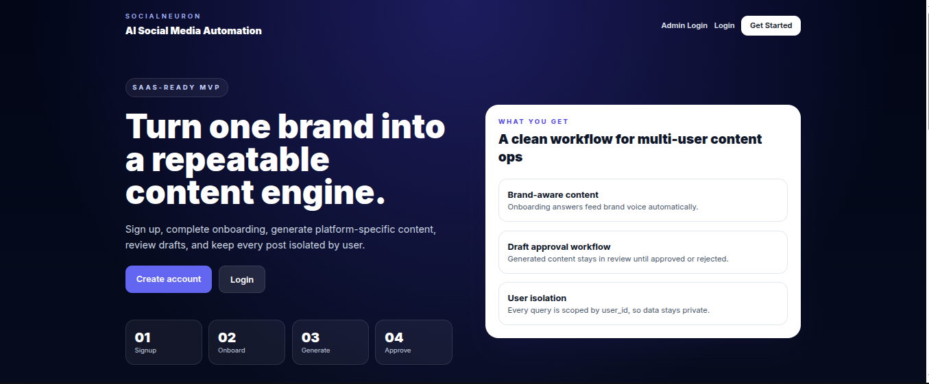
[Figure 5.1: Home Page]
Explanation: The home page presents SocialNEURON as a SaaS product and introduces the content automation workflow. It also provides navigation to authentication and contact inquiry so that visitors can understand the product before signing up.

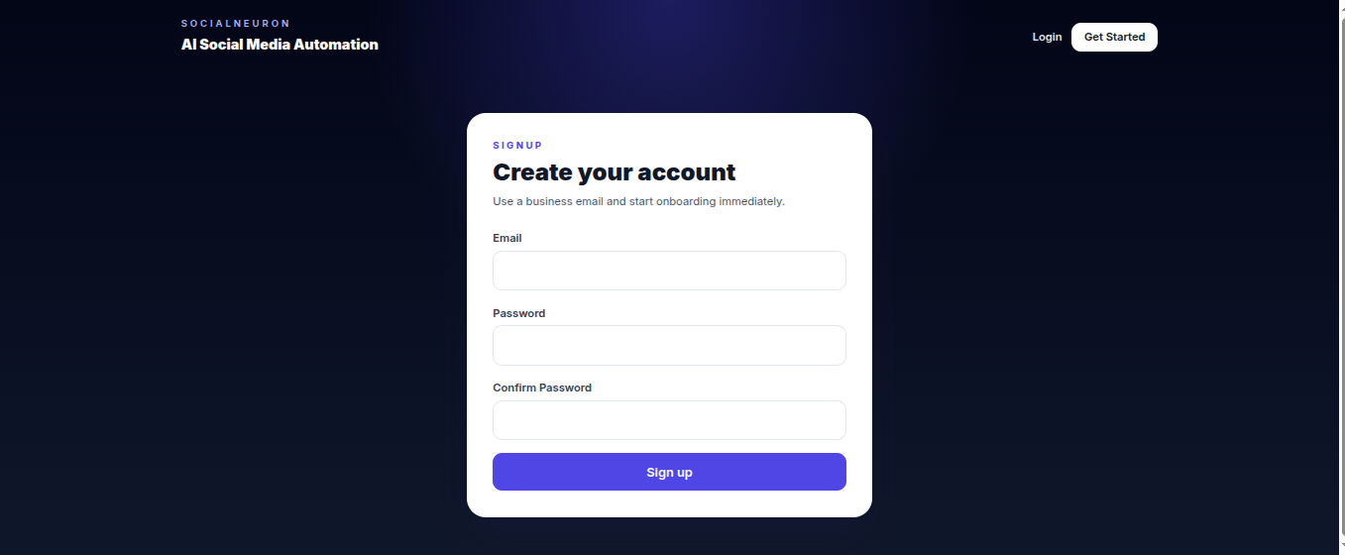
[Figure 5.2: Sign Up]
Explanation: The sign up screen collects the basic account credentials. After successful registration, the user is directed to onboarding so that brand-specific information can be captured before content generation begins.

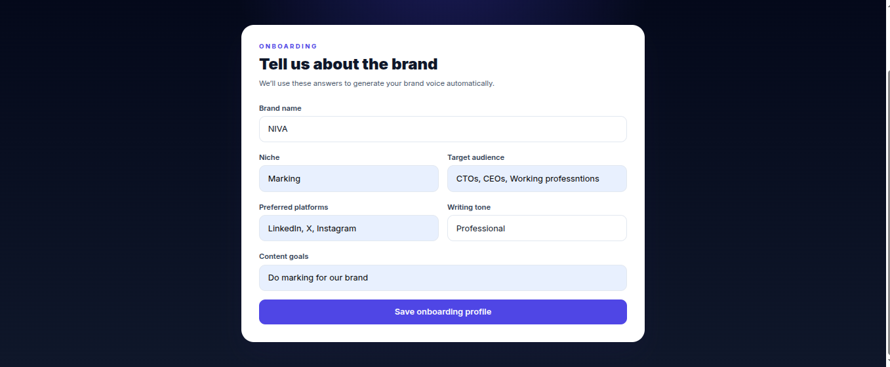

[Figure 5.3: Onboarding]
Explanation: The sign up screen collects the basic account credentials. After successful registration, the user is directed to onboarding so that brand-specific information can be captured before content generation begins.

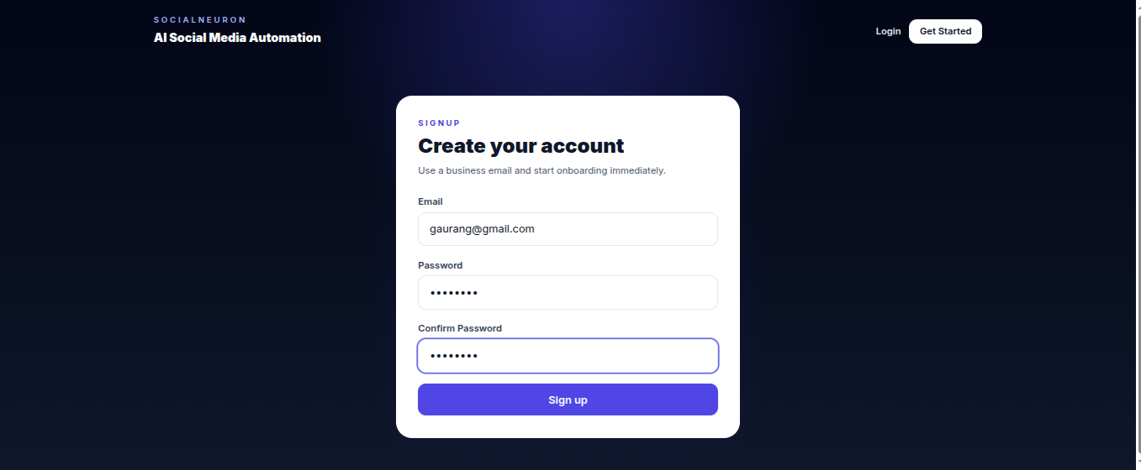
[Figure 5.4: Login]
Explanation: The login screen authenticates returning users and starts a protected session. Only authenticated users can access the dashboard, topic generator, upload, review, history, and settings pages.

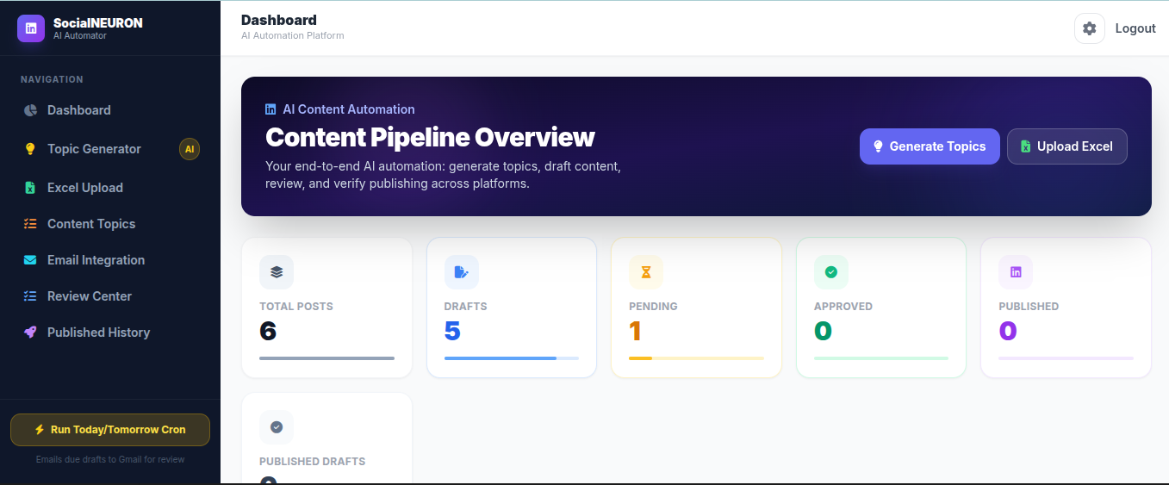

[Figure 5.5: Dashboard]
Explanation: The login screen authenticates returning users and starts a protected session. Only authenticated users can access the dashboard, topic generator, upload, review, history, and settings pages.

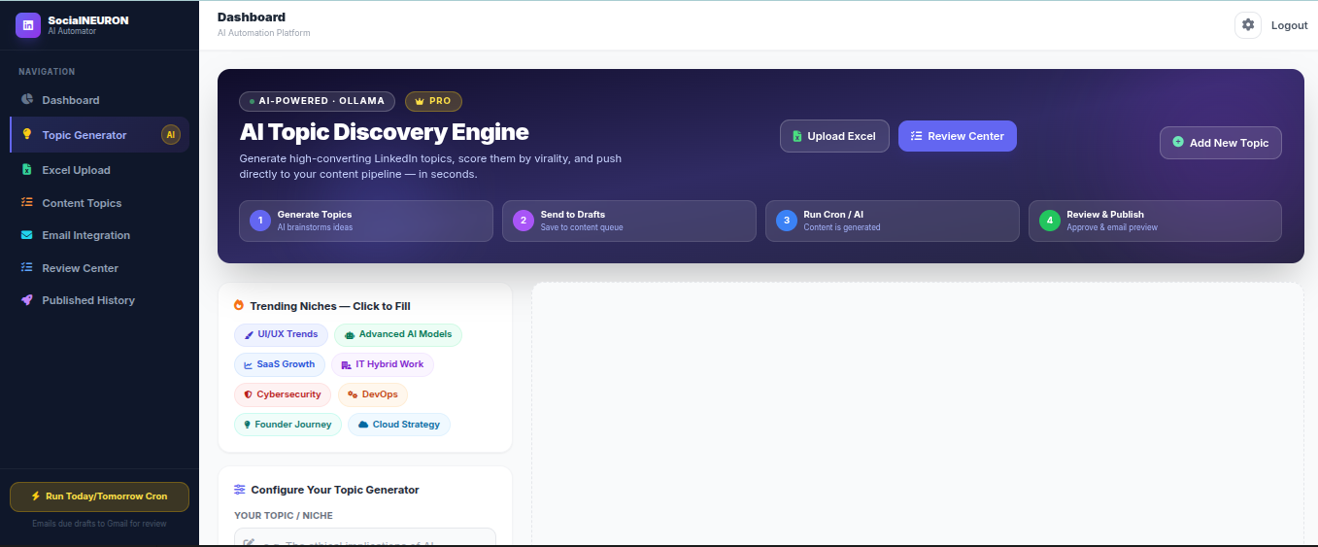

[Figure 5.6: Topic Generator]
Explanation: The topic generator allows the user to select query, tone, audience, platform, content type, and number of topics. The selected platform and content type are carried into the draft record when a topic is saved.

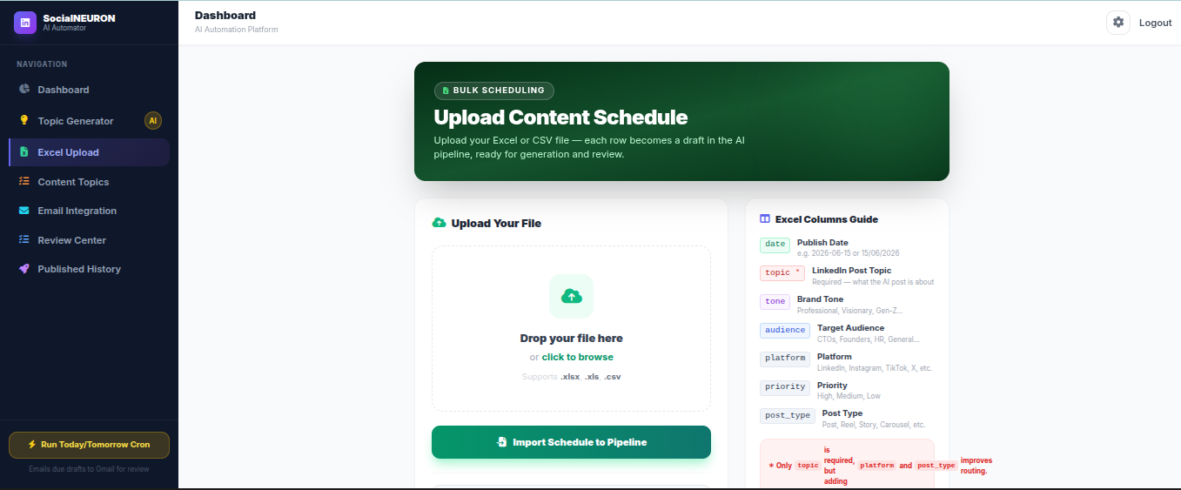

[Figure 5.7: Upload Content Schedule]
Explanation: The topic generator allows the user to select query, tone, audience, platform, content type, and number of topics. The selected platform and content type are carried into the draft record when a topic is saved.

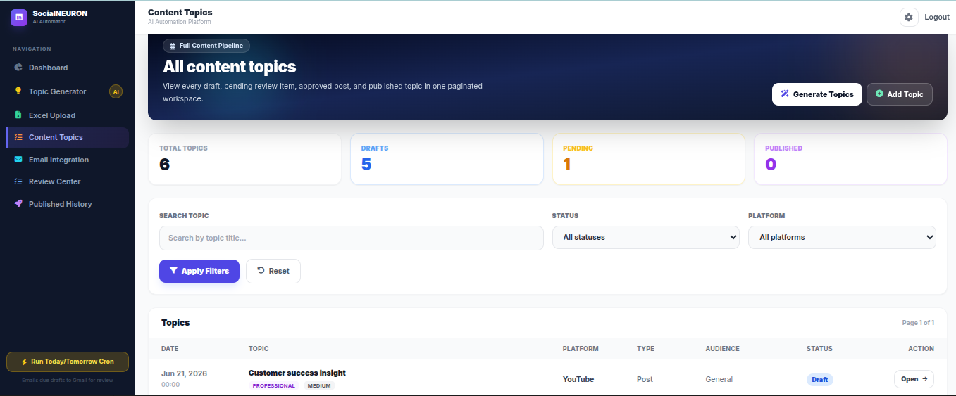

[Figure 5.8: Content Topics]
Explanation: The upload page supports Excel or CSV schedule import. This helps users prepare monthly content in a spreadsheet and then import all topics into SocialNEURON as draft records.

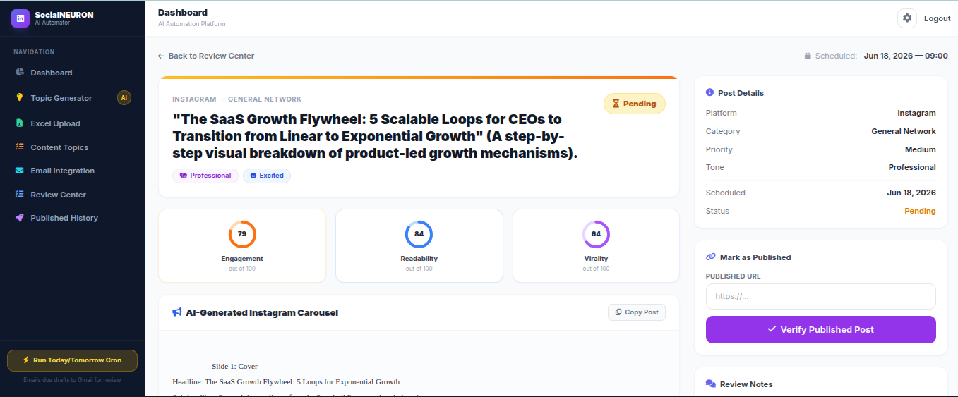

[Figure 5.9: Generated Post]
Explanation: The content topics page lists all scheduled topics with pagination, filters, platform, content type, audience, status, and quick open action. This page solves the problem of viewing a full month of content records.

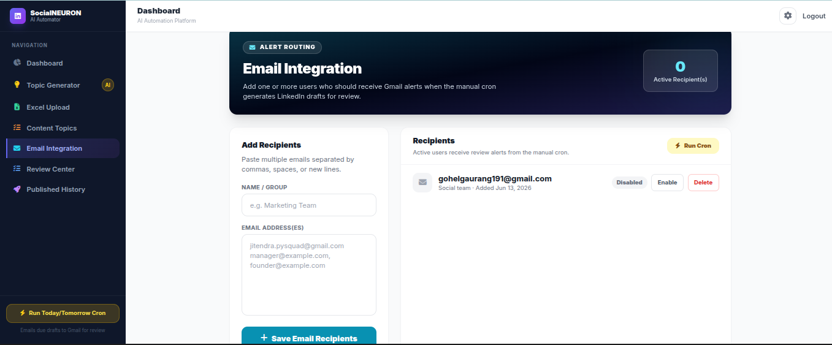

[Figure 5.10: Email Integration]
Explanation: The email integration page manages recipients who should receive content-ready notifications. Users can add, disable, enable, or delete recipients depending on team workflow.

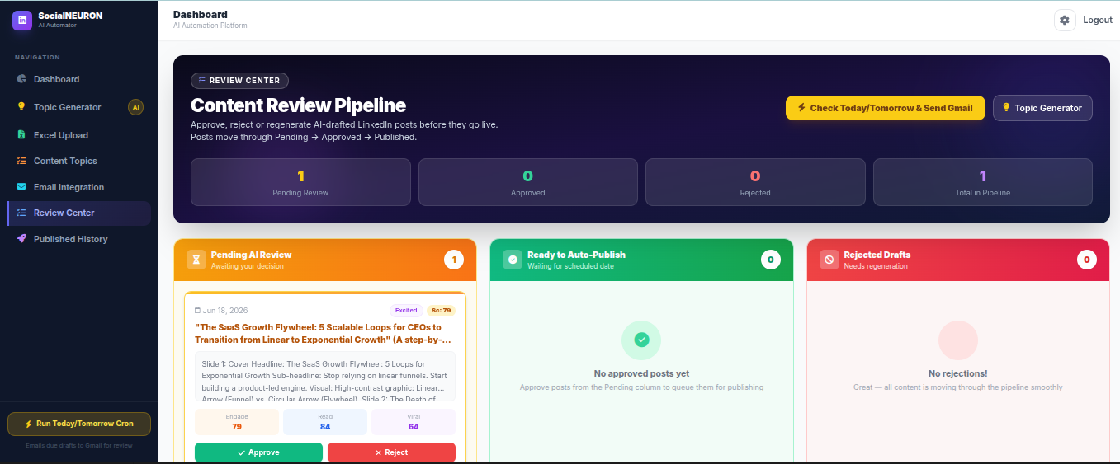

[Figure 5.11: Content Review Center]
Explanation: The email integration page manages recipients who should receive content-ready notifications. Users can add, disable, enable, or delete recipients depending on team workflow.

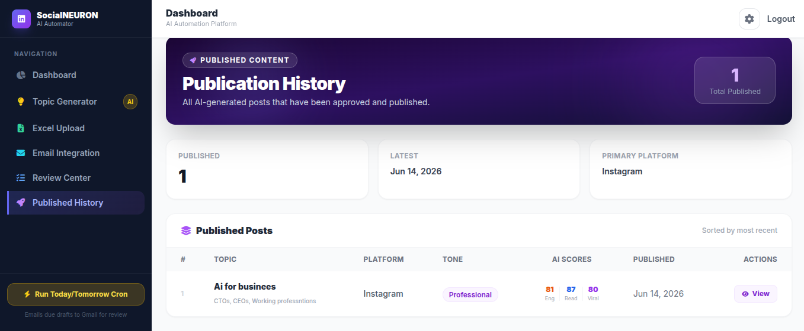
[Figure 5.12: Published History]
Explanation: The published history page shows content that has been manually verified as published. It stores the live link so that the user can later confirm where each post was published.

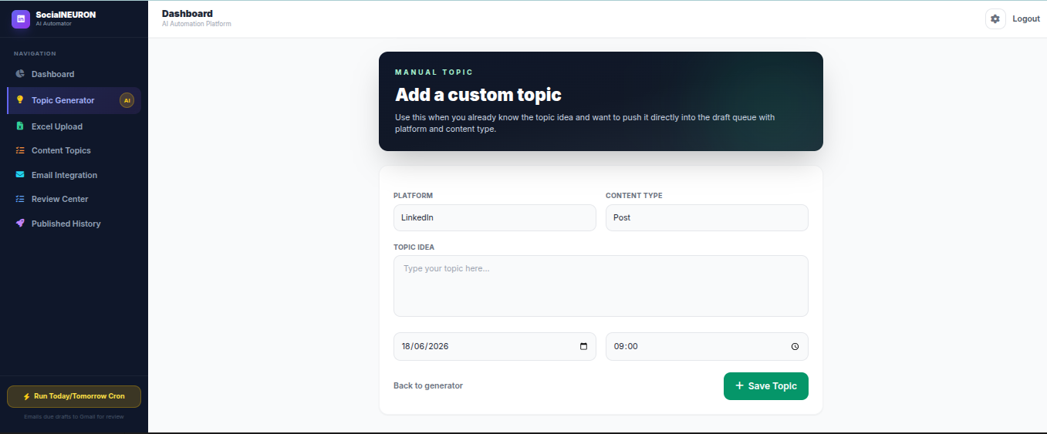
[Figure 5.13: Custom Topic]
Explanation: The published history page shows content that has been manually verified as published. It stores the live link so that the user can later confirm where each post was published.

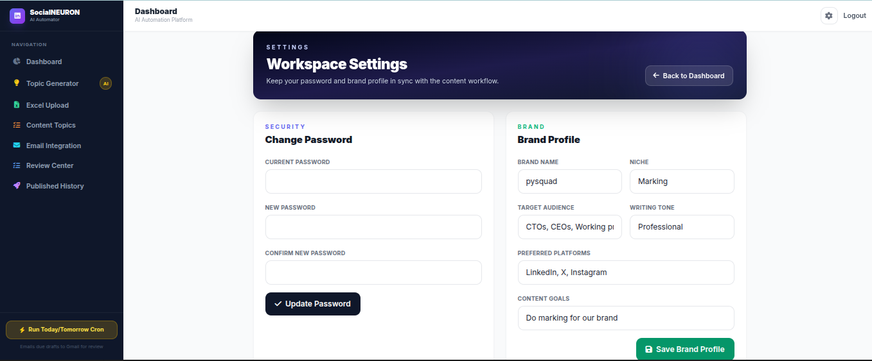

[Figure 5.14: Workspace Settings]
Explanation: The custom topic page allows a user to manually add a new idea with date, time, platform, content type, audience, and tone. This supports fast planning without requiring AI generation.

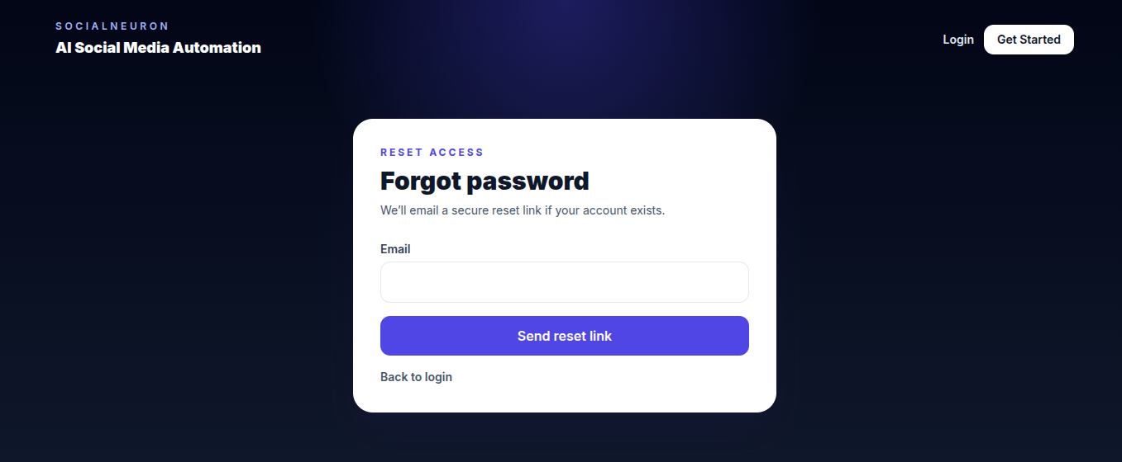

[Figure 5.15: Forgot Password]
Explanation: The settings page allows the user to update brand profile information and change password. Keeping this separate from the dashboard makes the main page cleaner.

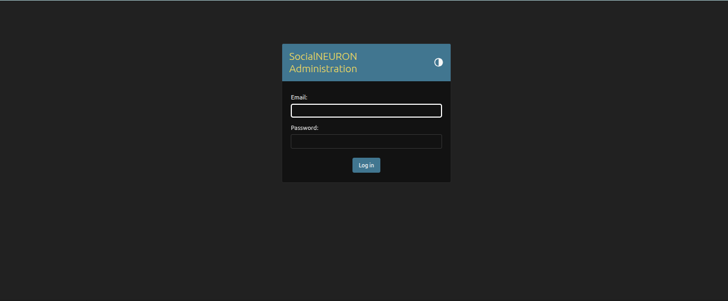
[Figure 5.16: Admin Login ]
Explanation: The login screen authenticates returning users and starts a protected session. Only authenticated users can access the dashboard, topic generator, upload, review, history, and settings pages.
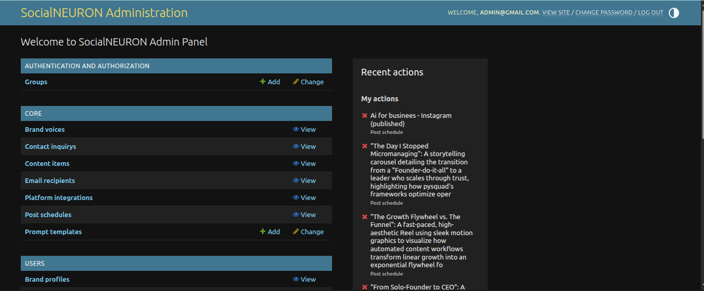

[Figure 5.17: Admin Dashboard ]
Explanation: The login screen authenticates returning users and starts a protected session. Only authenticated users can access the dashboard, topic generator, upload, review, history, and settings pages.

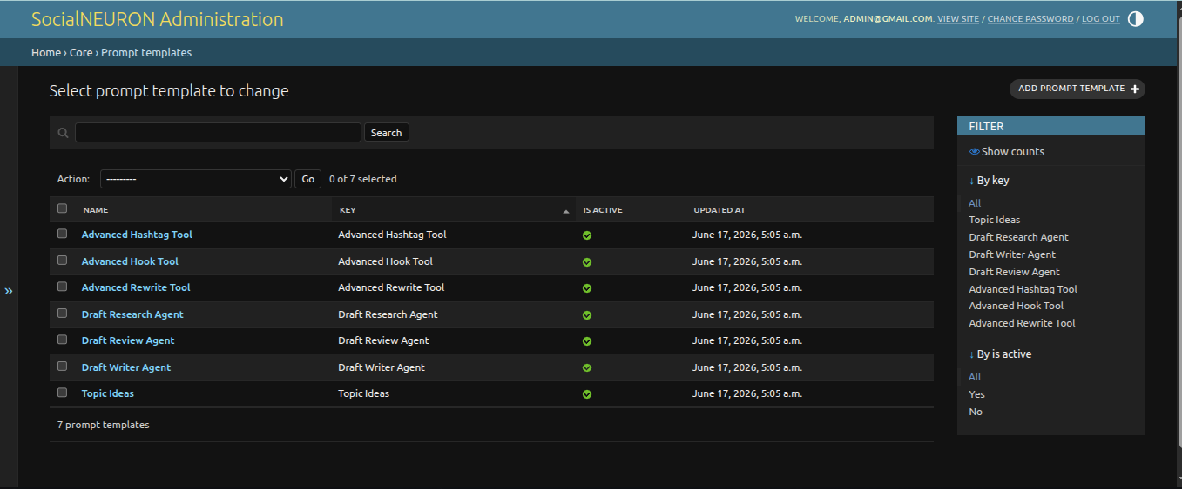
[Figure 5.18: Mange Prompt Templates]
Explanation: The dashboard gives a high-level view of total posts, drafts, pending items, approved items, published items, upcoming schedule, and recent activity. It is designed as the main control center for the user.

5.4 Conclusion
The implementation successfully creates a functional end-to-end content automation workflow. It integrates user management, AI generation, review controls, file import, email notifications, and public contact handling into a single Django application.

The implementation demonstrates that the selected architecture is practical. A user can move from onboarding to topic generation, scheduling, AI generation, review, approval, and published history through the web interface.
The screenshots included in this chapter verify the implemented modules visually. They show not only individual pages but also the continuity of the workflow across the application.

5.5 Implementation Details by Module
Authentication implementation uses a custom user model based on email identity. This is more suitable for SaaS products than username-based login because users commonly remember email addresses and because email is needed for password reset.
Onboarding implementation stores profile values in the BrandProfile model and converts them into brand voice context when AI prompts are prepared. This makes AI generation more personalized than using a single generic prompt for all users.
Topic generation implementation sends user-selected values to the AI generation service. The returned lines are cleaned and displayed as topic cards. When the user sends a topic to drafts, hidden fields preserve tone, audience, platform, and content type.
Excel upload implementation uses spreadsheet reading libraries to convert rows into scheduled draft records. This supports realistic monthly planning where many topics are created at once.
AI draft generation implementation uses a staged prompt process: research, writing, and review. This produces better structured content than a single prompt because each stage has a focused responsibility.
Review implementation updates post status and keeps the generated content visible on the post detail page. Regeneration reuses the same post record while comments preserve reviewer notes.
Publication implementation stores the live link entered by the user. This creates a simple verification trail and avoids unsupported automatic posting assumptions across platforms.
Dashboard implementation summarizes important counts and shows upcoming and recent records. The separate Content Topics page handles full monthly lists with pagination and filters.

5.6 Screenshot-Based Module Verification
The home page screenshot verifies that the project includes a public-facing product introduction. This is important for SaaS readiness because users should understand the value proposition before creating an account.
The signup, login, forgot password, and settings screenshots verify that account management flows are implemented. These screens support secure access and account recovery.
The onboarding and workspace settings screenshots verify that brand profile data can be entered and later updated. This supports personalized AI generation.
The topic generator, manual topic, and Excel upload screenshots verify that topics can enter the system through multiple paths. This flexibility is important because users may plan content manually, through AI, or using spreadsheets.
The dashboard, content topics, review center, post detail, email integration, and history screenshots verify that the content lifecycle can be tracked after topics are created. This demonstrates the end-to-end nature of the project.
The admin login, admin dashboard, and prompt template screenshots verify staff-level product configuration. Prompt management is especially important because AI behavior can be improved without source code edits.

4.8 Table-Level Design Details
The User table supports authentication and role management. It contains email, password, active status, staff status, superuser status, last login, and audit timestamps. The system uses email as the login identifier because it is more suitable for SaaS applications.
The BrandProfile table supports AI personalization. It stores brand name, niche, target audience, selected platforms, tone, and goals. These fields are converted into brand voice context when prompts are rendered.
The PostSchedule table supports content planning and lifecycle tracking. Its status field allows the same record to move through draft, pending, approved, rejected, and published stages. Its platform and post_type fields make it multi-platform.
The PromptTemplate table supports admin-managed AI behavior. It stores prompt key, name, description, template, active status, and timestamps. The prompt key is stable so that the code can request the correct template.

4.9 Module Interface Details
The dashboard interface provides summary information and navigation. It does not attempt to show every monthly topic because that would make the dashboard heavy. Instead, it links to the Content Topics page for full listings.
The Content Topics interface provides search, status filtering, platform filtering, pagination, and open action. It is useful when the user has uploaded or generated many topics for a month.
The Review Center interface is intentionally narrower. It displays review-ready items such as pending, approved, and rejected content. This keeps the user focused on decisions rather than raw topic planning.
The Post Detail interface combines generated content, status, scores, comments, AI helper actions, approval controls, and publish verification. It acts as the single operational page for one content item.

4.10 Input Validation Details
Signup validation checks password and confirmation. Forgot password validates email. Change password validates old password and matching new password. These checks reduce account-related errors.
Topic creation validation checks that title exists and date/time can be parsed. Save-to-draft forms preserve hidden values such as platform and post type so selected dropdown values are not lost.
Upload validation catches file parsing problems and reports them to the user. Contact inquiry validation checks required public form fields. Published verification validates that a URL is provided and begins with http or https.
Prompt validation checks template syntax so that malformed placeholders do not break AI rendering. Unknown placeholders are kept safe by fallback formatting behavior.

Chapter 6: Testing

6.1 Introduction
Testing verifies that the system works according to the requirements. The project was tested through module-level testing, integration testing, user interface testing, form validation testing, and workflow testing.

6.2 Types of Testing Performed
Testing was planned around the connected nature of the project. A small change in topic generation can affect saved drafts, post detail pages, cron generation, and review status. Therefore, regression testing is important after every workflow change.
Special attention was given to user-scoped data. Pages such as dashboard, review center, content topics, post detail, and history must show only records belonging to the logged-in user. This behavior is essential for a SaaS-style product.

Unit Testing
Individual functions such as password validation, schedule parsing, topic generation parsing, and contact submission handling can be tested independently to verify correctness of each unit in isolation.

Integration Testing
Integration testing checks whether modules work together. Examples include signup to onboarding flow, topic generation to draft saving, schedule upload to AI generation, and review approval to published history.

System Testing
The complete system is tested as a web application by navigating through all major workflows from login to content publication.

Validation Testing
Form validation checks required fields in contact inquiry, login, signup, reset password, topic creation, schedule upload, and published link entry.

Regression Testing
Regression testing verifies that updates such as contact form, settings page, email recipient deletion, topic platform selection, and score ring fixes do not break older workflows.

Test Cases
Test ID | Scenario | Expected Result | Status
TC-01 | User signs up with valid email and password. | Account created and redirected to onboarding. | Pass
TC-02 | User enters mismatched signup passwords. | Error message is displayed. | Pass
TC-03 | User updates brand profile from settings page. | Brand profile is updated. | Pass
TC-04 | User generates topics for Instagram Reel. | Results show selected platform and content type. | Pass
TC-05 | User uploads Excel schedule. | Rows are added as draft scheduled topics. | Pass
TC-06 | User runs cron for due draft. | AI content is generated and status becomes pending. | Pass
TC-07 | User runs cron again for already generated content. | Content is not regenerated unnecessarily. | Pass
TC-08 | User adds note on post detail. | Comment is saved and displayed. | Pass
TC-09 | User adds email recipient. | Recipient appears in email integration list. | Pass
TC-10 | User deletes email recipient. | Recipient is removed. | Pass
TC-11 | Visitor submits contact inquiry. | Inquiry is saved and success message displayed. | Pass
TC-12 | User marks post as published without URL. | Error message is displayed. | Pass

6.3 Conclusion
Testing confirms that the core modules of the SocialNEURON system meet the defined requirements. The application handles common workflows such as authentication, onboarding, topic generation, schedule upload, AI draft generation, review, email alerts, and contact inquiry submission.

6.6 Extended Regression Test Scenarios
Regression Scenario 1: After changing topic generator dropdowns, verify that selected platform and content type are visible in generated results, saved draft records, content topics page, post detail page, and AI prompt context.
Regression Scenario 2: After editing prompt templates, verify that topic generation, draft research, draft writing, review cleanup, hashtag suggestion, hook generation, and rewrite action still return usable results.
Regression Scenario 3: After changing dashboard or content topics page, verify that review center still only shows review-related statuses and does not become overloaded with ordinary draft topics.
Regression Scenario 4: After adding admin restrictions, verify that staff users can manage prompts and users, while normal users can only access their own dashboard and content workflow.

6.7 Viva-Voce Preparation Questions
Question: Why was Django selected? Answer: Django provides built-in support for models, admin, sessions, templates, URL routing, password hashing, CSRF protection, and migrations, making it suitable for rapid development of a secure web application.
Question: Why is automatic posting not implemented for all platforms? Answer: Each platform has different API policies and permissions. Manual publish verification is a realistic MVP approach that supports all platforms while keeping the workflow safe.
Question: How is user data protected? Answer: All protected views check the current session user and filter records by user_id. This prevents users from accessing posts that belong to other accounts.
Question: How can AI prompts be changed? Answer: Staff users can manage prompt templates from the dashboard or admin. The application uses stable prompt keys and safe fallback prompts to avoid breaking generation.

6.8 Final Scope for Future Work
Future work can include direct publishing integrations for platforms that provide official APIs. OAuth account connection can allow users to connect social accounts securely when platform rules permit it.
Future work can also include team workspaces, reviewer roles, content calendar drag-and-drop, subscription billing, usage limits, and advanced analytics for platform-wise performance.
The AI layer can be improved with prompt versioning, model selection, output quality rating, and A/B testing. These features would help administrators understand which prompts produce better content.
The reporting layer can be improved with charts for draft volume, approval rate, publication completion, platform distribution, and content type distribution. This would make SocialNEURON more valuable as a production SaaS product.

5.7 User Manual Notes
Step 1: The user signs up and completes onboarding. The onboarding form should be filled carefully because it influences future AI content. Important fields include brand name, niche, target audience, preferred platforms, writing tone, and goals.
Step 2: The user opens Topic Generator, enters a subject, selects tone, audience, platform, content type, and number of topics, then generates ideas. The user can choose a posting date and time before sending any topic to drafts.
Step 3: The user can also add a manual topic or upload an Excel calendar. These options are useful when the user already has planned ideas and does not need AI topic generation.
Step 4: The user runs the today/tomorrow generation workflow. Drafts become pending only when generated content is created. Existing generated content is not regenerated unnecessarily.
Step 5: The user opens Review Center or Post Detail, reviews the generated content, approves or rejects it, adds comments if needed, and later marks approved content as published with a live link.

5.8 Administrator Manual Notes
The administrator logs in with staff access. Staff users can manage prompt templates and user access. Prompt templates should be edited carefully because they affect AI output quality.
The administrator can use prompt management to improve topic ideas, draft writing, review cleanup, hashtag suggestions, hook generation, and rewrite behavior. Each prompt should keep the required placeholders that the application sends at runtime.
Operational records can be inspected for support, but the MVP treats customer-owned content carefully. This design reduces accidental editing of user data and supports SaaS-style responsibility separation.
If AI output becomes poor after prompt changes, the administrator can reset prompts to recommended defaults and test generation again using the topic generator and post regeneration flows.

5.9 Deployment Notes
For local demonstration, the application can run with Django development server, SQLite database, and Ollama service. This setup is sufficient for academic presentation and feature demonstration.
For production, DEBUG should be disabled, allowed hosts should be configured, a production database such as PostgreSQL should be used, and static files should be served using a proper web server configuration.
Email settings should use a verified SMTP provider. Secret values such as database password, email password, Django secret key, and AI service endpoint should be stored in environment variables.
Celery and Redis can be used for background generation and scheduled workflows. In a production SaaS system, workers should run separately from the web process so long AI tasks do not block page requests.
REFERENCES

- Dr. Babasaheb Ambedkar Open University, MCA-401 Software Development Project Guidelines. Available at: https://baou.edu.in/assets/pdf/MCA-401.pdf
- Django Software Foundation, Django Documentation. Available at: https://docs.djangoproject.com/
- Celery Documentation. Available at: https://docs.celeryq.dev/
- Pandas Documentation. Available at: https://pandas.pydata.org/docs/
- HTMX Documentation. Available at: https://htmx.org/docs/
- Ollama Documentation. Available at: https://ollama.com/

EXTENDED PROJECT DOCUMENTATION
The following pages are added to strengthen the MCA-401 report length and depth while preserving the original report content, website screenshots, and diagram images.
The testing process confirms that the system supports the main expected workflows and handles common validation cases. The most important tested areas are authentication, onboarding, content creation, platform preservation, upload, AI generation, review notes, email recipients, and publication verification.
For future development, automated Django tests can be expanded around all critical views and services. This would make the product safer to modify as new SaaS features such as teams, subscriptions, and direct publishing integrations are added.

6.4 Expanded Test Case Notes
TC-13 Platform Preservation: Select Instagram and Reel from topic generator, generate topics, save one to drafts, and open the post detail page. Expected result: the post shows Instagram as platform and Reel as content type.
TC-14 Draft Visibility: Create multiple draft topics and open the Content Topics page. Expected result: all draft records are visible with pagination, while the Review Center remains focused on pending, approved, and rejected content.
TC-15 User Isolation: Log in as one user and create several topics. Log in as another user and open dashboard, content topics, review center, and history. Expected result: records from the first user are not visible.
TC-16 Prompt Management Access: Log in as a normal user and try to access prompt settings. Expected result: access is denied. Log in as a staff user and open prompt settings. Expected result: prompt templates can be viewed and updated.
TC-17 Cron Duplicate Prevention: Run the cron flow once for a draft and confirm content is generated. Run the cron flow again for the same record. Expected result: existing generated content is not overwritten unnecessarily.
TC-18 Published Link Validation: Try marking a post as published without a URL or with a URL missing http or https. Expected result: the system shows validation error and does not mark the post as published.
TC-19 Email Recipient Management: Add multiple recipients, disable one, enable it again, and delete another. Expected result: the list updates correctly and only active recipients are used for notifications.
TC-20 Contact Inquiry: Submit the public contact form with valid details. Expected result: inquiry record is saved and success message is displayed. Submit with missing required fields. Expected result: validation message is shown.

6.5 Final Testing Reflection
Testing confirms that the project works as a connected system rather than isolated pages. The most important success condition is that a topic can move from idea to draft, draft to AI-generated content, content to review, review to approval, and approval to published history.
The testing process also confirms the importance of regression testing. When platform and content type support was added, saving generated topics had to preserve those values. Without regression testing, the post detail page could still show only the default platform.
For production, automated tests should be added for every critical view. These tests should check authentication requirements, user-specific filtering, form validation, prompt rendering, upload parsing, review actions, and published link handling.
The final tested application is suitable for academic demonstration because it includes real workflows, database persistence, AI integration, admin configuration, and user-facing screens. It also has clear future improvement paths.

