Football Analysis
Complete Technical Documentation Report
Project Type: Computer Vision / Sports Video Analytics / Object Detection and Tracking
Author Name: Not specified in repository
Technologies: Python, Ultralytics YOLO, OpenCV, supervision ByteTrack, NumPy, pandas, scikit-learn
Date: Generated from local repository state
Institution/Organization: Not specified in repository

1. Abstract
This project builds a football video analysis system that detects the ball, goalkeepers, players, and referees from video frames, tracks them across time, estimates team identity from jersey color, compensates for camera movement, projects motion to field coordinates, and renders tactical overlays such as ball possession, player speed, and cumulative distance. The main objective is to convert raw football footage into structured movement and possession information that can support analysis, demonstration, or academic project evaluation.

2. Project Overview
- Problem statement: raw sports video is difficult to analyze frame by frame without automated detection, tracking, and summarization.
- Primary use case: annotate football clips with player tracking, ball control, and motion-based metrics.
- End users: students, evaluators, computer vision practitioners, and developers extending sports analytics projects.
- Core features: object detection, object tracking, team assignment, camera motion estimation, perspective mapping, speed estimation, possession display, annotated video export.
- Main modules: trackers, team_assigner, player_ball_assigner, camera_movement_estimator, view_transformer, speed_and_distance_estimator, and shared utils.
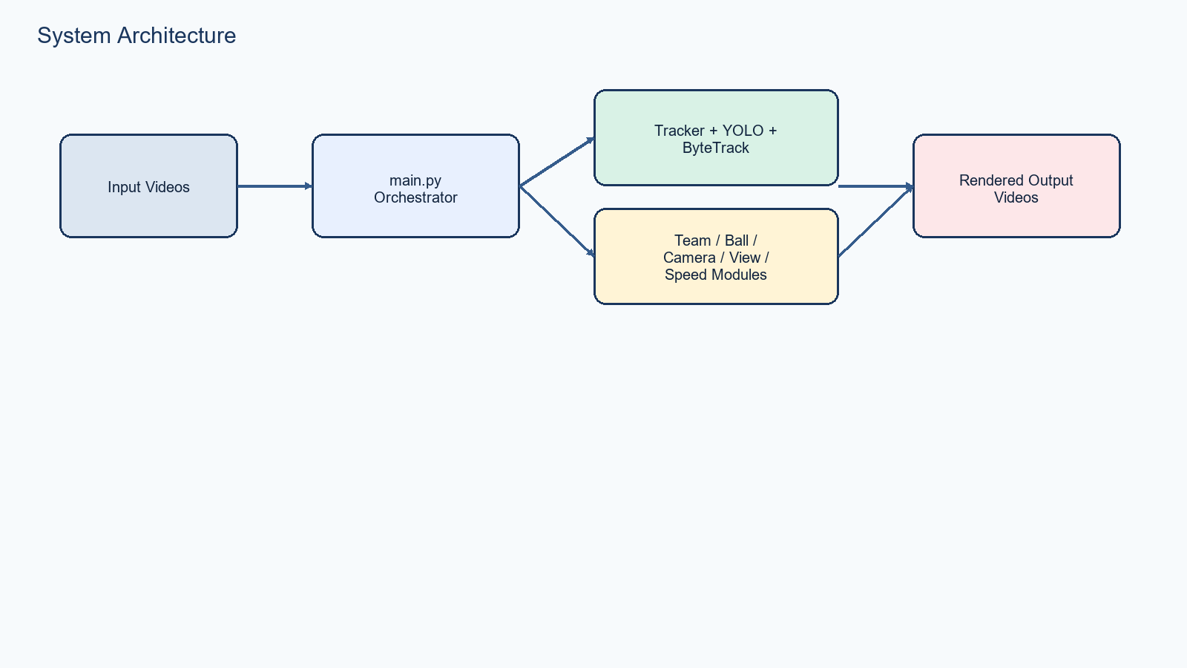

3. Folder Structure Analysis
Recursive project tree (limited to major project depth for readability):
Football_Analysis/
├── camera_movement_estimator
│ ├── __init__.py
│ └── camera_movement_estimator.py
├── development_and_analysis
│ └── color_assignment.ipynb
├── input_videos
│ ├── 08fd33_4.mp4
│ ├── 1.mp4
│ ├── 13433649_3840_2160_30fps.mp4
│ ├── 2.mp4
│ ├── 3.mp4
│ └── fbb.mp4
├── models
│ └── best.pt
├── output_videos
│ ├── 08fd33_4_output.avi
│ ├── 1_output.avi
│ ├── 2_output.avi
│ └── 3_output.avi
├── player_ball_assigner
│ ├── __init__.py
│ └── player_ball_assigner.py
├── reports
│ ├── build_full_project_report.py
│ ├── build_project_report.py
│ └── Football_Analysis_Project_Report.docx
├── speed_and_distance_estimator
│ ├── __init__.py
│ └── speed_and_distance_estimator.py
├── stubs
│ ├── 08fd33_4_camera_movement_stub.pkl
│ ├── 08fd33_4_track_stubs.pkl
│ ├── 1_camera_movement_stub.pkl
│ ├── 1_track_stubs.pkl
│ ├── 2_camera_movement_stub.pkl
│ ├── 2_track_stubs.pkl
│ ├── 3_camera_movement_stub.pkl
│ ├── 3_track_stubs.pkl
│ ├── camera_movement_stub.pkl
│ ├── fbb_camera_movement_stub.pkl
│ ├── fbb_track_stubs.pkl
│ └── track_stubs.pkl
├── team_assigner
│ ├── __init__.py
│ └── team_assigner.py
├── trackers
│ ├── __init__.py
│ └── tracker.py
├── training
│ ├── football-players-detection-1
│ │ ├── football-players-detection-1
│ │ │ ├── test
│ │ │ ├── train
│ │ │ └── valid
│ │ ├── data.yaml
│ │ ├── README.dataset.txt
│ │ └── README.roboflow.txt
│ └── football_training_yolo_v5.ipynb
├── utils
│ ├── __init__.py
│ ├── bbox_utils.py
│ └── video_utils.py
├── view_transformer
│ ├── __int__.py
│ └── view_transformer.py
├── main.py
├── README.md
├── requirements.txt
├── yolo_inference.py
└── yolov8m.pt
Folder purpose summary:
Folder | Purpose
camera_movement_estimator | Contains optical-flow based motion compensation logic.
development_and_analysis | Contains analysis notebooks used while building or validating parts of the pipeline.
input_videos | Stores source match videos passed to the analytics pipeline.
models | Stores trained model weights used for inference.
output_videos | Stores rendered output videos with overlays and analysis annotations.
player_ball_assigner | Contains nearest-player logic for assigning ball possession.
reports | Contains generated documentation artifacts and report builder scripts.
speed_and_distance_estimator | Contains transformed-motion speed and distance calculations.
stubs | Stores cached pickle files for tracks and camera movement to avoid repeated recomputation.
team_assigner | Contains jersey-color clustering logic used to assign players to teams.
trackers | Contains detection-to-tracking conversion and annotation drawing logic.
training | Contains model training notebooks, dataset metadata, and local training dataset export.
utils | Contains shared video and bounding-box helper functions.
view_transformer | Contains perspective transform logic for mapping image points to field coordinates.

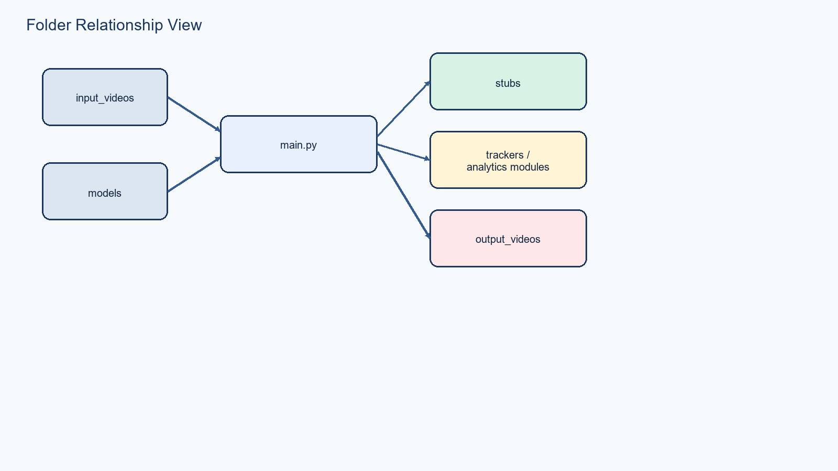

4. File-by-File Analysis

main.py
Primary execution script that orchestrates the full inference, tracking, analytics, and rendering pipeline.
- File path: C:\Users\gsrio\Music\FootBallAnalysis\Football_Analysis\main.py
- Exists: Yes
- Size: 5279 bytes
- Approximate line count: 128
- Direct imports: os; pathlib: Path; cv2; numpy; utils: read_video, save_video; trackers: Tracker; team_assigner: TeamAssigner; player_ball_assigner: PlayerBallAssigner; camera_movement_estimator: CameraMovementEstimator; view_transformer.view_transformer: ViewTransformer; speed_and_distance_estimator: SpeedAndDistanceEstimator
- Current configured input path: input_videos/1.mp4
- Current resize_width argument: None
- Current max_frames argument: 1200
- Current track stub pattern: f'stubs/{input_video_name}_track_stubs.pkl'
- Current camera stub pattern: f'stubs/{input_video_name}_camera_movement_stub.pkl'
- Current output save path expression: f'output_videos/{input_video_name}_output.avi'

yolo_inference.py
Standalone quick inference script for directly testing YOLO predictions on a video.
- File path: C:\Users\gsrio\Music\FootBallAnalysis\Football_Analysis\yolo_inference.py
- Exists: Yes
- Size: 316 bytes
- Approximate line count: 11
- Direct imports: ultralytics: YOLO

README.md
Human-readable overview, setup instructions, and project summary.
- File path: C:\Users\gsrio\Music\FootBallAnalysis\Football_Analysis\README.md
- Exists: Yes
- Size: 6324 bytes

requirements.txt
Python dependency list required to run the project.
- File path: C:\Users\gsrio\Music\FootBallAnalysis\Football_Analysis\requirements.txt
- Exists: Yes
- Size: 70 bytes

trackers/tracker.py
Core tracking module that runs YOLO inference, structures tracks, interpolates ball detections, and draws overlays.
- File path: C:\Users\gsrio\Music\FootBallAnalysis\Football_Analysis\trackers\tracker.py
- Exists: Yes
- Size: 8833 bytes
- Approximate line count: 236
- Direct imports: cv2; scipy.stats: triang; ultralytics: YOLO; supervision; pickle; os; numpy; pandas; sys; utils: get_center_of_bbox, get_bbox_width, get_foot_position

trackers/__init__.py
Package export file for Tracker.
- File path: C:\Users\gsrio\Music\FootBallAnalysis\Football_Analysis\trackers\__init__.py
- Exists: Yes
- Size: 28 bytes
- Approximate line count: 1
- Direct imports: tracker: Tracker

team_assigner/team_assigner.py
Assigns players to one of two teams using KMeans clustering over jersey-color crops.
- File path: C:\Users\gsrio\Music\FootBallAnalysis\Football_Analysis\team_assigner\team_assigner.py
- Exists: Yes
- Size: 2447 bytes
- Approximate line count: 74
- Direct imports: sklearn.cluster: KMeans

team_assigner/__init__.py
Package export file for TeamAssigner.
- File path: C:\Users\gsrio\Music\FootBallAnalysis\Football_Analysis\team_assigner\__init__.py
- Exists: Yes
- Size: 53 bytes
- Approximate line count: 7
- Direct imports: team_assigner: TeamAssigner

player_ball_assigner/player_ball_assigner.py
Chooses the player closest to the detected ball.
- File path: C:\Users\gsrio\Music\FootBallAnalysis\Football_Analysis\player_ball_assigner\player_ball_assigner.py
- Exists: Yes
- Size: 964 bytes
- Approximate line count: 29
- Direct imports: sys; utils: get_center_of_bbox, measure_distance

player_ball_assigner/__init__.py
Package export file for PlayerBallAssigner.
- File path: C:\Users\gsrio\Music\FootBallAnalysis\Football_Analysis\player_ball_assigner\__init__.py
- Exists: Yes
- Size: 52 bytes
- Approximate line count: 1
- Direct imports: player_ball_assigner: PlayerBallAssigner

camera_movement_estimator/camera_movement_estimator.py
Computes camera motion using Lucas-Kanade optical flow on edge features and renders motion text.
- File path: C:\Users\gsrio\Music\FootBallAnalysis\Football_Analysis\camera_movement_estimator\camera_movement_estimator.py
- Exists: Yes
- Size: 4674 bytes
- Approximate line count: 125
- Direct imports: os.path; pickle; cv2; numpy; sys; utils: measure_distance, measure_xy_distance

camera_movement_estimator/__init__.py
Package export file for CameraMovementEstimator.
- File path: C:\Users\gsrio\Music\FootBallAnalysis\Football_Analysis\camera_movement_estimator\__init__.py
- Exists: Yes
- Size: 63 bytes
- Approximate line count: 1
- Direct imports: camera_movement_estimator: CameraMovementEstimator

speed_and_distance_estimator/speed_and_distance_estimator.py
Computes and renders player speed and distance using transformed coordinates.
- File path: C:\Users\gsrio\Music\FootBallAnalysis\Football_Analysis\speed_and_distance_estimator\speed_and_distance_estimator.py
- Exists: Yes
- Size: 3462 bytes
- Approximate line count: 83
- Direct imports: sys; cv2; utils: measure_distance, get_foot_position

speed_and_distance_estimator/__init__.py
Package export file for SpeedAndDistanceEstimator.
- File path: C:\Users\gsrio\Music\FootBallAnalysis\Football_Analysis\speed_and_distance_estimator\__init__.py
- Exists: Yes
- Size: 67 bytes
- Approximate line count: 1
- Direct imports: speed_and_distance_estimator: SpeedAndDistanceEstimator

view_transformer/view_transformer.py
Defines and applies a perspective transform from image coordinates to pitch coordinates.
- File path: C:\Users\gsrio\Music\FootBallAnalysis\Football_Analysis\view_transformer\view_transformer.py
- Exists: Yes
- Size: 1868 bytes
- Approximate line count: 49
- Direct imports: cv2; numpy

view_transformer/__int__.py
Package export file for ViewTransformer; likely intended to be named __init__.py.
- File path: C:\Users\gsrio\Music\FootBallAnalysis\Football_Analysis\view_transformer\__int__.py
- Exists: Yes
- Size: 45 bytes
- Approximate line count: 1
- Direct imports: view_transformer: ViewTransformer

utils/bbox_utils.py
Geometry helper functions for centers, widths, distances, and player foot locations.
- File path: C:\Users\gsrio\Music\FootBallAnalysis\Football_Analysis\utils\bbox_utils.py
- Exists: Yes
- Size: 436 bytes
- Approximate line count: 19
- Direct imports: math

utils/video_utils.py
Video reading and writing helpers with optional resize and frame limiting.
- File path: C:\Users\gsrio\Music\FootBallAnalysis\Football_Analysis\utils\video_utils.py
- Exists: Yes
- Size: 990 bytes
- Approximate line count: 36
- Direct imports: cv2

utils/__init__.py
Package export file for utility functions.
- File path: C:\Users\gsrio\Music\FootBallAnalysis\Football_Analysis\utils\__init__.py
- Exists: Yes
- Size: 170 bytes
- Approximate line count: 3
- Direct imports: video_utils: read_video, save_video; bbox_utils: get_center_of_bbox, get_bbox_width, measure_distance, measure_xy_distance, get_foot_position

training/football_training_yolo_v5.ipynb
Notebook describing dataset download, Ultralytics training, and weight export.
- File path: C:\Users\gsrio\Music\FootBallAnalysis\Football_Analysis\training\football_training_yolo_v5.ipynb
- Exists: Yes
- Size: 43779 bytes
- Notebook cell count: 12
- Notebook is used for experimentation and does not participate directly in the main runtime import chain.
Cell | Type | Role preview
0 | code | !pip install ultralytics !pip install roboflow
1 | code | from roboflow import Roboflow rf = Roboflow(api_key="32S0IolmZV8gAq2ny32C") project [...]
2 | code | dataset.location
3 | code | import shutil shutil.move('football-players-detection-1/train', 'football-players- [...]
4 | markdown | Training
5 | code | !yolo task=detect mode=train model=yolov5x.pt data={dataset.location}/data.yaml [...]
7 | code | from google.colab import drive drive.mount('/content/drive')
8 | code | mkdir -p /content/drive/MyDrive/Colab\ Notebooks/football_analysis_project/yolov5
9 | code | !cp runs/detect/train/weights/best.pt /content/drive/MyDrive/Colab\ [...]
10 | code | !cp runs/detect/train/weights/last.pt /content/drive/MyDrive/Colab\ [...]

development_and_analysis/color_assignment.ipynb
Notebook used to prototype jersey-color clustering with KMeans.
- File path: C:\Users\gsrio\Music\FootBallAnalysis\Football_Analysis\development_and_analysis\color_assignment.ipynb
- Exists: Yes
- Size: 47573 bytes
- Notebook cell count: 11
- Notebook is used for experimentation and does not participate directly in the main runtime import chain.
Cell | Type | Role preview
0 | code | import cv2 import matplotlib.pyplot as plt import numpy as np from sklearn.cluster [...]
1 | code | image_path = "../output_videos/cropped_image.png" image = cv2.imread(image_path) [...]
2 | code | plt.imshow(image) plt.show()
3 | markdown | Take the top half of the image
4 | code | top_half_image = image[0: int(image.shape[0]/2), :] plt.imshow(top_half_image) plt.show()
5 | markdown | Cluster the image into two clusters
6 | code | #Reshape the image into 2D array image_2d = top_half_image.reshape(-1,3) #perform [...]
7 | code | corner_clusters = [clustered_image[0,0] , clustered_image[0,-1] , [...]
8 | code | player_cluster = 1- non_player_cluster print(player_cluster)
9 | code | kmeans.cluster_centers_[player_cluster]

training/football-players-detection-1/data.yaml
Ultralytics training configuration and class metadata file.
- File path: C:\Users\gsrio\Music\FootBallAnalysis\Football_Analysis\training\football-players-detection-1\data.yaml
- Exists: Yes
- Size: 395 bytes
Key | Value
Classes | ball, goalkeeper, player, referee
Number of classes | 4
Train path | football-players-detection-1/train/images
Validation path | football-players-detection-1/valid/images
Test path | ../test/images
Roboflow URL | https://universe.roboflow.com/roboflow-jvuqo/football-players-detection-3zvbc/dataset/1

training/football-players-detection-1/README.dataset.txt
Roboflow dataset export metadata and augmentation notes.
- File path: C:\Users\gsrio\Music\FootBallAnalysis\Football_Analysis\training\football-players-detection-1\README.dataset.txt
- Exists: Yes
- Size: 183 bytes

training/football-players-detection-1/README.roboflow.txt
Roboflow dataset provenance and license details.
- File path: C:\Users\gsrio\Music\FootBallAnalysis\Football_Analysis\training\football-players-detection-1\README.roboflow.txt
- Exists: Yes
- Size: 849 bytes

5. Function-by-Function Documentation
Function / Method | File | Parameters | Return Type | Kind | Called By
main | main.py | - | Not explicitly annotated | function | No direct local reference found
Tracker.__init__ | trackers/tracker.py | self, model_path | Not explicitly annotated | method | No direct local reference found
Tracker.add_position_to_tracks | trackers/tracker.py | self, tracks | Not explicitly annotated | method | main
Tracker.interpolate_ball_positions | trackers/tracker.py | self, ball_positions | Not explicitly annotated | method | main
Tracker.detect_frames | trackers/tracker.py | self, frames | Not explicitly annotated | method | Tracker.get_object_tracks
Tracker.get_object_tracks | trackers/tracker.py | self, frames, read_from_stub, stub_path | Not explicitly annotated | method | main
Tracker.draw_ellipse | trackers/tracker.py | self, frame, bbox, color, track_id | Not explicitly annotated | method | Tracker.draw_annotations
Tracker.draw_triangle | trackers/tracker.py | self, frame, bbox, color | Not explicitly annotated | method | Tracker.draw_annotations
Tracker.draw_team_ball_control | trackers/tracker.py | self, frame, frame_num, team_ball_control | Not explicitly annotated | method | Tracker.draw_annotations
Tracker.draw_annotations | trackers/tracker.py | self, video_frames, tracks, team_ball_control | Not explicitly annotated | method | main
TeamAssigner.__init__ | team_assigner/team_assigner.py | self | Not explicitly annotated | method | No direct local reference found
TeamAssigner.get_clustering_model | team_assigner/team_assigner.py | self, image | Not explicitly annotated | method | TeamAssigner.get_player_color
TeamAssigner.get_player_color | team_assigner/team_assigner.py | self, frame, bbox | Not explicitly annotated | method | TeamAssigner.assign_team_color, TeamAssigner.get_player_team
TeamAssigner.assign_team_color | team_assigner/team_assigner.py | self, frame, player_detections | Not explicitly annotated | method | main
TeamAssigner.get_player_team | team_assigner/team_assigner.py | self, frame, player_bbox, player_id | Not explicitly annotated | method | main
PlayerBallAssigner.__init__ | player_ball_assigner/player_ball_assigner.py | self | Not explicitly annotated | method | No direct local reference found
PlayerBallAssigner.assign_ball_to_player | player_ball_assigner/player_ball_assigner.py | self, players, ball_bbox | Not explicitly annotated | method | main
CameraMovementEstimator.__init__ | camera_movement_estimator/camera_movement_estimator.py | self, frame | Not explicitly annotated | method | No direct local reference found
CameraMovementEstimator._get_features | camera_movement_estimator/camera_movement_estimator.py | self, gray_frame | Not explicitly annotated | method | CameraMovementEstimator.get_camera_movement
CameraMovementEstimator.add_adjust_positions_to_tracks | camera_movement_estimator/camera_movement_estimator.py | self, tracks, camera_movement_per_frame | Not explicitly annotated | method | main
CameraMovementEstimator.get_camera_movement | camera_movement_estimator/camera_movement_estimator.py | self, frames, read_from_stub, stub_path | Not explicitly annotated | method | main
CameraMovementEstimator.draw_camera_movement | camera_movement_estimator/camera_movement_estimator.py | self, frames, camera_movement_per_frame | Not explicitly annotated | method | main
SpeedAndDistanceEstimator.__init__ | speed_and_distance_estimator/speed_and_distance_estimator.py | self | Not explicitly annotated | method | No direct local reference found
SpeedAndDistanceEstimator.add_speed_and_distance_to_tracks | speed_and_distance_estimator/speed_and_distance_estimator.py | self, tracks | Not explicitly annotated | method | main
SpeedAndDistanceEstimator.draw_speed_and_distance | speed_and_distance_estimator/speed_and_distance_estimator.py | self, frames, tracks | Not explicitly annotated | method | main
ViewTransformer.__init__ | view_transformer/view_transformer.py | self | Not explicitly annotated | method | No direct local reference found
ViewTransformer.transform_point | view_transformer/view_transformer.py | self, point | Not explicitly annotated | method | ViewTransformer.add_transformed_position_to_tracks
ViewTransformer.add_transformed_position_to_tracks | view_transformer/view_transformer.py | self, tracks | Not explicitly annotated | method | main
get_center_of_bbox | utils/bbox_utils.py | bbox | Not explicitly annotated | function | PlayerBallAssigner.assign_ball_to_player, Tracker.add_position_to_tracks, Tracker.draw_ellipse, Tracker.draw_triangle
get_bbox_width | utils/bbox_utils.py | bbox | Not explicitly annotated | function | Tracker.draw_ellipse
measure_distance | utils/bbox_utils.py | p1, p2 | Not explicitly annotated | function | CameraMovementEstimator.get_camera_movement, PlayerBallAssigner.assign_ball_to_player, SpeedAndDistanceEstimator.add_speed_and_distance_to_tracks
measure_xy_distance | utils/bbox_utils.py | p1, p2 | Not explicitly annotated | function | CameraMovementEstimator.get_camera_movement
get_foot_position | utils/bbox_utils.py | bbox | Not explicitly annotated | function | SpeedAndDistanceEstimator.draw_speed_and_distance, Tracker.add_position_to_tracks
read_video | utils/video_utils.py | path, resize_width, max_frames | Not explicitly annotated | function | main
save_video | utils/video_utils.py | output_video_frames, output_video_path | Not explicitly annotated | function | main

main.py

main
Parameters: None declared explicitly beyond defaults.
- Symbol kind: function
- Declared at line: 20
- Called by: No direct local call match found
- Internal call names referenced: read_video, Tracker, get_object_tracks, add_position_to_tracks, CameraMovementEstimator, get_camera_movement, add_adjust_positions_to_tracks, ViewTransformer, add_transformed_position_to_tracks, interpolate_ball_positions, SpeedAndDistanceEstimator, add_speed_and_distance_to_tracks, TeamAssigner, assign_team_color, enumerate, PlayerBallAssigner, enumerate, array, draw_annotations, draw_camera_movement, draw_speed_and_distance, save_video, Path, items, assign_ball_to_player, get_player_team, append, append

trackers/tracker.py

Tracker.__init__
Parameters: self, model_path
- Symbol kind: method
- Declared at line: 14
- Called by: No direct local call match found
- Internal call names referenced: YOLO, ByteTrack

Tracker.add_position_to_tracks
Parameters: self, tracks
- Symbol kind: method
- Declared at line: 18
- Called by: main
- Internal call names referenced: items, enumerate, items, get_center_of_bbox, get_foot_position

Tracker.interpolate_ball_positions
Parameters: self, ball_positions
- Symbol kind: method
- Declared at line: 29
- Called by: main
- Internal call names referenced: DataFrame, interpolate, bfill, get, tolist, get, to_numpy

Tracker.detect_frames
Parameters: self, frames
- Symbol kind: method
- Declared at line: 43
- Called by: Tracker.get_object_tracks
- Internal call names referenced: range, len, predict

Tracker.get_object_tracks
Parameters: self, frames, read_from_stub, stub_path
- Symbol kind: method
- Declared at line: 51
- Called by: main
- Internal call names referenced: detect_frames, enumerate, exists, print, from_ultralytics, enumerate, update_with_detections, append, append, append, open, load, tolist, tolist, open, dump, items

Tracker.draw_ellipse
Parameters: self, frame, bbox, color, track_id
- Symbol kind: method
- Declared at line: 113
- Called by: Tracker.draw_annotations
- Internal call names referenced: int, get_center_of_bbox, get_bbox_width, ellipse, rectangle, putText, int, int, int, int, int, int, int, int, int, int

Tracker.draw_triangle
Parameters: self, frame, bbox, color
- Symbol kind: method
- Declared at line: 160
- Called by: Tracker.draw_annotations
- Internal call names referenced: int, get_center_of_bbox, array, drawContours, drawContours

Tracker.draw_team_ball_control
Parameters: self, frame, frame_num, team_ball_control
- Symbol kind: method
- Declared at line: 177
- Called by: Tracker.draw_annotations
- Internal call names referenced: copy, rectangle, addWeighted, array, putText, putText

Tracker.draw_annotations
Parameters: self, video_frames, tracks, team_ball_control
- Symbol kind: method
- Declared at line: 205
- Called by: main
- Internal call names referenced: enumerate, copy, items, items, items, draw_team_ball_control, append, get, draw_ellipse, get, draw_ellipse, draw_triangle, draw_triangle, get

team_assigner/team_assigner.py

TeamAssigner.__init__
Parameters: self
- Symbol kind: method
- Declared at line: 4
- Called by: No direct local call match found
- Internal call names referenced: No nested calls detected by AST scan

TeamAssigner.get_clustering_model
Parameters: self, image
- Symbol kind: method
- Declared at line: 8
- Called by: TeamAssigner.get_player_color
- Internal call names referenced: reshape, KMeans, fit

TeamAssigner.get_player_color
Parameters: self, frame, bbox
- Symbol kind: method
- Declared at line: 19
- Called by: TeamAssigner.assign_team_color, TeamAssigner.get_player_team
- Internal call names referenced: get_clustering_model, reshape, max, set, int, int, int, int, int

TeamAssigner.assign_team_color
Parameters: self, frame, player_detections
- Symbol kind: method
- Declared at line: 42
- Called by: main
- Internal call names referenced: items, KMeans, fit, get_player_color, append

TeamAssigner.get_player_team
Parameters: self, frame, player_bbox, player_id
- Symbol kind: method
- Declared at line: 58
- Called by: main
- Internal call names referenced: get_player_color, predict, reshape

player_ball_assigner/player_ball_assigner.py

PlayerBallAssigner.__init__
Parameters: self
- Symbol kind: method
- Declared at line: 6
- Called by: No direct local call match found
- Internal call names referenced: No nested calls detected by AST scan

PlayerBallAssigner.assign_ball_to_player
Parameters: self, players, ball_bbox
- Symbol kind: method
- Declared at line: 9
- Called by: main
- Internal call names referenced: get_center_of_bbox, items, measure_distance, measure_distance, min

camera_movement_estimator/camera_movement_estimator.py

CameraMovementEstimator.__init__
Parameters: self, frame
- Symbol kind: method
- Declared at line: 13
- Called by: No direct local call match found
- Internal call names referenced: dict, cvtColor, zeros_like, max, dict, max

CameraMovementEstimator._get_features
Parameters: self, gray_frame
- Symbol kind: method
- Declared at line: 41
- Called by: CameraMovementEstimator.get_camera_movement
- Internal call names referenced: goodFeaturesToTrack

CameraMovementEstimator.add_adjust_positions_to_tracks
Parameters: self, tracks, camera_movement_per_frame
- Symbol kind: method
- Declared at line: 44
- Called by: main
- Internal call names referenced: items, enumerate, items

CameraMovementEstimator.get_camera_movement
Parameters: self, frames, read_from_stub, stub_path
- Symbol kind: method
- Declared at line: 55
- Called by: main
- Internal call names referenced: cvtColor, _get_features, range, exists, len, len, cvtColor, calcOpticalFlowPyrLK, enumerate, copy, open, load, _get_features, _get_features, copy, zip, ravel, ravel, measure_distance, _get_features, open, dump, len, copy, len, measure_xy_distance, len

CameraMovementEstimator.draw_camera_movement
Parameters: self, frames, camera_movement_per_frame
- Symbol kind: method
- Declared at line: 106
- Called by: main
- Internal call names referenced: enumerate, copy, copy, rectangle, addWeighted, putText, putText, append

speed_and_distance_estimator/speed_and_distance_estimator.py

SpeedAndDistanceEstimator.__init__
Parameters: self
- Symbol kind: method
- Declared at line: 9
- Called by: No direct local call match found
- Internal call names referenced: No nested calls detected by AST scan

SpeedAndDistanceEstimator.add_speed_and_distance_to_tracks
Parameters: self, tracks
- Symbol kind: method
- Declared at line: 13
- Called by: main
- Internal call names referenced: items, len, range, min, items, get, get, get, get, measure_distance, range

SpeedAndDistanceEstimator.draw_speed_and_distance
Parameters: self, frames, tracks
- Symbol kind: method
- Declared at line: 57
- Called by: main
- Internal call names referenced: enumerate, items, append, items, get, get, get_foot_position, list, tuple, putText, putText, map

view_transformer/view_transformer.py

ViewTransformer.__init__
Parameters: self
- Symbol kind: method
- Declared at line: 6
- Called by: No direct local call match found
- Internal call names referenced: array, array, astype, astype, getPerspectiveTransform

ViewTransformer.transform_point
Parameters: self, point
- Symbol kind: method
- Declared at line: 29
- Called by: ViewTransformer.add_transformed_position_to_tracks
- Internal call names referenced: astype, perspectiveTransform, reshape, int, int, pointPolygonTest, reshape

ViewTransformer.add_transformed_position_to_tracks
Parameters: self, tracks
- Symbol kind: method
- Declared at line: 40
- Called by: main
- Internal call names referenced: items, enumerate, items, array, transform_point, tolist, squeeze

utils/bbox_utils.py

get_center_of_bbox
Parameters: bbox
- Symbol kind: function
- Declared at line: 4
- Called by: PlayerBallAssigner.assign_ball_to_player, Tracker.add_position_to_tracks, Tracker.draw_ellipse, Tracker.draw_triangle
- Internal call names referenced: int, int

get_bbox_width
Parameters: bbox
- Symbol kind: function
- Declared at line: 8
- Called by: Tracker.draw_ellipse
- Internal call names referenced: No nested calls detected by AST scan

measure_distance
Parameters: p1, p2
- Symbol kind: function
- Declared at line: 11
- Called by: CameraMovementEstimator.get_camera_movement, PlayerBallAssigner.assign_ball_to_player, SpeedAndDistanceEstimator.add_speed_and_distance_to_tracks
- Internal call names referenced: sqrt

measure_xy_distance
Parameters: p1, p2
- Symbol kind: function
- Declared at line: 14
- Called by: CameraMovementEstimator.get_camera_movement
- Internal call names referenced: No nested calls detected by AST scan

get_foot_position
Parameters: bbox
- Symbol kind: function
- Declared at line: 17
- Called by: SpeedAndDistanceEstimator.draw_speed_and_distance, Tracker.add_position_to_tracks
- Internal call names referenced: int, int

utils/video_utils.py

read_video
Parameters: path, resize_width, max_frames
- Symbol kind: function
- Declared at line: 3
- Called by: main
- Internal call names referenced: VideoCapture, release, read, append, int, resize

save_video
Parameters: output_video_frames, output_video_path
- Symbol kind: function
- Declared at line: 26
- Called by: main
- Internal call names referenced: VideoWriter_fourcc, VideoWriter, release, write

6. Notebook Analysis

training/football_training_yolo_v5.ipynb
- Purpose: download the dataset, train the YOLO detector, and export resulting weights.
- Cell 0 installs ultralytics and roboflow.
- Cell 1 authenticates Roboflow, selects the project/version, and downloads the dataset in YOLOv5 format.
- Cell 3 manually moves split folders into the structure expected by the project.
- Cell 5 launches training with yolo task=detect mode=train model=yolov5x.pt data={dataset.location}/data.yaml epochs=10 imgsz=640.
- Cells 7-10 mount Google Drive and copy best.pt and last.pt into a persistent location.

development_and_analysis/color_assignment.ipynb
- Purpose: prototype and validate the jersey-color clustering logic later implemented in team_assigner.py.
- Loads a cropped player image, converts it to RGB, isolates the top half, reshapes pixels into a 2D feature array, and runs KMeans with 2 clusters.
- Uses corner-cluster voting to infer which cluster is background and which one likely belongs to the player's jersey.

7. Dataset Analysis
Property | Value
Dataset source | https://universe.roboflow.com/roboflow-jvuqo/football-players-detection-3zvbc/dataset/1
License | CC BY 4.0
Format | YOLOv5 PyTorch detection format
Classes | ball, goalkeeper, player, referee
Total local image count | 663
Train images | 612
Validation images | 38
Test images | 13
Augmentation | 50% horizontal flip and random brightness adjustment between -20% and +20%

- Dataset type: image detection dataset, not a tabular CSV dataset.
- Label encoding: YOLO bounding-box text files paired with images.
- Sample rows / correlation analysis: not applicable in the traditional tabular sense because the project uses image data and YOLO label files.
- Image dimensions vary by source clip frame extraction; the training config resizes at training time via imgsz=640.

8. Model Architecture Analysis
- Inference model used by the project runtime: models/best.pt loaded through ultralytics.YOLO.
- Training base model indicated by notebook: yolov5x.pt.
- Model task: object detection with four classes: ball, goalkeeper, player, referee.
- Training command in notebook specifies imgsz=640 and epochs=10.
- Loss, optimizer, and layer internals are managed inside Ultralytics and are not redefined in project source files.
- The repository stores final trained weights rather than a hand-written neural-network class definition.
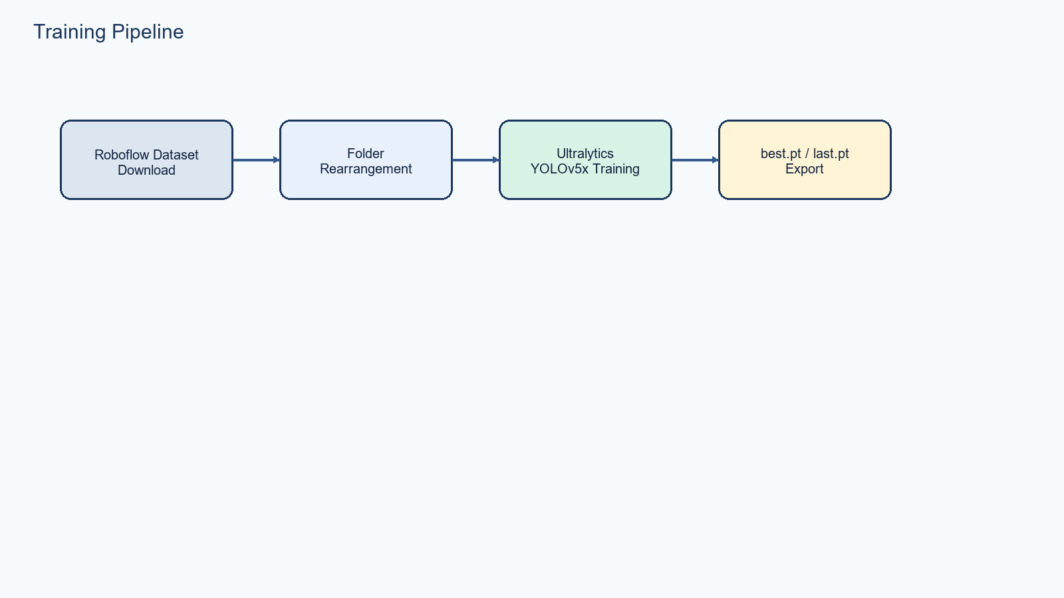

9. Training Pipeline Explanation
- 1. Data loading: notebook downloads the Roboflow dataset with the roboflow SDK.
- 2. Data preprocessing: folder restructuring and Roboflow-provided augmentation configuration.
- 3. Feature extraction: handled internally by the YOLO architecture during training.
- 4. Dataset split usage: train/valid/test paths are defined in data.yaml.
- 5. Model initialization: yolo detect train starts from yolov5x.pt pretrained weights.
- 6. Training loop: managed inside the Ultralytics trainer.
- 7. Loss calculation: managed inside Ultralytics for objectness/classification/box regression.
- 8. Optimization and backpropagation: handled by Ultralytics runtime.
- 9. Validation: validation data path is provided in data.yaml and evaluated during training.
- 10. Model saving: best.pt and last.pt written under runs/detect/train/weights.
- 11. Export / persistence: notebook copies these weights to Google Drive.

10. Input and Output Flow
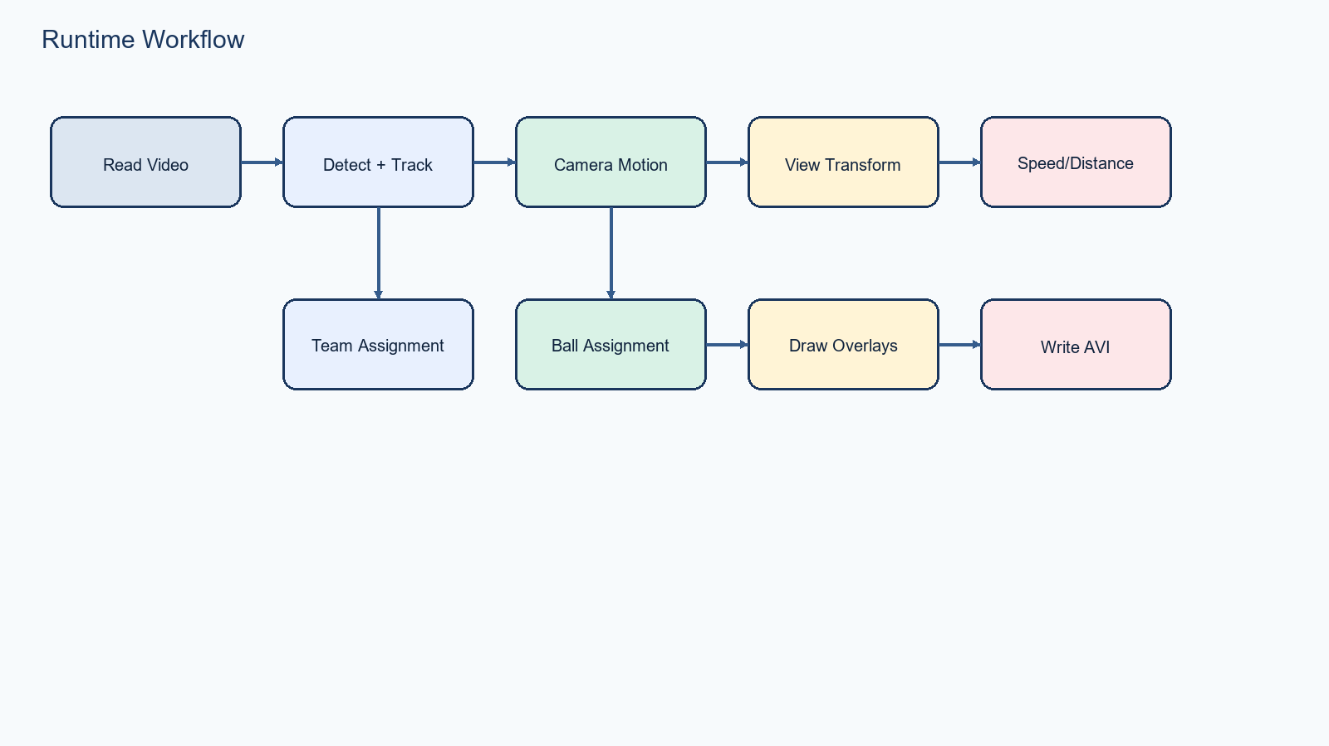
- User input: a chosen video path in main.py plus model weights in models/best.pt.
- Intermediate transformations: frame extraction, detection, tracking, motion adjustment, perspective mapping, team assignment, possession assignment, overlay rendering.
- Final output: an AVI video saved to output_videos with per-frame visual analytics overlays.
- Cached auxiliary outputs: pickle files in stubs storing tracking dictionaries and camera-motion vectors.

11. Library and Dependency Analysis
Library | Project role
ultralytics | Loads YOLO models, performs inference, and is used by the training notebook for model training.
supervision | Provides ByteTrack and detection wrappers for converting Ultralytics results into trackable objects.
cv2 / OpenCV | Video I/O, image resizing, drawing, color conversion, optical flow, perspective transform, and text rendering.
numpy | Array operations, polygon / point shaping, masking, and trajectory storage.
pandas | Interpolates missing ball detections.
scikit-learn | Runs KMeans for team color clustering.
pickle | Serializes and loads cached stubs.
yaml | Loads training metadata from data.yaml.
roboflow | Dataset download in the notebook.

12. Algorithm Explanation
Algorithm | Where used | How it works | Why selected | Limits
YOLO object detection | Tracker.detect_frames() | One-stage detector predicts boxes and classes directly from images. | Fast and widely used for real-time detection tasks. | Dependent on training data quality and can miss small fast objects like a football.
ByteTrack | Tracker.get_object_tracks() | Associates detections across frames to preserve ids over time. | Simple ready-to-use tracker available through supervision. | Current API is deprecated in installed supervision version.
KMeans clustering | TeamAssigner | Clusters jersey pixel colors into two groups and then clusters players into two teams. | No manual team labels are needed for the match clip. | Sensitive to lighting, crop quality, and background contamination.
Lucas-Kanade optical flow | CameraMovementEstimator | Tracks sparse corner features between consecutive frames to estimate camera motion. | Efficient sparse motion estimation for frame-to-frame compensation. | Can fail when insufficient stable features are found.
Perspective transform | ViewTransformer | Maps image points inside a four-point polygon into pitch coordinates. | Provides approximate metric space for speed and distance estimation. | Requires manually chosen corner coordinates and assumes a fixed geometry.
Nearest-neighbor possession assignment | PlayerBallAssigner | Selects the nearest player foot endpoint to the ball center within a threshold. | Simple heuristic with low computation cost. | May be incorrect during close contests, occlusion, or poor ball detection.

13. Evaluation Metrics
- The runtime repository does not compute accuracy, precision, recall, F1-score, ROC-AUC, or confusion matrices directly in code.
- README.md references RMSE and MAPE, but those metrics are not implemented in the inspected Python runtime files and appear to be leftover or unrelated documentation content.
- Operational runtime quality is mainly observed visually through the correctness of detections, tracks, overlays, and output videos.
- Where mathematically relevant, speed is computed as distance / time and converted from m/s to km/h by multiplying by 3.6.

14. Visualization and Output Analysis
- Ellipses indicate tracked players and referees. Player ellipses use the assigned team color; referee ellipses are yellow.
- Track ids are shown in filled rectangles near the player ellipse base.
- A green triangle marks the ball; a red triangle marks the player who currently has the ball according to the possession heuristic.
- Ball control percentages are computed cumulatively over processed frames and drawn in the lower-right overlay panel.
- Camera movement text is drawn on a translucent overlay near the top-left of the frame.
- Speed and distance are drawn below tracked players when transformed positions are available.

15. Execution Workflow
pip install -r requirements.txt
python main.py
# Optional quick detector-only check
python yolo_inference.py
- Place videos in input_videos/.
- Place trained best.pt in models/.
- If using long videos, adjust resize_width and max_frames in main.py to stay within memory limits.
- Per-video stubs should be cleared or renamed when switching inputs if you want fresh recomputation.

16. Error Handling and Edge Cases
- Missing supervision package causes ModuleNotFoundError at tracker import time.
- Broken Ultralytics roaming-profile settings can cause settings.json errors; current main.py redirects configuration into a local .ultralytics folder.
- Using stubs from one video with a different video can cause frame-count mismatch index errors.
- If no player is assigned the ball in the earliest frame, possession logic must handle an empty history; current main.py now falls back to 0.
- Large videos can exhaust memory because frames are stored in RAM before processing and again during rendering.
- Camera motion estimation can fail when no valid corners exist; current implementation now reacquires features and skips bad frames.

17. Performance Optimization
- Current optimization strategy: optional stub caching of tracks and camera motion to skip repeated expensive stages.
- Current video loading helper supports resize_width and max_frames to reduce memory load on long videos.
- Possible improvements: stream frames instead of loading entire videos; write output incrementally; reuse detection tensors; preserve source FPS; avoid duplicate full-frame copies in multiple rendering stages.

18. Future Improvements
- Replace or update deprecated ByteTrack integration to the current supervision API.
- Add a streaming pipeline that does not keep all frames in memory.
- Use stronger ball-tracking or re-identification for more robust possession estimates.
- Add evaluation scripts with measurable detection/tracking metrics.
- Expose the pipeline as a web app or API for interactive usage.
- Parameterize all hard-coded file paths, polygon points, FPS assumptions, and team overrides.

19. Conclusion
The Football_Analysis project successfully combines detector inference, tracking, team clustering, optical-flow based camera compensation, perspective projection, and trajectory-based metrics into a single end-to-end football analysis workflow. Its strengths are modularity, readability, and clear extension points. Its main technical limitations are memory usage, hard-coded assumptions, and partial dependence on notebook/manual setup steps. Even with those limits, the repository is a strong academic or prototype-level sports analytics implementation.

