Week 7: demo, API handoff, and responsible AI
This week puts a page on the server that already scores notebooks, and a second route that reads one score and says whether a person should review it. The served marks stay the Ridge marks from week3_combined. The optional Grok grader stays off. No model was refit.

1. What this week adds
- A demo page at http://127.0.0.1:8000/.
- POST /support-signal, a reader for a student-support tool.
- The architecture picture in docs/architecture.png.
- The responsible-AI page in docs/responsible_ai.md.

2. How to run the demo
From the package directory, when results/week6/asset/ and models/all-MiniLM-L6-v2-onnx/ are already present:
python -m venv .venv
.venv\Scripts\pip install -r requirements.txt
python -m src.api.app
Leave that window open. In a browser on this machine, open http://127.0.0.1:8000/. Choose a file and a lab id, then submit. The page sends the file to POST /evaluate-notebook. It shows code, explanation, documentation, overall, output match, errors, missing ideas, feedback, the weak-explanation flag, and confidence. It then posts that JSON to POST /support-signal. The second call does not score the notebook again.
The page says the student's code is not executed and the mark is a suggestion for the instructor.
If the asset folder or the encoder folder is missing, run python scripts/fetch_models.py and then python scripts/fit_week6_asset.py before starting the server.

3. Three notebooks to try
examples/language_model_lab.ipynb with LAB_SYN2. Overall 15.14. Output match 1.0. The flag is true, so the support signal asks for a review. Task T3 misses inverse probability and surprise. Show this file if there is time for only one.
examples/tfidf_lab.ipynb with LAB_SYN1. Overall 18.17. Output match 1.0. The flag is false and the errors list is empty, so the support signal does not ask for a review.
examples/language_model_weak.ipynb with LAB_SYN2. Overall 7.28. Output match 0. The file has syntax errors, so the support signal asks for a review.

4. Language-model example
Marks for examples/language_model_lab.ipynb and LAB_SYN2: code 7.87, explanation 5.13, documentation 2.14, overall 15.14 out of 20. Output match 1.0. flag_output_ok_explanation_weak is true. Explanation confidence is 0.986. That confidence is agreement between Week 2 and Week 3. It is not a probability.
The support signal for that score has source notebook-lab-evaluator, assignment_id LAB_SYN2, overall 15.14, max_score 20, needs_human_review true, and the feedback sentence as the reason. The reason names inverse probability and surprise.

5. Where this component sits
The boxes below are the path from a notebook file to the demo page. The last box places the component in the course picture: Labs under Academic Services, with the support signal going to Student Services.
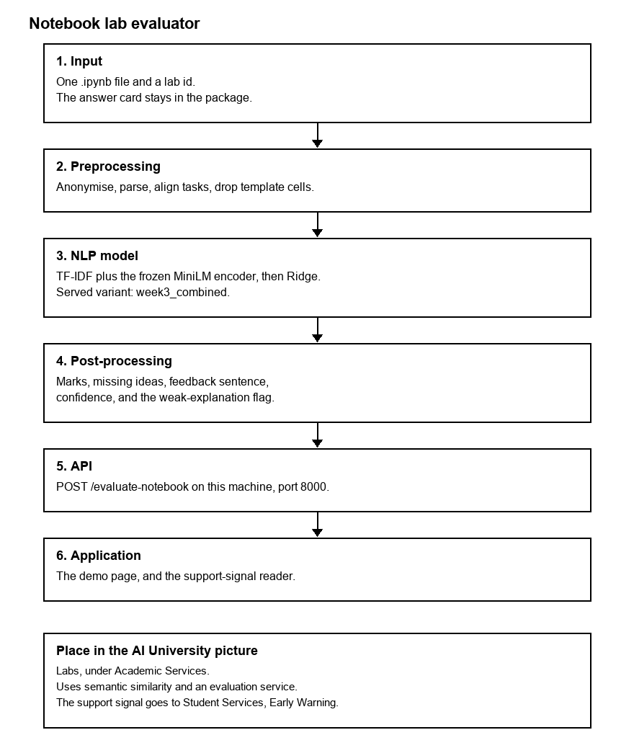
- Input. One .ipynb file and a lab id. The answer card stays in the package.
- Preprocessing. Anonymise, parse, align tasks, drop template cells.
- NLP model. TF-IDF plus the frozen MiniLM encoder, then Ridge. The served variant is week3_combined.
- Post-processing. Marks, missing ideas, a feedback sentence, confidence, and the weak-explanation flag.
- API. POST /evaluate-notebook on this machine, port 8000.
- Application. The demo page, and POST /support-signal.
This is not a live call to another group's server. This hand-in does not build their component. Another group calls POST /evaluate-notebook with a notebook and a lab id. A student-support tool calls POST /support-signal with the JSON that came back.

6. How another application calls the two routes
Score one notebook from a second window. On Windows, use curl.exe:
curl.exe -s -X POST http://127.0.0.1:8000/evaluate-notebook -F "assignment_id=LAB_SYN2" -F "file=@examples/language_model_lab.ipynb"
Ask whether a person should review a score already in hand. report is the JSON from the call above.
import httpx
signal = httpx.post("http://127.0.0.1:8000/support-signal", json=report)
signal.raise_for_status()
print(signal.json()["needs_human_review"])
For the language-model example that prints True. Field list and the answer-card files are in docs/manual.md. The short call is docs/API.md.

7. Responsible AI
The full page is docs/responsible_ai.md. The points below are the ones already recorded. No new experiment was run for this section.
- Privacy. Roll-number patterns are removed before scoring. The salt stays outside the repo. The server stays on this machine. Class notebooks are not in this package. With the Grok switch off, notebook text stays here.
- Bias. A wrong answer that reuses the reference words can look close. A correct paraphrase can score too low. The recorded MiniLM means are 0.861 and 0.424. Seventeen of twenty test explanations also appear in training. The test labels are rules, not faculty marks.
- Over-confidence. A mark printed to two decimal places can still be a poor match. Confidence is agreement between Week 2 and Week 3 on the explanation. Code and documentation confidence are null. It is not a probability.
- Human oversight. The instructor sets the mark. The flag and needs_human_review mean a person should read the notebook.
- Security. Student code is not executed. The score uses the outputs saved in the file. Do not bind the server to an open address if the notebooks are student work.
- Limits. On 12 synthetic test notebooks, Week 3 is not shown to beat Week 2. Explanation MAE is 1.346 against 1.512, and the interval on the difference includes zero. A new lab needs a new five-file card. The Week 4 NLI comparison was not scored.

8. Left for 31 October
The class demo is 31 October 2026, 9:00 to 13:00, 15 minutes. Still to write: the 10-page report, the slides, and a faculty answer card when one exists. This week does not add those.
Upload this file to the Week 7 Teams assignment. The running copy is the GitHub repository https://github.com/GaurangRGupta/notebook-lab-evaluator. The zip beside this file, Group3_Week7_nb_lab_evaluator.zip, is the offline copy and includes the encoder weights.

