
Veer Narmad South Gujarat University, Surat. Department of Information and Communication Technology
B.Sc. (Information Technology)

6th Semester

M.Sc. (Information Technology)5 Year

Integrated Course

[Year 2024-2025]

Propperty Management System

Team Members:

Seat No | Name
151 | Rahani Gaurang
152 | Ramani Ayush
175 | Nikit Sorathiya
145 | Akshay Poshiya

P a g e 1 | 6



6 INDEX
Sr. No | Topics |   Page no
1 | Project Definition | 3
2 | Scope of Work | 4
3 | Different Modules | 5
4 | Technologies Used | 6

P a g e 2 | 6


1. PROJECT DEFINITION:

The Property Management System (PMS) is a web-based application developed using the MERN stack (MongoDB, Express.js, React.js, and Node.js). It aims to streamline the process of property buying, selling, and renting by offering a comprehensive platform for users, property owners, and administrators to interact efficiently. This system provides user-friendly functionalities for managing property listings, facilitating transactions, and improving accessibility to real estate solutions.

Objective:

- To create a robust, scalable, and secure platform for property management.
- To facilitate easy interaction between property buyers, sellers, and renters.
- To enable administrators to manage property data, users, and transactions seamlessly.

P a g e 3 | 6

2. SCOPE OF WORK

- Platform for Property Listings:
- Buyers, sellers, and renters can interact on a unified platform.
- Properties can be listed for sale, rent, or purchase.

- User Authentication and Authorization:
- Secure login and registration for Buyers, Sellers, and Admin.
- Different access rights for users (Admin, Seller, Buyer).

- Property Search and Filters:
  - Search properties by location, type, price range, or availability.
  - Advanced filters for property details (e.g., size, amenities).

- Property Management:
- Property owners can add, update, and remove property listings.
- Admins can approve or manage listed properties.

- Interactive User Dashboard:
- Separate dashboards for buyers, sellers, and admins.
- Sellers can track property performance (views, inquiries).

- Transaction Management:
  - Sellers can view inquiries and respond.
  - Property buyers/renters can inquire, book, or schedule property visits.

- Admin Panel:
  - Manage all user roles (buyers, sellers, admins).
  - Manage property listings and transactions

- Responsive UI/UX:
  - A fully responsive, visually appealing interface using React.js.

- Real-time Notifications:
  - Notifications for inquiries, property updates, or status changes.

- Database Management:
  - Property and user data will be securely stored in MongoDB.

P a g e 4 | 6

3. DIFFERENT MODULES

User Module :

The User Module is designed to cater to the needs of buyers and sellers while providing secure access and role-based functionalities. This module facilitates user registration and login, ensuring data security through robust mechanisms. It supports role-based access control, allowing specific features to be accessible only to authorized roles such as buyers, sellers, or admins. Buyers can search for properties, view detailed listings, send inquiries, and even proceed with property rentals. They can book visits, review rental terms, and track the status of their rental applications, ensuring a seamless and transparent rental process. Sellers can manage their property listings by adding, editing, or removing properties and responding to inquiries promptly. This module streamlines user management, enabling admins to activate, deactivate, or update user roles and permissions while maintaining the integrity of user accounts. With a focus on user convenience and security, this module ensures a smooth property transaction experience for all users.

Admin Module :

The Admin Module serves as the operational backbone for managing platform activities and maintaining overall functionality. It provides administrators with tools to oversee user activities, manage property listings, and monitor transactions and inquiries. Admins can approve or reject property submissions to ensure that only verified listings are displayed to users. They can also track and manage property rentals, ensuring compliance with platform policies. The module enables comprehensive user account management, including role modifications and account suspensions when necessary. A centralized dashboard offers real-time insights into platform performance, user engagement, and inquiry trends, ensuring that administrators have full visibility and control. This module is pivotal in maintaining high standards of quality, operational efficiency, and user satisfaction across the platform.
.

P a g e 5 | 6

4. TECHNOLOGIES USED :

Technology | Purpose
MongoDb | Database M,anagement
Express.js | Backend Framework For API
React.js | Frontyend UI Development
Node.JS | Server-side Js Execution
Bcrypt.js | Password Encryption
Mongoose | MongoDB ODM for handlimg Schemas
JWT | Secure user authentication
Bootstrap | Frontend Design And Styling

P a g e 6 | 6

5. DATABASE DESIGN

- Agent Schema :

Sr no | Field Name | Data Type | Constraint | Description
1 | Name | String | Not Null | Agent's full name
2 | email | String | Unique Key | Contact email
3 | mobileno | String | Not Null | Contact mobile number
4 | password | String | Not Null | Encrypted password for authentication
5 | Profilepic | String | Not Null | Path/URL to profile picture
6 | publicurl | String | Not Null | Public profile URL
7 | role | String | Not Null | Role in the system (e.g., "agent")
8 | age | Number | Not Null | Age of the agent
9 | gender | String | Not Null | Gender of the agent
10 | city | String | Not Null | City of the agent's location
11 | state | String | Not Null | State of the agent's location
12 | address | String | Not Null | Full address
13 | bankname | String | Not Null | Name of the agent's bank
14 | bankaccountno | String | unique Key | Bank account number
15 | ifsccode | String | Not Null | Bank's IFSC code
16 | adharcardfront | String | Not Null | URL to front image of Aadhaar card
17 | pancard | String | Not Null | PAN card number or image URL
18 | status | String | Not Null | Account status (e.g., active, inactive)
29 | date | Date | Not Null | Date of registration


- Contact Schema :

Sr no | Field Name | Data Type | Constraint | Description
1 | Name | String | Not Null | Name of the person contacting
2 | email | String | Not Null | Contact email
3 | subject | String | Not Null | Subject of message
4 | message | String | Not Null | Content Of Message
5 | createdAt | Date | Not Null | Timestamp of when the contact was made
6 | phone | String | Not Null | Contact phone number (optional)

Sr no | Field Name | Data Type | Constraint | Description
1 | Name | String | Not Null | Name of the person contacting
2 | email | String | Not Null | Contact email
3 | rating | String | Not Null | Subject of message
4 | message | String | Not Null | Content Of Message
5 | profilepic | String | Not Null | Url to image
6 | createdAt | Date | Not Null | Timestamp of when the contact was made
- Feedback Schema :


- Otp Schema :

Sr no | Field Name | Data Type | Constraint | Description
1 | email | String | Not Null | Email Address For OTP verification
2 | otp | String | Unique | One-time password (OTP)

- User Schema:

Sr no | Field Name | Data Type | Constraint | Description
1 | Name | String | Not Null | Full name of the user
2 | email | String | Unique Key | Contact email
3 | mobileno | String | Not Null | Contact mobile number
4 | password | String | Not Null | Encrypted password for authentication
5 | Profilepic | String | Not Null | Path/URL to profile picture
6 | publicurl | String | Not Null | Public profile URL
7 | role | String | Not Null | Role of the user (e.g., buyer, seller)
8 | islogin | Boolean | Not Null | Indicates if the user is currently logged in

- Property Schema :

Sr no | Field Name | Data Type | Constraint | Description
1 | userid | String | Foreign Key | ID of the user who listed the property
2 | type | String | Unique Key | Property type (e.g., residential, commercial)
3 | description | String | Not Null | Detailed description of the property
4 | Property image | String | Not Null | URL to property images
5 | address | String | Not Null | Full property address
6 | state | String | Not Null | State where the property is located
7 | city | String | Not Null | City where the property is located
8 | size | Float | Not Null | Size of the property in square feet
9 | price | Float | Not Null | Price of the property
10 | propertyAge | Number | Not Null | Age of the property in years
11 | propertyType | String | Not Null | Specific property type (e.g., flat, villa)
12 | facing | String | Not Null | Direction the property faces (e.g., North)
13 | houseType | String | Not Null | Type of house (e.g., independent, duplex)
14 | facility | String | unique Key | List of available facilities
15 | furnishing | String | Not Null | Furnishing status (e.g., furnished)
16 | status | String | Not Null | Availability status (e.g., available, sold)
17 | mobileno | String | Not Null | Contact mobile number
18 | email | String | Not Null | Contact email address
19 | date | Date | Not Null | Date the property was listed
20 | agentid | String | Foreign Key | ID of the agent managing the property
21 | islike | Boolean | Not Null | Indicates if the property is liked by a user
22 | ispayment | Boolean | Not Null | Indicates if payment is completed



6 .SE MODEL USED :

The RAD (Rapid Application Development) model is a software development methodology focused on delivering a high-quality product in a short time. It emphasizes iterative development, quick prototyping, and active user involvement throughout the development process

Key Features of RAD Model:

- Rapid Prototyping: Functional prototypes are built quickly to gather feedback and refine requirements.
- Iterative Development: Development happens in small, manageable iterations.
- Active User Involvement: Continuous collaboration with users to ensure the product aligns with their needs.
- Component-Based: Reusable components are created and integrated to save time.
- Time Efficiency: Aims to deliver a working product faster than traditional methods.

Why Use RAD ?

- Faster Development: Ideal for projects with tight deadlines as it reduces development time.
- Adaptability: Flexible to accommodate changing requirements during the development process.
- User-Centric: Ensures the final product meets user expectations through ongoing feedback and involvement.
- Prototyping: Allows stakeholders to see tangible progress early, minimizing risks and misunderstandings.
- Simplifies Complex Systems: Breaks the project into smaller, manageable modules for easier development and integration.


7 .DATA-FLOW DIAGRAM

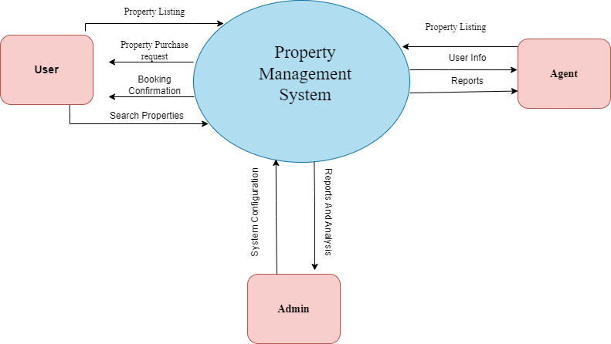

LEVEL – 0

