
Veer Narmad South Gujarat University, Surat. Department of Information and Communication Technology
B.Sc. (Information Technology)

6th Semester

M.Sc. (Information Technology)5 Year

Integrated Course

[Year 2024-2025]

Propperty Management System

Team Members:

Seat No | Name
151 | Rahani Gaurang
152 | Ramani Ayush
175 | Nikit Sorathiya
145 | Akshay Poshiya

P a g e 1 | 6


INDEX
Sr. No | Topics | Page no
1 | Introduction  - Project Profile | 3
2 | Proposed System  2.1 Scope  2.2 Objectives  2.3 Advantages  2.4 Limitations  2.5 Technologies used | 4
3 | System Planning  3.1 Software Engineering Model | 5
4 | System Analysis And Modelling  4.1 Software Requirement Specification  4.2 Dataflow Diagram  4.3 Process Specification  4.3 E-R Diagram | 6
5 | Software Design  5.1 Database Design ( Table Design)

1.INTRODUCTION :

  - Project Profile

Project Title :
Property Management System

Project Definition:

The Property Management System (PMS) is a robust, web-based application designed to simplify and streamline the processes of property buying,selling,and renting. This platform serves as a comprehensive solution, enabling seamless interaction among users, property owners, and administrators

By integrating user-friendly functionalities, the PMS empowers stakeholders to efficiently manage property listings, handle transactions, and access real estate services with ease. It offers advanced tools for creating, updating, and promoting property details, ensuring that users can find suitable options quickly. Property owners benefit from intuitive features to showcase their offerings, while administrators can oversee and manage the platform's operations effectively.

The system also incorporates tools for secure and transparent transactions, fostering trust among users. With its focus on accessibility, the PMS ensures that real estate solutions are readily available to a diverse audience, making it an indispensable tool in the modern property market.

2. PROPOSED SYSTEM :

2.1 SCOPE

1. Context :
The Property Management System (PMS) is a web-based application designed to streamline real estate transactions and interactions among property owners, users, and administrators. It fits into the larger context of the real estate industry by providing a digital platform for property buying, selling, renting, and management.

2. Information Objectives
The system facilitates the exchange of critical data objects to meet user requirements.
- Input Data Objects:
  - User-provided information such as name, email, mobile number, and feedback.
  - Property details including type, size, price, location, and images.
  - Agent information such as banking details, profile pictures, and IDs (e.g., Aadhaar).
  - OTPs and user credentials for authentication and security.
- Output Data Objects:
- Property listings with filters for location, price, size, and amenities.
- Detailed property and agent profiles for buyers, sellers, and renters.
- Transaction history and payment details for administrators and users.
- Feedback and ratings for listed properties and agents.

3. Function and Performance:
- Functions

  - Listing Management: Property owners can create, update, and manage property listings, including uploading images and providing descriptions.
  - Search and Filter: Users can search for properties based on criteria such as price, location, and size.
  - Agent Interaction: Users can contact agents assigned to properties for further assistance.
  - Secure Transactions: The system supports online payments and ensures transactional security via OTP validation and encrypted communication.
  - Feedback Collection: Users can provide feedback and ratings for properties and agents, which are visible to future users.
  - Administrative Oversight: Administrators can manage users, agents, and property listings to ensure quality and compliance.
- Performance Characteristics:
  - Simultaneous Users: The system is designed to support up to 1,000 simultaneous users initially, with provisions for scaling.
  - Response Time: The average response time for user actions should not exceed 2 seconds under normal conditions.
  - Availability: The system must maintain 99.5% uptime.
  - Storage: The system supports high-resolution property images and large datasets, ensuring efficient retrieval and display.

2.2 OBJECTIVES:

- The system provides a unified platform for property buying, selling, and renting, connecting property owners, users, and agents efficiently.
- It enables property owners and agents to manage property details, including descriptions, images, and pricing, ensuring accurate and up-to-date listings.
- Users can search for properties using advanced filters such as location, price, size, property type, and amenities, enhancing accessibility and convenience.
- The platform ensures secure handling of payments and sensitive user data through encrypted communication and robust authentication methods like OTP verification.
- A feedback and rating system is integrated to promote trust and transparency, enabling users to make informed decisions based on others’ experiences.
- Administrators are equipped with tools to oversee platform operations, enforce compliance with regulations, and manage user accounts and property listings.
- The system is designed to be scalable, accommodating an increasing number of users while remaining accessible on both desktop and mobile devices.
- Real-time communication channels between users and agents are provided, facilitating prompt responses to inquiries and efficient transaction management.

2.3 ADVANTAGES:

Property mangemt system is best platform for selling , buying and renting your properties here are some advanatges of PMS :

- Centralized Management: The system consolidates all property-related information in one place, making it easier for users, property owners, and agents to access and manage listings.
- Improved Efficiency: Automated processes for listing creation, search, and transaction management reduce the time and effort required to buy, sell, or rent properties.
- Enhanced User Experience: With features like advanced search filters, real-time communication, and easy access to property details, the system provides a seamless experience for all users.
- Secure Transactions: The integration of secure payment gateways and OTP-based authentication ensures that financial transactions and user data are protected from unauthorized access.
- Transparency and Trust: The feedback and rating system fosters trust by allowing users to view reviews and ratings from other users, helping them make more informed decisions.
- Scalability: The system is designed to handle a growing number of users and property listings, ensuring that it can scale as the business expands.
- Administrative Control: Administrators have full control over the system, enabling them to manage listings, users, and ensure the quality and compliance of the platform.
- Accessibility: The platform can be accessed on both desktop and mobile devices, providing users with flexibility to interact with the system from anywhere at any time.

2.4 LIMITATIONS:

Here are some limiations of property managemt system

- Dependence on Internet Connectivity:
Since the Property Management System is a web-based platform, it requires a stable internet connection for users to access and interact with the system. In regions with poor internet connectivity, users may face challenges accessing the platform or performing tasks such as searching for properties or completing transactions.
- Data Security and Privacy Risks:
The system stores sensitive user information, including personal details and payment data. Despite implementing security measures such as encryption and OTP verification, there is always a risk of data breaches, hacking attempts, or unauthorized access. Ensuring complete data security requires continuous monitoring and updates to safeguard against emerging threats.

2.4 TECHNOLOGIES USED

Technology | Purpose
MongoDb | Database Management
Express.js | Backend Framework For API
React.js | Frontyend UI Development
Node.JS | Server-side Js Execution
Bcrypt.js | Password Encryption
Mongoose | MongoDB ODM For Handling Schemas
JWT | Secure User Authentication
Bootstrap | Frontend Design and Styling

3. SYSTEM PLANNING

3.1 Software Engineering Model

The RAD (Rapid Application Development) model is a software development methodology focused on delivering a high-quality product in a short time. It emphasizes iterative development, quick prototyping, and active user involvement throughout the development process

Key Features of RAD Model:

- Rapid Prototyping: Functional prototypes are built quickly to gather feedback and refine requirements.
- Iterative Development: Development happens in small, manageable iterations.
- Active User Involvement: Continuous collaboration with users to ensure the product aligns with their needs.
- Component-Based: Reusable components are created and integrated to save time.
- Time Efficiency: Aims to deliver a working product faster than traditional methods.

Why Use RAD ?

- Faster Development: Ideal for projects with tight deadlines as it reduces development time.
- Adaptability: Flexible to accommodate changing requirements during the development process.
- User-Centric: Ensures the final product meets user expectations through ongoing feedback and involvement.
- Prototyping: Allows stakeholders to see tangible progress early, minimizing risks and misunderstandings.
- Simplifies Complex Systems: Breaks the project into smaller, manageable modules for easier development and integration.

4. SYSTEM ANALYSIS AND DESIGN

4.1 Software Requirement Specification

Functional Requirements :

- User Registration and Authentication
The system shall allow users to register by providing their name, email, phone number, and password. Registered users shall be able to log in and manage their profiles.
- Property Listing Management
The system shall allow property owners and agents to create, update, and delete property listings. Each listing shall include details such as property type, description, size, price, images, and location.
- Property Search Functionality
The system shall allow users to search for properties based on filters such as location, price range, size, property type, and amenities (e.g., furnished or unfurnished).
- Property Detail View
The system shall display detailed information about a property including images, description, price, location, and contact details of the property owner or agent.
- User-Initiated Contact
The system shall allow users to send messages or inquiries to property agents or owners regarding listings.
- Admin Dashboard
The system shall provide an admin interface to manage user accounts, property listings, and monitor platform activity. Admins can also modify or delete listings if necessary.
- Transaction Management
The system shall enable users to process payments securely for property transactions. It will also verify payments through an OTP (One-Time Password) system for security.
- Feedback and Rating System
The system shall allow users to provide feedback and rate properties and agents after completing transactions.
- User Profile Management
The system shall allow users to update their personal details, profile pictures, and contact information.
- Property Liking
The system shall allow users to "like" or save properties they are interested in for future reference.

Non Functional Requirements :

- Availability
The system shall be available 99.5% of the time, excluding planned maintenance periods.
- Performance
The system shall respond to user requests (such as property searches or form submissions) within 2 seconds under normal load conditions.
- Scalability
The system shall be capable of handling up to 1,000 simultaneous users, and the platform should scale to support up to 10,000 users as the user base grows.
- Security
The system shall use HTTPS for secure communication. It will implement OTP-based authentication for user logins and payments. All sensitive data, including user information and payment details, shall be encrypted and stored securely.
- Compliance with Data Privacy Regulations
The system shall comply with GDPR or other relevant data protection regulations to ensure the privacy and protection of user data.
- Compatibility
The system shall be compatible with modern web browsers, including Chrome, Firefox, and Safari, and will be accessible on both desktop and mobile devices.
- Usability
The system shall provide a user-friendly interface that is intuitive and easy to navigate. This will reduce the learning curve for users, even those with minimal technical knowledge.
- Backup and Recovery
The system shall implement regular data backups and have a disaster recovery plan in place to ensure data integrity and availability in case of failure.
- Localization
The system shall support multiple languages and regions, allowing users to switch between languages and adjust location-based property filters accordingly.

4.2 Data Flow Diagram

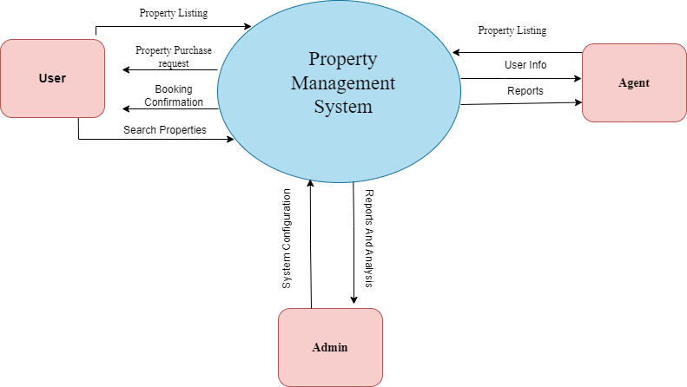

LEVEL - 0

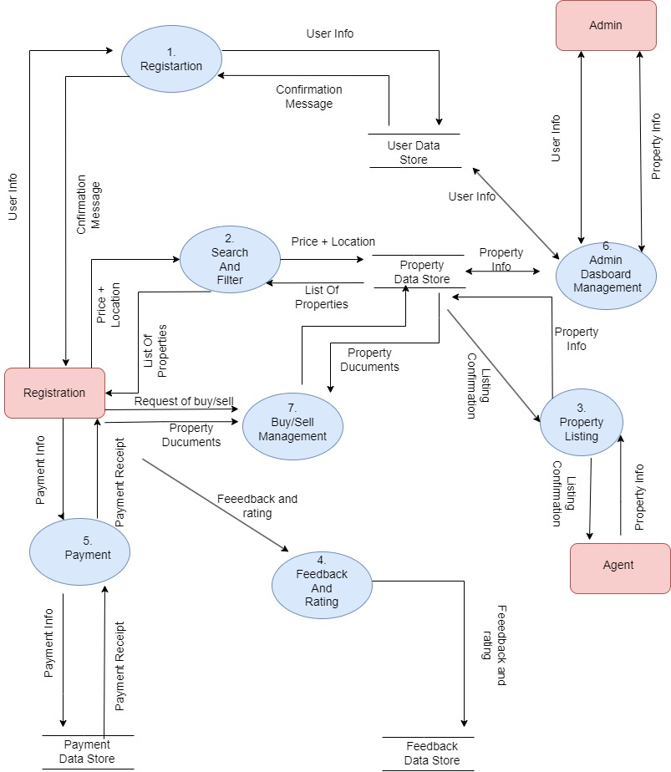

LEVEL – 1

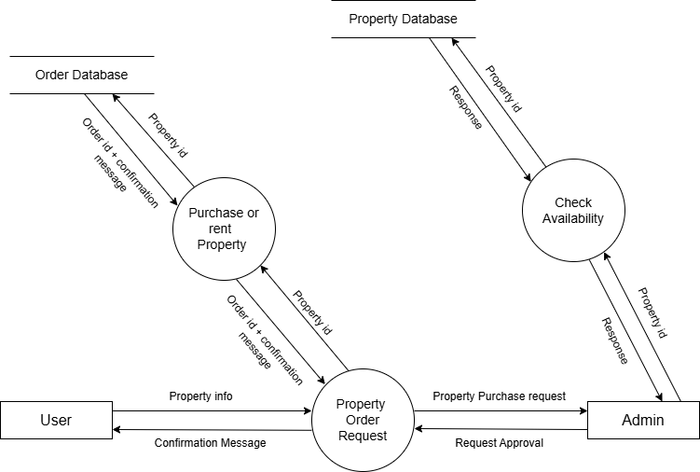

LEVEL 2 of process 7

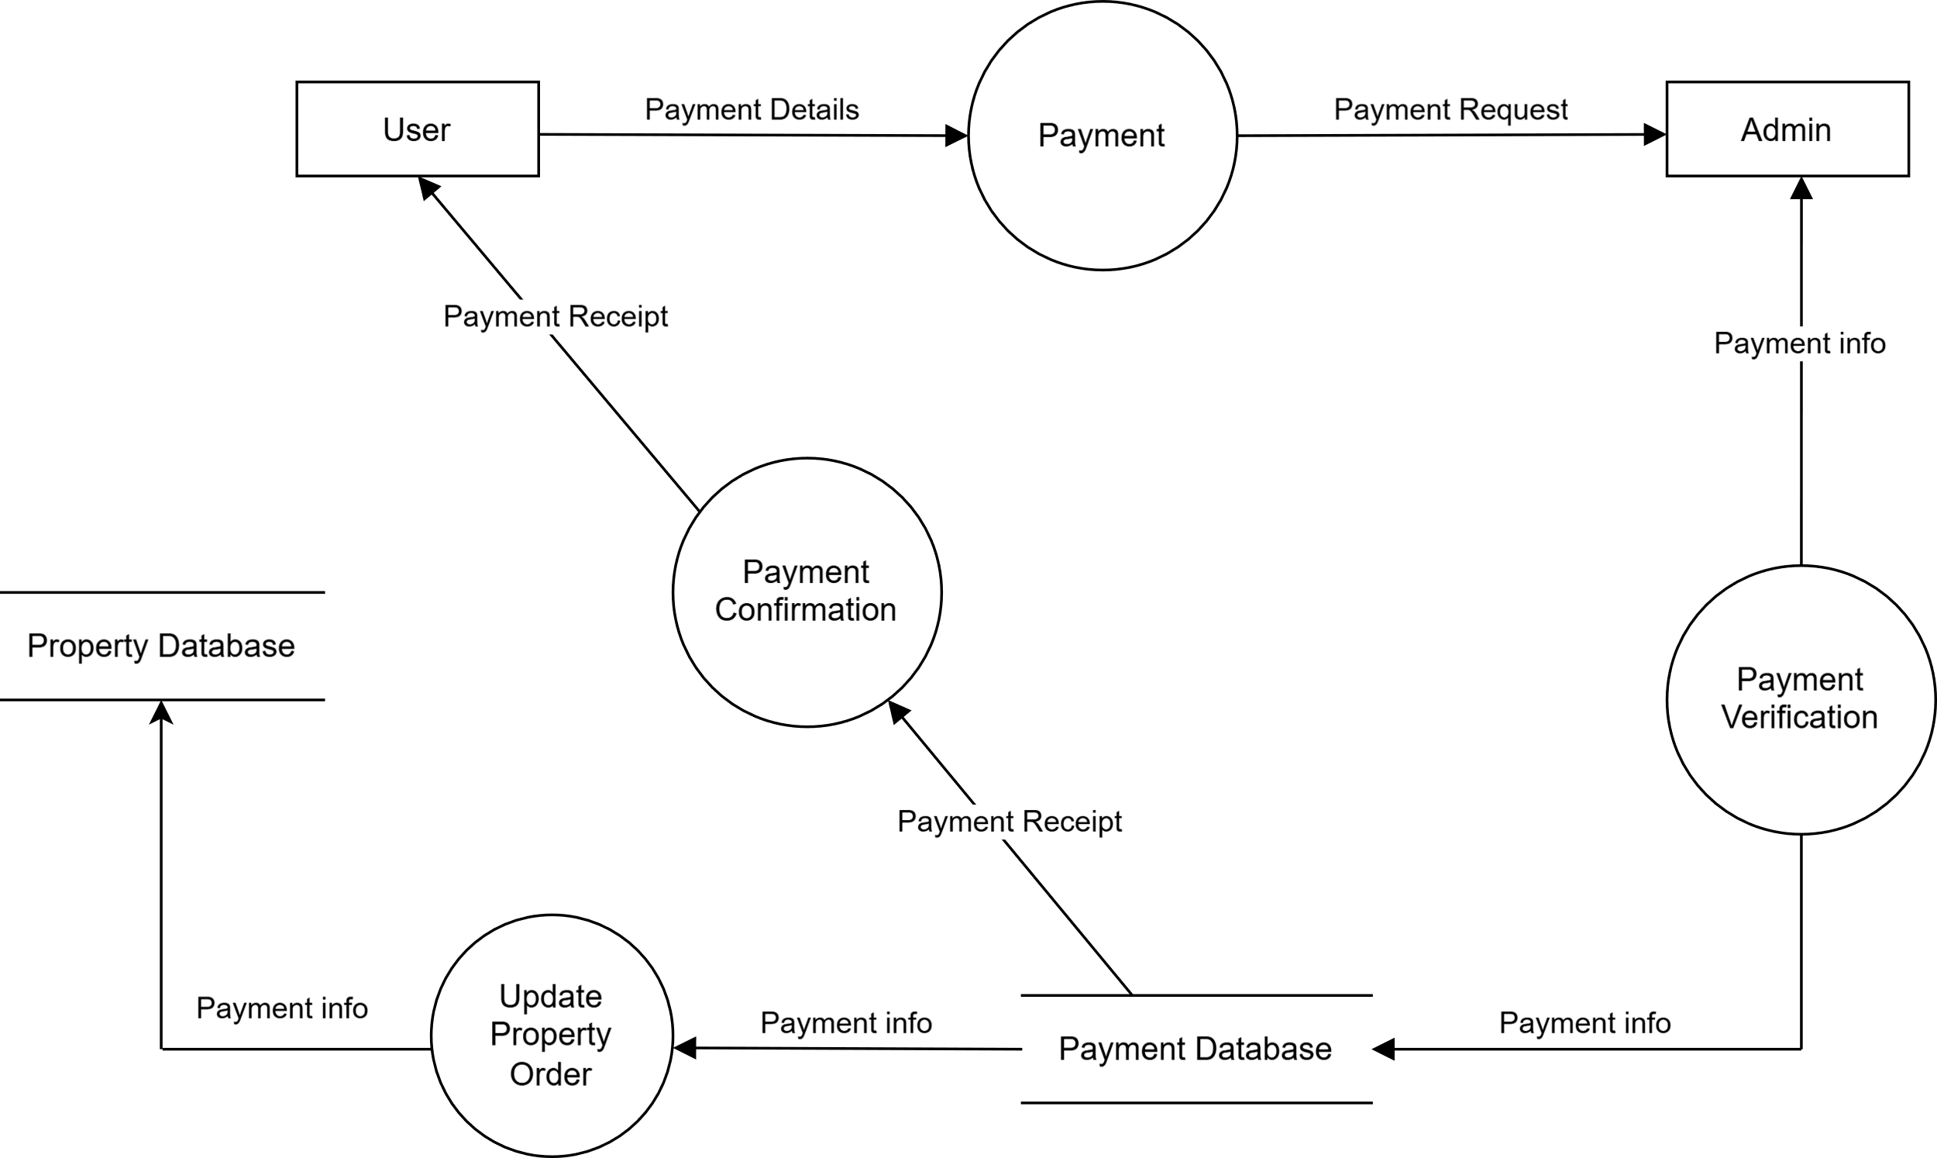

LEVEL – 2 of process 5

4.3 Process Specification

 | Process 1
Process Name | Registration
Description | Allows users to Register using the required information.
Input | Name + Email Password + address + Other User’s required information
Output | Details added in database + Confirmation Message To uer
 | Process 2
Process Name | Search And Filter
Description | Allows users to Search And Filter Properties
Input | Price + Location + ther required info
Output | List Of Properties

 | Process 3
Process Name | Property Listing
Description | Allow Agent to list properties in system
Input | Price + location + pictures+ type +other info
Output | Details added in database + Confirmation Message To agent

 | Process 4
Process Name | Feedback and rating
Description | Allow user to give feedback and rating
Input | Rating (out of 10) and feedback mesage
Output | thank you message

 | Process 5
Process Name | Payment
Description | Allow user to do payment
Input | Amount + Upi id +Otp + Password
Output | Payment Receipt To User

 | Process 6
Process Name | Admin Dashboard Management
Description | Allow Admin To manage users and properties
Input | User data +Property data
Output | Update and manage data in user database and property database

 | Process 7
Process Name | Property Buy / Sell
Description | Allow user Buy And Sell Properties
Input | Buy and Sell request
Output | Confirmatio message + update data in user and roperty database

4.4 E-R Diagram

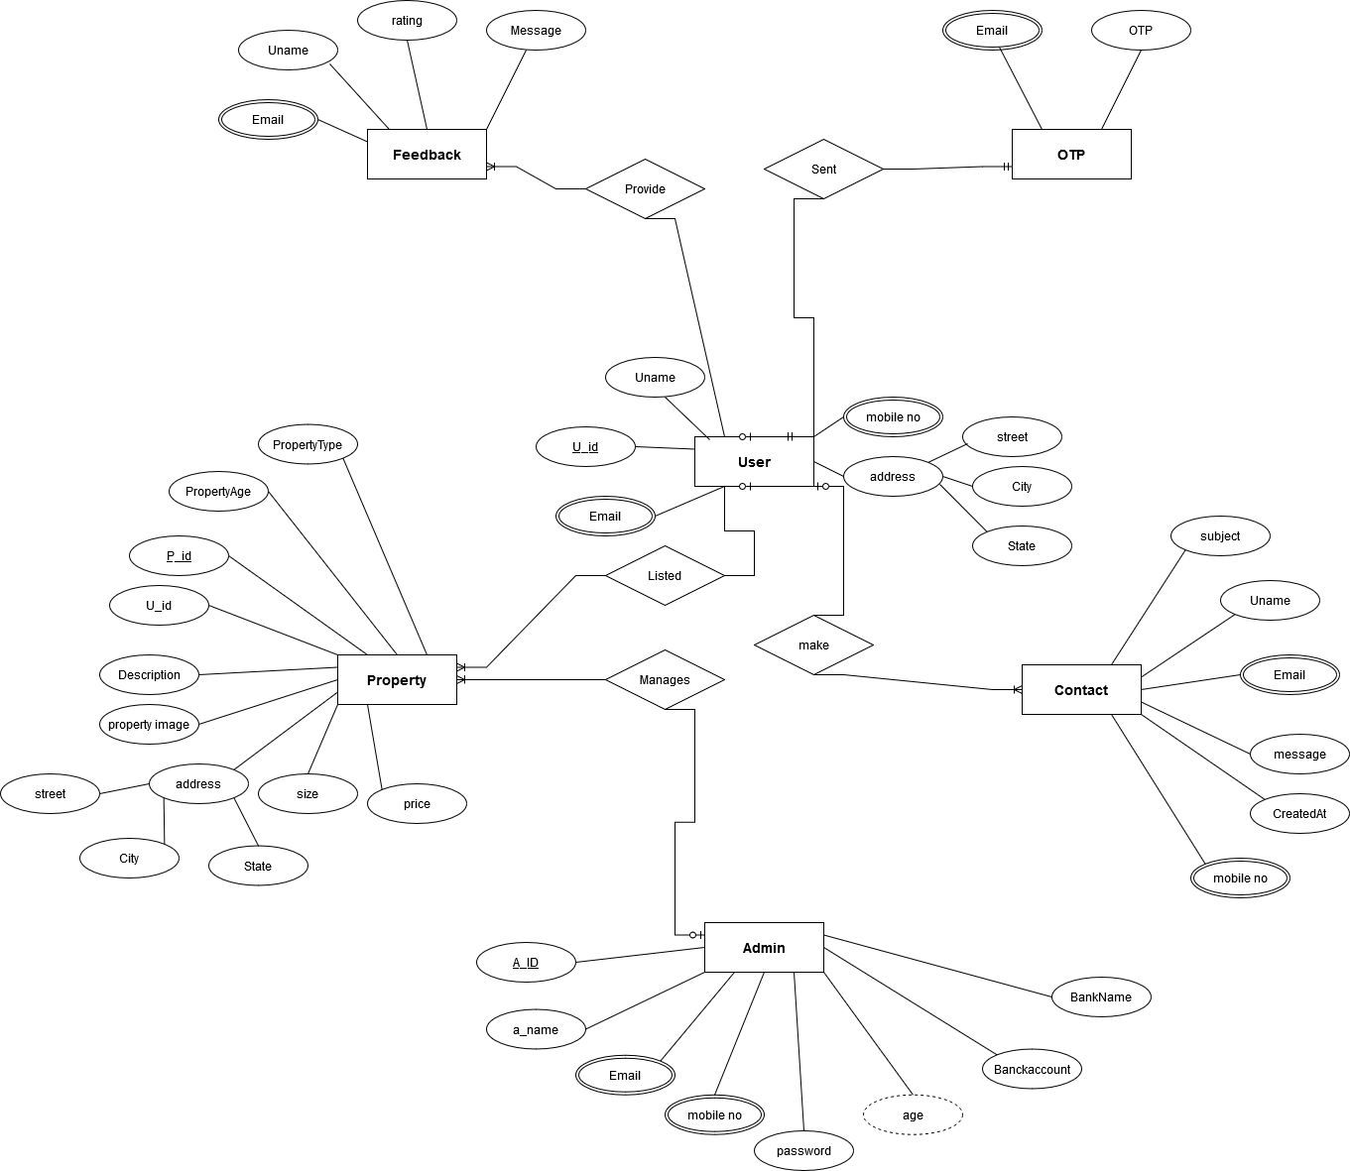

5. SOFTWARE DESIGN

5.1 TABLE DESIGN

- Agent Schema :

Sr no | Field Name | Data Type | Constraint | Description
1 | Name | Varchar(30) | Not Null | Agent's full name
2 | email | Varchar(30) | Unique Key | Contact email
3 | mobileno | Varchar(30) | Not Null | Contact mobile number
4 | password | Varchar(30) | Not Null | Encrypted password for authentication
5 | Profilepic | Varchar(30) | Not Null | Path/URL to profile picture
6 | publicurl | Varchar(30) | Not Null | Public profile URL
7 | role | Varchar(30) | Not Null | Role in the system (e.g., "agent")
8 | age | Integer | Not Null | Age of the agent
9 | gender | Varchar(30) | Not Null | Gender of the agent
10 | city | Varchar(30) | Not Null | City of the agent's location
11 | state | Varchar(30) | Not Null | State of the agent's location
12 | address | Varchar(30) | Not Null | Full address
13 | bankname | Varchar(30) | Not Null | Name of the agent's bank
14 | bankaccountno | Varchar(30) | unique Key | Bank account number
15 | ifsccode | Varchar(30) | Not Null | Bank's IFSC code
16 | adharcardfront | Varchar(30) | Not Null | URL to front image of Aadhaar card
17 | pancard | Varchar(30) | Not Null | PAN card number or image URL
18 | status | Varchar(30) | Not Null | Account status (e.g., active, inactive)
29 | date | Date | Not Null | Date of registration


- Contact Schema :

Sr no | Field Name | Data Type | Constraint | Description
1 | Name | Varchar(30) | Not Null | Name of the person contacting
2 | email | Varchar(30) | Not Null | Contact email
3 | subject | Varchar(30) | Not Null | Subject of message
4 | message | Varchar(30) | Not Null | Content Of Message
5 | createdAt | Date | Not Null | Timestamp of when the contact was made
6 | phone | Varchar(30) | Not Null | Contact phone number (optional)

Sr no | Field Name | Data Type | Constraint | Description
1 | Name | Varchar(30) | Not Null | Name of the person contacting
2 | email | Varchar(30) | Not Null | Contact email
3 | rating | Varchar(30) | Not Null | Subject of message
4 | message | Varchar(30) | Not Null | Content Of Message
5 | profilepic | Varchar(30) | Not Null | Url to image
6 | createdAt | Date | Not Null | Timestamp of when the contact was made
- Feedback Schema :


- Otp Schema :

Sr no | Field Name | Data Type | Constraint | Description
1 | email | Varchar(30) | Not Null | Email Address For OTP verification
2 | otp | Varchar(30) | Unique | One-time password (OTP)

- User Schema:

Sr no | Field Name | Data Type | Constraint | Description
1 | Name | Varchar(30) | Not Null | Full name of the user
2 | email | Varchar(30) | Unique Key | Contact email
3 | mobileno | Varchar(30) | Not Null | Contact mobile number
4 | password | Varchar(30) | Not Null | Encrypted password for authentication
5 | Profilepic | Varchar(30) | Not Null | Path/URL to profile picture
6 | publicurl | Varchar(30) | Not Null | Public profile URL
7 | role | Varchar(30) | Not Null | Role of the user (e.g., buyer, seller)
8 | islogin | Boolean | Not Null | Indicates if the user is currently logged in

- Property Schema :

Sr no | Field Name | Data Type | Constraint | Description
1 | userid | Varchar(30) | Foreign Key | ID of the user who listed the property
2 | type | Varchar(30) | Unique Key | Property type (e.g., residential, commercial)
3 | description | Varchar(30) | Not Null | Detailed description of the property
4 | Property image | Varchar(30) | Not Null | URL to property images
5 | address | Varchar(30) | Not Null | Full property address
6 | state | Varchar(30) | Not Null | State where the property is located
7 | city | Varchar(30) | Not Null | City where the property is located
8 | size | Double | Not Null | Size of the property in square feet
9 | price | Double | Not Null | Price of the property
10 | propertyAge | Varchar(30) | Not Null | Age of the property in years
11 | propertyType | Varchar(30) | Not Null | Specific property type (e.g., flat, villa)
12 | facing | Varchar(30) | Not Null | Direction the property faces (e.g., North)
13 | houseType | Varchar(30) | Not Null | Type of house (e.g., independent, duplex)
14 | facility | Varchar(30) | unique Key | List of available facilities
15 | furnishing | Varchar(30) | Not Null | Furnishing status (e.g., furnished)
16 | status | Varchar(30) | Not Null | Availability status (e.g., available, sold)
17 | mobileno | Varchar(30) | Not Null | Contact mobile number
18 | email | Varchar(30) | Not Null | Contact email address
19 | date | Date | Not Null | Date the property was listed
20 | agentid | Varchar(30) | Foreign Key | ID of the agent managing the property
21 | islike | Boolean | Not Null | Indicates if the property is liked by a user
22 | ispayment | Boolean | Not Null | Indicates if payment is completed
