**DATABASE MANAGEMENT SYSTEM**

**ASSIGNMENT – 1**

Name : Gaurang Tyagi

Roll No. : 16

Ques1.) Write an SQL query to create a database named 'StudentDB'.

Ans.) CREATE DATABASE StudentDB;

Ques2.) Inside 'StudentDB', create a table named 'Students' with the following columns:

- StudentID (INT, Primary Key)  
- Name (VARCHAR(50))  
- Age (INT)  
- Department (VARCHAR(50))  
- Marks (INT)

Ans.) use School_DB;

CREATE TABLE Students (

   StudentID INT PRIMARY KEY,

   Name VARCHAR(50),

   Age INT,

   Department VARCHAR(50),

   Marks INT

);

**OUTPUT 🡪**

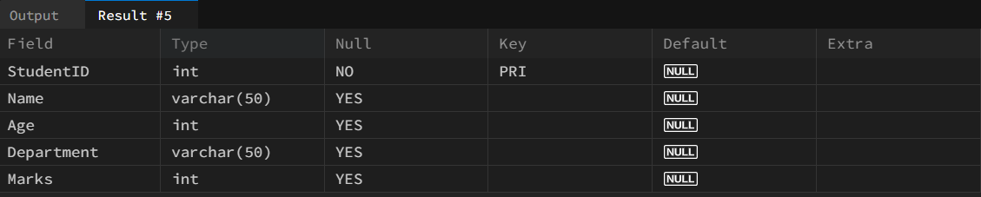

Ques3.) Insert at least 5 records into the 'Students' table.

Ans.) INSERT **INTO** Students (StudentID, **Name**, Age, Department, Marks) VALUES

(1, 'Rahul Sharma', 20, 'Computer Science', 85),

(2, 'Sneha Verma', 21, 'Mathematics', 90),

(3, 'Aman Gupta', 22, 'Physics', 78),

(4, 'Priya Singh', 20, 'Chemistry', 88),

(5, 'Karan Mehta', 23, 'Computer Science', 92);

OUTPUT🡪

