**DATABASE MANAGEMENT SYSTEM**

**ASSIGNMENT – 2**

Name : Gaurang Tyagi

Roll : 16

Ques1.) Create a database named School_DB.

Ans.) CREATE DATABASE School_DB;

Ques2.) . Inside this database, create a table named 'Students' with the following columns:  
 - student_id (INT, Primary Key)  
 - name (VARCHAR(50))  
 - age (INT)  
 - grade (VARCHAR(10)).

Ans.) CREATE TABLE IF NOT EXISTS Students(

student_id int PRIMARY KEY,

name varchar(50),

age int,

grade varchar(10)

);

DESC students;

OUTPUT🡪

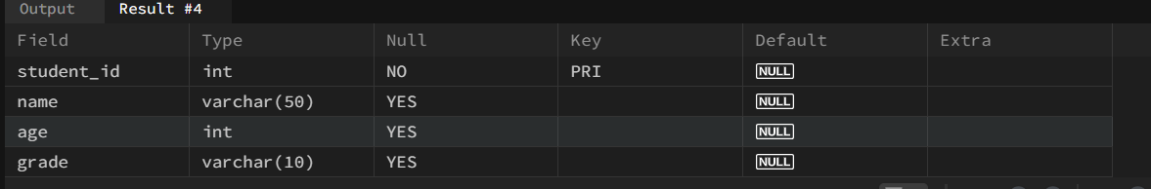

Ques3.) Insert dummy records into the 'Students' table.

Ans.) INSERT INTO Students VALUES

( 1,"Alice",14,"8th"),

( 2,"Bob",15"9th"),

 (3,"Charlie",13,"7th"),

( 4,"David",14,"8th"),

 (5,"Eva",15,"9th"),

 (6,"Frank",16,"10th"),

(7,"Grace",12,"6th"),

( 8,"Helen",14,"8th");

OUTPUT🡪

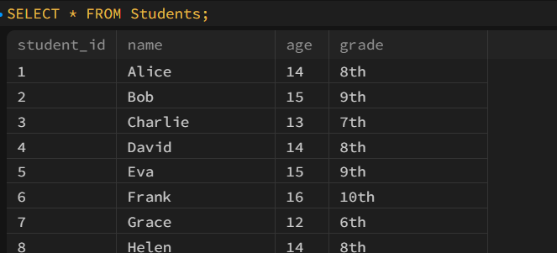

Ques4.) Select all records from 'Students'.

Ans.) SELECT * FROM Students;

OUTPUT🡪

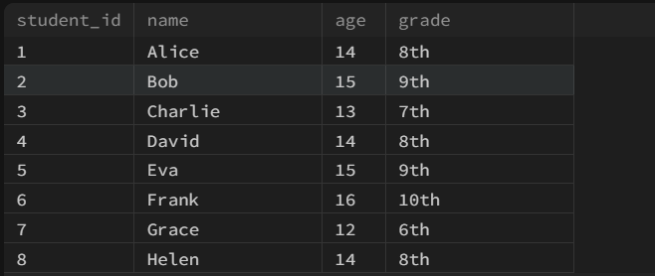

Ques5.) Select names and grades of students only.

Ans.) SELECT name,grade from Students;

OUTPUT🡪

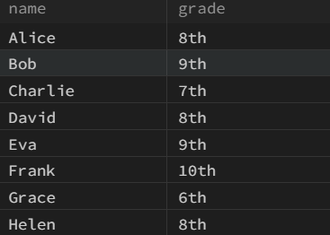

Ques6.) Select students who are older than 14 years.

Ans.) SELECT * from Students WHERE age>14;

OUTPUT🡪

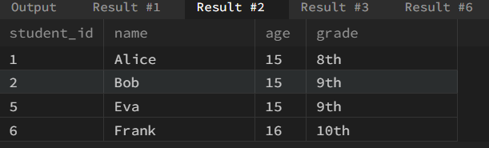

Ques7.) Select students in '8th' grade.

Ans.) SELECT * from Students WHERE grade="8th";

OUTPUT🡪

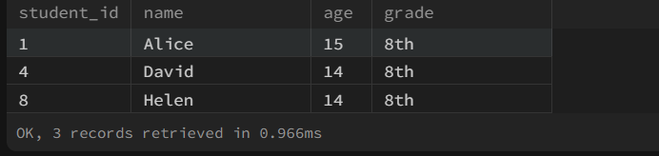

Ques8.) Update Alice age from 14 to 15.

Ans.) UPDATE Students set age=15 WHERE name="Alice";

OUTPUT🡪



Ques9.) Delete a student record with student_id = 3.

Ans.) DELETE FROM Students where student_id=3;

OUTPUT🡪



Ques10.) Delete all students in '7th' grade.

Ans.) DELETE FROM students WHERE grade = "7th";

Ques11.) Write an SQL query to drop the 'Students' table from the database.

Ans.) DROP TABLE IF EXISTS students;