**DATABASE MANAGEMENT SYSTEM**

**ASSIGNMENT – 3**

Name : Gaurang Tyagi

Roll No. : 16

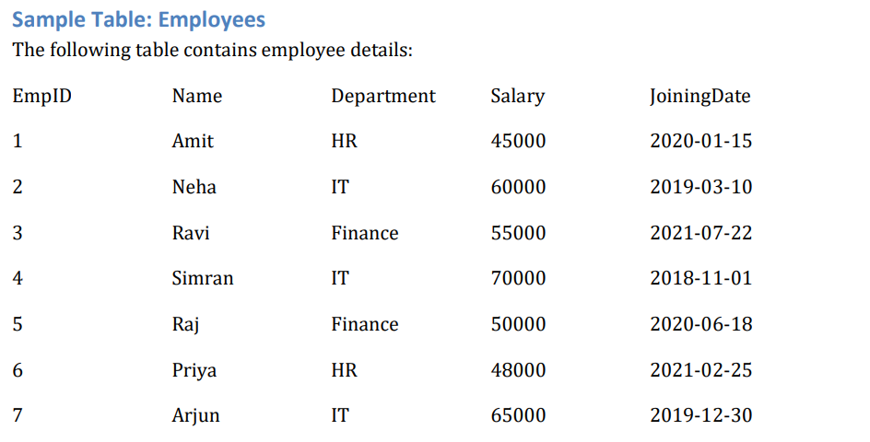

Ques1.) Retrieve all employees who work in the IT department.

Ans.) **SELECT** * **FROM** employees **where** department = "IT";

OUTPUT🡪

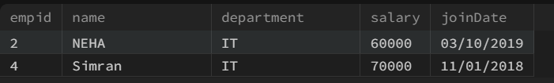

Ques2.) Find employees with a salary greater than 55,000.

Ans.) **SELECT** * **FROM** employees **where** salary > 55000;

OUTPUT🡪

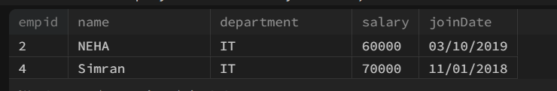

Ques3.) Display the names of employees who joined after 2020-01-01.

Ans.) **SELECT** **name** **from** employees **WHERE** joiningdate > "2020-01-01";

OUTPUT🡪

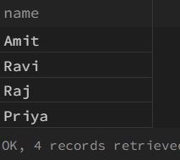

Ques4.) Calculate the average salary of employees in each department.

Ans.) **SELECT** **name**,AVG(salary) **as** "average_salary" **from** employees **GROUP** **BY** department;

OUTPUT🡪

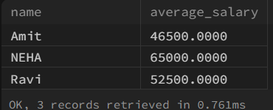

Ques5.) Find the highest salary in the Finance department.

Ans.) **SELECT** **name**,max(salary) **from** employees **GROUP** **BY** department **having** MAX(salary) **and** department = "Finance";

OUTPUT🡪



Ques6.) Count the number of employees in each department.

Ans.) **SELECT** department, COUNT(*) **as** "#of employees" **from** employees **GROUP** **BY** department;

OUTPUT🡪

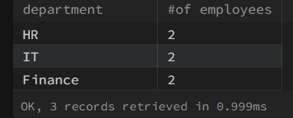

Ques7.) Display employees ordered by their salary in descending order.

Ans.) **SELECT** * **FROM** employees **ORDER** **BY** salary **DESC**;

OUTPUT🡪

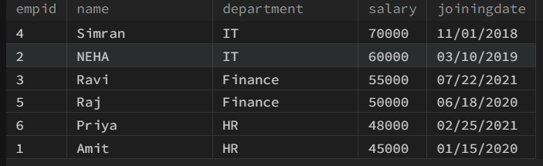

Ques8.) Find departments having more than 2 employees.

Ans.) **SELECT** department, COUNT(*) **as** "#employees" **FROM** employees **GROUP** **BY** department **having** COUNT(*) > 2;

OUTPUT🡪

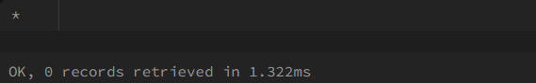

Ques9.) Show the total salary expenditure of the IT department.

Ans.) **SELECT** department, SUM(salary) **as** "Salary_Expenditure"  **FROM** employees **GROUP** **BY** department **having** department = "IT";

OUTPUT🡪

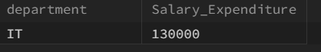

Ques10.) Retrieve employees whose names start with 'R'.

Ans.) **SELECT** * **FROM** employees **WHERE** **name** **LIKE** "R%";

OUTPUT🡪

