**DATABASE MANAGEMENT SYSTEM**

**ASSIGNMENT – 4**

Name : Gaurang Tyagi

Roll No. : 16

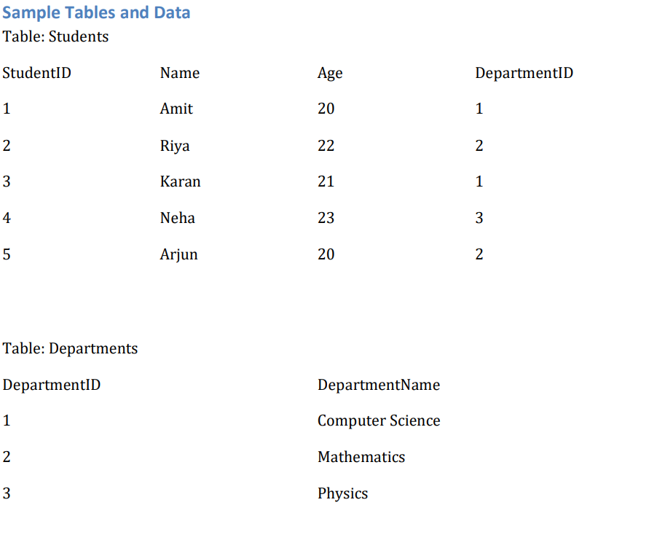 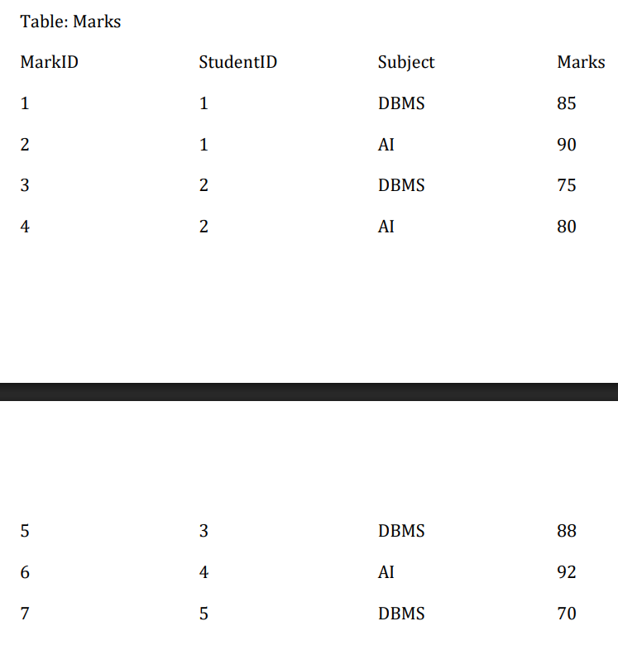

Ques1. Retrieve all students along with their department names.

Ans.) **SELECT** **name**,DepartmentName **from** students,departments **where** students.department - departments.DepartmentID;

OUTPUT🡪

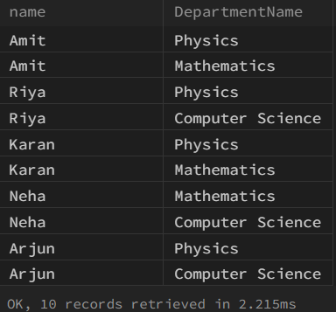

Ques2.) Find the average marks obtained by each student.

Ans.) **SELECT** AVG(m.marks) "AVG_MARKS",s.**name** **FROM** students s **JOIN** marks m **on** m.StudentID = s.StudentID **GROUP** **BY** s.StudentID;

OUTPUT🡪

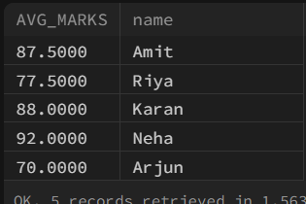

Ques3.) Find the maximum marks in each subject.

Ans.) **SELECT** m.**Subject**,max(m.marks) **from** Marks m **GROUP** **BY** m.**Subject**;

OUTPUT🡪

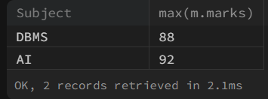

Ques4. List students who scored more than 80 in all subject.

Ans.) **SELECT** s.**name** **from** students s **JOIN** marks m **ON** s.StudentID = m.StudentID **GROUP** **BY** m.StudentID **having** MIN(m.marks) >= 80;

OUTPUT🡪

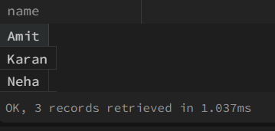

Ques5.) Retrieve all students ordered by their average marks in descending order.

Ans.) **SELECT** s.**name**,AVG(m.marks) **as** "AVG_MARKS" **FROM** students s LEFT **JOIN** marks m **ON** s.StudentID = m.StudentID **GROUP** **BY** s.StudentID **ORDER** **BY** AVG_MARKS DESC;

OUTPUT🡪

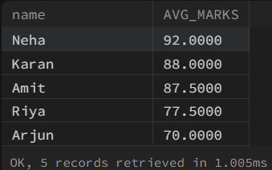

Ques6.) Find the total marks scored by students in each department.

Ans.) **SELECT** d.DepartmentName,sum(m.marks) **as** TOTAL **FROM** Marks m **JOIN** Students s **ON** m.StudentID = s.StudentID **JOIN** Departments d **ON** s.Department = d.DepartmentID **GROUP** **BY** d.DepartmentID;

OUTPUT🡪

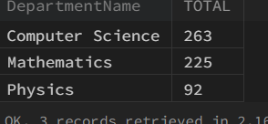

Ques7.) Display students who have not received any marks yet.

Ans.) **SELECT** s.**name** **FROM** students s **WHERE** s.StudentID **not** **in** ( **SELECT** StudentID **from** students );

OUTPUT🡪



Ques8.) Retrieve department names along with the number of students enrolled in each department.

Ans.) **SELECT** d.DepartmentName, count(*) **as** NUM_OF_STUDENTS **FROM** departments d **JOIN** students s **ON** d.DepartmentID = s.Department **GROUP** **BY** d.DepartmentID;

OUTPUT🡪

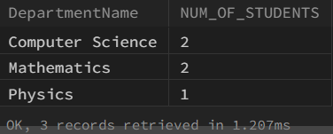

Ques9.) Find the student with the highest marks in AI subject.

Ans.) **SELECT** **Subject**,max(Marks) **FROM** Marks **WHERE** **Subject** = "AI"  **GROUP** **BY** **Subject**;

OUTPUT🡪



Ques10.) Display all students along with their average marks (if any), showing 0 where marks are not available.

Ans.) **SELECT** s.**name**,COALESCE(AVG(m.marks),0) **as** AVG **FROM** students s RIGHT **JOIN** marks m **ON** s.StudentID = m.StudentID **GROUP** **BY** s.StudentID;

OUTPUT🡪

