Lab Assignment 1 - User Authentication and Access Control

Name – Gaurang Tyagi

Roll – 16

Date – 07-08-2026

Part A - Password Cracking

What we did
We made 5 test user accounts on Kali Linux, each with a password of different strength (weak to strong). Then we tried to crack their password hashes using a tool called John the Ripper, and noted how long each one took.

Steps
1. Created 5 Linux users and set a different password for each one (a simple one like 123456, a common word, a medium one with symbols, and a long random one).
2. Got the password hashes using this command:
sudo unshadow /etc/passwd /etc/shadow > combined.txt
grep user combined.txt > mytest.txt
3. Ran John the Ripper on the hash file using the rockyou wordlist:
john --format=crypt --wordlist=/usr/share/wordlists/rockyou.txt mytest.txt
4. Let it run for max 10 minutes. Whatever got cracked, we noted the password and time. Whatever didn't crack, we marked it as not cracked.
5. Checked the final result with:
john --format=crypt --show mytest.txt

Results
User | Password | Hash Type | Cracked? | Time Taken
user1 | 123456 | yescrypt | Yes | few seconds
user2 | password1 | yescrypt | Yes | few seconds
user3 | Tr0ub4dor&3 | yescrypt | No | not cracked in 10 min
user4 | Summer2024! | yescrypt | No | not cracked in 10 min
user5 | random 16-char password | yescrypt | No | not cracked in 10 min

Screenshots
Screenshot 1 - John cracking the weak passwords:
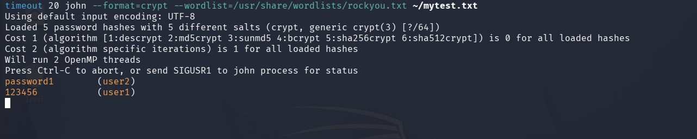
Screenshot 2 - Final result (--show command):
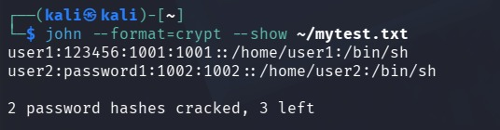

What we observed
Passwords like 123456 and password1 got cracked in just a few seconds because they are common passwords already present in the wordlist John uses. Passwords with a mix of letters, numbers and symbols (like Tr0ub4dor&3 or Summer2024!) did not get cracked in 10 minutes because they are not simple dictionary words. The long random password was the strongest and didn't crack at all. So basically, longer and more random passwords are much harder to crack than just adding a few numbers or symbols to a common word.

Part B - Access Control (DAC) on Linux

What we did
We created two users, userA and userB, and a shared folder called /labshare. Then we used permissions (chmod, chown) and ACL (setfacl/getfacl) to control who can read/write in that folder, and tested it by trying to access it as userB.

Steps
1. Created the users and the shared folder:
sudo useradd -m userA
sudo passwd userA
sudo useradd -m userB
sudo passwd userB
sudo mkdir /labshare
2. Made userA the owner and set basic permissions:
sudo chown userA:userA /labshare
sudo chmod 750 /labshare
3. Used setfacl to give userA full access and userB only read access:
sudo setfacl -m u:userA:rwx /labshare
sudo setfacl -m u:userB:r-x /labshare
getfacl /labshare
4. Tested as userB - could read the folder but could not create a file in it (permission denied).
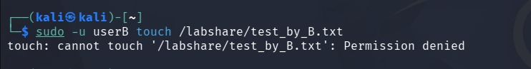
5. Then removed userB's access completely:
sudo setfacl -x u:userB /labshare
sudo setfacl -m u:userB:--- /labshare
getfacl /labshare
6. Tested again as userB - this time even listing the folder gave permission denied.
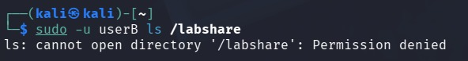

Command Transcript
sudo useradd -m userA
sudo passwd userA
sudo useradd -m userB
sudo passwd userB
sudo mkdir /labshare
sudo chown userA:userA /labshare
sudo chmod 750 /labshare
sudo setfacl -m u:userA:rwx /labshare
sudo setfacl -m u:userB:r-x /labshare
getfacl /labshare
sudo -u userA touch /labshare/fileA.txt (works)
sudo -u userB ls /labshare (works, read-only)
sudo -u userB touch /labshare/test.txt (Permission denied)
sudo setfacl -x u:userB /labshare
sudo setfacl -m u:userB:--- /labshare
sudo -u userB ls /labshare (Permission denied)

What we observed
With chmod alone we could give or block access at a basic owner/group/other level, but setfacl let us set permission for one specific user (userB) without changing anything for anyone else. First we gave userB read-only access and it worked exactly like that - could see files but not create new ones. After removing the ACL rule and blocking userB completely, even listing the folder failed with permission denied. This shows how Linux access control can be adjusted very precisely for each user on a shared resource.

Why Authentication and Access Control Matter
Authentication checks who a person is (using a password or login), and access control decides what that person is allowed to do after logging in. Both are needed to keep data confidential. If passwords are weak, anyone can guess or crack them and log in as someone else - our Part A showed this clearly, where 123456 and password1 were cracked in seconds while a long random password stayed safe. Even after someone logs in correctly, access control makes sure they can only see or change what they're supposed to. In Part B, we saw how userB could be given limited (read-only) or zero access to a shared folder, even though userB was a valid, logged-in user. Without access control, any logged-in user could read or modify everyone else's files, which would break confidentiality completely. So authentication and access control work together - one confirms identity, the other limits what that identity can do.

Two Suggestions to Improve Password Policy
- Ask users to make passwords at least 12 characters long instead of just asking for one number or symbol - longer passwords are much harder to crack than short 'complex' ones.
- Turn on multi-factor authentication (like an OTP or authenticator app) for important accounts, so that even if someone's password gets leaked or cracked, it alone isn't enough to log in.

