MCA – INFORMATION SECURITY
ZERO-TRUST TRUST SCORING
FOR IoT DEVICES

Name : Gaurang Tyagi
Roll No. – 16

1. Introduction and Literature Review
The Internet of Things (IoT) connects devices such as cameras, sensors, locks and televisions to gateways, cloud services and local networks. These devices differ in their normal traffic patterns, operating hours, destinations and impact if compromised.

This project implements a small, reproducible trust-scoring simulation. At every time step it calculates Behaviour (B), Context (C), History (H) and Risk (R), combines them into a security assessment, updates a running trust score, and maps the score to ALLOW, MONITOR, RESTRICT or ISOLATE.

2. IoT Simulation
Five heterogeneous virtual devices are modelled. Their normal packet-rate baselines, operating hours, allowed destinations and criticality values follow the assignment guide. Time step t is mapped to hour-of-day using t mod 24; the steps are simulated units, not real elapsed minutes.

ID | Device type | Normal traffic | Active hours | Allowed destination(s) | Criticality
D1 | Smart Camera | 120 ± 15 packets/s | 24 hours | Cloud server; NVR | 0.6
D2 | Smart Sensor (control) | 10 ± 2 packets/s | 24 hours | Gateway only | 0.4
D3 | Smart Lock | 2 ± 0.5 packets/s | 06:00–23:00 | Home hub only | 0.9
D4 | Smart TV | 200 ± 60 packets/s | 16:00–24:00 | Streaming servers | 0.3
D5 | Medical/environmental sensor | 20 ± 3 packets/s | 24 hours | Hospital gateway | 1.0

D2 is the control device and remains Normal for all 120 steps. D1 and D3 follow

Normal → Suspicious → Attack-like → Recovery;

D4 follows Normal → Suspicious → Recovery without an Attack-like phase; D5 follows the four states with its attack and recovery shifted later than D1/D3.

3. Trust Model

3.1 Four input scores
- Behaviour (B): compares generated packet rate with the device-specific mean and standard deviation, then reduces the score for failed logins. Let z = |rate − mean| / std. The traffic score is max(0, 1 − z/5); a penalty of 0.06 per failed login is subtracted, capped at 0.30. B is clipped to [0, 1].
- Context (C): starts at 1.0, subtracts 0.4 if the observation is outside the device’s active hours, and subtracts 0.4 if the destination is not on the allowed list. C is clipped to [0, 1].
- History (H): the mean of the previous ten Behaviour scores, or 1.0 before any prior observation exists. This makes history depend on past data rather than the current observation alone.
- Risk (R): R = 0.5 × failed_login_score + 0.3 × unusual_destination + 0.2 × criticality. failed_login_score = min(failed_logins/7, 1); unusual_destination is 1 when the destination is not allowed and 0 otherwise. R is clipped to [0, 1]. A higher R lowers the security assessment.

3.2 Weighted assessment and trust update

The baseline weights are wB = 0.35, wC = 0.20, wH = 0.20 and wR = 0.25; they sum to 1. Behaviour receives the largest baseline weight because it represents current observed activity. Context and history add situational and temporal information, while Risk captures potentially dangerous indicators and device criticality.
S(t) = wB·B(t) + wC·C(t) + wH·H(t) + wR·(1 − R(t))
T(t) = clip[0,1]( α·T(t−1) + (1 − α)·S(t) )
Each device starts at T(0) = 1.0. The main run uses α = 0.7. A higher α retains more previous trust and smooths noise but can delay detection; a lower α reacts faster but can fluctuate more.

3.3 Resource awareness

Battery level reduces the effective Behaviour weight: wB(t) = wB,base × (0.5 + 0.5 × Battery(t)/100). The weight removed from Behaviour is redistributed proportionally among Context, History and Risk, preserving a total weight of 1. This represents lower confidence in detailed behaviour reports when the device battery is depleted. CPU and memory are simulated and capped at 90%; battery is bounded between 0 and 100%. These caps are modelling assumptions, not universal hardware limits.

3.4 Decision thresholds

Trust score | Decision | Interpretation
0.75–1.00 | ALLOW | Normal access
0.50–<0.75 | MONITOR | Access continues under closer monitoring
0.25–<0.50 | RESTRICT | Limited access
0.00–<0.25 | ISOLATE | Network access blocked in the simulation

4. Experimental Setup

The simulation uses NumPy, pandas and Matplotlib in Python. A fixed random seed (42) is used for the main run to make generated observations reproducible. Each device is simulated for 120 steps, producing 600 device-time observations. The required submission CSV contains the 16 assignment-specified columns; the notebook also uses additional internal fields (such as packet rate and failed logins) for calculations and event analysis.
Device | Normal | Suspicious | Attack-like | Recovery
D1 | 0–39 | 40–59 | 60–79 | 80–119
D2 | 0–119 | — | — | —
D3 | 0–39 | 40–59 | 60–79 | 80–119
D4 | 0–39 | 40–79 | — | 80–119
D5 | 0–49 | 50–69 | 70–89 | 90–119

Four experiments are represented: (1) normal control operation using D2; (2) behavioural deviation during Suspicious states; (3) high-risk Attack-like observations with elevated traffic, failed logins and/or unusual destinations; and (4) gradual Recovery rather than an instantaneous reset. Event records are written when a decision changes or trust falls by at least 0.15.

5. Results
Across all 600 observations, mean trust is 0.714 (standard deviation 0.224), with a minimum of 0.112 and maximum of 0.985. Decisions are ALLOW for 372 observations, MONITOR for 107, RESTRICT for 81 and ISOLATE for 40. No Normal-state observation was RESTRICT or ISOLATE in this run. Mean trust by state is highest in Normal operation (0.878), lower in Suspicious (0.563), lowest in Attack-like (0.236), and rises during Recovery (0.690).

Graph 1. Trust score over time with states marked
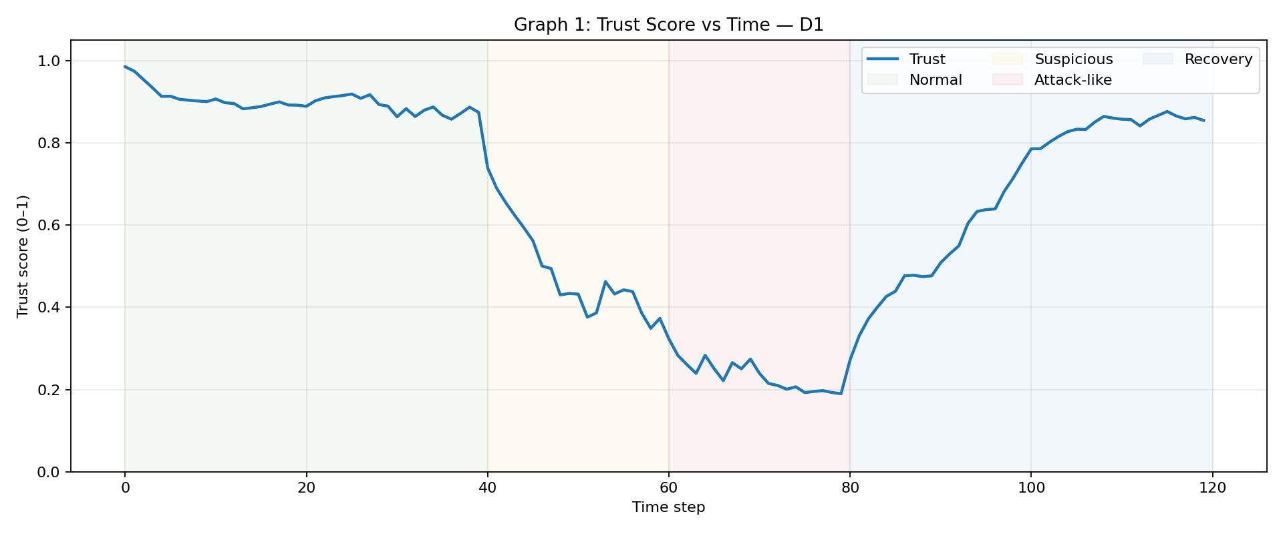
Figure 1. D1 trust decreases during Suspicious and Attack-like phases, then gradually recovers. Shaded regions identify the simulated states.

Results: Behaviour and trust inputs

Graph 2. Behaviour score over time
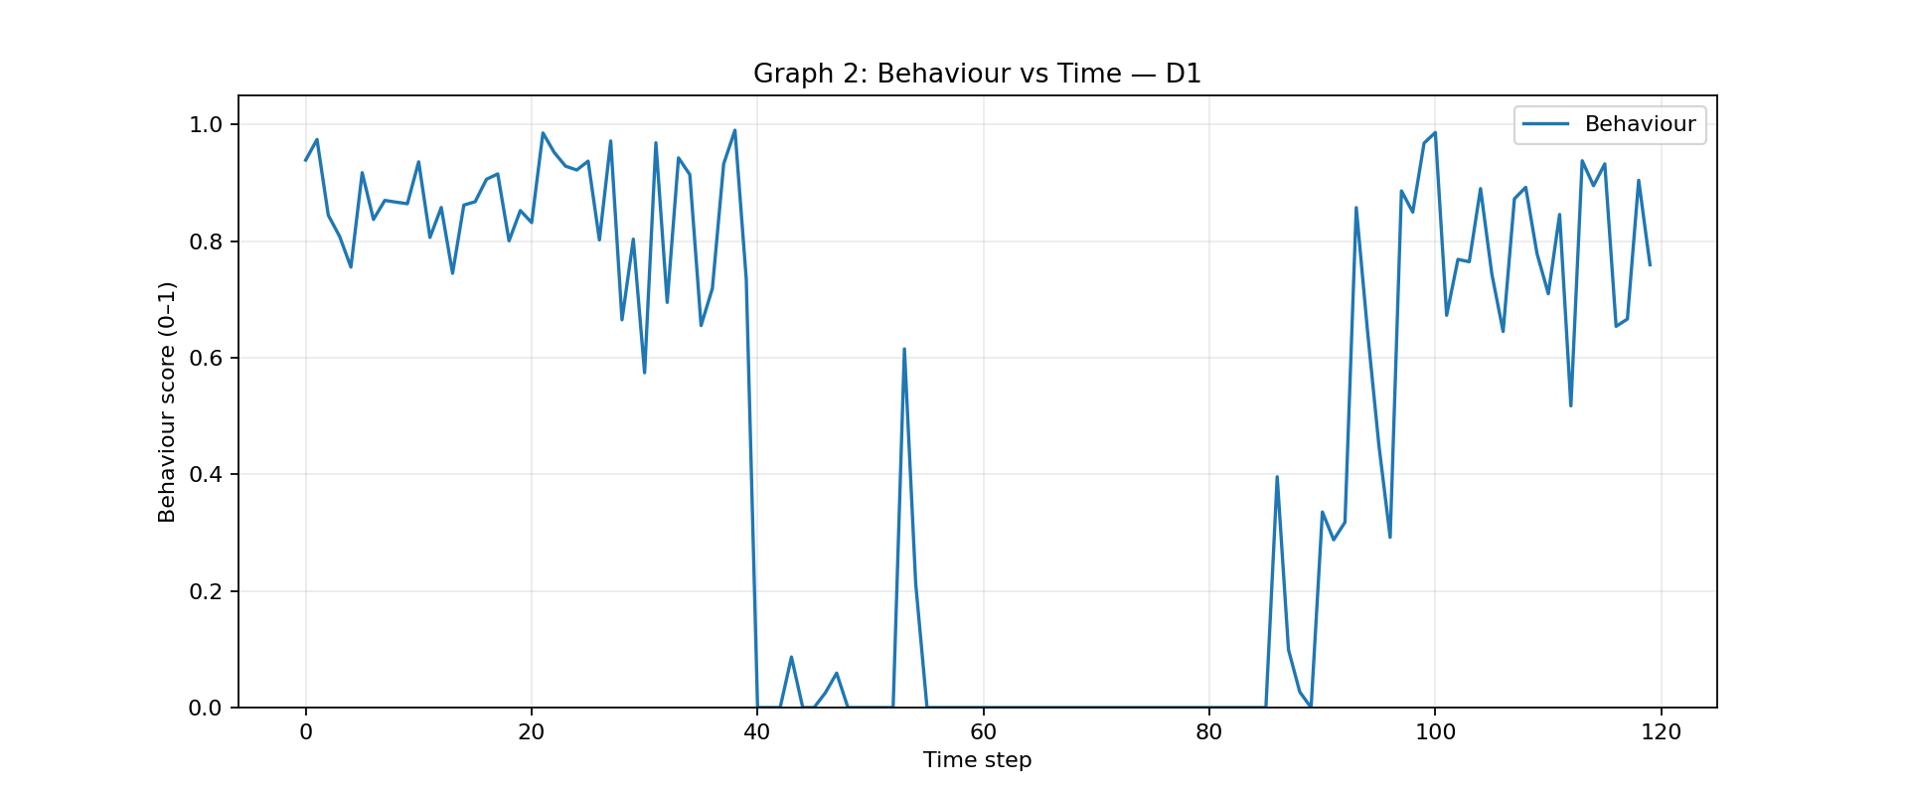
Figure 2. D1 Behaviour falls when generated traffic departs from its baseline and/or failed logins are present; it improves as generated observations return toward normal.

Graph 3. B, C, H and R over time
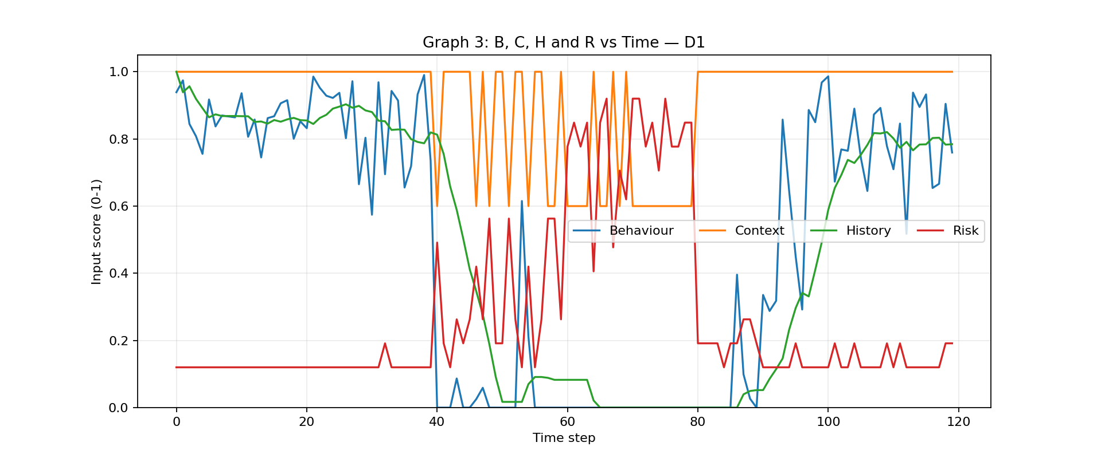
Figure 3. D1 input scores show different roles: Behaviour responds to current activity, Context reflects schedule/destination compatibility, History changes with prior Behaviour, and Risk rises with risk indicators.

The input trajectories explain why trust is not driven by a single signal. For example, Context may temporarily improve if a generated destination is allowed, while Behaviour and History can remain low after abnormal observations. Since Risk is inverted in the weighted security assessment, a larger Risk value reduces the assessment and therefore tends to lower trust.

Results: Decisions and performance

Graph 4. Trust score and decision thresholds
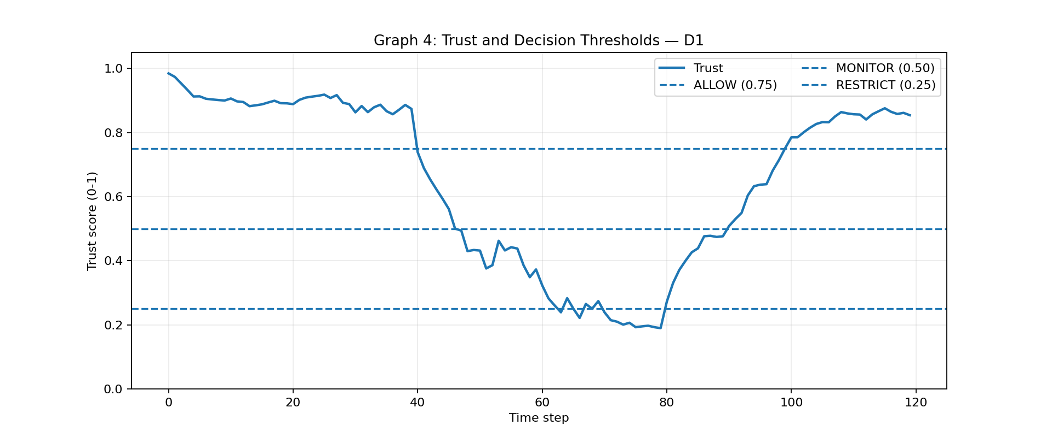
Figure 4. Horizontal thresholds map D1 trust to ALLOW (0.75), MONITOR (0.50), RESTRICT (0.25) and ISOLATE (below 0.25).

5.1 Performance measures
ID | Device | Detection delay (steps) | False restriction | Recovery time (steps) | Trust stability (SD) | Mean normal trust
D1 | Smart Camera | 7 | 0.0% | 19 | 0.026 | 0.900
D2 | Smart Sensor | N/A | 0.0% | N/A | 0.018 | 0.902
D3 | Smart Lock | 10 | 0.0% | 22 | 0.036 | 0.830
D4 | Smart TV | 24 | 0.0% | 12 | 0.046 | 0.854
D5 | Medical/Environmental Sensor | 10 | 0.0% | 18 | 0.033 | 0.862

Detection delay is the first RESTRICT/ISOLATE decision after the start of an abnormal phase. Recovery time is the number of steps from the start of Recovery until trust returns to at least 0.75. False restriction rate is the proportion of Normal-state observations assigned RESTRICT or ISOLATE. Trust stability is the population standard deviation of trust during Normal operation; lower values indicate less variation. D2 has no detection-delay or recovery-time value because it has no abnormal or recovery phase.

5.2 Selected security events
Device | Step | State | Trust: previous→new | Decision | Event
D1 | 40 | Suspicious | 0.874→0.739 | MONITOR | Decision changed
D1 | 47 | Suspicious | 0.500→0.494 | RESTRICT | Decision changed
D1 | 63 | Attack-like | 0.260→0.239 | ISOLATE | Decision changed
D1 | 80 | Recovery | 0.190→0.272 | RESTRICT | Decision changed
D1 | 99 | Recovery | 0.714→0.751 | ALLOW | Decision changed
D3 | 50 | Suspicious | 0.569→0.492 | RESTRICT | Decision changed
D3 | 68 | Attack-like | 0.269→0.239 | ISOLATE | Decision changed
D5 | 73 | Attack-like | 0.257→0.236 | ISOLATE | Decision changed
D5 | 108 | Recovery | 0.735→0.772 | ALLOW | Decision changed

6. Discussion

6.1 Effect of memory factor α
α | Mean detection delay | False restriction | Mean recovery time | Mean trust SD | Mean normal trust
0.3 | 6.50 | 0.0% | 14.00 | 0.038 | 0.861
0.5 | 7.25 | 0.0% | 14.25 | 0.033 | 0.863
0.7 | 13.50 | 0.0% | 18.50 | 0.031 | 0.867
0.8 | 13.33 | 0.0% | 21.25 | 0.031 | 0.872

The α comparison was run with seed 42 to compare settings consistently against one another. In the generated results, α = 0.3 has the shortest average detection delay (6.50 steps) and mean recovery time (14.00 steps), while α = 0.7 has a longer average detection delay (13.50 steps) and a lower average trust standard deviation (0.031). False restriction remained 0% for all tested α values. The main run uses α = 0.7 as a compromise that smooths changes while still allowing trust to fall substantially during Attack-like periods.
The comparison suggests that faster response is possible with lower α, but that choice should be validated against more realistic data.

6.2 Interpretation
- Normal control: D2 has mean Normal trust of 0.902 and trust stability of 0.018, and it has no false restrictions in this simulation.
- Detection: all devices with abnormal phases reach RESTRICT or ISOLATE. Detection delay varies by device because the generated inputs, baseline traffic and state start times differ.
- Attack-like states: mean trust falls to 0.236, and 40 observations are ISOLATE. High Risk, low Behaviour and accumulated low History jointly suppress the trust score.
- Recovery: trust does not reset instantly. Recovery times range from 12 to 22 steps among devices with recovery phases, reflecting the exponential update and continuing random variation.
- Resource awareness: reducing the Behaviour weight as battery falls models lower confidence in detailed reports; weight is redistributed so the assessment remains a convex weighted score. In this run, CPU and memory reach the chosen 90% cap and minimum battery is 26.71%. The caps are simulation design choices, not measurements from real devices.

7. Limitations
- All observations are synthetic. Real IoT traffic, adversarial adaptation, sensor faults, network congestion and device-specific protocols may behave differently.
- Weights, penalties, thresholds and state schedules are hand-selected rather than learned from labelled data or validated by a security operations team.
- The risk formula uses a small set of factors and a simple failed-login normalization. It cannot represent all attack types or the relationships among signals.
- The resource model uses simple random increments and fixed caps. It does not model real battery discharge curves, processor architectures, memory pressure or communication costs.
- The simulation treats time steps as hourly positions for context checks, but performance delays are reported in steps; they should not be interpreted as minutes without a separate time calibration.

8. Conclusion

This simulation demonstrates how a Zero-Trust-inspired decision layer can continuously combine current behaviour, context, past behaviour and risk into a trust score for heterogeneous IoT devices.

Trust remained high for the normal control device, fell during suspicious and attack-like activity, triggered restrictive decisions, and gradually recovered after normal operation resumed.

The α comparison highlights a trade-off between response speed and stability.
The results are useful for explaining the mechanics of continuous trust evaluation, but a real deployment would require representative traffic, calibrated weights and thresholds, broader threat scenarios, and validation against false positives and missed detections.

