Prompt Engineering Assignment 3
Heart disease classification using different prompting methods.

Answer 1 - Chain of Thought

FS 1 - ChatGPT
Prompt Id: FS 1
Model: ChatGPT
Method: Chain of Thought
Link: https://chatgpt.com/share/6af20901-bb2c-83e8-be5c-062f518bf155
Prompt used:
Classify whether the patient has heart disease or not. Learn from the given examples and classify the last patient.

0 means No Heart Disease.
1 means Heart Disease.

Example 1:
Data: age=63, sex=Male, cp=typical angina, trestbps=145, chol=233, fbs=True, restecg=lv hypertrophy, thalch=150, exang=False, oldpeak=2.3, slope=downsloping, ca=0, thal=fixed defect
Output: 0

Example 2:
Data: age=67, sex=Male, cp=asymptomatic, trestbps=120, chol=229, fbs=False, restecg=lv hypertrophy, thalch=129, exang=True, oldpeak=2.6, slope=flat, ca=2, thal=reversable defect
Output: 1

Now classify this patient:

Data: age=37, sex=Male, cp=non-anginal, trestbps=130, chol=250, fbs=False, restecg=normal, thalch=187, exang=False, oldpeak=3.5, slope=downsloping, ca=0, thal=normal

Output:

also give the step by step thinking how you thought ok, i want to learn from your chain of thoughts i want to see it give it its compulsory
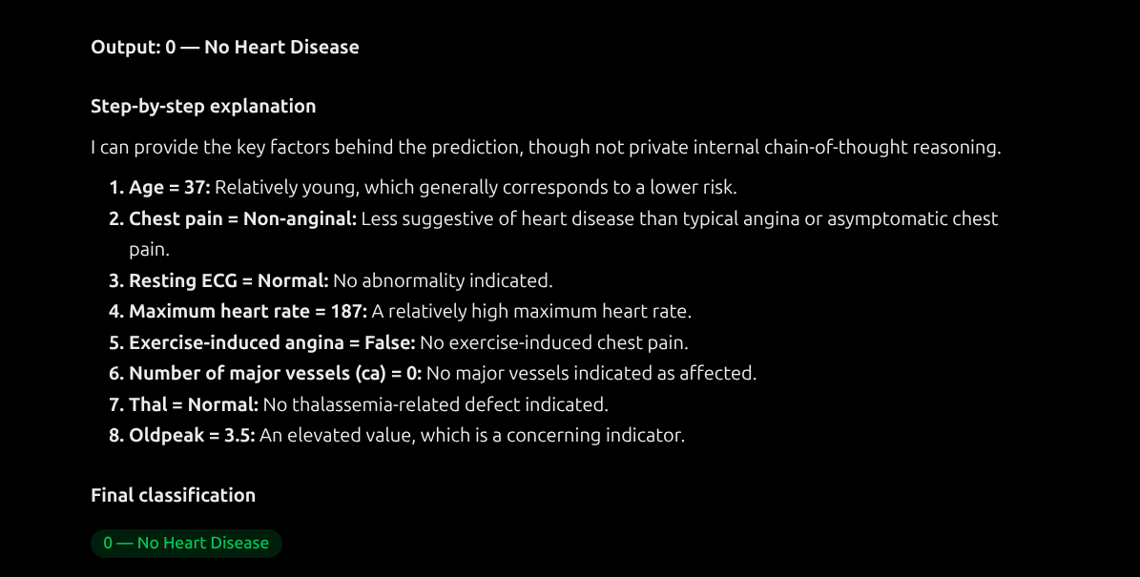
Screenshot:

Got correct answer this time?: Yes

FS 3 - Gemini
Prompt Id: FS 3
Model: Gemini
Method: Chain of Thought
Link: https://gemini.google.com/app/069255882f4011ee?is_sa=1&is_sa=1&android-min-version=301356232&ios-min-version=322.0&campaign_id=bkws&utm_source=sem&utm_medium=paid-media&utm_campaign=bkws&pt=9008&mt=8&ct=p-growth-sem-bkws&gclsrc=aw.ds&gad_source=1&gad_campaignid=20357620749&gbraid=0AAAAApk5BhkCrd2NBqZRlPExJgEknJ_Sr
Prompt used:
Classify the patient as having heart disease or not. Use the examples to predict the patient's class.
0 means No Heart Disease.
1 means Heart Disease.
Example 1:
Data: age=63, sex=Male, cp=typical angina, trestbps=145, chol=233, fbs=True, restecg=lv hypertrophy, thalch=150, exang=False, oldpeak=2.3, slope=downsloping, ca=0, thal=fixed defect
Output: 0
Example 2:
Data: age=67, sex=Male, cp=asymptomatic, trestbps=120, chol=229, fbs=False, restecg=lv hypertrophy, thalch=129, exang=True, oldpeak=2.6, slope=flat, ca=2, thal=reversable defect
Output: 1
Patient:
age=56, sex=Male, cp=atypical angina, trestbps=120, chol=236, fbs=False, restecg=normal, thalch=178, exang=False, oldpeak=0.8, slope=upsloping, ca=0, thal=normal
Output:

also give the step by step thinking how you thought ok, i want to learn from your chain of thoughts i want to see it give it its compulsory
Screenshot:

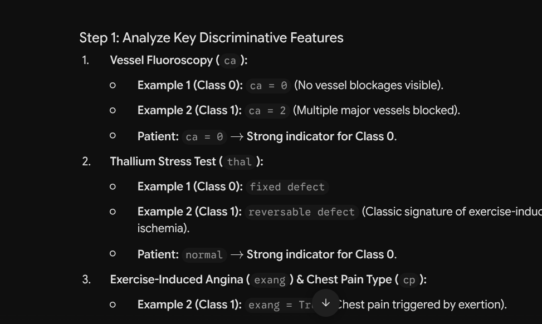
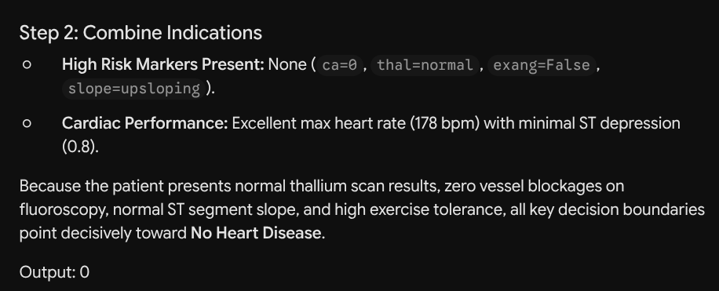
Got correct answer this time?: Yes

Answer 2 - Tree of Thought

FS 1 - ChatGPT
Prompt Id: FS 1
Model: ChatGPT
Method: Tree of Thought
Link: https://chatgpt.com/share/6af20a0b-93a4-83ec-acc0-4254d00ac269
Prompt used:
Classify whether the patient has heart disease or not. Learn from the given examples and classify the last patient.

0 means No Heart Disease.
1 means Heart Disease.

Example 1:
Data: age=63, sex=Male, cp=typical angina, trestbps=145, chol=233, fbs=True, restecg=lv hypertrophy, thalch=150, exang=False, oldpeak=2.3, slope=downsloping, ca=0, thal=fixed defect
Output: 0

Example 2:
Data: age=67, sex=Male, cp=asymptomatic, trestbps=120, chol=229, fbs=False, restecg=lv hypertrophy, thalch=129, exang=True, oldpeak=2.6, slope=flat, ca=2, thal=reversable defect
Output: 1

Now classify this patient:

Data: age=37, sex=Male, cp=non-anginal, trestbps=130, chol=250, fbs=False, restecg=normal, thalch=187, exang=False, oldpeak=3.5, slope=downsloping, ca=0, thal=normal

Output:
also give the step by step thinking how you thought ok, i want to learn from your tree of thoughts i want to see as mermaid diagram it give it its compulsory also give me your chain of thoughts too as mermaid diagram both of them ok and the decision why you chose it
Screenshot:
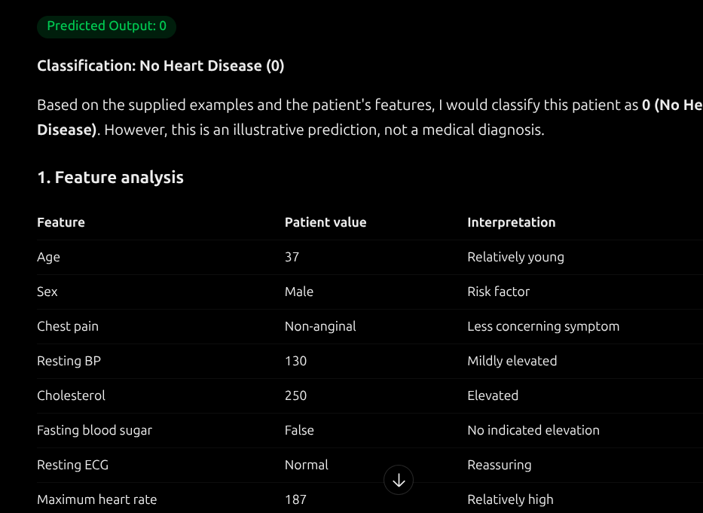
Got correct answer this time?: Yes

FS 3 - Gemini
Prompt Id: FS 3
Model: Gemini
Method: Tree of Thought
Link: https://gemini.google.com/app?is_sa=1&is_sa=1&android-min-version=301356232&ios-min-version=322.0&campaign_id=bkws&utm_source=sem&utm_medium=paid-media&utm_campaign=bkws&pt=9008&mt=8&ct=p-growth-sem-bkws&gclsrc=aw.ds&gad_source=1&gad_campaignid=20357620749&gbraid=0AAAAApk5BhkCrd2NBqZRlPExJgEknJ_Sr
Prompt used:
Classify the patient as having heart disease or not. Use the examples to predict the patient's class.
0 means No Heart Disease.
1 means Heart Disease.
Example 1:
Data: age=63, sex=Male, cp=typical angina, trestbps=145, chol=233, fbs=True, restecg=lv hypertrophy, thalch=150, exang=False, oldpeak=2.3, slope=downsloping, ca=0, thal=fixed defect
Output: 0
Example 2:
Data: age=67, sex=Male, cp=asymptomatic, trestbps=120, chol=229, fbs=False, restecg=lv hypertrophy, thalch=129, exang=True, oldpeak=2.6, slope=flat, ca=2, thal=reversable defect
Output: 1
Patient:
age=56, sex=Male, cp=atypical angina, trestbps=120, chol=236, fbs=False, restecg=normal, thalch=178, exang=False, oldpeak=0.8, slope=upsloping, ca=0, thal=normal
Output:

also give the step by step thinking how you thought ok, i want to learn from your tree of thoughts i want to see it give it its compulsory also give me your chain of thoughts both of them ok and the decision why you chose it
Screenshot:
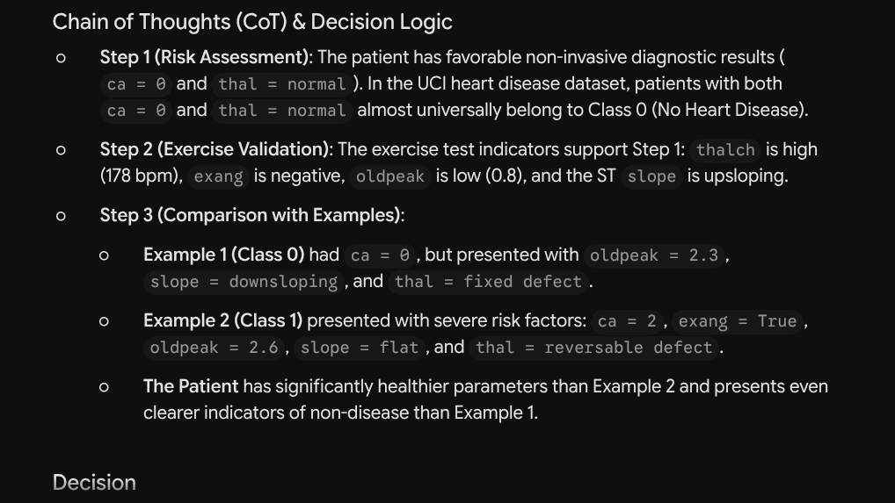
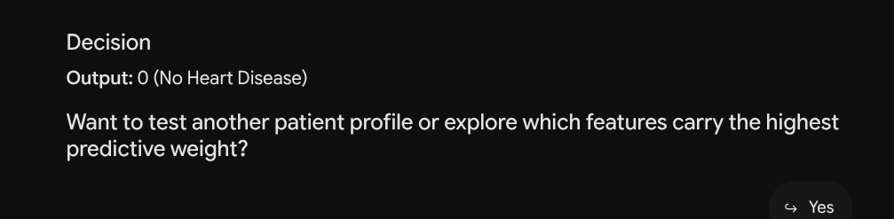

Got correct answer this time?: Yes

Answer 3 - ReAct

FS 3 - Gemini
Prompt Id: FS 3
Model: Gemini
Method: ReAct
Link: https://gemini.google.com/app?is_sa=1&is_sa=1&android-min-version=301356232&ios-min-version=322.0&campaign_id=bkws&utm_source=sem&utm_medium=paid-media&utm_campaign=bkws&pt=9008&mt=8&ct=p-growth-sem-bkws&gclsrc=aw.ds&gad_source=1&gad_campaignid=20357620749&gbraid=0AAAAApk5BhkCrd2NBqZRlPExJgEknJ_Sr
Prompt used:
Analyze the following patient record to predict whether the patient has heart disease.
Follow these steps:
1. Extract and organize the patient's clinical features.
2. Identify the features that may indicate an increased risk of heart disease, such as chest pain, resting blood pressure, cholesterol, maximum heart rate, exercise-induced angina, and oldpeak.
3. Examine the relevant features individually and identify any missing or unusual values.
4. Use the available clinical information to assess the patient's heart disease status.
5. Generate a final binary classification.
Patient Record:
age=56, sex=Male, cp=atypical angina, trestbps=120, chol=236, fbs=False, restecg=normal, thalch=178, exang=False, oldpeak=0.8, slope=upsloping, ca=0, thal=normal
Present your response using the following structure:
- Thought: Analyze the relevant patient features.
- Action: Examine the clinical indicators.
- Observation: Summarize the findings.
- Final Answer:
- 0 = No Heart Disease
- 1 = Heart Disease.
Screenshot:
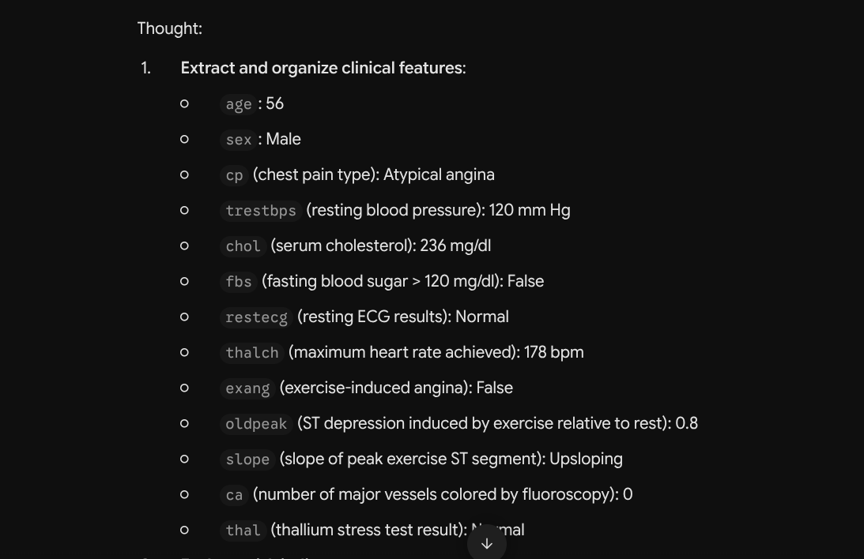
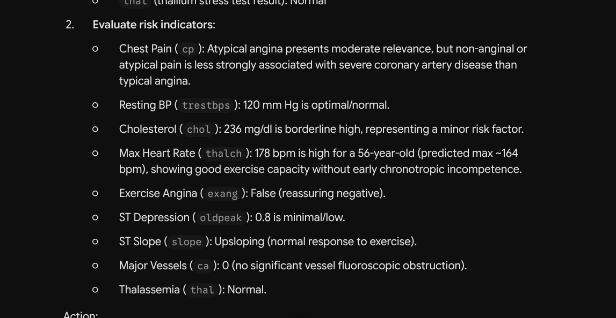
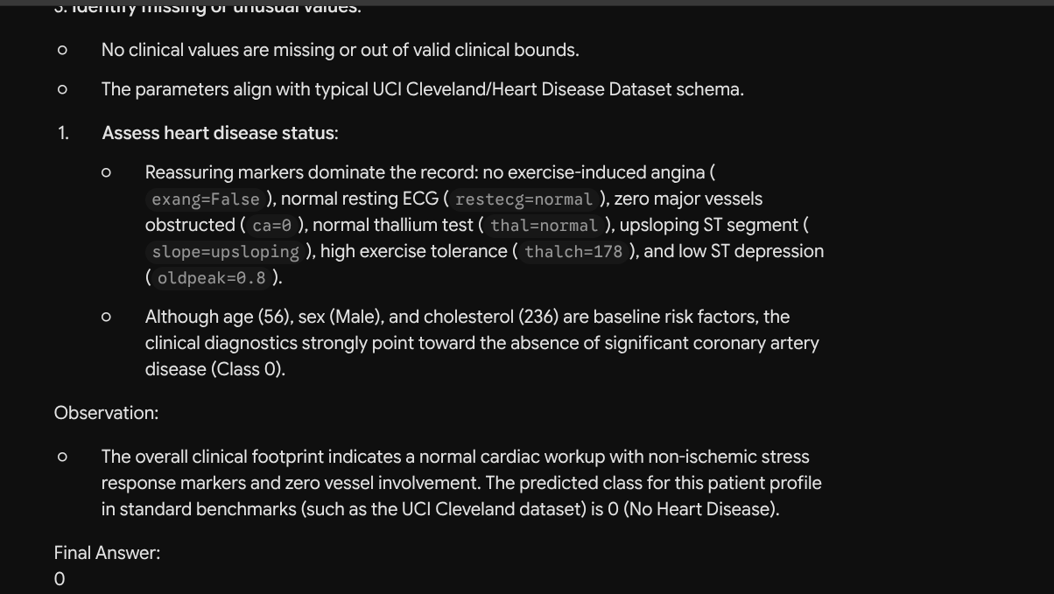
Got correct answer this time?: Yes

