**The impact of showcasing clothing items on a model**

**in terms of influencing consumer behavior**

Group 14: Gaurangi Agrawal, Lila Su, Bonny Yang, Chris Kuo

#### **Introduction**

In the competitive retail and fashion landscape, understanding consumer behavior is paramount for businesses aiming for success. Visual product presentation is a key factor influencing consumer decision-making. This study investigates whether dressing models in clothing enhances consumer purchase desire, with a focus on Zara, one of the world's leading fashion retail brands.

**Research Question: Whether dressing models in clothing enhances consumer purchase desire?**

**Hypothesis: Clothing displayed on models can potentially boost consumers' purchase intent, thereby increasing sales for the company.**

#### **Methodology**

##### **Goal of the Experiment**

Consumer behavior research has long emphasized the impact of visual stimuli on preferences and purchase intentions, particularly in the fashion industry where models play a crucial role in advertising. This study aims to explore the relationship between clothing presentation on models and consumer behavior, shedding light on the dynamics between visual presentation and purchase intentions. By analyzing this interaction, our goal is to provide valuable insights for marketers to devise effective visual marketing strategies and empower consumers to make informed choices in an image-centric market landscape.

##### **Survey Design**

We conducted a comprehensive survey focusing on diverse demographic factors, including gender, age group, location, and monthly expenditure on shopping. Our primary objective was to understand consumer preferences through a series of questions.

Participants were first asked about their gender, age group, location, and monthly shopping expenditure. Subsequently, they were presented with a set of fifteen questions, each probing their preferences in various scenarios. Notably, within these questions, we incorporated a randomized approach via the Qualtrics function, varying the presentation of images.

In particular, one image was consistently displayed across both experimental and control groups. This image featured clothing items without being modeled. However, the second image varied between the treatment and control groups. In the treatment group, participants were presented with an image showcasing clothes on a model. In contrast, in the control group, the second image remained consistent with the first—displaying clothes without a model.

This method ensured that randomization was question-specific, with the randomizer determining group assignment for each question, allowing us to assess the impact of presenting clothes on a model versus clothes displayed without a model on participants' preferences. By randomizing questions rather than respondents, we ensured an unbiased evaluation of these preferences across different demographic segments, providing valuable insights into consumer behavior and preferences in the shopping domain. We also can improve comparability. Randomizing questions ensures that each respondent is evenly exposed to treatment groups’ questions and control groups’ questions. As they receive a unique sequence of questions, it becomes easier to compare responses across different groups or segments of respondents. This can be particularly useful in analyzing survey data and drawing meaningful insights.

Additionally, we designed a total of 15 questions, with 8 questions focusing on female clothing and 7 questions focusing on male clothing to eliminate gender bias. For item selection, we chose top items like vests, hoodies, and t-shirts, as well as bottom items like skirts, shorts, and pants.

#### **Data Analysis**

##### **Data Cleaning**

The data we downloaded is structured such that each respondent's answers to every question are recorded in separate columns. However, for our analysis, it's more suitable to have each question represented as a row rather than a column. To achieve this transformation, we utilized the `melt` function, which effectively converts columnar data into row-based data.

After applying the `melt` function, our dataset has been reshaped to have a total of 15 questions multiplied by 129 respondents, resulting in 1935 rows. This restructuring allows us to conduct analyses more effectively, as each row now corresponds to a single respondent's answer to a specific question. This format facilitates various analytical techniques, including summarization, visualization, and modeling, enabling us to derive insights from the data in a more intuitive and comprehensive manner.

##### **Exploratory Data Analysis**

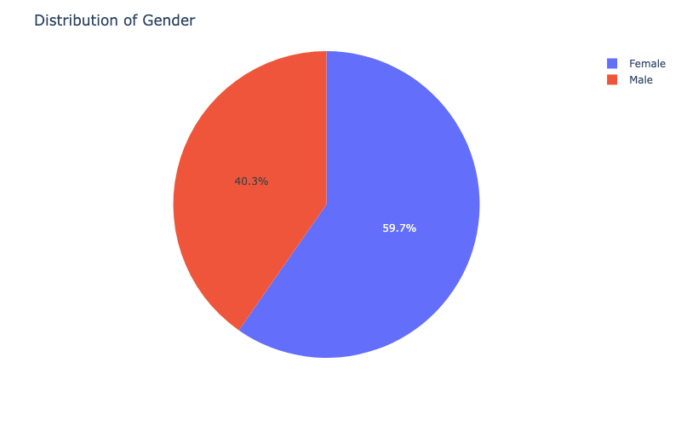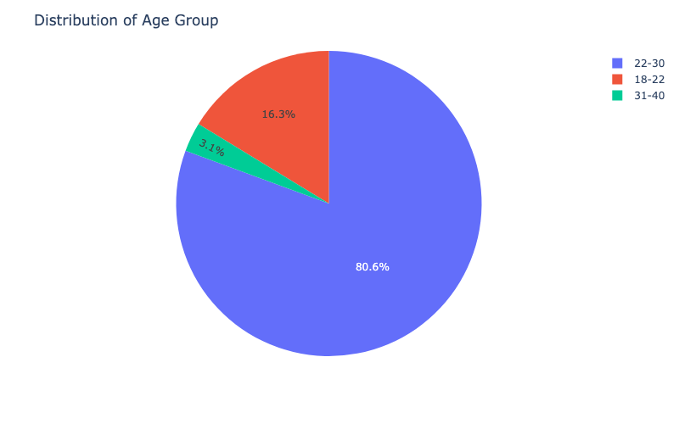

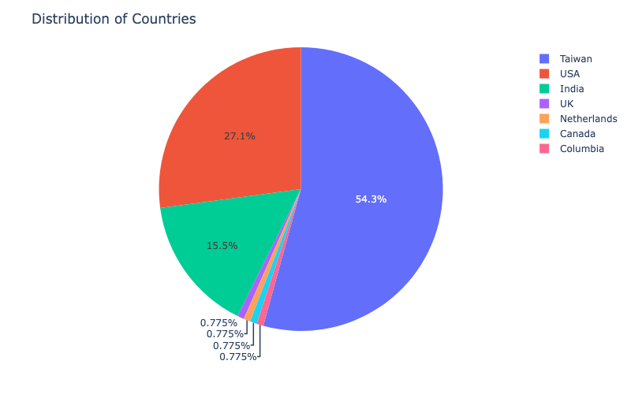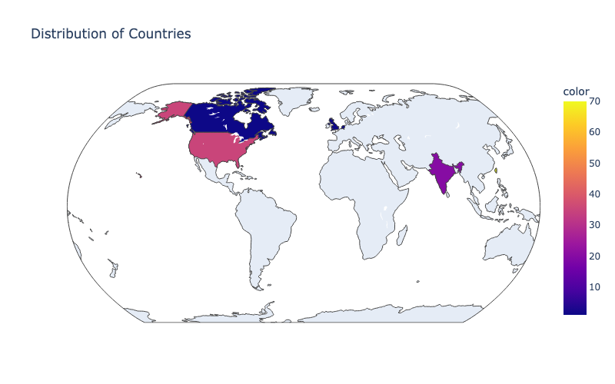

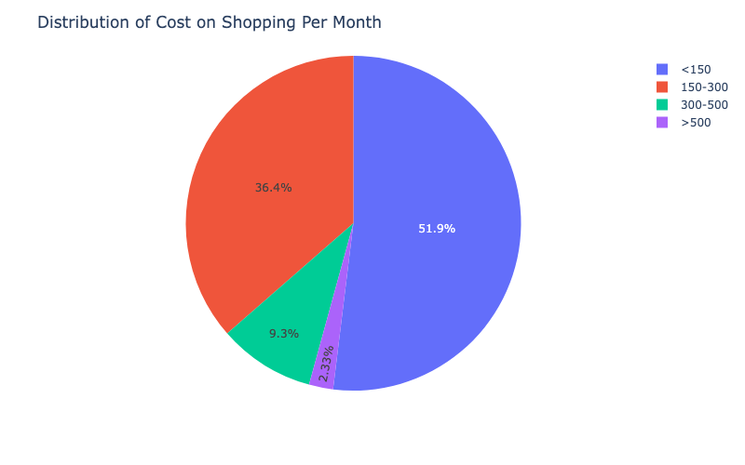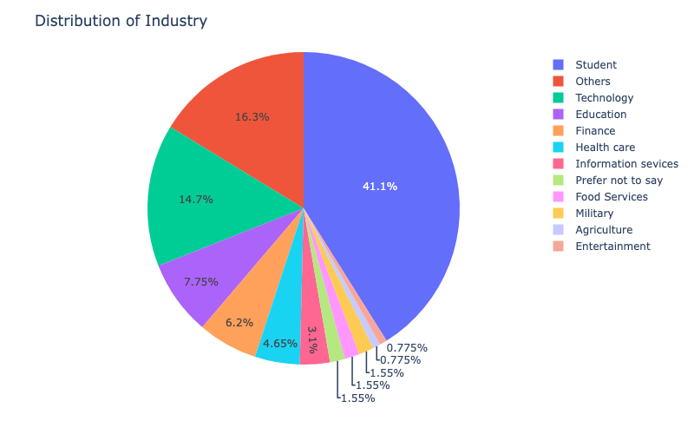

We collected a total of 129 surveys, with an average response time of about 2 minutes and 55 seconds. Approximately 60% of the respondents were female. Moreover, a significant 97% of the respondents were aged below 30 years old. Regarding the age distribution, the majority fell within the range of 22 to 30 years old, followed by 16% aged between 18 and 22 years old. Only 3% were aged 30 years and above. This distribution reflects the concentration of young participants, which is reasonable as 40% of the respondents were students. The survey participants represented a diverse range of industries, with technology and education being the second and third most prevalent respectively. As for residence, the majority of respondents were from Taiwan, United States, and India. We also consider monthly shopping expenditures to be an important variable for our experiment. The distribution is concentrated below 300 US dollars. After the preliminary exploratory data analysis, our next step will be survey analysis.

##### **Estimated Average Treatment Effect**

###### **Average Treatment Effect**

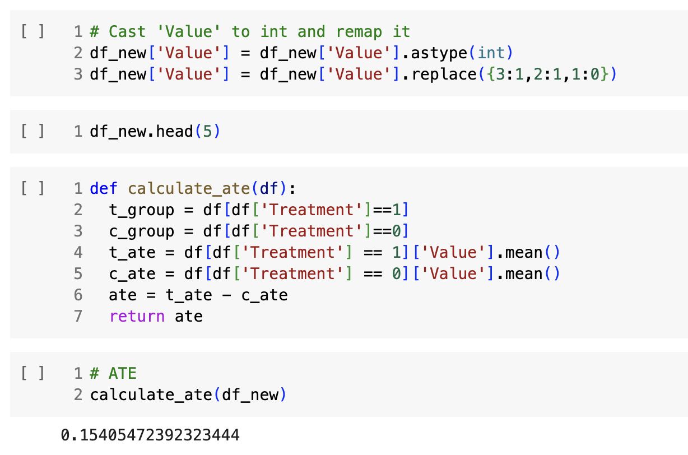

###### **Conditional Average Treatment Effect**

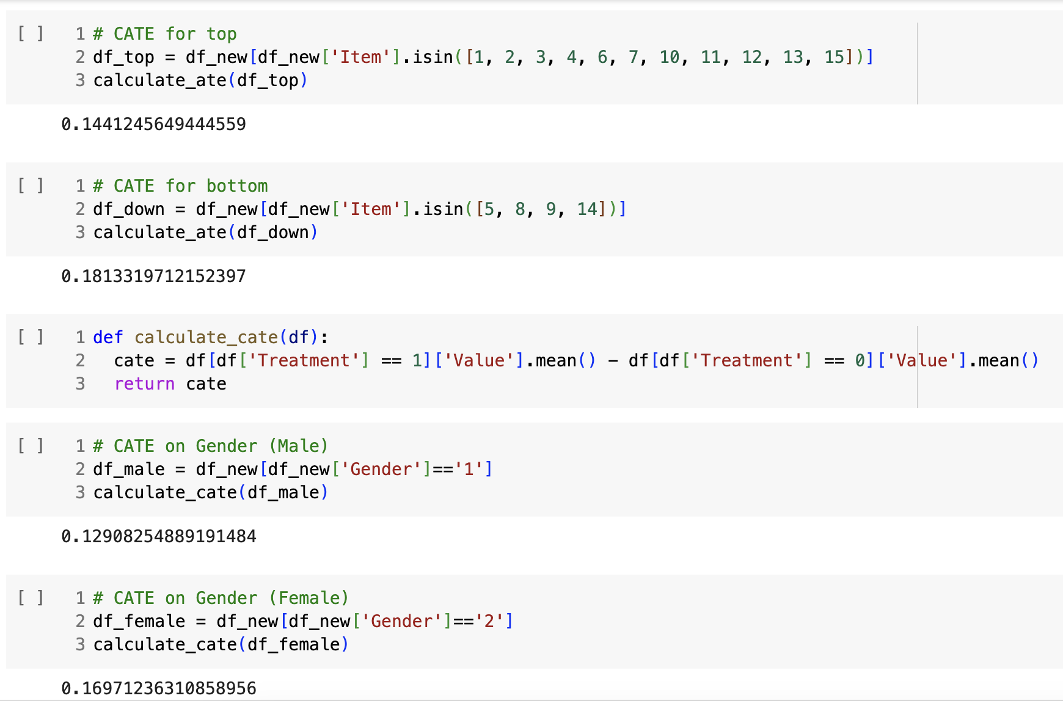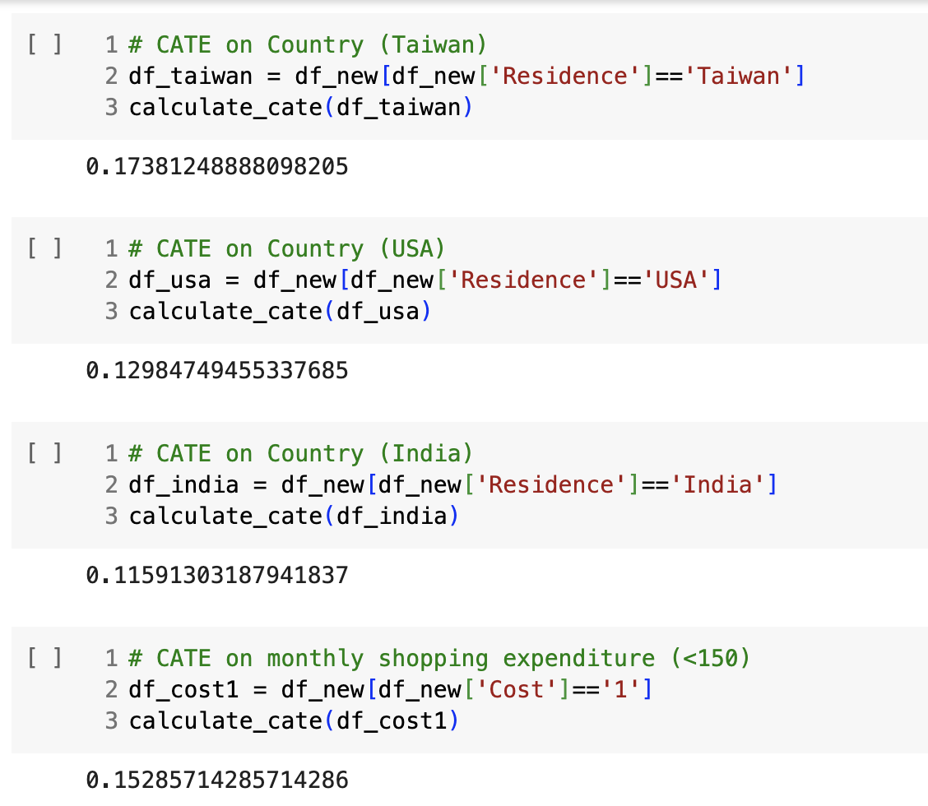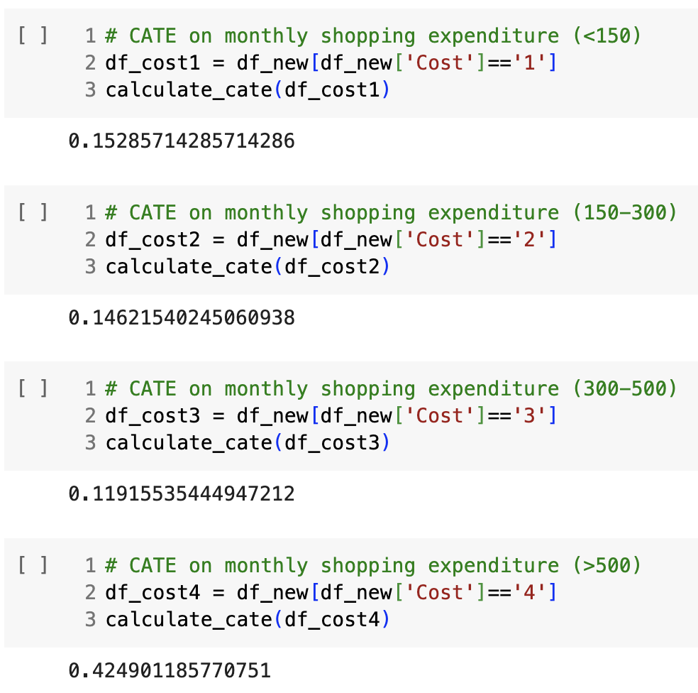

The ATE of 0.154 indicates that presenting clothes on models has a positive effect on encouraging customers to make a purchase. Additionally, we observed some conditional average treatment effects, with bottom clothing showing a slightly stronger effect compared to top clothing probably because consumers need models more to imagine how bottoms would look like on themselves. And females exhibit a higher treatment effect than males. Among the group of individuals who spend the most, with monthly expenditures exceeding 500 us dollars, there is a considerably higher treatment effect than other groups. Therefore, we assume that they are more susceptible to the influence of clothes being presented on models. Moreover, the treatment effect of presenting clothes on models differs in different regions. Specifically, in Taiwan, the treatment effect is 0.17, suggesting a relatively higher impact compared to the USA and India. In the USA, the treatment effect is slightly lower at 0.13, while in India, it is lower at 0.12. This disparity in treatment effects across regions could be influenced by various factors such as cultural preferences, shopping behaviors, and advertising norms.

##### **Linear Regression**

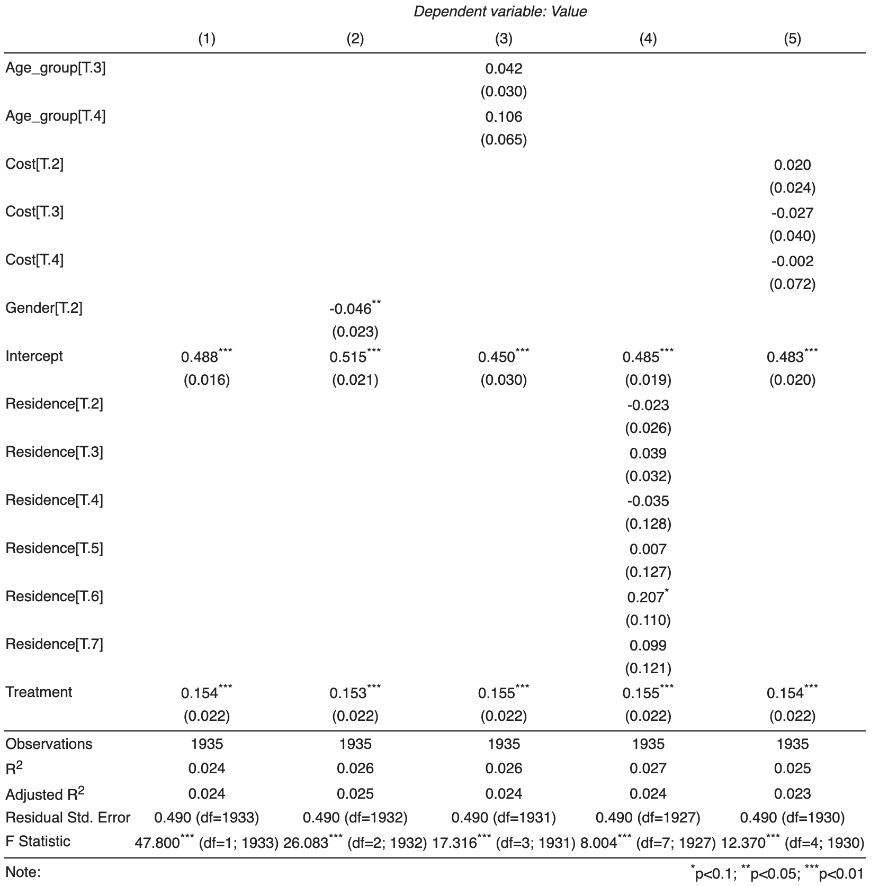

We ran five different regression models based on various variables, including Age Group, Cost, Gender, Residence, and Treatment. The graph above presents several findings.

1. The variable 'Treatment' has a consistently positive and statistically significant effect on the dependent variable 'Value' across all five model specifications, indicating that the treatment likely leads to an increase in the outcome measure.
2. The 'Gender[T.2]' variable in model (2) shows a significant negative association with the dependent variable, suggesting that the group represented by this category has a lower 'Value' on average when compared to the baseline group.
3. The age group variables 'Age_group[T.3]' and 'Age_group[T.4]', and the 'Cost' variables across different tiers ('Cost[T.2]', 'Cost[T.3]', and 'Cost[T.4]') do not show a consistent significant effect in any of the models, indicating that these factors may not play a significant role in the dependent variable 'Value'.
4. The intercept is statistically significant across all models, indicating that when all other variables are at their reference levels, the dependent variable 'Value' has a positive baseline value.

Overall, while the treatment appears to be an influential factor, the models suggest that other unmeasured factors might also be important in explaining the variation in the dependent variable. Additionally, the statistical significance of the 'Gender[T.2]' coefficient in model (2) is an important finding.

##### **Randomization Check**

Collectively, we gathered data from 129 participants, each answering 15 questions, resulting in a total of 1935 data points. The distribution between treatment (971) and control (964) groups was nearly equal, indicating a close to 50% - 50% randomization across questions.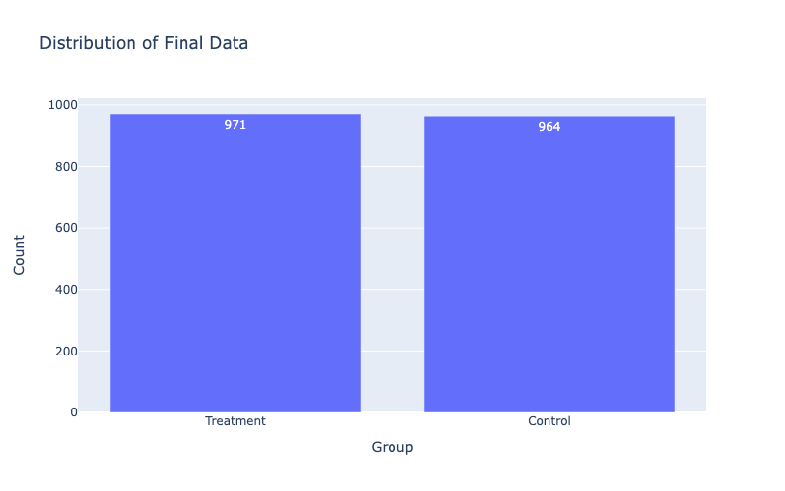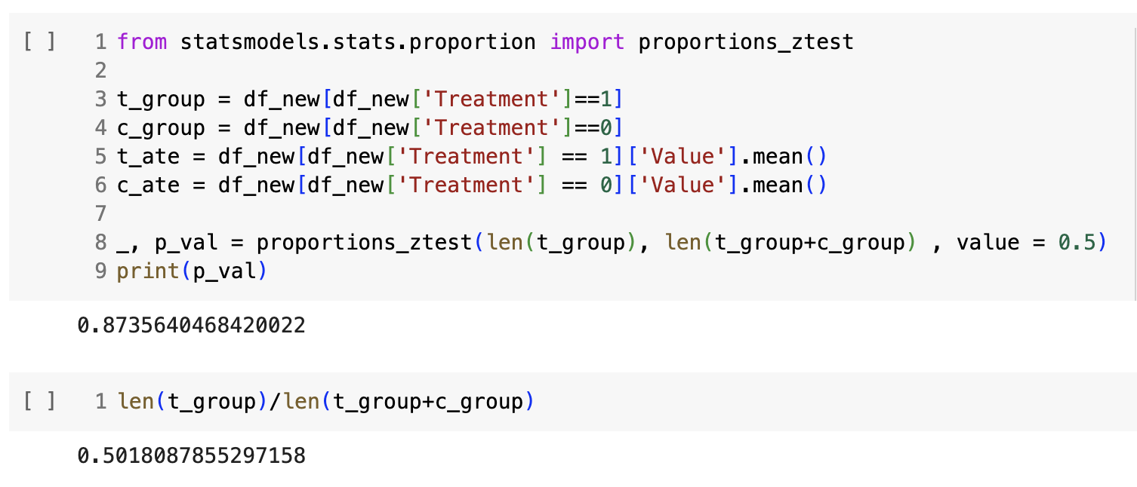

We conducted a proportions_ztest to verify the proper randomization of our experiment. The resulting p-value was 0.874, implying that we cannot reject the null hypothesis. Consequently, we have confidence in the randomization of our experiment.

##### **Statistical Power**

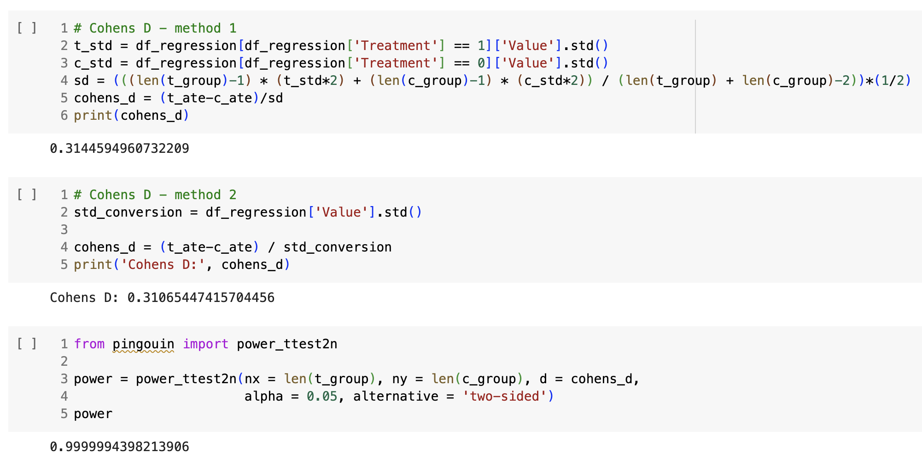

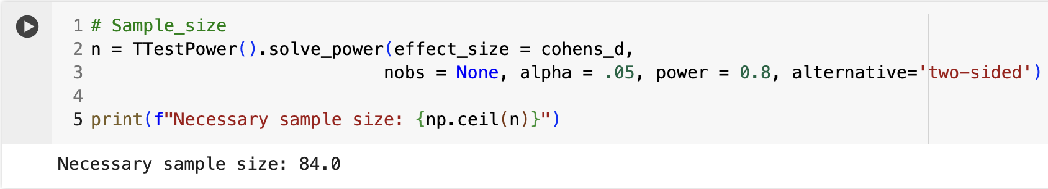

In the statistical power section, we employed three different methods: Cohen's D, Power t-test and a TTestPower test to calculate the statistical power. The result from Cohen's D was 0.3144, indicating a small to medium effect size. This value suggests that the difference between the treatment and control groups is noticeable, albeit not large. Regarding the power, a value of 0.9999 implies a 99.99% probability that our test will detect an effect, provided that there is indeed an actual effect present. Last but not least, the TTestPower yields a result of necessary sample size of 84.

#### **Limitations**

##### **Survey Design**

Selection bias refers to the systematic error introduced in a research study when the sample or participants chosen for the study are not representative of the larger population from which they are drawn. This bias occurs when certain factors influence which individuals or data points are included in the sample, leading to an unrepresentative sample that may not accurately reflect the population's characteristics. Selection bias can distort the study results and undermine the validity and generalizability of the findings. It can arise due to various reasons, such as non-random sampling methods, self-selection bias, or the exclusion of certain groups from the study population. To mitigate selection bias, researchers often employ random sampling techniques and carefully consider the selection criteria to ensure the sample's representativeness.

##### **Age Group**

A potential limitation of the survey is the skewed distribution of age groups among respondents, with a predominant focus on a narrow range. Specifically, approximately 80.6% of respondents fell within the 22-30 age bracket, with only 3.1% in the 31-40 age range and 16.3% in the 18-22 age group. This imbalance restricted the diversity of perspectives represented in the survey, hindering our ability to fully capture and analyze opinions across various age demographics.

##### **Item Selection**

The survey's second limitation lies in its limited coverage of covariates and the restricted range of options provided for respondents. With only 4 questions dedicated to bottom wear and 11 to top wear, our ability to explore consumer preferences and satisfaction levels was significantly hindered.

This constraint diminished the depth and breadth of insights that could have been obtained from the survey responses. By offering a constrained set of questions, we risk overlooking critical factors that influence consumer behavior and sentiment, such as fabric quality, fit, style, and price point.

While this limitation accurately reflects the survey's scope, it highlights the need to broaden the range of covariates and options in future surveys. Doing so will enable a more comprehensive examination of consumer preferences and satisfaction levels.

#### **Conclusion**

During the experiment, we aimed to assess the impact of presenting clothing on models on consumer preferences and purchasing behavior. Participants were randomly assigned to either the treatment group (viewing clothing on models) or the control group (viewing clothing without models), resulting in an even distribution. Our analysis revealed a significant effect of displaying clothing on models, highlighting its influence on shaping consumer preferences.

While the experiment demonstrated a positive treatment effect, it also had notable limitations. The majority of participants were young adults aged 22-30, with a higher representation of females (60%), thereby limiting the generalizability of the findings to a more diverse consumer base. Additionally, the survey lacked comprehensive covariate coverage and offered limited options for exploring preferences across different clothing types (bottom and top wear).

Despite limitations, the study provides valuable insights for fashion retailers like Zara, emphasizing the importance of visual presentation in consumer decision-making. It highlights the need for further research involving a broader demographic and wider product range. Acknowledging both the role of models and study limitations enables businesses to formulate balanced strategic decisions in the fashion industry.

#### **Appendix**

Preview of Survey Form

##### **Control Treatment**

