### User Story for Purchase Pet Insurance

|  |  |
| --- | --- |
| **As a** | registered user of <https://policybazaar.com> |
| **I want** | an option to choose from various Pet Insurance Plans |
| **So that** | I can purchase an insurance policy for my Pet on the website |
| **Acceptance Criteria** | 1. User logs into <https://policybazaar.com>, and the system displays the **Home** page 2. User clicks on the **‘Pet Insurance’** command button   (Refer: Appendix 2, Wireframe 1 & Appendix 3 – Data Table)   1. System navigates the user to the ‘**Pet Insurance Landing’** page in the same window   (Refer: Appendix 4, Wireframe 2 & Appendix 5 – Data Table)   1. User selects their pet (Dog/Cat) and clicks on it 2. System navigates to the ‘**Select a Plan’** page in the same window   (Refer: Appendix 6, Wireframe 3 & Appendix 7 – Data Table)   1. System displays various pet insurance plans with quick details 2. User selects a preferred plan and clicks on it 3. System navigates to the ‘**Plan Details’** page in the same window   (Refer: Appendix 8, Wireframe 4 & Appendix 9 – Data Table)   1. System displays full information about the selected plan. 2. User clicks the **Buy Now** button 3. System navigates to the ‘**Purchase and Payment’** page (same window)   (Refer: Appendix 10, Wireframe 5 & Appendix 11 – Data Table)   1. User enters all required Pet and Owner details, accepts the **Terms and Conditions**, and clicks on the **Proceed to Payment** button   (Refer: Appendix 12 – Validations Table)   1. User completes the payment on the existing PolicyBazaar payment service 2. Upon successful payment verification:  * System displays a **confirmation pop-up**   (Refer: Appendix 13, Wireframe 6 & Appendix 14 – Data Table)   * System sends a **confirmation email** to the user's registered email ID with the policy details   (Refer: Appendix 15, Wireframe 7) |

**Appendix 1:** ‘Purchase Pet Insurance’ Process Flow

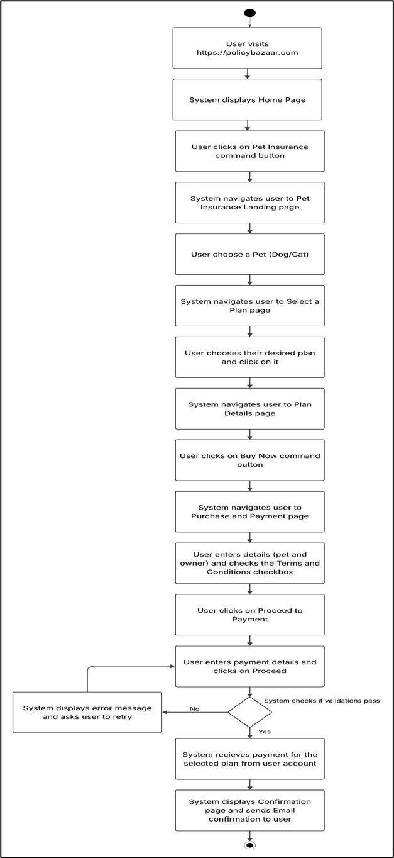

**Appendix 2:** Display ‘Pet Insurance’ Command Button on ‘Home’ Page, Wireframe 1

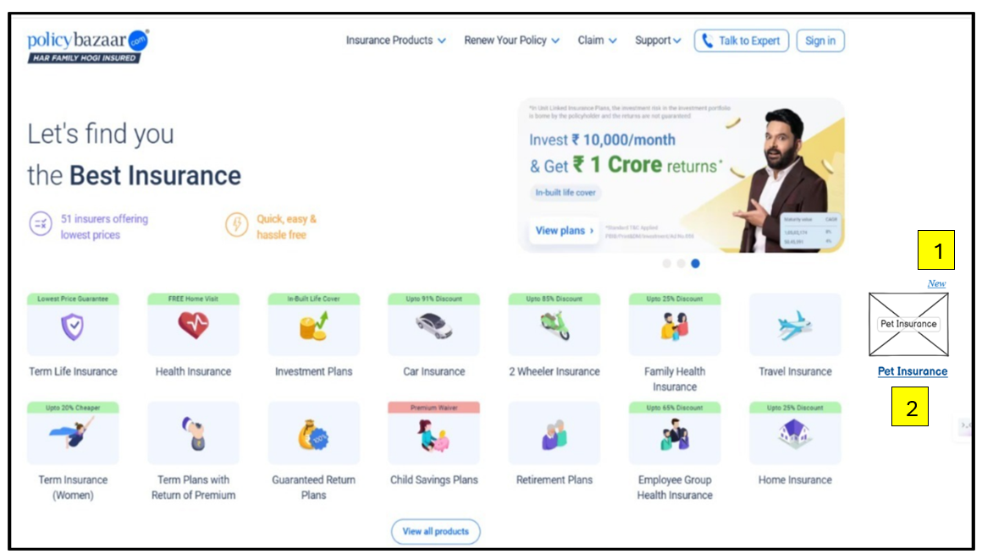

**Appendix 3:** Data Table for ‘Transfer Funds’ Command Button

|  |  |  |  |  |  |  |  |
| --- | --- | --- | --- | --- | --- | --- | --- |
| **Sr. No.** | **Field Name** | **Field Type** | **Content** | **Required Field?** | **Min. Char.** | **Max Char.** | **Notes** |
| 1 | New Badge | Label | New | N/A | N/A | N/A | Positioned above Pet Insurance tile to indicate its newly added |
| 2 | Pet Insurance Button | Command Button | Pet Insurance | N/A | N/A | N/A | Newly added tile in product grid; clicking navigates to pet insurance page |

**Appendix 4:** ‘Pet Insurance Landing’ Page, Wireframe 2

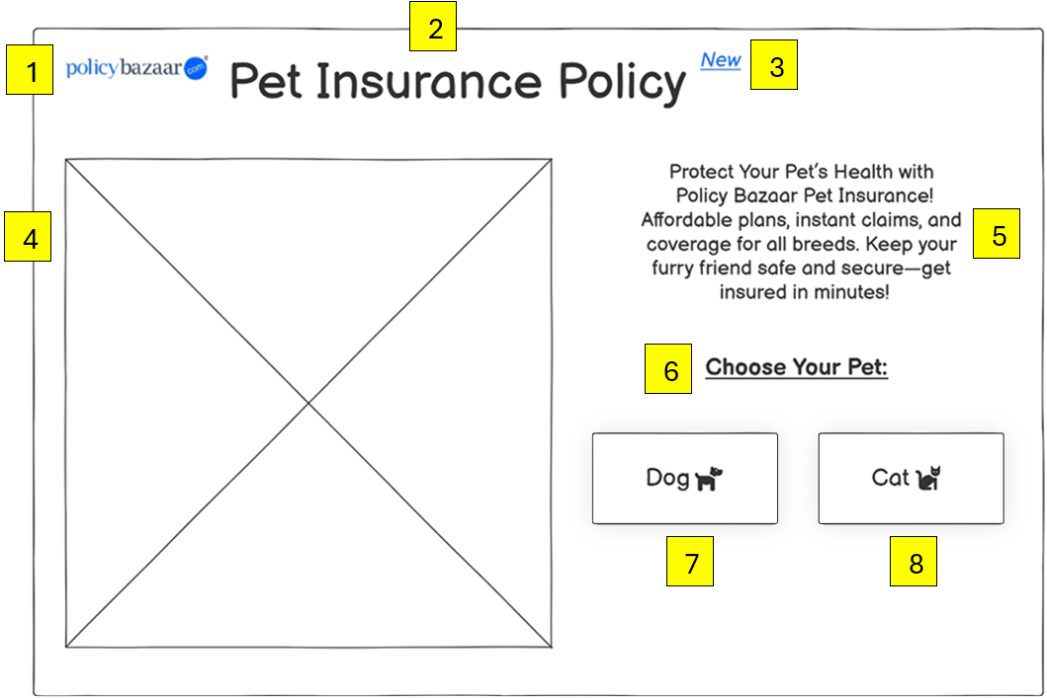

**Appendix 5:** ‘Pet Insurance Landing’ Page Data Table

|  |  |  |  |  |  |  |  |
| --- | --- | --- | --- | --- | --- | --- | --- |
| **Sr. No.** | **Field Name** | **Field Type** | **Content** | **Required Field?** | **Min. Char.** | **Max Char.** | **Notes** |
| 1 | Logo | Image | policybazaar.com logo | N/A | N/A | N/A | Brand identity/logo displayed at top-left corner |
| 2 | Page Title | Label / Heading | Pet Insurance Policy | N/A | N/A | N/A | Main heading for the page |
| 3 | "New" Badge | Label | New | N/A | N/A | N/A | Blue label beside title to indicate freshness or newly launched |
| 4 | Banner Image | Image Placeholder | Promotional visual (X-marked box) | N/A | N/A | N/A | Placeholder image for pet/promo graphic |
| 5 | Description Text | Paragraph Label | Protect Your Pet’s Health... (full description text shown) | N/A | N/A | N/A | Descriptive text to inform user about benefits of insurance |
| 6 | Section Heading | Label | Choose Your Pet: | N/A | N/A | N/A | Indicates action area where user picks between pet types |
| 7 | Dog Button | Command Button | Dog 🐶 | N/A | N/A | N/A | On click, shows dog-specific plans |
| 8 | Cat Button | Command Button | Cat 🐱 | N/A | N/A | N/A | On click, shows cat-specific plans |

**Appendix 6:** ‘Select a Plan’ Page, Wireframe 3

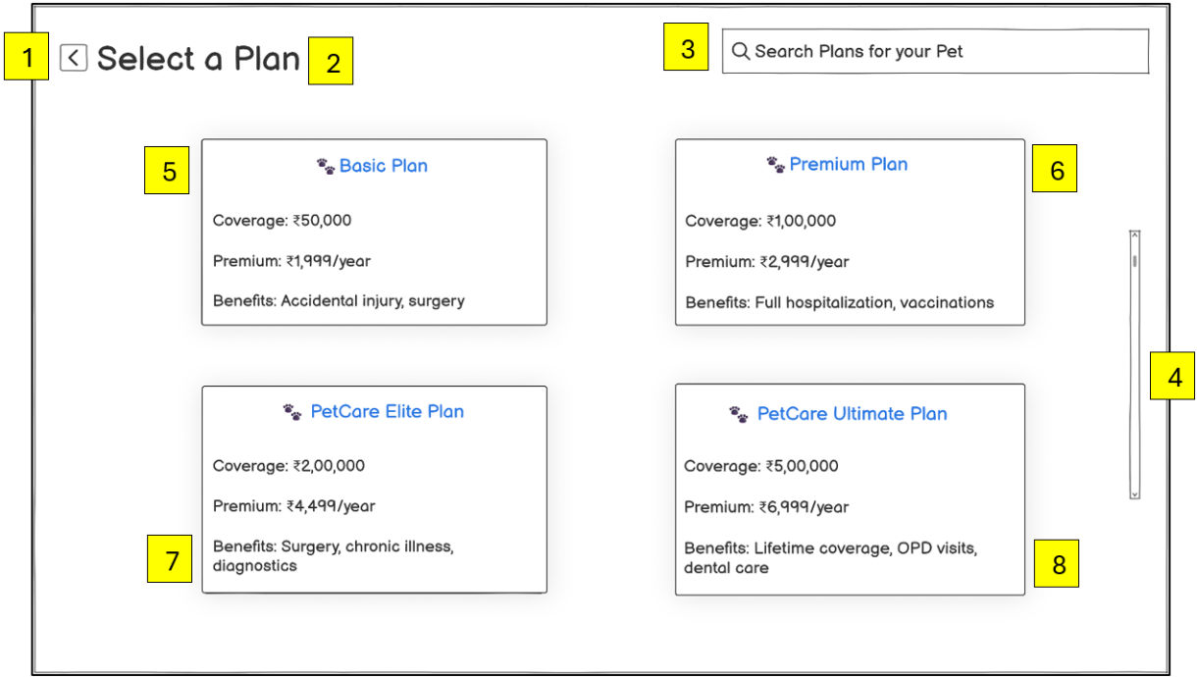

**Note:** This plan selection wireframe is reusable for both Dog and Cat policies. Plan cards dynamically load based on the pet type selected on the previous screen.

**Appendix 7:** ‘Select a Plan’ Data Table

|  |  |  |  |  |  |  |  |
| --- | --- | --- | --- | --- | --- | --- | --- |
| **Sr. No.** | **Field Name** | **Field Type** | **Content** | **Required Field?** | **Min. Char.** | **Max Char.** | **Notes** |
| 1 | Back Icon Button | Command Button | ← | N/A | N/A | N/A | Navigates user back to ‘Pet Insurance Landing’ page |
| 2 | Page Title | Label / Heading | Select a Plan | N/A | N/A | N/A | Header indicating current screen |
| 3 | Search Bar | Search Input | Search Plans for your Pet | No | 1 | 100 | Allows users to search/filter plans by name or feature |
| 4 | Scrollbar | Scrollbar | Vertical Scrollbar | N/A | N/A | N/A | Allows scrolling through list of plans if content overflows |
| 5 | Basic Plan Card | Container Group | Coverage: ₹50,000; Premium: ₹1,999/year; Benefits: Accidental injury, surgery | N/A | N/A | N/A | Card layout for “Basic Plan”; content changes based on selected pet (Dog/Cat) |
| 6 | Premium Plan Card | Container Group | Coverage: ₹1,00,000; Premium: ₹2,999/year; Benefits: Full hospitalization, vaccinations | N/A | N/A | N/A | Card layout for “Premium Plan”; content changes based on selected pet (Dog/Cat) |
| 7 | PetCare Elite Plan Card | Container Group | Coverage: ₹2,00,000; Premium: ₹4,499/year; Benefits: Surgery, chronic illness, diagnostics | N/A | N/A | N/A | Card layout for “PetCare Elite Plan”; content changes based on selected pet (Dog/Cat) |
| 8 | PetCare Ultimate Plan Card | Container Group | Coverage: ₹5,00,000; Premium: ₹6,999/year; Benefits: Lifetime coverage, OPD visits, dental care | N/A | N/A | N/A | Card layout for “Ultimate Plan”; content changes based on selected pet (Dog/Cat) |

**Appendix 8:** ‘Plan Details’ Page, Wireframe 4

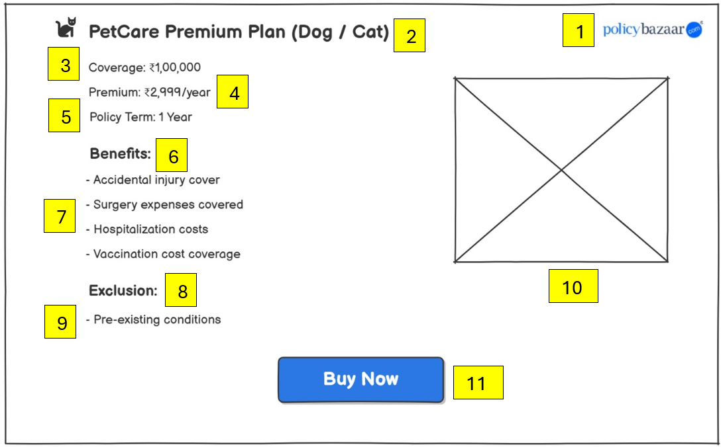

**Appendix 9:** ‘Plan Details’ Page Data Table

|  |  |  |  |  |  |  |  |
| --- | --- | --- | --- | --- | --- | --- | --- |
| **Sr. No.** | **Field Name** | **Field Type** | **Content** | **Required Field?** | **Min. Char.** | **Max Char.** | **Notes** |
| 1 | Logo | Image | policybazaar.com logo | N/A | N/A | N/A | Displayed at top-right corner for brand identity |
| 2 | Plan Title | Label / Heading | PetCare Premium Plan (Dog / Cat) | N/A | N/A | N/A | Dynamic text, changes based on pet selection |
| 3 | Coverage Amount | Text Label | Coverage: ₹1,00,000 | N/A | N/A | N/A | Indicates insurance coverage amount |
| 4 | Premium Amount | Text Label | Premium: ₹2,999/year | N/A | N/A | N/A | Yearly cost of the plan |
| 5 | Policy Term | Text Label | Policy Term: 1 Year | N/A | N/A | N/A | Duration of the policy |
| 6 | Benefits Heading | Label (Bold) | Benefits: | N/A | N/A | N/A | Section heading for list of benefits |
| 7 | Benefits List | Bullet List | - Accidental injury cover - Surgery expenses covered - Hospitalization costs - Vaccination cost coverage | N/A | N/A | N/A | Describes plan advantages |
| 8 | Exclusion Heading | Label (Bold) | Exclusion: | N/A | N/A | N/A | Section heading for exclusions |
| 9 | Exclusion Text | Bullet Point | - Pre-existing conditions | N/A | N/A | N/A | Specifies what is not covered |
| 10 | Plan Image Placeholder | Image Placeholder | X-marked box | N/A | N/A | N/A | Placeholder for pet/plan related image |
| 11 | Buy Now Button | Command Button | Buy Now | Yes | N/A | N/A | CTA to purchase policy |

**Appendix 10:** ‘Purchase and Payment’ Page, Wireframe 5

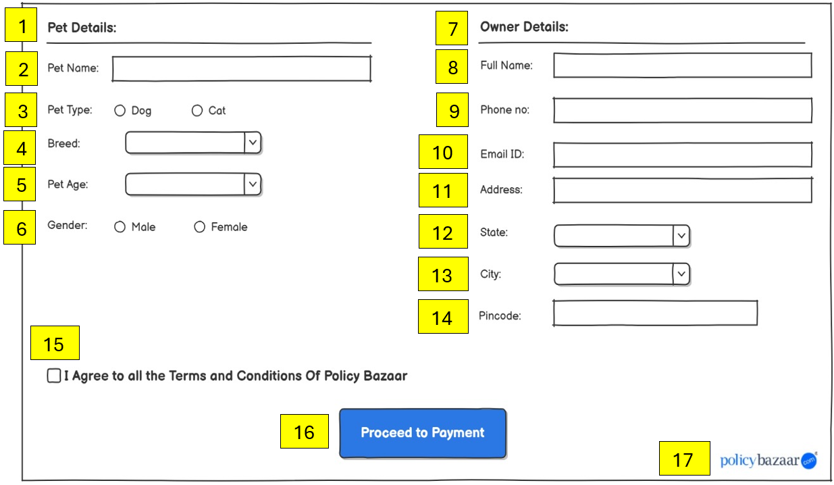

**Appendix 11:** ‘Purchase and Payment’ Page Data Table

|  |  |  |  |  |  |  |  |
| --- | --- | --- | --- | --- | --- | --- | --- |
| **Sr. No.** | **Field Name** | **Field Type** | **Content** | **Required Field?** | **Min. Char.** | **Max Char.** | **Notes** |
| 1 | Section Heading (Pet) | Label / Section | Pet Details: | N/A | N/A | N/A | Heading for left section (pet-specific input) |
| 2 | Pet Name | Input Text Field | Pet Name: | Yes | 1 | 30 | Free text input for pet's name |
| 3 | Pet Type | Radio Buttons | Dog / Cat | Yes | N/A | N/A | Mandatory pet type selection |
| 4 | Breed Dropdown | Dropdown Menu | Breed: (dropdown) | Yes | N/A | N/A | Shows breed list based on selected type |
| 5 | Pet Age | Dropdown Menu | Pet Age: (dropdown) | Yes | N/A | N/A | Age in years, typically from 1–20 |
| 6 | Pet Gender | Radio Buttons | Male / Female | Yes | N/A | N/A | Mandatory selection |
| 7 | Section Heading (Owner) | Label / Section | Owner Details: | N/A | N/A | N/A | Heading for right section (owner-specific input) |
| 8 | Full Name | Input Text Field | Full Name: | Yes | 2 | 50 | Owner’s full name |
| 9 | Phone No | Input Text Field | Phone no: | Yes | 10 | 10 | Must be a valid Indian mobile number |
| 10 | Email ID | Input Text Field | Email ID: | Yes | 5 | 50 | Used for verification & policy receipt |
| 11 | Address | Textarea | Address: | Yes | 5 | 200 | Residential address |
| 12 | State | Dropdown Menu | State: (dropdown) | Yes | N/A | N/A | List of Indian states |
| 13 | City | Dropdown Menu | City: (dropdown) | Yes | N/A | N/A | Filtered list based on selected state |
| 14 | Pincode | Input Text Field | Pincode | Yes | 6 | 6 | Must be valid 6-digit Indian postal code |
| 15 | Terms and Conditions Checkbox | Checkbox | I Agree to all the Terms and Conditions of Policy Bazaar | Yes | N/A | N/A | Must be ticked before payment |
| 16 | Proceed to Payment Button | Call-to-Action Button | Proceed to Payment | Yes | N/A | N/A | Final action to move to payment page |
| 17 | Logo | Image | policybazaar.com logo | N/A | N/A | N/A | Bottom-right corner for brand identity |

**Appendix 12:** ‘Transfer Funds’ Page Validations Table

|  |  |
| --- | --- |
| **Failed Validation** | **Error Message Displayed** |
| All required data is entered | <Data Field> is a required field. Please enter a value for <Data Field> |
| All the entered data is valid | Value for <Data Field> is invalid. Please enter a valid value for <Data Field> |
| Only one pet type is selected | <Pet type> error. User can select only one pet type. |
| Only one breed is selected | Please select only one breed. |
| Only one age is selected | Please select an age. |
| Only one gender type is selected | Select Gender. |
| Phone number is 10 digit and is active | <phone number> is invalid. Enter a valid email id. |
| Email id is in valid format | <email id> is invalid. Enter a valid email id format. |
| Pincode is a 6 digit numeric value | <pincode> is invalid. Enter a valid 6 digit pincode. |

**Appendix 13:** ‘Confirmation’ Page, Wireframe 6

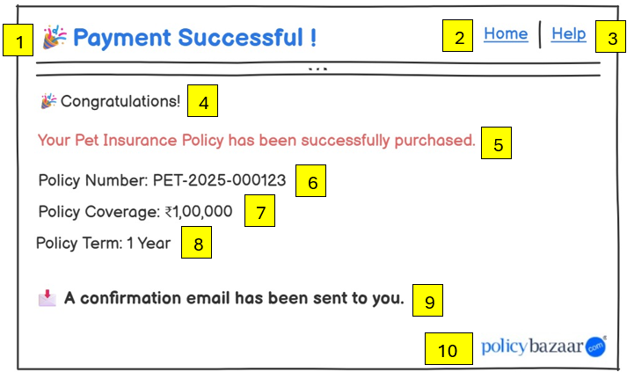

**Appendix 14:** ‘Confirmation’ Page Data Table

|  |  |  |  |  |  |  |  |
| --- | --- | --- | --- | --- | --- | --- | --- |
| **Sr. No.** | **Field Name** | **Field Type** | **Content** | **Required Field?** | **Min. Char.** | **Max Char.** | **Notes** |
| 1 | Page Title | Label / Heading | 🎉Payment Successful! | N/A | N/A | N/A | Main heading confirming payment status |
| 2 | Navigation Link - Home | Navigation Link | Home | No | N/A | N/A | Redirects to home page |
| 3 | Navigation Link - Help | Navigation Link | Help | No | N/A | N/A | Opens help/support documentation |
| 4 | Subheading Text | Label | 🎉 Congratulations! | N/A | N/A | N/A | Short congratulatory message |
| 5 | Confirmation Message | Paragraph Label | Your Pet Insurance Policy has been successfully purchased. | N/A | N/A | N/A | Key info text displayed in red |
| 6 | Policy Number Text | Text Label | Policy Number: PET-2025-000123 | N/A | N/A | N/A | Dynamic, system-generated policy ID |
| 7 | Policy Coverage Text | Text Label | Policy Coverage: ₹1,00,000 | N/A | N/A | N/A | Reflects user-selected plan |
| 8 | Policy Term Text | Text Label | Policy Term: 1 Year | N/A | N/A | N/A | Standard term for issued policy |
| 9 | Confirmation Note | Info Label (Bold) | 📩A confirmation email has been sent to you. | N/A | N/A | N/A | Sends email confirmation to user |
| 10 | Logo | Image | policybazaar.com logo | N/A | N/A | N/A | Placed bottom-right for brand identity |

**Appendix 15:** Email Confirmation, Wireframe 7

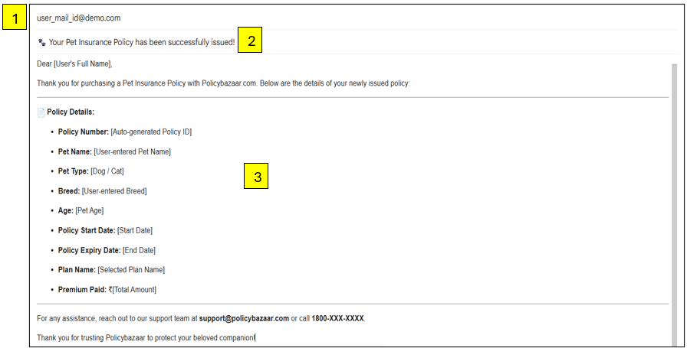

1. User’s registered mail id.
2. Subject of the mail.
3. Body of the mail including:

Dear [User's Full Name],

Thank you for purchasing a Pet Insurance Policy with Policybazaar.com.  
Below are the details of your newly issued policy:

**📄 Policy Details:**

**Policy Number:** [Auto-generated Policy ID]

**Pet Name:** [User-entered Pet Name]

**Pet Type:** [Dog / Cat]

**Breed:** [User-entered Breed]

**Age:** [Pet Age]

**Policy Start Date:** [Start Date]

**Policy Expiry Date:** [End Date]

**Plan Name:** [Selected Plan Name]

**Premium Paid:** ₹[Total Amount]

You can download your policy documents and access support by logging into your account at [www.policybazaar.com](https://www.policybazaar.com).

For any assistance, reach out to our support team at **support@policybazaar.com** or call **1800-XXX-XXXX**.

Thank you for trusting Policybazaar to protect your beloved companion!

Warm regards,  
**Team Policybazaar**

• Dynamic fields (e.g. Name, Policy Number, Pet Details) must be fetched from the user input and system-generated values.

• Email should be triggered only **after successful payment confirmation**.