**Software Requirements Specification**

**for**



**Version 1.0 approved**

# Prepared by:

PES1UG20CS134 – DIVIJA L

PES1UG20CS141 – G DHATHRI

PES1UG20CS150 – GAURAV DNYANESH MAHAJAN

PES1UG20CS174 – JALLURI HARSHITHA DEVI

SECTION C, 5TH SEM 12-09-2022

**Table of Contents**

**Table of Contents** 2

**Revision History 3**

**1. Introduction** [**4**](https://docs.google.com/document/d/1BrGhBoa3rwe5VY2UKqKFnXAjbLSB35gR/edit#heading=h.1fob9te)

1.1 Purpose [4](https://docs.google.com/document/d/1BrGhBoa3rwe5VY2UKqKFnXAjbLSB35gR/edit#heading=h.3znysh7)

1.2 Intended Audience and Reading Suggestions [4](https://docs.google.com/document/d/1BrGhBoa3rwe5VY2UKqKFnXAjbLSB35gR/edit#heading=h.2et92p0)

1.3 Product Scope [8](https://docs.google.com/document/d/1BrGhBoa3rwe5VY2UKqKFnXAjbLSB35gR/edit#heading=h.tyjcwt)

1.4 References [8](https://docs.google.com/document/d/1BrGhBoa3rwe5VY2UKqKFnXAjbLSB35gR/edit#heading=h.3dy6vkm)

**2. Overall Description** [**9**](https://docs.google.com/document/d/1BrGhBoa3rwe5VY2UKqKFnXAjbLSB35gR/edit#heading=h.1t3h5sf)

2.1 Product Perspective [9](https://docs.google.com/document/d/1BrGhBoa3rwe5VY2UKqKFnXAjbLSB35gR/edit#heading=h.4d34og8)

2.2 Product Functions [10](https://docs.google.com/document/d/1BrGhBoa3rwe5VY2UKqKFnXAjbLSB35gR/edit#heading=h.2s8eyo1)

2.3 User Classes and Characteristics [11](https://docs.google.com/document/d/1BrGhBoa3rwe5VY2UKqKFnXAjbLSB35gR/edit#heading=h.17dp8vu)

2.4 Operating Environment [13](https://docs.google.com/document/d/1BrGhBoa3rwe5VY2UKqKFnXAjbLSB35gR/edit#heading=h.3rdcrjn)

2.5 Design and Implementation Constraints [13](https://docs.google.com/document/d/1BrGhBoa3rwe5VY2UKqKFnXAjbLSB35gR/edit#heading=h.26in1rg)

2.6 Assumptions and Dependencies [13](https://docs.google.com/document/d/1BrGhBoa3rwe5VY2UKqKFnXAjbLSB35gR/edit#heading=h.lnxbz9)

**3. External Interface Requirements** [**14**](https://docs.google.com/document/d/1BrGhBoa3rwe5VY2UKqKFnXAjbLSB35gR/edit#heading=h.35nkun2)

3.1 User Interfaces [14](https://docs.google.com/document/d/1BrGhBoa3rwe5VY2UKqKFnXAjbLSB35gR/edit#heading=h.1ksv4uv)

3.2 Software Interfaces [15](https://docs.google.com/document/d/1BrGhBoa3rwe5VY2UKqKFnXAjbLSB35gR/edit#heading=h.44sinio)

3.3 Communications Interfaces [15](https://docs.google.com/document/d/1BrGhBoa3rwe5VY2UKqKFnXAjbLSB35gR/edit#heading=h.2jxsxqh)

**4. Analysis Models 15**

**5. System Features** [**16**](https://docs.google.com/document/d/1BrGhBoa3rwe5VY2UKqKFnXAjbLSB35gR/edit#heading=h.z337ya)

5.1 System Feature 1 [16](https://docs.google.com/document/d/1BrGhBoa3rwe5VY2UKqKFnXAjbLSB35gR/edit#heading=h.3j2qqm3)

5.2 System Feature 2 17

5.3 System Feature 3 17

5.4 System Feature 4 [18](https://docs.google.com/document/d/1BrGhBoa3rwe5VY2UKqKFnXAjbLSB35gR/edit#heading=h.1y810tw)

**6. Other Non-functional Requirements** [**18**](https://docs.google.com/document/d/1BrGhBoa3rwe5VY2UKqKFnXAjbLSB35gR/edit#heading=h.4i7ojhp)

6.1 Performance Requirements [18](https://docs.google.com/document/d/1BrGhBoa3rwe5VY2UKqKFnXAjbLSB35gR/edit#heading=h.2xcytpi)

6.2 Safety and Security Requirements [18](https://docs.google.com/document/d/1BrGhBoa3rwe5VY2UKqKFnXAjbLSB35gR/edit#heading=h.1ci93xb)

6.3 Software Quality Attributes [18](https://docs.google.com/document/d/1BrGhBoa3rwe5VY2UKqKFnXAjbLSB35gR/edit#heading=h.3whwml4)

**7. Other Requirements** [**19**](https://docs.google.com/document/d/1BrGhBoa3rwe5VY2UKqKFnXAjbLSB35gR/edit#heading=h.3as4poj)

**Appendix A: Glossary** [**19**](https://docs.google.com/document/d/1BrGhBoa3rwe5VY2UKqKFnXAjbLSB35gR/edit#heading=h.1pxezwc)

**Appendix B: Field Layouts** [**20**](https://docs.google.com/document/d/1BrGhBoa3rwe5VY2UKqKFnXAjbLSB35gR/edit#heading=h.2p2csry)

**Appendix C: Requirement Traceability matrix** [**20**](https://docs.google.com/document/d/1BrGhBoa3rwe5VY2UKqKFnXAjbLSB35gR/edit#heading=h.147n2zr)

**Revision History**

|  |  |  |  |
| --- | --- | --- | --- |
| **Name** | **Date** | **Reason For Changes** | **Version** |
|  |  |  |  |
|  |  |  |  |

Introduction

Purpose

Depression is a mental disorder that can impair many facets of human life. Though it is not easily detected, it has profound and varied impacts. It causes you to persistently feel blue or numb, and it hinders your ability to live a normal life. With much thought, we came up with a product called **Detangle.**

Detangle is a mobile application to detect the depression level in

patients by facial and Twitter analysis. Detangle is currently in version 1.0. The

purpose of this document is to define and describe the requirements of the

project and to spell out the system’s functionality and its constraint.

Intended Audience

Depression goes further than just feeling sad. It’s a mental illness that affects the way you think, feel and act. Though it is not easily detected, it has profound and varied impacts. It has different levels of severity too. Depression is a leading cause of mental ill health, which has been found to increase the risk of early death to in today’s world, the stresses of daily life events may increase chances of depression. Moreover, it is a major cause of suicidal ideation and leads to significant impairment in daily life.

We are firstly planning to deal with a certain age group one at a time. The different age groups are: **adolescence** (13 – 18 years), **young adults** (18 – 30 years), **middle-aged adults** (31 –59 years) and **senior citizens** (above 60 years). Globally, one in seven 10-19-year-olds experiences a mental disorder, accounting for 13% of the global burden of disease in this age group. The different age groups are: **adolescence** (13 – 18 years), **young adults** (18 – 30 years), **middle-aged adults** (31 –59 years) and **senior citizens** (above 60 years).

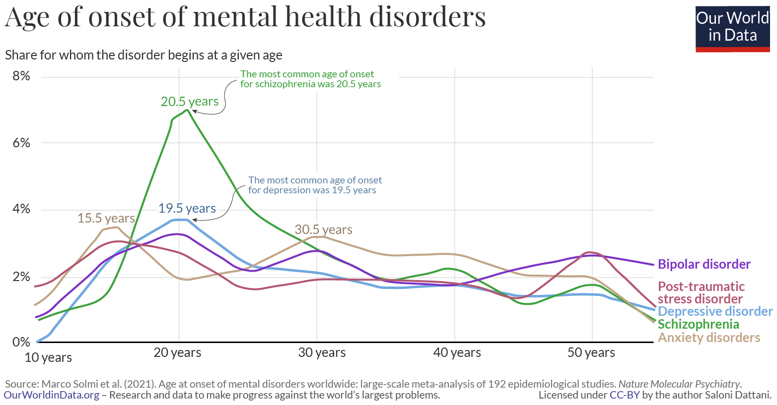

Adolescence is a unique and formative time. Physical, emotional, and social changes, including exposure to poverty, abuse, or violence, can make adolescents vulnerable to mental health problems. Protecting adolescents from adversity, promoting socio-emotional learning and psychological well-being, and ensuring access to mental health care are critical for their health and well-being during adolescence and adulthood. Some students find themselves struggling emotionally as they learn to juggle their workload, balance a budget and get along with new roommates, all while being away from home for the first time. While it’s totally normal for this new set of challenges to cause stress during a transitional phase, it can sometimes progress beyond the occasional university blues and develop into symptoms of depression. In teens, symptoms may include sadness, irritability, feeling negative and worthless, anger, poor performance or poor attendance at school, feeling misunderstood and extremely sensitive, using recreational drugs or alcohol, eating or sleeping too much, self-harm, loss of interest in normal activities, and avoidance of social interaction.

Globally, it is estimated that **1 in 7 (14%) 10–19-year-olds experience mental health conditions, yet these remain largely unrecognized and untreated**. Depression also leads to suicidal thoughts, and suicide is the fourth leading cause of death among 15–19-year-olds. The consequences of failing to address adolescent mental health conditions extend to adulthood, impairing both physical and mental health and limiting opportunities to lead fulfilling lives as adults.

Depression is not a normal part of growing older, and it should never be taken lightly. Adults face depression due to **work stress, unemployment, work and personal life imbalance, financial issues** etc. Unfortunately, depression often goes undiagnosed and untreated in older adults, and they may feel reluctant to seek help.

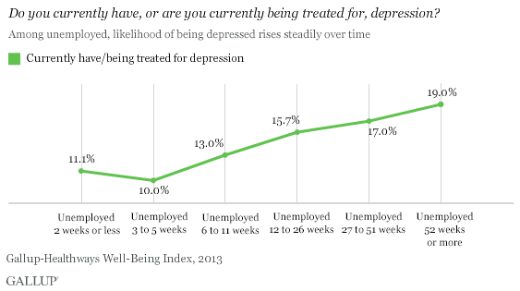

For some older adults with depression, sadness is not their main

symptoms. They could instead be feeling more of numbness or a lack of interest

in activities. They may not be as willing to talk about their feelings.

Maintaining a positive mental health and treating any mental health conditions is crucial to stabilizing constructive behaviours, emotions, and thoughts. Focusing on mental health care can increase productivity, enhance our self-image, and improve relationships. In 2020 the Covid-19 pandemic has taught us that maintaining mental health is very essential and crucial. It is one of the main inspirations for us to create this app and help society to a certain extent.

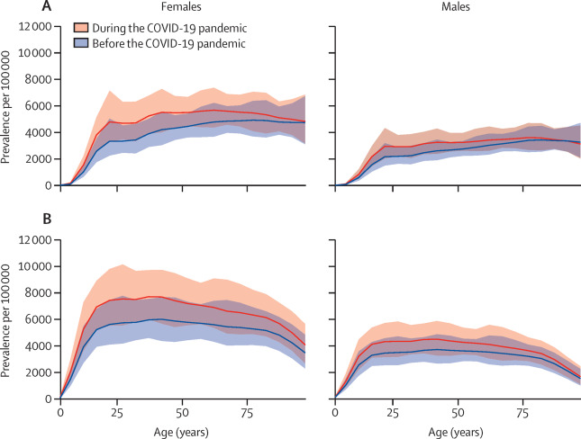

Global prevalence and burden of depressive and anxiety disorders in 2020 due to the COVID-19 pandemic

It is always essential to support our friends and family at good and bad times. While family and friends can help by offering support in finding treatment, they cannot treat a person’s depression. Some of the things that can be done are:

* Encouraging the person to seek medical treatment and stick with the treatment plan the doctor prescribes.

·

* Participate in activities the person likes to do.

·

* Doing physical activities like yoga, meditation, cycling or just reading them a book. Physical activity can be great for boosting mood.

·

* Help in setting up medical appointments/ accompanying the person to the doctor’s office.

Our app is not specific to depression disorder only but can be used by any person who wants to clear their mind, read facts about mental health, pen down their thoughts in a safe place and take questionnaires.

Product Scope

Often, a person going through mental health issues hesitate to consult a counsellor. So, the purpose of our project is to create a wellness app that will analyse a person’s facial features and also analyse their social media activities which will be used for predicting if that person is depressed or non-depressed and if depressed then what is the level of depression in that person.

We aim to do depression analysis using

* **Face Analysis,**
* **Twitter Text analysis**
* **Analysis using a questionnaire**.

This app mainly targets the young adults who find it difficult to open up and discuss it with their guardians in this version.

Our ultimate wellness app Detangle aims to keep you posted on your mental health by taking the most common depression screening tool that is the questionnaire, practicing self-care, for example by creating a healthy sleep routine.

If you are supporting the depressed person, it helps you book appointments with a therapist near your location, suggests yoga centres and many other suggestions.

In the future, we are planning to keep updating our app with different features

like chat-bots etc.

References

We have completed proper research on depression from trustable data provided by the WHO(World Health Organization), and NIMH(National Institutes of Mental Health).

Links referred for our SRS development are:

* <https://www.who.int/news-room/fact-sheets/detail/adolescent-mental-health>
* <https://www.nia.nih.gov/health/depression-and-older-adults#support>

* <https://www.mayoclinic.org/diseases-conditions/teen-depression/symptoms-causes/syc-20350985#:~:text=Many%20factors%20increase%20the%20risk,as%20physical%20or%20sexual%20abuse>

* <https://www.mayoclinic.org/diseases-conditions/depression/symptoms-causes/syc-20356007>
* <https://www.healthline.com/health/depression/facts-statistics-infographic#causes-and-risk-factors>

Overall Description

Product Perspective

Now-a-days, the whole world has been witnessing high suicide rates and depression, behavioural disorders and mental illness especially among teens and young adults. Though there are doctors and psychologists who can help people dealing with mental health issues, a lot of people can’t afford therapy, worry about the stigma associated to mental health or do not have access to treatment for various reasons. This has prompted us ask ourselves a provocative question: Could the same devices that people blame for causing depression, stress and anxiety be used to detect it?

The main aim of this app is to detect angst in teens and young adults. This app uses image processing models and sentiment analysis to try and predict depression episodes or potential self-harm. It also keeps track of the social media history of the user which helps a lot in determining the state of mind of the user over a period of time.

The goal of this project is:

* The users should feel comfortable sharing their problems on the application.
* To reach out to those who are facing depression, but are unable to afford medical treatment or are reluctant to seek treatment.
* Should be accessible to everyone.
* Affordable.
* User information must be protected and the opinion for anonymity should be included.
* Should inspire users to take control of their lives and give them a sense of confidence.
* Should organize information in a way to help professionals to make a diagnosis and determine a treatment path when needed.
* Should be targeted to whoever needs to use it.
* Should be developed without bias, judgement or stigma.

Product Functions

This project is about creating an app to detect depression which is a fusion of a questionnaire and an ai/ml model which recognizes facial expressions using image processing. Facial expressions are the most important form of non-verbal communications to express a person’s emotional or mental state. A large number of studies are currently undergoing on ‘Facial Feature Analysis’ for emotion recognition from images which effectively help in prediction of mental health condition of human beings. To predict depression, a photograph of the person is captured, from which the face of the person is extracted. Then, the facial features are extracted and classification of the facial features is done. The level of depression is identified by calculating the number of negative emotions present picture.

The app will implement the following functionalities:

* Image Processing
* Twitter analysis
* Mental health questionnaire

This app also keeps track of the social media searches and comments of the user which helps to keep track of the state of mind of the user. Based on meantal health questionnaire, image processing and data from social media, the app estimates the level of depression of the user and classifies it as mild, moderate or severe depression and gives suggestions based on the results.

**Training Dataset Creation:**

In addition to disgust, anger, fear, frustration, etc. The “NEUTRAL” face also implies lack of interest or emotion which can be categorized under depression. The input is consequently a dataset of happy, neutral, contempt and disgust faces. The training dataset created contains n images each of Happy, Neutral, Contempt, Disgust faces. Finally, we have a total of 4n images in the input training dataset. For testing, the system captures the frontal face of the student, using system webcam. From the picture, the face is cropped and the features are extracted.

User Classes and Characteristics

Depression is the most common mental disorder among the population. It is estimated that 5% of the total adult population suffer from depression. Approximately 3.8% of the total population is affected, including 5% among adults and 5.7%% among adults older than 60 years. Depression is different from usual mood fluctuations and short-lived emotional responses to challenges in everyday life. Especially when recurrent and with moderate or severe intensity, depression may become a serious health condition. It can cause the affected person to suffer greatly and function poorly at work, at school and in the family. At its worst, depression can lead to suicide. Over 700 000 people die due to suicide every year. Suicide is the fourth leading cause of death in 15-29-year-olds.

Although there are known, effective treatments for mental disorders, more than 75% of people in low- and middle-income countries receive no treatment (2).  Barriers to effective care include a lack of resources, lack of trained health-care providers and social stigma associated with mental disorders. In countries of all income levels, people who experience depression are often not correctly diagnosed, and others who do not have the disorder are too often misdiagnosed and prescribed antidepressants.

Depression can affect anyone. However, certain groups of people may be more likely to experience the condition. Females are more likely to experience depression than males. Adults aged **18–25** years are most likely to have at least one major depressive episode.

**Children:**

According to the CDC, [78.1%Trusted Source](https://www.cdc.gov/childrensmentalhealth/data.html) of children aged 3–17 years who had depression received treatment for it. A study in the Journal of the American Academy of Child and Adolescent Psychiatry found that children aged 7–12 years with depression had a [66% rate of remission](https://www.jaacap.org/article/S0890-8567(14)00890-9/pdf) when undergoing family-based interpersonal psychotherapy.

**Adults:**

Research from 2020 found that [antidepressants](https://www.medicalnewstoday.com/articles/248320) helped relieve symptoms in [40–60%](https://www.ncbi.nlm.nih.gov/books/NBK361016/) of people with depression. The study also suggested that antidepressants prevented around a third of people from experiencing depression again in the future. An NSDUH survey found that around [65% of people](https://www.nimh.nih.gov/health/statistics/major-depression.shtml)  who experienced at least one major depressive episode in a year received both medication and therapy for the condition.

**Males:**

A 2015 study found that [33%](https://www.cdc.gov/nchs/data/databriefs/db206.pdf) of males who had daily feelings of anxiety or depression took medication for those feelings, whereas around 25.7% spoke to a mental health professional. [Researchers](https://www.sciencedirect.com/science/article/abs/pii/S0165032719305014) in 2020 discovered that males who completed at least 150 minutes of physical activity per week reduced their risk of developing depression. Also, increased duration and intensity of physical activity further reduced the likelihood of depression in males.

**Females:**

According to the [WHO](https://www.who.int/mental_health/prevention/genderwomen/en/) , females are more likely to receive a prescription for psychotropic medication for common mental health conditions than males. They also note that females are more likely than males to seek help for common mental health conditions from their primary care physician.

**Older Adults:**

The ADAA report that more than [2 million](https://adaa.org/finding-help/older-adults) people over the age of 65 have depression. Among other factors, depression in older adults may be the result of illness, disability, or an increased dependence on others. Doctors frequently miss depression in people of this age group, as their focus tends to be more on physical health than psychological health.

Operating Environment

This app is being developed to work on android operating system.

Design and Implementation Constraints

We have to design different windows for different types of utilities such as face analysis, twitter analysis, questionnaire, daily facts, thoughts and user profile. The implementation part is yet to be done, but we have a clear picture as to how our windows would look.

Assumptions and Dependencies

The user is familiar with Android OS and also with the installation and usage of application software. The user is on social media, preferably twitter. The user has an email-id associated with him/her.

External Interface Requirements

User Interfaces

The user interface for the app is very clear, distinct and simple avoiding any complicated feature to retain the simplicity of use of the application. First comes the LOGIN or REGISTER window to facilitate the first-time users as well as the recurring users who have already registered. An individual can create an account to get access to the application.

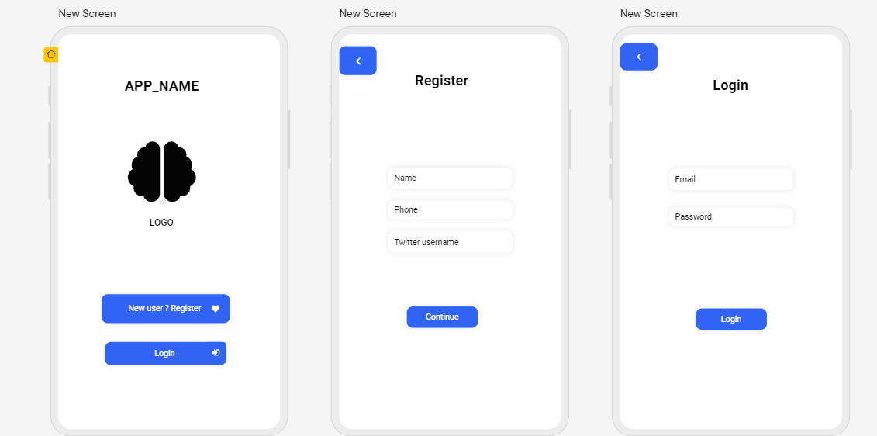

After the login or registration, the user is directed towards the menu page which will have an assortment of options which include Face analysis , Twitter analysis , a utility where the user can note his/her own thoughts, a questionnaire option so that a user can self-analyse the level of depression, a daily fact option to generate facts regarding depression and mental health in general, a reports option so that the user can have an access , a profile option to view the profile and a logout option if the user is very discreet and wants to keep it private.

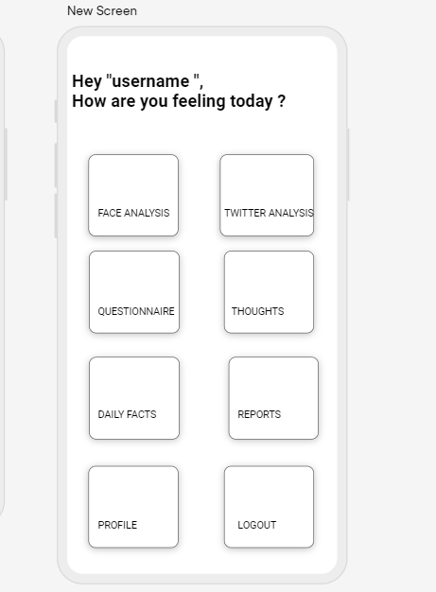

Interfaces for further utilities are to be decided based on implementation.

Software Interfaces

The software interface which will be used is Flutter, an open-source UI software development kit to develop cross platform applications. The software can be generated from a single codebase for Android, iOS, Linux, macOS, Windows, Google fuchsia. The database used is Firebase provided by Google which makes application related analytics accessible easily. The tools and libraries used belong to the programming language called dart.

Communications Interfaces

The Android app communicates with a web server which is built on top of the Pyramid Python framework and Nginx HTTP web server. This web server is also the main interface that the user uses to give commands to in addition to controlling the rover through the web interface.

Analysis Models

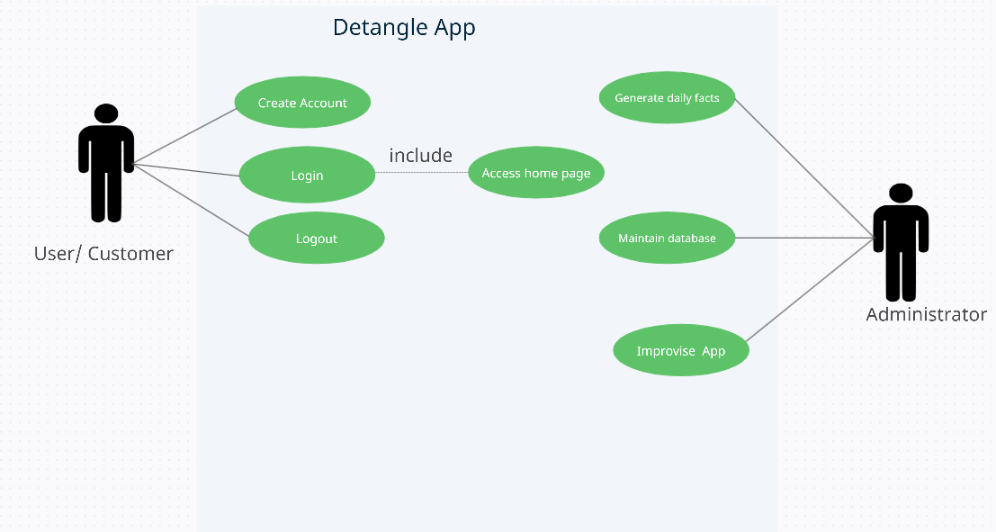

System Features

Many people are experiencing mental health problems. The app helps in detecting the depression level of the people in order to help them. This app works on android operating system. The app finds out the depression level and checks if the person is Happy, Neutral, Contempt, Disgust. If the person has higher depression level the app recommends a psychiatrist who the person can contact in the nearby location of the person. These are found out by using the responses of the questionnaire provided and also face detection using image processing. It also keeps track of the social media history of the user to determine his state of mind over the particular period of time.

System Feature 1- Image processing

5.1.1 Description and Priority

This feature captures the image of the user to find the level of depression. Then facial features are extracted from the image. This is of high priority because it gives the whole idea of the mental state the user.

5.1.2 Stimulus/Response Sequences

The user uploads a photograph of the person whose mental health condition is required. The depression level is identified by calculating the number of positive expressions like a smile, in the uploaded picture.

5.1.3 Functional Requirements

The user must give access to the camera or gallery to capture the picture. If the image has multiple faces the component throws an error.

System Feature 2 - Social media Analysis (preferably Twitter)

5.2.1 Description and Priority

This feature tracks the social media history of the user. It checks the responses given by the user and tries understand his/her mental condition. This feature is of moderate priority.

5.2.2 Stimulus/Response Sequences

The user gives access to multiple social media. The system tracks the response given by the user for a particular period of time. It also gives the percentage of negativity and positivity.

5.2.3 Functional Requirements

The user must give access to social media accounts which helps in knowing the user’s mental state.

System Feature 3 – Questionnaire

5.3.1 Description and Priority

Multiple questions are given to the user and the responses are stored locally. The questions help in knowing the level of help user requires. This feature is of high priority.

5.3.2 Stimulus/Response Sequences

User is given a questionnaire and the app stores the responses to know the mental state of the person. It gives a score which determines the level of depression.

5.3.3 Functional Requirements

The user must give honest responses to the questions so that proper help can be given.

System feature-4 Thoughts

5.4.1 Description and Priority

A text area is given to the user in which he/she can describe their thoughts. This feature is of moderate priority.

5.4.2 Stimulus/Response Sequences

The user describes their thoughts and feelings which are stored in the application’s database.

5.4.3 Functional Requirements

User gives input in the text area.

Other Non-functional Requirements

Performance Requirements

The goal is to develop a holistic depression detection system first with later developments into diagnosis and recommendation system. The application is capable of detecting the level of depression using facial analysis technique, textual analysis by allowing the user to connect their twitter account. Also, the questionnaire will help the user to self-analyse their state of mind by answering a set of questions. Performance requirements in general would be a smartphone with an Android OS.

Safety and Security Requirements

The user requires login credentials to access the app. The image and the details provided by the user are stored locally. The details are not shared among anyone**.**

Since the application is still in its nascent stage, with subsequent additions of features,

the requirements for safety will be improvised with effect of time.

Software Quality Attributes

As mentioned earlier, since the application is in its nascent stage, the focus would be on the robustness of the app. Also, the application would be usable, maintainable portable reliable and reusable. Since the interface used for development is Flutter , the application can also be developed for iOS and other operating systems thus inducing interoperability and flexibility as well.

**Appendix A: Glossary**

**Detangle:** The name of the application to be developed for which this document has been created. The two letter De stand for the cause, that is, depression and the word detangle in its entirety is to solve mental health problems and help people detangle their minds.

**Depression:** Depression is a mood disorder that causes a persistent feeling of interest. Also called major depressive disorder or clinical depression, it affects how you feel, think and behave and can lead to a variety of emotional and physical problem.

**SRS**: SRS stands for Software Requirement Specification. A software requirements specification (SRS) is a document that describes what the software will do and how it will be expected to perform. It also describes the functionality the product needs to fulfil all stakeholders’ (business, users) needs.

**Image processing:** Image processing is a method to perform some operations on an image, in order to get an enhanced image or to extract some useful information from it. It is a type of signal processing in which input is an image and output may be image or characteristics/features associated with that image.

**UI:** The abbreviation for UI is User Interface. The user interface (UI) is the point of human-computer interaction and communication in a device. This can include display screens, keyboards, a mouse and the appearance of a desktop. It is also the way through which a user interacts with an application or a website.

**Sentiment Analysis:** Sentiment analysis, also referred to as opinion mining, is an approach to natural language processing (NLP) that identifies the emotional tone behind a body of text. This is a popular way for organizations to determine and categorize opinions about a product, service or an idea.

**Appendix B: Field Layouts**

|  |  |
| --- | --- |
|  |  |

**Appendix C: Requirement Traceability Matrix**

|  |  |  |  |  |  |  |  |
| --- | --- | --- | --- | --- | --- | --- | --- |
| **Sl. No** | **Requirement ID** | **Brief Description of Requirement** | **Architecture Reference** | **Design Reference** | **Code File Reference** | **Test Case ID** | **System Test Case ID** |
|  |  |  |  |  |  |  |  |
|  |  |  |  |  |  |  |  |