B.TECH. (CSE)
V SEMESTER
UE20CS303 –SOFTWARE ENGINEERING

PROJECT REPORT ON
DETANGLE

SUBMITTED BY
NAME | SRN
DIVIJA L | PES1UG20CS134
G DHATHRI | PES1UG20CS141
GAURAV DNYANESH MAHAJAN | PES1UG20CS150
JALLURI HARSHITHA DEVI | PES1UG20CS173

August – Nov 2022
DEPARTMENT OF COMPUTER SCIENCE & ENGINEERING
BENGALURU – 560100, KARNATAKA, INDIA

TABLE OF CONTENTS
Sl.No | TOPIC | PAGE No
 | PROPOSAL OF THE PROJECT | 3
 | SOFTWARE REQUIREMENTS SPECIFICATION | 4
 | PROJECT PLAN | 26
 | DESIGN DIAGRAMS | 28
 | TEST CASES | 32
 | SCREEN SHOTS OF OUTPUT | 41

SYNOPSIS
Project Description:
Depression is a mood disorder that causes a persistent feeling of sadness and loss of interest. It affects how you feel, think and behave and can lead to a variety of emotional and physical problems. Often, an individual with mental health issues is reluctant to consult a counsellor. Detangle is a mobile application to overcome mental health problems and detect the depression level in patients by facial and Twitter analysis. Our main goal is to analyse a person’s facial features as well as his/her social activities to detect if that person is depressed or normal. It also gives the level of depression.
Plan of work:
The app essentially works on:
- Mental Health Questionnaire
- Image Processing
- Sentiment Analysis
- Feature to allow the user to express their thoughts. The goal of this project is:
- To reach out to those who are facing depression, but are unable to afford medical treatment or are reluctant to seek medical help.
- User information must be protected; the users should feel comfortable sharing their problems on the app.
User Interface:
Flutter.
Operating System:
Android OS.

Software Requirements
Specification
for

Version 1.0 approved
Prepared by:
12-09-2022

Table of Contents
Table of Contents v
Revision History vi
1. Introduction 7
1.1 Purpose 7
1.2 Intended Audience and Reading Suggestions 7
1.3 Product Scope 7
1.4 References 11
2. Overall Description 13
2.1 Product Perspective 13
2.2 Product Functions 13
2.3 User Classes and Characteristics 15
2.4 Operating Environment 17
2.5 Design and Implementation Constraints 17
2.6 Assumptions and Dependencies 17
3. External Interface Requirements 17
3.1 User Interfaces 17
3.2 Software Interfaces 17
3.3 Communications Interfaces 20
4. Analysis Models
5. System Features 20
5.1 System Feature 1 20
5.2 System Feature 2 (and so on) Error! Bookmark not defined.
6. Other Nonfunctional Requirements 21
6.1 Performance Requirements 23
6.2 Safety Requirements 23
6.3 Security Requirements 23
6.4 Software Quality Attributes 23
6.5 Business Rules 23
7. Other Requirements Error! Bookmark not defined.
Appendix A: Glossary 24
Appendix B: Field Layouts Error! Bookmark not defined.
Appendix C: Requirement Traceability matrix Error! Bookmark not defined.

Revision History
Name | Date | Reason For Changes | Version

Introduction

Purpose
Depression is a mental disorder that can impair many facets of human life. Though it is not easily detected, it has profound and varied impacts. It causes you to persistently feel blue or numb, and it hinders your ability to live a normal life. With much thought, we came up with a product called Detangle.
Detangle is a mobile application to detect the depression level in patients by facial and Twitter analysis. Detangle is currently in version 1.0. The purpose of this document is to define and describe the requirements of the project and to spell out the system’s functionality and its constraint.

Intended Audience
Depression goes further than just feeling sad. It’s a mental illness that affects the way you think, feel and act. Though it is not easily detected, it has profound and varied impacts. It has different levels of severity too. Depression is a leading cause of mental ill health, which has been found to increase the risk of early death to in today’s world, the stresses of daily life events may increase chances of depression. Moreover, it is a major cause of suicidal ideation and leads to significant impairment in daily life.
We are firstly planning to deal with a certain age group one at a time. The different age groups are: adolescence (13 – 18 years), young adults (18 – 30 years), middle-aged adults (31 –59 years) and senior citizens (above 60 years). Globally, one in seven 1019-year-olds experiences a mental disorder, accounting for 13% of the global burden of disease in this age group. The different age groups are: adolescence (13 – 18 years), young adults (18 – 30 years), middle-aged adults (31 –59 years) and senior citizens (above 60 years).

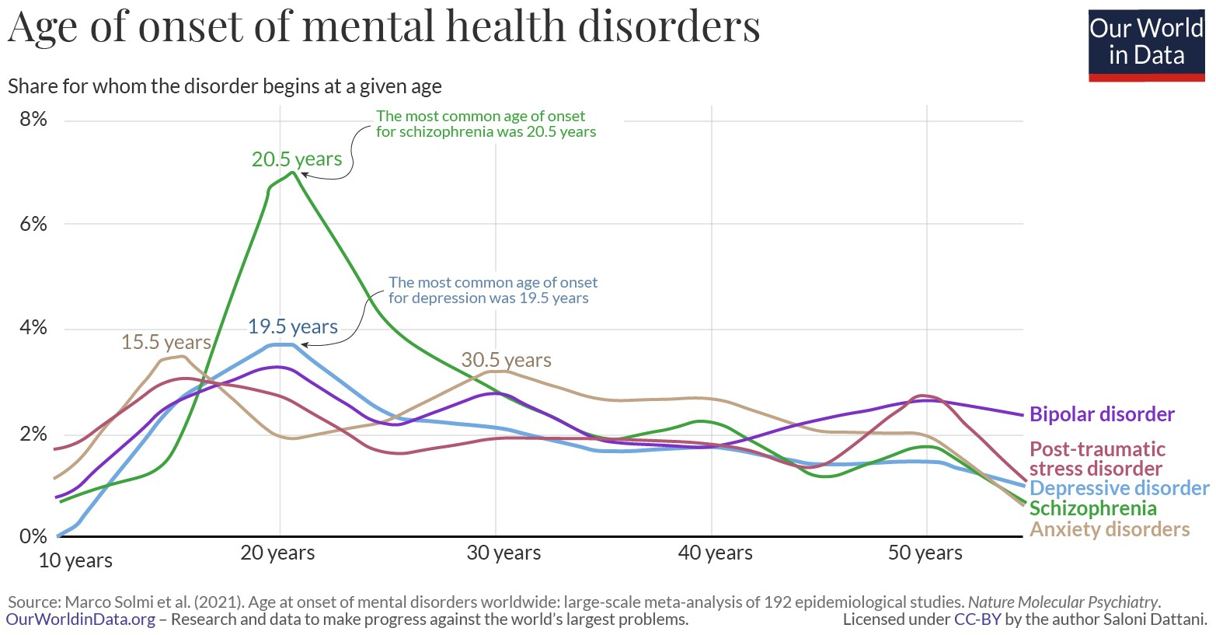
Adolescence is a unique and formative time. Physical, emotional, and social changes, including exposure to poverty, abuse, or violence, can make adolescents vulnerable to mental health problems. Protecting adolescents from adversity, promoting socioemotional learning and psychological well-being, and ensuring access to mental health care are critical for their health and well-being during adolescence and adulthood. Some students find themselves struggling emotionally as they learn to juggle their workload, balance a budget and get along with new roommates, all while being away from home for the first time. While it’s totally normal for this new set of challenges to cause stress during a transitional phase, it can sometimes progress beyond the occasional university blues and develop into symptoms of depression. In teens, symptoms may include sadness, irritability, feeling negative and worthless, anger, poor performance or poor attendance at school, feeling misunderstood and extremely sensitive, using recreational drugs or alcohol, eating or sleeping too much, self-harm, loss of interest in normal activities, and avoidance of social interaction.

Globally, it is estimated that 1 in 7 (14%) 10–19-year-olds experience mental health conditions, yet these remain largely unrecognized and untreated. Depression also leads to suicidal thoughts, and suicide is the fourth leading cause of death among 15– 19-year-olds. The consequences of failing to address adolescent mental health conditions extend to adulthood, impairing both physical and mental health and limiting opportunities to lead fulfilling lives as adults.

Depression is not a normal part of growing older, and it should never be taken lightly. Adults face depression due to work stress, unemployment, work and personal life imbalance, financial issues etc. Unfortunately, depression often goes undiagnosed and untreated in older adults, and they may feel reluctant to seek help.

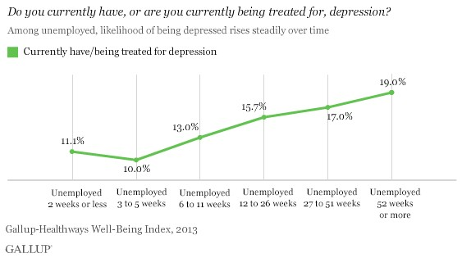

For some older adults with depression, sadness is not their main symptoms. They could instead be feeling more of numbness or a lack of interest in activities. They may not be as willing to talk about their feelings.

Maintaining a positive mental health and treating any mental health conditions is crucial to stabilizing constructive behaviours, emotions, and thoughts. Focusing on mental health care can increase productivity, enhance our self-image, and improve relationships. In 2020 the Covid-19 pandemic has taught us that maintaining mental health is very essential and crucial. It is one of the main inspirations for us to create this app and help society to a certain extent.
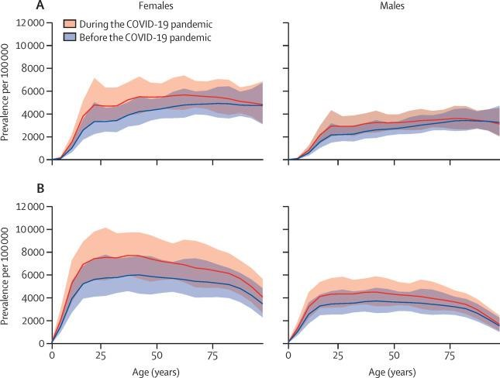
Global prevalence and burden of depressive and anxiety disorders in 2020 due to the COVID-19 pandemic

It is always essential to support our friends and family at good and bad times. While family and friends can help by offering support in finding treatment, they cannot treat a person’s depression. Some of the things that can be done are:

- Encouraging the person to seek medical treatment and stick with the treatment plan the doctor prescribes. ·
- Participate in activities the person likes to do.
- Doing physical activities like yoga, meditation, cycling or just reading them a book. Physical activity can be great for boosting mood.
- Help in setting up medical appointments/ accompanying the person to the doctor’s office.

Our app is not specific to depression disorder only but can be used by any person who wants to clear their mind, read facts about mental health, pen down their thoughts in a safe place and take questionnaires.

Product Scope
Often, a person going through mental health issues hesitate to consult a counsellor. So, the purpose of our project is to create a wellness app that will analyse a person’s facial features and also analyse their social media activities which will be used for predicting if that person is depressed or non-depressed and if depressed then what is the level of depression in that person.

We aim to do depression analysis using
- Face Analysis,
- Twitter Text analysis
- Analysis using a questionnaire.

This app mainly targets the young adults who find it difficult to open up and discuss it with their guardians in this version.
Our ultimate wellness app Detangle aims to keep you posted on your mental health by taking the most common depression screening tool that is the questionnaire, practicing self-care, for example by creating a healthy sleep routine.
If you are supporting the depressed person, it helps you book appointments with a therapist near your location, suggests yoga centres and many other suggestions. In the future, we are planning to keep updating our app with different features like chat-bots etc.

References
We have completed proper research on depression from trustable data provided by the WHO(World Health Organization), and NIMH(National Institutes of Mental Health).

Links referred for our SRS development are:
- https://www.who.int/news-room/fact-sheets/detail/adolescent-mentalhealth
- https://www.nia.nih.gov/health/depression-and-older-adults#support
- https://www.mayoclinic.org/diseases-conditions/teen-depression/symptomscauses/syc-
- 20350985#:~:text=Many%20factors%20increase%20the%20risk,as%20physic al%20or%20sexual%20abuse
- https://www.mayoclinic.org/diseases-conditions/depression/symptomscauses/syc-20356007
- https://www.healthline.com/health/depression/facts-statisticsinfographic#causes-and-risk-factors

Overall Description

Product Perspective
Now-a-days, the whole world has been witnessing high suicide rates and depression, behavioural disorders and mental illness especially among teens and young adults. Though there are doctors and psychologists who can help people dealing with mental health issues, a lot of people can’t afford therapy, worry about the stigma associated to mental health or do not have access to treatment for various reasons. This has prompted us ask ourselves a provocative question: Could the same devices that people blame for causing depression, stress and anxiety be used to detect it?
The main aim of this app is to detect angst in teens and young adults. This app uses image processing models and sentiment analysis to try and predict depression episodes or potential self-harm. It also keeps track of the social media history of the user which helps a lot in determining the state of mind of the user over a period of time.
The goal of this project is:
- The users should feel comfortable sharing their problems on the application.
- To reach out to those who are facing depression, but are unable to afford medical treatment or are reluctant to seek treatment.
- Should be accessible to everyone.
- Affordable.
- User information must be protected and the opinion for anonymity should be included.
- Should inspire users to take control of their lives and give them a sense of confidence.
- Should organize information in a way to help professionals to make a diagnosis and determine a treatment path when needed.
- Should be targeted to whoever needs to use it.
- Should be developed without bias, judgement or stigma.

Product Functions
This project is about creating an app to detect depression which is a fusion of a questionnaire and an ai/ml model which recognizes facial expressions using image processing. Facial expressions are the most important form of non-verbal communications to express a person’s emotional or mental state. A large number of studies are currently undergoing on ‘Facial Feature Analysis’ for emotion recognition from images which effectively help in prediction of mental health condition of human beings. To predict depression, a photograph of the person is captured, from which the face of the person is extracted. Then, the facial features are extracted and classification of the facial features is done. The level of depression is identified by calculating the number of negative emotions present picture.
The app will implement the following functionalities:
- Image Processing
- Twitter analysis
- Mental health questionnaire
This app also keeps track of the social media searches and comments of the user which helps to keep track of the state of mind of the user. Based on meantal health questionnaire, image processing and data from social media, the app estimates the level of depression of the user and classifies it as mild, moderate or severe depression and gives suggestions based on the results.

Training Dataset Creation:
In addition to disgust, anger, fear, frustration, etc. The “NEUTRAL” face also implies lack of interest or emotion which can be categorized under depression. The input is consequently a dataset of happy, neutral, contempt and disgust faces. The training dataset created contains n images each of Happy, Neutral, Contempt, Disgust faces. Finally, we have a total of 4n images in the input training dataset. For testing, the system captures the frontal face of the student, using system webcam. From the picture, the face is cropped and the features are extracted.

User Classes and Characteristics
Depression is the most common mental disorder among the population. It is estimated that 5% of the total adult population suffer from depression. Approximately 3.8% of the total population is affected, including 5% among adults and 5.7%% among adults older than 60 years. Depression is different from usual mood fluctuations and short-lived emotional responses to challenges in everyday life. Especially when recurrent and with moderate or severe intensity, depression may become a serious health condition. It can cause the affected person to suffer greatly and function poorly at work, at school and in the family. At its worst, depression can lead to suicide. Over 700 000 people die due to suicide every year. Suicide is the fourth leading cause of death in 15-29-year-olds.
Although there are known, effective treatments for mental disorders, more than 75% of people in low- and middle-income countries receive no treatment (2). Barriers to effective care include a lack of resources, lack of trained health-care providers and social stigma associated with mental disorders. In countries of all income levels, people who experience depression are often not correctly diagnosed, and others who do not have the disorder are too often misdiagnosed and prescribed antidepressants.
Depression can affect anyone. However, certain groups of people may be more likely to experience the condition. Females are more likely to experience depression than males. Adults aged 18–25 years are most likely to have at least one major depressive episode.

Children:
According to the CDC, 78.1%Trusted Source of children aged 3–17 years who had depression received treatment for it. A study in the Journal of the American Academy of Child and Adolescent Psychiatry found that children aged 7–12 years with depression had a 66% rate of remission when undergoing family-based interpersonal psychotherapy.
Adults:
Research from 2020 found that antidepressants helped relieve symptoms in 40–60% of people with depression. The study also suggested that antidepressants prevented around a third of people from experiencing depression again in the future. An NSDUH survey found that around 65% of people who experienced at least one major depressive episode in a year received both medication and therapy for the condition.
Males:
A 2015 study found that 33% of males who had daily feelings of anxiety or depression took medication for those feelings, whereas around 25.7% spoke to a mental health professional. Researchers in 2020 discovered that males who completed at least 150 minutes of physical activity per week reduced their risk of developing depression. Also, increased duration and intensity of physical activity further reduced the likelihood of depression in males.
Females:
According to the WHO , females are more likely to receive a prescription for psychotropic medication for common mental health conditions than males. They also note that females are more likely than males to seek help for common mental health conditions from their primary care physician.
Older Adults:
The ADAA report that more than 2 million people over the age of 65 have depression. Among other factors, depression in older adults may be the result of illness, disability, or an increased dependence on others. Doctors frequently miss depression in people of this age group, as their focus tends to be more on physical health than psychological health.

Operating Environment
This app is being developed to work on android operating system.

Design and Implementation Constraints
We have to design different windows for different types of utilities such as face analysis, twitter analysis, questionnaire, daily facts, thoughts and user profile. The implementation part is yet to be done, but we have a clear picture as to how our windows would look.

2.6 Assumptions and Dependencies
The user is familiar with Android OS and also with the installation and usage of application software. The user is on social media, preferably twitter. The user has an email-id associated with him/her.

External Interface Requirements

User Interfaces
The user interface for the app is very clear, distinct and simple avoiding any complicated feature to retain the simplicity of use of the application. First comes the LOGIN or REGISTER window to facilitate the first-time users as well as the recurring users who have already registered. An individual can create an account to get access to the application.

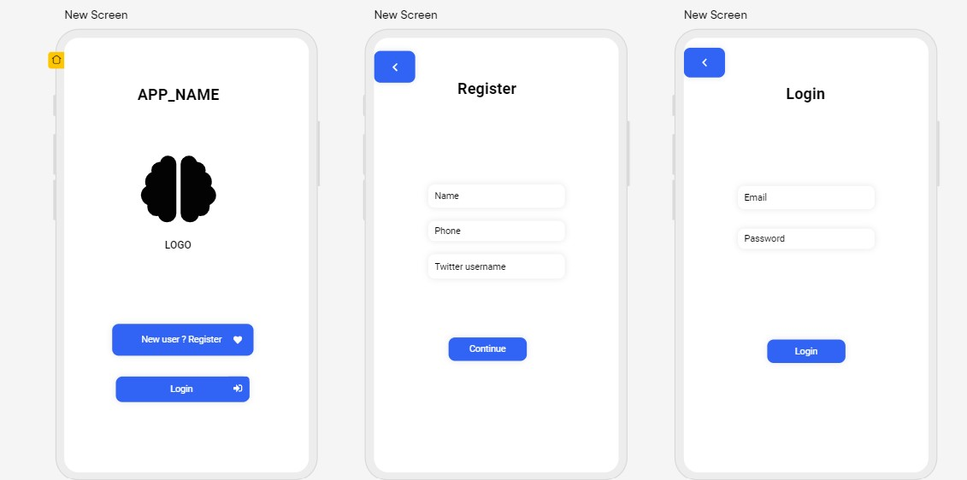

After the login or registration, the user is directed towards the menu page which will have an assortment of options which include Face analysis , Twitter analysis , a utility where the user can note his/her own thoughts, a questionnaire option so that a user can self-analyse the level of depression, a daily fact option to generate facts regarding depression and mental health in general, a reports option so that the user can have an access , a profile option to view the profile and a logout option if the user is very discreet and wants to keep it private.

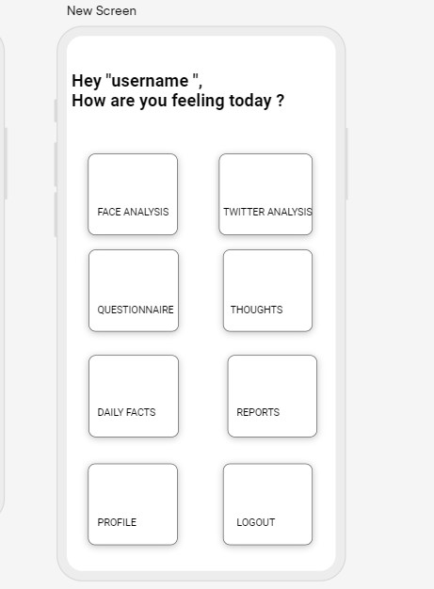

Interfaces for further utilities are to be decided based on implementation.

Software Interfaces
The software interface which will be used is Flutter, an open-source UI software development kit to develop cross platform applications. The software can be generated from a single codebase for Android, iOS, Linux, macOS, Windows, Google fuchsia. The database used is Firebase provided by Google which makes application related analytics accessible easily. The tools and libraries used belong to the programming language called dart.

Communications Interfaces
The Android app communicates with a web server which is built on top of the Pyramid Python framework and Nginx HTTP web server. This web server is also the main interface that the user uses to give commands to in addition to controlling the rover through the web interface.

Analysis Models

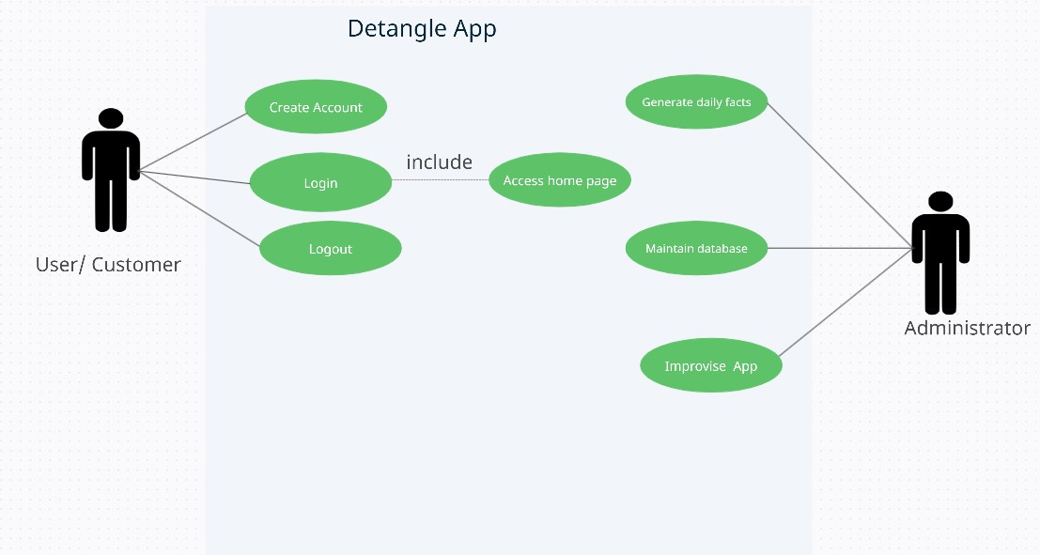

System Features
Many people are experiencing mental health problems. The app helps in detecting the depression level of the people in order to help them. This app works on android operating system. The app finds out the depression level and checks if the person is Happy, Neutral, Contempt, Disgust. If the person has higher depression level the app recommends a psychiatrist who the person can contact in the nearby location of the person. These are found out by using the responses of the questionnaire provided and also face detection using image processing. It also keeps track of the social media history of the user to determine his state of mind over the particular period of time.
System Feature 1- Image processing
5.1.1 Description and Priority
This feature captures the image of the user to find the level of depression. Then facial features are extracted from the image. This is of high priority because it gives the whole idea of the mental state the user.
5.1.2 Stimulus/Response Sequences
The user uploads a photograph of the person whose mental health condition is required. The depression level is identified by calculating the number of positive expressions like a smile, in the uploaded picture.
5.1.3 Functional Requirements
The user must give access to the camera or gallery to capture the picture. If the image has multiple faces the component throws an error.

System Feature 2 - Social media Analysis (preferably Twitter)
5.2.1 Description and Priority
This feature tracks the social media history of the user. It checks the responses given by the user and tries understand his/her mental condition. This feature is of moderate priority.
5.2.2 Stimulus/Response Sequences
The user gives access to multiple social media. The system tracks the response given by the user for a particular period of time. It also gives the percentage of negativity and positivity.
5.2.3 Functional Requirements
The user must give access to social media accounts which helps in knowing the user’s mental state.

System Feature 3 – Questionnaire
5.3.1 Description and Priority
Multiple questions are given to the user and the responses are stored locally. The questions help in knowing the level of help user requires. This feature is of high priority.
5.3.2 Stimulus/Response Sequences
User is given a questionnaire and the app stores the responses to know the mental state of the person. It gives a score which determines the level of depression.
5.3.3 Functional Requirements
The user must give honest responses to the questions so that proper help can be given.

System feature-4 Thoughts
5.4.1 Description and Priority
A text area is given to the user in which he/she can describe their thoughts. This feature is of moderate priority.
5.4.2 Stimulus/Response Sequences
The user describes their thoughts and feelings which are stored in the application’s database.
5.4.3 Functional Requirements
User gives input in the text area.

Other Non-functional Requirements

Performance Requirements
The goal is to develop a holistic depression detection system first with later developments into diagnosis and recommendation system. The application is capable of detecting the level of depression using facial analysis technique, textual analysis by allowing the user to connect their twitter account. Also, the questionnaire will help the user to self-analyse their state of mind by answering a set of questions. Performance requirements in general would be a smartphone with an Android OS.

Safety and Safety Requirements
The user requires login credentials to access the app. The image and the details provided by the user are stored locally. The details are not shared among anyone. Since the application is still in its nascent stage, with subsequent additions of features, the requirements for safety will be improvised with effect of time.

Software Quality Attributes
As mentioned earlier, since the application is in its nascent stage, the focus would be on the robustness of the app. Also, the application would be usable, maintainable portable reliable and reusable. Since the interface used for development is Flutter, the application can also be developed for iOS and other operating systems thus inducing interoperability and flexibility as well.
Appendix A: Glossary
Detangle: The name of the application to be developed for which this document has been created. The two letter De stand for the cause, that is, depression and the word detangle in its entirety is to solve mental health problems and help people detangle their minds.
Depression: Depression is a mood disorder that causes a persistent feeling of interest. Also called major depressive disorder or clinical depression, it affects how you feel, think and behave and can lead to a variety of emotional and physical problem.
SRS: SRS stands for Software Requirement Specification. A software requirements specification (SRS) is a document that describes what the software will do and how it will be expected to perform. It also describes the functionality the product needs to fulfil all stakeholders’ (business, users) needs.
Image processing: Image processing is a method to perform some operations on an image, in order to get an enhanced image or to extract some useful information from it. It is a type of signal processing in which input is an image and output may be image or characteristics/features associated with that image.
UI: The abbreviation for UI is User Interface. The user interface (UI) is the point of human-computer interaction and communication in a device. This can include display screens, keyboards, a mouse and the appearance of a desktop. It is also the way through which a user interacts with an application or a website.
Sentiment Analysis: Sentiment analysis, also referred to as opinion mining, is an approach to natural language processing (NLP) that identifies the emotional tone behind a body of text. This is a popular way for organizations to determine and categorize opinions about a product, service or an idea.
Appendix B: Field Layouts

Appendix C: Requirement Traceability Matrix
Sl. No | Requirement ID | Brief Description of Requirement | Architecture Reference | Design Reference | Code File Reference | Test Case ID | System Test Case ID

Project Plan Document
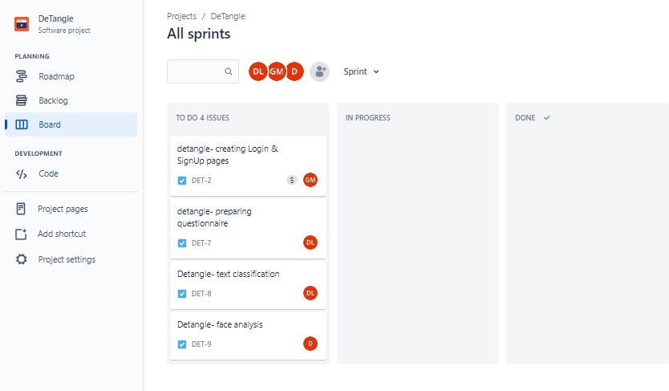
BASIC SPRINTS- EACH MEMBER IS ASSIGNED WITH TASKS 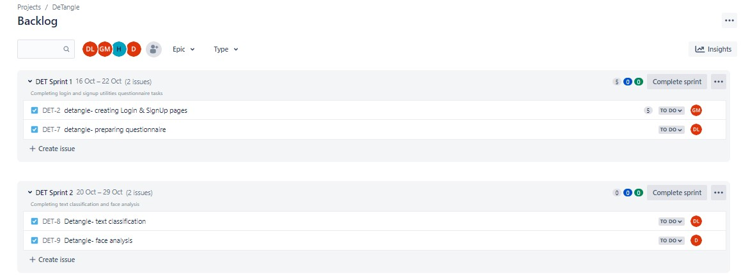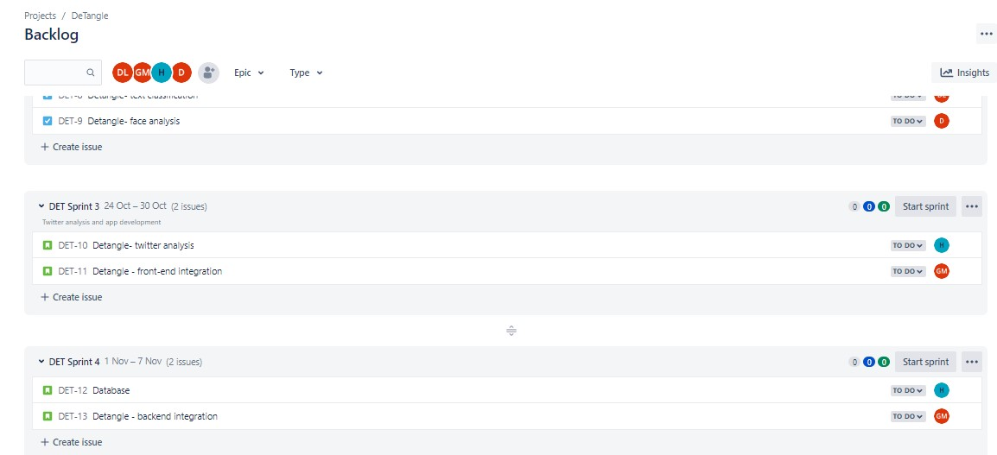

HIGH LEVEL DIAGRAM:
BASIC UML OF DETANGLE
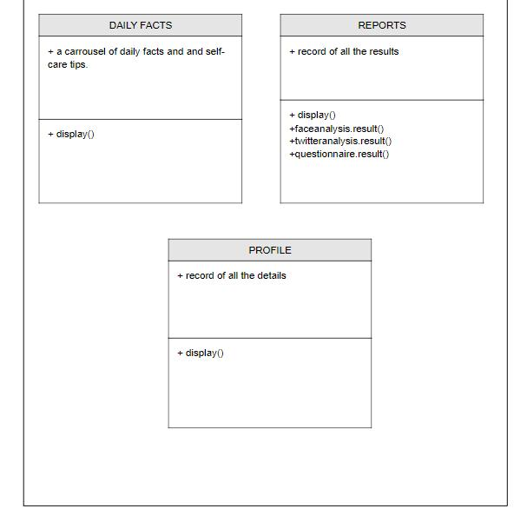

DFD
LOW LEVEL DIAGRAM:
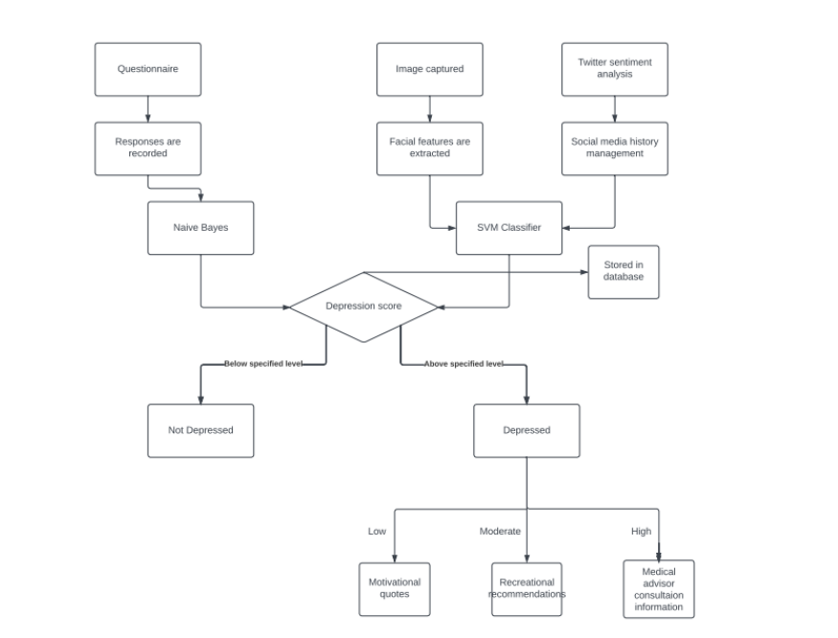

UNIT TESTING
A unit is the smallest block of code that functions individually. The first level of testing is Unit testing, and this problem statement is geared towards the same.
• Discuss with your teammates and demarcate units in your code base. Note: discuss why the code snippet you have chosen can be classified as a unit

Considering our members' discussions, we made the decision to designate one of the app's units as the login page, which is the primary utility that users are expected to utilise.
The login feature is the first utility that can be evaluated to determine whether an application is functioning out of all the other features it offers.

Develop test cases for both valid and invalid data

Some of the test cases that we could collaboratively come with were:
FOR VALID DATA:
- Verify if a user will be able to login with a valid username and valid password.
- Verify if the data in password field is either visible as asterisk or bullet signs.
- Verify if the font, text colour, and colour coding of the Login page is as per the standard.

FOR INVALID DATA:
- Verify if a user cannot login with a valid username and an invalid password.
- Verify the login page for both, when the field is blank and Submit button is clicked.
- Verify the login page for both, when the field is blank and Submit button is clicked.

Ideate how you could further modularize larger blocks of code into compact units with your teammates
- Upon integration of the login unit with the home page, the entire home screen and other utilities can be tested.

STATIC TESTING

Static testing involves validating your code without any execution. Under this problem statement, you will be expected to analyse and calculate the cyclomatic complexity of your code.
• Using the unit you selected in the first problem statement as an example, develop the control flow graph of your problem statement.

Using the Control flow graph, calculate the cyclomatic complexity of your code.
- The number of nodes is 6
- The number of edges is 5
- The connected component with the exit node is 1
- Using the formula: M - N + 2P
- The cyclomatic complexity will be 3.

Using the cyclomatic complexity as an indicator, Ideate and code your unit again to reduce complexity .
- Since we have already used a reduced number of components in this unit , cyclomatic complexity of 3 seems to be good.
Acceptance Testing

Assume your neighbouring team is the client for your code. Give them an idea of what your product is and the software requirements for the product.

Exchange your code base and test each other’s projects to see if it meets user requirements

- We exchanged our code base with Diya’s [PES1UG20CS137] team who are developing a timetable generator using python.

If you identify a bug in the project you are testing, inform the opposing team of the bug

- We identified a minor bug regarding classroom size. The team did not recognise the classroom size while allotting the timetable. We suggested them to consider classroom size so that the timetable allotted to users did not overcompensate the capacity.

As a team, based in clients experience, ideate modifications to the existing project that could improve client experience

- They could add a single LOC considering the size like a len() function.

Test Plan Document
Instructions:
1: Prepare at least 8-10 test cases for each implemented use case (functional requirements) as per the below given template which should include Unit, Integration and System Test cases.
2: Carry out manual testing for all the test cases and populate the columns Actual Result and Test Result.
Template of a Test case:
Test Case ID | Name of Module | Test case description | Pre-conditions | Test Steps | Test data | Expected Results | Actual Result | Test Result
UT_01 |  | Connectivity  Checking app is able to work with and without internet | Internet Connectivity | Trying to use the app with and without internet | With internet  Without  Internet | Works perfectly with internet  …….. | PASS  PASS | PASS  PASS
UT_02 |  | Registration  Checking if the user can register with and without internet | Installation of the app is a must. | Trying to register with and without internet | With internet  Without internet | Should be able to register for with internet case. | PASS | PASS
UT_03 |  | Login details  Checking if it works with valid and invalid email ID. | Registering via email ID. | Trying to register with Valid mail ID and Invalid mail ID. | Valid ID  Invalid ID | Registration is successful.  Registration is unsuccessful. | True to the expectations. | PASS
UT_04 |  | Login details  Checking if it works with valid and invalid email ID. | Registering via twitter id. | Trying to register with Valid id and Invalid id. | Valid ID  Invalid ID | Registration is successful.  Registration is unsuccessful. | Works with valid id.  Doesn’t work with invalid id. | PASS  PASS
UT_05 |  | Testing Dark and light Modes  Toggling between light and dark mode. | Successfully  registered account. | Trying the light and dark mode. | Dark Mode  Light Mode | Should work successfully in both modes. | Dark Mode works  Light Mode works. | PASS  PASS
UT_06 |  | Facial Analysis  Checking if depression can be detected with more than one person in the image. | Successfully  registered account. | Uploading an image / clicking an image with more than one face. | With one face  With more than one face | Provides an accurate result.  Error should be thrown. | Works with a single face.  Throws error for multiple faces. | PASS  PASS
UT_07 |  | PHQ-9 Questionnaire  User must take up a quiz to score his/her depression level. | Successfully  registered account. | Questions need to be answered honestly. | The score ranges from 0 to 30. | The person with a score ranging from 10 to 15 as mild depression .  The person with a score ranging from 16 to 25 as moderate depression .  The person with a score ranging above 25 as severe depression . | The depression score and result was accurate. | PASS  PASS  PASS
UT_08 |  | Daily Facts  Facts about depression, awareness facts and activities to overcome depression. | Successfully  registered account. | Facts the motivate the user and also suggesting exercises that would decrease depression. | Opening the facts column. | Need to be motivating and appropriate to depressed users. | Yes, it gives proper insight on depression. | PASS
UT-09 |  | REPORTS | Successfully  registered account and the user should have taken the PHQ-9,  taken the face analysis as well as twitter analysis. | The user should have taken the PHQ-9 , taken the face analysis as well as twitter analysis. | Opening the reports column | Should display the results of analysis taken by the user. | Yes, displayed all the test results taken by user. | PASS
UT-10 |  | PROFILE | Successfully  registered account. | 1.Viewing  2.Change |  |  |  | PASS  FAIL
UT-11 |  | LOGOUT | Successfully  registered account. | Clicking on the logout option should enable log out the user. | Clicking on the logout option should enable log out the user and take the user back to signup or login page. | should be able to log out successfully. | Yes, successfully logged out of them. | PASS
Test Case ID : Each test case should be represented by a unique ID. To indicate test types, follow some convention like "UT_01" indicating "Unit Testing - Test Case#1."
- Name of the module : Specify the name of the main module or sub module being tested
- Test Case Description : Specify the summary or test purpose in brief
- Pre- Conditions : Any requirement that needs to be done before execution of this test case.
- Test Steps : Mention all the steps in detail and specify the order in which it is to be executed.
- Test Data : Input for the test case to be executed. Specify different data sets with precise values to be used as input. (create test case for both valid and invalid inputs)
- Expected Results : Mention the expected results including error or precise messages that should be displayed on screen
- Actual Results : After execution of test case fill this column with the result obtained
- Test Result (Pass/Fail) : Mark this field as “fail” if the actual result is not same as expected result else mark as “pass”.
CODE SNIPPET OF ONE OF THE KEY UTILITIES IN THE APP THAT IS FACIAL DETECTION
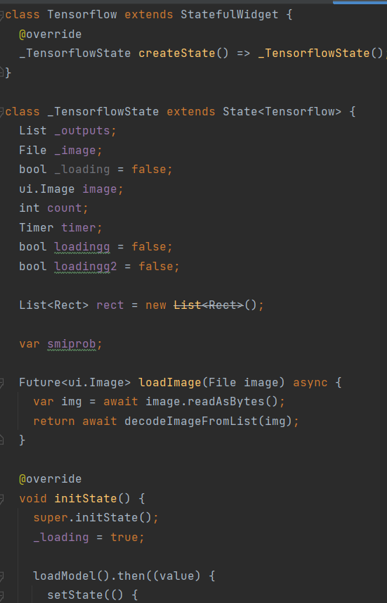
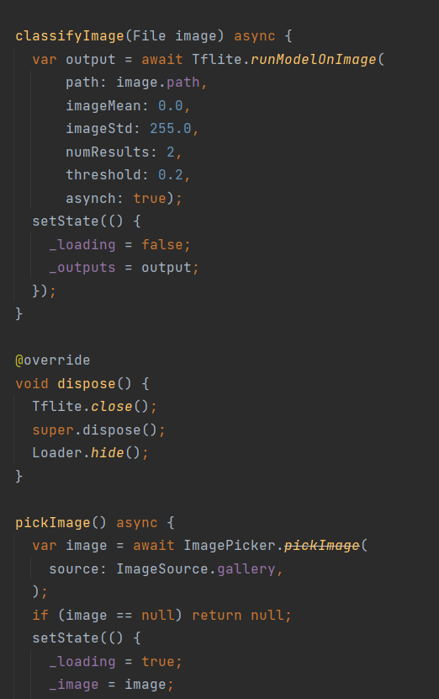
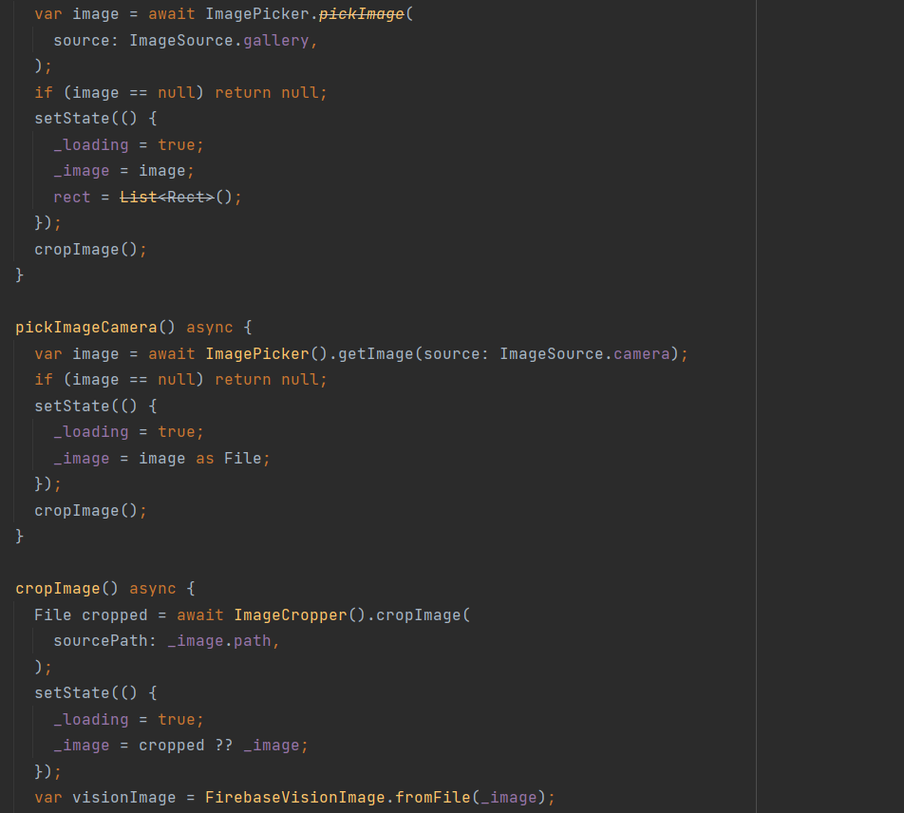

Screenshots of Output
