CREATE TABLE Employees (

EmployeeId int(11) NOT NULL AUTO_INCREMENT,

SSNumber varchar(11) NOT NULL,

LastName varchar(50) NOT NULL,

FirstName varchar(50) NOT NULL,

MiddleName varchar(50) DEFAULT NULL,

Gender varchar(6) NOT NULL DEFAULT 'MALE',

DOB date NOT NULL,

Email varchar(75) NOT NULL,

Mobile varchar(14) DEFAULT NULL,

HTel varchar(14) NOT NULL,

AddressLine1 varchar(75) NOT NULL,

AddressLine2 varchar(75) DEFAULT NULL,

City varchar(50) NOT NULL,

State varchar(50) NOT NULL,

PostCode varchar(10) NOT NULL,

PRIMARY KEY (EmployeeId),

INDEX SSNumber (SSNumber),

INDEX DOB (DOB),

INDEX PostCode (PostCode),

INDEX FullName (LastName,FirstName)

);

CREATE TABLE Allowances (

AllowanceId int(11) NOT NULL AUTO_INCREMENT,

AllowanceName int(11) NOT NULL,

AllowanceDescription varchar(250) DEFAULT NULL,

Amount decimal(10,2) NOT NULL DEFAULT '0.00',

PRIMARY KEY (AllowanceId),

INDEX AllowanceName (AllowanceName)

);

CREATE TABLE SalaryScales (

SalaryScaleCode tinyint(4) NOT NULL,

SalaryScaleName varchar(50) NOT NULL,

SalaryScaleDescription varchar(250) DEFAULT NULL,

MinimumSalary decimal(10,2) NOT NULL DEFAULT '0.00',

MaximumSalary decimal(10,2) NOT NULL DEFAULT '0.00',

PRIMARY KEY (SalaryScaleCode),

INDEX SalaryScaleName (SalaryScaleName)

);

CREATE TABLE Positions (

PositionId int(11) NOT NULL AUTO_INCREMENT,

PositionName varchar(75) NOT NULL,

PositionDesctiption varchar(250) DEFAULT NULL,

Details text,

SalaryScaleCode tinyint(4) NOT NULL,

PRIMARY KEY (PositionId),

FOREIGN KEY SalaryScaleCode (SalaryScaleCode)

REFERENCES SalaryScales (SalaryScaleCode)

ON UPDATE CASCADE ON DELETE RESTRICT,

INDEX PositionName (PositionName)

);

CREATE TABLE Vehicles (

VehicleId int(11) NOT NULL AUTO_INCREMENT,

VIN varchar(17) NOT NULL,

RegistrationNo varchar(10) NOT NULL,

Year year(4) DEFAULT NULL,

Make varchar(25) DEFAULT NULL,

Model varchar(25) DEFAULT NULL,

Color varchar(25) DEFAULT NULL,

PositionId int(11) NOT NULL,

PRIMARY KEY (VehicleId),

FOREIGN KEY PositionId (PositionId)

REFERENCES Positions (PositionId)

ON UPDATE CASCADE ON DELETE RESTRICT,

INDEX VIN (VIN),

INDEX RegistrationNo (RegistrationNo)

);

CREATE TABLE PositionAllowances (

PosAllowId int(11) NOT NULL AUTO_INCREMENT,

AllowanceId int(11) NOT NULL,

PositionId int(11) NOT NULL,

PRIMARY KEY (PosAllowId),

FOREIGN KEY AllowanceId (AllowanceId)

REFERENCES Allowances (AllowanceId)

ON UPDATE CASCADE ON DELETE RESTRICT,

FOREIGN KEY PositionId (PositionId)

REFERENCES Positions (PositionId)

ON UPDATE CASCADE ON DELETE RESTRICT

);

CREATE TABLE EmployeePositions (

EmpPosId int(11) NOT NULL AUTO_INCREMENT,

EmployeeId int(11) NOT NULL,

PositionId int(11) NOT NULL,

StartDate date NOT NULL,

EndDate date DEFAULT NULL,

Comments text,

PRIMARY KEY (EmpPosId),

FOREIGN KEY EmployeeId (EmployeeId)

REFERENCES Employees (EmployeeId)

ON UPDATE CASCADE ON DELETE RESTRICT,

FOREIGN KEY PositionId (PositionId)

REFERENCES Positions (PositionId)

ON UPDATE CASCADE ON DELETE RESTRICT,

INDEX StartDate (StartDate)

);

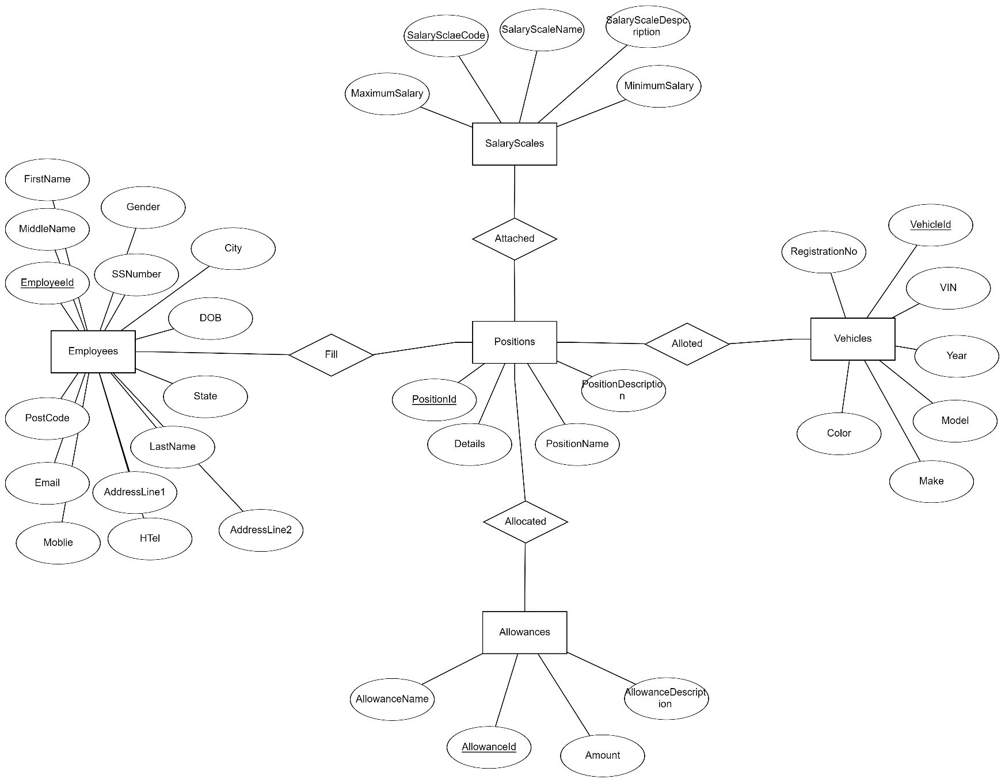**ER DIAGRAM**