**CREATING TWO TABLES**

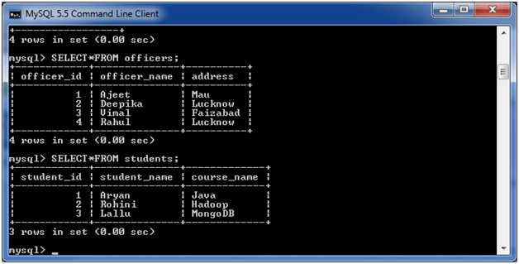

**MYSQL INNER JOIN:**

**SELECT** officers.officer_name, officers.address, students.course_name

**FROM** officers

**INNER** JOIN students

**ON** officers.officer_id = students.student_id;

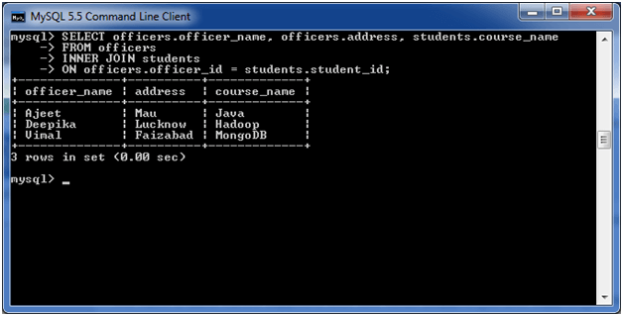

**MYSQL LEFT OUTER JOIN:**

**SELECT**  officers.officer_name, officers.address, students.course_name

**FROM** officers

LEFT JOIN students

**ON** officers.officer_id = students.student_id;

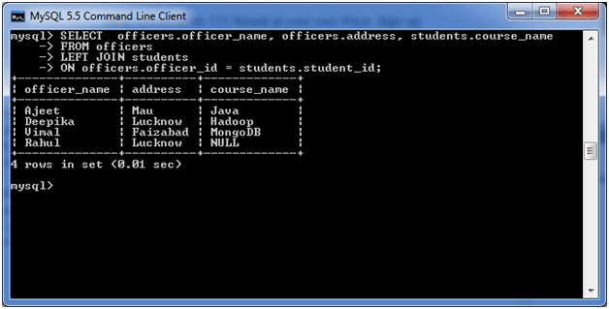

**MYSQL RIGHT OUTER JOIN:**

**SELECT** officers.officer_name, officers.address, students.course_name, students.student_name

**FROM** officers

RIGHT JOIN students

**ON** officers.officer_id = students.student_id;

