Diagonal sum in binary tree

Consider Red lines of slope -1 passing between nodes (in following diagram). The diagonal sum in a binary tree is the sum of all node datas lying between these lines. Given a Binary Tree of size n, print all diagonal sums.

For the following input tree, output should be 9, 19, 42.

9 is sum of 1, 3 and 5.

19 is sum of 2, 6, 4 and 7.

42 is sum of 9, 10, 11 and 12.

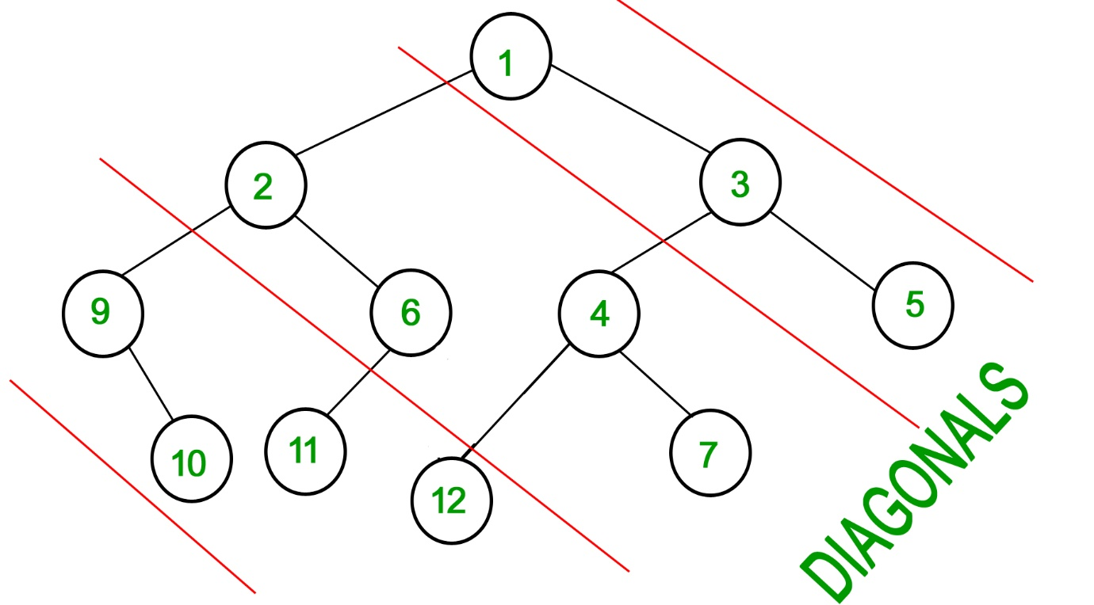

**Example 1:**

**Input:**

  4

  / \

  1 3

  /

  3

**Output:**7 4

**Example 2:**

**Input:**

  10

  / \

  8 2

  / \ /

  3 5 2

**Output:**12 15 3

**Your Task:**  
You don't need to take input. Just complete the function**diagonalSum()**that takes root **node** of the tree as parameter and returns an array containing the diagonal sums for every diagonal present in the tree with slope -1.

**Expected Time Complexity**: O(nlogn).  
**Expected Auxiliary Space:**O(n).